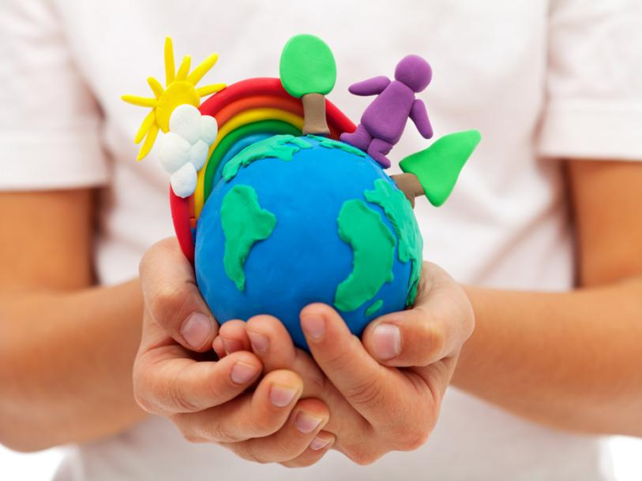

The Urgent Reality of Climate Change
Contemporary challenges: Making a DIFFERENCE
Jaroslav Demeter (2240603)

Climate change is a huge deal that has a ton of impacts on our planet. As the temperature of the Earth keeps going up, it affects everything from our environment to our society.

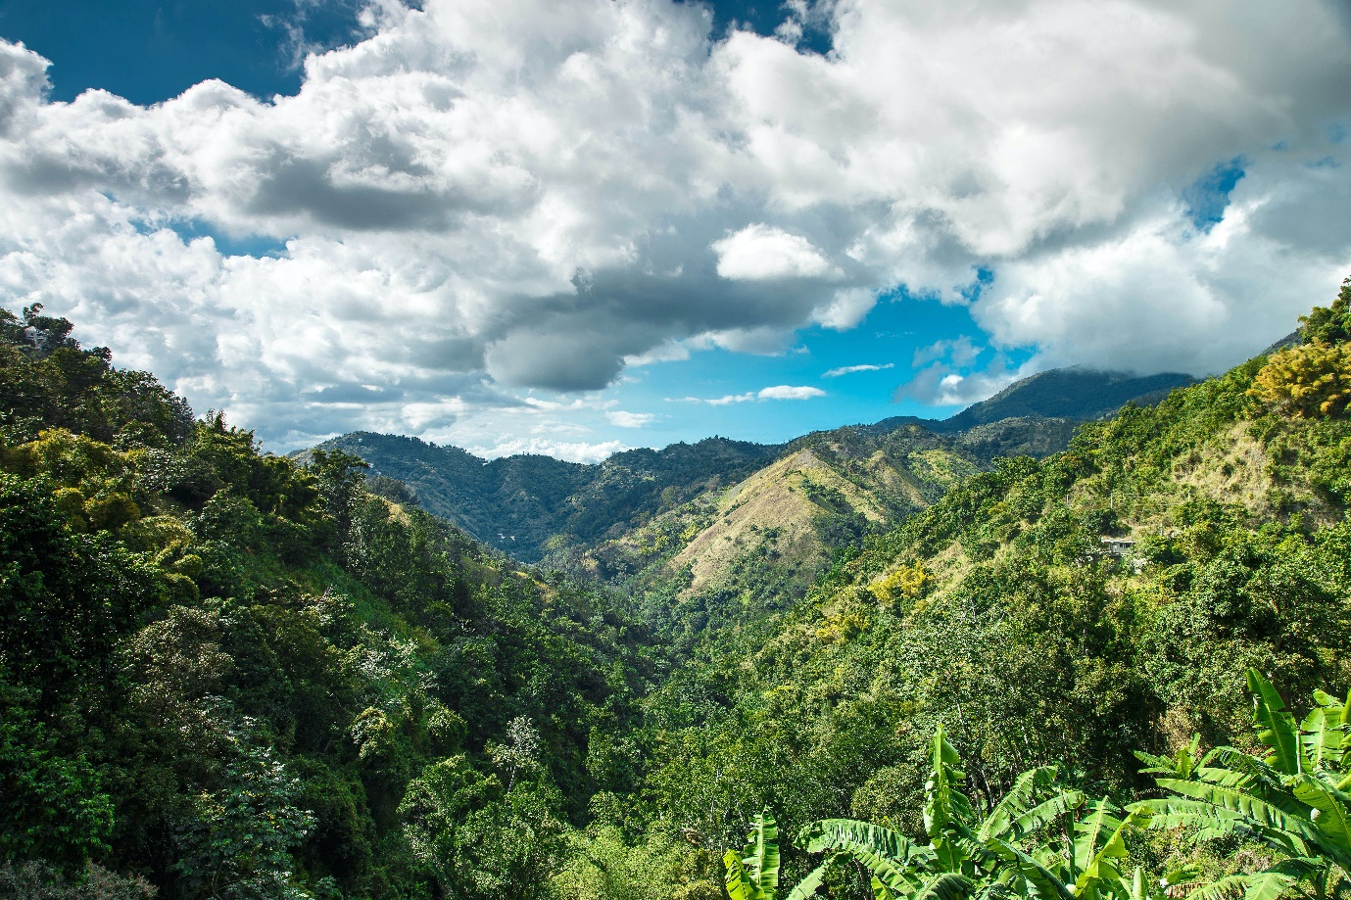

Climate change happens because of stuff we humans do. We emit carbon dioxide, methane, and nitrous oxide when we burn fossil fuels, cut down trees, and do industrial stuff. These gases trap heat, which makes the earth warmer - that's what we call the greenhouse effect. (IPCC,2023)

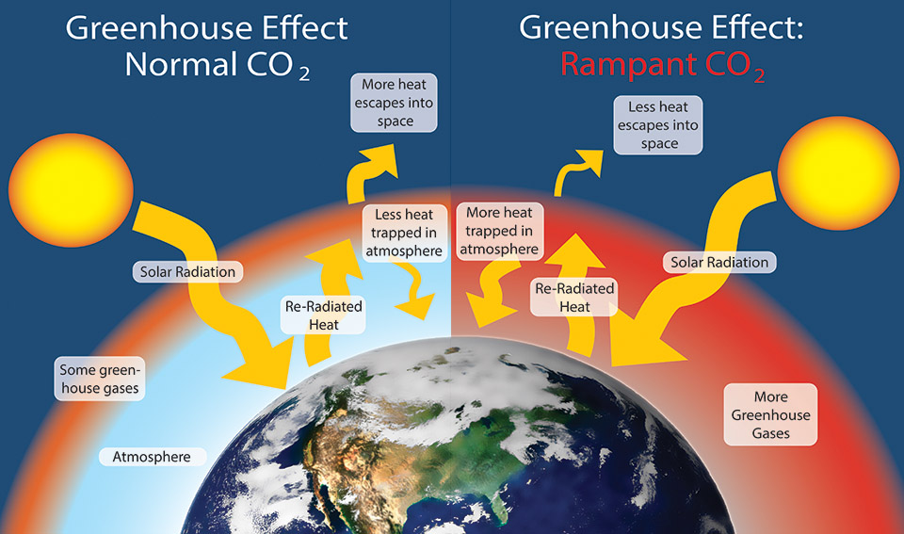
(National Park Servis,2020)

Climate change is affecting the whole world big time. The temperatures are going up, and that's making hurricanes, droughts, and heatwaves happen more often and with more intensity. As glaciers and polar ice caps keep melting, the sea level is on the rise, and that poses a risk to communities living near the coast. Climate change also means we're losing species, our oceans are becoming more acidic, and agriculture is getting messed up. (NASA,2023)

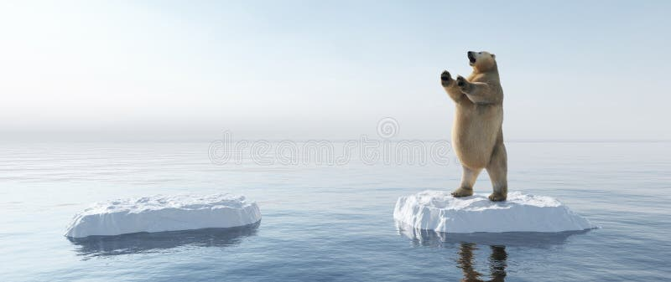

You can totally help fight climate change just by reducing your carbon footprint. Simple things like saving energy, taking public transport, and reusing and recycling can make a real difference. You can also make a positive impact by encouraging sustainable practices and supporting businesses that care about the environment. (EPA,2023)

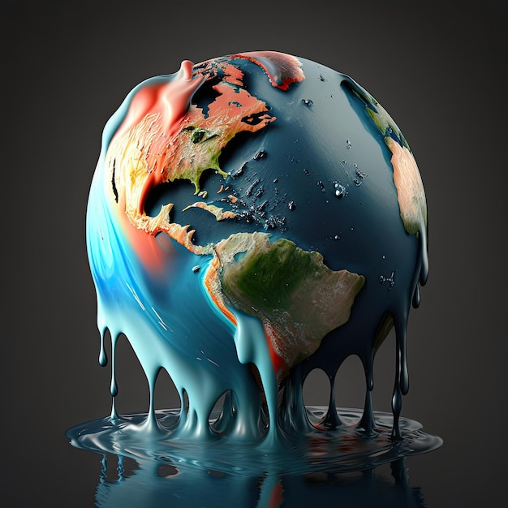

Did you know that we need to reduce our greenhouse gas emissions by almost 50% by 2030? A recent report from the United Nations shows that this is necessary to prevent the devastating effects of global warming. The good news is that we still have time to take the right steps, but we need to act quickly before it's too late. According to the report, meeting this new target is our last chance to prevent the planet from warming beyond 1.5 degrees Celsius, compared to pre-industrial levels. The report was compiled by over 93 scientists and is based on indisputable scientific evidence. Manish Bapna, the CEO of the Natural Resources Defence Council, who wasn't part of the report, agrees that this is true. He also warns us that we need to change our course quickly if we don't want to end up hurtling towards destruction.
So, to put it simply, climate change is a pretty big deal all around the world and we humans cause it. It has a pretty significant impact on both the environment and society. To tackle it properly, we must work together and do things like reduce greenhouse gas emissions, adopt sustainable practices, and take individual and collective action. Remember, climate change isn't just about the environment, it's about being good to each other and making sure we leave the planet in good shape for future generations. (Will Sulivan,2023)

EPA. (.). Climate change impacts. [Online]. epa.gov. Last Updated: 29 September 2023. Available at: https://www.epa.gov/climate-indicators [Accessed 23 October 2023].

Global Climate Change, Vital Signs of The Planet. (.). The effects of climate change. [Online]. climate.nasa.gov/effects/. Last Updated: 19 October 2023. Available at: https://climate.nasa.gov/effects/ [Accessed 23 October 2023].
IPCC. (2023). The Intergovernmental Panel on Climate Change. [Online]. ipcc.ch. Last Updated: 2023. Available at: https://www.ipcc.ch/ [Accessed 23 October 2023].

National Park servis..(16 0ctober 2020). What is climate change? [Online]. Golden gate. Available at https://www.nps.gov/goga/learn/nature/climate-change-causes.htm. [Accessed 23 October 2023].

Will Sullivan. (2023). U.N. Climate Change Report Calls for Urgent Action. Smithsonian Magazine. 22 March 2023, p...

The Rise of Machines

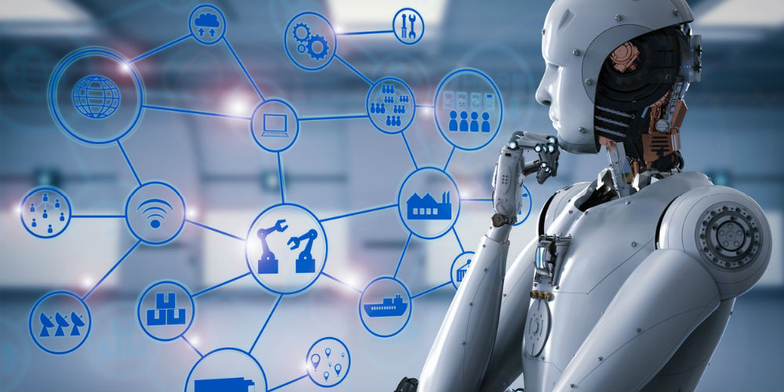

Contemporary Challenges: Making a Difference
Jaroslav Demeter (2240603)

With all the technological advancements happening today, people are beginning to worry about the future of work. Will robots take over our jobs, or will they open new opportunities? Artificial intelligence has the potential to revolutionize our way of living and working, but it's unclear whether it will be a good thing for everyone.

As robots become more advanced, many people are scared that they'll replace human workers, leading to a lot of people losing their jobs. Those who work in manual labour might be hit especially hard, as their jobs are more likely to be taken over by machines. They might not have the right skills to transition to other types of work. However, even highly skilled professions like law, healthcare, engineering, banking, and accounting might be impacted as AI gets better and better. (The Royal Society, 2016)

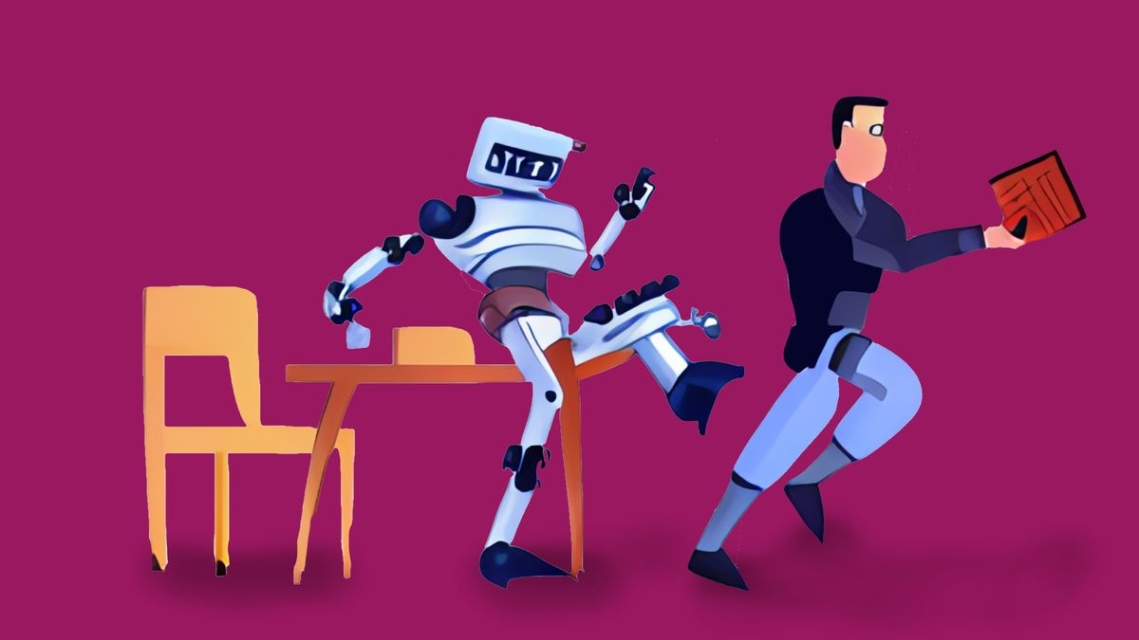

Lots of movies and stories are about super-smart machines that turn against their makers and destroy them. You've probably seen this in movies like 2001: A Space Odyssey and The Matrix and read about it in tons of sci-fi books. It's a popular idea that storytellers have used for a long time. (ISSUU, 2019)

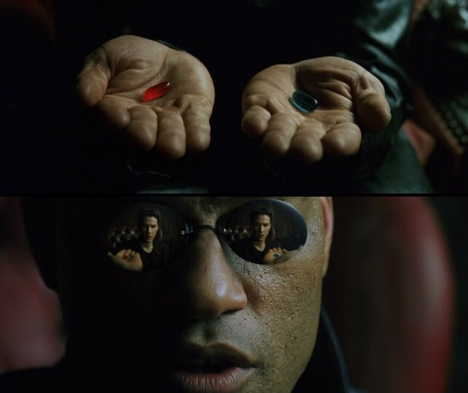

AI, or Artificial Intelligence, is like a smart computer that uses learning and data to give answers. AI is good when you want accuracy and speed.
On the other hand, human intelligence comes from our experiences and senses. We can adjust to new situations and emotions like self-reflection, compassion, and determination play a big role in how we think. Unlike AI, our intelligence can grow, and change based on our experiences and environment. It's best to use human intelligence when you want creative, emotional, or ethical solutions.
Everybody's talking about AI these days, and the question on everyone's mind is: Will AI get smarter than humans? Well, as of now, the answer is a big nope. AI might be all over the place, but it still has a long way to go before it can match human intelligence. (Fiverr, 2023)

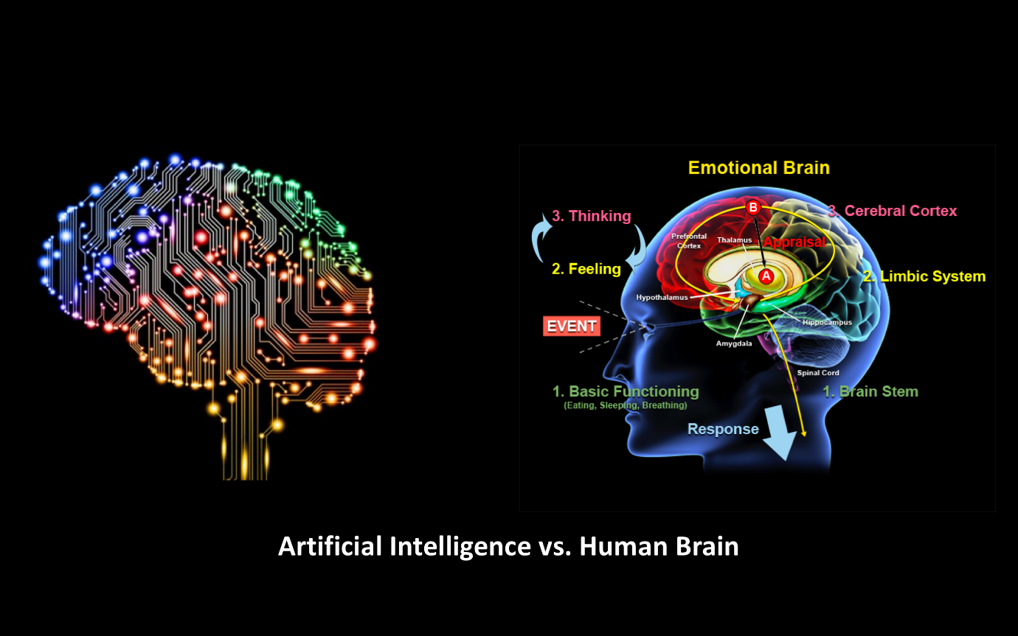

Did you know that there are three types of creativity? According to Margaret Boden, they are combinational, exploratory, and transformational. Combinational creativity combines familiar ideas, while exploratory creativity tweaks established styles to generate new ideas. Both are like how generative AI uses algorithms to produce art.
Transformational creativity, however, goes a step further and creates something entirely original beyond existing structures and styles. This is where AI and copyright debates come into play.
AI's creative processes are different from human artists' processes. AI is systematic and processes information predictably, albeit often in unexpected ways. Unlike artists, AI is consumer-centric and market-driven, meaning we only get the art we ask for, which may not be what we truly need. (We forum, 2023)

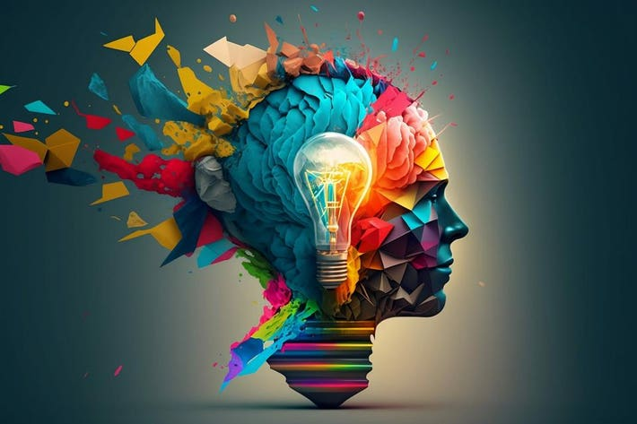

Did you know that AI can't naturally learn from its own experience and mistakes, just like humans? Although, unlike humans, creating an AI that can learn on its own is both incredibly difficult and expensive. While there are some AIs, like AlphaGo, developed by Google, that can learn and even invent new strategies, most AIs will need human intervention to improve over time. Therefore, without the programming for self-learning, AI will heavily rely on human guidance and assistance to develop and evolve. (Tableau, 2023)

Fiverr. (2023). AI vs. Human: Creativity, Abilities, and Skills (Which is Better?). [Online]. fiverr.com. Last Updated: 16 Jun 2023. Available at: https://www.fiverr.com/resources/guides/business/ai-vs-human [Accessed 28 October 2023].

Liam Kelly and Tom Hall. (2019). The rise of the machines. WC1E..(4), p...[Online]. Available at: https://issuu.com/universityoflondon/docs/wc1e_issue_4_2019/s/10610585 [Accessed 28 October 2023].

Tableau. (.). What are the advantages and disadvantages of artificial intelligence (AI)?. [Online]. tableau.com. Last Updated: 2023. Available at: https://www.tableau.com/data-insights/ai/advantages-disadvantages?cq_cmp=20663578515&cq_net=x&cq_pla [Accessed 28 October 2023].

The Royal Society. (.). Rise of the machine. [Online]. royalsociety.org. Last Updated: 14 October 2016. Available at: https://royalsociety.org/blog/2016/10/rise-of-the-machines/ [Accessed 28 October 2023].

World Economic Forum. (2023). Artificial Intelligence. [Online]. weforum.org. Last Updated: 16 Jun 2023. Available at: https://www.weforum.org/agenda/2023/06/ai-cannot-replace-human-creativity/ [Accessed 28 October 2023].

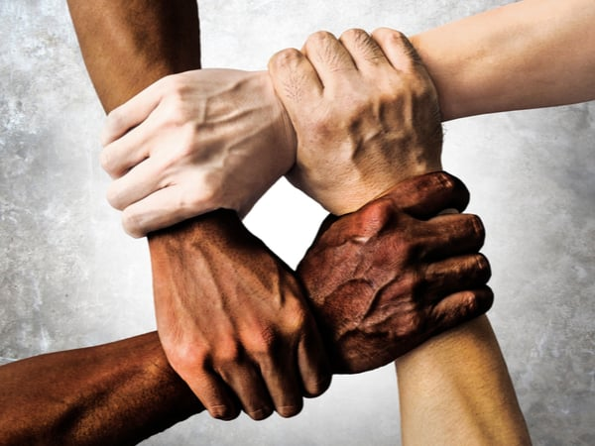

Racism

Contemporary Challenges: Making a Difference
Jaroslav Demeter (2240603)

Racism is when some people get treated better than others just because of their race. It can happen in different ways like the way people are represented, what people believe, how they talk to each other, how organizations work, and how society is structured. This makes some people feel more powerful and important than others while making other people feel left out and discriminated against. (Nicky Lisa Cole, 2019)

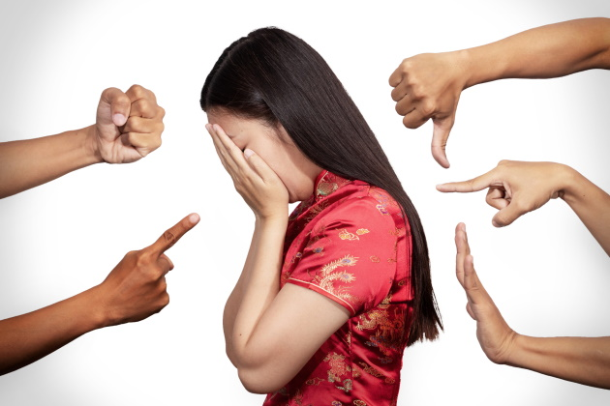

Did you know that according to Merriam-Webster, "racism" refers to the belief that a person's race is a fundamental determinant of their traits and abilities? Unfortunately, this belief has led to the development of harmful notions of superior and inferior races. As a result, racism also refers to the systematic oppression of certain racial groups, giving other groups social, economic, and political advantages. In this article, we explore ten root causes of racism against Black individuals, both at the systemic and individual levels. Let's work together to create a more inclusive and equitable society for everyone! (Merriam-Webster, .)
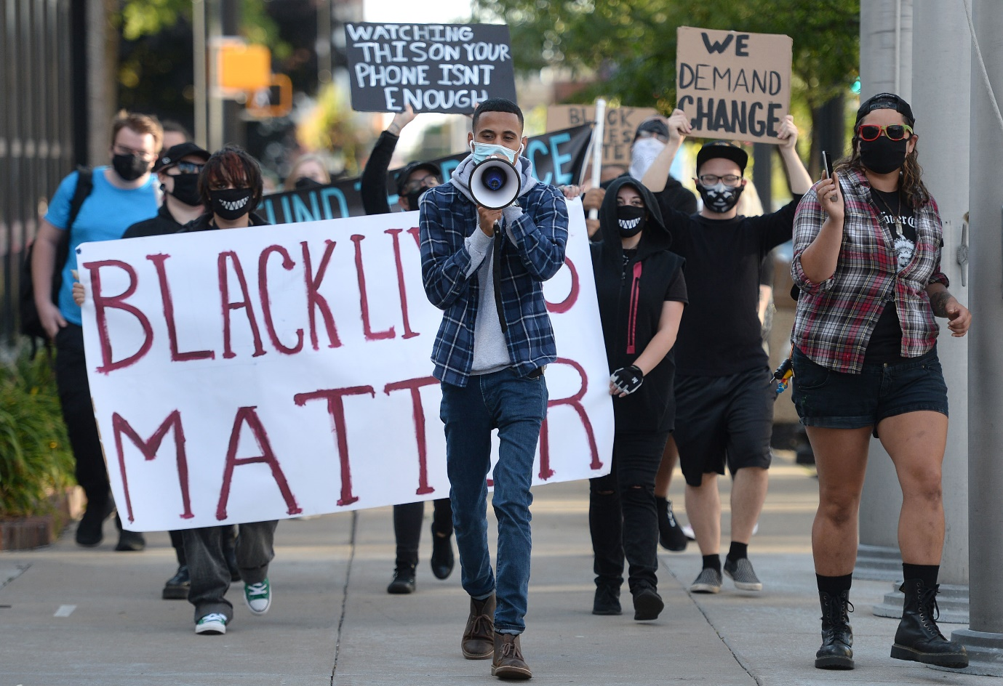

People love putting labels on each other. Like, if someone dresses in a certain way, they're supposed to be into a particular type of music. Or if someone goes to a certain school, they must be swimming in cash. It's not just that, though. We also tend to stereotype people based on their race. Like, some people might think a particular race is just "lazy" or "brainy" or whatever. But here's the thing - don't judge people based on their group. Take the time to get to know people from different backgrounds. You might be surprised at how much you have in common. (Australian government,)

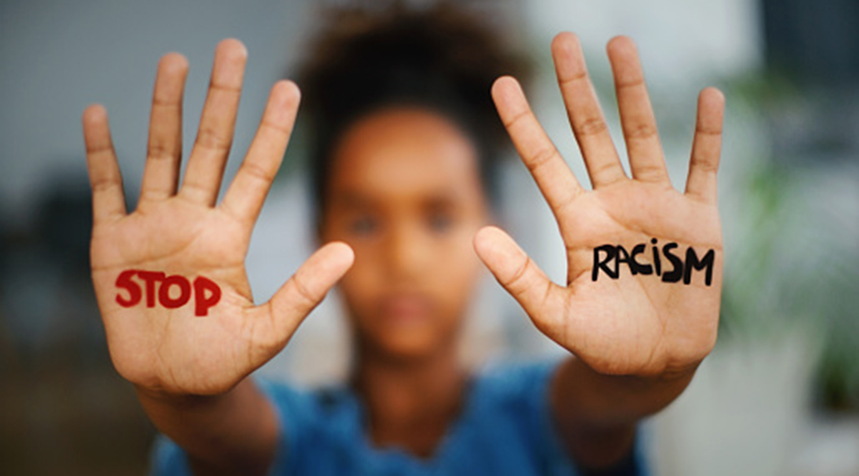

It's super important for organizations, researchers, policymakers, and providers to recognize and tackle the negative impact of racism on NDRE youth's health, well-being, and development, as well as youth-serving providers. To make that happen, they need to take a clear stand against discriminatory policies, practices, and events and actively engage in interdisciplinary efforts to create environments that are safe and supportive for individuals from diverse backgrounds.

I think it's important that we work together to prevent racial discrimination and build a culture of peace. Discriminatory attitudes and behaviours are learned and not genetic, so it's crucial that we teach our children the value of diversity from an early age. We can do this in our homes, schools, and through the social content we consume.

By promoting appreciation for differences and building tolerance for pluralism, we can create a society that is strong, resilient, and sustainable. As Kofi Annan once said, "Ignorance and prejudice are the handmaidens of propaganda. Our mission, therefore, is to confront ignorance with knowledge, bigotry with tolerance, and isolation with the outstretched hand of generosity. Racism can, will, and must be defeated."

Let's work together to combat ignorance, intolerance, and bigotry with education, generosity, and a commitment to diversity. Together, we can make the world a better place! (UNDP Ghana, 2022)

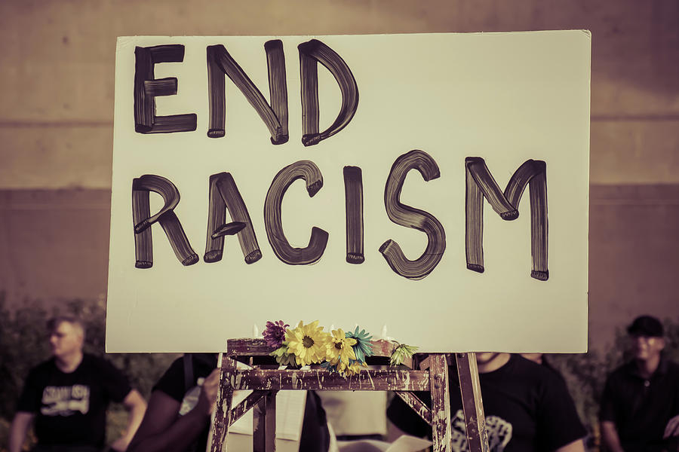

Australian Government. (.). Why are people racist [Online]. humanrights.gov.au. Last Updated: .. Available at: https://humanrights.gov.au/sites/default/files/whyarepeopleracist.pdf [Accessed 3 November 2023].

Human Rights Careers. (.). 10 Root Causes of Racism. [Online]. humanrightscareers.com. Last Updated: .. Available at: https://www.humanrightscareers.com/issues/root-causes-of-racism/ [Accessed 3 November 2023].

Journal of Adolescence Health. (2018). Racism and Its Harmful Effects on Nondominant Racial–Ethnic Youth and Youth-Serving Providers: A Call to Action for Or. [Online]. jahonline.org. Last Updated: .. Available at: https://www.jahonline.org/article/S1054-139X(18)30239-8/fulltext [Accessed 3 November 2023].

Nicky Lisa Cole. (1 August 2019). Defining Racism Beyond its Dictionary Meaning: A System of Power, Privilege, and Oppression. [Online]. racism.org. Last Updated: 14 July 2019. Available at:https://racism.org/articles/defining-racism/3115-defining-racism-beyond [Accessed 3 November 2023].

UNDP Ghana. (2022). End Racism. Build Peace. [Online]. undp.org. Last Updated: 21 September 2022. Available at: https://www.undp.org/ghana/blog/end-racism-build-peace [Accessed 3 November 2023].

