
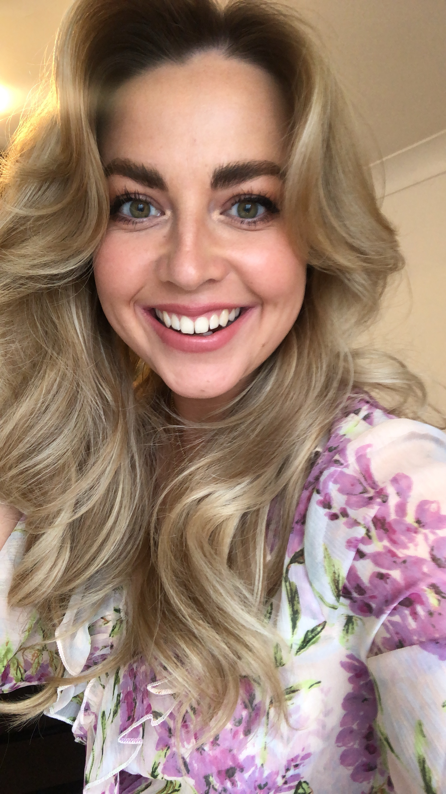

Y math o athro hoffaf bod
The kind of teacher I aspire to be

- Trustworthy
- Enthusiastic
- Patient
- Approachable
- Professional
- Someone who will try her best to get the best out of each pupil

Profiad addysgu blaenorol
Previous teaching experiences
I have organised and delivered my own dance, drama & fitness classes and summer schools to children aged 4-16 years. I was also a Learning Support Assistant for five years in a secondary school as well as working as a cover supervisor for a year.

Rhesymau dros ddewis addysgu fel proffesiwn
Reasons for entering the teaching profession
I really enjoyed school as a child but, I know not everyone has had the same experience as me. I want to ensure every child I teach feels like school is a safe place they can come and be anything they want and deserve to be.
Amdana i…/About me…
- Jade Cascarina
- 28
- Bridgend
- Originally from Cornwall
Interests…
- Dancing
- Photography
- Blogging

Cefndir academaidd
Academic history
8 x GCSE A-D
3 x A Levels
BA Hons Dance 2:1
.
Meysydd / pynciau medraf eu haddysgu
Areas / subjects I could teach

- Drama
- Dance
- P.E
- Media Studies

