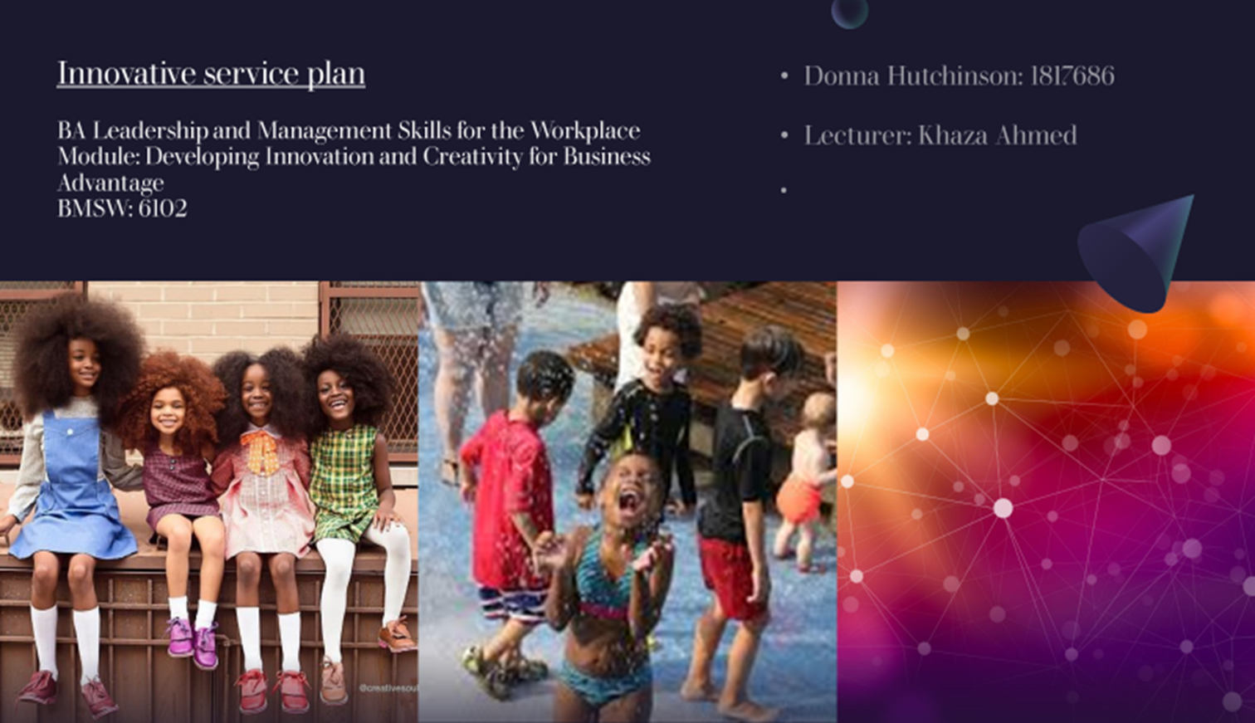

Contents Page

- Cover page

- Contents page

- Introduction

- Concept – The Void

- Breakdown of the sectors within website/app

- Finance

- B2C and Swot

.
- Who is the Market? / Promotions and launch party

- Incremental Innovation

- Conclusion

- Ref
- Appendices Fig 1

Introduction

Within this report a task has been set to bring to fruition a saleable, innovative service, that attends to the customers ever evolving and emerging needs and wants. So what does this report entail, within this report is the proposal for an online service, geared towards promoting well-being within families, yet mainly targeting children.
In this era were talking and freely expressing opinions sharing emotions has become the way of the world, and technology has vast become ever ready and at the disposal of everyone from infants to the elderly. Having a counselling platform that caters to the emotional well being of children, is something not only desired but required. This website/ app fosters a safe environment for individuals to openly share, talk or vent their frustrations.

“The way to get started is to quit talking and begin doing”
“Walt Disney”

Main Body
Concept:

1. The Void
Within a very short time frame mobile phones have vast become the number one way people choose to communicate with one another (see fig 1). By the end of 2020, there were 5.22 billion smartphone users, or 66 percent of the world's population (DataReportal, 2021). An additional 93 million users were added in 2021, which in turn lead to 1.8% increase of business, (and finances) in a very short time span the potential for growth for this service is huge.
how quickly and dependent / reliant people have become on technology. Mobile phones are not only to make telephone calls anymore, with an array of ways in which people choose to communicate, (via messaging, emailing texting, voice notes, group meetings, skype calls, messenger, whattsapp, FaceBook etc )and new apps and services popping up every day. What is more incredible all these things are all made easily accessible anytime through your hand-held device.
So why when communicating appears to be so easy, why is understanding one another so hard?
So what is the proposal? Combine the love of art and the benefits and teachings of emotional wellbeing all interlocked with technology.
Welcome to The Void, an app designed with children’s well-being in mind, yet accentuates the importance of self-love, and the positivity of self-understanding and patience within the family. Combining the love of art and the benefits of emotional stability and healthy mental well being, combined all with technology
within the world you dictate what joys or catastrophes take place as a result of your emotionally wellbeing, and so the emotional learning about mental self-care begins.

Breakdown of the sectors within website/app

Upon entering the website or the app, a child is taken to a vast nothingness of space this is called THE VOID,

- THE VOID = from here the adventure begins, an individual first has to create their world. Take a star choose how the world comes into existence, will it begin with an explosion, does it slowly bloom, will two worlds collide creating the birth for a new one, will it be a shaped like a globe maybe a pyramid
give it rings, the possibilities are endless 🌎

- THE BEGINNING = Now a world has been created, and so now the work begins. As they fill their world with whatever they want, from the thousands of choices and options,

- Life = select from the thousands of life forms on offer, opt to augment its size, change its colour, add legs give it fur scales the possibilities can be endless.

- Weather = Yes we all feel happy, but its important to know that we all also feel sad, angry even a little disorientated from the world and people in it sometimes, it is also important to know you’re not alone in feeling this way and its normal. Online and in the app the weather can act as gauge to a child’s emotional well-being. On your home planet weather can be anything from green lava spewing out of purple mountains, to aqua sludge for rain again the possibilities are endless and completely up to the child.

- Avatar = All children are required to create an avatar, anything goes, all shapes and forms, several eyes a butt for a face the choice is theirs.

STAFF
- Mentors/councilors = Just like everyone who enters the void mentors will be required to create an avatar themselves. Mentors also have a profile So children will be able to scroll through the many different avatars and pick on an avatar they are drawn to find out a little more about the mentor. For example “I am Superhero Sadness Smasher, my super powers include banishing evil, and helping each child find the light within” Etc.
Each mentors page has a section for parents to examine the credentials of their child’s chosen counsellor, including what they specialize in, and a list of their qualifications.
Staff will be outsourced through social platforms such as LinkedIn and be required to hold an UpToDate CRB check, as well as all required credentials.

- My Home Planet = This sector allows children to login and adjust the weather to match their emotions ( left unchecked, like emotions, damage can be incremental or detrimental depending on how long they leave their emotions unchecked
A child will be required to log in each day and see how their world has progressed from the night before. Has life formed? what’s happened to the vegetation? Depending on a child’s mood the last time the were actively online will determine what’s happened to their home planet in the present day. For example if a child is feeling angry and decides to create a tumultuous storm, (representing how they felt that day.) but then neglected to log in for a couple of days, ( avoiding ones emotions) when they do eventually log back in, they may find that their storm (anger) left unchecked turns into a tsunami and has devasted their home planet in parts, then a little message pops us explaining and connecting the actions of the digital world to that of the human one, helping them to understand the importance of communicating. Then a prompt from the Void mascot will remind the participant to book a session, and the child can continue to repair their world as they would themselves.
In aid with creating their own universe, by logging in each day and expressing themselves and sharing how they feel, children receive a new item to add to their home planet. Zoom in and out of your home planet and add constellations given as rewards for major breakthroughs, or simply personal growth. With each step taken within the void there are hidden inspirational messages, mantras to help boost confidence and self esteem as well as teaching patience and understanding.

- The Chatroom
Online and in the app there is readily available a chat room forum, where kids can go and mingle with other children and mentors. As their avatars mingle, talk and play games together, helping them build companionship confidence and the ability to share their emotions with others taking these new found skills into the real world..
- Time lapse = By utilizing the time lapse feature a child can speed up or slow down and rewatch the birth of their creation and all it has endured up to the current date. Marking personal growth and triumphs, feeling a sense of pride and accomplishment through witnessing their personal journey, and learning that even from devastation, with time beautiful things can come to fruition once more.
- Parents forum = Here parents can interact with mentors, ask advice, leave comments, and leave positive affirmations/comments for their child to read.
- They can also leave positive comments for mentors or to stress concern about an issue here too.
- The parents platform is also a place for parents to meet and talk with other parents, again encouraging interactions via the digital world and the real one.

- FINANCE=

- The website and app will allow parents to choose the subscription that works best for their household. As mental health is the overall goal, a child will always be able to log in create and destroy when it comes to their home planet, as this in itself is a form of therapy.
- A monthly Membership fee, ( included in this package is a set number of hours of counselling sessions with the child’s chosen counsellor/mentor )
- Session for session fee ( pay foreach counselling session as they happen)
- Family plan (households with more than one child receive a discount, again depending on the sessions they opt in for)
- Blook booking ( book in a block of sessions, to have at the child’s discretion)
- Payments can be mad through several payment options, Direct Debit (for memberships), PayPal, Google pay and card payments for singular sessions will all be accepted,

Business 2 Consumer (B2C)

This counselling service (business model ) is based on a business to consumer ecommerce, this style of business has already revolutionized the business sector giving consumer every opportunity review a service or product before committing to an order. Stores such Amazon already hugely utilise through this platform.

S.W.O.T

- STRENGHTS =
- Location the service will be readily available to miliions due it being an online platform.
- A healthy environment in which to communicate
- Grow friendships and mend family relationships
- Improve emotional stability and grow a greater understanding of oneself.
- Learning to be compassionate and understanding of others
- Readily accessible
- Being able to undergo a counselling session within the comforts of a persons home can be more conducive to some individuals therapy.
- There is no other platform offering this service.

- WEAKNESS =
- Engineering problems
- Time lag between the real and the digital world

- OPPORTUNITIES =
- Creation of new job opportunities
- Huge potential for growth
- Ready management of mental stability
- Reduced overheads, for example as there is no rent on a private space

- THREATS =
- Competitors could try and replicate what the void has to offer
- Data theft
- Because it’s not face to face, possible absence of verbal and non-verbal cues could provide a problem.
- Counsellors/mentors credibility could come into question ( due diligence is necessary to ensure all credentials are genuine and all up to date )

Promotions and the launch

The platform will be promoted through all social networks such as LinkedIn, Facebook, Instagram.
Approach YouTube influencers and have them discuss their experiences using the online/app service. Also utilize these avenues for the countdown to the big launch. On a successful launching the first 20 subscribers gets a months’ worth of sessions online for free or within the app.

Who is the Market
Initially the platform was designed and created with children in the forefront, with its secondary function fostering and creating bonds within the family.
But in the future in can be adapted for schools psychologist counsellors hospitals any number of organizations who continue with the maintenance of children’s wellbeing.

Incremental innovation.

Like most innovations, this service's goal is to improve upon the services that currently exists. The objective is to increase and broaden current options, such as the market and the services customer base. This service its geared towards incremental innovation which can, sometimes, influence the industry in a more significant way than radical innovation.

Conclusion

The theory behind the website/app is to encourage and to teach children the added benefits of talking, how important it is to express emotions healthily, what negative effects can occur when an individual holds onto that anger, sadness or frustration stop the mental hurt and dilapidation of a child before those mine ailments become full blown bouts of depression or fears of discontent etc. The old saying “Prevention is better than a cure. “

“there has been less focus on population-based or preemptive interventions that prevent problems before they occur.”
There are several existing counselling platforms online, apps geared towards adults and even a few that market teens, but no other counselling service that helps children of all ages and guides families in better understanding one another, and thus in turn other people. As it stands there is nothing in the market that caters to the family as a whole.
For parents there is the added peace of mind and opportunities to build and work on their relationships by having the ability to log in online, and actively check on a child’s home planet, from this they can gage how that child’s emotional level is that day, week, month.
So while the app is essential a counselling service, its gateway is designed to be the key to something greater. A world where children who become teenagers who become adults, who learn to love and accept themselves and who they are. And in turn learn to Love an accept everyone else.
The theory behind the website/app is to encourage and to teach children the added benefits of talking, how important it is to express emotions healthily, what negative effects can occur when an individual holds onto that anger, sadness or frustration stop the mental hurt and dilapidation of a child before those mine ailments become full blown bouts of depression or fears of discontent etc. The old saying “Prevention is better than a cure. “

References

Black, M.M. and Krishnakumar, A., (1998.). Children in low-income, urban settings: interventions to promote mental health and well-being. American Psychologist, 53(6), p.635. [Accessed on 29 Jun. 2022]
Digital 2021: Global overview report. DataReportal. [Accessed on 4 Jul. 2022]

Etheridge, B. and Spantig, L., (2020.). The gender gap in mental well-being during the Covid-19 outbreak: evidence from the UK (No. 2020-08). ISER Working paper series. [Accessed on 14 June 2022].

Investopedia. (n.d.). Business-to-Consumer (B2C): What You Need to Know. [online] Available at: https://www.investopedia.com/terms/b/btoc.asp#:~:text=B2C%20is%20typically%20used%20to%20refer [Accessed 12 Jul. 2022].

Jay, A. (n.d.). Number of Smartphone and Mobile Phone Users Worldwide in 2020: Demographics, Statistics, Predictions - Financesonline.com. [online] financesonline.com. Available at: https://financesonline.com/number-of-smartphone-users-worldwide/. [Accessed on 2 Jul. 2022].

Mind (2020). The Mental Health Emergency. [online] Available at: https://www.mind.org.uk/media-a/5929/the-mental-health-emergency_a4_final.pdf.

Newmark, J., (2007.). From Talk to Action: What Performance Improvement is Really All About. Radiology management, 29(3), p.18 [Accessed on 17 Jun. 2022]

psycnet.apa.org. (n.d.). APA PsycNet. [online] Available at: https://psycnet.apa.org/doiLanding?doi=10.1037%2F0003-066X.53.6.635 [Accessed on 27 Jun. 2022].

Appendices



