University of Wales Trinity Saint David
Wales Institute of Science and Art


Electronic Circuits Testing and Applications

Electrical Control Systems ACHA4010

Yash Patani
2306509
06/04/2025
Contents
1 Task 3 1
1.1 Scope Time Division Calculations (3) 1
1.2 Function Generator output square wave (3) 1
1.3 Capacitor charge and discharge wave marked at correct points. (3) 1
1.4 Basic Capacitor Calculations (3) 1
1.5 Capacitor discharge table (2) 1
1.6 Plot log(V) Gradient (2) 1
1.7 Gradient Calculations and Compare(4) 1
1.7.1 Gradient Calculations 1
1.7.2 Comparison table 1
1.8 Capacitor Uses (5) 1
1.9 Inaccuracies Question (4) 1
2 References 2

Task 3

Scope Time Division Calculations (3)

f= 1/period(t)
Period(t)= 1/f
DivNumberTime= 10
Period = 4mS
Frequency = 1/4mS
Frequency = 250Hz

Function Generator output square wave (3)
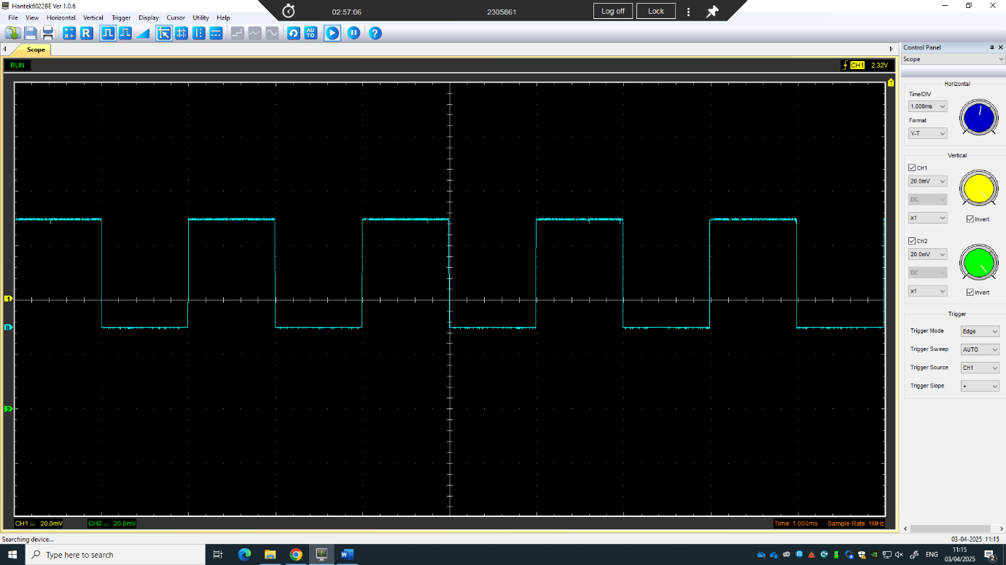

Capacitor charge and discharge wave marked at correct points. (3)

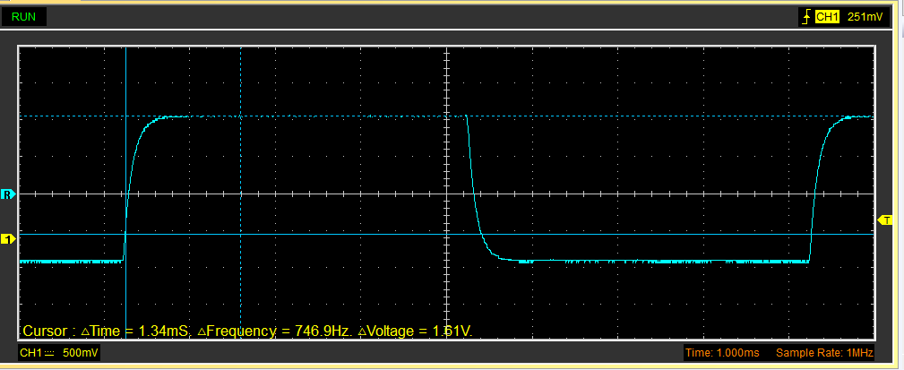

Basic Capacitor Calculations (3)

Range of Voltage = 1.55V
Time Constant = Range of Voltage x 0.632 = 0.9765V
Find value of time constant at 0.9765V
Time Constant = 165uS
Capacitance = Time Constant / Resistance
Capacitance = 165x10^-6S/100
Capacitance = 1.65x10^-6 Farads = 1.65uF

Capacitor discharge table (2)
Time (s) | Voltage (V) | ln (V) | dy = y2 – y1  dy = ln(V)2-ln(V)1 | dx = x2- x1  dx = Time2 – Time1 | dy/dx
0.00982 | 0.85960 | -0.06570 | x | x | x
0.01000 | 0.55840 | -0.25305 | -0.18700 | 0.00013 | -1438.46154
0.01018 | 0.36390 | -0.43902 | -0.18500 | 0.00013 | -1423.07692
0.01036 | 0.26980 | -0.56896 | -0.13000 | 0.00013 | -1000.00000
0.01054 | 0.21960 | -0.65837 | -0.08900 | 0.00013 | -684.61538
0.01072 | 0.20080 | -0.69724 | -0.03900 | 0.00013 | -300.00000
0.01090 | 0.17570 | -0.75523 | -0.05800 | 0.00013 | -446.15385
0.01108 | 0.16940 | -0.77109 | -0.01600 | 0.00013 | -123.07692
0.01126 | 0.15690 | -0.80438 | -0.03300 | 0.00013 | -253.84615
0.01144 | 0.14430 | -0.84073 | -0.03600 | 0.00013 | -276.92308

Plot log(V) Gradient (2)
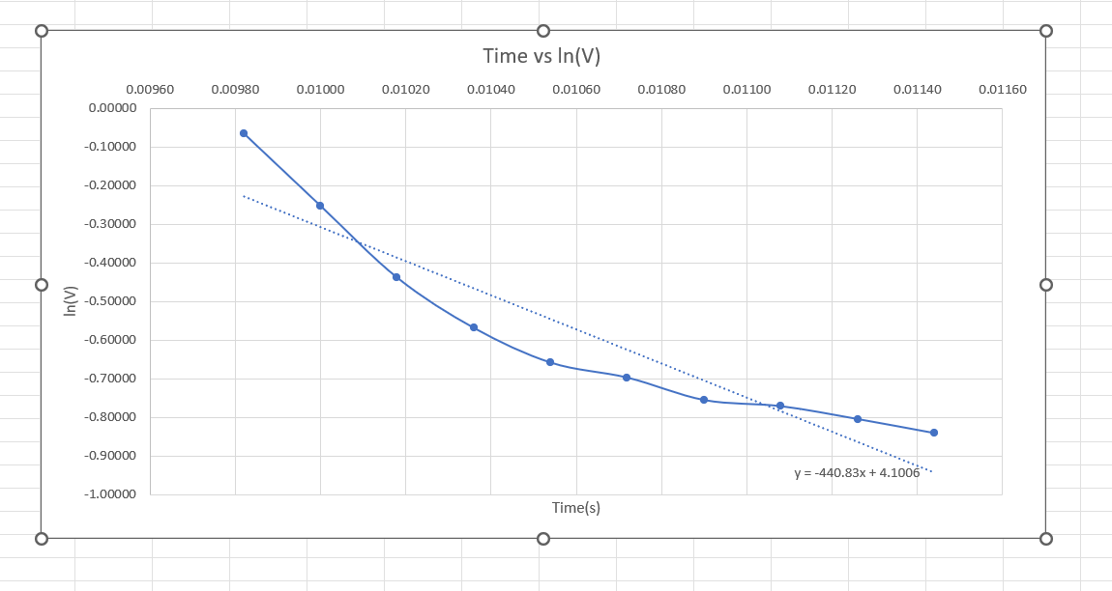

Gradient Calculations and Compare(4)

Gradient Calculations

Comparison table
 | Capacitance | Delta | Percentage difference
Actual | 1 µF | x | X
Marker Calculation | 1.65µF | 0.65 | 65%
Gradient Calculation | 2.27 µF | 1.27 | 127%

Capacitor Uses (5)
Capacitors can have many uses in electrical, automotive and motorcycle applications. Some examples are, power supply smoothing in electronics, capacitors can filter and smooth the output of rectified AC to provide stable DC voltage in power supplies. Or they can be used in energy storage for flash circuits, where they are used in camera flashes to store and rapidly release energy. Capacitors can also be used in signal coupling to block DC while allowing AC to pass in audio and communication circuits. When combined with resistors, capacitors can be used in timing circuits, like timers, oscillators and generators. Capacitors can be used to regulate and filter voltage in electronics. Capacitors are able to stabilize voltage and power flow in sensitive electronic circuits like micro-controllers and CPU’s.
In cars, capacitors can be used in ignition systems, as capacitors are able to rapidly discharge energy to create a high-voltage spark which can be used to spark ignition in motorcycles or small engines. They can also be used ton enhance audio systems. Capacitors provide small bursts of power to car audio amplifiers to prevent voltage drops and maintain sound quality. Capacitors can be used in start-stop power systems, as they are able to supply instant power to electronics when the engine is off.
In motorcycles, capacitors can be used in battery-less operation in small bikes, as instead of batteries, capacitors can be used to power basic electrical systems, like lights and ignition. Capacitors can also be used in voltage stabilization in LED lighting modes. Capacitors help prevent flickering or dimming in aftermarket LED upgrades, especially on older bikes without proper regulation.

Inaccuracies Question (4)

The measurements recorded could be different to the specified value due to various factors. Things like instrument errors, like calibration issues, where the instruments are not properly calibrated and can give incorrect readings. Resolution limits could also affect recorded data, as measuring devices may have limits in precision, so small variations may not be detected. Aging and wear could also factor into results, as over time, sensors or components can degrade, which could reduce accuracy.
Human error can be another reason why the recorded data is different to the specified values. Measuring errors, where the incorrect use of equipment, such as improper placement could impact results. Misreading scales, or misinterpreting digital outputs could affect results too. Also, assumptions or rounding can give incorrect results, as neglecting significant figures or rounds too early in calculations could produce incorrect data.
Components like capacitors have part tolerances, where they are expected to vary within a range. Also, specified data can often be idealized or based on controlled conditions, so as the experiment was conducted in a real-world scenario, results could end up being different than expected.

References
Ashwinprakas (2018) 'DIY: Eliminating Motorcycle Battery &amp; Adding a Capacitor,' Team-BHP.com. https://www.team-bhp.com/forum/motorbikes/199120-diy-eliminating-motorcycle-battery-adding-capacitor.html? (Accessed: April 6, 2025).
Mao, S. (2024) 'Looking Closer at Smoothing Capacitors in Electric Vehicles,' Simon Mao, 16 October. https://blog.knowlescapacitors.com/blog/looking-closer-at-smoothing-capacitors-in-electric-vehicles? (Accessed: April 6, 2025).
Notes, E. (no date) Capacitor Smoothing Circuits & Calculations » Electronics Notes. https://www.electronics-notes.com/articles/analogue_circuits/power-supply-electronics/capacitor-smoothing-circuits.php? (Accessed: April 6, 2025).

