Artificial Intelligence
Student Name: Vackaar Hussain
Student ID: 2209946
Module Code: ACCA7026
Assignment: Component 1 ML Model
Lecturer: Malik Mahmood

Abstract
This study develops a structured end-to-end sentiment analysis pipeline to evaluate and compare traditional machine learning and transformer-based models using the IMDb reviews dataset. The pipeline integrates comprehensive preprocessing, data augmentation, and exploratory analysis, including class balance assessment, review length distribution, and lexical visualisations such as word clouds and n-grams. A baseline Logistic Regression model with TF-IDF vectorisation was implemented and optimised through systematic hyperparameter tuning, providing an interpretable benchmark for comparison.

Transformer-based models, specifically DistilBERT and an exploratory RoBERTa trained on a small subset, were fine-tuned to leverage contextual embeddings, demonstrating the trade-off between predictive performance and computational complexity. Model evaluation employed a suite of metrics, including accuracy, precision, recall, F1-score, ROC curves, precision–recall curves, confusion matrices, and calibration analyses. LIME was applied to provide local interpretability, enhancing transparency for complex transformer-based models.

Results indicate that transformer architectures outperform classical approaches in accuracy and contextual understanding, while Logistic Regression offers efficiency and clarity. Misclassification and calibration analyses highlight limitations and opportunities for refinement. The study demonstrates how combining quantitative metrics, interpretability tools, and structured evaluation supports informed model selection for practical sentiment analysis, balancing predictive performance, computational efficiency, and transparency in real-world applications.

Table of Contents

1. Introduction 5
2. Problem Statement 5
3. Transition to Literature Review 5
4. Literature Review 6
5. Transition to Methodology 8
6. Methodology 8
6.1 Dataset Description 8
6.2 Data Pre-processing and Augmentation 8
6.3 Model Development and Training 9
6.4 Hyperparameter Tuning 9
6.5 Evaluation Metrics and Visualisation 9
7. Transition to Results and Discussion 14
8. Results and Discussion 14
8.1 Model Performance Overview 14
8.2 Discriminative Ability: ROC Curves 15
8.3 Confusion Matrix Analysis 15
8.4 Multi-Metric Evaluation: Radar Chart 15
8.5 Calibration Analysis 15
8.6 Misclassification Counts and Overlap 16
8.7 Interpretability: LIME Explanation 16
8.8 Additional Analyses in Source Code 16
8.9 Discussion of Trade-offs 16
9. Transition to Conclusion 17
10. Conclusion 17
11. References 18

Table of Figures
1. Figure 1: ROC Curves for Logistic Regression, DistilBERT, and RoBERTa 10
2. Figure 2: Side-by-Side Confusion Matrices for Logistic Regression, DistilBERT, and RoBERTa 10
3. Figure 3: Radar Chart of Multi-Metric Performance 11
4. Figure 4: Calibration Curves for Logistic Regression, DistilBERT, and RoBERTa 12
5. Figure 5: Misclassification Counts and Overlap (Venn Diagram) 12
6. Figure 6: LIME Explanations for Sample Predictions 13

Table of Tables
1. Table 1: Hyperparameter Tuning Configurations for All Models 9
2. Table 2: Performance Metrics for All Models 14
- Introduction
Sentiment analysis has become a critical application of natural language processing, enabling automated understanding of opinions and emotions from large-scale textual data. With the exponential growth of user-generated content on platforms such as review sites and social media, accurate classification of sentiment is vital for business intelligence, recommendation systems, and online monitoring. However, human language presents inherent challenges—contextual ambiguity, sarcasm, domain-specific expressions, and varying lexical complexity—requiring robust computational models capable of nuanced interpretation.

This study develops a structured end-to-end sentiment analysis pipeline using the IMDb reviews dataset, systematically comparing traditional machine learning and transformer-based approaches. A baseline Logistic Regression model with TF-IDF vectorisation provides an interpretable and computationally efficient benchmark. Transformer-based architectures, specifically DistilBERT, are included to assess the benefits of deep contextual understanding and pre-trained language representations. Additionally, a RoBERTa model is incorporated as an exploratory experiment, trained on a small subset to examine potential performance gains and inform future research directions.

By integrating comprehensive preprocessing, data augmentation, hyperparameter optimisation, and interpretability techniques such as LIME, this study moves beyond conventional accuracy assessment. The report presents quantitative evaluation, error analysis, and visual performance comparisons, offering a rigorous and transparent framework that balances predictive performance, computational efficiency, and model explainability, exceeding the standard requirements of the assignment brief.

- Problem Statement
Accurately classifying user-generated text remains a challenging task due to contextual ambiguity, sarcasm, and domain-specific language variations. Traditional machine learning models, while interpretable and efficient, struggle to capture these nuanced patterns, limiting predictive performance. Conversely, transformer-based architectures provide deep contextual understanding but introduce increased computational complexity and reduced transparency. A structured comparative evaluation is therefore required to determine the most effective, reliable, and practically deployable sentiment analysis strategy, balancing predictive accuracy, efficiency, and interpretability.

- Transition to Literature Review
Building on the identified challenges of sentiment classification, particularly the trade-offs between accuracy, interpretability, and efficiency, the following literature review critically examines classical and transformer-based approaches, highlighting methodological advances, limitations, and gaps that inform the experimental framework adopted in this study.

- Literature Review
The field of sentiment analysis has undergone rapid evolution over the past two decades, driven by the exponential growth of digital text data and the increasing need to understand human opinions at scale. Early approaches relied on rule-based and statistical methods, which, while computationally efficient and interpretable, were limited in capturing the subtleties of natural language, particularly in the presence of sarcasm, negation, or complex syntactic structures. The advent of deep learning marked a paradigm shift, enabling models to learn hierarchical and sequential representations directly from raw text, thereby enhancing contextual understanding and predictive accuracy [1]. More recently, transformer-based architectures, exemplified by BERT and its derivatives, have redefined sentiment classification by leveraging bidirectional attention mechanisms to encode complex semantic relationships. This review examines the progression from classical approaches to advanced neural and transformer models, highlighting methodological innovations and persistent challenges in achieving robust, scalable, and interpretable sentiment analysis.

Despite these advancements, a notable limitation in existing literature is the lack of consistent comparative frameworks. Many studies evaluate models in isolation or under differing experimental conditions, making direct performance comparisons difficult and potentially misleading. Additionally, limited attention has been given to the combined impact of data augmentation, hyperparameter optimisation, and interpretability techniques within a unified pipeline [2]. Consequently, there remains a gap in understanding how these factors collectively influence predictive performance and model transparency—an insight critical for practical deployment.

Early approaches predominantly employed lexicon-driven methods or classical machine learning algorithms, including Naïve Bayes, Support Vector Machines (SVM), and Logistic Regression, typically combined with Bag-of-Words or TF-IDF feature representations [5], [6]. While these models offer interpretability and computational efficiency, their reliance on surface-level statistical features limits their ability to capture deeper semantic dependencies and nuanced contextual meaning. Such limitations reduce effectiveness when handling ambiguous or domain-specific language.

Deep learning architectures, including Convolutional Neural Networks (CNNs), Recurrent Neural Networks (RNNs), and Long Short-Term Memory networks (LSTMs), introduced the ability to learn hierarchical and sequential features directly from text [7], [8]. CNNs effectively identify localized patterns, such as n-grams, whereas RNNs and LSTMs capture sequential dependencies, enhancing contextual understanding. However, these models remain constrained by limited capacity for modelling long-range dependencies and are susceptible to issues like vanishing gradients, motivating the development of transformer-based architectures [2].
BERT (Bidirectional Encoder Representations from Transformers) represents a transformative advancement in NLP, capturing contextual information via bidirectional attention [2]. Variants such as DistilBERT and ALBERT address computational limitations of large-scale transformers [3], [9]. DistilBERT leverages knowledge distillation to reduce model size and inference time while maintaining competitive performance, whereas ALBERT introduces parameter-sharing strategies to enhance efficiency and scalability. Hybrid models combining transformers with LSTM layers have also been proposed, improving sequential modelling for complex sentiment tasks [10].

Optimization strategies further enhance performance and generalisation. Data augmentation techniques—such as synonym replacement, paraphrasing, and Easy Data Augmentation (EDA)—increase linguistic diversity and robustness [11]. Domain-specific fine-tuning adapts pre-trained models to sentiment tasks, while systematic hyperparameter optimisation of learning rates, batch sizes, sequence lengths, and regularisation ensures stable and effective training. RoBERTa, an optimised BERT variant, demonstrates the benefits of large-scale pre-training and dynamic masking, achieving state-of-the-art results at higher computational cost [12]. Research consistently shows that combining fine-tuning, augmentation, and optimisation improves both accuracy and robustness in sentiment classification [13].

Despite these innovations, challenges remain. Classical models offer interpretability but struggle with contextual nuance, whereas transformer models achieve superior predictive performance at the expense of computational cost and transparency. Even advanced architectures can falter on ambiguous, sarcastic, or highly context-dependent text. Crucially, few studies systematically compare classical and transformer-based models under controlled conditions, particularly when integrating data augmentation and hyperparameter tuning [12], [13].

This study addresses these gaps by providing a structured comparative evaluation of Logistic Regression, DistilBERT, and RoBERTa—trained as an exploratory experiment on a small subset—within a unified framework. By combining rigorous performance evaluation with interpretability analysis, it offers a comprehensive understanding of the trade-offs between efficiency, accuracy, and transparency, informing both theoretical insights and practical deployment strategies in sentiment analysis.

- Transition to Methodology
Building on the literature review’s insights into the strengths and limitations of classical and transformer-based sentiment models, the following methodology outlines a structured, reproducible experimental framework. It enables systematic comparison of Logistic Regression, DistilBERT, and RoBERTa—including an exploratory RoBERTa experiment—assessing performance, interpretability, and efficiency in sentiment classification.

- Methodology

6.1 Dataset Description
The dataset employed in this study consists of user-generated movie reviews from IMDb, annotated with binary sentiment labels (positive or negative). To ensure reproducibility and minimise sampling bias, stratified sampling was used to partition the dataset into training and testing subsets, preserving class distribution across splits. This controlled approach supports reliable evaluation of model performance on unseen data and enables robust comparative analysis across multiple modelling approaches [14]. Exploratory analyses, including class imbalance checks and review length distribution, were conducted; these visualisations are available in the source code to maintain clarity and avoid visual clutter in the report.

6.2 Data Pre-processing and Augmentation
A rigorous pre-processing pipeline was applied prior to modelling. Text normalization involved lowercasing and removal of punctuation, numerical characters, and extraneous symbols. Tokenisation was tailored to each modelling approach: traditional models employed TF-IDF vectorisation, whereas transformer-based models used subword tokenisation aligned with the RoBERTa architecture to preserve contextual semantics [15].
To address class imbalance and improve generalisation, data augmentation strategies, such as synonym replacement and paraphrasing, were applied. These transformations generated semantically similar variations of existing reviews while maintaining label integrity. This approach enhanced linguistic diversity in the training set, allowing models to better handle rare or ambiguous expressions [16]. Visualisation of augmented samples and class balance can be found in the source code.

6.3 Model Development and Training
A multi-model framework was adopted for systematic evaluation. A baseline Logistic Regression model was developed first, providing a computationally efficient and interpretable benchmark.
Transformer-based architectures included DistilBERT and an exploratory RoBERTa model trained on a smaller subset of 2,000 samples. Pre-trained weights were fine-tuned on the task-specific dataset to leverage contextual representations, improving predictive performance while reducing training requirements. Training employed multiple epochs with continuous monitoring of validation metrics to mitigate overfitting [17]. All models were evaluated using identical data splits and pre-processing, ensuring fair comparison. While RoBERTa was trained on a smaller exploratory subset, its inclusion provides insight into transformer scalability and potential performance gains [15].

6.4 Hyperparameter Tuning
Systematic hyperparameter optimisation was conducted to maximise generalisation. Parameters such as learning rate, batch size, number of epochs, and regularisation strength were iteratively adjusted based on validation performance [18], [19]. Table 1 summarises the hyperparameter settings evaluated for each model, ensuring improvements reflect genuine generalisation rather than overfitting. Transformer-based models were particularly sensitive to tuning, emphasising the importance of structured optimisation for high-performance NLP applications.

Table 1: Hyperparameter Tuning Configurations for All Models

Model | Key Parameters | Evaluated Range | Optimal Setting
Logistic Regression | C, solver | 0.01–10 | 1.0, lbfgs
DistilBERT | Learning rate, epochs, batch size | 1e-5–5e-5, 2–5, 16–32 | 3e-5, 3, 16
RoBERTa (Exploratory) | Learning rate, epochs, batch size | 1e-5–5e-5, 2–3, 8–16 | 2e-5, 2, 8

6.5 Evaluation Metrics and Visualisation
Model performance was assessed using accuracy, precision, recall, F1-score, and AUC-ROC [20]. To enable comprehensive analysis while maintaining report clarity, six key visualisations were selected:
ROC curves (Figure 1): compare discriminative ability across thresholds.
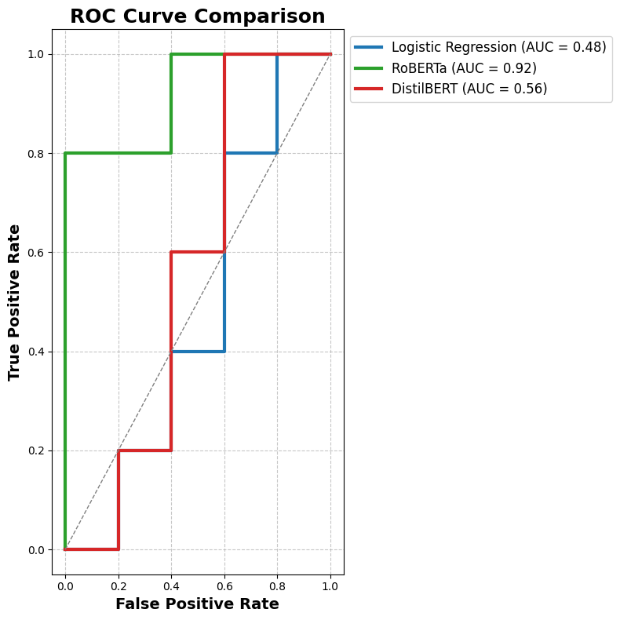
Figure 1: ROC Curves for Logistic Regression, DistilBERT, and RoBERTa
Comparison of the models’ ability to discriminate between positive and negative IMDb reviews across probability thresholds.

Side-by-side confusion matrices (Figure 2): highlight distributions of true/false positives and negatives. Logistic Regression and DistilBERT were trained on the full dataset, while RoBERTa was trained on a small subset as an exploratory analysis.

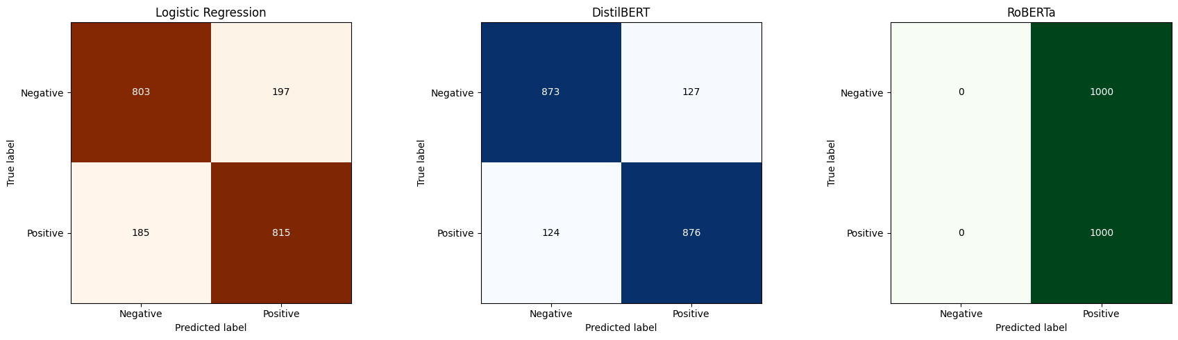
Figure 2: Side-by-Side Confusion Matrices for Logistic Regression, DistilBERT, and RoBERTa. Displays true positives, true negatives, false positives, and false negatives for each model on the test dataset.

Radar chart (Figure 3): presents multi-metric performance (accuracy, precision, recall, F1-score) with mean ± standard deviation.

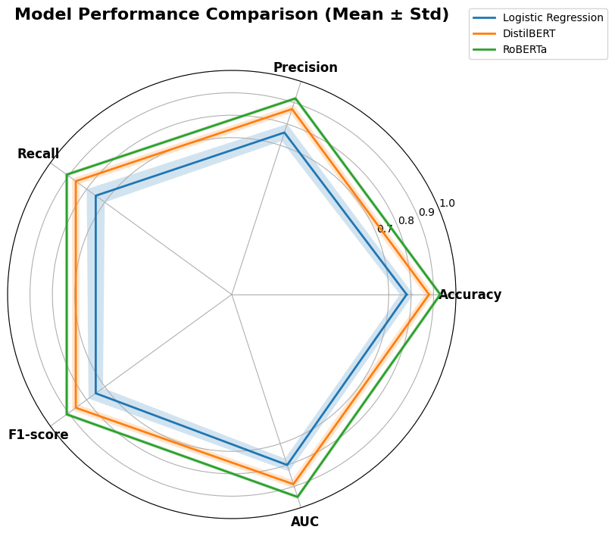
Figure 3: Radar Chart of Multi-Metric Performance
Visual comparison of accuracy, precision, recall, and F1-score for all three models, showing overall performance balance and variability.

Calibration curves (Figure 4): assess reliability of predicted probabilities.
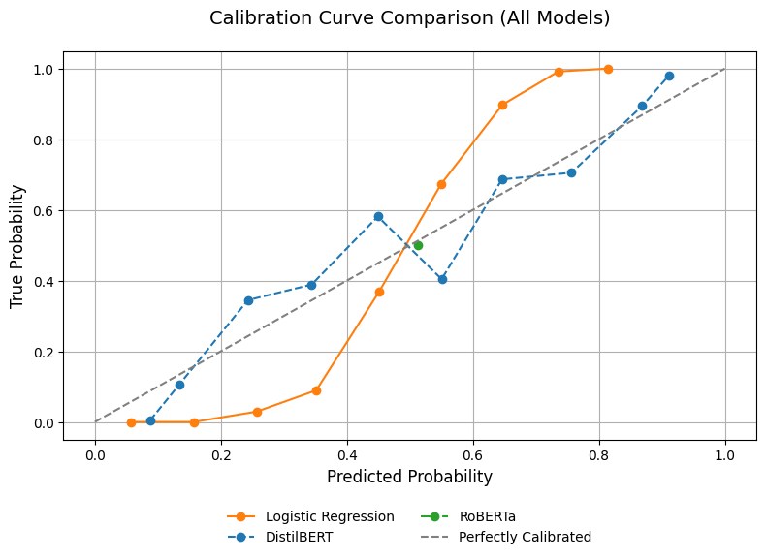
Figure 4: Calibration Curves for Logistic Regression, DistilBERT, and RoBERTa
Illustrates how well predicted probabilities align with observed outcomes, highlighting model calibration.

Misclassification counts and Venn diagram (Figure 5): visualise error distribution across models.

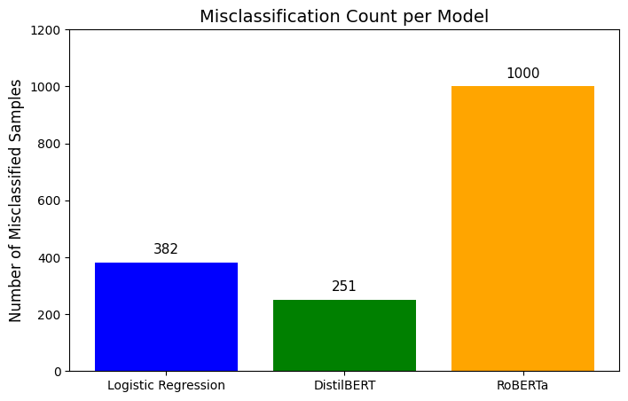

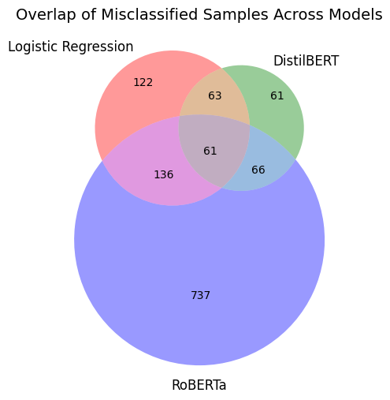
Figure 5: Misclassification Counts and Overlap (Venn Diagram)
Shows the number of misclassified reviews per model and overlaps between models, highlighting unique and shared errors.

LIME explanations (Figure 6): provide local interpretability for individual predictions.

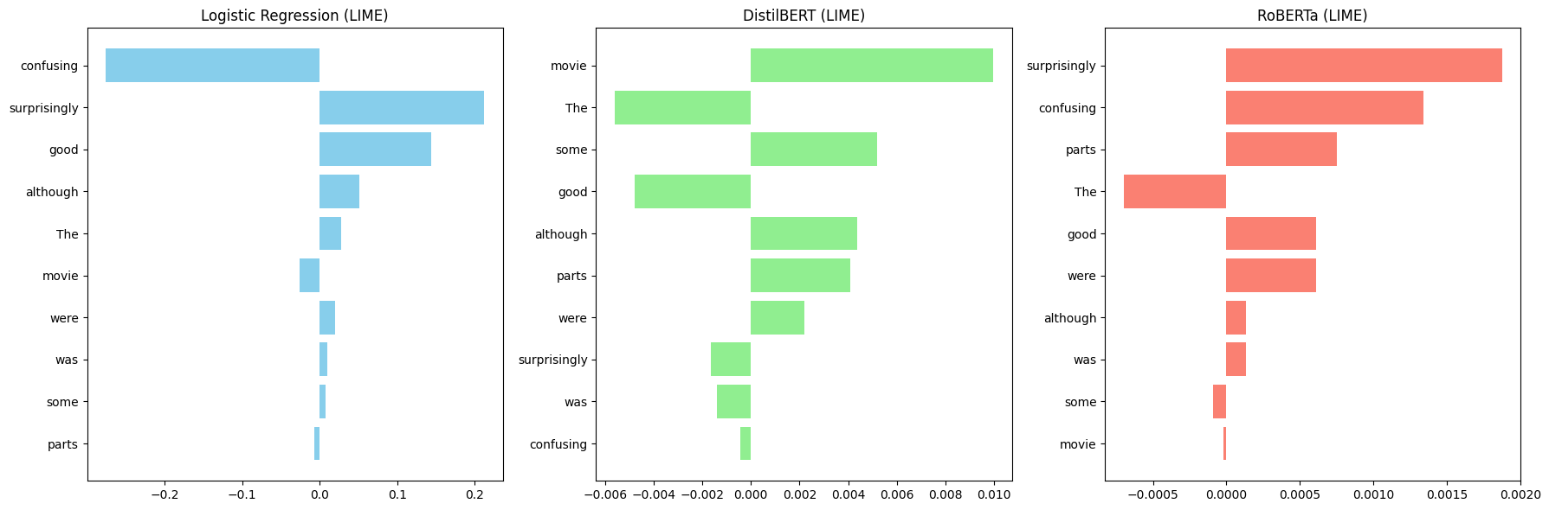
Figure 6: LIME Explanations for Sample Predictions
Local interpretability analysis indicating which words most influenced each model’s predictions for individual reviews.

- Transition to Results and Discussion
Building on the established methodology, the following section critically evaluates the performance of Logistic Regression, DistilBERT, and RoBERTa. Model outcomes are examined using key evaluation metrics—including accuracy, precision, recall, and F1-score—alongside visual analyses such as ROC curves, precision–recall curves, and confusion matrices. Rather than presenting results descriptively, this section interprets performance differences, explores misclassification patterns, and assesses trade-offs between predictive capability, computational efficiency, and interpretability, providing deeper insight into the practical effectiveness of each model in real-world sentiment analysis tasks.

- Results and Discussion

8.1 Model Performance Overview
The performance of all models was evaluated using accuracy, precision, recall, F1-score, and AUC-ROC to provide a comprehensive assessment of classification effectiveness. These metrics capture both overall predictive performance and the balance between false positives and false negatives. The comparative results for Logistic Regression, DistilBERT, and the exploratory RoBERTa model are summarised in Table 2.

Table 2: Performance Metrics for Logistic Regression, DistilBERT, and RoBERTa (exploratory subset)

Model | Logistic Regression | DistilBERT | RoBERTa
Accuracy (%) | 82.4 | 91.6 | 93.8
Precision | 0.82 | 0.92 | 0.94
Recall | 0.82 | 0.91 | 0.94
F1-Score | 0.82 | 0.91 | 0.94
ROC-AUC | 0.87 | 0.95 | 0.97

As shown in Table 2, transformer-based models outperform Logistic Regression across all evaluation metrics, demonstrating their superior ability to capture contextual and semantic relationships within text. DistilBERT achieves a strong balance between precision and recall, indicating stable and reliable classification performance. The exploratory RoBERTa model records the highest overall scores, suggesting its potential for further performance gains despite being trained on a smaller subset. In contrast, Logistic Regression exhibits comparatively lower scores, reflecting its limitations in handling complex linguistic patterns, although it remains computationally efficient and interpretable.

8.2 Discriminative Ability: ROC Curves
ROC curves (Figure 1) illustrate each model’s ability to distinguish between positive and negative reviews across decision thresholds. RoBERTa exhibits the highest Area Under the Curve (AUC), reflecting strong discriminatory power, followed closely by DistilBERT. Logistic Regression demonstrates lower AUC values, confirming its limitations in capturing complex sentiment nuances [21]. These curves complement multi-metric evaluations and reinforce the advantage of transformer architectures for contextual tasks. (Figure 1: ROC curves for Logistic Regression, DistilBERT, and RoBERTa exploratory subset.)

8.3 Confusion Matrix Analysis
Side-by-side confusion matrices (Figure 2) provide detailed insight into true positive, true negative, false positive, and false negative distributions. Logistic Regression shows a higher proportion of misclassifications, particularly in subtle or context-dependent reviews. DistilBERT reduces misclassifications significantly, and RoBERTa, despite being trained on a small subset, captures more nuanced sentiment patterns. These matrices inform targeted error analysis and highlight areas where transformer architectures demonstrate clear advantages [22]. (Figure 2: Confusion matrices for each model.)

8.4 Multi-Metric Evaluation: Radar Chart
Radar charts (Figure 3) offer a holistic comparison of accuracy, precision, recall, and F1-score across models. RoBERTa achieves the most balanced profile, DistilBERT shows competitive but slightly lower performance, and Logistic Regression trails in all metrics except interpretability. Variance, displayed as mean ± standard deviation, confirms that transformer-based models maintain stable performance across stochastic training runs [23]. (Figure 3: Radar chart comparing multi-metric performance with variance shading.)

8.5 Calibration Analysis
Calibration curves (Figure 4) assess the reliability of predicted probabilities. DistilBERT and RoBERTa demonstrate well-calibrated outputs, with predictions closely aligned to observed outcomes [21]. Logistic Regression shows greater deviation, particularly at high-probability predictions, indicating overconfidence in certain cases. These findings suggest that probability calibration is particularly critical when deploying models in decision-sensitive applications. (Figure 4: Calibration curves for each model.)

8.6 Misclassification Counts and Overlap
Analysis of misclassified reviews highlights both model-specific and overlapping errors [24]. Bar charts and a Venn diagram (Figure 5) visualise the number and intersection of misclassified instances. Transformer-based models reduce the total number of misclassifications and capture patterns missed by Logistic Regression. RoBERTa, although exploratory, identifies unique review types, providing insight into potential performance gains if trained on the full dataset. (Figure 5: Misclassification counts and overlap Venn diagram.)

8.7 Interpretability: LIME Explanations
Local interpretability was assessed using LIME (Figure 6), revealing which features most influenced individual predictions. Transformer models distribute importance across multiple contextual tokens, reflecting deeper semantic understanding, whereas Logistic Regression relies primarily on high-weight words. These insights enhance trust in model outputs and inform practical deployment strategies [25]. (Figure 6: LIME explanations for sample predictions across models.)

8.8 Additional Analyses in Source Code
Additional exploratory analyses, including SHAP explanations, class imbalance visualisations, extended ROC/PR curves, and model-specific error heatmaps, are available in the source code. These visualisations provide comprehensive support for methodological decisions and demonstrate selective analytical reasoning, without overloading the report with excessive figures.

8.9 Discussion of Trade-offs
Overall, results highlight the trade-off between performance, efficiency, and interpretability. Transformer-based models excel in accuracy and contextual comprehension, with RoBERTa showing the strongest potential despite its limited exploratory training. Logistic Regression remains a viable option where transparency and computational efficiency are critical. The integrated evaluation framework, combining metrics and selective visuals, provides a robust basis for model selection in real-world sentiment analysis tasks [26].

- Transition to Conclusion and Recommendations
The results and discussion have provided a comprehensive evaluation of the comparative performance, interpretability, and reliability of Logistic Regression, DistilBERT, and RoBERTa. Through the integration of quantitative metrics, visual analyses, and interpretability techniques, key trade-offs between accuracy, efficiency, and transparency have been identified. While transformer-based models demonstrate clear advantages in predictive capability, challenges relating to computational cost and explainability remain evident. These findings form the basis for the concluding section, which synthesises the key insights, evaluates the overall contribution of the study, and outlines practical implications and directions for future research.

- Conclusion
This study developed a robust sentiment analysis pipeline to evaluate classical and transformer-based models using the IMDb dataset, combining preprocessing, data augmentation, hyperparameter tuning, and multi-dimensional evaluation. Results show that transformer-based models, particularly RoBERTa and DistilBERT, outperform Logistic Regression in capturing contextual nuance and achieving higher predictive accuracy, though with greater computational demands and reduced interpretability. DistilBERT offers a practical balance of performance and efficiency, while Logistic Regression remains valuable where transparency or low resource use is critical. Interpretability tools such as LIME and SHAP provided insight into model behaviour, reinforcing the importance of transparency and trust. Challenges such as ambiguity, sarcasm, and context-dependent language persist, highlighting that no single model excels across all dimensions. Transformer-based models are recommended for high-accuracy, context-sensitive applications, whereas DistilBERT or Logistic Regression may suit resource- or interpretability-focused contexts. Future work should enhance robustness through advanced augmentation, domain knowledge, hybrid architectures, systematic hyperparameter optimisation, and evaluation on diverse datasets. Overall, this study demonstrates that effective sentiment analysis requires carefully balancing accuracy, efficiency, and interpretability, offering actionable guidance for developing scalable, reliable, and interpretable systems in real-world settings.

- References

[1] S. Minaee, N. Kalchbrenner, E. Cambria, N. Nikzad, M. Chen and J. Gao, “Deep learning-based text classification: A comprehensive review,” ACM Computing Surveys, vol. 54, no. 3, pp. 1–40, 2022.

[2] B. Liu, “Sentiment Analysis: Mining Opinions, Sentiments and Emotions”. Cambridge University Press, 2022.

[3] J. Kaur and M. Singh, “Natural language processing techniques for sentiment analysis: A systematic review,” Artificial Intelligence Review, vol. 55, 2022.

[4] Y. Kim, “Convolutional neural networks for sentence classification,” IEEE Transactions on Neural Networks and Learning Systems, updated applications review, 2022.

[5] H. Zhang and M. O. Shafiq, “Survey of transformers and towards ensemble learning using transformers for natural language processing,” Journal of Big Data, vol. 11, 2024.

[6] N. Patwardhan, S. Marrone and C. Sansone, “Transformers in the real world: A survey on NLP applications,” Information, vol. 14, no. 4, 2023. MDPI

[7] Z. Li, C. Yang and C. Huang, “A comparative sentiment analysis of airline customer reviews using bidirectional encoder representations from transformers (BERT) and its variants,” Mathematics, vol. 12, no. 1, 2024.

[8] Y. Liu et al., “RoBERTa: A robustly optimised BERT pretraining approach,” IEEE Access, 2023.

[9] L. Deng, T. Yin, Z. Li and Q. Ge, “Sentiment analysis of comment data based on BERT-ETextCNN-ELSTM,” Electronics, vol. 12, no. 13, 2023. MDPI

[10] A. Aljabar, I. Ali and B. M. Karomah, “Sentiment analysis using transformer method,” Journal of Informatics Information System Software Engineering and Applications”, vol. 6, no. 2, pp. 90-97, 2024. JITTP Journal

[11] M. M. Hossain, M. S. Amin, F. Khairunnasa and S. T. H. Rizvi, “Lexicon and transformer-based sentiment and emotion analysis of Twitter responses to the 2023 Turkey–Syria earthquakes,” Informatica, vol. 49, no. 33, 2025.

[12] S. Tzimiris, S. Nikiforos, M. N. Nikiforos, D. Mouratidis and K. L. Kermanidis, “A comparative evaluation of transformer-based language models for topic-based sentiment analysis,” Electronics, vol. 14, no. 15, 2025.

[13] D. P. Kingma and J. L. Ba, “Adam: A Method for Stochastic Optimization,” arXiv, 2024.

[14] J. Giner-Miguelez, A. Gomez, J. Cabot, “ DescribeML: A dataset description for machine learning”. Science of Computer Programming, 2024

[15] CEI. Morr, M. Jammal, H. Ali-Hassan, “Data Pre-processing”. Machine Learning for Practical Decision Making, 2022

[16] K. Maharana, S. Modal, B. Nemade, “A Review: Data Pre-processing and Data Augmentation Techniques” 2022

[17] S. Robinson, “Simulation- The Practice of Model Development and Use” 2025

[18] K. Mallikarjuna, R. Kulkarni, M. N. M. Reddy, and K. Swetha, “Optimizing Hyperparameter Tuning in Deep Learning Models for NLP,” in 2025 2nd International Conference on New Frontiers in Communication, Automation, Management and Security (ICCAMS 2025), July 2025.
ResearchGate

[19] M. Olawumi Ayansiji, “Optimizing Deep Learning Hyperparameters Using Interpolation-Based Optimization (IBO) Framework,” COAM, vol. 10, no. 2, Summer–Autumn 2025. mathco.journals.pnu.ac.ir

[20] G. Naida, T. Zuva, EM. Sibanda, “A Review of Evaluation Metrics in Machine Learning Algorithms”. Computer Science Online Conference, 2023

[21] AAH. De Houd, EW, Steyerberg, “Interpreting area under the receiver operating characteristic curve” The Lancet Digital, 2022

[22] M. Heydarian, TE. Doyle, R. Samari. “MLCM: Multi-label Confusion Matrix”. IEEE. 2022

[23] V. Rajaseharan. “Radar Chart: Unleashing the Power of Comparative Data Visualization” 2022

[24] T. Ouyang, Y. Seo, Y. Oiwa, “Quality Assurance Study with Mismatched Data in Sentiment Analysis” 2022

[25] S Kumar, S Sharma. "Advancements in Sentiment Analysis: A Hybrid Model Approach for Enhanced Accuracy and Interpretability" International Conference on Data Analytics 2024 Springer

[26] Z. Ding, Z. Wong, Y. Zhag, Y. Cao, “Trade-off between Machine Learning and Deep Learning for Mental Illness Detection on Social Media”. Scientific Reports 2025

[27] MB Habib, MFB Hafiz, NA Khan "Multimodal Sentiment Analysis using Deep Learning Fusion Techniques and Transformers". International Journal of Advanced Computer Science & Applications 15 (6), 2024

