Ash Toner (2514500)
UWTSD - Software Engineering

Computer Architecture and Operating Systems
ACCA4022
Table of Contents
Introduction 2
Task 1 – Key functions of general Operating Systems 2
What is an Operating system? 2
What does an OS do? 2
o Process and Memory Management (Apple macOS) 3
o Processes and Memory Management (Windows OS) 5
o Errors and Diagnostic Tools 6
Task 2 – Windows OS CLI commands 7
PowerShell Overview 7
PowerShell CLI Commands 7
o Process Management 7
o File & Directory Management 8
o Network Testing/Monitoring 10
Task 3 – Linux OS CLI commands 11
Bash Overview 11
Bash CLI Commands 11
o File & Directory Management 11
o Network Testing/Monitoring 11
o User Management 12
o Task Automation 14
Task 4 - Windows OS scripts 15
Batch Scripting 15
Batch Script Example 15
Task 5 – Linux OS scripts 16
Bash Scripting 16
Bash Script Example 16
Conclusion 17
OS Summary 17
CLI Commands 17
Scripting 17
References 18
Appendix 19
Evidence of Engagement with 1 Online Certified Course 19

Introduction
This report details information about operating systems, what they are and what they do with examples from macOS, Windows and Ubuntu Linux booting from windows subsystem for Linux, WSL. Also in this report, is examples of Bash/Batch scripting as well as a run through of core OS processes.

Task 1 – Key functions of general Operating Systems

What is an Operating system?
An operating system (OS) controls a computer system though a collection of programs, examples of these are Windows, Linux, macOS [1].
Operating systems are made up of 5 layers, the user interface (UI), system services, the kernel, hardware abstraction layer (HAL) and hardware [2].

What does an OS do?
An OS will typically manage files, processes, hardware and the UI. This can include taking on tasks like multiprogramming, multitasking and multithreading, scheduling, interrupt handling and resource management as well as graphical or command line interface (GUI or CLI) [1].

Process and Memory Management (Apple macOS)
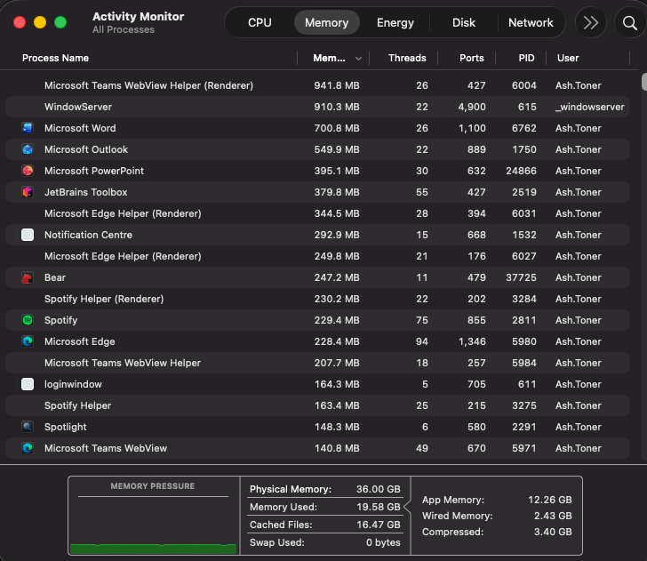
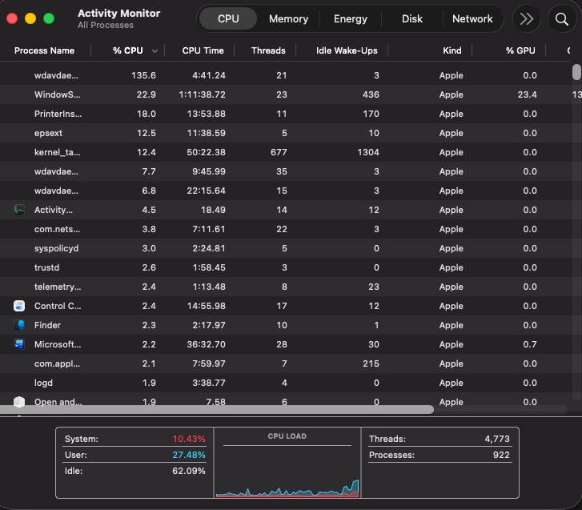
Below is an example of CPU allocation and memory usage on MacOS’s Activity Monitor:

Activity Monitor is Apple macOS’s equivalent of Window’s Task Manager and more. It’s a useful tool for investigating CPU usage and monitoring the system and its applications. It provides a user friendly, easy to read list of all processes and applications currently running on the system. This makes spotting and stopping spyware or programs that shouldn’t be running easier as well as making diagnosing performance issues easier.
- For example, investigating Microsoft’s Word application’s CPU usage presents as the following:
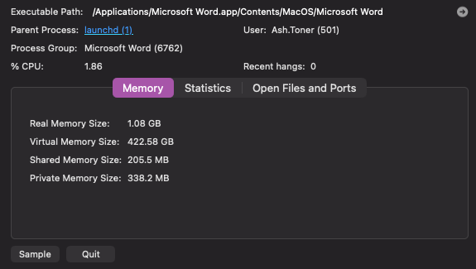
In this menu, it’s possible to quit the application or get a “Sample” report. This report is a plain text analysis of Word every 1 millisecond for 5 seconds, getting a deep dive into how Word is using the system.
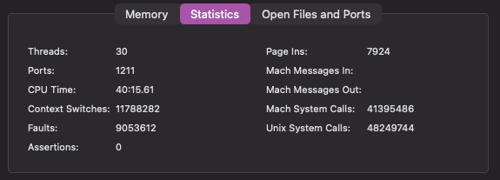
Further statistics show threading, ports used, CPU usage time and other useful diagnosing information.
CPU activity, threading, number of current processes, memory pressure and usage as well as its allocation can be viewed through Activity Monitor.

CPU
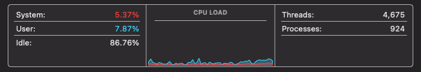
CPU load is a measure of the “amount of processing work that a computer’s CPU is handling at any given time”. Keeping CPU load low improves system lifespan and increases performance [3]. As seen here, 86.76% of the CPU is idle (not being used) which is efficient and expected behaviour considering the system currently only really has a Microsoft Word document running among other system critical processes.

Memory
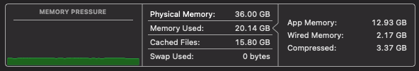
This display shows how much memory (in RAM) the system is using up. According to Apple’s guide, macOS performs best when efficiently using and managing all the computer’s memory; so, performance does not improve using less memory [4]. However, memory usage and memory pressure of not the same. Memory usage, as said previously, should remain high for maximum efficiency but memory pressure should be low. As memory pressure in the screenshot above is showing as low and green, the system is using all its RAM efficiently.

Activity Monitor also reads the following:

Disk Usage
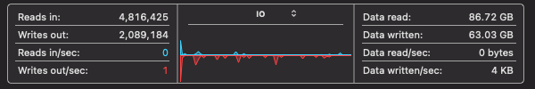

Network Traffic
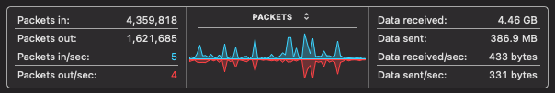

Processes and Memory Management (Windows OS)
Below is a screenshot of Windows’ Resource Monitor. Like Apple’s Activity Monitor, it looks at CPU usage, disk activity, network traffic with memory usage with graphs on the right to show these 4 areas in action.
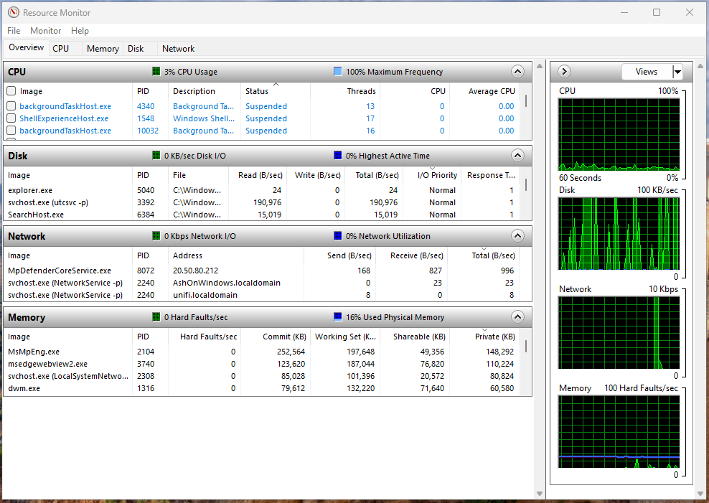
The screenshot above is from an Oracle VirtualBox [5] VM running Windows. As the VM is only a percentage of the system’s CPU and memory usage, data and network traffic may be different to the system’s (macOS) CPU and memory usage.

Errors and Diagnostic Tools
Using the same Windows VM, diagnostic and error spotting tools can be found by opening up the command line and running perfmon /rel to open up Reliability Monitor. This is shown below:
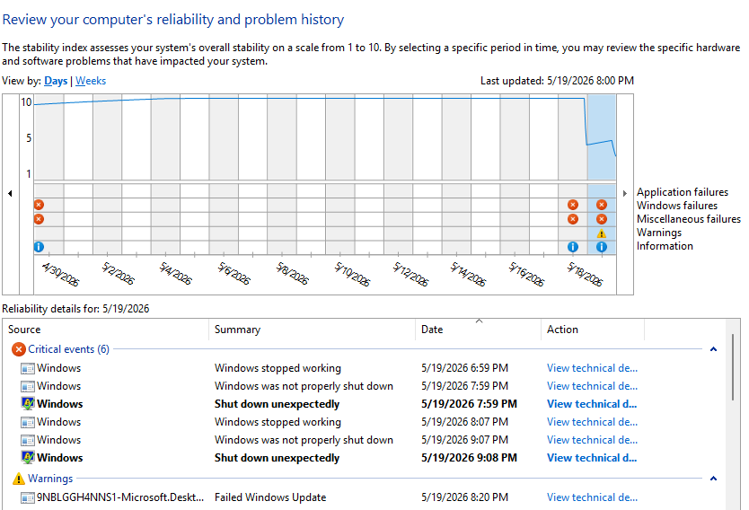
As said before, unusual behaviour is to be expected when investigating a VM as a VM is more complex than the standard system. The errors presented are because of the nature of this VM. Nonetheless, they can still be investigated.
Below demonstrates the window that pops up when an “Action” is clicked next to the event.
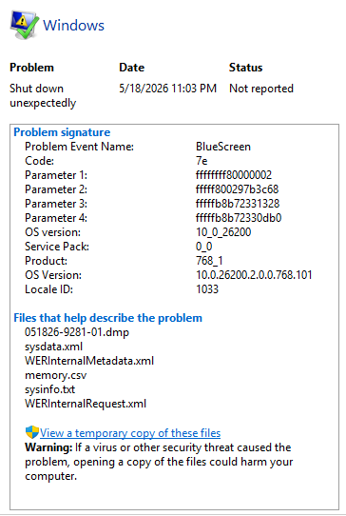
This is a report of the incident. From this you can see it’s a blue screen event, probably caused by incorrectly shutting down the VM.
More detail can be achieved by looking at a temporary copy of the files to diagnose the exact issue.

Task 2 – Windows OS CLI commands

PowerShell Overview
PowerShell is an object orientated command line shell, scripting language and a configuration management framework that’s cross platform [6]. While most commonly used in Windows or Linux, it can also be installed and used onto macOS. PowerShell is a versatile tool built on the .NET framework and can perform many tasks like system management, network monitoring and automation [7].

PowerShell CLI Commands

Process Management
To list all running processes, run
Get-Process
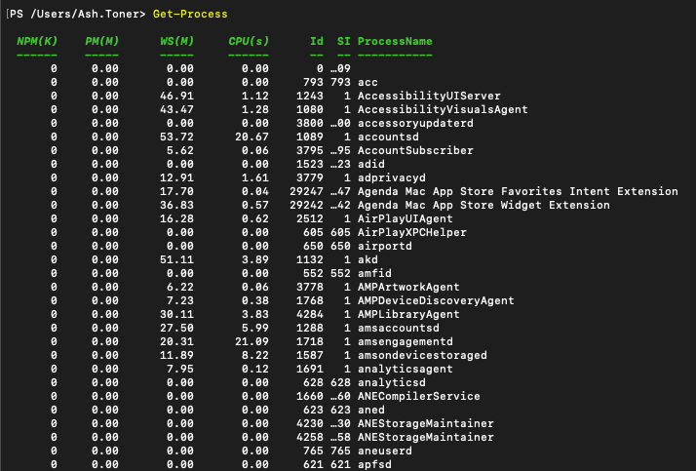 (Very long list, this is only a section)
This command returns System.Diagnostics.Process objects, which contain detailed properties and methods for each process.

To list all running processes and filter by name, run
Get-Process -Name “filter”
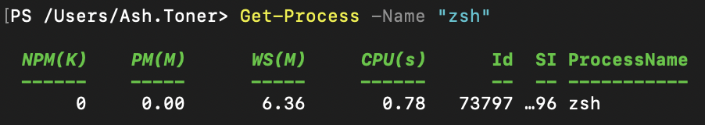
This command returns System.Diagnostics.Process objects, which contain detailed properties and methods for each process that match the filter (zsh in this case).

File & Directory Management
To get a list of contents in the current directory, run
dir
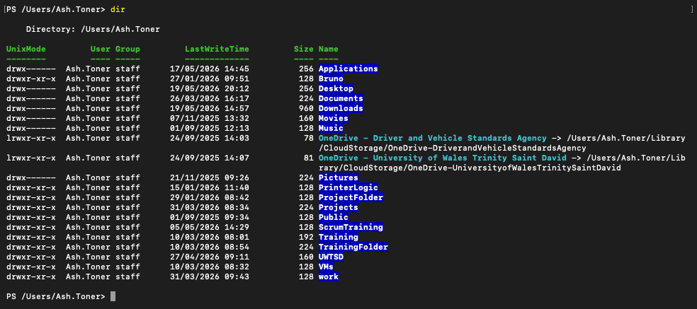
This is the root folder of a Mac directory; all files are listed above.

To create a new folder in the current directory, run
mkdir directory-name
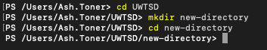
Carrying on from the previous session, cd is used to move to a directory inside the current directory. From there, a new folder was made called “new-directory”. To prove this folder exists, the 3rd line on the screenshot moves to the new directory, “new-directory” then the 4th line shows a new line operating from the new directory. “new-directory”.

To make a new text file in the current directory, run
echo “File Contents”>newfilename.txt
PS /Users/Ash.Toner/UWTSD/new-directory> echo "File Contents :)">new-file.txt
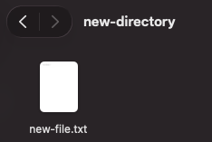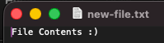
Above shows the command used to make the file, along with the file made and its contents.
To display the contents of a text file, run
type name-of-file.txt
As seen by the previous test, “new-file.txt” does contain only “File Contents :)”.

To delete a file, run
del name-of-file.txt
The screenshot above depicts the file being deleted, followed by an error message when trying to read the file contents proving the file had been deleted.

To go back to the previous directory, run
cd ..
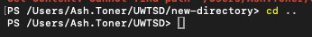

Network Testing/Monitoring
To see the IP address of the system, run
Netstat
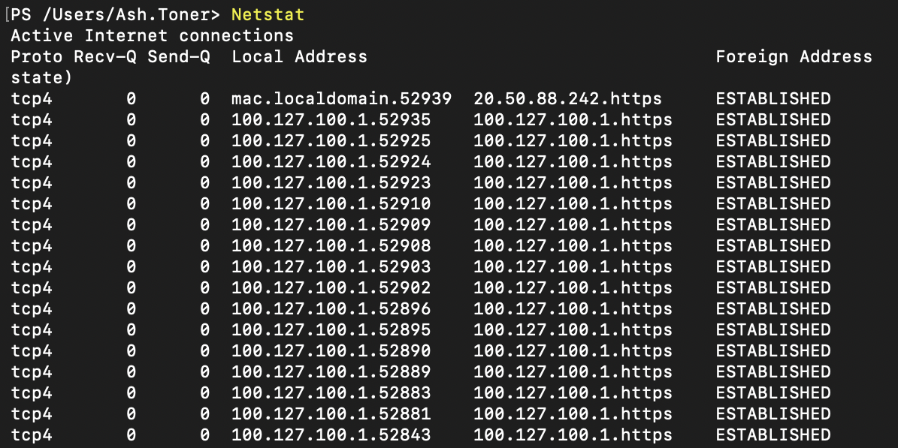
This command displays network information like listening ports, TCP addresses and active connections [8].

To test connectivity by sending out a ping to a certain host, run
ping host-domain
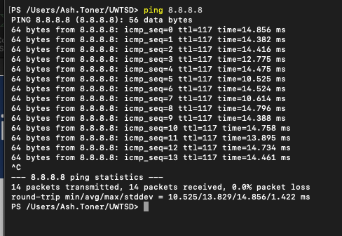
8.8.8.8 is the domain name used to test connectivity and response time to Google’s public DNS server [9]. The ping command just sends out a test signal to the domain specified, used to test network connection.

Task 3 – Linux OS CLI commands

Bash Overview
Bash, Bourne Again Shell, is an improved version of the original Unix shell developed by Stephen Bourne [10]. Like PowerShell, Bash is a versatile command-line interface and a scripting language that handles automation and system management, mostly used by developers for greater control and understanding of the OS.

Bash CLI Commands
To clear the current session, run
clear
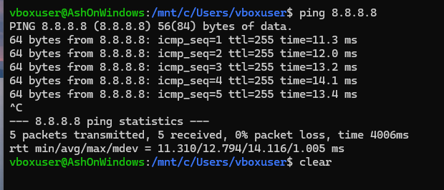

File & Directory Management
To print the current working directory, run
pwd

Network Testing/Monitoring
Like PowerShell, Linux CLI also runs,
ping 8.8.8.8
See previous for information.

User Management
To view the username on the system, run
whoami
The user is vboxuser@AshOnWindows, so the username is the default vboxuser because it was never changed when the VM was st up.

- Linux has users and groups:
To add a user to the system, run
sudo useradd -m username

To create a group, run
sudo groupadd groupname

To create a user and assign them to a group in one step, run
sudo useradd -m -g groupname username
To verify a user’s group membership, run
groups username
“username” might have been a poor name for a username in this scenario, but this command demonstrated that the username of the user “username” is in fact “username.

To confirm the user’s UID, GID, and groups, run
id username
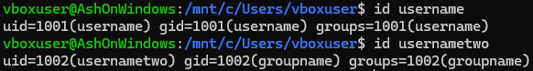
This command displays the user’s ID, the user’s primary group ID, and all group memberships for the user specified [12].

To delete a user from the system, run
sudo userdel username
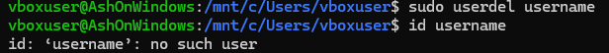
As seen above, the username “username” has been deleted as the task getting the username of “username” failed saying the user did not exist.

To delete a group, run
sudo groupdel groupname

Task Automation
To start running a Cron job, run
sudo service cron start
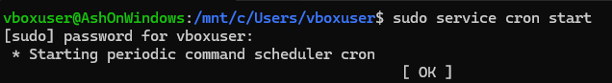
A Cron job is a “Linux program that allows users to schedule the execution of a piece of software, often in the form of a shell script or a compiled executable” [13]. They’re mostly used in scheduling when jobs need to be run at a specific time or for automating repetitive tasks.

To check the status of a Cron job, run
service cron status
This command demonstrates that the Cron job called “service” made above is running.

Task 4 - Windows OS scripts

Batch Scripting
A Batch script in Windows is contained in a simple text file with a .bat extension. It has a one click execution and can perform things like basic file handling to network diagnostics. It’s useful for automation and system maintenance and supports logic such as loops, conditions and variables [14].
Running a Batch file boots up a terminal window, displaying whatever the script is programmed to print out.

Batch Script Example
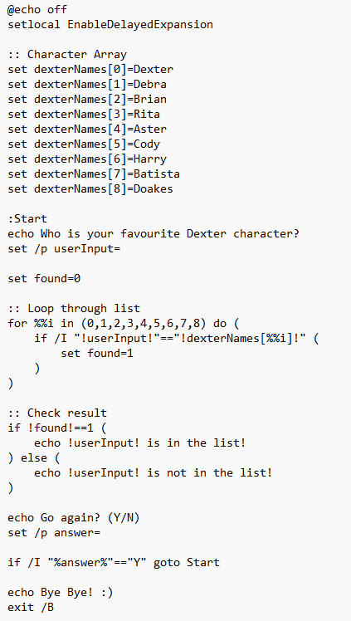
Below is an example of a Batch script, it includes the following:
  - @echo off – used to stop displaying each command in the command prompt as it runs.
  - setlocal… - “Enables the delayed environment variable expansion until the matching endlocal command is encountered, regardless of the setting before the setlocal command was run” [15].
- :: - code comments.
- set – variable setting.
- dexterNames[0] – array position assigning.
- :Start – function, the main function in this case.
- /p - a switch used to prompt the user for input.
- for … do – a loop.
- /I – a switch used to make string comparisons case insensitive.
- if – an if statement.
- echo – outputs a message.
- goto – redirects to the function specified
- exit /B - exits the current batch script or subroutine.

Task 5 – Linux OS scripts

Bash Scripting
Much like Batch scripting, Bash scripting also allows for automation, system management and workflow efficient. Instead of running commands one by one in terminal, a script allows for multiple commands to be run in one single step [16]. Bash files always start with #!bin/bash at the very top and scripts are interpreted rather than compiled; this means all functions need to be declared before use.

Bash Script Example
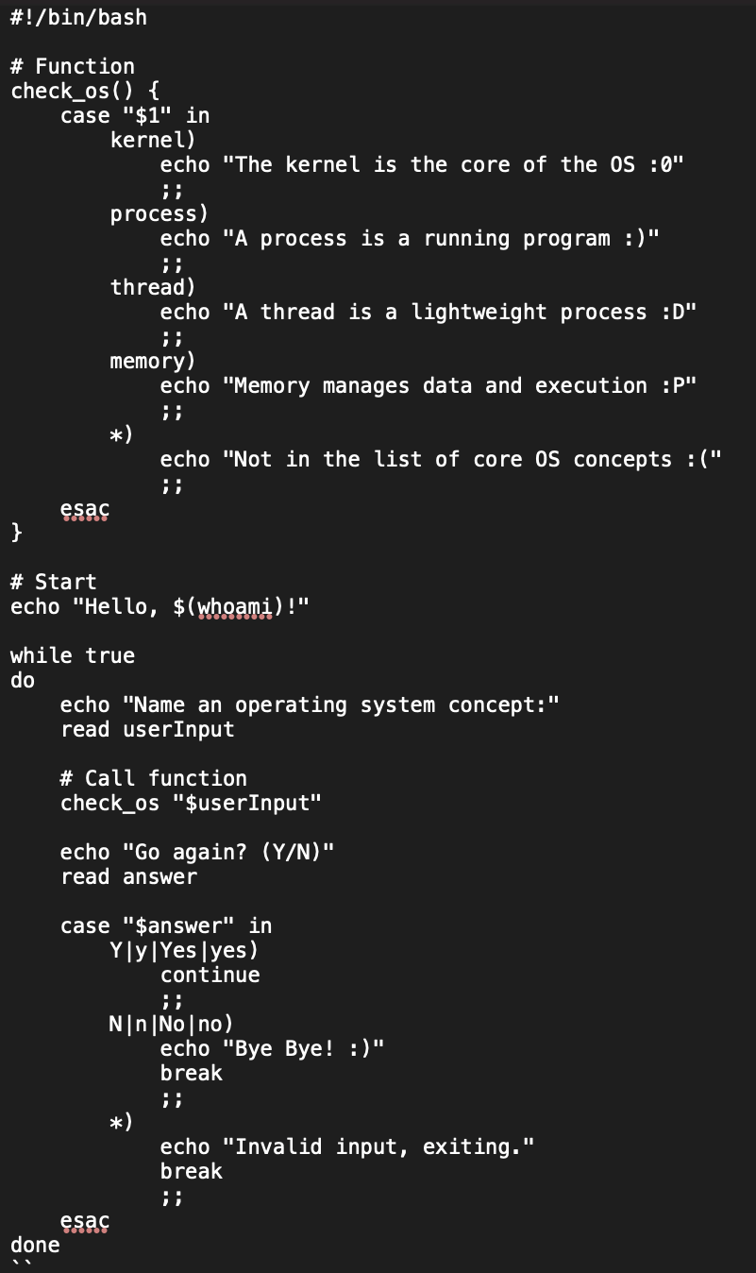
Running the script by macOS terminal
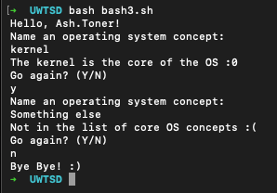
Running the script by macOS terminal:

This script makes use of comments, switch statements, functions, echo lines and while loops.

Conclusion

OS Summary
Operating systems are a core part of everything to do with a computer. Without an OS, a computer would not run. An OS is made up of 5 layers and many processes such as the Hardware Abstraction Layer (HAL), Kernel, System Services, and the UI [2].

CLI Commands
While using a GUI is useful, especial to those who are not as technologically literate, a CLI generally provides a much greater level of detail comparted to a GUI. From the CLI, you can carry out tasks like making directories, creating files, writing to files all the way to system management and even deleting the entire OS. A well written GUI should have permissions in place to stop the average user breaking the system, while a CLI does not. Commands written in the CLI will immediately run once you send them off, which is time efficient if the user is familiar with the system.

Scripting
Scripting is a really powerful tool. It allows for tedious, repetitive tasks to be automated which is especially useful for developers in regard to writing and maintaining code as well as keeping clean workflows [17].

References
- BBC, “Operating systems - Computers - Edexcel - GCSE Computer Science Revision - Edexcel - BBC Bitesize,” www.bbc.co.uk. https://www.bbc.co.uk/bitesize/guides/zkrr97h/revision/10
- J. Williams, “UWTSD Moodle - OS 1 - Lecture - Intro History Types,” UWTSD Moodle, Feb. 02, 2026. https://moodle.uwtsd.ac.uk/mod/folder/view.php?id=721088 (accessed Feb. 02, 2026).
- H. Team, “CPU Load: What is it, and How to Read and Manage it,” Hostwinds Blog, Jun. 28, 2024. https://www.hostwinds.com/blog/cpu-load-what-is-it-and-how-to-read-and-manage-it (accessed May 19, 2026).
- Apple, “Activity Monitor User Guide,” Apple, 2026. https://support.apple.com/en-gb/guide/activity-monitor/actmntr34865/mac (accessed May 19, 2026).
- Oracle, “Oracle VM VirtualBox,” VirtualBox, 2023. https://www.virtualbox.org/ (accessed May 19, 2026).
- sdwheeler, “What is PowerShell? - PowerShell,” Microsoft.com, Jul. 07, 2025. https://learn.microsoft.com/en-us/powershell/scripting/overview?view=powershell-7.6 (accessed May 19, 2026).
- GeeksforGeeks, “What is PowerShell? Getting Started with PowerShell,” GeeksforGeeks, Dec. 06, 2024. https://www.geeksforgeeks.org/operating-systems/what-is-powershell/ (accessed May 20, 2026).
- J. Williams, “UWTSD Moodle - OS 3 - Tutorial - Sys Mon - File sys CMD,” UWTSD Moodle, Feb. 09, 2026. https://moodle.uwtsd.ac.uk/mod/folder/view.php?id=721088 (accessed Feb. 09, 2026).
- Microsoft Co-Pilot, “Gen AI - Ping 8.8.8.8,” May 20, 2026.
- W3 Schools, “W3Schools.com,” W3schools.com, 2022. https://www.w3schools.com/bash/ (accessed May 20, 2026).
- Bash Commands, “How to Use Bash: A Quick Guide for Beginners,” Bash Commands, Feb. 26, 2025. https://bashcommands.com/how-to-use-bash (accessed May 20, 2026).
- GeeksforGeeks, “Id Command in Linux with Examples,” GeeksforGeeks, Feb. 19, 2019. https://www.geeksforgeeks.org/linux-unix/id-command-in-linux-with-examples/ (accessed May 20, 2026).
- T. Swart, “Cron Jobs: the Complete Guide for 2023,” cronitor.io, 2023. https://cronitor.io/guides/cron-jobs (accessed May 20, 2026).
- GeeksforGeeks, “Writing a Windows Batch Script,” GeeksforGeeks, Apr. 13, 2018. https://www.geeksforgeeks.org/techtips/writing-windows-batch-script/ (accessed May 20, 2026).
- robinharwood, “Setlocal,” Microsoft.com, Feb. 03, 2023. https://learn.microsoft.com/en-us/windows-server/administration/windows-commands/setlocal (accessed May 20, 2026).
- GeeksforGeeks, “Bash Scripting Introduction to Bash and Bash Scripting,” GeeksforGeeks, Apr. 19, 2022. https://www.geeksforgeeks.org/linux-unix/bash-scripting-introduction-to-bash-and-bash-scripting/ (accessed May 20, 2026).
- Arunachalam B, “What Are Scripts and How Do They Work? Improve Your Productivity with Scripting,” freeCodeCamp.org, Jan. 27, 2025. https://www.freecodecamp.org/news/what-are-scripts-and-how-do-they-work (accessed May 20, 2026).
- Microsoft Learn, “Manage Virtual Machines with the Azure CLI,” Microsoft.com, 2025. https://learn.microsoft.com/en-us/training/modules/manage-virtual-machines-with-azure-cli/ (accessed May 20, 2026).

Appendix

Evidence of Engagement with 1 Online Certified Course
Below is a screenshot proving completion of a course taken on Microsoft Learn titled “Manage virtual machines with the Azure CLI “[18]. The course detailed a step-by-step of Azure VMs and a further understanding of task management through Azure CLIs.


