Nicholas Liam Gelstharp – 2211042
Data Warehousing & Data Mining – Data Warehousing

Task 1
1.1:
An online transaction processing (OLTP) database is essential a database that is by design one that is used to handle the day to day running of a business as it will be able to manage and process a lot of information reliably and in real time [1]. For Rags’n’Riches this will include taking customer orders, tracking stock and transactions, recording deliveries and producing invoices and it will have a highly normalised table structure. A data warehouse is not designed to be used with real time data, it is instead designed for organisations to analyse data without having this data analysis impact on the performance of the systems that it is analysing [2]. A data warehouse is often not concerned with data normalisation and may use a star schema constructed of facts and dimension tables. This means that for Rags’n’Riches the objective of being able to scale their operations by having a more strategic oversight and the ability to run complex queries without impacting on service delivery. Analysis could be performed within the data warehouse that will be able to analyse almost any aspect of the business across all branches, including analysis of fuel costs as they are a major concern to perhaps discover the best and most efficient logistics and also a data warehouse could help with the inventory by producing forecasts and trends using complex algorithms that would have otherwise potentially caused significant performance issues in the current systems. All of this data can then be used to make the business more efficient and ultimately profitable.
1.2:
A data warehouse can have many different structures as shown in the following diagram. [3]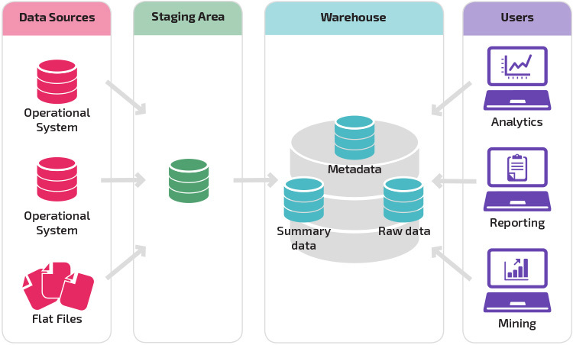

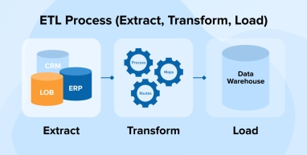
Within this structure there are three layers. The first is the data layer where all of the different data sources will feed into data warehouse. For Rags’n’Riches this will include the OLTP system which would provide the vast majority of the information that is used within the warehouse and it will include any information contained within it. Also from an internal perspective any other system that is utilised by the organisation could also feed into it, so for example finance systems, logistics etc. From an external perspective there may be sources that also feed into it, which could include the fuel card company that is used for company vehicles. This will allow for an holistic approach to the analysis of the business. The next stage or section for the data warehouse will be the ETL (Extract, Transform, Load) process [4]. This is the process whereby all of the information is copies from their original systems and is processed (transformed) into a format that will allow it to be analysed and used for analysis. This is vital as all systems will have a different underlying data structure and so for that reason, they all need to be standardised and stored in a way that will allow the data warehouse to analyse them as any different information types or dates in a different format will break any reporting. Once the data is processed it is then loaded into the data warehouse ready for analysis. This whole process will take place automatically every time the data is refreshed, and the benefit of this is that through the holistic analysis this can provide new insight can be generated that will allow the senior leadership team to be able to better understand the successes and potential changes needed to help the business scale and expand in a way that is more likely to be successful, and through use of a data warehouse regular operations will not be impacted [5].
1.3:
A data mart is essentially a section of a data warehouse that is focussed on one particular aspect of a business. Their purpose is to be able to make specific data available to a defined group that will allow them to quickly be able to access the information and the insights that they need in order to be able to analyse and make management decisions using it [6]. For Rags’n’Riches this means that utilising a data warehouse with a data mart could be a great solution as the managing, finance, sales and marketing directors can all utilise data marts which can be specifically tailored to their needs. For examples the managing director could have a section that provides a high level overview of all of the business and its departments including any KPIs or strategic goals that they may need to monitor or perhaps milestones and progress that is being made towards them. The finance director could have a more drilled down view of the financial transactions being processed by the business and their impact on the business, as well as quick and easy access to budget utilisation as well as trends analysis and forecasting, with the ability to highlight where corrections may need to be made to the course that the business is on. The sales and marketing director could look at the trends in purchasing, the demand across the year, the segmentation of customers and look to see how actions could be taken to either take advantage or target identified areas, or where more action is needed to attract different people or people at different times of the year as well as things like which sources are most successful and which are providing a return on investment as far as marketing is concerned. Overall data marts could be the ideal solution for this scenario and the various directors as well as their direct reports if needed and depending on the size of the organisation.
1.4:
An OLTP system will likely use a normalised structure, this is essentially the principle that data should not be kept in multiple places as this then ensures that there is no conflicting information and it ensures both consistency and efficiency which could impact on performance in a real-time system depending on the amount of information being stored and indexed. This is great for performance but not very good for analysis, because in order to be able to produce reports joins between tables will need to be made which can be difficult and also again can impact on performance. A data warehouse takes the data out of its “core” systems so it is impossible that analysis on it will impact the real time systems. Also the tables within a data warehouse are designed for efficiency of analysis and this means normalisation is not a priority. Instead it will have fact and dimension tables [7]. The fact tables will store quantitative data such as how many rentals the business made, or how much they cost in total, and the dimension tables will provide the context of who those customers were what the items were etc. Below is an example created for Rags’n’Riches which shows how four normalised tables from the OLTP system are used to create a rentals table which can then easily be used to analyse how many days an item was rented, costs and totals as just one simple example.
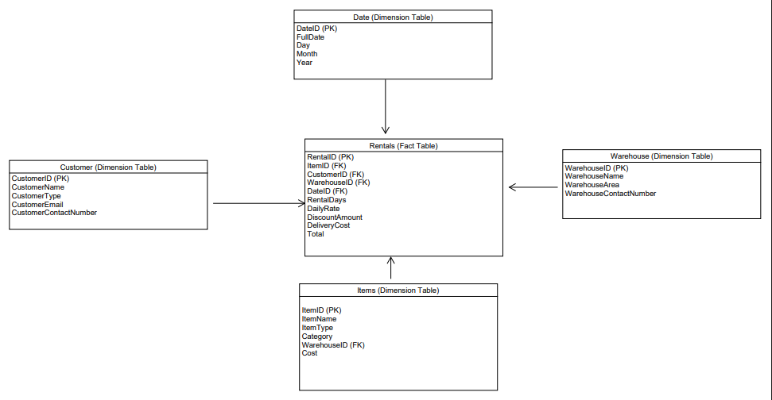

Task 2
2:1:
In order to move forwards with the data warehouse as a solution, data will need to be taken from both internal and external sources. The internal sources of information will include the companies existing data infrastructure which is used currently to manager orders, inventory, logistics, HR systems and stock levels systems. The external data that will need to be exported into the data warehouse includes market data, fuel card provider data and any other data such as costings that external providers could provide to assist with trend analysis. These can be captured at given frequencies be it monthly, daily or hourly depending on how recent the reporting needs to be. The extraction of this data will have a performance impact on their systems and so this would need to be taken into consideration.

2:2:
Rags’n’Riches could employ a large star-join dimensional model which would then be appropriate for the use case described as analysis across the business and its many departments would then be efficiently achieved. This would essentially move away from the traditional normalised data structure and instead use multiple fact tables which are supported by dimension tables. The fact tables would include details of rental transactions, transport and logistics operations and inventory. The master data would be related to customers, items, employees etc. The metadata tables would describe the systems that the information is extracted from, how the ETL process is performed and the aggregate data would include things like profitability, popularity of items and transport costs. This metadata is needed because it will improve how the organisation manages and processes data through its consistent application, and it will also be helpful for audits and resolving and identifying issues if they arise. The aggregate data is essentially baked in calculations that will be performed for information that is likely to be regularly needed. This is a much more efficient way of completing these and improves the performance of the data warehouse. Below is a visual representation of this star-join dimensional model.
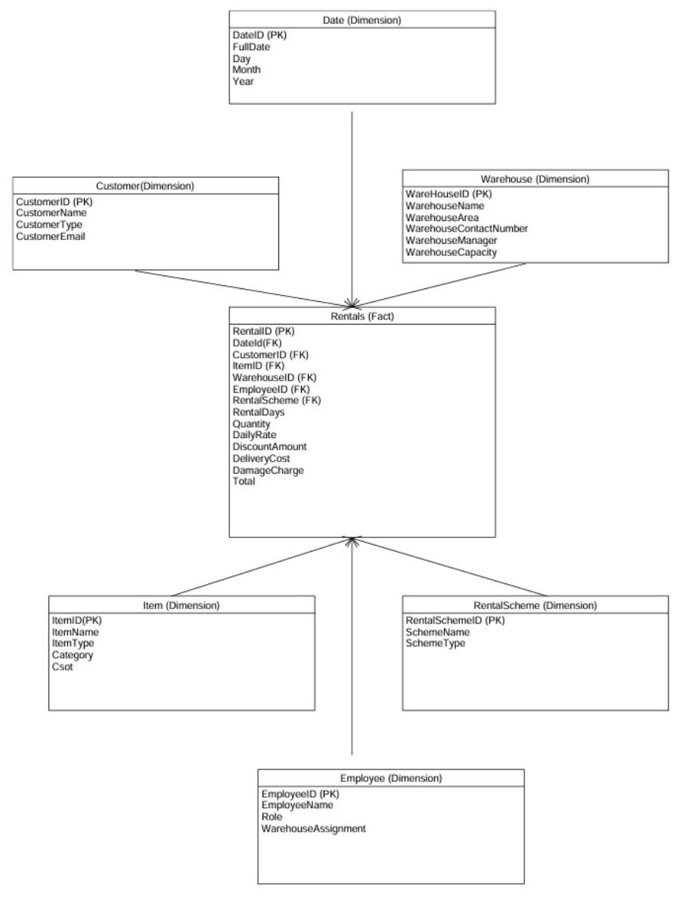
Fig 1.1

Additional Fact Tables:
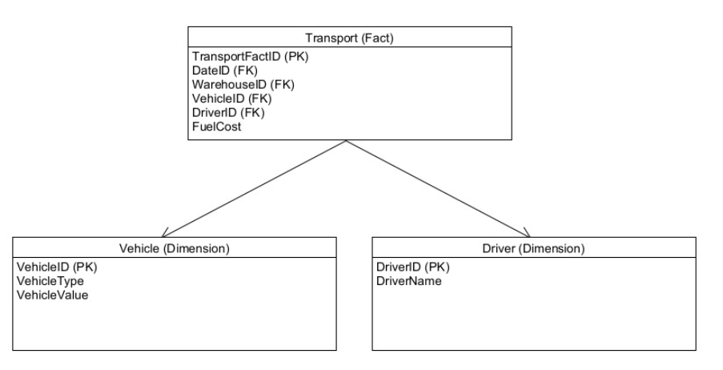
Metadata & Aggregate Data Tables
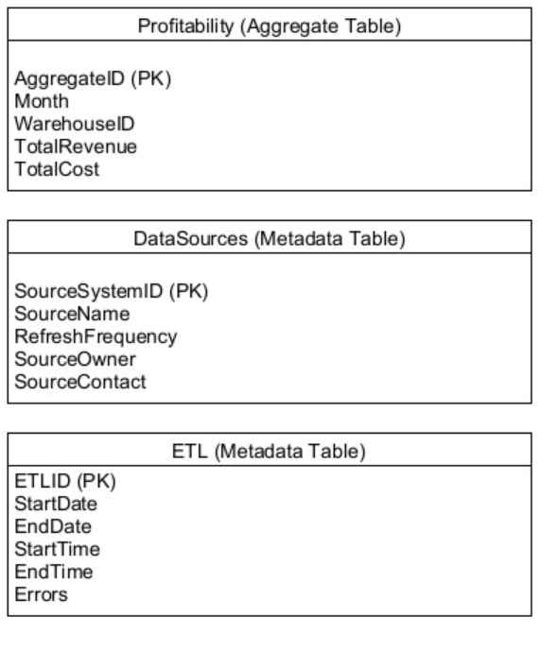

2:3:
With the organisational structure and directors within Rags’n’Riches there is the potential to implement multiple different data marts which should then improve the usability of the data warehouse solution by providing customised and specialised insights into those areas of the business. For example, a data mart could be established for Finance to service senior managers, management or operational staff. The purpose of the data mart could be to based around revenue, fuel costs, items looking specifically at their financial performance and being able to identify trends and also if required compare against organisational targets and KPI’s as related to finance. The schema that could be used to support this would be using the same schema as shown in fig 1.1 calculating totals mainly related to the rentals fact table, but using the dimensions tables to provide the context.
A further data mart that could be implemented would be for the logistics of the business as there are many different costs, vehicles, drivers and items that are being managed and moved around and so seeing performance of individual drivers could be useful in looking at staff performance or routes taken. A marketing or sales data mart could also be useful as the organisation could employ A B marketing and then use the data mart to be able to compare which marketing is most successful and really utilise the transactions fact accompanied by the marketing efforts before and after campaigns to properly understand the impact and cost benefits of such endeavours.
2:4:
The organisation will need an ETL process that will draw from, as previously mentioned, all internal current OLTP systems will need to have data captured from them at defined intervals which is determined by how up to date the reporting needs to be. For example if a high level strategic overview is needed, a daily or weekly update would be fine, but if reporting needs to be on near live date, the updates may need to be multiple times a day. After extraction, the transformation will be automatically applied which will take all of the different formats that the information is in and made them standardised so that they can be used for analysis. This will be things like making sure all dates are recorded exactly the same, all items are recorded exactly the same way and things like this. After the data is transformed it will then be loaded into the staging area, then the calculations needed for the data marts will be performed and this will complete the ETL for the data warehouse.
2:5:
The main data quality and information governance that will need to be considered will be duplicated data, as the combination of information from external systems and potentially multiple internal systems means that customers information or information about purchases could be duplicated in subtly different ways. There could also be missing information that would be very difficult to automate in the transformation process as it would likely need human intervention to have complete records. Access to this information would also be very important because of GDPR and also storing information for purposes beyond the scope of which they were originally captured could be both an ethical and legal issue that would need to be considered. However, the data warehouse could be used to efficiently respond to data access requests as all of the information from all of the systems could be efficiently stored in a central location. Regular reviews and audits of access logs, and looking for missing information could also be very useful as part of the business as usual processes.

References

[1] | R. Elsmari and S. B. Navathe, Fundamentals of Database Systems, Boston: Pearson, 2016.
[2] | W. H. Inmon, Building the Data Warehouse, Indianapolis: Wiley, 2005.
[3] | Panoply, “Data Warehouse Architecture: Traditional vs. Cloud Models,” Panoply, [Online]. Available: https://panoply.io/data-warehouse-guide/data-warehouse-architecture-traditional-vs-cloud/. [Accessed 5th May 2026].
[4] | TatvaSoft, “ETL Process,” TatvaSoft, 17 March 2026. [Online]. Available: https://www.tatvasoft.com/blog/etl-process-extract-transform-load/. [Accessed 5th May 2026].
[5] | T. Golfarelli and S. Rizzi, “Data Warehouse Design: Modern Principles and Methodologies,” New York, McGraw-Hill, 2009, p. 275.
[6] | IBM, “What is a data mart,” IBM, [Online]. Available: https://www.ibm.com/think/topics/data-mart. [Accessed 5th May 2026].
[7] | M. Kimball and R. Ross, “The data warehouse toolkit: The definitive guide to dimensional modelling,” Hoboken, Wiley, 2013, pp. 3-10.

