
fUTURE DEVELOPMENTS IN THE FIELD OF MARKETING
NIKE


Executive Summary
Date: 8th of January 2024
University of Wales Trinity Saint David
BMMB7026
Lecturer: Gwyneth Jones
Author: Sandra Boscaneanu 2016826
The contemporary business landscape, characterised by climate change and shifting global trends, necessitates firms to invest in renewable and sustainable practices. NIKE, a prominent athletic footwear brand, operates in the competitive athletic industry, focusing on developing, marketing, and selling athletic footwear, apparel, and equipment. The company's operating segments include North America, Europe, Middle East & Africa (EMEA), Greater China, and Asia Pacific & Latin America (APLA). NIKE operates in a highly competitive industry with high entry barriers, as revealed by Porter's Five Forces analysis. The company's strong brand image and diverse product range provide an advantage, but potential shifts in consumer preferences could impact buyer bargaining power. NIKE employs a direct-to-consumer approach and robust marketing to maintain its position, while low supplier influence is countered by challenges related to fluctuating raw material prices. The threat of substitute products is moderate, but NIKE's brand loyalty and innovation help mitigate this competitive aspect. The study highlights the importance of sustainability in today's competitive business landscape, with firms prioritizing sustainability gaining a competitive edge. NIKE has incorporated sustainability into its strategies and operations, evident in initiatives like the "MOVE TO ZERO" sustainability plan. The Kurt Lewin change management model is applied to assess how NIKE has adapted its marketing strategies to align with sustainability goals. Macro-environmental analysis using PESTLE emphasizes the impact of global trends, consumer awareness, environmental regulations, and supply chain resilience on NIKE's marketing strategies. NIKE employs market segmentation and differentiation strategies to target diverse consumer preferences and establish a competitive edge. The company's marketing concept focuses on understanding and meeting customer needs, with significant investments in market research to stay attuned to changing consumer preferences. The NikePlus loyalty program, personalized recommendations, and exclusive member benefits contribute to fostering customer loyalty. The study discusses the impact of NIKE's marketing slogan, "Just Do It," and how controversial marketing decisions, such as featuring Colin Kaepernick, have influenced public perception. To navigate challenges posed by climate change and evolving consumer expectations, the SOSTAC model it has been suggested to adopt to overcome these challenges.

1

Table of Contents
Executive Summary 0
1.0 Introduction 3
2.0 Main Findings 4
2.1.1 Porter Five Forces 4
2.1.1Concept and importance of marketing 4
2.2 Change Management 8
2.3 Marco and micro marketing 11
2.3.2 Segmentation Targeting Positioning strategy and marketing mix. 14
2.3.4 Communication media mix 17
2.3.5 Marketing metrics 18
3.0 Conclusion 19
4.0 Recommendations 20
References 22

Table 1 Porter Five Forces 4
Table 2 Marketing concepts 6
Table 3 PESTLE 11
Table 4 SWOT 14
Table 5 STP STRATEGY 15
Table 6 Marketing Mix 16
Table 7 Communication mix 17

1.0 Introduction
The climate change movement and worldwide trends exert pressure on firms to allocate resources towards investing in renewable and sustainable practices. NIKE is a footwear store that operates exclusively in the athletic business, focusing on the development, marketing, and sale of athletic footwear, apparel, and equipment. The operating segments that the NIKE brand reports on include North America, Europe, Middle East & Africa (EMEA), Greater China, and Asia Pacific & Latin America (APLA). These sectors include the NIKE and Jordan brands. Therefore, This research incorporates a range of reliable sources, including journal articles, eBooks, books, newspapers, industry publications, and websites.

Main Findings

2.1.1 Porter Five Forces
The analysis of Porter's Five Forces as shows in Table 1 reveals that Nike operates in a highly competitive industry with high barriers to entry. Nike's strong brand image(NIKE, 2023) and diverse product range give it an advantage but shifts in consumer preferences could increase buyer bargaining power. Nike's direct-to-consumer approach and robust marketing help maintain its position. The influence of suppliers is low, but fluctuating raw material prices pose challenges. The threat of substitute products is moderate, but Nike's brand loyalty and innovative offerings mitigate this. The industry has highly competitive rivalry, with Nike facing strong opponents. Nike's commitment to innovation and strategic initiatives positions it well in the industry (MarketLine, 2023).
Table 1 Porter Five Forces
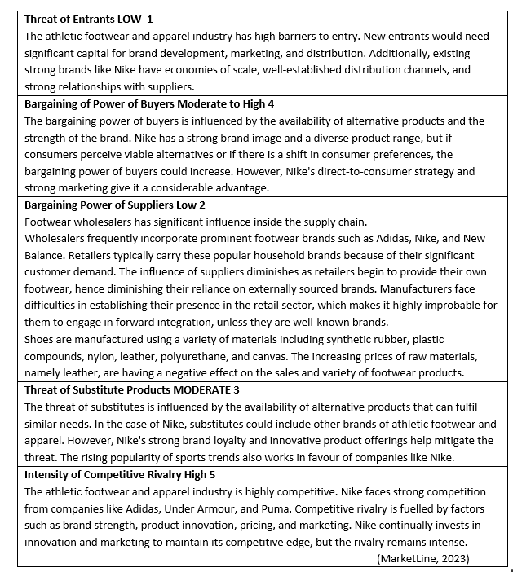Furthermore Gigauri et al. (2023a) states that in today's competitive business climate, firms that prioritise for social and environmental sustainability among customers and other important stakeholders, as customer are willing to buy from sustainable firms. sustainability are more likely to achieve a competitive edge due to the increasing concern.

2.1.1Concept and importance of marketing
According to Dibb et al. (2012) marketing is a multifaceted business process that involves creating, communicating, delivering, and exchanging offerings that have value for customers, partners, and society at large. It is a dynamic and strategic activity that revolves around understanding customer needs and wants, and then developing and delivering products or services that satisfy those needs. Marketing encompasses a range of activities, including market research, product development, pricing, promotion, distribution, and customer relationship management. In contrast, Kotler and Armstrong (2017) argue that modern marketing should not be seen just as the act of generating a sale through persuasive communication, but rather as the act of satisfying client demands. If marketers successfully connect customers, understand their needs, develop goods that provide outstanding customer value, and implement effective pricing, distribution, and advertising methods, these items will achieve effortless sales. Haldar (2022) gives another definition: marketing is a corporate function and process that aims to maximise returns to owners by building relationships with valuable customers and making the company more competitive.
According to Nike's focus on the "21 consecutive years of increasing dividend payouts" highlights its dedication to constantly rewarding shareholders by distributing a portion of the company's income as dividends and building shareholder value through share repurchases. Shareholder returns are essential indicators that showcase the company's fiscal well-being, expansion, and dedication to providing value to its owners.
Additionally, Max (2015) asserts that there are five Marketing Concepts, referred to as marketing management perspectives. These are as follows: Production, product, selling, marketing and societal marketing concept.
The table 2 below shows the cons and pros between various marketing concepts.
Table 2 Marketing concepts
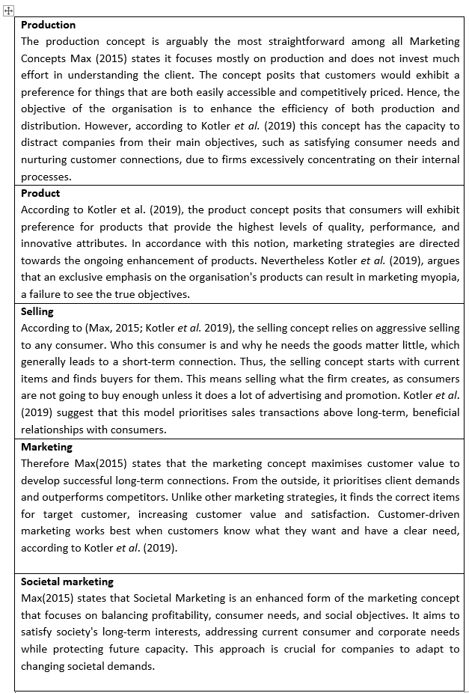
Consecutively, according to Nike (2023a) the company invest in for the following marketing activities, advertising, sponsorship and endorsements, digital marketing, product launches, market research and innovative technologies. Furthermore, according to MarketLine, (2023) NIKE uses a direct-to-consumer approach. Since the brand has fully embraced a direct-to-consumer approach, NexFord University (2023) even longtime wholesale partners are no longer authorised to purchase their products. This has substantially altered the way in which individuals purchase Nike shoes. At present, Nike conducts most of its shoe sales through digital channels, including its website and applications. Additionally, the business has branded immersive outlets.
The marketing concept applied to Nike.
Thus, Petro (2016) states that Nike places a strong emphasis on understanding and meeting customer needs. Nike adapts its products to align with market demands and places a strong emphasis on building long-term relationships with its customers. The company invests significantly in market research according to (MarketLine, 2023), to stay attuned to changing consumer preferences, trends, and behaviours. Furthermore, The NikePlus loyalty program, personalised recommendations, and exclusive member benefits are designed to foster customer loyalty (Forrester, 2019). Additionally, Nike is known for high-profile endorsements and sponsorship with athletes, teams, and events. This partnership contributes to brand visibility and association with sports excellence. Successively, Hussein H. (2023) asserts that NIKE's strategic use of celebrity endorsement aids in the company's efforts to restore trust and enhance brand image by effectively shaping customer views and attitudes towards the brand.
However, Byon et al. (2022), argue that celebrity endorsement has inherent risks, such as the possibility that the promoted celebrity may be linked to scandal, misconduct, or allegations. This not only damages their own reputation but also reflects adversely on the brand they are endorsing. Moreover, celebrity endorsement is expensive, the company had endorsement contract obligations totalling $7.6 billion in May 2023, according to Nike(2023a). These obligations encompass base compensation and minimum guaranteed royalty fees committed to athletes, public figures, sports teams, and leagues endorsing the company's products. Nevertheless, Rajagopal (2019) asserts that customer views are influenced by their social and personal opinions of product features, pricing, and perceived use value. Social and celebrity endorsements have a substantial impact on customer buying attitudes via both direct and indirect means.
Societal Marketing applied to NIKE.
For instance, NIKE has increasingly integrated societal concerns into its business practices. Initiatives such as the "Move to Zero" sustainability plan and commitments to reducing carbon emissions reflect a growing awareness of the broader impact of its operations (Nike, 2023a).Nike engages with communities through initiatives like the Community Impact Fund (Nike, 2023b), addressing social issues, and contributing to community development. This aligns with a societal orientation that extends beyond immediate customer relationships. Furthermore, according to Rowell (2023) the slogan ”Just Do it” help NIKE gain popularity, the slogan was first introduced in 1988, and the company still using it today. However, Taylor (2023) argues that Nike has chosen to generate controversy by including Colin Kaepernick to commemorate the 30th anniversary of their slogan, a former NFL quarterback known for his contentious actions, in their advertising campaign. The decision has ignited a contentious discussion, with one faction advocating for a boycott of the company and the other expressing words of endorsement. On the other hand, Kotler and Armstrong (2017), Nike surpasses its competitors by effectively delivering on its promise to inspire and support regular athletes with the slogan "Just do it."
Therefore, Nike's marketing department plays a central role in creating brand awareness, fostering customer engagement, and driving sales. Its influence extends across various platforms, from traditional advertising to digital and social media channels.

2.2 Change Management
Hussain et al. (2016) characterised change management as a continuous process of renewing an organisation’s direction, structure, and capabilities to align with the changing needs of both external and internal customers. Climate change can significantly impact industries and, consequently, the marketing strategies of companies.
The Kurt Lewin’s change management model has been used to analyse how climate change influenced NIKE marketing strategies, the model consists of three stages unfreezing, changing, and refreezing.
Unfreezing
Unfreezing involves recognising the need for change by understanding the external environment. According to Nike (2022), the company creates awareness of the need for sustainability, launching initiatives like “MOVE TO ZERO”, footwear recycling, circular economy.
Changing
NIKE implemented sustainable practices in its supply chain, introduced eco-friendly materials and redesigned its products to reduce environmental impact. An example is Nike refurbished footwear initiative, where people bring back their used footwear. Nevertheless, Curtis and Hansson (2019) contend that while the initiative to reduce waste going to landfills is excellent, a significant concern arises from the greenhouse gas emissions resulting from the transportation of these products from Europe and America to recycling facilities in USA. This transportation necessitates covering vast distances, dispersing more gas emissions. Nevertheless, Promes (2016) suggests that when new techniques and concepts of workplace practice are introduced, employees may experience resistance as an emotional reaction to the change.
Refreezing
Refreezing includes ensuring that employees are aligned with the new sustainability-focused strategies. The company has also engaged in collaborations and partnerships to advance sustainable practices. Embedding sustainability into its corporate culture, Nike demonstrates a long-term commitment to addressing climate change. Hawker (2023)state that Tulipshare, an activist investor, submitted an inquiry for Nike's board to produce a report evaluating the efficiency of its supply chain management system in upholding the company's human rights obligations and equitable objectives. Besides, a consortium of investors, which includes ABN AMRO and CCLA Investment Management, sent a letter to the firm earlier this month, urging them to confront accusations of pay fraud totalling US$2.2 million at two factories operated by its suppliers.
The below section of the report was derived from the presentation notes that were utilised in the task one of the assignments.
Figure 1 Change Management
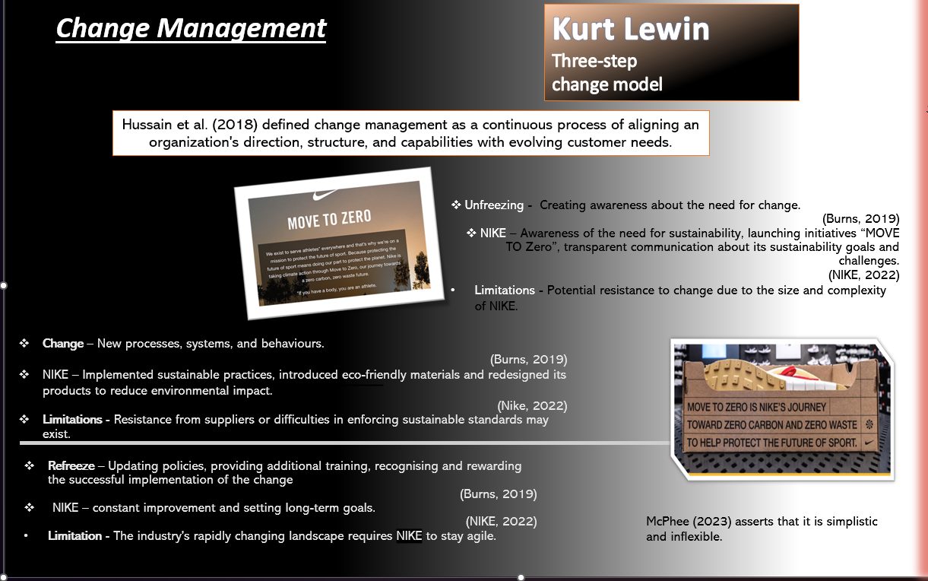
Burnes (2004) states that Lewin's approach seeks to comprehend group conduct by examining the comprehensive and nuanced environment in which the action occurs.
Burnes(2004) asserts that Kurt Lewin's paradigm, introduced in 1947, is among the earliest and fundamental models for deliberate change. It clarifies the conflicting forces that support the current situation and those who strive for transformation. To modify the stage of "quasi-stationary equilibrium," one can amplify the driving factors for change, diminish the forces that maintain the present state, or utilise a mix of both forces to promote proactive and reactive organisational change. This may be accomplished by fostering the exchange of information among individuals and employing a change leadership approach that promotes and supports change.
Nevertheless, McPheat (2023) contends that this model may be overly simplistic for certain individuals, as managers and team leaders see that it oversimplifies the way humans react to change. In addition, McPheat (2023) argues that it may also be inflexible to maintain that firms consistently undergo changes, which contradicts the third stage of Lewin's Model, Refreeze. Ultimately, Bartunek and Woodman (2015) argue that the previously established behaviours or methods will require defrosting, and the change model will need to be re-implemented, as businesses environment is in continuous changing.

2.3 Marco and micro marketing
Furthermore, (Kotler et al. 2019, pp 70-72) define the macro environment as the broader social factors that impact the microenvironment, including demographic, economic, ecological, technical, political, and cultural elements. Conversely, the microenvironment refers to the variables near the firm that impact its capacity to interact with and supply to its consumers. These factors include the company itself, suppliers, marketing intermediates, customer marketplaces, rivals, and publics.
Blythe (2013) contends that the macro environment is challenging to manipulate or control, but the microenvironment is more easily controlled by the enterprise.
Thus, PESTLE has been used to analyse the external landscape of NIKE.

Table 3 PESTLE
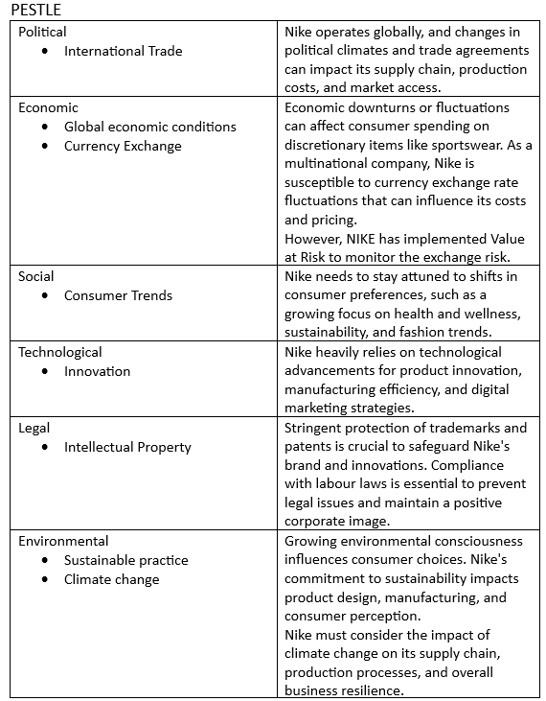
The table 3 above shows the impact of climate change on NIKE at a macro level, the company marketing strategy has been influenced by the following factors.
Global Trend and Consumer awareness
According to Venghaus et al. (2022) climate change awareness has become a global trend, influencing consumer preferences towards sustainable and eco-friendly products. Furthermore, Deloitte (2023) states that costumers are ready to pay more for sustainable products and have higher interest in sustainable and ethical practices.
Nike has adjusted its marketing strategy to highlight sustainability efforts, emphasizing eco-friendly materials and production processes. This includes initiatives like using Fly Knit in their products. However, according to Robertson(2023), Nike faced a class action lawsuit due to allegations of making misleading sustainability claims, commonly referred to as "greenwashing". The lawsuit alleges that Nike has engaged in illegal practices by falsely promoting certain clothing items as sustainable and supportive of their waste- and carbon-reducing initiative called 'Move to Zero'. These items are claimed to be made from non-biodegradable plastic-based materials, which contradicts the retailer's 'green' claims and attempts to exploit consumers' preference for environmentally friendly products.
Environmental regulations
Increasing global regulations and standards related to environmental sustainability can shape Nike's operational and marketing practices. Nike has been actively involved in initiatives related to the circular economy, demonstrating its commitment to sustainability and responsible business practices(NIKE, 2023). Additionally, Ricardo(2021) states that the circular economy is an economic model that focuses on minimizing waste, promoting recycling, and ensuring that products and materials are used efficiently throughout their life cycles. On the other hand, Ricardo(2021) argue that companies may struggle to sell products designed for longevity and repairability if consumer demand for disposable and trendy items persists.
Ricardo (2021) highlights risks in the circular economy: consumer hesitation and reduced willingness to pay for refurbished products due to concerns about quality, potential malfunctions, repair costs, uncertainties regarding benefits, and worries about hygiene and safety issues associated with used items.
Supply chain resilience
Climate change impacts supply chains globally, leading to disruptions and challenges in manufacturing and distribution . In addition to disrupting manufacturing supply chains due to transportation and agricultural input issues, Kyriakopoulou et al. (2023) state that heat exhaustion and equipment malfunctions can lower productivity and working hours. Production shortages and supply chain damage might result. High temperatures may increase trade costs by raising storage facility cooling expenditures. According to Nike, (2022) Suppliers frequently encounter challenges in securing funding to invest in decarbonisation technologies. NIKE is collaborating with the International Finance Corporation's Global Trade Supplier Finance programme (IFC GTSF) to offer favourable financing rates to qualified suppliers, contingent upon their adherence to our Foundational Expectations and performance criteria. Suppliers play a crucial role in the total value delivery network of a firm, as stated by Kotler et al. (2019, p71). Asserts that issues with suppliers may have a significant impact on marketing. Consequently, managers must closely monitor the availability and cost of supplies, as any shortages or delays could result in lost sales in the near term and harm consumer satisfaction in the long term.
Microenvironment and SWOT analysis
According to Blythe(2013) the internal environment of a company include its internal culture, staff relationships, and resource limitations, which influence all the organisation's actions and choices. Every company function within the constraints of finite resources. Companies develop expertise in their field by strategically utilising the resources available to them. The more efficiently these resources are utilised, the more successful the company will be in a competitive market. Ensuring optimal functioning of the internal environment is a crucial facet of management. On the other hand, CFI Team (2023)argue that micromarketing takes a It takes a lot of time, effort, and information because the marketer must carefully pick the group of people they want to reach. Besides that, the marketer must spend time planning the campaign.
SWOT analysis has been undertaken to analyse the internal environment of Nike. Please refer to Table 4 below
Table 4 SWOT
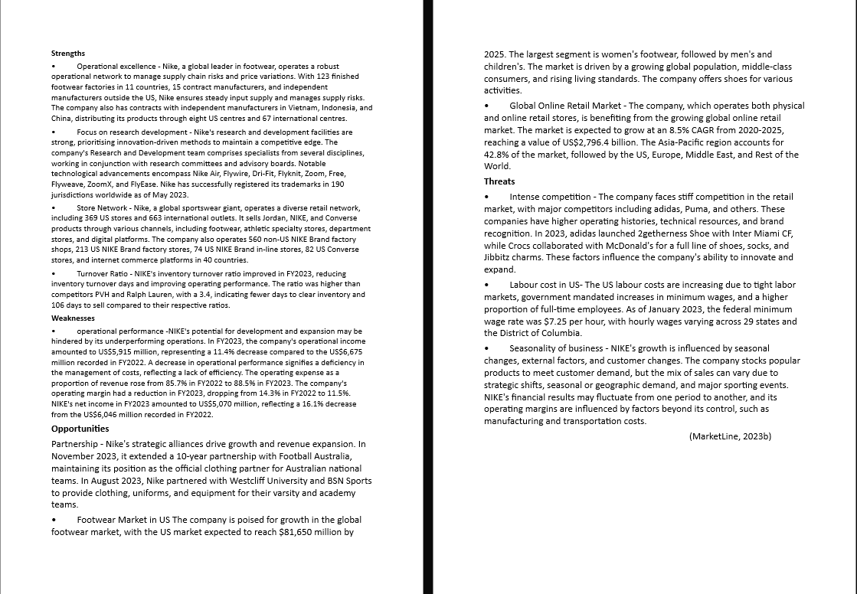

2.3.2 Segmentation Targeting Positioning strategy and marketing mix.
Market segmentation, as stated by Dolnicar et al. (2018), offers numerous advantages. It compels organisations to assess their current position and future goals, prompting them to reflect on their strengths relative to competitors and gain a deeper understanding of consumer preferences. Conversely, believes that the implementation of market segmentation necessitates a significant investment by the organisation, the bigger the campaign the more expensive will be. Thus, Yoseph and AlMalaily (2019) claim that behavioural segmentation allows businesses to use predictive analytics to anticipate and influence consumer purchasing behaviours and results.
According to (Teachers, 2023a) behavioural segmentation is a marketing strategy that divides a large client base into smaller, more specific groups based on their preferences, behaviours, and purchases. Understanding human behaviour allows marketers to tailor their messaging and offerings to each category's needs. This lets companies create powerful, personalised marketing campaigns. Nike interacts with different audiences by personalising messaging, goods, and experiences with this method. However, Dolnicar et al. (2018) contend that the data is not easily available, especially when segmenting non-buyers, loyalty segmentation and social influence segmentation. The table 5 shows how NIKE uses the STP strategy.
Table 5 STP STRATEGY
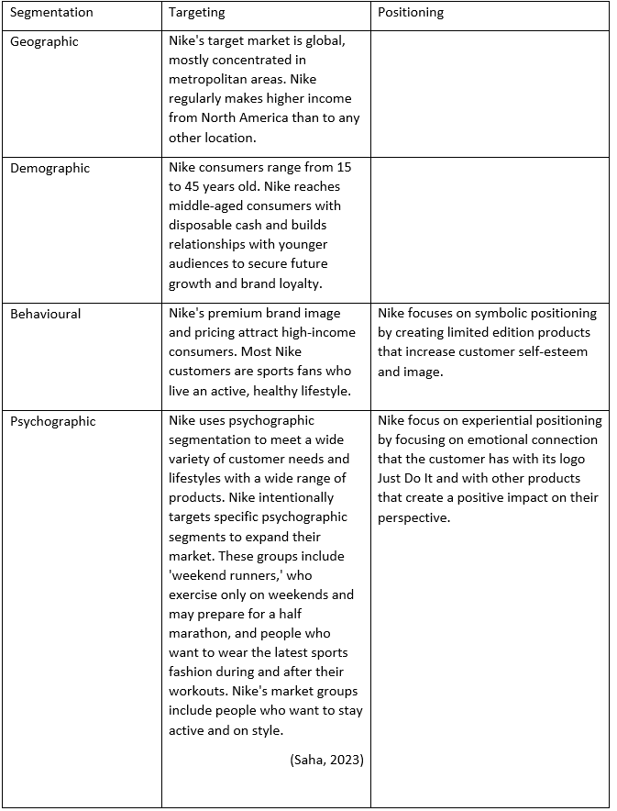
Marketing Mix
According to (Two teacher, 2023b) the integration of each component within Nike's marketing mix is intricately designed to align with the overarching business objectives. For instance, the superior quality of their products corresponds with a pricing strategy that reinforces the premium image of their brand. Simultaneously, the well-structured distribution network ensures product accessibility, while the promotion strategy works to establish emotional connections with customers, fostering brand awareness. Table 6 below shows Nike's marketing mix is dynamic and adaptive, allowing the brand to stay relevant in the ever-changing consumer landscape. The company continues to leverage innovation, technology, and powerful branding to maintain its position as a global leader in the athletic apparel and footwear industry.
Table 6 Marketing Mix
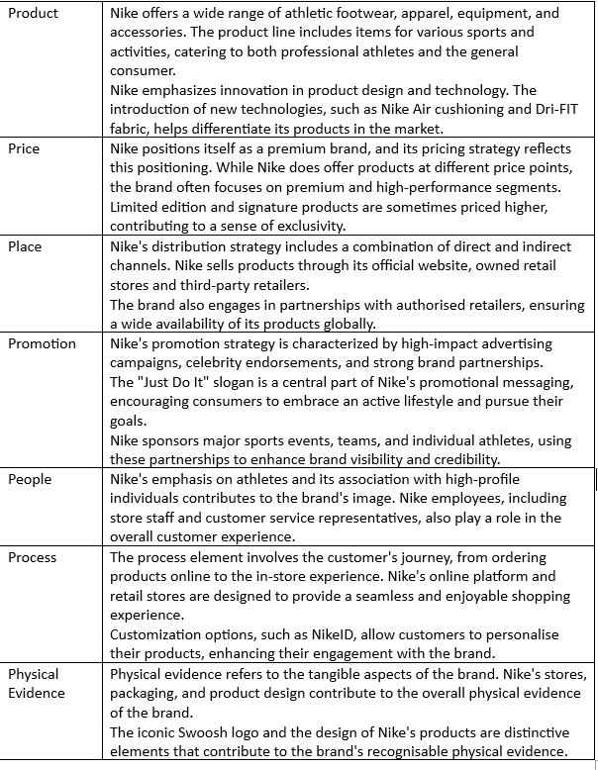

2.3.4 Communication media mix
Nike, as a multinational brand, utilises a varied communication blend to effectively reach and engage its intended audience. The communication mix comprises a range of components that collaborate to transmit the company's message and establish a robust brand identity. Below in table 7 are few essential elements of Nike's communication mix.
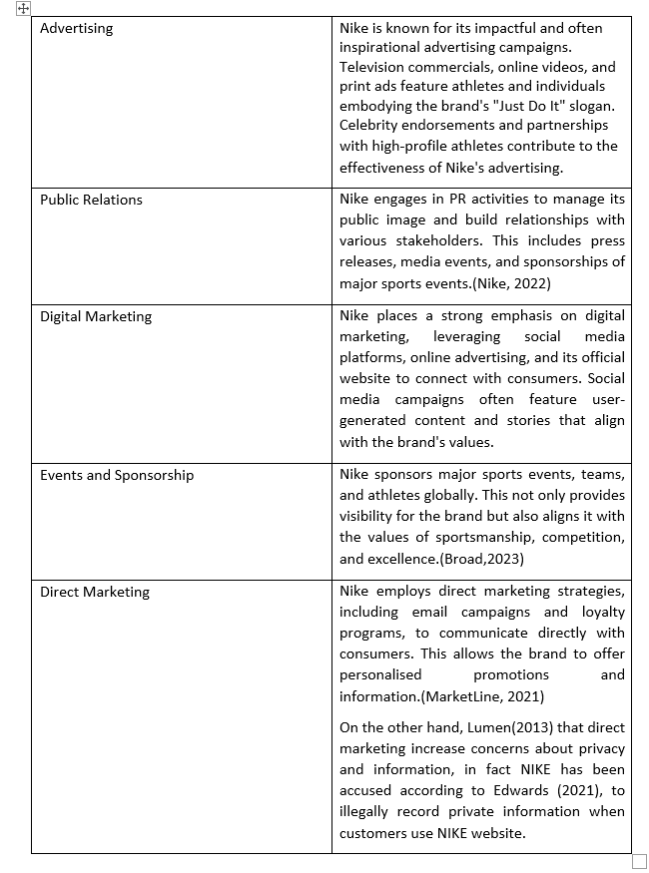
Table 7 Communication mix
According to Borad(2023), Nike's distinctive "Just Do It" motto and the renowned "swoosh" emblem have effectively distinguished the brand from its rivals, cultivating a devoted consumer base that is prepared to pay a higher price for Nike's merchandise. According to MarketLine(2021), Nike campaign to commemorate 30th years of its slogan was successful, with the company's stock rising by 5% in the weeks after the commercial release. The ad featuring Colin Kaepernick received the Creative Arts Emmy for Outstanding Commercial. Nike's polarising campaign demonstrates the power of well-executed controversial ads.

2.3.5 Marketing metrics
According to MarketLine(2023) Nike possesses strong research and development capabilities and consistently allocates resources to foster innovation and remain up to date with industry developments. Notable technologies offered by Nike include Nike Air, Flywire, Dri-Fit, Flyknit, Zoom, Free, Flyweave, ZoomX, and FlyEase. These technologies are available in several categories such as running, basketball, football, men's training, women's training, and apparel. Nike benefits from the 'first mover' advantage, which enables it to maintain a competitive edge and provide its clients with cutting-edge goods and services. The company's capitalised research and development (R&D) expenditures amounted to $353 million in FY2022. Furthermore, Widuri and Sutanto (2019) assert that companies employing a differentiation strategy prioritise the development of exceptional and distinctive items to set themselves apart from their rivals. In addition, the companies' competitive edge will appeal to clients who are not concerned with their spending. Hence, difference empowers companies to command higher prices. Nike's branding strategy centres around differentiation through the creation of a distinct image that is closely linked to its products.

3.0 Conclusion
Nike, a leading athletic brand, faces both challenges and opportunities in the competitive athletic industry due to climate change and evolving consumer expectations. The company's marketing strategies, based on Porter's Five Forces, focus on operational excellence, research and development, and a vast store network. Strategic alliances and market growth opportunities are identified as key drivers for future expansion. However, Nike must address weaknesses like operational performance to support sustained growth. The company's commitment to operational excellence, research and development, and a diverse store network contribute to its global leadership. However, challenges like increasing labor costs in the US and seasonality of the business require careful consideration. The study also explores Nike's marketing mix, emphasizing its interconnected elements to support overall business goals. It highlights Nike's focus on operational excellence, research and development, a diverse store network, and efficient inventory turnover. Opportunities such as strategic alliances and growth in specific markets align with Nike's core competencies. In response to climate change, Nike has undergone change management, incorporating sustainability into its strategies and operations. The Kurt Lewin's change management model is applied to assess how Nike has changed its approach to align with sustainability goals. A macro-environmental analysis using PESTLE highlights the influence of global trends, consumer awareness, environmental regulations, and supply chain resilience on Nike's marketing strategies. Market segmentation and differentiation strategies are essential components of Nike's approach to target diverse consumer preferences and establish a competitive edge. Furthermore, Nike's marketing strategies demonstrate its resilience, adaptability, and commitment to sustainability. By addressing challenges, capitalising on opportunities, and staying true to its core values, Nike positions itself for continued success in the ever-evolving athletic business landscape.

4.0 Recommendations

Based on the conclusion, focusing on operational efficiency, sustainability, and strategic market expansion, Nike can navigate the challenges posed by climate change and evolving consumer expectations, positioning itself for continued success in the athletic industry.
The SOSTAC model is used to make the following suggestions. Chaffey et al. (2022) says that thousands of groups around the world use this way of planning. Furthermore, Suharyati et al .(2023), states that by implementing the SOSTAC method, organisations achieve distinctive marketing strategies that establish a competitive edge in the marketplace. This advantage could materialise in improved marketing effectiveness, as evidenced by increased profitability, expansion of sales, and the acquisition of new customers. The acronyms SOSTAC stands for:
Situation analysis – Leverage Nike's operational excellence, strong R&D capabilities, and diverse store network to maintain and enhance its global leadership. Address operational performance challenges by implementing efficiency measures and cost management strategies. Explore and capitalise on market growth opportunities, especially in strategic alliances and targeted markets.
Objectives - Improve operational efficiency by implementing cost-effective measures, streamlining processes, and optimising the supply chain. Further embed sustainability into Nike's corporate culture by setting specific objectives related to environmental impact reduction and ethical practices. Set clear objectives for entering new markets or expanding market share in existing ones, aligning with Nike's core competencies.
Strategy - Continue prioritizing research and development to drive innovation, ensuring that new products align with sustainability goals and resonate with evolving consumer expectations. Strengthen existing strategic alliances and explore new partnerships, focusing on those aligned with sustainable practices and contributing to market growth. Implement strategies to address labor cost challenges in the US, possibly through technological advancements, process optimization, or strategic outsourcing.
Tactics - Develop and implement programs to enhance operational efficiency, reduce costs, and improve overall performance. Launch targeted marketing campaigns to communicate Nike's commitment to sustainability, educating consumers on eco-friendly practices and products. Tailor marketing and product strategies to suit the unique demands and preferences of specific markets identified for growth.
Actions - Allocate resources to technology that enhances operational efficiency, reduces labor costs, and supports sustainability goals. Develop campaigns to educate consumers about Nike's sustainable initiatives, building brand loyalty through transparency and ethical practices. Conduct thorough market research to understand specific market needs and preferences, informing product development and marketing strategies.
Control - Establish key performance indicators (KPIs) to measure progress in operational efficiency, sustainability goals, and market expansion. Implement regular audits of sustainability practices, ensuring compliance with environmental regulations and ethical standards. Continuously monitor market dynamics, adjusting strategies as needed to respond to changes in consumer expectations and competitive landscape.

References
MarketLine (2023). MarketLine Industry Profile Global Footwear Retail. [online]
Available at: https://advantage-marketline-com.ezproxy.uwtsd.ac.uk/Analysis/ViewasPDF/global-footwear-retail-183598
(Accessed: 3 January 2024)

Bartunek, J.M. and Woodman, R.W. (2015). Beyond Lewin: Toward a Temporal Approximation of Organization Development and Change. Annual Review of Organizational Psychology and Organizational Behavior, 2(1), pp.157–182.
doi: https://doi.org/10.1146/annurev-orgpsych-032414-111353

Dibb, S., Simkin, L., Pride, W.M. and Ferrell, O.C. (2012). Marketing concepts and strategies. Sixth ed. United Kingdom : Cengage Learning.
Kotler, P, & Armstrong, G 2017, Principles of Marketing, EBook, Global Edition : Principles of Marketing
Harlow, United Kingdom: Pearson Education, Limited
Available from: ProQuest Ebook Central.
(Accessed on: 3 January 2024).

Petro, G. (2016). Nike Just Does It - Keeping An Eye On The Customer. Forbes. [online]
Available at: https://www.forbes.com/sites/gregpetro/2016/07/08/nike-just-does-it-keeping-an-eye-on-the-customer/
(Accessed: 3 January 2024)

Taylor, D. (2023). Nike’s ‘Just do it’ just keeps doing it and has been for over 30 years. [online] Taylor Brand Group.
Available at: https://www.taylorbrandgroup.com/nikes-just-do-it-just-keeps-doing-it-and-has-been-for-over-30-years/
(Accessed: 05 January 2024)

Robertson, L. (2023). How Ethical Is Nike? [online] Good On You.
Available at: https://goodonyou.eco/how-ethical-is-nike/
(Accessed: 5 January 2024)

Dr Piali Haldar (2022). Marketing Management for the Beginners.
WEBSITE: Book Bazooka Publication.
EBOOK Available at https://www.google.co.uk/books/edition/Marketing_Management_for_the_Beginners/vJduEAAAQBAJ?hl=en&gbpv=1
(Accessed: 5 January 2024)

Max (2015). The 5 Marketing Concepts - Marketing Management Orientations. [online] Marketing-Insider.
Available at: https://marketing-insider.eu/marketing-concepts/?utm_content=cmp-true
(Accessed: 5 January 2024)

Kotler, PT, Armstrong, G, Harris, LC, & He, H 2019, Principles of Marketing. (pp.11-12)
Harlow, United Kingdom: Pearson Education Limited
Available from: ProQuest Ebook Central.
(Accessed: 5 January 2024).

Forrester (2019). Nike Is Setting The Standard For Omnichannel Loyalty In Every Industry. [online] Forbes.
Available at: https://www.forbes.com/sites/forrester/2019/12/26/nike-is-setting-the-standard-for-omnichannel-loyalty-in-every-industry/
(Accessed: 5 January 2024)

MarketLine (2023b). NIKE Inc -SWOT Analysis. [online]
Available at: https://advantage-marketline-com.ezproxy.uwtsd.ac.uk/Company/Profile/nike_inc?swot
(Accessed: 04 January 2024)
Nike (2023a). FORM 10-K.
Available at: https://s1.q4cdn.com/806093406/files/doc_downloads/2023/414759-1-_5_Nike-NPS-Combo_Form-10-K_WR.pdf .
(Accessed on: 4 January 2024)
Nike (2023b). Championing Our Nike Community Impact Fund. [online] Nike.com.
Available at: https://about.nike.com/en/impact/initiatives/championing-our-nike-community-impact-fund
(Accessed: 5 January 2024)

Rowell, R. (2023). Nike: Sportswear and Brand-Building Powerhouse.
ABDO Publishing Company.

Rajagopal (2019). Contemporary Marketing Strategy Analyzing Consumer Behavior to Drive Managerial Decision Making.
Switzerland: Springer International Publishing

Gigauri, I., Palazzo, M. and Ferri, M.A. (2023a). Handbook of Research on Achieving Sustainable Development Goals With Sustainable Marketing.(p133)
Hershey, PA: Hershey IGI Global.
doi: https://doi.org/10.4018/978-1-6684-8681-8

Gigauri, I., Palazzo, M. and Ferri, M.A. (2023b). Handbook of Research on Achieving Sustainable Development Goals With Sustainable Marketing.(pp.149-169)
Hershey, PA: Hershey IGI Global.
doi: https://doi.org/10.4018/978-1-6684-8681-8

NIKE. (2022). FY22 NIKE, Inc. Impact Report.
Available at: https://media.about.nike.com/files/995eda87-a1be-4d7f-8788-49b9dc00c486/FY22-NIKE,-Inc.-Impact-Report.pdf

Promes, M. (2016). Change management and organizational learning in a new working environment : a longitudinal and mixed methods research design.
München: Herbert Utz Verlag.

Hussein, H. (2023). The Impact of Celebrity Endorsement in Brand Crisis Management: Insights from Nike. [online] www.linkedin.com.
Available at: https://www.linkedin.com/pulse/impact-celebrity-endorsement-brand-crisis-management-insights-hesham/
(Accessed: 5 January 2024)

Byon, K.K., Yim, B.H. and Zhang, J.J. (2022). Marketing Analysis in Sport Business.
United Kingdom: Taylor & Francis.

Curtis, A. and Hansson, A. (2019). Examining the Viability of Corporate Recycling Initiatives and Their Overall Environmental Impact: The Case of Nike Grind and the Reuse-A-Shoe Program. Case Studies in the Environment, 3(1), pp.1–7.
doi: https://doi.org/10.1525/cse.2019.001974

Burnes, B. (2004). Kurt Lewin and the Planned Approach to change: a re-appraisal. Journal of Management Studies, [online] 41(6), pp.977–1002.
doi: https://doi.org/10.1111/j.1467-6486.2004.00463.x
(Accessed on: 19 November 2023)

Burnes, B. (2019). The Origins of Lewin’s Three-Step Model of Change. The Journal of Applied Behavioral Science, 56(1), pp.32–59.
doi: https://doi.org/10.1177/0021886319892685
(Accessed on: 18 November 2023)
McPheat, S. (2023). Advantages and Disadvantages of Lewin’s Change Model. Leadership and Management Training Courses UK | MTD Training.
Available at: https://www.mtdtraining.com/blog/advantages-disadvantages-lewins-change-model.htm
(Accessed: 4 January 2023 )

Lumen Learning (2019). Microenvironment vs. Macroenvironment | Retail Management. Lumenlearning.com.
Available at: https://courses.lumenlearning.com/wm-retailmanagement/chapter/microenvironment-vs-macroenvironment/
(Accessed: 5 January 2024)

Blythe, J. (2013). The Marketing Environment. [online] sagepub.com.
(PDF) Available at: https://uk.sagepub.com/sites/default/files/upm-binaries/58888_blythe_pandp_chapter_2_the_marketing_environment.pdf
(Accessed: 6 January 2024).

Venghaus, S., Henseleit, M. and Belka, M. (2022). The impact of climate change awareness on behavioral changes in Germany: changing minds or changing behavior? Energy, Sustainability and Society, 12(1).
doi: https://doi.org/10.1186/s13705-022-00334-8

Teachers, T. (2023a). How Nike uses Behavioural Segmentation to Create Personalised Marketing Campaigns. [online] Two Teachers.
Available at: https://www.twoteachers.co.uk/post/how-nike-uses-behavioural-segmentation-to-create-personalised-marketing-campaigns
(Accessed: 6 January 2024)

Dolnicar, S., Grün, B. and Leisch, F. (2018). Market Segmentation Analysis : Understanding It, Doing It, and Making It Useful.
Singapore : Springer Singapore Springer Nature.

MarketLIne (2021). Nike, Inc.: Value Chain Analysis. [online]
Available at: https://advantage-marketline-com.ezproxy.uwtsd.ac.uk/Analysis/details/nike-inc-value-chain-analysis-138061
(Accessed: 4 January 2024).
NexFord University (2023). Nike’s New Business Model Focusing on DTC: What Business Students Stand to Learn [online] www.nexford.edu.
Available at: https://www.nexford.edu/insights/nikes-new-business-model-focusing-on-dtc-what-business-students-stand-to-learn#:~:text=Now%2C%20it%20is%20incredibly%20difficult
(Accessed: 07 January 2024)

Widuri, R. and Sutanto, J.E. (2019). Differentiation Strategy and Market Competition as Determinants of Earnings Management. Proceedings of the International Conference on Tourism, Economics, Accounting, Management, and Social Science (TEAMS 2018), 69.
doi: https://doi.org/10.2991/teams-18.2019.30

Borad S. B.(2023) Advantages and Disadvantages of Differentiation Strategy.
Available at : https://efinancemanagement.com/financial-management/pros-cons-differentiation-strategy
(Accessed: 6 January 2024)

Yoseph, F. and AlMalaily, M. (2019). New market segmentation methods using enhanced (rfm), clv, modified regression and clustering methods. International Journal of Computer Science and Information Technology, 11(01), pp.43–60.
doi: https://doi.org/10.5121/ijcsit.2019.11104

Fung, Y.-N., Choi, T.-M. and Liu, R. (2019). Sustainable planning strategies in supply chain systems: proposal and applications with a real case study in fashion. Production Planning & Control, 31(11-12), pp.883–902.
doi: https://doi.org/10.1080/09537287.2019.1695913

Hawker, E. (2023). Nike in Hot Water with Investors Over Workers’ Rights. [online] ESG Investor.
Available at: https://www.esginvestor.net/nike-in-hot-water-with-investors-over-workers-rights/
(Accessed: 4 January 2024)

Saha, T. (2023). Nike Customer Product Segmentation. [online] Medium.
Available at: https://jsaha437.medium.com/nike-customer-product-segmentation-fc1838df8121
(Accessed: 5 January 2024)

Teachers, T. (2023b). The Secret to Nike’s Marketing Success: Exploring Their Marketing Mix. [online] Two Teachers.
Available at: https://www.twoteachers.co.uk/post/the-secret-to-nike-s-marketing-success-exploring-their-marketing-mix
(Accessed: 5 January 2024)

CFI Team (2023). Micromarketing. [online] Corporate Finance Institute.
Available at: https://corporatefinanceinstitute.com/resources/management/micromarketing/
(Accessed: 4 January 2024)

Lumen (2013). Common Marketing Communication Methods | Introduction to Business. [online] Lumenlearning.com.
Available at: https://courses.lumenlearning.com/wm-introductiontobusiness/chapter/common-marketing-communication-methods/
(Accessed: 5 January 2024)
Deloitte (2023). Sustainable Consumer 2023 - Sustainable Products. [online] Deloitte United Kingdom.
Available at: https://www2.deloitte.com/uk/en/pages/consumer-business/articles/sustainable-consumer-what-consumers-care-about.html
(Accessed: 6 January 2024)
Kyriakopoulou, D., Kyriacou, G. and Pearson, N. (2023). How does climate change impact on international trade? [online]
Available at: https://www.lse.ac.uk/granthaminstitute/explainers/how-does-climate-change-impact-on-international-trade/#:~:text=As%20well%20as%20the%20disruption
(Accessed: 5 January 2024)
Ricardo (2021). Expanding the knowledge base around the role of consumers in the circular economy Promoting circular behaviour in textiles and electronics. [online]
(PDF) Available at: https://www.eea.europa.eu/publications/influencing-consumer-choices-towards-circularity/role-of-consumers-in-the-ce
(Accessed: 7 January 2024).

Suharyati, Nobelson and Handayani, T. (2023). The Impact of Sostac’s Digital Marketing Planning Strategy on Marketing Performance Through Competitive Advantage. [online] International Journal of Entrepreneurship and Sustainability Studies.
doi: https://doi.org/10.31098/ijeiis.v3i1.1325

Chaffey, D., R. Smith, P. and Smith, P. (2022). Digital marketing excellence : planning, optimizing and integrating online marketing.
United Kingdom: Taylor & Francis.

