UNIVERSITY OF WALES TRINITY SAINT DAVID
CONTINUING PROFESSIONAL DEVELOPMENT SCHEME

APPLICATION FOR ASSOCIATE FELLOW

SECTION ONE:

NAME | Hilda Ojonugwa Obaje
INSTITUTE/CENTRE/UNIT | Institute of Health and Management
POSITION (E.g. Lecturer/Senior Lecturer/Principal Lecturer/Director of Discipline/Other (please specify) | Lecturer
ROLE (E.g. Lecturer/Programme Manager/Admissions Tutor/Module Leader/Librarian/Student Support/Other (please specify) | Lecturer
Referee  Please could you tick the box if you have sent in your referee’s statement? (Please be aware if we do not receive your referee’s statement at the time of the submission or a maximum of 2 days after the panel submission date then your application will be passed to the next Panel meeting).  If your supporting statements are not included with your application, you must ensure your referees send their supporting statements to the Academic Office by the deadline. The Academic Office will not chase referees. | Yes ☐ No √
Date of Training | 17th November 2023
Mentor | Argyro Kantara

Section Two: Context Statement
I started lecturing at university level in 2016, at the University of Abuja, Department of English, Sandwich Programme, where I thought a module titled Language and Society for a year. From 2020 to 2021, I participated in voluntary lecturing in my Church, Winners Chapel Luton, where a group of lecturers, including me, organised free lectures for struggling international students from various universities. I convened courses such as Critical Thinking, Academic Writing and Plagiarism. I also provided research training. Currently, I am a lecturer at the University of Wales Trinity Saint David, Institute of Health, and Management. Since 2022 till date, I have taught two modules, supervised MBA dissertations and marked numerous summative assignments. Over the years, my experiences, reflections, and feedback have helped me to continually refine my strategies and get better by the day. In this report, I will make references to my roles as a lecturer and dissertation supervisor in the United Kingdom.

SECTION THREE: A2 AND A3

A2: Teaching and/or Supporting Learning.
In this section, I will use the experiences I gained from teaching a module at the University of Wales Trinity Saint David for illustration. I started by studying the reflection circle of my previous teaching experiences (details found in appendix 1) at the same university. This was to enable me to avoid the mistakes I made and build on my strengths in terms of my choice of teaching methods and assessment approach. I hereby discuss how I taught the module and supported the students in terms of K1 - subject material: new research informing my teaching, and K2 – my choice of teaching method and assessment approach.

My first reflection was in terms of new research informing my teaching. In my previous module, I had employed the lecture method of teaching when I did most of the talking and the students only listened. At that time, I observed that my classes were boring and uninterested to the students. This became a concern to me. A forage into the literature, including Short and Martin (2011), Bond, et al. (2020) and Abdel Meguid and Collins (2017) revealed that, first, lecture method/presentation lecture is traditional and should be discouraged in higher education, because it does not encourage student engagement. Second, contemporary higher education lecturers should embrace seminar lecture /performance lecture, when teaching and learning process involves the active participation of both teachers and students. Moreover, I noted that student’s involvement in the teaching and learning process can encourage behavioural engagement such as active participation and persistence, cognitive engagement such as deep learning and self- regulation, and affective engagement such as sense of belonging (Bond, et al., 2020; Hollister, et al., 2022). In addition, and fortunately for me, I have been added to a staff development online platform where we are constantly given tips on contemporary teaching methods and strategies including how to enhance student engagement and collaboration during lectures. Furthermore, I watched the lecture recordings of my senior colleagues to gain more inspirations.

Therefore, in terms of teaching method, I adopted the performance lecture method for this module, and students were reasonably engaged. I started the classes by exchanging greetings when we happily greeted one another in our different languages. I introduced the topic and encouraged exchange of ideas among all of us. Some ways I achieved this were asking the students to state what they already knew about the topic, asking open-ended questions to elicit their participate in discussions, assigning students to breakout room to discuss some topics, asking students to give examples and scenarios based on experiences and so on. A good example was when I assigned the students to break out rooms and encouraged each group to choose and discuss one of these topics - climate change, obesity, poverty, and racism. Within the allocated time, the students had on their own, researched on these problems, and applied the design thinking techniques to brainstorm on possible solutions.

In terms of assessment approach, the module handbook already contained both assignments one and two. However, it was my duty to fathom strategies to support the students to pass the assignments. Assignment one was a 5-minute presentation by each student on a contemporary challenge. Assignment two was an essay on design thinking process. From the reflection on my previous module, I had observed that giving formative assignments can help the students to perform better in summative assignments. And from the literature, I gathered that formative assignments could clarify criteria for success, reveal the extent to which students have learnt, provide feedback which help students to improve, allows students to take ownership of learning and enhance the participation of students in the teaching-learning process (Morris, Perry, and Wardle, 2021; Gálvez-López, 2023; Cañadas, L., (2023). Therefore, in preparation for the group presentation, I organised a mock presentation (oral formative) session for each group of five students, and for the essay, I gave them a written formative assignment to prepare them for the summative assignment.

Moreover, for me to further support the students efficiently, I upheld all the relevant professional values (V1, V2, V3, and V4). I observed that many of the students were mature, international students, in full time employment, and had young children to cater for, hence, they needed extra support. Therefore, I offered 1-2-1 support sessions outside the timetables and treated every student with due respect irrespective of race and status. The classes were online to increase participation for those who cannot travel to Swansea,
and as mentioned above, I have engaged in continuous professional development by attending staff development meetings and foraging the literature for new trends. In the end, it was observed that the students who attended the module passed with varying grades as shown in the following screenshot of students’ evaluation record.

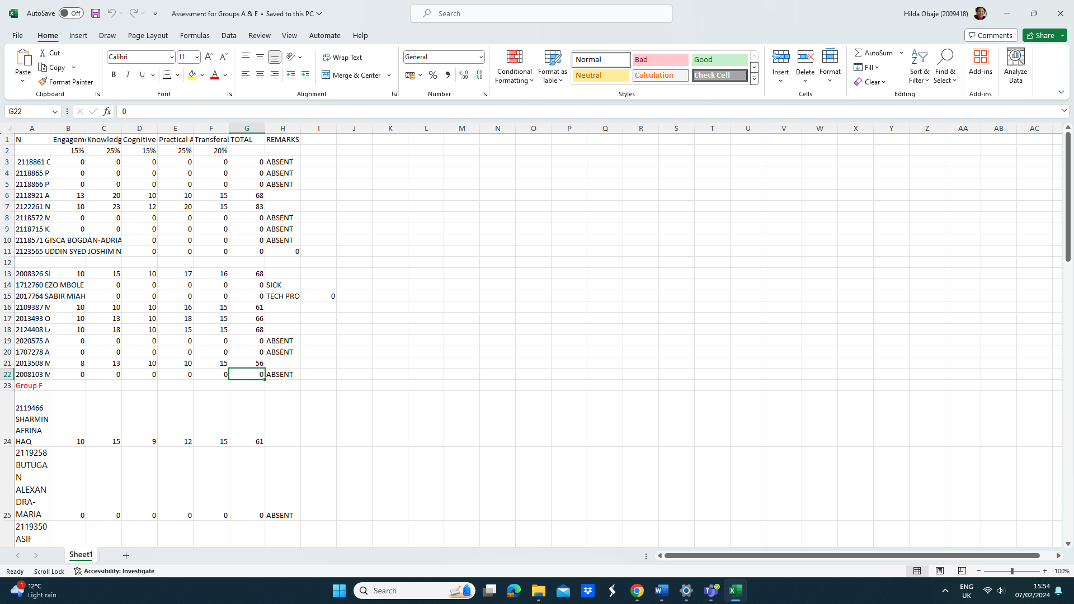

A3: Assessing and giving feedback to Learners.

Over the years, I have adopted different feedback strategies and activities to improve learning experiences. In this section, I will demonstrate the appropriateness of some feedback activities I have adopted in the learning experience of the MBA dissertations I have supervised. The primary tasks of the supervisor were to provide advice and guidance to the students to choose appropriate topic, resources, timescale, ethical considerations and produce standard dissertations worthy of level 7. However, for me to support the students to produce good high-quality dissertations, I have encouraged them to write drafts on which I gave feedback. The paragraphs that follow contain the details of the types of feedback I adopted to help my students scaffold in their learning experience.

Extant literature on feedback have emphasised that effective research-informed feedback in higher education should be the shared responsibilities of both teachers and students, and students should be given the opportunity to seek feedback, do self-assessment and make sense of feedback (Henderson, et al., 2019; Winstone and Carless, 2019; Carless, 2022). For these reasons, my top choice feedback has been the exemplars feedback where I showed students some sample distinction and failed dissertations to enable them to self-judge their own draft dissertations and make necessary corrections. This type of feedback is a form of internal feedback, which helps students to examine the standard of other people’s work to develop their own capabilities (Tam, 2021; To, Panadero and Carless, 2022; Hawe, Lightfoot and Dixon, 2019).

Another important reason for adopting this feedback strategy is the fact that some of my students were low achievers and bombarding them with so many explanations can confuse them. This idea was also captured in the literature - cognitive load theory which has revealed that the human brain has a limited capacity and teachers are advised to give students only the needed information, if not, learning cannot take place as envisaged (Kennedy and Romig, 2021; Rahmat, (2023). Therefore, sending them some sample dissertations helped them compare their drafts to the samples, do self-assessment and make appropriate corrections. However, to avoid cognitive overload and the duplication of other people’s work, I gave only a few exemplars and adhered to Carless’ (2022, p.8) guidance such as “Design an appropriate assessment sequence, select instructive exemplars, facilitate dialogue around exemplars and Support students to use exemplars to enhance their work”.

Another types of feedback I engage in is dialogic feedback when students are given the opportunity to converse freely with the teacher about their own performance (Rao and Norton, 2020; Steen-Utheim and Wittek, 2017; Espasa, et al. 2018.). After the students submit drafts, I normally make comments on the drafts and return them, then, we converse about their performances, my comments, and the way forward. In this way, and as rightly observed in (Rao and Norton, 2020), both the student and the supervisor share interpretations, negotiate meanings, clarify interpretation and the students can constructively make sense of the feedback and improve their dissertations. I have also adopted the formative feedback strategy (discussed above) for my dissertation students. The students are given the final opportunity to submit the draft dissertation containing all the chapters, then, I used the dissertation marking guidelines provided in the module handbook to assess their draft dissertations and give them formal feedback and estimated scores. They made the final corrections and submitted their dissertations.

Depending on the circumstances, the feedback I give my students can either formal or informal. I give informal feedback after I have built a rapport with the students, especially outside of the usual meeting time; at other times, I give formal feedback, which is always planned and systematic (Meikleham and Hugo, 2020, Thomson and Trigwell, 2018).

My feedback and assessment strategies have also featured professional values (V1, V2 and V3). I have given informal feedback, outside the usual/planned meeting times in form of 1-2-1 support to cater for of students in need, including low achievers. This has improved their performances and increased student participation. In addition, I have engaged in continued scholarship as my choice of assessment approach are anchored on current trends in the literature. In the end, the students I supervised have passed with varying grades. Some of their comments are noted below:
S1 - First of all, I would like to express my deepest gratitude to my supervisor Ms. Hilda Objae, for her constant encouragement and guidance. She has walked me through all the stages of the writing of this thesis. Her effective suggestions helped me read a lot of relevant literature, which laid the foundation for the research and writing. Thanks again to Ms. Hilda Objae!
S2 - …. I am very happy to see the results. And I want to express my great gratitude for your patient and detailed guidance.

CITATIONS

Abdel Meguid, E. and Collins, M., (2017). “Students’ perceptions of lecturing approaches: traditional versus interactive teaching”, Advances in medical education and practice, pp.229-241.

Bond, M., et al., (2020). “Mapping research in student engagement and educational technology in higher education: A systematic evidence map”, International journal of educational technology in higher education, 17(1), pp.1-30.

Cañadas, L., (2023). “Contribution of formative assessment for developing teaching competences in teacher education”, European Journal of Teacher Education, 46(3), pp.516-532.

Carless, D., (2022). “From teacher transmission of information to student feedback literacy: Activating the learner role in feedback processes”, Active Learning in Higher Education, 23(2), pp.143-153.

Espasa, A., et al., (2018). “A Dialogic Feedback Index measuring key aspects of feedback processes in online learning environments”, Higher Education Research & Development, 37(3), pp.499-513.

Gálvez-López, E., (2023). “Formative feedback in a multicultural classroom: a review”, Teaching in Higher Education, pp.1-20.

Hawe, E., Lightfoot, U. and Dixon, H., (2019). “First-year students working with exemplars: Promoting self-efficacy, self-monitoring and self-regulation”, Journal of Further and Higher Education, 43(1), pp.30-44.

Hawe, E., et al., (2021). “Using rubrics and exemplars to develop students’ evaluative and productive knowledge and skill”, Journal of Further and Higher Education, 45(8), pp.1033-1047.

Henderson, M., et al., (2019). “Conditions that enable effective feedback”, Higher Education Research & Development, 38(7), pp.1401-1416.

Hollister, B., et al., (2022). “Engagement in online learning: student attitudes and behaviour during COVID-19”, In Frontiers in Education (Vol. 7, p. 851019). Frontiers Media SA.

Kennedy, M.J. and Romig, J.E., (2021). Cognitive load theory: An applied reintroduction for special and general educators”, TEACHING Exceptional Children, p.00400599211048214.

Lawson, S., Sanders, K. and Smith, L., (2015). “Commodification of the information profession: A critique of higher education under neoliberalism”, Journal of librarianship and scholarly communication, 3(1).

Meikleham, A. and Hugo, R., (2020). “Understanding informal feedback to improve online course design”, European Journal of Engineering Education, 45(1), pp.4-21.

Morris, R., Perry, T. and Wardle, L., (2021). “Formative assessment and feedback for learning in higher education: A systematic review”, Review of Education, 9(3), p.e3292.

Rahmat, N.H., (2023). Reducing Cognitive Overload in Online Academic Writing: A Case Study”, International Journal of Academic Research in Business and Social Science, 13 (2) pp. 1377 – 1391.

Rao, N. and Norton, L., (2020). Dialogic feedback: what we know and what remains to be known[Online]. Available at https://scholar.google.com/scholar?hl=en&as_sdt=0%2C5&q=Rao%2C+N.+and+Norton%2C+L.%2C+%282020%29.+%E2%80%9CDialogic+feedback%3A+what+we+know+and+what+remains+to+be+know&btnG= (Accesses 5 February 2024).

Steen-Utheim, A. and Wittek, A.L., 2017. Dialogic feedback and potentialities for student learning”, Learning, Culture and Social Interaction, 15, pp.18-30.

Short, F. and Martin, J., (2011). Presentation vs. Performance: Effects of Lecturing Style in Higher Education on Student Preference and Student Learning. Psychology teaching review, 17(2), pp.71-82.

Tam, A.C.F., (2021). “Undergraduate students’ perceptions of and responses to exemplar-based dialogic feedback”, Assessment & Evaluation in Higher Education, 46(2), pp.269-285.

Thomson, K.E. and Trigwell, K.R., (2018). “The role of informal conversations in developing university teaching?”, Studies in Higher Education, 43(9), pp.1536-1547.

To, J., Panadero, E. and Carless, D., (2022). “A systematic review of the educational uses and effects of exemplars”, Assessment & Evaluation in Higher Education, 47(8), pp.1167-1182.

Winstone, N. and Carless, D., (2019). Designing effective feedback processes in higher education: A learning-focused approach. Routledge.

SECTION FOUR: DECLARATION

Please sign and date in the box below to confirm that the application you are submitting is your own work.

Signature | Hilda Obaje
Date | 5th February 2024

Appendix 1: My reflection on the first Taught Module at UWTS Using Gibbs Reflection Circle
- Description: I was a part of a team teaching a module at the UWTSD and this was the first module I was teaching in a UK university.
- Feeling: I was very familiar with the subject areas and felt proud and happy that I was lecturing in a prestigious UK university. However, I was nervous because I speak English as second language and afraid that my teaching may not appeal to British students. My confidence was also reduced because my knowledge of using Teams was limited.
- Evaluation: I evaluated my performance every week based on professional values, areas of activities and core values. My students comprised students from different races, some of them were international students, nursing parents and working full time. Therefore, in terms of professional values, I ensure I respected all learners equally, irrespective of race and level of smartness; adopt simple English that is understood by all; and offered 1-2-1 support to those who missed classes due to family obligations, health challenge and genuine work commitments. I also kept attending staff trainings and watching the recorded lectures of the module leader to improve my teaching strategies.

In terms of core knowledge, I had kept reading around the subject areas of the module, especially, to understand the current trends. In addition, I had to request for a special training on the use of Teams features and this was granted. In terms of method of teaching, I started with presentation lecture method where I did most of the talking. I observed that some students were absent minded, others muted themselves and majority of the students refused to answer questions and interact with me and their colleagues. This became a challenge to me that I had to inquire about how to make my classed better. I watched the lectures of my senior colleagues and read literatures. It was down on me that I needed to change my teaching method from the traditional presentation lecture method to performance lecture where both teacher and students participate actively. In no time, most students became active in class.

In terms of assessment approach, for the oral presentation, I discussed the contents of the assignment with students and thought that would be enough. Surprisingly, during the presentation, some students became nervous and could not do well. When I inquired, I fathomed that if I had engaged them in mock presentations, they would have performed better. Therefore, for the essay assignment, I made sure I gave them a formative assignment to prepare them for the summative assignment.

Overall, my teaching and supporting strategies seemed excellent because I got positive informal comments from my module leader and some students. In addition, the data of the students’ summative assignments shows that I did well as most students passed the module with varying marks.
- Analysis: Based on my experience teaching this module, I had realised that my spoken English was well understood by the students. Therefore, in my next module, I should concentrate on the professional values, core knowledge and areas of activities so that I can thrive in this profession. Most importantly, I learnt to always adopt the performance lecture method instead of the presentation lecture method and give formative assignment before the summative assignment.
- Conclusion: In addition, the need to keep digging deeper in the literature around the subject areas cannot be overemphasised because some of the students are very smart. Most importantly, I must adhere to quality assurance.
- Action Plan: I should always adhere to quality assurance by implementing professional values, core values as I engage with all core areas of teaching and learning activities.

