
LCMB7003 STRATEGIC MANAGEMENT

STRATEGIC MANAGEMENT: A CASE STUDY "NETFLIX COMES TO BOLLYWOOD
STUDENT NAME: Bhargava Sai Chedipothala
STUDENT ID: 2116942
LECTURER NAME: GLADIUS KOLUTHUNGAN
Code of the Module: LCMB7003

Contents
Executive Summation 3
Introduction 4
Section A 5
Netflix History…. 5
Netflix Mission and Vision Statement. 6
Vision Statement for Netflix 6
Netflix's strategic goal 7
Netflix uses Bollywood to highlight the economic success of India. 7
Pestel analysis 8
Industry analysis 9
Porter’s 5 Forces Model 11
Section c 16
VRIO OF NETFLIX 16
Value Chain Analysis of Netflix 17
Ansoff Matrix 19
SWOT ANALYSIS 21
Conclusion: 21
Recommendation 21
References 22

Executive Summation
Organizations have traditionally produced success and growth strategies. The core of this analysis for the chosen organization is the strategic dynamics that a successful corporation must experience. A strategy process is necessary for the organization to properly finish a strategic evaluation of the key challenges it faces. This cycle starts with an organizational strategic analysis, progresses through the development of a strategy, takes into account strategic alternatives or options, and then ends with the implementation of the strategy before the cycle is compelled to repeat due to gaps found for future sustainability and growth.
To analyze the new difficulties that have evolved in the industry that are pertinent to the strategic management strategy Netflix has chosen to seek its competitive advantage, the focus of this paper is based on Netflix (the selected case study) and the environment in which it operates. Additionally, pertinent concepts and techniques will be used, and recommendations based on the results of the report will be made.

Introduction
Shaping organizational strategic management processes, as well as cutting-edge strategic thinking and practices that promote organizational performance in the cutthroat commercial environment, are crucial. Understanding how the organization's internal and external surroundings interact, as well as how the amount of competition in the market influences its strategy, is essential. culminating in the execution of a plan for the organization's expansion and success.
The purpose of the research is to discover and evaluate Netflix's strategic decisions so that the company may implement its plan while utilizing the proper theories, models, procedures, and concepts. To achieve this, environmental approaches like PESTEL analysis and Porte's Five Forces will be carefully analyzed to identify opportunities and dangers for the organization in the internal, external, and industry environments of Netflix (Value Chain analysis and VRIO analysis). Since research has proven that every organization needs strategy management to get a competitive edge in the market for electric vehicles, this article covers Netflix's strategic decision among the possibilities available for carrying out the option that was picked.
The first part of this study will look at Netflix's corporate history, including details on the company's founding date, significant figures, financial status, and operational environment. This part will also discuss the business's mission, vision, and purpose in addition to its successes in terms of strategy. The external (macro) environmental study of Netflix uses the PESTLE technique in Section 2 to uncover environmental opportunities and hazards. Additionally, Porter's Five Forces industry study that was used to evaluate the sector's competitiveness is included in this section.
The VRIO model and Value Chain model are used in the third segment to analyze internal variables (microanalysis) to assess resources and capabilities and pinpoint internal strengths and weaknesses. Based on the outcomes of the environmental investigation, this phase will be concluded with a SWOT analysis and also Ansoff matrix. The last section will cover various ideas Netflix may employ to get a competitive edge in the car industry.

Section A

Netflix History….
Netflix subscribers receive monthly access to a vast variety of movies and TV series through the company's online streaming video services. Netflix is streamable on smartphones, tablets, desktop computers, and smart TVs. Reed Hastings and Marc Randolph founded Netflix Inc., a US streaming service and production company, in Los Gatos, California. The company's OTT television service, which allows users to watch movies and TV programmes, generates the majority of its revenue. Additionally, users may access regional films and TV series (Statista, 2018). There were 151 million paying Netflix subscribers in the US as of September 2019, and 60 million of them had previously received a bill. Around 6.55 million people's internet records have been looked at (Netflix, 2020a). According to US sanctions, it is forbidden to be delivered to several nations, including Iran, China (by local law), North Korea, Syria, and Crimea. Brazil, South Korea, India, Japan, the Netherlands, and South Korea are just a few of the nations where it operates. membership in the American Motion Picture Association (MPAA). Netflix accomplished a lot of milestones and achieved significant advancements between 1997 and 2019. Netflix 2020b Figure 3. Netflix was said to account for more than 15% of Internet downlink traffic. Additionally, it controlled 26.58% of the global streaming video market. The majority of the 58% of downstream Internet traffic that streaming video may have generated was due to this. The most notable impact may be seen in video streaming, which accounts for 57.69% of all traffic in the global application category. However, it only represented 2.4% of the social mobile network's overall mobile application traffic share. 2019 (Sandvine).

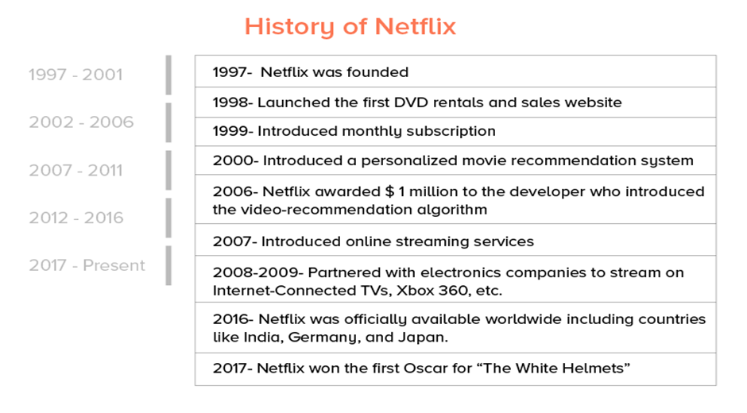
Source: (Saxena, 2022)

Netflix Mission and Vision Statement.
The stated purpose of Netflix Inc. is to "entertain the world." The company's role as a provider of on-demand movie streaming services serves as the cornerstone of this mission statement. Because of this, the company's business purpose places a major emphasis on the entertainment sector in line with its mission statement. The business is successful because it satisfies the demands and preferences of its customers regarding the media they access. The guiding principles included in Netflix's company mission statement are as follows::
- Entertainment
- Wide-reaching scale
The corporate objective of Netflix is pretty explicit. The purpose of the organization is expressly stated in the first objective of Netflix's corporate mission statement. However, this industry category typically includes live events, performance art, television shows, and movies. As a result, even while it outlines potential strategic objectives for the company's future, this section of the mission statement may inadvertently provide a hazy impression of how Netflix does business. Consider the claim that the company's "main purpose is to build our streaming subscription business," for example. Netflix's considerable competitive advantage, daring expansion objectives, and company mission are all tied to this core business plan. For instance, if the general public is to be sufficiently delighted, a rise in the global membership of the streaming-movie sector is essential. The company's second business goal is to increase the number of Netflix subscribers. Netflix has altered the organizational structure of its company to provide online services to a variety of clients and markets due to its extensive global reach. The mission statement of the on-demand video streaming corporation lists global expansion as one of its top priorities.
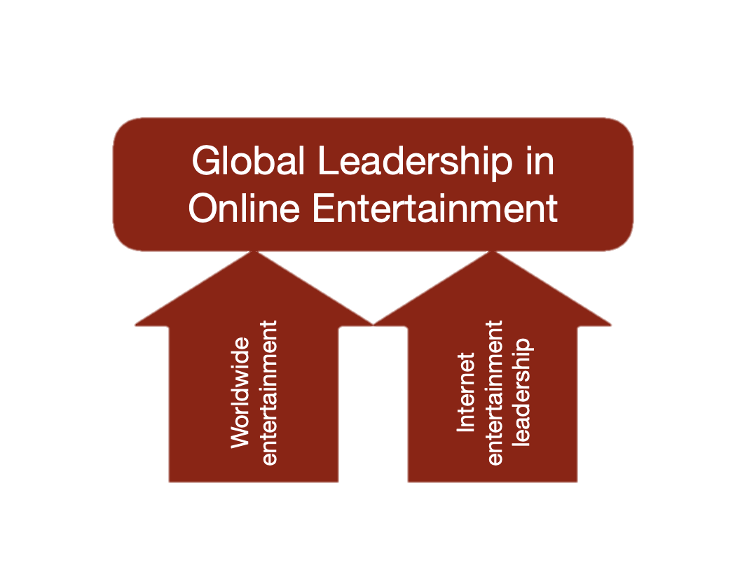
a visual portrayal of Netflix's business vision and goal, demonstrating its management in the world of online entertainment. (Image: Rancord.org)

Vision Statement for Netflix
to "remain one of the top firms in the digital entertainment age," in the words of Netflix Inc. The organization's strategy objective to outperform the competition while taking into account significant companies like Amazon and Walmart is highlighted by this vision statement. It adheres to the business mission statement. One of Netflix's objectives, according to a number of its official publications, is to "remain leading by producing a terrific entertainment experience." Given these elements, the following guiding principles are highlighted in Netflix's corporate vision statement.:
- Ongoing leadership
- Internet
- Entertainment
The strategic management of the company claims that this objective has already been met. In a prior version of its corporate vision statement, Netflix made an effort to establish itself as a market leader. To preserve its position as a leader and its operational performance while reaching the objectives of the corporate vision, the organization must be effective. The word "Internet" emphasizes how important online media is to how businesses work in the company's vision statement. Similar to how the company's mission statement links to its function as an entertainment organization, Netflix's corporate vision does as well. Because it motivates staff to support the company's ongoing growth and carry out its mission statement by guaranteeing customer happiness and industry leadership, Netflix's organizational culture is crucial.

Netflix's strategic goal
The main goal of Netflix's strategy is to make the most of its superior operational efficiency and affordable information technology. To expand its streaming business internationally, the corporation needs to invest heavily in marketing. Based on Netflix's business strategy, these strategies are designed to save expenses while expanding into new markets. The business model of the internet organization incorporates strategic management assistance for the improvement and globalization of information technology. Implementing these strategic consequences is the responsibility of operational management at Netflix Inc. They make sure that all operational areas operate in unison to support the ambitious development goals, improve the business model, and further the overall strategy for competitive advantage.
Due to its business approach and competitive edge, the company is unaffected by challenges from Walmart, Amazon, Google, Apple, HBO, Disney, and other significant corporations. Because of its aggressive expansion plans, Netflix can expand while remaining competitive. For the competitive advantages of the organization to be operational in the real world, these growth plans must be in line with the overall strategy and business model of the company. (MOORE, 2019)

Netflix uses Bollywood to highlight the economic success of India.
Due to the success of its American original content, such as "House of Cards," "Orange is the New Black," and "Stranger Things," Netflix counts 125 million members worldwide.
It has recognized the necessity of offering regional programming, like other American entertainment firms, to lure viewers from some of the important developing nations that are expected to drive development over the next ten years.
The Hindi thriller "Sacred Games" had its international premiere less than a month after "Lust Stories." It did so in the middle of a power battle over 21st Century Fox Inc. FOXA.O between Walt Disney Co. DIS.N and Comcast Corp. CMCSA.O.
Netflix and Amazon have exposed younger Indians to Western aesthetics and morals; in "Lust Stories" and "Sacred Games," these components are mixed with the significant local film industry.
Netflix has said that it will expand its $8 billion investment in original content this year to preserve its dominance in the global streaming industry. According to the most current data available, the business's international streaming revenue climbed by over 58 percent in 2017. India is at the center of that growth as accessing China's highly restricted market is challenging. Netflix has three more original programs slated for release this year compared to Amazon's predicted ten, even though both firms have been vying for some of the best stand-up comedians in the nation for specials.
Bollywood actor Saif Ali Khan plays a policeman with 25 days to thwart a terrorist threat to Mumbai in the action-packed police procedural "Sacred Games," which is well-known to viewers outside of Bollywood. It is helmed by a seasoned veteran of the Bollywood business Anurag Kashyap and stars Nawazuddin Siddiqui and Radhika Apte.
In the movie "Sacred Games," police officer Sartaj Singh is seen getting an unexpected call that helps him catch notorious criminal Ganesh Gaitonde.
As the story develops, the stakes of the game rise substantially from what they once appeared to be.

About 250 specially invited Netflix fans and celebrities were met by the movie's cast and directors, all renowned veterans of India's enormous Bollywood film system, outside Bengaluru's Forum Mall for the premiere.

Pestel analysis
Both large global organizations and smaller businesses like Netflix Svod carefully evaluate political factors when making investment decisions. The political climate and other variables influence both corporate spending and long-term viability. Political considerations include things like the political system in place, democratic institutions, the chance of conflict, the potential for a military coup, the economy's adherence to the rule of law, etc.
Political
• Politically, government rules have a significant impact on the SVOD industry. According to the Indian government, there are no intentions to restrict internet content.
• Legislative Techniques In the different markets it serves, SVOD faces a range of difficulties.
• Local government has a big impact on the rules and legislation that regulate how the industry operates.
• Indians are more politically savvy in general. There have sometimes been grievances, most prominently with one of the episodes. affecting governmental issues.
Economical
• Compared to the US, India has a lesser purchasing power. In India, a family's average monthly income is 51.255 USD, compared to 40005 USD in the US. Many SVOD companies find it difficult to charge as much as they do in the US.
• Growing socioeconomic inequality will have a detrimental impact on consumer attitudes and purchasing behaviors.
• Given that the typical Netflix cast costs $10.55 but the average US movie ticket costs $8.975, there is another consideration. A cinema ticket in India typically costs $1.55, yet a month's worth of Internet access costs $95.
• Currency rate: Svad investment plans may be impacted by the short- and long-term implications of changing currency rates.
Social
• Preferences may change depending on a person's cultural preferences. Local content will be more advantageous than other content.
• Toto should make an effort to teach local staff members who are knowledgeable of local opinions and conventions to better serve its customers.
• drew people together and bridged cultural differences.
Technological
• Services with a slow internet connection are offered to compensate for the low broadband penetration.
• The maturity of technology is still in its infancy.
• Technology's maturity is still in its early stages.
• Giving supply chain actors more authority speeds up the development of new goods.
• SVOD is giving its channel partners more access, which generates a sizable profit share.
Environment
• The SVCD approach now prioritizes environmental factors due to increased information.
• The SVOD sector complies with regulations and meets customer expectations.
• The Paris Climate Agreement has set certain objectives for national governments.
• Operational costs are increasing as a result of potential Net Neutrality and ongoing environmental agency inspections.
• Governments are offering incentives to stimulate investment in the renewable energy sector.
Legal
Legal considerations are frequently crucial when it comes to issues like how to enter a market, how to operate a firm in a certain sector, and how to resolve interpersonal conflicts. A lot of issues, including some who want to complain and those who want the government to penalize them, will arise if the system is flawed, according to Netflix Svod.
To comply with local data laws, Netflix Svod must determine what has to be done. The degree of IP rights protection provided by the nation's legal framework should be evaluated by Netflix Svod. 2019 (EMBA Pro)

Industry analysis
The life cycle of the industry involves four phases:
- Introduction
- development
- Attract & Retain
- Scale
introduction
One method to ensure the success of an SVOD platform is to invest all of your resources in a piece of content that has a sizable and loyal fan audience. As an illustration, CBS All Access recently said that it will be extending its service to new nations as a result of the phenomenal success of Star Trek Discovery since its debut. As seen here, individuals may launch a platform with just one strong show. 2018 (Parrot Analytics)
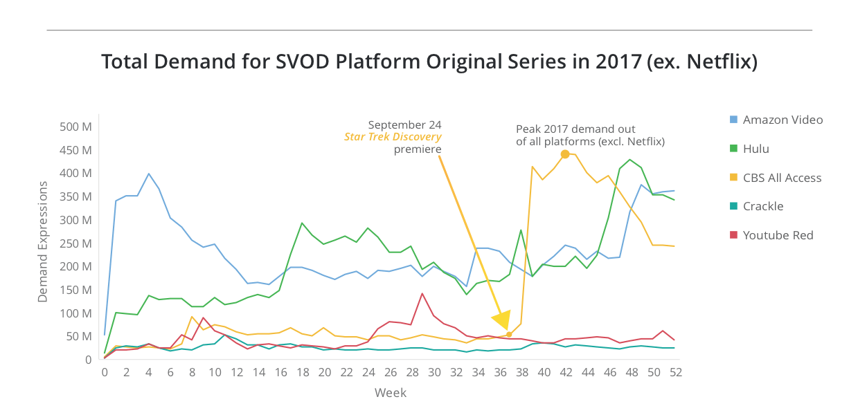
Source: (Parrot analytics, 2018)
Growth:
Once the SVOD is up and running, the average number of viewers of its original content must continue to rise. Hulu's originals are in high demand, which means that as more people get interested in them, more will join up for the site. 2018 (Parrot Analytics)
Attract and Retain
Draw in and Hold on An SVOD provider must maintain its unique content assets to keep users from leaving and attract new ones. The service must concentrate on three categories of programming: churn reducers, specialty attractors, and subscription drivers. As of 2018, Parrot Analytics
The scale of World Dominance
Following its meteoric rise to fame, Netflix goes on to rule the world: (a) Increasing the number of prprogramsike The Crown that cater to particular demographics.
By renaming and publicizing La Casa de Papel as "Money Heist," Netflix was able to transform it into a worldwide sensation. 2018 (Parrot Analytics)
Currently, Disney+ has roughly 12% of the SVOD revenue industry, coming in second to Netflix with 29% of the market. Hotstar is used by a lot more individuals because it is less expensive to sign up for. Indian-language OTT content has been purchased and sold in the past year for almost $1 billion. Indian viewers are "open to new ideas," according to Monika Shergill, vice president of programming for Netflix in India. She said that viewership of Korean material had increased by 400%, that kids' programming had increased by 100%, and that non-scripted forms from all over the world had increased by 250%. Movies that were intended for theatres but couldn't be broadcast because of the epidemic have been aired on Amazon and Disney+ Hotstar, respectively. On the other side, Netflix has aired films that weren't intended for theatrical release.
During the occasion, there was also a discussion about the Tata Sky Binge smartphone app, which mixes content from ten OTT streaming services. The CEO of Disney+ and Hotstar, Sunil Rayan, and Gandhi both expressed their joy at the theatres being reopened. They both anticipated that even though India will still be a movie-going nation, certain films would always have their worldwide premieres on digital networks. India, despitprioritizingng mobile, highlighted at APOS the rise of linked TV usage to access OTT services. This is duebecauseen compelled to stay at home, individuals were more likely to improve their equipment. 2021 (SHACKLETON).

Porter’s 5 Forces Model
According to the evaluation of the external environment, Netflix will surely have opportunities and threats. In 1979, Harvard School professor Michael Porter created Porter's five forces as a straightforward framework for assessing an organization's competitive strength and market position. Using Porter's Five Forces Framework, a study of the industry's competitive environment will be done. The following five conflicting factors are taken into account by the framework when deciding if a sector is appealing: Threats to the market include: The five primary market dynamics include new rivals, substitutes, consumer and supplier power, new competitors, and internal market competition, according to Johnson et al. (2014). A methodical way to characterize Netflix's competitive advantage for continuous, sustained profitability in the market will be provided by the five forces framework.
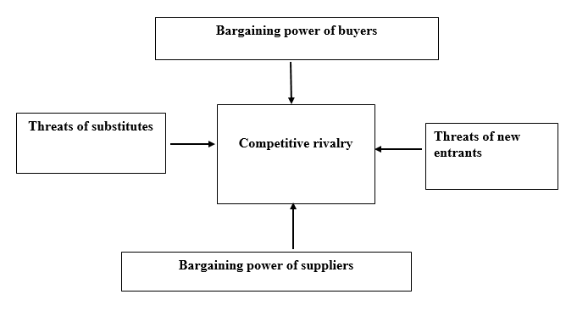
5 Porter models framework. (source: Pinterest).
Threats from New Rivals.
Threats from fresh competitors highlight how susceptible seasoned market players are to them. More people will join if the company is profitable and entry barriers are low, raising the risk for new rivals.
According to The Way Ahead, it is less probable that new Netflix rivals would open up shop in India if the following conditions are met:
• Market entry requires investments of time, money, and resources. This impact is also diminished if customers place a high value on the distinctive experience and the items are different.
• YouTube hosts Hindi video content. There won't be as much threat from new rivals if the present legal system throws certain barriers in the way of new businesses looking to enter the market. As a result, the requirement to adhere to strict, time-consuming regulatory procedures may dissuade new businesses from joining the market.
• If consumers have a high psychological barrier to switching brands and are already loyal to well-known companies, the risk will be minimal.
• The risk will be lower if consumers have a strong psychological barrier to switching brands and are already loyal to well-known enterprises.
Several new competitors would emerge if Netflix entered the Bollywood market.
• The present restrictions encourage the recruitment of new members.
• Consumers are prone to switching brands since they have little to no brand loyalty.
• Consumers are comparatively unloyal to brands and are hence open to switching.
• The response of the established market players is ineffective as a deterrent.
• The response of the current market participants is ineffective as a deterrent.
How is Netflix in India? How will it counter the danger posed by burgeoning rivals?
• The Way Ahead on Bollywood's client connection management section Netflix might increase customer loyalty. There will be higher psychological switching costs.
• The risk will be lower if consumers have a strong psychological barrier to switching brands and are already loyal to well-known enterprises.
• Netflix Bollywood To build a strong foundation for the distinction, Netflix may also participate in R&D initiatives, acquire critical user data, and provide cutting-edge products and services.
The threat of Replacement Goods or Services
Since there exist alternatives, the competitive environment is challenging for Netflix in India The Way Ahead, and other established businesses. The high risk of replacement proves that customers can satisfy their needs with alternatives from many sectors' products and services. The severity of this threat to Netflix India will depend on several factors.
The danger of alternative products or services is more prevalent when
• There is a less expensive choice that originates from a different sphere of the economy.
• The psychological effects of switching from one industry to a substitute product are negligible.
• A viable replacement at least matches The Way Ahead's performance and quality on Netflix India.
However, this only poses a slight threat to Netflix India. what will occur next and when;
• It will cost a lot of money to switch to the alternative product (due to high psychological costs or higher economic costs).
• The value that Netflix offers its members cannot be matched by any comparable service in India. How to Move Forward (in terms of quality and performance).
• The value that Netflix offers its members cannot be matched by any comparable service in India. How to Move Forward (in terms of quality and performance).
How might Netflix lessen the likelihood of substitute goods and services in India?
• By emphasizing how Netflix's given product or service is superior to the alternatives, it may reduce the danger of replacement goods or services in India.
• To entice customers to buy, it must offer a fantastic customer experience and exceptional value.
• It may raise the cost of switching by promoting loyalty.
• Not to mention that it might increase quality, optimize value, and provide a clear point of differentiation to discourage customers from using a rival product.
Competition between reputable businesses
How many competitors Netflix in India has is revealed by the battle between well-known businesses. Due to their intense competition, other Indian companies may greatly push Netflix, which might impede their ability to expand independently. Because of aggressive pricing and targeting methods employed by firms, profitability in these areas is poor.
In India, Netflix won't encounter many competitors from other firms if;
• The market is rapidly growing.
• There is a clear market leader in place.
• The items are fairly unique, and each market participant concentrates on a different subsegment.
• For consumers, switching has significant psychological and financial repercussions.
Similar to this, national Netflix companies have become more competitive as a result of recent developments. For instance, if market players deliberately diversify and focus on the same area, the company would face strong competition from other well-established enterprises. If consumers are not loyal to their current brands and switching to other brands only incurs little switching costs, there will be more severe competition. When their market shares are equal, their product offerings are identical, and their sectors are advancing slowly, competitors frequently employ aggressive techniques to overcome one another. The competition amongst already-established businesses is Netflix's primary strategic worry in India due to these and other causes.
How can Netflix manage the rivalry with other businesses in India?
Netflix in India should concentrate on the implicit needs and expectations of its users to strengthen the basis for differentiation. Switching should be more expensive since it facilitates long-term customer ties. The company must also invest in operations for research and development of new consumer categories. When adversaries periodically cooperate, both sides' needs are met. The business could also take this recommendation into account.
The Suppliers' Purchasing Power
The Porter 5 Force Model's depiction of suppliers' negotiating power accurately depicts the pressure that suppliers put on corporate organisations using a variety of strategies, such as lowering product quality, limiting product availability, or increasing pricing. Buyers pay a price when suppliers have significant negotiation power (business organizations). Strong supplier negotiating power may make it more challenging for Netflix India to expand and generate revenue, which would intensify sector competition. This industry may be more tempting due to its great profitability and increasing possibilities than others with less supplier power..
Suppliers to Netflix in India will have substantial negotiating leverage if:
• Where there are more customers, there are more providers.
• The cost of switching providers might significantly affect customers (for example, due to contractual relationships).
• The suppliers' case against Netflix in India is strengthened when there are few suppliers and a large demand for the goods they are providing.
• The competition brought about by suppliers' forward integration has harmed Netflix's standing in India.
• The suppliers' position against the company would deteriorate if Netflix India lacked the necessary training, market expertise, and price awareness.
• The suppliers' position against the company would unquestionably deteriorate if Netflix India lacked the necessary training, market expertise, and price awareness.
However, the following circumstances will weaken Netflix's Indian suppliers' negotiating position:
• The suppliers are not local.
• low switching costs
• The product lacks enough distinctiveness.
• some products can be used as substitutes.
• Netflix is extremely cost-conscious in India and is well-versed in the sector.
• Integration of the forward suppliers offers no danger.
What negotiation stance would the supplier take, according to Netflix India?
Reduced reliance on one or a limited number of suppliers could improve Netflix India's ability to defend against competitors. It will become increasingly sensitive to pricing. Long-term contracts with suppliers from many sectors help Netflix India increase the effectiveness of its supply chain while also lowering its negotiating leverage. Finally, if there is sufficient demand for the products and the company has the necessary knowledge and skills, it may be possible for Netflix India to find alternate means of supplying them. To establish its viability, a thorough cost-benefit analysis is required. Diversifying the company's product lines and redesigning its products may also aid in reducing the market impact of suppliers.
Buyer Bargaining power
Buyer negotiating power indicates the demands that customers have on businesses to deliver premium items at prices that outperform the market and with first-rate customer service. This factor directly affects Netflix India's ability to accomplish its operational objectives. A successful negotiation stance raises industry competitiveness and decreases profitability. On the other hand, when consumer power is low, the market is less competitive, which raises the likelihood that Netflix India will be successful and grow.
Buyers have more negotiation power because of the following factors:
• As the number of their Indian customer’s declines, they have more negotiation power with Netflix.
• A limited number of customers will have a similar big purchasing power to a small number of providers (commercial organizations).
• Low switching costs may provide clients greater negotiating power since they are less expensive (both financially and psychologically).
• Corporate clients are more marketable when they can integrate backward. Backward integration shows that customers may create the items themselves rather than buying them from Netflix in India.
• Customers have more negotiation power due to their high degree of market awareness, price sensitivity, and propensity to buy standardized items in mass.
• Low price sensitivity, low market knowledge, high switching costs, low customer concentration (which suggests a geographically dispersed customer base), the inability of customers to integrate backward, buying specialized goods in small quantities, and low price sensitivity are some factors that lower buyers' bargaining power.
How will Netflix in India Ahead handle the purchasing power of the customer base?
By growing and diversifying, Netflix's Indian customer base may be able to influence users' ability to make purchases. This may be done by employing strategies for product diversification, concentrating on new market segments, and introducing new products. Marketing and promotion tactics may be helpful in this regard. By embracing innovation and offering top-notch customer service, they may lose some of their negotiating strength, which might raise switching prices. These strategies may be employed by Netflix in India to strengthen its position in the market.

Section c

VRIO OF NETFLIX
Jay B. Barney created the VRIO Framework in the beginning to assess the relative value of resources to the company. Value of the Resource, Rareness of the Resource, Imitation Risk, and Organizational Competence are the letters that make up the acronym VRIO. A resource-based strategic analysis tool is VRIO. By better comprehending how resources fit into the company's broader business plan, managers at Netflix Svod may be able to employ VRIO to maintain a competitive edge.
With the use of information from the case study Netflix in India: The Way Ahead, the resource-focused VRIO analysis of Netflix Svod was completed. The foundation of resource-based strategy research is the notion that strategic resources can provide Netflix Svod a chance to maintain a competitive edge over its sector rivals. This ongoing competitive edge will help Netflix Svod maintain profitability that is above normal for the industry and fend off competition.
A company's resources may be divided into two groups: tangible resources and intangible resources. For Netflix Svod, tangible resources include material possessions like land, structures, tools, stockpiles, and money. For Netflix Svod, some examples of intangible resources are the company's management and administrative abilities, brand recognition and goodwill, intellectual property rights, copyrights, and trademarks, as well as its unique relationships with supply chain partners.
Does Netflix Svod think this resource is worthwhile? The company's financial, human, marketing, and operational resources, according to the case study's authors Tripti Ghosh Sharma, Suraj S, Mitali Srivastava, and Tarun Chandoke, are its most important assets.
Rare: "Netflix Svod" must determine if the resources it requires to function are expensive or difficult to get. If they are not hard to get by, both current market participants and new entrants will have minimal trouble acquiring them and entering the market.
Costly to Copy - In the majority of businesses, interruptions are currently a source of growing concern. One of Netflix Svod's primary differentiators is that it is difficult to imitate, according to data from Netflix in India: The Way Ahead. Competitors might replicate Netflix Svod's products on a bigger scale in one of two ways: either they develop replacement items that upend the market's existing structure, or they just copy the company's products.
organizational ability and resource management capabilities It establishes how well the business has been able to utilize the valuable, elusive, and challenging-to-replicate resources of the market. The degrees of exploitation for Netflix Svod items may be examined in two different ways. Is there still an opportunity for growth, or will the organization be unable to make the most use of its resources?
The company's leadership group and execution strategy typically have a big impact on how much labor is exploited. As a result, the level of exploitation is a reliable indicator of a company's capacity to effectively manage its human resources. A company's capacity to do activities that rely on its strategic resources changes or improves with time.
A more complex formulation of the VRIO analysis is VRIN, where "N" stands for non-substitutable. If rivals cannot come up with alternative plans to take advantage of the advantages it offers, a resource is unavoidable. In the VRIO research, the disruption risk may be included in the imitation risk.

Value Chain Analysis of Netflix
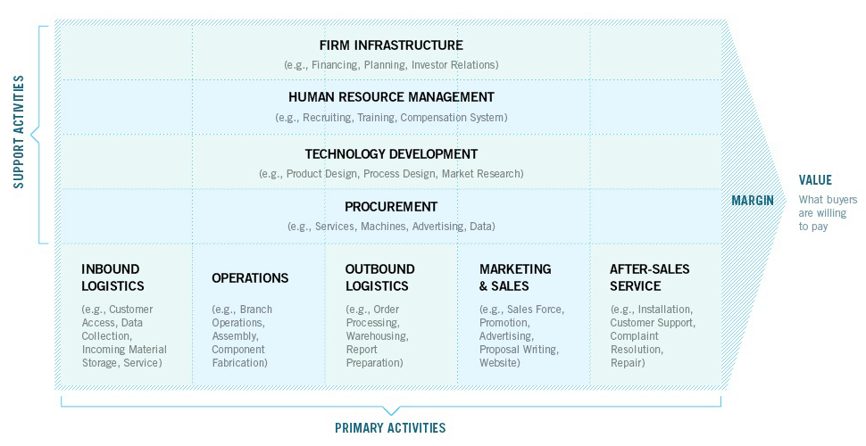
A more extensive industrial value chain, which comprises companies that make up the Netflix Svod value chain, is made up of firms that operate upstream (as suppliers), downstream (as distribution channels), or both. Every action that Netflix India's management makes must be understood in the context of that value system, and the manager must take into account any potential consequences that enhancing or omitting any activity may have on the value chain. Each person must choose how their values fit into the larger system.
The value chain graphic shows the five major categories that Netflix Svod's main activities come within.
Inbound Logistics
Inputs for the commodities are obtained, stored, and distributed as a result of Netflix Svod's actions. It could entail a digital media corporation collecting and storing client data via product storage, resource management, and architecture. Currently, outsourcing is used for the majority of Netflix Svod's inbound logistical activities.
Operations
activities that assist the production of final items by the firm. Although the topic is too broad to be covered in full in this article, one illustration is the use of consumer data to target consumers with adverts based on their usage patterns.
Outbound Logistics
To provide the completed items to channel partners and end consumers, Netflix Svod completes several operations. Outbound logistics duties include scheduling, distributing, warehousing, and distribution in addition to processing orders for wholesalers and retailers.
Marketing and Sales
Netflix Svod is taking these actions to provide customers options when purchasing a company's goods. Some of these responsibilities include selecting a price strategy, supervising the sales force, and managing advertising and promotion, and marketing.
Services
To be used efficiently, the equipment requires upkeep and care after purchase, according to Netflix Svod. A few of the services provided by Netflix Svod include post-sale maintenance, front- and back-end software alignment, installation services, component supply, and training.
The company's primary activities are assisted by Netflix Svod's support functions, as the name suggests. Porter categorized the auxiliary activities into four major groups. Each of these groups may be further broken down into a range of distinctive value-creating actions that are exclusive to the industry that Netflix Svod works in. The following are the four most common support roles:
Firm Infrastructure
The infrastructure of the Netflix Svod firm is supported by several processes, including planning, legal advice, quality control, finance and accounting, and general administration.
Even though the operations' scopes varied because of Netflix Svod's diversity even inside its organization, they all support the whole value chain. Quality control, financial, and legal compliance are handled by the other business divisions, although Netflix Svod is in charge of the organization's overall budget and strategy.
Manage Human Resources
In a world where everyone desires to be a learning organization, each company's ability to succeed rests on its ability to manage its people resources effectively. The HRM support operations include hiring, training & development, selection, remuneration, and people planning at both the corporate and business unit levels.
Although it has an impact on each company's capacity to compete, human resource management is crucial in specific industries. For instance, in consulting organisations, human resources are the primary source of competitive advantage.
Technological advancement
Nowadays, practically all organizational operations are supported by technologyThe development of technology has become a source of competitive advantage in the technology sector. Field testing, feature design, component design, technology selection, and process engineering are a some of the technical development tasks that Netflix Svod could do.
Activities Related to Procurement at Netflix Svod
The value chain uses inputs, which are purchased as part of the procurement procedures of Netflix Svod. Real purchase inputs are not included. Inputs that are purchased include things like raw materials, supplies, tools, machinery, lab equipment, office equipment, and structures.
For things like procedures, vendor management, information systems, supply chain partner qualification criteria, and ongoing performance review, procurement uses technology, much like all other value chain operations.
When examining Netflix in India, stay away from the following measures and KPIs:
Growth or market share is another inaccurate goal since organizations often prioritize gaining market share over profitability.
Sales growth is a bad objective for value chain research since it is simple to increase sales by drastically reducing expenses, as many managers are aware.
Value chain assessments that confuse shareholder value with stock price are bound to fail. Despite the preference of the top management for a competitive strategy, it is more advantageous in the long run and more successful in the short to medium term.

Ansoff Matrix
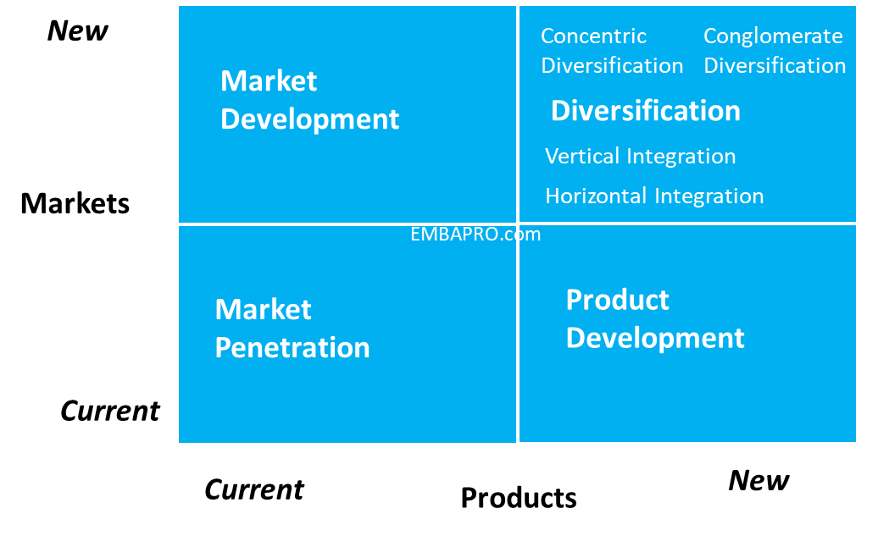

A company will implement a market penetration plan when it recognises a chance to expand its market share in the existing industry. It combines a sales-driven approach with a contemporary environment. Some strategies to expand market penetration include a better dealer network, more sales contact points, direct customer involvement, a higher customer lifetime value, a larger basket share of overall customer spending, etc. The Ansoff Matrix is a method for examining competitive strategy. Ansoff's matrix may be used by Netflix Svod management to better understand market entry, market growth, product diversification, and product development efforts in order to achieve more sustainable profitability.
The goal of the Netflix Svod market development plan is to increase the markets and distribution channels for the business's present goods. This can entail expanding into fresh local or foreign markets, teaming up with businesses that complement one another to boost sales of present items, etc. In a notable example of market growth, Tesla is constructing charging stations at exact distances to enable consumers in new areas to utilize its cars.
Product development is the process by which Netflix Svod creates new products or adds new features to existing ones. Microsoft is one of the most well-known companies that uses product development methodologies. Microsoft updates its Windows Office programme every so often. Even if the corporation maintains developing improved versions of the items to meet market expectations, the consumers and marketplaces for the products mostly remain the same.
Netflix When a product and a market are both unexplored for the company, Svod may employ diversification techniques. When a business sees an opportunity, whether it's in a related field or something completely different, it diversifies its operations. Think about Microsoft's Xbox debut in the video gaming market. The company had to develop a completely different distribution and revenue model than the one it was using for its Enterprise Productivity division because the product and the consumer market were both new to the company.
"Horizontal diversification" refers to the introduction of novel, technologically unconnected products to the market.
If a business wants to ensure supply or the inclusion of its products in completed goods, it may decide to enter the supplier's or customer's company. Vertical integration is the procedure in the issue.
The introduction of new, closely related products into (new) markets is known as concentrated diversification.

Conglomerate diversification is the process of introducing entirely new, technologically unrelated items into new markets.
SWOT ANALYSIS: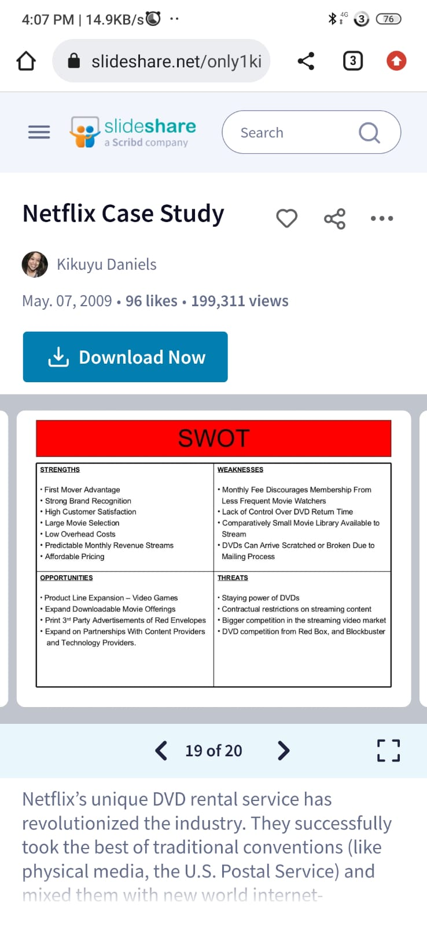

Conclusion:
This study was able to examine and analyze Netflix's strategic intents and basic problems in Bollywood with the use of several analytical tools and frameworks. It was essential to first gain a broad grasp of Netflix's internal operations by researching the company's mission, vision, and purpose. The strategic objectives of the company and how Netflix's success as an innovative organization was influenced by its performance were the main topics of the study. The external environment research was conducted using PESTEL analysis, which gave insight into the environmental factors affecting the organization. The industry is then studied using Porter's Five Forces, Value Chain, and VRIO frameworks, along with a thorough industry analysis. A SWOT analysis was performed as a result of these conclusions to learn more about Netflix's relative strengths and weaknesses, prospective opportunities and threats, and other factors.
Recommendation:
For Netflix to reach 100 million members, India must expand. The biggest threat comes from the intense rivalry that Netflix faces from its many competitors, which is becoming worse by the day. In all respects, including the high cost, the exclusion of rival streaming services, and the singular concentration on streaming services, we advised Netflix to maintain its original strategy.
If Netflix wants to boost revenue and reach its goal of 100 million Indian subscribers, it must include adverts in its streaming service. Because Indians are so price-conscious, the company will be able to provide streaming services to those customers at a lesser cost by doing this.
The following are the main challenges Netflix may have when incorporating advertisements into its services:
might irritate the reader and lessen the article's caliber.
It will be difficult to defend the addition of ads to Netflix's staff, consumers, and content creators because it signifies a strategic shift for the corporation.
Services can operate more slowly as a result.
It is challenging to convince users to accept this change in streaming services.

References
Anonymus. (2022). porter5forcesanalysis. Online: EMBA PRO.
Balakrishnan, M. (2022). The In-depth SWOT Analysis of Netflix- An Explorative Study. online: Selectra.in.
BHUSHAN, N. (2018). Netflix CEO Reed Hastings on Why the “Next 100 Million” Subscribers Will Be “Coming From India”. Los Angeles: hollywoodreporter.
Bstrategy insight. (2021). Netflix Value Chain Analysis. online: www.bstrategyinsights.com.
Business Today.IN. (2022, January 22). Netflix's lack of success in India 'frustrating', says cofounder Reed Hastings. online: Business Today.IN.
cuofano, G. (2022). pestel-analysis. online: FourWeekMBA.
Don Sull, S. T. (2021, /january 30). Netflix Goes to Bollywood. Retrieved from https://www.thecasecentre.org: https://www.thecasecentre.org/caseSpotlight/2022/Netflix#tab-generic-thecase-tab
EdrawMax. (2021, December 12). Netflix Value Chain Analysis. Retrieved from https://www.edrawmax.com: https://www.edrawmax.com/article/netflix-value-chain-analysis.html
EMBA Pro. (2019). MBA PESTEL : Netflix India PESTEL / PEST Analysis. Online: EMBA Pro.
Grant, R. M. (2015). Contemporary Strategy Analysis: Text and Cases Edition, 9th Edition. London: Wiley.
Harvey, M. (2020, September 01). Netflix-in-India-The-Way-Ahead-Ansoff-Matrix. Retrieved from https://www.essay48.com: https://www.essay48.com/case/8031-Netflix-in-India-The-Way-Ahead-Ansoff-Matrix
IBS America. (2020). Porter’s Competitive Strategy:

