

Assessment 1 – Reading Task Template
PART 1: Upload your photo of your A3 in-class notes here:
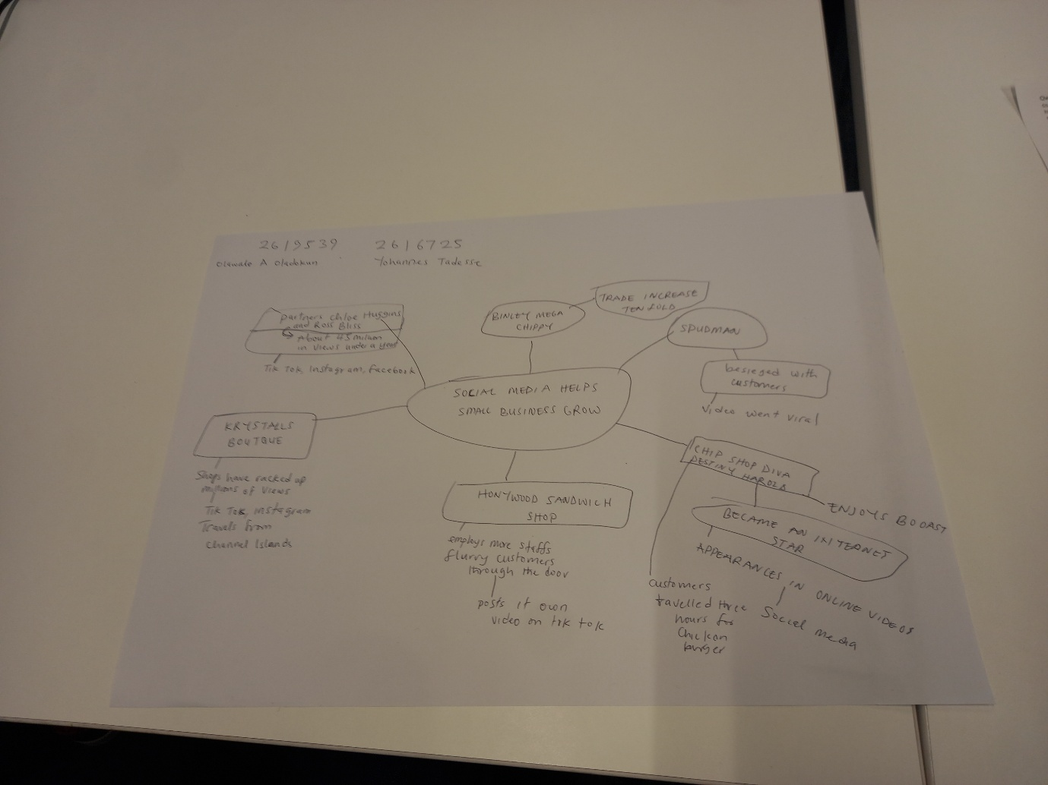

PART 2:
- Answer every question below in 1-3 full sentences.
- Use your own words. Do not use generative AI to answer these questions.
- Include a specific detail from the text when asked.
REMINDER
- The main idea is the overall message of the whole text.
- A key point helps to explain the main idea.
- A specific detail or example from the text shows that the key point is true.

- What is the main idea of the whole text?
The whole message states that with the aid of social media small business can increase their reach and their target audience which in turn increases their customer base.

- What is one key point that supports the main idea, and which specific example from the text shows this?
A specific example would be biney mega chipey. They were a small business until they used the power of social media and went viral.

- What is a different key point that supports the main idea, and which specific example from the text shows this?
A different example would be spudman and how they used the same example of posting on social media and increased their customer base.

- Which part of the text do you think is most important, and why?
Social media increasing the number of eyes on their companies is the most important as it increases the amount of customers that come to the shop.

Reflection:
- What did you find difficult in this task (including in-class components), and why was it difficult?
I found it difficult to make the mind map as it was the first time I have done that.

- What helped you with this difficulty, and how did it help you?
A discussion with my classmate and my other group helped me understand how to create a mindmap.

