The major environmental factors affecting organisations

Jodie Barnett

Module code: BMHR7012

Student number: 1905258

Word count: 1560 (max 1600 words)

Two PESTLE factors affecting NPTCBC for online forum
- Sociological
Neath Port Talbot County Borough Council (NPTCBC) is a Local Authority which offers a wide range of public services and is the largest employer within Neath Port Talbot, with nearly 6,400 employees. NPTCBC is faced with many social concerns leading its corporate strategic direction, with one of the biggest challenges in today’s society being mental health related illnesses.
With the swing in our culture, both socially and within the workplace, there are a mass of factors which could be contributing to this, including the aftermath of the COVID-19 pandemic which has seen a shift in lifestyle factors with concerns in job security and predominantly, the cost of living crisis.
(MacRae, 2021) argues that the pandemic has had an impact on workers’ mental and physical health.
(Mind, 2023a) emphasises the link between money and mental health stating that money problems can trigger emotions of both anxiety and panic as well as needing money for the basic necessities in life to help stay well. Sarah Marsh (2023) highlights that recent figures from the Financial Conduct Authority shows that the cost of living crisis has accelerated a 25% rise in borrowing to support the UK public with household bills.
Neath Port Talbot (NPT) is regarded as one of the highly deprived areas in Wales according to (Welsh Government, 2019), seen as a contributing factor to mental health issues with death from suicide being a key determinant with rates far worse than the average in Wales (Public Health Wales, 2022).
(CIPD, 2023a) advises that mental health issues will affect one in four people at some point in their lives and in turn, will have a substantial impact on both employee well-being and is a major cause of long-term absence from work. (Mind, 2023b) is a charity that supports those experiencing mental health and highlights the importance of staff wellbeing and the organisational benefits in supporting the mental health of the workforce.
(ACAS, 2023) reiterates the law on mental health and that employers have a duty of care and must therefore, do all they reasonably can to support an employees’ health and wellbeing.
In the financial year of 2021/2022, NPTCBC reported that on average sickness absence levels amongst the workforce was 12.1 days with mental health related absences being the number two reason (COVID-19 being number one). Making NPTCBC one of the highest Council’s in Wales and above the Welsh average of 11.2 days (figure 1).
Sickness absence endures costs and with NPTCBC being a public sector organisation, they can be very much criticised for how they utilises public monies.
NPTCBC have a positive approach in supporting those presented with mental health which includes the operational occupational health service. This service offers an advisory and consultancy support for employees aiming to better health and wellbeing to able them to carry out their jobs effectively. The service has seen an increase in referrals disclosing mental health concerns since the start of the pandemic in 2020. The number of referrals made that related to mental health in 2016 to 2019 were 357, followed by 434 for 2020 to 2023.
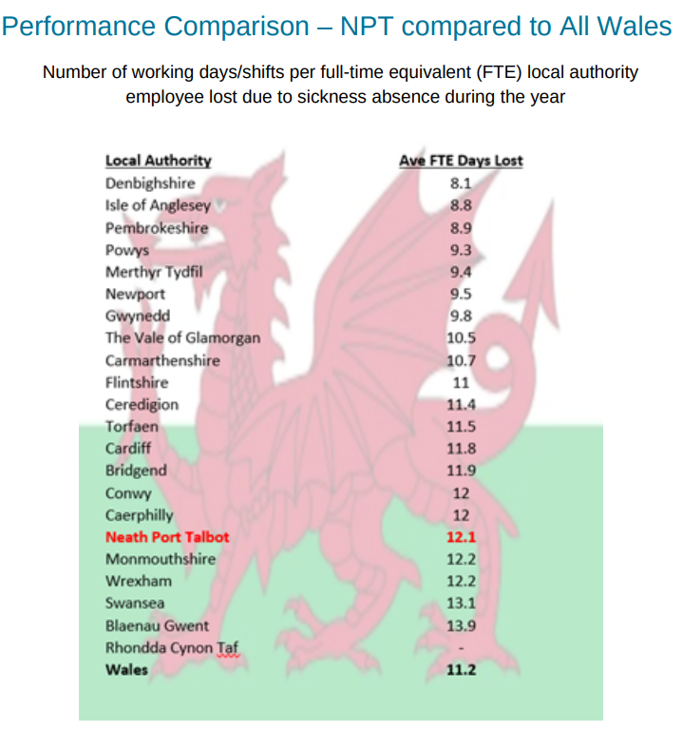
(Figure 1: Workforce Information report: Quarter 4 2021/2022)
Various campaigns have been launched including the ‘Let’s Talk, Check-In’ initiative developed in recognition that the majority of their workforce are now ‘lone’ working from home. They have also pledged to work in partnership with Time to Change Wales.
NPTCBCs Corporate Plan covers the period 2022 – 2027 (NPTCBC, 2022a) and sets out the Council’s approach to recovery including the aftermath of the COVID-19 pandemic.
This plan aligns with their Future of Work Strategy - Strategic Workforce Plan 2022 – 2027 (NPTCBC, 2022b). This plan highlights their well-being objectives, which includes a priority to create a safe workplace in supporting the health and well-being of its employees through the development of a mental health strategy in partnership with Time to Change Wales (figure 2).
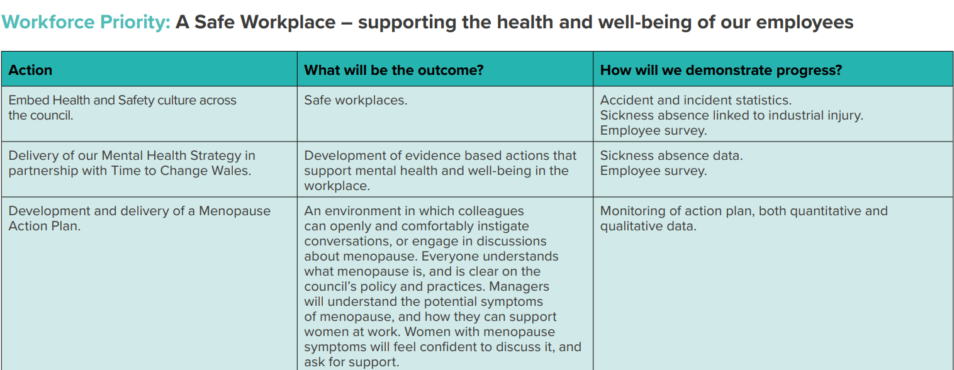
(Figure 2: The Future of Work Strategy: Strategic Workforce Plan 2022-2027)
The HR function holds a pivotal role in promoting both employee well-being and engagement across the Council, whilst tackling the stigma associated with mental health. NPTCBC had previously been known to have a shortfall when it comes to communicating to its staff with (Debra Clark, 2023) outlining that communication is key to promoting an organisation’s wellbeing initiatives and support, otherwise it is worthless if employees do not know about it.
(MacRae, 2021) argues that employers should prioritise work engagement, which is seen as a ‘positive, fulfilling work-related state of mind’. Work engagement can be seen to increase work energy levels as well as giving them a feeling of purpose in a work sense.
(Bhatt, et al, 2023) reiterates that organisations prioritising workforce well-being, may increase productivity and innovation, as well as enhancing recruitment and retention and strengthening the employer brand values.
It is noticeable that there is already some positive work being undertaken from a people management perspective, but the Council needs to keep going in the right direction to support those struggling with mental health illnesses, whilst promoting NPTCBC as a safe workplace through effective communication.

- Economic
With NPTCBC being a local authority organisation, they are very much reliant on Welsh Government funding to support the deliverance of its services throughout the local community. NPTCBC provides services to over 140,000 residents, making it the 9th largest council in Wales (ONS, 2021)
(Welsh Government, 2023) are facing significant financial pressures which it is led to believe will have an impact on their UK Spring Budget in March 2024, estimating that this will be £900m lower than the budget that was set by the UK Government at the last spending review in 2021. They have highlighted that this will be the toughest financial situation they have faced since devolution.
This is largely due to record levels of inflation the country is currently faced with, with (BBC, 2023) emphasising that many factors are causative to high inflation, including the upsurge in energy costs, lack of goods and materials as well as the consequence of COVID-19.
With this in mind, NPTCBC is set for a significant reduction in their settlement funding from Welsh Government as it prepares its budget for the financial year of 2024/2025. At this moment in time, the Council is not yet in a position to fully know the budget deficit for next year as they are awaiting details of funding from the Welsh Government. However, it is clear that the Council is facing an increase in its costs of £16m relating to pay and inflation and £4.7m relating to service pressures.
It is inevitable that the Council will be faced with momentous budget pressures, which could potentially result in cuts across both services and their workforce. The Council is already challenged with the prospect of workforce strikes due to national pay disputes, supported by trade unions.
The aftermath of the COVID-19 pandemic has already seen a rise in both unemployment and economic inactivity rates, with the later set at 26.6% of the population, emphasising that NPT is on average higher than across Wales and the UK (ONS, 2023)
The Council has very much set a precedence in avoiding compulsory redundancies to date and with the possibility of them having to consider cuts to its workforce to reduce costs, HR will play a pivotal role in ensuring that this is adopted through the promotion of their redeployment strategy to ensure that unemployment across the workforce is kept to a minimum.
It is clear that with the uncertainty of job losses, HR will need to ensure that both employee well-being and communication is at the forefront of their agenda. Dewhurst and Fitzpatrick (2022, p. 144) stress that effectively communicating to employees is not only crucial to improving engagement, but has a positive impact on the organisational culture and overall performance.
The Council also operates a voluntary redundancy scheme, which historically has been very favourable, especially for those employees considering retirement. In the last two years, a total of 22 employees left the organisation through the voluntary redundancy application process, generating a total savings in salary costs of £1,209.351. This information was provided using the Councils data reporting tool (SAP Business Objects, 2023)
The Council’s redeployment process has also been highly successful in recent years with employees being regarded as ‘at risk’ given the best opportunity to apply for any vacancies through their prior consideration process in line with their recruitment and selection policy. This policy emphasises the commitment of the Council in finding suitable alternative roles for its workforce.
The Council is also committed to upskilling their workforce, using their internal training and development programmes through insight of their Strategic Workforce Plan 2022 – 2027, which is very much aligned with the (CIPD, 2023b) workforce planning ethos that an organisation will thrive if they have “the right people, with the right skills, in the right roles, with the right shape, in the right place, at the right time and the right cost”
It is clear that the Council will need to be ready to embrace their budgetary challenges over the next few months and leading into the new financial year, but with focus very much on their people management strategy in not only ensuring that workforce cuts are kept to a minimum, but that employee wellbeing is affiliated through regular communication and employee voice on the Council’s budget.

References
ACAS (2023) Supporting mental health at work – understanding the law. Available at: Understanding the law - Supporting mental health at work - Acas (Accessed 29 October 2023)
BBC (2023) What is the UK inflation rate and why is it so high? Available at: What is the UK inflation rate and why is it so high? - BBC News (Accessed: 27 October 2023)
Bhatt, et al, (2023) The workforce well-being imperative: paving the way for human sustainability in workplace culture, UK: Deloitte Insights.
CIPD (2023a) Mental health in the workplace. Available at: Mental health in the workplace | CIPD (Accessed: 21 October 2023).
CIPD (2023b) CIPD launches practical guidance on workforce planning. Available at: CIPD launches practical guidance on workforce planning | CIPD (Accessed: 27 October 2023)
Clark, D. (2023) How to ensure wellbeing communications are engaging. Available at: How to ensure employee wellbeing communications are engaging (personneltoday.com) (Accessed: 27 October 2023)
Dewhurst, S. and Fitzpatrick, L. (2022). Successful Employee Communications: A Practitioner's Guide to Tools, Models and Best Practice for Internal Communication. United Kingdom: Kogan Page.
MacRae, I. (2021) What did 2020 teach us about employee wellbeing? Available at: What did 2020 teach us about employee wellbeing? | CIPD (Accessed: 25 October 2023)
Marsh, S. (2023) ‘We had no money’: desperate UK public increasingly turning to pawnbrokers to make ends meet. Available at: ‘We had no money’: desperate UK public increasingly turning to pawnbrokers to make ends meet | Borrowing & debt | The Guardian (Accessed: 22 October 2023).
Mind (2023a) The link between money and mental health. Available at: The link between money and mental health - Mind (Accessed: 22 October 2023).
Mind (2023b) Taking care of your staff’s mental health. Available at: Taking care of your staff's mental health | Mind - Mind (Accessed: 21 October 2023).
NPTCBC (2022a) Corporate Plan 2022-2027. Available at: Corporate plan 2022-2027 – Neath Port Talbot Council (npt.gov.uk) (Accessed: 21 October 2023).
NPTCBC (2022b) The Future of Work Strategy – Strategic Workforce Plan 2022-2027. Available at: NPT Connect - The Future of Work Strategy - Strategic Workforce Plan 2022-2027.pdf - Default (sharepoint.com) (Accessed: 21 October 2023).
ONS (2021) Population of Wales in 2021, by unitary authority. Available at: Population of Wales 2021, by region | Statista (Accessed: 26 October 2023)
ONS (2023) Employment, unemployment and economic inactivity in Neath Port Talbot. Available at: Neath Port Talbot's employment, unemployment and economic inactivity - ONS (Accessed: 21 October 2023).
Public Health Wales (2022) A picture of health in Neath Port Talbot. Available at: phw.nhs.wales/services-and-teams/observatory/data-and-analysis/publication-documents/pictures-of-health-for-local-authorities-wales-centre-for-health/wchcommunityprofiles-neathporttalbot-pdf/ (Accessed: 21 October 2023).
SAP Business Objects (2023) (Version 14.3.2.4272.4) [Computer program]. Available at: https://bi4-c9.webitrent.com/BOE/BI (Accessed: 27 October 2023)
Welsh Government (2019) Welsh index of Multiple Deprivation (WIMD) 2019. Available at: Welsh Index of Multiple Deprivation (WIMD) 2019: results report (gov.wales) (Accessed: 21 October 2023).
Welsh Government (2023) Written Statement: Update about Budget 2023-24. Available at: Written Statement: Update about Budget 2023-24 (9 August 2023) | GOV.WALES (Accessed: 27 October 2023)

