

Source: https://twitter.com/AppleLaborers

  - Reflection on a Presentation to Change Management in Apple
Violeta Rachleviciene (2133814) | LCMB 7000/Mushfiqur Rahman | 16/12/2022

CONTENTS

CONTENTS
INTRODUCTION
THE CHANGE MANAGEMENT MODELS
The Kübler-Ross curve model
John Kotter an eight-stage change management model
The Kübler-Ross curve model
CONCLUSION
REFERENCES

INTRODUCTION
Our evidence-based analysis of the new business priorities and new employees’ expectations for the work environment shows, that Apple is facing some problems and only new management can create clarity, energy and success for both, employees and Apple businesses.

Source: https://appleinsider.com/. Apple Together is a group of Apple employees fighting for an environment where everyone can do their best work.
In the presentation, we discussed the change management program, which focused to create, lead and communicate a new vision and strategy at Apple, including employee behaviour transformation.
In this role, I, as IHR director with other senior managers, demonstrated excellent experience, to support, drive and advise, working towards important transformation across Apple.

THE CHANGE MANAGEMENT MODELS
According to public sources, there are in excess of ten methodologies for change management. After careful consideration, we shortlisted and decided to take an in-depth look at more than three changing management theories.
Human response to changes we applied to the Kubler-Ross change curve model. Usually, most people go through shock, anger, bargaining, depression, and acceptance.

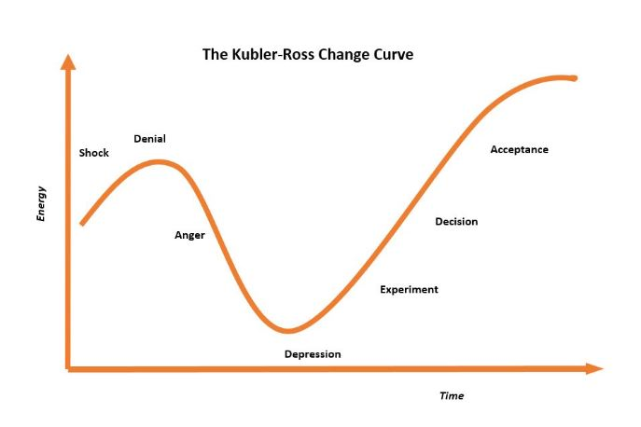
Source: https://changemanagementinsight.com/kubler-ross-change-curve-model/

One of the leading professors of the change management School John Kotter came up with an eight-stage change management model including how to change leaders and how to motivate people to face the future and take action. There are three key points to success:
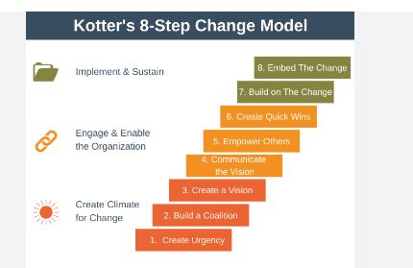
Source: https://expertprogrammanagement.com/2021/02/kotters-8-step-change-model/

To create a positive environment for change. Firstly, we should take the initial three steps. Create urgency. People need to understand it’s necessary and needs action now. Secondly, to try and push changes through “change ambassadors”. To involve influential, respected and visible people in the organization. Finally, prepare a vision of where we want to go and how to get there and a strategy. It should be easily understood by the employees who will be affected in the future because of a new Apple vision.
Steps four to six: to engage people and communicate a vision – to win the people’s hearts, by framing the message in the right way. Empower employees to do things differently and remove barriers. Finally, we should energize the team by generating short-term wins. For example, to communicate a success story regularly or award people who help to reach Apple targets. In addition, to get as many adopters as possible in the shortest amount of time.
Realize the strategy. Long-term changes take time. Because of this, we need to repeat steps four to six above so that people stay focused on the new vision and set new goals. The final, two steps, are to ensure the changes are fully implemented and sustainable. The changes must be included in the organization – in the daily work of every employee.
Also, we discussed Lewin’s change management model. This theory was created by Kurt Lewin more than 80 years ago, but it is still very popular nowadays because of its simplicity. The first of the three-step change model is to unfreeze, second – to change and third – to freeze or refreeze.

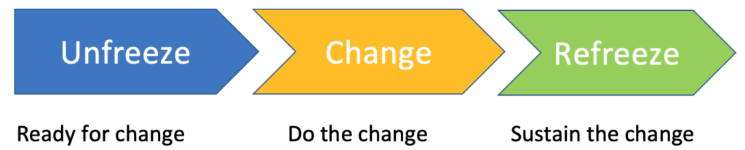

Source: Kurt Lewin Change Model – SanzuBusinessTraining.com. Available at: https://sanzubusinesstraining.com/kurt-lewin-change-model/.

By and large, to succeed and avoid failure in changing management, we need to demonstrate the ability to innovate and adapt these theories focusing on Apple’s goals and employees’ well-being. In addition, supporting them during the cost-of-living crisis. For instance, the company can make a one-off payment to all team members, because the cost of living, has been a challenge and cause of concern for many.

CONCLUSION
The business environment world is changing fast. Apple is there to lead not to follow. To create a positive impact of changing management in the company, they need to be aware of the big picture.
Albert Einstein famously said, "If I had an hour to solve a problem, I'd spend 55 minutes thinking about the problem and 5 minutes thinking about solutions." (Cataria, 2014)
To think of what can lead Apple to effective transformation, you need to get away from your desk and experience the situation to get closer to your answer, and how to prepare the right solution.
I am confident with the change management models that I selected for Apple because, after the presentation, I could see that the most effective way to implement changes from the classic models improved in practice, this can be seen by reviewing the documentation of various management models used over the last 30 years.
Focusing on changing management at Apple I learned as well:
-how important it is to see the need for change in time.
- be intentional about what you're looking to achieve.
- bring to Apple a realistic change management scenario, based on the company’s new challenges, and also motivate Apple’s employees.
- create not only a new vision but to change Apple’s employees’ attitudes and behaviours.
- Apple is nothing without a good team. Due to this, communication with the people about changes, to win their hearts, by framing the message in the right way is paramount.
-not give up in the middle of change management initiatives and be patient to wait for the effects.
In addition, after the presentation, in my view, we need to follow up with the team and analyse again what can be improved or upgraded next time.

REFERENCE LIST
1. Apple (n.d.). Careers at Apple. [online] Apple.com. Available at: https://www.apple.com/careers/uk/benefits.html.
2. Evans, J. (2022). Apple’s new workplace transition isn’t going well. [online] Computerworld. Available at: https://www.computerworld.com/article/3650676/apples-new-workplace-transition-isnt-going-well.html.
3. Gaba, V. (2022). Learn to lead change effectively. [online] https://www.insead.edu/executive-education/leadership/leading-successful-change-faculty. Available at: https://www.insead.edu/executive-education/leadership/leading-successful-change.
4. Kotter, J. (2016). Our Iceberg Is Melting. Pan Books.
5. Kotter, J.P. (2008). A sense of urgency. Boston, Mass.: Harvard Business Press.
6. Mugabe, F. (2022). Apple employees openly criticize management over work from home policy. [online] Available at: https://hr-congress.com/2022/05/09/apple-employees-openly-criticize-management-over-work-from-home-policy/.
7. Lewin, K. 1958, 'Group decision and Social Change,' in 'Readings in Social Psychology,' eds. Maccoby, E. E, Newcomb, T. M. and Hartley, E. L. Holt, Rinehart and Winston, New York, pp. 197–211.
8. Chavan, & Bhattacharya, S. (2022). Study of employees’ behaviour during organizational change: effects of business theatre on Kubler-Ross model. Cardiometry, 22, 237–243.
9. Cataria, V. (2014). 3 Things About Problem Solving Which Albert Einstein Teaches Us. [online] www.linkedin.com. Available at: https://www.linkedin.com/pulse/20140609042202-59384553-3-things-about-problem-solving-which-albert-einstein-teaches-us/.

