MODULE:
EFFECTIVE TEAM WORKING AND COMMUNICATION

Lecturer:
CHRIS FELICES

MODULE CODE:
BMSK4002

ASSIGNMENT:
A REPORT ON COMMUNICATION WITHIN THE WORKPLACE

Contents
Executive Summary 2
Introduction 2
Main Findings 2
Background of case 2
Recommendations 7
References 9

A Report on communication within the workplace

Executive Summary

Michelle Sullivan owns a toy store in Swansea that has rapidly grown within a year from a small sized business, employing 5 people to now a medium sized business employing 27 people. As a business consultant this report has been provided to aid Michelle in acknowledging effective channels of communication to continue the success of her business. Based on communication within the workplace, this report aims to help the Toy Store, prevent from losing business. Provided also are recommendations in order to tackle any challenges that may result due to a lack of or poor communication.

Introduction

This report is based on communication within the workplace. With the use of a case study, this report will explore the different ways of ensuring effective communication within the workplace. The importance of communication and its role amongst workers will also be outlined, along with the most effective ways of communication in the workplace environment. With the use of academic teamwork theories, this report provides detailed explanations of how to improve teamwork in an organisation, with recommendations for the case study company. The case study at hand is a Toy Store in Swansea, which will be discussed further. An action plan has also been included to help acknowledge the next steps for the business.

Main Findings

In this section the report will move on to focus on the case study and various ways that Michelle, or a business in general can implement effective communication with their employees.

Background of case

The focus company of this case study is a Toy store. The owner of the toy store in Swansea, Michelle Sullivan, runs a medium sized business and due to the increase of employees in the establishment, Michelle wants to ensure that effective channels of communication are in place. To avoid any potential problems becoming bigger issues, that could result in a detrimental effect on the business, Michelle is looking for recommendations within this report to help her.

Some information on the focus company gathered from the case study;
- Michelle employs 27 people (varied age and experience)
- There are 3 managers, 6 stockroom employees, 2 cleansers, 14 sales assistants, two security guards.
- One sales assistant is absent on long term sickness
- Employees mostly work part time
- Employees work varied hours during store opening, 8.00am – 10.00pm and also night shifts
- There are only ad hoc teams based on employees working the same shift, no formal teams in the business
- There is a maximum of 8 individuals working in the store at any one time
- New staff are trained on the job by the manager on duty at the time

With the information provided in the case study it is clear to see that the employee structure in the business doesn’t run as a collective team. It is not clear what specific communication channels are used in the store, however on the basis of the information provided, an assumption of a lack in basic communications between members of staff can be made. Due to the fact that there are no formal teams within the business, it can be said that the communication within the business would be negatively impacted.

Groups v Teams

Improving teamwork in an organisation with the application of teamwork theories

In terms of improving teamwork, the question at hand is, as to whether the Toy Store would benefit from changing the idea of the employees not being a ‘group’ but instead a ‘team’.
“A team is not a bunch of people with job titles, but a congregation of individuals, each of whom has a role which is understood by other members” (Belbin.com, 2019). It may be the case that within the Toy Store employee structure, the employees have job titles however the understanding of each role, and the roles of the colleagues is absent. In reference to the case study, it is essential for Michelle Sullivan to acknowledge the importance of her staff to be classed as a ‘team’ rather than a ‘group’. This report will move on to explain the importance of understanding the roles of team members within a team.

Dr Meredith Belbin defined a team role as “a tendency to behave, contribute and interrelate with others in a particular way” (Belbin.com, 2015). The development of the Belbin Team Roles theory surfaced in 1970, that identified 9 different behaviours that individuals display in the workplace. They are also categorised into three groups: Action Orientated, People Orientated and Thought Orientated (Mindtools.com, 2019)
Associated with typical behavioural and interpersonal strengths, the nine team roles are listed below with a short description provided also:

Action Orientated roles;
- Shaper – provide the necessary drive to ensure the team keeps moving and does not lose focus or momentum.
- Implementer – an individual that needs to plan a workable strategy and carry it as efficiently as possible.
- Completer Finisher – individuals with this behaviour, polish and scrutinise the work for errors. They aim for the highest standards of quality control.
People Orientated roles;
- Resource Investigator – has an inquisitive nature to find ideas to bring back to the team.
- Team Worker – this individual helps the team to gel, uses versatility to identify the work required.
- Co-ordinator – this individual has a need to focus on the team’s objectives, draw out team members and delegate work appropriately.
Thought Orientated Roles;
- Plant - this individual is highly creative and good at solving problems in unconventional ways.
- Monitor Evaluator – the individual provides a logical eye, making impartial judgements where required, they also weigh up the team’s options in a dispassionate way.
- Specialist – bring in-depth knowledge of a key area to the team. They provide specialist knowledge and skills.
Using Belbin’s theory can help the toy store to allocate team members with specific roles to identify their strengths and weaknesses.

Bruce Tuckman 1965, proposed the ‘Forming – Storming – Norming – Reforming’ theory. The theory focuses on how a team tackles a task from “the initial formation of the team through to the completion of the project” (Teambuilding.co.uk, 2019). The report will now explore each stage of Tuckman’s theory.
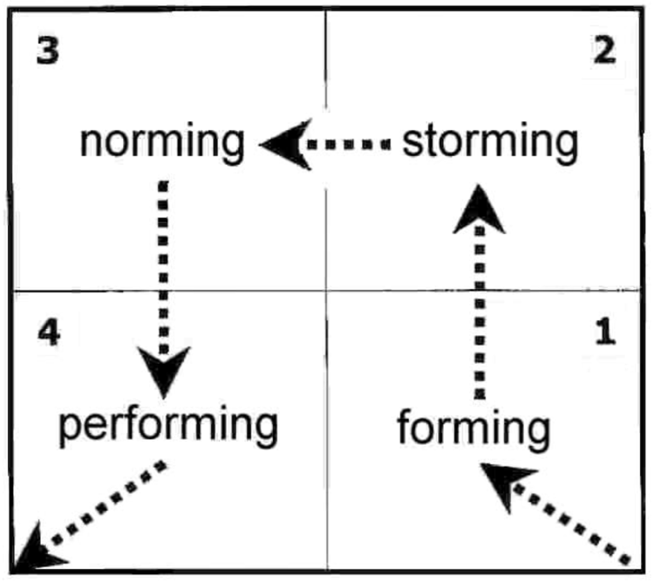
Diagram taken from (Businessballs.com, 2019)
FORMING
In this stage the team is assembled and the task is allocated. Time spent “planning, collecting information and bonding” (Teambuilding.co.uk). High dependence on the leader for guidance and direction (Businessballs.com, 2019). The individuals do not know each other enough to trust one another (Teambuilding.co.uk, 2018).

STORMING
Addressing the task at hand. This phase can be very destructive for the team if badly managed. (Teambuilding.co.uk, 2018) If there is no support of established processes or strong relationships with colleagues, team members who stick with the task at hand may experience stress. This is said to be the stage where most teams fail. (Mindtools.com, 2019)

NORMING
In this stage differences are resolved; colleagues’ strengths are appreciated and a leader’s authority is respected. This stage is said to be “a move towards harmonious working practices with teams agreeing on the rules and values by which they operate” (Teambuilding.co.uk, 2018)

PERFORMING
When a team’s goal is achieved, they have reached the performing stage. They are more strategically aware. In this stage it is easy for individuals to feel a part of the team, people who join or leave won’t disrupt performance. “disagreements occur but now they are resolved within the team positively, and necessary changes to processes and structure are made by the team.” (Businessballs.com, 2019)

ADJOURNING
Through further research Tuckman refined the theory in 1975 and added ‘Adjourning’ as a fifth stage to his model. Due to the fact that project teams only exist for a fixed period, this is the stage that can be difficult for team members who are inclined towards routines and have developed close working relationships. (Mindtools.com, 2019)

Communication

Why effective communication (verbal and non-verbal) is important for the continued success of the organisation

Michelle Sullivan must ensure that within the business there is continuous communication between herself and her employees. It’s important to acknowledge different type of communication especially in the workplace, if a manager wants to understand their employees.
Non-verbal communication can consist of the following;
- Tone of voice
- Body language and posture
- Eye contact
- Facial expression
- Volume of speech
(WorkplaceStrategiesForMentalhealth.com, 2019)
These factors can all impact how a person communicates and also how the communication is interpreted. Research has found that “55% of our message comes from body language” and
38% of our message comes from tone of voice, whilst only 7% of our message is conveyed by the words we use (Mehrabian, 2007). Managers must ensure to acknowledge both verbal and non-verbal communication.

Importance of two-way communication

For a business to run smoothly and efficiently it is important for there to be continuous communication between managers and employees. A survey of 1,000 employees in the UK found, “47% of the respondents said that managers fail to communicate with them regularly.” (Hunter,2016)

Shannon & Weaver’s Mathematical theory of communication 1948, was designed to encourage developments between a sender and receiver. Concepts within this model are, “information source, transmitter, noise, channel, message, receiver, information, destination, encode and decode” (Communication theory, 2019). Provided below is a diagram of the theory in practice.

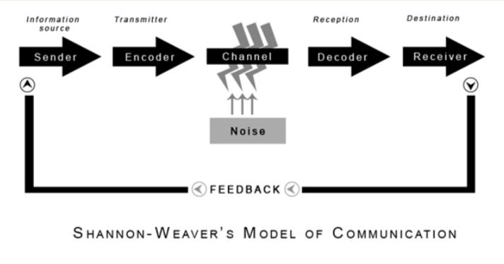
Diagram taken from (Communication theories and libraries, 2019)
This theory acknowledges that there can be three levels of problems of communication:
- Technical problems
- Semantic problems
- Effectiveness problems

Shannon Weaver model recognises that communication is a two-way process and can be quantifiable. (Businesstopia, 2019)
Michelle Sullivan and her managers can make use of this model, by recognising the “noise” element in their communications with staff members and look for ways of either preventing them or removing them.

Similar to the Shannon Weaver model, the Schramm model 1954 also acknowledges two-way communication between a sender and a receiver. Study.com, 2019). The image provided below depicts the model.
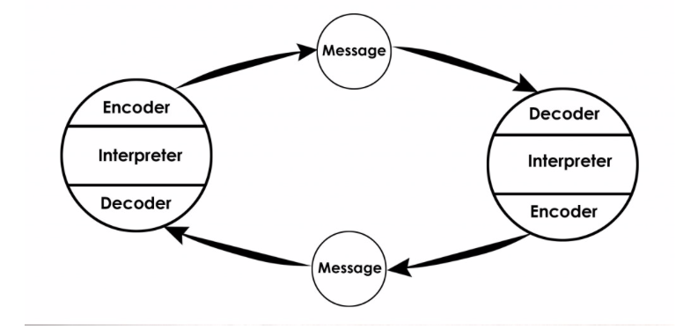
Image taken from (communication theory, 2019)

This circular theory depicts that communication is circular in nature. According to this theory, each person can act as both the sender and receiver. In comparison to the Shannon Weaver mathematical model that is more technological, the Schramm model incorporates human behaviour in communication processes. However, this model does not acknowledge ‘noise’ or factors that can disrupt communication.

Effective Methods of communication

To encourage effective methods of communication the manager of the Swansea Toy Store must try to think outside the box. A company created an app for their employees to download, which kept all the employees updated with event schedules, department talks, conference venues, employees were able to interact together and build working relationships (Pitt-Cramman, 2018). Creating an app can be costly, therefore may not be what the Toy Store should invest in, however, the manager can take advantage of the ever-growing use of social media and create online group chats on Facebook or WhatsApp for example. Further examples of effective methods are provided in Recommendations.

Recommendations

To promote effective working performance within the business, as a manager Michelle must acknowledge how important it is to understand working in groups and teams. Using Belbin’s theory, identifying team roles would help to recognise the strengths of team members and also their weaknesses. Which would help to take full advantages of the strong attributes that the team members provide in order to be successful. Belbin self-perception test can help allocate which role suits each employee. “Research showed that the most successful teams were made up of a diverse mix of behaviours.” (Belbin, 2019).
Belbin’s team roles are “used by over 40 percent of the top 100 companies in…. thousands of organisations throughout the world to enhance individual and team performance” (Belbin.com, 2015)

The case study states that an employee is absent on long term sickness. In order to help with managing the Toy Store when they are understaffed, Michelle must, Prioritise, emphasise teamwork, gain help from past employees, allow breaks and communicate openly and frequently (Haughton, 2017). This can be done by creating, a plan of action, potentially bring in past employees that already understand the processes in the business.

As a manager it is important to clearly outline communication channels, “ensuring your staff feel comfortable to discuss any work/project issues and receive guidance, can boost teamwork, maintain morale and avoid a decline in productivity. (Haughton, 2017)
Using social media to create group chats can help to keep part time employees in the loop of what’s happening in the store. Another recommendation for the toy store would be to have anonymous feedback sheets that employees can complete in confidence to share their thoughts and feelings about processes.
To make sure that Michelle is satisfying the needs to her employees and communicating well, one to one meeting can be introduced for staff to discuss individual performance for example.

Action plan

Recommended action | Who is responsible for actioning? | To be completed by (date) | Potential Costs Incurred?
Form teams (Belbin) | Michelle | ASAP | None
Feedback sheets | All employees to fill the forms out | Completed regularly | Minor printing costs
One 2 one | Michelle | Monthly | None
Establish communication channels | All managers | Immediate
Social media – group chats | Michelle/ any of the managers | immediate | None

References

Belbin.com. (2015). Team Roles in a Nutshell. [online] Available at: https://www.belbin.com/media/1335/belbin-for-lecturers.pdf [Accessed 11 Apr. 2019].
Belbin.com. (2019). Belbin and Tuckman: Supporting your team at every stage. [online] Available at: https://www.belbin.com/resources/blogs/belbin-and-tuckman/ [Accessed 12 Apr. 2019].
Belbin.com. (2019). The Nine Belbin Team Roles. [online] Available at: https://www.belbin.com/about/belbin-team-roles/ [Accessed 11 Apr. 2019].
Businessballs.com. (2019). Tuckman: Forming, Storming, Norming and Performing - BusinessBalls.com. [online] Available at: https://www.businessballs.com/team-management/tuckman-forming-storming-norming-performing-model/ [Accessed 12 Apr. 2019].
Businesstopia. (2019). Shannon and Weaver Model Of Communication - Businesstopia. [online] Available at: https://www.businesstopia.net/communication/shannon-and-weaver-model-communication [Accessed 12 Apr. 2019].
Communication Theories and Libraries. (2019). Shannon-Weaver Model of Communication. [online] Available at: https://communicationinlibraries.wordpress.com/2013/12/07/shannon-weaver-model-of-communication/ [Accessed 12 Apr. 2019].
Communication Theory. (2019). Shannon and Weaver Model of Communication. [online] Available at: https://www.communicationtheory.org/shannon-and-weaver-model-of-communication/ [Accessed 12 Apr. 2019].
Filev, A. (2017). Three ways to prevent communication breakdown in teams - Personnel Today. [online] Personnel Today. Available at: https://www.personneltoday.com/hr/three-ways-prevent-communication-breakdown-teams/ [Accessed 12 Apr. 2019].
Haughton, J. (2017). 5 Ways to Achieve Top Results From Your Short-staffed Team. [online] Managers.org.uk. Available at: https://www.managers.org.uk/insights/news/2017/february/5-ways-to-achieve-top-results-from-your-short-staffed-team?sc_trk=follow%20hit,%7B86CB756B-AB02-44E6-995A-305C69252B29%7D,Teamwork [Accessed 12 Apr. 2019].
Hunter, D. (2016). Poor communication is the biggest reason for wanting to leave a job. [online] Fresh Business Thinking. Available at: https://www.freshbusinessthinking.com/poor-communication-is-the-biggest-reason-for-wanting-to-leave-a-job/ [Accessed 12 Apr. 2019].
Mehrabian, A. (2007). Nonverbal Communication. New Brunswick, NJ: Aldine Transaction
Mindtools.com. (2019). Belbin's Team RolesHow Understanding Team Roles Can Improve Team Performance. [online] Available at: https://www.mindtools.com/pages/article/newLDR_83.htm [Accessed 12 Apr. 2019].
Mindtools.com. (2019). Forming, Storming, Norming, and PerformingUnderstanding the Stages of Team Formation. [online] Available at: https://www.mindtools.com/pages/article/newLDR_86.htm [Accessed 12 Apr. 2019].
Pitt-Cramman, H. (2018). Tried and tested: this company built an app for employee communication. [online] Managers.org.uk. Available at: https://www.managers.org.uk/insights/news/2018/january/tried-and-tested-this-company-built-an-app-for-employee-communication [Accessed 12 Apr. 2019].
Study.com. (2019). Osgood-Schramm Model of Communication: Definition & Application - Video & Lesson Transcript | Study.com. [online] Available at: https://study.com/academy/lesson/osgood-schramm-model-of-communication-definition-application.html [Accessed 12 Apr. 2019].
Teambuilding.co.uk. (2019). Tuckman; Forming - Storming - Norming - Perfoming. [online] Available at: https://www.teambuilding.co.uk/theory/Forming-Storming-Norming-Performing.html [Accessed 11 Apr. 2019].

Workplacestrategiesformentalhealth.com. (2019). verbal vs non verbal communication. [online] Available at: https://www.workplacestrategiesformentalhealth.com/mmhm/pdf/full_communicating_0.pdf [Accessed 12 Apr. 2019].

