L4 - Computer Architecture and Operating Systems (ACCA4022) – Assignment 1
Charlie Keirl (2103422)

Contents
What Are Operating Systems? 3
Task 1 – Key Functions of an Operating System 3
OS Kernel 3
Memory Management 3
Device Management 3
Threading and Multi-Threading 4
Security 4
Task 2 - Use of Windows CLI Commands 4
“dir” Command 4
“echo” Command 4
“color” Command 5
“cd” Command 5
“cd..” Command 5
“whoami” Command 5
“netstat” Command 5
“ipconfig” Command 6
“ping” Command 6
“exit” Command 6
Task 3 – Use of Linux OS CLI Commands 7
“whoami” Command 7
“ls” Command 7
“clear” Command 7
“mkdir” Command 7
“rm -R” Command 7
“tree /” Command 8
“sudo” Command 8
“sudo -h” Command 8
“history” Command 9
“cd” Command 9
Task 4 – Use of Windows OS Scripts 9
Variables and User Input 9
“Goto” Command 9
“if” Statement 10
For Loops 10
Arrays 11
Functions 11
Task 5 – Use of Linux OS Scripts 12
Variables 12
“IF” Statement 12
Case Statement 13
Loops 14
Arrays 14
Functions 14
User Input 15
References 15
Appendices 17
Types of Operating Systems – General 17
Types of Operating Systems – Network 17
Types of Operating Systems – Mobile 18
Evidence of engagement with one online certified course 18

What Are Operating Systems?
An operating system is the main system within your computer. It controls both the hardware and software within your computer. It’s used for opening, closing and running applications, controlling file management, controls all the hardware within your device while being used and will also control other peripherals in use by your PC (such as your mouse and keyboard). [1]

Task 1 – Key Functions of an Operating System

OS Kernel
The OS Kernel is the main interface that controls both the hardware and the software of the computer. It is the most essential and most used part of an operating system. Some examples of what the Kernel can do are:
- Determine what process is to be executed next and in what order.
- Monitor the device’s memory and can see where the memory is being used and for what purpose.
- Used as a translator for hardware to be able to communicate with processes currently being executed within the PC.
- Receive requests to do certain processes when it receives a “System Calls”. [2]

Memory Management
There are two types of memory within your PC, primary and secondary. Primary memory is your PC’s main memory device while running (RAM) and secondary is the external memory that you use to store files on. [3] Your OS will control both of these and try to make them run as efficiently as possible.
One feature it can do is use virtual memory. This is when the RAM cannot handle the amount of data sent in and the OS will then use some of your hard drive to be used as RAM instead. [4] The only downside is that your hard drive is a lot slower than RAM so the OS will only send the least important processes there instead.
To make sure that the right memory goes to the right place, Job scheduling is performed in which the OS will decide what process is the most important and will then schedule their execution and time frame based on that. [5] Without job scheduling, your pc could go into deadlock which is the process when your pc is waiting for a process to be completed but it cannot and therefore freezes your computer as it cannot move on until that process is done. [6]

Device Management
Device management will control all the input and output devices within your computer. The three main types of devices are; boot devices, character devices and network devices. The OS will also manage the data that goes between these devices as well as monitoring their status and enforces any policies that are required to go with them. [7]
Your OS will use device drivers to be able to communicate with software and hardware and how to use both of them together. The drivers allow the OS to be able to utilise the hardware within the computer to be able to allow the user to use the software. [8]

Threading and Multi-Threading
Threading is the order of execution of tasks within a process.[9] Multi-threading (context switching) is when the PC will run multiple threads “at once” to increase the efficiency of your PC. However, due to the limitations of your CPU, the threads are actually executed one at a time but so fast that it seems like your CPU can do more than one at a time. [10]

Security
The OS will also provide security for your device such as firewalls, encryption, permissions, authentication and intrusion detection systems. The OS will use these security features to stop your PC from becoming riddled with viruses and malware and to protect your data from being stolen, manipulated or deleted. [11]

Task 2 - Use of Windows CLI Commands

“dir” Command
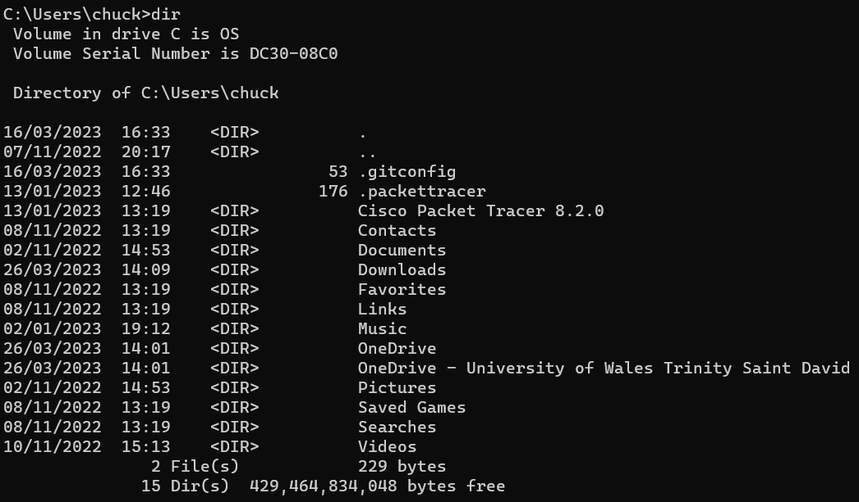
This command will produce a list of the current contents and files within the directory.

“echo” Command
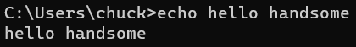
This command will display whatever the user types in, just like the print command in Python.

“color” Command
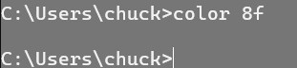
This command will change the colour of the command line’s background using hexadecimal to determine the colour. [12]

“cd” Command
This command will change what directory you will navigate within.

“cd..” Command
This command will take you back one directory, for me this was back to the original directory.

“whoami” Command
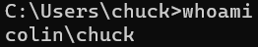
This command will display the PC’s name and the current user’s name.

“netstat” Command
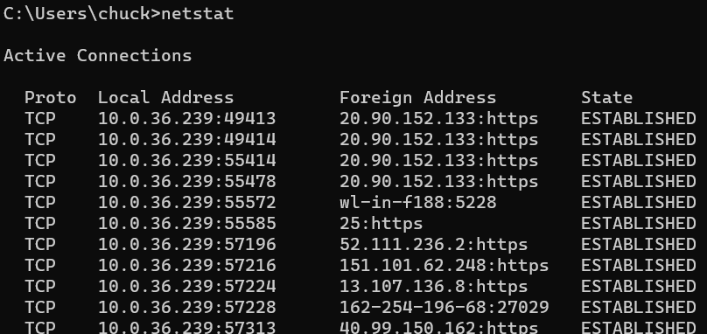
This command will display the information such as TCP addresses and any active connections currently within your PC.

“ipconfig” Command
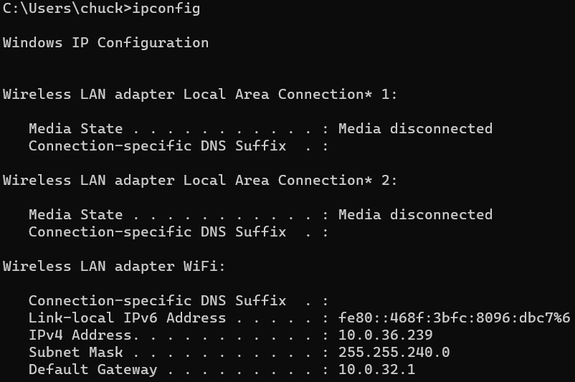
This command will display all of your network configurations including the IP address, subnet mask and the default gateway of your network. [13]

“ping” Command
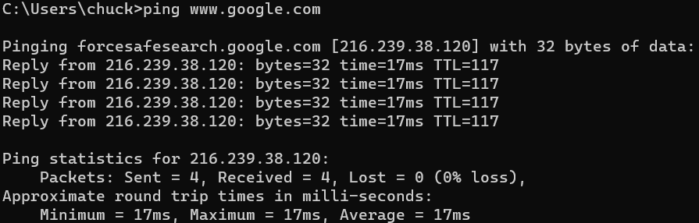
This command will test the connection between your device and a specific host, whether that’s a local PC on your network or a website such as Google.com.

“exit” Command
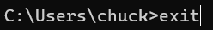
This command will close the command line as soon as enter is pressed after typing the command.

Task 3 – Use of Linux OS CLI Commands

“whoami” Command
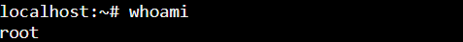
This command will display the current username of the user.

“ls” Command
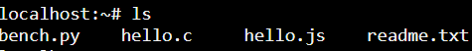
This command will display the current directory of the command line.

“clear” Command
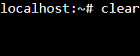
This command will clear the entire command line to make it nice and clean for you to use.

“mkdir” Command
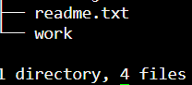
This command will create a new directory within the system. We can check if it worked using the “tree” command. [14]

“rm -R” Command
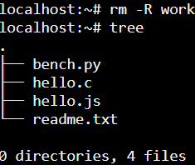
This command will delete the named directory and all content stored within. [15]

“tree /” Command
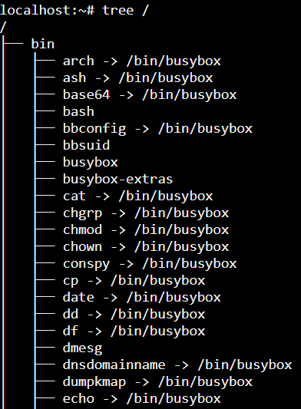
This command will display the entire directory of the system. This command will take a while to execute as it has to list every single directory.

“sudo” Command
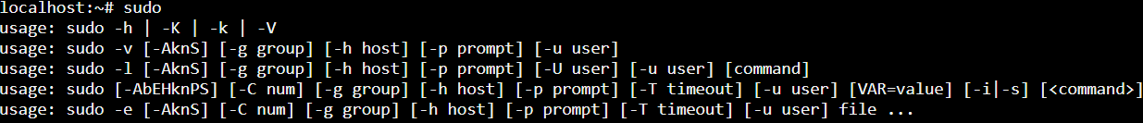
This command will give the user “superuser” privileges meaning that they can access any restricted areas and files within the system.

“sudo -h” Command
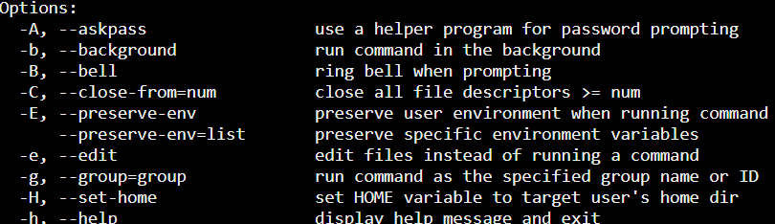
This version of the “sudo” command will list some of the commands that the user can use.

“history” Command
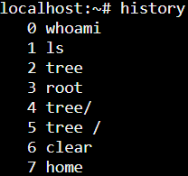
This command will display a history of the commands the user has recently entered.

“cd” Command
This command will take the user back the home directory.

Task 4 – Use of Windows OS Scripts

Variables and User Input
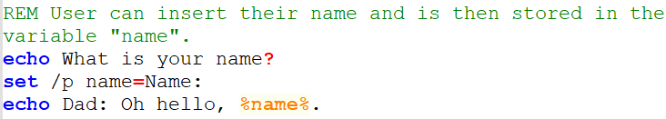
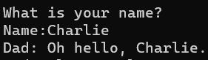
A variable is used here for the user to be able to enter their name into the code by using the “/p” command and is then called upon and displayed within a message.

“Goto” Command
This command is used to call to a function set later on in the program and will skip the current code until the function appears. This is used a great deal in programs as it allows us to call upon the function multiple times in the code. [16]

“if” Statement
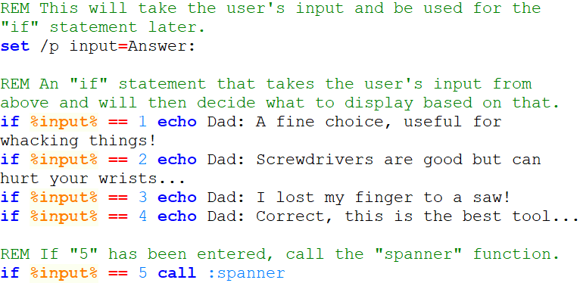
Here I have created an “if” statement that will take the user’s input and depending on what they have entered, will decide what output they get. For example, if they enter the number 2, it will display this:
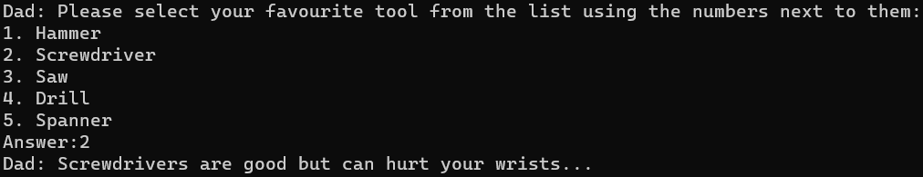

For Loops
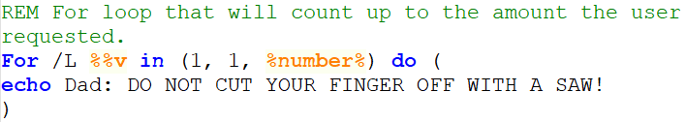
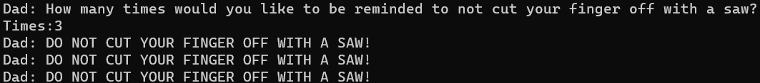
Here I have created a “for loop” that will ask the user how many times they wish to see a message. The loop will then take that number and run the program that many times by using a counter and counting up to that number while running the program set within the loop. [17]

Arrays
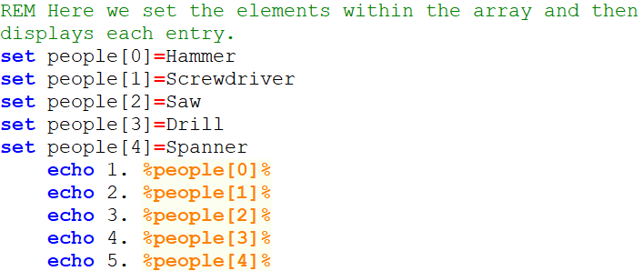
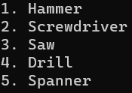
Above I have created an array that contains all of the tools. Underneath the array, it will display to the user each element within the array.

Functions
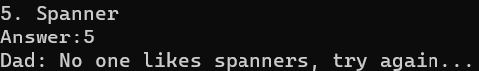
Here, a function is used within the code. I have created a function called “spanner” that will display a message if the user selects this option within the “if” statement. If the option is select within the “if2 statement, the function is called upon and the code within the function is run.
To download and see the code for yourself, go here:
task 4.bat

Task 5 – Use of Linux OS Scripts

Variables
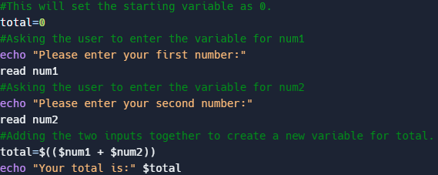
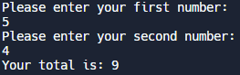
Here we can see my use of creating a variable and then adding the two values together to create a new total for the variable named total.

“IF” Statement
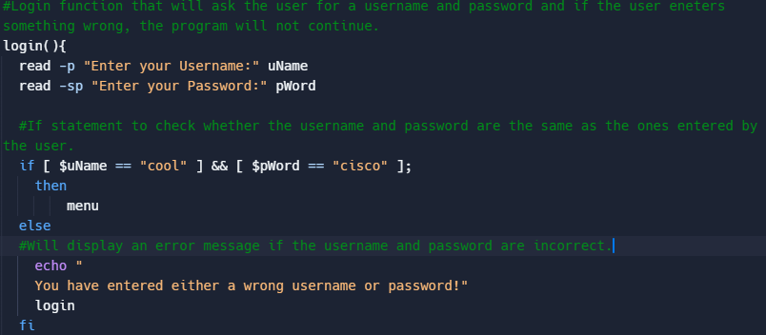
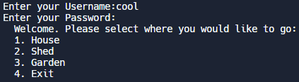
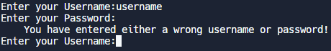
Above I have created a simple login system for my program. It will ask the user for a username and password and then uses an “if” statement to check whether it matches the required ones.

Case Statement
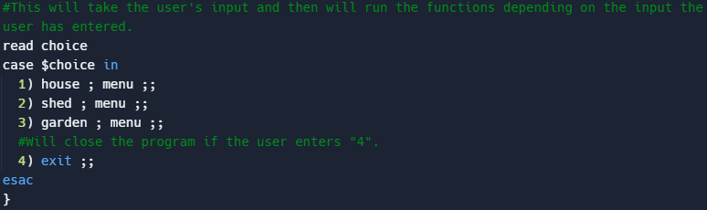
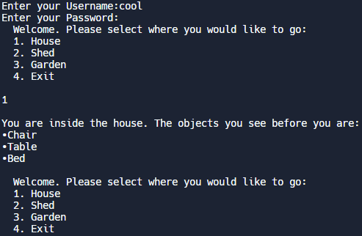
The purpose of a case statement is to allow the user to select from multiple different options, similar to an “if, elif and else” statement. [18] Here I have used a case statement to create a menu to allow the user to select what function they wish to run.

Loops
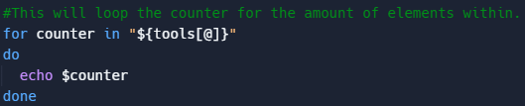
This section will loop and print out the elements using a counter until there are no other elements to print.

Arrays
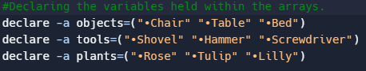
In this section of the code, I have declared all the variables held within the different arrays for each of the areas. These are then called upon later on in the loops above.

Functions
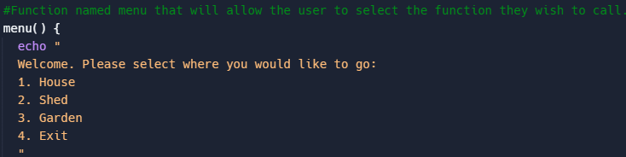
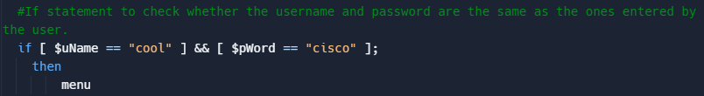
Here I have created a function called “menu” that is then called upon after the user logs in. This allows us to create a verification system and to have the menu code separate from the main without having the program run the menu straight away and used only when called for. [19]

User Input
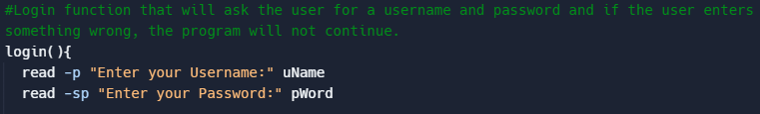
User input is used here to decide whether or not the user has access to the program by using an “if” statement. It will check what the user has inputted and then see if it is the same as the one programmed in.
To download and see the code for yourself, go here:
Task 5.docx

References
[1] Anonymous (). Understanding operating systems - University of Wollongong UOW. Available: https://www.uow.edu.au/student/learning-co-op/technology-and-software/operating-systems/ [Accessed Mar 5, 2023].
[2] Anonymous (-05-03T06:28:25+00:00). What is an OS Kernel? | Baeldung on Computer Science. Available: https://www.baeldung.com/cs/os-kernel [Accessed Mar 19, 2023].
[3] Anonymous (). Difference Between Primary Memory and Secondary Memory. Available: https://www.naukri.com/learning/articles/difference-between-primary-memory-and-secondary-memory/ [Accessed Mar 19, 2023].
[4] T. Monitor, "What is virtual memory?" 2022. Available: https://techmonitor.ai/what-is/what-is-virtual-memory-4929986.
[5] Anonymous "Job Scheduling," Available: https://www.techopedia.com/definition/7882/job-scheduling.
[6] D. Agrawal. (-02-24T00:00:00.000Z). Deadlock in OS. Available: https://www.scaler.com/topics/operating-system/deadlock-in-os/ [Accessed Mar 19, 2023].
[7] Anonymous (). Device Management in Operating System - javatpoint. Available: https://www.javatpoint.com/device-management-in-operating-system [Accessed Mar 19, 2023].
[8] Anonymous "What Is a Device Driver? Definition, Types, and Applications," Available: https://www.spiceworks.com/tech/devops/articles/what-is-device-driver/.
[9] S. Vivek. (-01-31T00:00:00.000Z). Threads in Operating System. Available: https://www.scaler.com/topics/operating-system/threads-in-operating-system/ [Accessed Mar 19, 2023].
[10] Anonymous (). What is context switch? | Definition from TechTarget. Available: https://www.techtarget.com/whatis/definition/context-switch [Accessed Mar 19, 2023].
[11] D. Smith. (-03-18T18:38+00:00). The Role of Operating Systems in Security. Available: https://www.companionlink.com/blog/2021/03/the-role-of-operating-systems-in-security/ [Accessed Mar 20, 2023].
[12] Anonymous "Color cmd command," 2020. Available: https://www.geeksforgeeks.org/color-cmd-command/.
[13] R. Mens. (-10-14T09:31:33+00:00). How To use the IPConfig Command and Options Explained. Available: https://lazyadmin.nl/it/ipconfig-command/ [Accessed Mar 26, 2023].
[14] G. Jevtic. (-04-08T09:20:34+00:00). How to Create a Directory in Linux with mkdir Command {Examples}. Available: https://phoenixnap.com/kb/create-directory-linux-mkdir-command [Accessed Mar 26, 2023].
[15] I. T, "Remove Directory in Linux: How to Delete Files and Folders," 2021. Available: https://www.hostinger.co.uk/tutorials/how-to-remove-files-and-folders-using-linux-command-line/.
[16] Anonymous (-06-17T08:00:00-05:00). Learning the Powerful Goto Batch Command. Available: https://adamtheautomator.com/goto-batch/ [Accessed Mar 30, 2023].
[17] Anonymous "Batch File For Loop - Implementation And Explanation," Available: http://www.trytoprogram.com/batch-file-for-loop/.
[18] B. Marijan. (-12-15T15:15:02+00:00). Bash case Statement Syntax and Examples. Available: https://phoenixnap.com/kb/bash-case-statement [Accessed Mar 28, 2023].
[19] Anonymous (-01-14T20:31:47+01:00). Bash Functions. Available: /post/bash-functions/ [Accessed Mar 29, 2023].
[20] Anonymous (). What is Windows?. Available: https://www.computerhope.com/jargon/w/windows.htm [Accessed Mar 5, 2023].
[21] Anonymous (). End of Support for Previous Versions of Windows | Microsoft. Available: https://www.microsoft.com/en-gb/windows/end-of-support [Accessed Mar 5, 2023].
[22] Anonymous (). What is Linux? | Opensource.com. Available: https://opensource.com/resources/linux [Accessed Mar 5, 2023].
[23] Anonymous (). Operating System Market Share Worldwide. Available: https://gs.statcounter.com/os-market-share [Accessed Mar 5, 2023].
[24] B. Stegner. (-08-08T16:00:00Z). What Is Windows Server and How Is It Different From Windows?. Available: https://www.makeuseof.com/tag/windows-server-different-windows/ [Accessed Mar 5, 2023].
[25] Anonymous (-02-19T05:00:10+00:00). What is Android? Here's everything you need to know. Available: https://www.androidauthority.com/what-is-android-328076/ [Accessed Mar 5, 2023].
[26] B. Stegner. (-01-08T17:00:00Z). What Is iOS? Apple's iPhone Software Explained. Available: https://www.makeuseof.com/tag/what-is-ios/ [Accessed Mar 5, 2023].

Appendices

Types of Operating Systems – General
One of the most common operating systems you’re probably familiar with is the Windows OS. This is one of the main operating systems out there and is the most common OS found within home desktops. [20] The versions that is used most commonly today would either be Windows 10 or Windows 11. In some cases, Windows 7 can still be found in the wild but it no longer supported my Microsoft as of 2020. [21]
Another OS you might have heard of is the Linux OS. Linux is another OS that is used greatly today. The main difference between the Linux OS and Windows is that Linus is open source whereas Windows is closed source (only the company that made it can make changes).[22] This means that the source code found within the OS can be easily altered and programmed into whatever the user wishes it to be. It means that companies and businesses can use this OS as a base line and then create their own OS from it. Because of this, Linux is now the most used OS of all time because of how flexible it is.
The macOS (Macintosh Operating System) is also another OS that you’ve probably heard of. macOS is Apple’s own operating system, similar to Microsoft’s Windows, however is only found on Apple’s own desktop products (MACs and MAC Books) and is not opensource. Because of this limitation with Apple only using it on their own products, the macOs is not as commonly used as Windows or Linux but is still used in great quantities by those with Apple products (roughly 6% of the global population [23]).

Types of Operating Systems – Network
Severs require powerful machines and having an OS that is designed to aid in just that will make a tremendous difference. Similar to the Windows OS we discussed above, Windows Server is Microsoft’s answer to an OS designed specifically for servers. Windows Server is pretty similar to Windows OS however it has a few extra features that can aid in server management such as the Active Directory and DHCP. Windows Server also has fewer hardware limitations compared to Windows OS because of how much power is required for a server to be run efficiently. [24]

Types of Operating Systems – Mobile
The two main mobile OS’s are Android and iOS. Android was created by Google and is currently the most used operating system used on mobile devices. The main reason for this is because Android was created from Linux and therefore is opensource. Many of the big mobile phones companies, such as Samsung, Google and Motorola, use Android as their OS for their mobile phones due to the fact that Android is also very flexible. [25]
iOS is Apple’s other operating system however this one was built for mobile devices. Just like with the macOS, iOS is used solely on Apple’s mobile phone range (the iPhone) and is also closed source. Usually, iOS has better security than that of Android due to the fact that iOS can only be edited by Apple however depending on who utilises Android, security can become just as strong as iOS. [26]

Evidence of engagement with one online certified course
Below I used the Microsoft Learn course: Automate administrative tasks by using PowerShell to learn a bit about PowerShell. Here is my engagement with the course:



