You need to explain the possible ways of addressing performance issues in terms of productivity and incentivisation to the client

Incentivisation in its basic terms is “A process by which a provider is motivated to achieve extra value added services over those specified originally and which are of material benefit to the user. These should be attainable against pre-defined criteria. The process should benefit both parties” (CIPS, 2006). There are various types of incentivisation on a construction project. The incentivisation proposal can be from the client to the main contractor or from the contractor to its sub-contractors. All forms of incentivisation mid contract includes the mutual agreement of new specified targets. These targets are often with respect to cost, program, safety and quality of work and are often agreed with consequences in place should the recipient of the incentive not achieve their new targets (Most often in the form of financial compensation). The need for incentivisation usually arises in cases of performance issues.
Example of incentivisation.
The client’s budget is sourced from a private committee held fund and the completion date of their student accommodation is set to the 1st of April 2022. The programme requires a 14-month duration. Due to issues securing a contractor, work commences on April 1st 2021 leaving a 12 month window for works to be completed. To ensure work can be completed on time the client is offering the main contractor a time cost incentive for the works to be completed on time. If the main contractor utilities its labour to a higher extent each month the client will offer an additional sum of money not specified in the original contract on competition. This additional sum of money is subject to the contractor completing the agreed works at an earlier agreed date.
The contractor may utilise their labour in some of the following ways;
- Offering overtime when possible
- Securing additional sub-contractors for various aspects of work
- Employing temporary staff
- Changing the hours of work for additional hours on site

The cost incentive provided by the client should encompass the additional cost for the options above.

Sometimes when applying incentivisation techniques at the management level money does not provide the same incentive it would to a labourer. This is due to the considerable difference in pay scales between for example a quantity surveyor earning £70,000 and a labourer earning £24,000. Another way to apply incentive techniques is to do it on a personal level. For example if the client (As mentioned above) is building student accommodation and has previously built and part owns a day-care centre or gym then they may want to use their influence with these establishments to offer free gym membership for a set period of time or offer free childcare. These incentives would be more favourable to those who regularly use the gym or have small children.
Another example for instance could be to offer free football and rugby tickets to staff when building sport stadiums.
The aim is to provide an incentive on the personal level where knowing your workforce plays an important part of deciding which technique and reward you are going to offer.

You need to produce a sketch of a site set up given the proximity to the IQ building with assumption that the staff and students are in the completed building (20%).

Current IQ Building as constructed opposite student and staff car park.
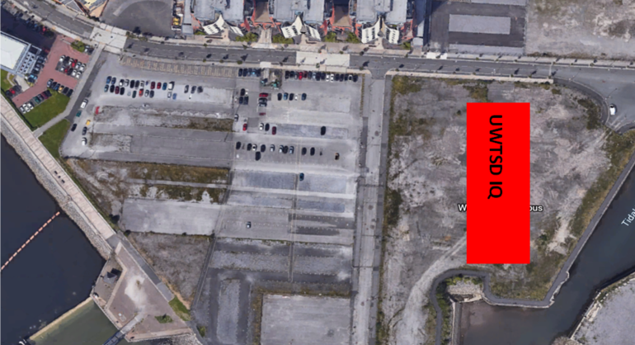
Proposed Site Layout
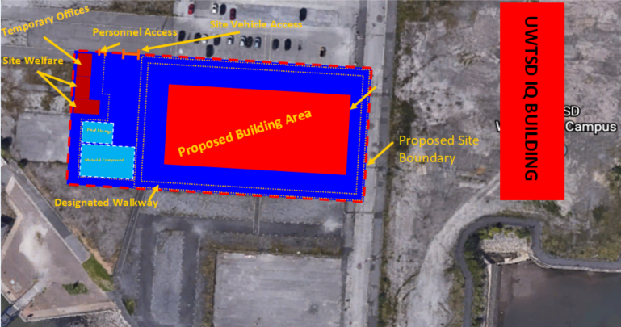
Please see attached PDF for detail and scale

The proposed site layout area will encompass:
· On site material compound
· On site plant storage
· Biometric Security for personnel access with an on site manned security office to enforce its use.
· Designated vehicle access point
· On site welfare unit/offices
· Designated walk routes for the health and safety of staff
· 3m high non-transparent site hording
Protection of staff and students
To protect the staff and students of the nearby IQ structure all vehicles delivering materials or plant will only be permitted between the hours of 0600am to 0800am.
All site staff should be in attendance by 0800am for work start.
All site staff will share the staff and students car park with heavy emphasis on parking at the very top and walking down onto site as not to inconvenience the staff and students.
Signage will be shown at all entrances/exits as to advise on parking procedures.
Please see below the proposed car park arrangements.
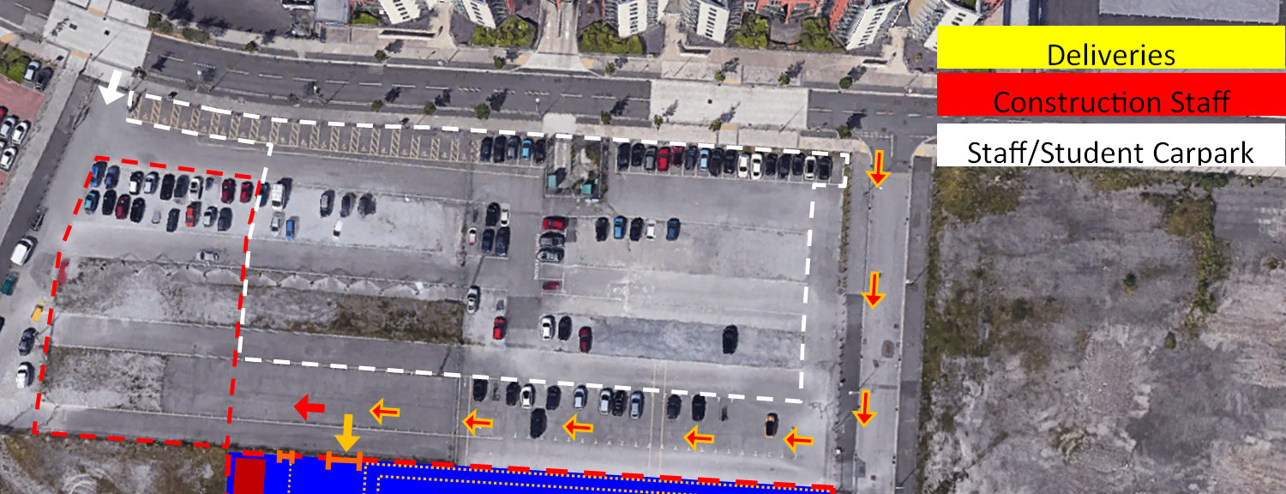

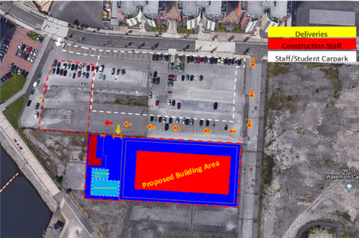
There is a strike by the local concrete company which is set to begin on the first day you require concrete. The strike is due to last 2 weeks. Show how this affects the project within the report addressed to the client. The client has asked you to analyse how much it would cost to bring in concrete from further away during this strike. The extra cost would be 10p per cubic meter (20%).

Delays on a construction project can be costly. They can have a knock on effect and have an adverse effect on the overall construction program. With the possible additional cost of having to source new suppliers.
The formula for calculating the increased cost is as follows;
Q(Cubic Meterage of concrete to be poured) X R(Previous cubic meterage rate)= Original cost (£)
Q(Cubic Meterage of concrete to be poured) X R(New cubic meterage rate)= Revised cost (£)
Original cost – Revised cost = Total losses of using the new supplier (£)

Unfortunately applying a time constraint on a specific part of a project will also have consequences through the construction program. For example the below image shows a 2 week constraint on the ring beam poring which has a knock on effect on the task due after this.
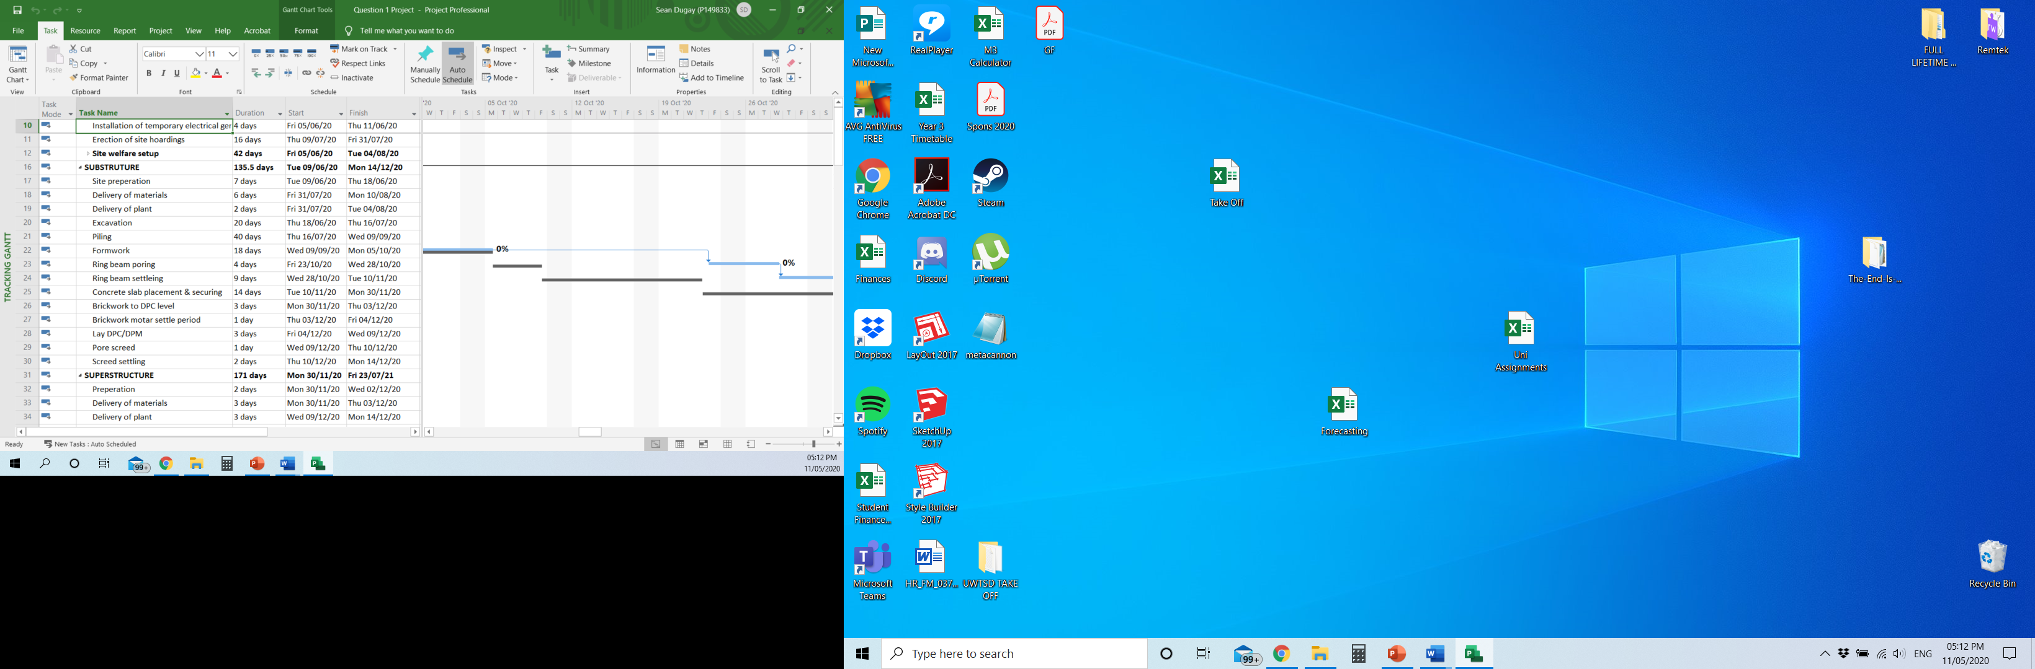
The grey areas are the projects original baseline and once the two week constraint was put in place we can see the project differs from its baseline.
As shown in the image below the base line and the remaining task all differ due to the time constraint placed in the earlier task. This increases the projects finish date. This also increases the overall projects timeline of which the site manager and assistant site manager must be present throughout.
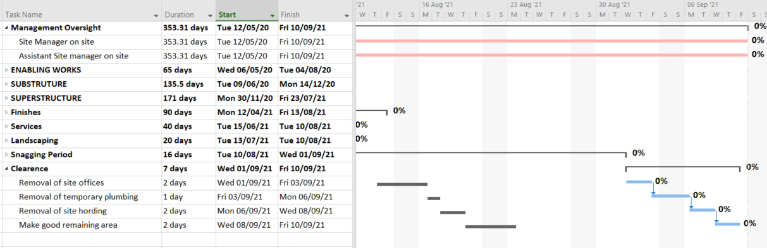
There may also be additional costs for the hire of plant, additional costs for site security and labour. This extended deadline may also have consequences detailed in the agreed contract. It is at this point the contractor has to decide which course of action to take. To accept the 2 week halt of works or to source another supplier at an additional cost.
Further information on time constraint effects can be found on the MS Project file attached.

References
CIPS, 2006. Incentivisation. [Online]
Available at: https://www.cips.org/Documents/Resources/Knowledge%20Insight/Incentivisation.pdf
[Accessed 10 05 2020].

