Topic: Challenges of Urban Outfitters to expand operations in China

Executive summary
Strong economic rise and increased domestic usage are often rendered in tandem with its and china economic status. The Chinese market was known to be extremely dynamic and to deliver several possibilities to foreign retailers. The enormous sector, with its 1.4 billion possible buyers, will make any company entrepreneur dream of profits skyrocketing and a sustainable bottom line forever (Worldbank, 2019). However, it is often not easy to evaluate and recognize how to widen to a market that is probable to be comparatively different from the domestic market. Moreover, Retailers need to know which worldwide strategies may be used to fit the new market and what strategic decisions need to be tailored. China's growth as a consumer society has recently been discovered, but recent figures have verified that the once output-oriented powerhouse has become much more domestically based, generating numerous opportunities for firms wanting to expand abroad.

Based on these opportunities created by the Chinese market, the aim of this study is to provide a proposal for a fashion retail giant-Urban Outfitters (UO) to expand operations in China in order to increase market share and sales.

Methods of analysis of the UO and China's internal and external environment have been: China's economic and sociological setting, the UO SWOT analysis, China Hofstede's cultural dimensions and four key challenges which are regulatory, cultural, innovation and human resource, as well as a recommendation for UO on how to expand its operations in China in order to achieve a sustainable competitive advantage.

1. Introduction
It's become much easier to do business in and with China than it was years ago, and doing business doesn't mean everyone's going to make money. Since more than 30 years ago, China has embarked on unprecedented economic growth, rising to become the world's-largest economy by 2020. In addition to focusing on improving domestic consumption, a fresh road to healthy and sustainable development under the 12th Five-Year Plan (2011-2015) opens up new opportunities for accelerated technological progress and business expansion in China (Brødsgaard, 2013). To foreign investors, China still has a variety of challenging areas. In addition to the cultural and linguistic challenge, businessmen could be confronted with intellectual property rights, anti-trust laws, foreign currency restrictions and diverse people across China.

1.1 Research motivation
As a massive rising economy, China became one of the most famous foreign direct investment destinations in the world. However, foreign firms are progressively confronted with a number of challenges, particularly throughout the "soft landing" of China's economy and in the midst of an anti-globalization surge (Mao, 2015). Based on a comprehensive analysis of current literature, this thesis provides detailed summary of several of China's major challenges facing foreign firms, focusing on two business-related challenges, namely cultural and regulatory challenges, as well as two management challenges, namely human resources and innovation. The study sets out the organizational implications for future research and planning directions for Urban Outfitters (UO).

However, as the increasing pressure from fast fashion labels and consumer spending pullback continues to worry the U.S. Urban Outfitters turned their attention to global expansion. Recent notice that the American clothing retailer plans to open its first Asian retail store later this month in Hong Kong (Trefis Team, 2014). While UO entered Asia a few years ago through a relationship with World Co Ltd., this will be the first time a company-operated store has been launched. As the domestic fashion industry is saturating, global expansion has become a necessary step for US retailers. Moreover, while UO performed extremely well last year in an up-to-date retail environment, its growth has recently decreased due to some poor selections of goods. Therefore, extending its reach to some lucrative markets in China appears to be a sensible move.

1.2 Research framework
The thesis of the study is purely theoretical from the standpoint of the business - Urban Outfitters and China Emerging Market, and as such, it depends on previous research articles and the related literature available, which ensures that the literature review is the core methodology of the analysis.

2. Company Background
This section describes the company background of Urban Outfitters.

2.1 Company’s product portfolio
Urban Outfitter (UO) is a major luxury specialty retailer trading under its labels Urban Outfitters, BHLDN, Terrain, Free People and Anthropologie and offering a range of trendy clothing, footwear and home goods in a welcoming and creative shop environment (Urban Outfitters, 2019). Its main strategy is to provide customers with unified storage environments that create emotional connexions. It also operates a wholesale division under the labels Leifsdottir and Free People. The company offers its products as well as its retail stores and promotes its goods directly to consumers through its e-commerce platforms and catalogues.

UO targets adolescents between the ages of 18 and 30 years of age with a wide range of products, including men's and women's casual clothing boots, makeup, cosmetics and athletic gear and equipment, as well as a selection of goods and home gifts. UO has been characterized as a hipster, trendy, bohemian, catlike, kitschy and strange clothing, such as t-shirts emblazoned with the words ' Atari' or' Jive Turkey.' They are renowned for the hipster movement and trend catering that combines the influence of decades gone by. Group-owned 230 UO stores, 176 of which were located in the US,40 in Europe and 14 in Canada (Urban Outfitters, 2019).

2.2 Domestic and foreign market environment for the development of the consumer goods
Most of UO's business is limited to the US, where, unlike most of its competitors, it continues to grow rapidly. Similar to chains, including American Eagle and Gap Inc, UO operates a significantly lower number of stores in the country and has a market share of only 1.15% (Trefis Team, 2015). Although the rise of fast-fashion players and rapid growth threatened the entire casual clothing market, like UO, the expansion of its shop kept the company's earnings in the U.S. rising at an average annual rate of almost 10% between 2010 and 2019, driven by a combination of retail expansion and similar profits (Trefis Team, 2015).

Although UO's domestic sales growth was strong and encouraging, its global business continued to increase its share of total profits for the group. UO's overseas operations are scattered across Canada and Europe, accounting for 14 per cent of its sales in 2015 (Trefis Team, 2015). Over the last five years, revenue growth from these regions has been robust, clearly indicating that the business has effectively expanded its presence in these countries. Looking at UO both in the U.S. and overseas, the store will have to think about self-cannibalization for years to come. Developing factors are therefore unlikely to be limited anytime soon. In reality, it effectively leverages its World Co Ltd (Trefis Team, 2015). The alliance of the company with it and the recent expansion in Hong Kong will add even more energy to international development. This could lead UO's foreign business to continue to outpace its domestic production, and that healthy competition would ultimately benefit the group (Trefis Team, 2015).

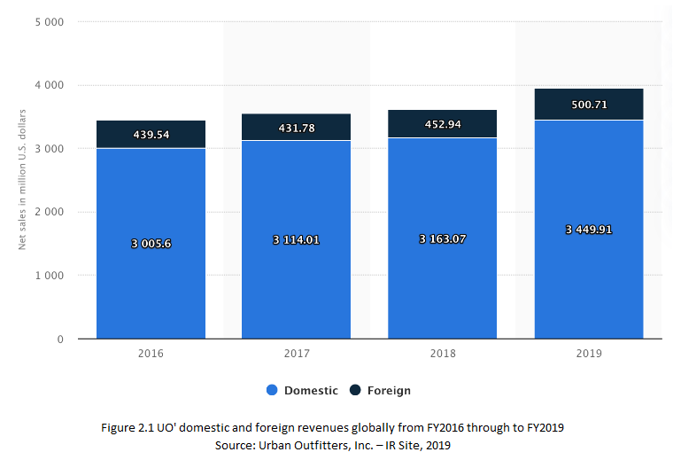

Figure 2.1 shows UO's global domestic and foreign revenues from FY2016 to FY2019. UO's domestic net sales contributed approximately US$ 3.45 billion to FY2019 (Urban Outfitters, Inc.–IR Site, 2019). Expanding the market to more countries is good for producing more international sales and eventually helping the company to diversify its threats globally.

2.3 The rationale of expanding Operations to China
Economic reforms in China (1978) also contributed to an unprecedented shift in the complexity of the business environment and the outlook for foreign investors and private firms. In November 2001, China officially joined the World Trade Organization (WTO), culminating in a further rapid increase in foreign investment and trade. China, with its $10 trillion annual growth of 7%, is an enormous force that is reshaping the global economy and growing to be the second-largest economy after the United States in the world (Anglès, 2019). Some even envisage transcending the U.S. as the world's largest economy by 2020. In addition to focusing on improving domestic consumption, a new path towards healthy and sustainable development under the 12th Five-Year Plan (2011-2015) opens up new opportunities for continued expansion of industrial enterprise and innovation in China (Anglès, 2019).

China is the center of business. There is a huge and competent workforce, as almost 20% of the world's population is in China. Among the factors that contribute to China's growth are not only the large population, but also hard-working attitudes and literacy (the literacy rate is 93% compared to 61% in India) (Anglès, 2019). China has outstanding universities that produce a large pool of highly qualified graduates. Given the history of state-owned enterprises, the people of China have a long history of entrepreneurialism.

Growth in modern retail is also guided by the patterns of consumers in China that underlie it. Recent trends provide for millennial growth, low-level market movements, "green and healthy" lifestyles, shortening and accelerating trend periods, and the need for complete digitization and connection. The retail sector is also changing at a dizzying rate, and this transition goes far beyond online shopping to offline shopping. This was well known to the Chinese e-commerce company Alibaba (more than 600 million buyers a day and revenue of USD 39.9 billion in 2018) (Russell and Liao, 2019).

3 Country Background
China's market entry problem has become one of the most important foreign firms of all sizes and shapes. In view of the severe economic climate in the United States and Europe, China's economy has continued to grow at double-digit levels in recent years. With China projected to overtake the US as the world's second-largest economy by 2020 and to remain the global growth engine for the next decade, it has become crucial for most B2B companies to know how to enter diverse and large markets (B2B International, 2014).

3.1 Economic setting
China sees itself at a pivotal moment. Between 2000 and 2019, China's economy almost doubled, making Japan the second-largest in the world after the United States. Investment has been the fastest-growing factor since private consumption dropped from 46% of GDP in 2000 to 33% in 2010 (McKinsey Greater China, 2019). Globally, indications of slower growth have expressed concern about China's inertia: either growth can continue over the next few years, even where it will try to come from.

In the absence of major global economic shocks, research estimates that China's GDP is likely to continue to grow at an annualized rate of around 7.9 per cent in the next 10 years, up from 1.7 per cent in Germany and 2.8 per cent in the United States (Figure 3.1). From now on, the difference is that the driving force will be use rather than production. It will account for 43% of total GDP growth in 2020 compared to a projected investment contribution of 38% (McKinsey Greater China, 2019). Moreover, China's sheer size and scope poses barriers that are different from any other market (such as other Asian markets, including South Korea and Japan), with a landmass greater than the United States and a population of more than 1.3 billion (McKinsey Greater China, 2019). While it is evident that China represents an enormous market potential for global manufacturing services and goods, it is also accurate that it can be extremely difficult to understand where those opportunities exist and how they can be achieved. Whether it is a large foreign multinational with a proven presence in China and a first-time market entrant with no previous experience in China, Western companies of all sizes and shapes often find their success in China hindered by a lack of local understanding.
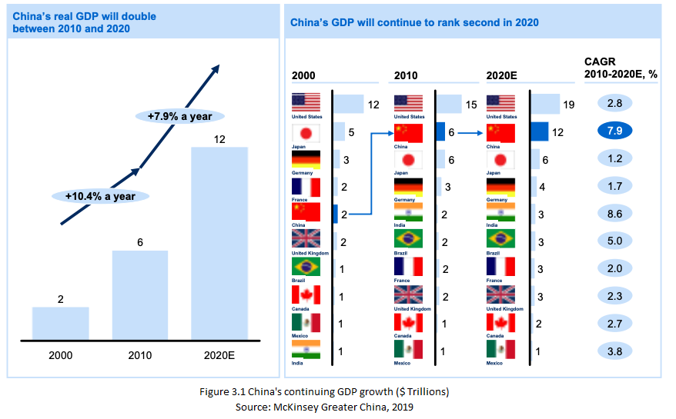
Moreover, the first realization commonly required by foreign companies is that China is by no means a homogeneous and uniform economy. While China is united in a geopolitical sense, the picture is far more fragmented and disparate in economic and social terms. In recent years, the uneven levels of economic development in different parts of China have tended to deepen many of the social and economic disparities that remain in the various provinces. For example, there are wide variations between different provinces in terms of education levels, consumer spending patterns, population per capita GDP, average income levels, literacy rates and attitudes, etc. As such, it is certainly not a misconception to say that China is actually a collection of individual sub-markets characterized by significantly different economic, social characteristics.

Changes in economic profiles have been and will continue to be the most significant trends shaping the consumer landscape. The Chinese are certainly getting richer: the disposable per capita income of urban consumers will double from around $20,000 RMB to around $40,000 RMB between 2010 and 2020 (Trading Economics, 2019). This will be similar to current living standards in South Korea, but still a major step forward in some developing countries, including Japan (approximately $25,000) and the US (approximately $45,000) (Trading Economics, 2019) (Figures 3.2 and 3.3).

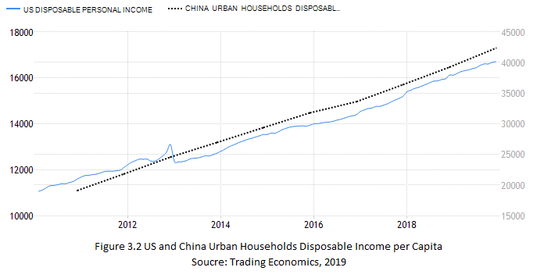
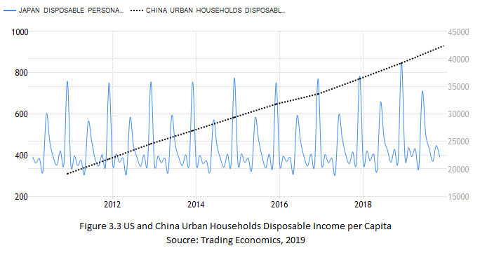
Nevertheless, the existing massive income-level differences will continue although the figures will change significantly at each point (see table 2). The vast majority of the population currently comprises of "value" buyers — these already living in families with an annual disposable income of among $6,000 to $16,000 (approximately $37,000 RMB to $106,000 RMB , Figure 3.4)—which is almost sufficient to meet their basic needs as "mainstream" buyers, relatively affluent families with an annual disposable income of among $16,000 and $34,000 (approximately $106,000RMB to $229,000RMB , Figure 3.4) (McKinsey Greater China, 2019). These households are less than 14 million, accounting for merely 6% of the population of the city. In addition, a small group of "affluent" customers with household incomes of more than $34,000 make up merely 4.26 million households or 2% of the urban population.

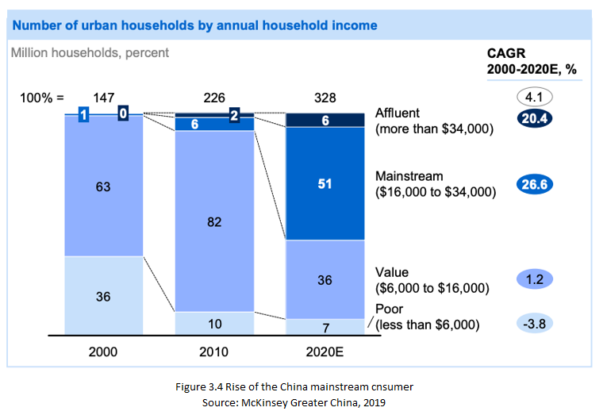

3.2 Sociological setting
China's one-child policy has also generated a gender imbalance and the significance that many families still attach to having a son. Between the ages of 25 and 34, there will be 13 million more males than females by 2020 (Huang, Lin and Zhang, 2019). Given this traditional predisposition against male children, women have a growing role to play in the economy. The presence throughout the workplace has already been high—67% compared to 58% in the United States, 52% in Hong Kong, 48% in Japan, and 33% in India in 2019 (Huang, Lin and Zhang, 2019) . One-child policy also liberated a number of people from caring for large families, suggesting that employment rates in the workplace would continue to increase.

Women are certainly making the most of their independence: research shows that 52% of women in the United States strive to achieve to top jobs, compared to 76% in China, and that women are not uncommon in the committees of classified China A-share businesses (Rakhmanov, 2018). 47% of working women had a career at the workplace in 2010, compared to 43% in 2003 (Tursun, 2017). If the pace of female participation in work continues, more than half of working women are projected to have a position in the workplace by 2020.

4 Analysis and discussion
This section describes the general analysis and discussion in this report.

4.1 Theoretical background
The theoretical models and techniques of study that are presented in this thesis are:

1. The SWOT-model was selected because it provides an overview of the firm and its rivals ' internal strengths and weaknesses. The SWOT-model often shows specific market factors that are important for market analysis (Bower, 1991).
2. Hofstede's theory of cultural aspects was selected because it would be able to analyze cultural differences between the Western countries and China (Hofstede, 1993).

4.1.1 SWOT
This SWOT analysis (Table 4.1) describes every UO's strengths, weaknesses, opportunities and threats but does not inform managers what they can do. Using sophisticated SWOT analysis or TOWS matrix to solve this constraint and help develop correct strategies (Bower, 1991). Here list the techniques for Strengths-Opportunities (SO) that include the use of strengths to maximize opportunities. This outlines the techniques for Strengths-Threats (ST), which include the use of strengths to counter challenges. This includes the strategies of Weaknesses-Opportunities which include utilizing opportunities to turn weaknesses to strengths. Eventually, techniques for weakness-threats (WT) include resolving vulnerabilities in order to avoid threats.
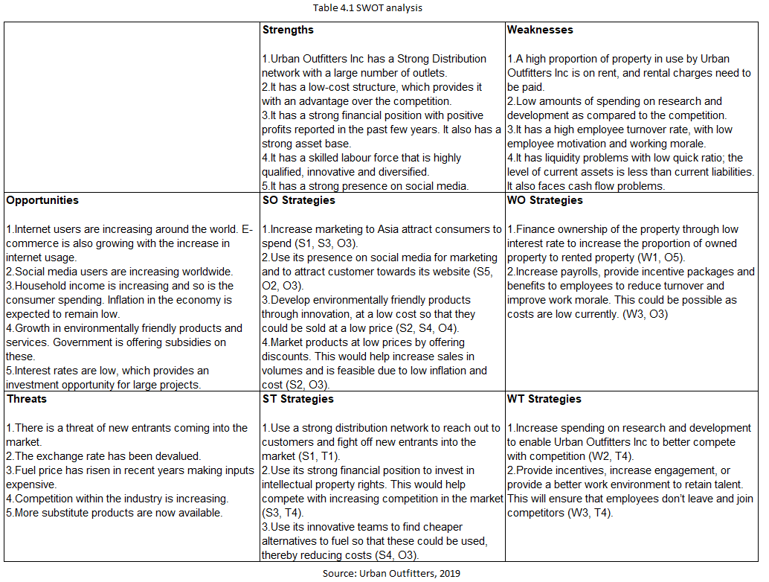
4.1.2 Hofstede’s Cultural Dimensions - Difference in Business Culture between China and West
Hofstede defined four dimensions of the value system based on culture: distance of power individualism / collectivism, masculinity / feminininity, and avoidance of uncertainty In another study, a fifth aspect called long-term / short-term orientation was defined by Bond and Hofstede. Hofstede's five dimensions structure describing the cultural differences shown in Table 4.2(Hofstede, 1993).
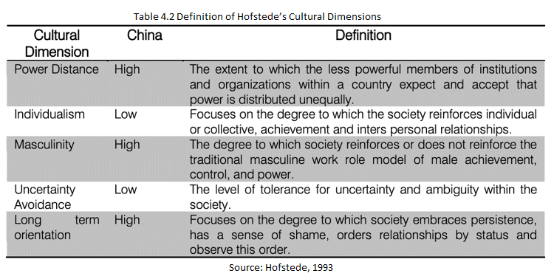

The collectivist way of thinking still abounds in the Chinese business community, even in sectors which experiment with free enterprise. This is counter to the philosophy of individualism predominating in the West. Comprehension of agreed traditional Chinese conduct and protocol would promote business collaborative and further negotiations with business ventures between non-Chinese and Chinese business partners. Though most countries and cultures had their own modes of communication, the distinctions in types of communication between the Western and Asian cultures are most prominent. Chinese people have a strong role orientation which inhibits them from recognizing how essential it is to develop relationships and gain confidence from others. Getting poor listening skills is most often contributing to misconceptions that ruin the agreement or escalate the conflict. They are ignorant about the essential traditions and courtesies that say a lot of people can't make a engage or positive first impression in small talk.

It is important to keep in mind that many of the most complex facets of the protocol of industry and culture have to do all the way one feels about the environment. The table 4.3 below shows some of the variations between how the Western and Chinese people talk about values and culture
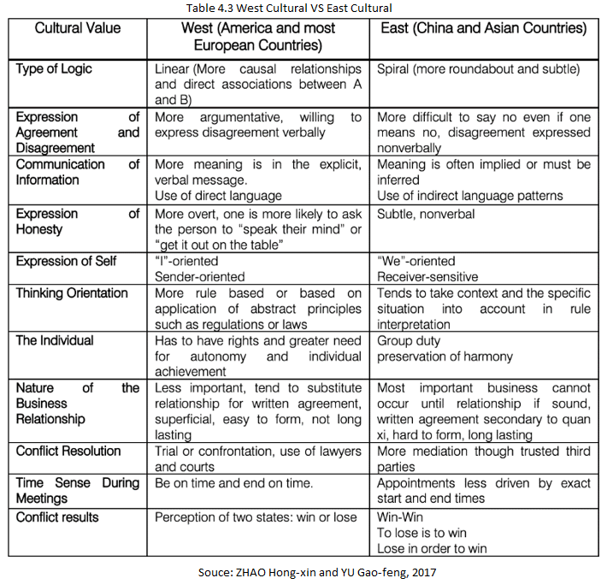

4.2 Challenges
Amid such theoretical analyses, it shows that China has many opportunities that are suitable for UO with the section 3 Country Background and SO Strategies in the section 4.1.1 SWOT analysis but it is not an easy task to do retail in a foreign country, and China's competitive market leads to a rather difficult environment and cultural differences in the section 4.1.2 Hofstede’s Cultural Dimensions. Given its remarkable economic growth, China remains a transformative economy as it transitions from a place where there were little transactions that funded institutions (example Centrally Planned Economies). Therefore, introducing management methods from the advanced Western countries in China may still be troublesome (Warner, 2009). This demands more research that is contextualised and novel. This thesis, based on an analysis of existing research, provides a comprehensive of certain key issues facing western companies in China also provides guidance for future business practice and research. Constructing with the latest business developments in China and international business research (IB), the main emphasis is now on 2 key business environment challenges, including cultural and regulatory challenges, as well as two key management challenges, notably human resource management and innovation.

4.2.1 Identification of potential challenges
This section describes the identification of potential challenges for UO enters China market.

4.2.1.1 Regulatory challenges
Chinese foreign businesses face political, financial, and regulatory problems on 2 major area. Firstly, China is an emerging market represented by a relatively lax regulatory environment which is rapidly evolving. Regulatory changes are dynamic across a wide range of domains, including avoidance of pollution and environmental regulation; control of the financial/capital sector; land regulation; labor markets; and Internet media information, etc. Furthermore, relevant policy processes are usually less explicit. This could mean, for example, that fairly standard day-to-day tasks, such as securing a permit, could theoretically become a burden on management capital.

Secondly, and perhaps far more significant due to their asymmetric effects, state and central government players will theoretically leverage local structural fragility and legislative uncertainty to benefit and fund domestic businesses preferentially (Sutherland, 2003). However, China has long promised aggressive domestic manufacturing programs to nurture national champions. For instance, the East Asian development model (especially the South Korean and Japanese industrial policies, with their huge chaebol and keiretsu groups) follows the strategy of creating a ' national squad ' of about 100 major internationally competitive corporate groups (Guest and Sutherland, 2009). Indeed, this Chinese strategy for development goes back to the early 1980s. The four decades-long growth is now approaching the zenith. Interventions in fields including new technology, e-commerce have been comprehensive, persistent and very influential (World Bank, 2012).

One of today's key geopolitical issues, the China-US Partnership, is closely linked to these current industrial policies. For example in early 2019, international trade negotiations centered on government-driven loans (through the state-controlled banking system), Chinese public procurement and state subsidies, and forced transfer technologies. In short, China appears to be taking regulatory, domestic law and policy action in favor of its domestic companies. In addition, policymakers seem to be strongly engaged in this form of state-orchestrated capitalism. For instance, in existing negotiations of trade, opposed to ' pulling teeth ' by US negotiators due to China's ' obstructionism on access to the market, ' only ' cosmetic, non-impact compromises ' have been made on important issues such as subsidies. Like the US, opinion has also firmly turned against Chinese activities in the European Union.

4.2.1.2 Cultural challenges
China does have a long history that goes back over 5 millennia. It does not come as a surprise that Chinese culture has a major impact on Asia. The Chinese culture has traditionally generated, under the impact of Buddhist, Taoist and Confucian faiths, a profound and rich system of values that have evolved uniquely in every municipality/region of China (Li, 2012). Culture can be identified among groups of people as distinct psychological, beliefs, norms behaviours, rules and systemic assumptions (Langley, 1993). International Business (IB) was concerned with the different processes of companies on the world stage, where different cultures could conflict and/or merge with each other between groups of people (Kwon, 2010). Until Hofstede's pioneering analysis of labour-related principles using information based on worker behaviour surveys of 88,000 IBM sub-unit workers in 40 states, however, there is no suitable cultural index for research by IB scholars (Kreweras, 1982). However, the quantum leap or flowering of the IB studies was primarily focused on these seminal works following the development of the 4 cultural dimensions of Hofstede and later on the Singh and Kogut cultural distance index, which provided the 1st indicator of cultural differences among countries (Kogut and Singh, 1988). IB scholars now frequently carry out research on MNE's international activities across different countries cultures to discover how they have an indirect and direct impact on critical decision-making, the allocation of resources at headquarters, the global network, and the integration of MNE's relations and organizational performance (Zeng et al., 2012).

Although IB scholars had already primarily studied phenomena of cultural in the form of regional differences in culture among host countries and home countries, less attention was paid to sub-national cultural differences within countries, China also explicitly points out that, given the increasing complexity of a country's population, intra-national variations can often be equally significant (Kwon, 2010). For example, in order to empirically investigate employee labor principles in China, Hofstede's national cultural dimensions are extended to sub-national cultural variability measures within mainland China. It notes that sub-national cultures vary between Taiyuan (China's central region) and Shenzhen (China's southern region) in China and that intra-country disparities have been linked to international subsidiary differentials (Ma, Tong and Fitza, 2012). Moreover one issue with earlier studies on sub-national or national cultural differences would be that they barely explore the interaction among sub-national and national differences in culture, particularly when foreign MNEs work in China. However, recent research had also added to such culture-related literature, examining differences in culture on both domestic and cross-country levels, and discovering how certain factors simultaneously influence resource allocation in the creative transition between receiving and sending branches in China (Miao, Zeng and Lee, 2015).

To date, limited research has looked at the impact of cultural differences within and/or across nations. Moreover, relative cultural studies between countries (such as US) and China could make significant contributions to future studies or make them more generalizable. Finally, these cultural differences within and across countries may have an impact on cultural friction and subsidiary staffing in local subsidiaries of international firms; therefore, such research could include significant uses and applications (Singh et al., 2019).

4.2.1.3 Innovation management challenges
Managing innovation in China is critical to both domestically and internationally stakeholders. In the last four decades, it has expressed itself primarily through strategic alliances between foreign and domestic companies in the context of joint ventures. Learning from collaborative partners can contribute to capacity development and to industry upgrading in the form of international partnerships (Zhou and Li, 2008). Although several joint ventures promote learning, knowledge and expertise to increase innovation capacity, international partners recommend not to share the innovation centre to domestic Chinese partners (Herrigel, Wittke and Voskamp, 2013). This largely due to the lack of defence of intellectual property rights. Moreover, where regulatory frameworks allow, joint venture companies in China seek to become an owned wholly foreign subsidiary (Puck, Holtbrügge and Mohr, 2008). Throughout this way, western companies inside corporate borders will protect and develop innovation. China's rapid economic growth also calls for a shift from "Made in China" to "Built-in China" to expand the global competition with the global value chain. Crucially, Chinese creativity's struggle is overcoming the middle-income pit of becoming an innovation economy (Sucală, 2018).

Two new innovation management strategies have drawn substantial interest in both academic research and government policy interventions, which are "Chinese cross-border mergers and acquisitions (M&As) for growth and technology upgrade" and "abroad highly qualified expertise come back to China". First, in search of advanced technology, Chinese firms responded through M&A to the national "Go Abroad" policy. This emerging trend presents difficulties for Chinese acquirers since they wouldn't have the required absorption capacity or misunderstanding of institutional structures to manage strategic assets like technologies and brands in host countries (Liu et al., 2018). One main inspiration in China's attempts to globalize is literacy. Yet effective management of creativity and the transition of expertise involve boundary spanners with appropriate ability and experience. In other terms, human side psychological micro-foundations in strategic collaborations between their Chinese counterparts and foreign firms will significantly affect innovation management (Iles and Zhu, 2012). Second, high-skilled expertise returning to China in the overseas countries became a national strategy. In addition to starting their own innovative and entrepreneurial businesses, returnees can also enter Chinese research universities, institutions and foreign firms to enhance their research capacity. On the organizational and regional level, returners can contribute to entrepreneurship and innovation. Notably, returners can even make up for China's shortage of university ability to promote national entrepreneurship and innovation. The presence and involvement of foreign firms with domestic and returnee firms will contribute to the management of innovations (Liu and Huang, 2018).

By linking the business strategy and innovation management sector, it proposes that emerging economies provide an imaginative laboratory for the generation of new ideas for innovation while addressing the competitive challenges facing both domestic and international companies (Govindarajan and Ramamurti, 2011). For example, reversing innovation will help both China and the rest of the country via offering ' value of many' in addition to ' value of money.' The rapid deployment of advances in technology, such as Big Data and Artificial Intelligence in the digital economy era, creates opportunities for change and growth for both foreign and Chinese companies. We say that China might contribute to innovation, also disruptive innovation despite strong government commitment; foreign firms need to reconsider their innovation strategies to thrive in this competitive digital economy (Li, 2019). Nevertheless, the rest of the world and China fundamentally keep together a common future and China's creativity will eventually bring co-prosperity for the country. The direction forward is to work together and collaborate.

4.2.1.4 Human resource management challenges
One of China's biggest obstacles for multinationals has been retaining and recruiting highly qualified workers. Although there are many college graduates (In 2017 there have more than 7 million graduates), the number of highly qualified talents sought by foreign companies remains limited especially at a higher level of management (Warner, 2009). As a result, highly skilled workers will demand high salaries and quickly switch jobs, culminating in high turnover rates for employees. That's costly for international companies. While foreign firms have lucrative higher-paid jobs, Chinese expertise in the new golden age requires as much as high pay, such as training / development opportunities and flexibility at the workplace (Zhao and Du, 2012). Elsewhere, local Chinese companies have mimicked the foreign companies ' HRM program and become attractive workers. Although foreign firms depend on expatriates in the past, foreign expatriates are much less interested in moving to China, making it much harder for international companies to attract top talent. While Western companies are struggling, foreign firms may have fewer problems with their Asian peers because of the country of origin consequences. Further studies are needed to understand better how international companies could attract Chinese job seekers and how they can retain employees (Zhou and Li, 2008).

The growing problem for foreign and domestic companies alike is rising diversity. Chinese domestic labour-force population patterns are shifting. China is quickly turning into an ageing society. Chinese fertility rates were 1.6 kids per person in 2016, far below traditional fertility replacement rates. In the Chinese background, the bulk of current HRM research focuses on the comparatively younger generations. Throughout China, despite substantial differences throughout interest across generations, little is understood about how businesses should handle an age-diverging group of employees. The inherent complexity of the Chinese labor market would be an external barrier to diversity. The geographical disparity is a significant feature of Chinese HRM activitie. Given the agglomeration of current foreign firms in some countries, it will be practically and theoretically important to explore further interactions among the different regional situations and the efficacy of HRM in international companies. In the meantime, their expatriated talents also become more multicultural within foreign firms. Growth of non-traditional ex-pats in China indicates difficulties in promoting these adaptive human distribution strategies in foreign companies. In addition to international mobility, Chinese workers ' internal mobility could become an ever more important matter (Kang, Shen and Benson, 2016).

5 Conclusion and recommendation
Although China is an exciting market for international companies, this thesis shows most of the main barriers that UO faces when expanding business in China. Table 5.1 describes these and the implications for potential research and practice.
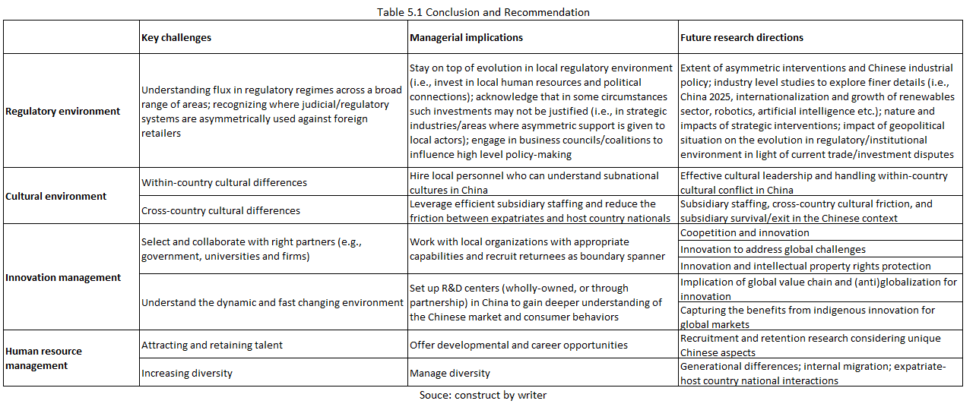

Firstly, China's business environment has become highly difficult in the last decade for global MNEs. The administrative regulatory environment in China entails a change across a wide array of regions (Chang and Cooke, 2015). Moreover, domestic companies lack accountability and transparency in the Chinese legislative system, particularly in some technical industries such as robotics and AI. Most current geopolitical tensions are linked to such asymmetrical trade practices between China and the US / EU (Li, Lee and Zhang, 2018). More work is therefore needed to fully explore the effects and triggers of shifts in industrial policies. It is recommended that UO engage in political connections and human resources to influence policy and/or consider new regulations.

Secondly, China's cultural environment has become a major potential issue for foreign businesses. While many researchers have studied the position of cultures and cultural differences in shaping MNE's activities, there is comparatively less examination of cultural discrepancies between countries (Ambos and Ambos, 2009). Given China's cultural and regional complexities, finding subnational cultural differences within the country isn't surprising (Tung, 2007). Additional study is expected to manage the impact with cultural differences inside and across countries on the strategic management, leadership and recruitment of foreign subsidiaries in China. To regards of the localization, the UO should consider regional differences in employee strategies (Hitotsuyanagi-Hansel, Froese and Pak, 2016).

Thirdly, China's foreign firms also face massive management obstacles, notably in managing innovation. Although China used to gain expertise from global MNEs through foreign partnerships, by introducing international M&As and recruiting highly skilled returners, it now promotes home-grown creativity (Herrigel, Wittke and Voskamp, 2013). Therefore, UO must consider new aspects of innovation management, including the micro-foundation of strategic partnerships with Chinese collaborators and the involvement of local innovation. As an evolving resource-rich country, China might contribute to digital-era innovation. UO may consider learning from China via collaborations with local partners as well as the establishment of R&D centres in China. Further studies are necessary to fully understand how cooperation and creativity from foreign subsidiaries will benefit international MNEs in China.

Eventually, HRM was one of overseas MNE's top management obstacles. Foreign businesses in China are having difficulty recruiting and maintaining highly skilled staff. In the coming years, the situation is likely to persist, if not escalate, due over part to the growing demographic condition (McKinsey & Company, 2012). Changing regional and demographic discrepancies are capable of bringing greater diversity to the workforce. MNEs from Western industrialised countries, now acquainted with these problems, could in better positions to handle this diversity. Chinese companies may learn how to deal with the increasingly diverse Western MNE workforce. UO are encouraged to better understand Chinese talent's desires and change their HRM to retain and attract their workers appropriately. Given these unique, complex characteristics, there is a need for more research to understand better talent management in China (Froese, 2011).

In brief, China provides UO with major challenges but also great opportunities. It has discussed some of these main problems in this thesis potential management response tactics and established areas for future research. It is important that UO recognise the unique business climate and acquire internal credibility to be competitive in China. UO is expected to hire local talent, communicate with the local environment and develop important connections to achieve these goals. By doing so, UO may further expand the depth of understanding the Chinese management.

