
Level 5 Work-Based Group Project (ACDA5022) – Group Project Portfolio
By Jesamy Kellow (2030428)
L4 Ordnance, Munitions and Explosives (OME) Apprenticeship

I declare this report is the product of my own work and is not being submitted for any other degree etc.

Abstract

This report explores what the author contributed to the work-based group project in the Level 4 Ordnance, Munitions and Explosives apprenticeship. The project was to design a firework show to celebrate the graduation of the OME apprentices, so the theme of the show must represent this. The report goes into the group itself, what the author had contributed and what they didn’t contribute, as well as discussing how it was working in a group and how it worked out, or not. A presentation was given to the stakeholders and feedback was provided for such so this will also be explored in the report to help show group strength and weakness.

Contents

Abstract 1
Contents 2
1. Introduction 3
2. The Goal 3
3. The Group 3
4. The Role 3
4.1. Assisting the group 3
4.1.1. Group leader and planner 4
4.1.2. Systems engineering 4
4.1.3. Display design work. 4
4.2. Work the Trials and Test manager was responsible for 4
4.2.1. Types of trials 4
4.2.2. Trial considerations and paperwork 5
4.2.3. Chosen trials. 5
4.2.4. Firework firing system. 5
4.2.5. Firing plan and layout 5
4.2.6. Site layout 5
4.2.7. Disposal process 5
4.3. Work the Trials and Test manager had to pass over. 6
4.3.1. Vegan fireworks 6
4.3.2. Types of fireworks 6
5. Meeting the Goal 6
6. Presentation feedback 7
7. Response to feedback 8
7.1. Positives 8
7.2. Improvements 8
8. Reflections 9
8.1. Design process 9
8.2. Planning and hitting deadlines 9
8.3. Team behaviours 10
9. Conclusion 10
References 11
Appendix 12

Introduction
This report outlines the steps taken to complete a group project which required designing a firework show. The project had some goals to fulfil in any means necessary to get to the end goal while following relevant regulations and procedures. The author of this report discusses the role played and what contributions were made to the group project. Finally, a presentation was given to the stakeholders on the display itself which was given feedback and a response to the feedback is also provided to determine how the group worked together and challenges faced working in a group to produce a project.

The Goal
As the team’s assigned group project, they had to design a firework show following a brief. There was a list of factors within the brief which the group had to follow to provide a successful show; these were [1]:
- The display theme needs to represent OME, the university and education.
- The fireworks are to be fired from the quayside near the IQ building.
- The audience will be located in and around the IQ campus.
- A duration of at least 30 seconds up to two minutes is desirable.
- The materials budget for the fireworks display has a maximum of £10000.
- The display shall not break any legal limitations/regulations.
- Airborne display debris shall be assessed, and any associated safety issues addressed.
- Logistics and safety plans will be required.
- Environmental effects are to be considered and documented.

The Group
Once the goal had been determined, the group got together to determine the roles they needed to complete the project as well as aligning with each other’s strengths. These four roles were:
- Systems engineer – Thomas Caswell – Enjoyed the Systems engineering module earlier on in the course and wanted to use the tools further, also had the smallest amount of explosive experience beforehand so this could be a strength to the other roles.
- Safety Specialist – Christopher Morris – Is already a trained risk assessor and Control or Substances Hazardous to Health (COSHH) assessor so this role best suits them.
- Storage and Transport coordinator – Ashley Pidgeon – Trained Explosive vehicle driver and has experience with storage and transportation rules and regulations.
- Trials and Test Manager (The Author of this report) – Jesamy Kellow – Licensed Trials Conducting Officer (TCO) with the most practical experience of working with explosives, producing documentation, and conducting disposal processes.

The Role
As the Trials and Test manager, there was a lot of pre work required before any specific work could be carried out. It was determined very early on in the process that systems engineering tools must be completed before most other work. Once these tools were used, things like display operator competency, contingency plans, types of fireworks/trials, conducting trials, conducting the actual display and the clear up procedures could be planned out. Although these are the things, we deemed necessary to include in the plan, other roles were naturally picked up by the trials manager as they are a natural motivator, planner and leader.

Assisting the group
Throughout the project there were aspects where the trials and test manager was required to assist the group. The way they helped are discussed in the following sections.

Group leader and planner
As the Trials and test manager, there is a natural ability to plan, lead and motivate a team to conduct trials. As this comes naturally while in a working environment, it also came naturally in the group project environment.
Notes were taken throughout every meeting whether face to face or on teams to provide records or the group actions, key decisions and discussions, these are provided in minutes in appendix [1]. This was important so the group knew what they needed to do in time for the next meetings as well as what each other were working on to provide and ask for help where necessary. This also helped display a clear direction and worked as a motivator to complete work quickly and efficiently.
As the planner of the group, the trials manager also created the final presentation design on behalf of the group as they had the most experience with creative and successful presentation design. The information for each member was then inputted into the slides and made cohesive using the templates decided by the trials manager.

Systems engineering
While the systems engineer was working through the tools and models, the group decided to help with the tools as more opinions and different viewpoints can provide different outcomes.
More specifically, the Trials and test manager, assisted in completing the stakeholder influence map by determining stakeholders and ranking them due to their impact of change and level of influence.
Once the holistic requirement model (HRM) had been carried out by the systems engineer, there were a list of things that needed to be completed to satisfy the model. One of these requirements was “Selecting a display operator”, which the trials and test manager provided using the document [2] to satisfy this requirement. Another requirement was to carry out contingency and emergency plans. The group met up together and made these contingency and emergency plans which were attached to the end of the presentation as hidden slides, the trials and test manager had a large contribution to these from previous experience.

Display design work.
Early in the planning of the display, it became obvious that the design would be the last thing to be completed so it could work with everything found in the planning stages. It was decided that the whole group would contribute to the design.
The safety specialist was using the software and the rest of the group chose the music and layouts to collectively make a firework display. One issue the group had was that the software, FWSim, was being used as a free trial which only gave a few hours to complete the display, once the time was up then it could no longer be edited. The software also wasn’t the clearest when it came to producing the firing plan in appendix [2] as only screenshots from the software could be used to make this, and any overlapping fireworks could have been missed off the plan.
Following the brief to have the firework display represent the OME course, it was determined that the group would primarily use the university colours, Blue and Yellow, relevant symbols were also used; a heart because of the song lyrics and atomic symbol to represent the Ordnance, Munitions and Explosives (OME) course and the group’s company. The song “Boom, Boom, Boom, Boom!! – the Vengaboys” was chosen because it was uplifting, fun and considered easy to make a display to because of the clearly defined “Booms”, also representing OME from the common onomatopoeic explosion sounds caused from OME.

Work the Trials and Test manager was responsible for
When deciding the roles, the trials and test manager decided what activities they wanted cover in their investigations, the following sections discuss the work that they were responsible for.

Types of trials
To conduct a successful firework firing, it is necessary to conduct testing. The testing was used to solidify and backup safety assessments, by testing noise and fallout zones, as well as testing the fireworks to see what they look like and see if they work in the show, looking specifically at angle of ascension and colours in the presentation, but also things like height, timing and size in other examples of testing. The tests determine if the fireworks are as the manufacturer specifies to ensure safety and a well designed and timed firework display.

Trial considerations and paperwork
To conduct a trial, safe conditions must be provided to the operators. The trial considerations in the presentation in appendix [3]. Once a safe environment has been made, it is important to ensure competency in the operators and provide appropriate paperwork to provide traceability for safety and as a prompt to the operators to ensure work is completed to a good quality and to a safe standard. This paperwork includes a competent authority document (CAD) and creating a safe system of work which includes process instructions, risk assessments, brief tracking and anything else deemed necessary in the risk assessment.

Chosen trials.
The trials and test manager then chose a couple of trials as examples of how they would be carried out. These were angle of ascension of aerial fireworks and firework colours which can be seen in appendix [3], slides [31-32]. The two example trials were chosen to represent a safety trial and a design trial. Angle of ascension determines whether the data provided by the manufacturer is accurate, and any deviation can be calibrated for the actual show to improve the design of it. The colour testing is being used to match up the colours to those required. The group has decided that the University of Wales Trinity Saint David (UWTSD) colours will be used which are a dark navy and a yellow, there is also a desire for to also use red and green in the firework designs to represent for pictures, specifically the atomic symbol to represent the company and some hearts to align with the lyrics in the chosen song.

Firework firing system.
Next, there was investigation into the firework firing system. The components, the controllers, modules and igniters/fuses, can be seen in appendix [3], slide [33]. The Cobra systems were chosen as they are a highly reliable and tested firing system as proven by their company’s mission “COBRA places safety, reliability, and ease of use as the foundation of every product feature and design” [3]. and it is important to choose something reliable to reduce the risk of mistakes and misfires during the show.

Firing plan and layout
After the firework show had been designed through the software, the trials and test manager could then plan out a firing plan and a layout for the firing site. The firing plan can be seen in appendix [2] and the layout with the area names and number of fireworks in each section can be seen in appendix [3]. The layout has been chosen to have an even spread of fireworks across the site so they can be spaced apart as much as they can to minimise the risk of embers causing pre-fires.

Site layout
The trials and test manager then looked at what would be required in the set-up process. Firstly, it is to check over the ground area to ensure it is reasonably flat, or can be made flat, and that there is nothing dangerous in the area. If the initial area chosen could not be made flat, then there were contingency areas which could be used which were determined from the zoning work done by the safety specialist. The tubes are then set up and made weatherproof using waterproof sheeting, so damage is not caused to the fireworks if it rains. Finally, communications were investigated in [4, 5] and it was determined that radios were the most effective and would be the quickest and easiest to use.

Disposal process
Finally, it is important to think about the disposal and clear up process before conducting the display. Clear up procedures can be missed easily as the ‘goal’ of firing the display has been completed at that point. However, clear up is just as important to keep stakeholders content. It is necessary to have a contingency plan in place for misfires and duds, which were provided at the end of the presentation, as extra information if required. They can be seen in appendix [3], slide [16]. A suggested clear up procedure was also provided in [6, 5] and can be seen in the appendix also.

Work the Trials and Test manager had to pass over.
Due to the shear amount of work, which was assigned to the trials and test manager, some of it had to be passed over to other members who were willing to take up the work.

Vegan fireworks
When provided with the spreadsheet containing a large variety of possible fireworks, it was noticed that some of them had things like beetles mixed in for the colouring, which of course makes these not vegan/vegetarian. It is common nowadays for people to think more about the environment and animal cruelty, so it was deemed important to try and make the group’s show vegetarian and vegan if possible. This little project was passed over the transport and storage coordinator as they had less to cover in the presentation and were happy to help include this in the group’s work.

Types of fireworks
The other aspect which was passed over was the types of fireworks. The trials and test manager’s workload was too high for them to handle, so they asked for some help form anyone that would be willing to. Transport and storage coordinator decided that this area would be relevant to them too so were happy to take the work over from the manager to lighten the workload. As the smallest group, there was a much higher need for the group to help each other out and share work where needed. The group were good at taking things on happily from each other to help each other out.

Meeting the Goal
The trials and test manager has met the goals of the project and will be demonstrated in the following section.
“The display theme needs to represent OME, the university and education.”
There was a huge input from the trials and test manager towards this goal. The testing was used to determine the specific colouring of the university colours, the atomic symbols were used to represent OME, and the company and the song was chosen because of defined “Booms” representing OME from the common onomatopoeic explosion sounds caused from OME.
“The fireworks are to be fired from the quayside near the IQ building.”
Using the zoning determined form the safety specialist, the trials and test manager could determine the best use of area around the quayside. If one area could not be made suitable flat then there are others determined, if the wing direction could pose a risk to the spectators, then again there are others determined.
“The audience will be located in and around the IQ campus”.
As above, there is multiple areas determined around the IQ campus which can be used for the audience, although where the audience stands will stay the same depending on which area is chosen, they may just have to change the direction they are facing. This was decided for ease for the audience and to hopefully keep moral high ready for the show.
“A duration of at least 30 seconds up to two minutes is desirable.”
The full show is 2 minutes and two seconds, however the final firework gets sent off well within the 2-minute limit, as can be seen in the firing plan in appendix [2], the last fireworks go off at 1:54:80 and the first one doesn’t go off until 00:04:11 so the firework show is well within the 2-minute limit.
“The materials budget for the fireworks display has a maximum of £10000.”
The group’s final costing was priced at £7945.53 which can be seen in appendix [3], slide [34], however this is excluding VAT. So, including VAT of 20%, the final costing goes up to £9,534.63, which is still within the defined budget of £10000. The trials and test manager collected all the different fireworks and costed them up to see how much the show would cost and this was successfully completed.
“The display shall not break any legal limitations/regulations.”
With both the display and the trials contributing to the safety and design of the show, legal limitations and regulations have been in place. Looking at amounts being used; suitable storage and transportation limits were in place to ensure their limits were not exceeded and to make it easier for the trials and test manager to work with the storage and transport coordinator to store and transport the fireworks. Also, suitable documentation has been pointed out and completed to comply with regulations. Also, choosing an appropriately qualified and experienced display operator was discussed to ensure the highest amount of safety and the lowest risk to injury.
“Airborne display debris shall be assessed, and any associated safety issues addressed.”
Airbourne display was assessed by the safety operator and using that information, the trials and test manager was happy that any debris could be cleared effectively. Any that landed in the sea was negligible as the coast guard and marina managers were aware of the possibility of this causing very minimal issues. Any debris on land has monitored during the show and the clear up procedure has been provided in appendix [3], slide [41] to show the clear up has been considered and to ensure waste routes were available.
“Logistics and safety plans will be required.”
The trials and test manager determined the final time that the fireworks could be moved due to issues with weather in order to have enough time available to set up the fireworks somewhere else. Safety plans in the form of emergency plans and contingency plans have been provided in appendix [3], slides [16].
“Environmental effects are to be considered and documented.”
The environmental factors have been considered and documented by the group’s systems engineer however also, the possibility of a vegan display was also pushed by the trials and test manager to ensure this route had been considered due to environmental factors. It was deemed not possible to conduct a vegan show however a vegetarian show is possible as animal products can be exchanged.

Presentation feedback
Presentation feedback has been provided in appendix [4] and the key point from the feedback is as follows in figure [1], displaying the overall scoring and figure [2], displaying the written feedback given to the trials manager and to the group as a whole:
Final Viva
Project type: | Development | Score as Percentages
1. Response to Questioning | 15/30 | 50%
2. Presentation of Design | 20/30 | 67%
3. Demonstration | 15/20 | 75%
4. Presentation Style | 5/10 | 50%
5. Presentation Quality | 8/10 | 80%
TOTAL | 63/100 | 63%

Figure [1] – Table of results provided as Feedback.

Feedback to Trials Manager | Feedback to Group
List of criteria for competent supplier, good  Trials and tests. Where does the target information come from. Are you verifying performance or trying to meet a target with your own design?  Overall diagram of firing control would be good??  Firing plan good  Disposal and misfires. Are there any frequent issues from any of the types used? Past accidents. | Talk to your audience, try not to read off the telly.  I got a lot of what each of you had done to produce the display but not an overall goal for the display design.  There was a lot of the how but not the what.  Would the higher altitude effects be seen with the incoming cloud cover on the day.  Have a look at the weather forecasts supplied on Moodle and see how these affect your decisions.  Stand up when you speak. It shows intent.

Figure [2] – table of feedback given to Trials manager and to group.

Response to feedback
In figure [1], the table shows the score received for each aspect of the presentation, along with the percentage for each aspect.

Positives
Starting with the positives, the areas with the highest percentage scores are “presentation quality” and “demonstration”. The trials manager created the presentation as this was a part of the planning role that the trials manager took on naturally in the group. So, it was a successfully chosen design and the presentation had a very high amount of time and quality put into it. Secondly, the “demonstration” was carried out by the safety specialist, however the group, including the trials manager, assisted in the design, including the music choices and fireworks chosen. The trials manager did specifically choose the colours for the firework to complete the brief of representing the university, as well as representing our company, OME and the nuclear sector.
In the personal written feedback in figure [2], the “list of criteria for competent suppliers” was “good” and the “firing plan” was also “good”. The full firing plan can be seen in appendix [2].

Improvements
There are two particular focus areas which have the lowest percentage of 50%, these are “response to questioning” and “presentation style”. It is clear from both the personal written feedback and group written feedback in figure [2], that these would be the lower marked aspects of the presentation.
Firstly for “response to questioning”, the question was asked around why the testing was being carried out, this was answered however the question was misunderstood so got marked down. Many answers were provided from both the trials and test manager and the safety specialist with things such as calibrating the fireworks, verifying noise assessments and testing colours, however the stakeholder wanted measurable answers to know which limits were being worked to and what limits were being used, such as the amount of acceptable decibels or the timing tolerances of the fireworks. Secondly, around past events on misfires and duds, frequent issues had not been investigated by the author, which was a clear factor missing in the project. This research has since been conducted with the following findings:
Firework misfires, tend to be a relatively common occurrence, especially around October/November time when there are multiple firework displays due to bonfire night and Diwali. This year, October and November 2023, there have been multiple occurrences of fireworks being shot into crowds in and outside of the UK, a couple of examples can be seen in the United Kingdom [7] and New Zealand [8].
In both situations, briefings were held amongst the organisers and first aiders responded to injured parties. Thankfully, both incidents had preparations in place for such mistakes and could quickly get first aiders to respond. As shown in the research, misfires do happen and it would be near impossible to prevent one happening so, it is important to learn from mistakes/ incidents of others and to be prepared in case of an incident unfortunately happening.
Another aspect which was missed was the amount of cloud cover on the day. The safety specialist conducted the weather condition reporting however the whole group focused on rain and wind conditions but missed cloud cover conditions in the project. There are clearly some things that have been missed in the project which have let down the “response to questioning” aspect however next time, further investigation and depth into these aspects will be focussed on to improve this 50% rating.
Finally, “presentation style”, as a group the presentation style suffered mostly due to room layout and misunderstood focus on the presentation. Due to the layout of the room, it was difficult to stand up and it was difficult to have the screen and stakeholders at opposite end of the table so the focus could be at one or the other at one time. Next time, a different layout and a better rehearsal process would have improved the presentation style from the group. Next, there was a lot of talk of the how things were done but not the what and a lot of talk about what each member of the group had done but not the overall goal. As the group had been told it was supposed to be done as though the display had already been carried out and not as though the group were selling it to the stakeholders, the focus was missed, and the way of presenting was not as expected. Next time to improve this, it is important to understand the focus and target audience clearly to ensure the right method of presentation is used.

Reflections

Design process
The actual designing of the show is relatively easy in comparison to what is needed before the show can be designed. While working through the project, more and more tasks came about to make a successful project and a successful and safe show. The overall design of the show doesn’t take too long to do on the software as long as colour themes and a general idea is decided before it commences.
There was a misunderstanding of what the presentation was to do. The group were told, as shown in the minutes in appendix [1], it was to be presented as though the show had already been carried out and it was just informing the viewers of what the group had done, however from the group feedback, the viewers wanted the group to sell their firework display to them, which was missed so the marks received were lower which was disappointing.

Planning and hitting deadlines
The author of this report gathered early on that the rest of the team were going to need more motivation and push to do work than hoped. It was clear someone would need to step up and lead the team to make sure everything was done before well before the deadline, and this was done naturally by the author. The author had to set an earlier deadline due to other commitments and others in the group complied with this quite well to ensure the work was completed and ready to go when commitments were over, the deadline was set as early as possible, so the team were aware of the possible issues, so there was plenty of time to amend plans.
To track our progress, a Gant chant, which can be seen below in figure [3], was produced from our systems engineer under instruction from the author. This really helped with timelines or actions and tasks raise in the group’s meetings. The minutes for these meetings, completed by the author can be seen in appendix [1].

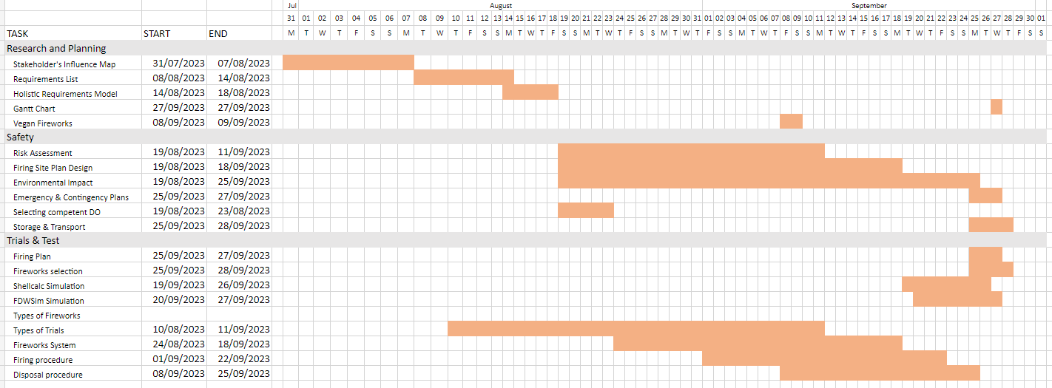
Figure [3] – Gant chart produced for time management.

Team behaviours
There was a mixture of good and bad behaviours experienced in the group. However, these did get better through time. There was an initial demotivation from the group as there was a lot of time until the work was due, so there wasn’t an urgent need to start the work. Once the leader had stepped into place, this got much easier as a plan was formed. Regular meetups to discuss progress and ask for help were put in, both on Teams and face to face, which worked effectively with the minutes paired alongside them to track the actions and key decisions made in the discussions. The group in general were very good at helping each other and asking for help. When the group were made aware that the presentation was worth zero marks towards the final grade of the module, most of the team members lost a lot of motivation and the trials manager found it very difficult to get any motivation back from the group.
The best experienced soft skills were helping others and teamwork, the worst soft skills were enthusiasm and motivation which was not enjoyable for moral within the team.
In general, the group worked very well together and stepped up where needed and tried hard to deliver a good presentation, so the author is happy with how the group performed.

Conclusion
In conclusion, the author has learned a lot about themselves, such as the ability to step into a leadership and planning position in a group as well as being the motivator to complete work. The group project was successfully completed, although with initial issues and feedback to improve upon for next time. However, the end goal was reached in designing a firework display fulfilling the goals introduced in the project briefing.

References

[1] | University of Wales Trinity of St David, “Group Project Assignment Brief,” Swansea, 2023.
[2] | Explosive Industry Group, “Part 2 - Planning the Display,” in Working Together on Firework Displays, 2018, pp. 9-10.
[3] | “Meet COBRA,” August 2009. [Online]. Available: https://www.cobrafiringsystems.com/about.html. [Accessed 09 November 2023].
[4] | Explosive Industry Group, “Communications,” in Working Together on Firework Displays, 2018, p. 12.
[5] | Illuminate Consult 2017, in Person with Specialist Knowledge, Category F4 Fireworks Issue 18.0, 2017, pp. 50-53.
[6] | Explosive Industry Group, “Clearing Up After The Display,” in Working Together on Firework Displays, 2018, p. 57.
[7] | G. Kalsi, Several children are injured as fireworks display 'misfires and slams into crowd' as horrified parents describe 'throwing' their kids out of the way, Stoke-On-Trent: Main Online, 2023.
[8] | D. Laing, Diwali: Firework misfires into crowd at Hastings festival, Hawke's Bay: Hawke's Bay Today, 2023.

Appendix

Appendix 1: Minutes provided from group meetings.

Group Project minutes
01/08/2023 at 10:00am

Participants
Ashley Pidgeon
Christopher Morris
Jesamy Kellow
Tom Caswell

Minutes
Looked at JK presentation.
- CM decided to explain ‘Paperwork’ slide better further with JK mentioning less safety related paperwork.
- AP decided to take ‘Types of fireworks’ from JK to reduce workload.
Stakeholder influence map model created by TC.
- Used book from firework course book to assist with finding stakeholders – 19 determined.
- Completed model with input from all.
Discussion around show design
- Discussed different options for types of shows (none decided yet) – Vegan, low noise, IR, UV, daytime, drones and sheep (being the most panicked stakeholders)

Key decisions
- Team name “Pidge’s Squibs”
- Frequency of meeting – fortnightly meeting with longer monthly meeting
Actions
Holder | Action | COMPLETED
All | Relook at stakeholder influence map model to check the 19 determined stakeholders are in the correct quadrants. | COMPLETED
CM | To write COSHH and Risk assessment for next meeting. | COMPLETED
AP | Look into types of fireworks
TC | Create new systems model for next meeting | COMPLETED
JK | Improve current slides and make slide template for group. | COMPLETED

22/08/2023 at 14:30

Participants
Jesamy Kellow
Thomas Caswell

Minutes
Discussed previous actions. Closed two.
TC – Showed new requirements model.
- TC disclosed the information on initial requirements was found using the assessment specification.
- JK and TC looked through what TC had done and added some new information.
- Action added for ALL to have input in the model.
JK - showed new slide template.
JK - showed current situation of slides as well as information gathered on them pulled from RED and BLUE guides and firework training manual.
- TC said it was good information and would be useful for the requirements model.
- Action added for JK, CM, AP to share information with group to help with systems models.
All - Discussed EPA briefly.

Key decisions:
- Discussed due dates (roughly 30th October to give presentations) to help with timing planning.
- JK offered to meet more frequently for accelerated meetings to ensure enough systems models can be completed before the deadlines.
- All pre-work is to be completed before “design week” (w/c 25th September) due to work commitments in US.

Holder | Action | COMPLETED
All | Relook at stakeholder influence map model to check the 19 determined stakeholders are in the correct quadrants. | Completed
CM | To write COSHH and Risk assessment for next meeting. | COMPLETED
AP | Look into types of fireworks
All | Input data into the requirements model and check over what is written. Use info gathered in personal investigation areas. | COMPLETED
JK, CM, AP | Share information with group to help with new models. | COMPLETED
Key: Red – Carried over from previous meetings.

24/08/2023 at 14:30

Participants
Jesamy Kellow
Ashley Pidgeon
Christopher Morris

Minutes
AP – discussed what he had researched so far.
- Storage legislations
- Movement legislations
AP – shared paper on “what goes wrong” during transport and storage of fireworks.
- On a ship and in an iso container on fire.

CM – discussed he had been working on the risk assessment.
- found there is no need to carry out COSHH assessment as this comes with the firework manufacturing instructions.

CM – shared research document containing general information and list of local companies which would need to be informed.

Key decisions
- Agreed to remain at AWE for the upcoming university week to use time most wisely.
- Agreed all work will be completed ready for “design week” during w/c 25th September.
- Decided to invite Steve Millar to next group meeting and to Thursday of the university week to check our progress.
- No new actions found.

Holder | Action | COMPLETED
All | Relook at stakeholder influence map model to check the 19 determined stakeholders are in the correct quadrants. | CLOSED
CM | To write COSHH and Risk assessment for next meeting. | CLOSED
AP | Look into types of fireworks
All | Input data into the requirements model and check over what is written. Use info gathered in personal investigation areas. | COMPLETED
JK, CM, AP | Share information with group to help with new models. | CLOSED
Key: Red – Carried over from previous meetings.

04/09/2023 at 14:30

Participants
Jesamy Kellow
Christopher Morris
Ashley Pidgeon
Thomas Caswell
Stephen Millar

Minutes
Discussed previous actions and closed three.
CM – Discussed progress with his section.
- A layout plan was shown as well as two further contingencies.
- Weather was discussed with plan to arrange fireworks to suit.
- Zoning areas and road closures were discussed.
AP – Discussed progress with his section.
- Storage limitations with distance from the fireworks.
- Buying in fireworks with shop restrictions
- Issues with storage if the show is cancelled (must be stored properly if longer than 24 hours.
At this point SM joined the meeting and answered some questions for the group.
- SM – discussed our presentation should be done as if it were in the past. We need to report on what we did rather than what we’re going to do.
- Informed us there were both group and individual scores for the presentation.
- JK – asked about which fuses are practically used in displays, the answer being an electric fuse with quick match; others are used more for delays.
- JK – asked about site layout for display. Normally it depends on arcing layout with shells normally having one full gap of material between shells.
Discussed song choice briefly – iron maiden?

Key decisions
- Change report/presentation tense to be in the past.

Holder | Action | COMPLETED
AP | Look into types of fireworks
All | Input data into the requirements model and check over what is written. Use info gathered in personal investigation areas. | COMPLETED
CM | Use ShellCalc software to generate fallout zones ready for design week | COMPLETED
TC | Read through ER14 as well as red and blue books on fireworks | COMPLETED
JK | Finish research information for presentation | COMPLETED
Key: Red – Carried over from previous meetings.

13/09/2023 at 14:30

Participants
Jesamy Kellow
Thomas Caswell
Shaun Dooley
Christopher Morris

Minutes
SD – portfolio discussed with all participants.
SD – practical assessment discussion
- to do at university or not
- XSO on door of test room

CM - Risk assessment discussed.
- Looking into noise levels (silent fireworks and eco-friendly ones)
- SD – metal shower fireworks
Discussed what our roles are with SD.
Discussed what makes a firework conduction officer needs to be competent – has been added into the presentation.
Discussed target audience and focus area.

Key decisions
- Regular meeting place determined. C21.2

Holder | Action | COMPLETED
AP | Look into types of fireworks | COMPLETED
All | Create a Gant chart | COMPLETED
All | Test software on work and personal computers to see if they work | COMPLETED
Key: Red – Carried over from previous meetings.

Appendix 2: Firing plan.
Index | Firing Time (Min:Sec:Milliseconds) | Type | Effect | Firing Position | Firing Angle
1 | 00:04:10 | Mines | 3" Silver glitter (tubed) | L2-B | 0
2 | 00:04:10 | Mines | 3" Silver glitter (tubed) | C-B | 0
3 | 00:04:10 | Mines | 3" Silver glitter (tubed) | R1-B | 0
4 | 00:04:10 | Fountain | MONTE VESUVIO. Lovely fanned fountain, starting with fluffy gold then into silver crackling. RETAIL | L-F | 45
5 | 00:04:10 | Fountain | MONTE VESUVIO. Lovely fanned fountain, starting with fluffy gold then into silver crackling. RETAIL | R-F | -45
6 | 00:04:10 | Fountain | ETNA'S REVENGE. One minute fountain with crackling, coloured stars, silver chrys and red stars with crackling gold. RETAIL | C-F | -45
7 | 00:04:10 | Fountain | ETNA'S REVENGE. One minute fountain with crackling, coloured stars, silver chrys and red stars with crackling gold. RETAIL | C-F | 45
8 | 00:04:10 | Cake | GENDER B. 13 shot cake. Our gender reveal cake starts with a fountain to build the tension before a burst of BLUE to signify the gender. RETAIL | C-B | 0
9 | 00:11:30 | Shell | 3" Gold blink to blue | L1-B | 0
10 | 00:11:30 | Shell | 3" Gold blink to blue | L2-B | 0
11 | 00:11:30 | Shell | 3" Gold blink to blue | R2-B | 0
12 | 00:11:30 | Shell | 3" Gold blink to blue | R1-B | 0
13 | 00:17:30 | Mines | 3" Silver glitter (tubed) | L2-B | 0
14 | 00:17:30 | Mines | 3" Silver glitter (tubed) | C-B | 0
15 | 00:17:30 | Mines | 3" Silver glitter (tubed) | R1-B | 0
16 | 00:17:30 | Fountain | MONTE VESUVIO. Lovely fanned fountain, starting with fluffy gold then into silver crackling. RETAIL | L-F | 45
17 | 00:17:30 | Fountain | MONTE VESUVIO. Lovely fanned fountain, starting with fluffy gold then into silver crackling. RETAIL | R-F | -45
18 | 00:17:30 | Cake | GENDER B. 13 shot cake. Our gender reveal cake starts with a fountain to build the tension before a burst of BLUE to signify the gender. RETAIL | C-F | 0
19 | 00:25:00 | Shell | 4" Red strobe crown to blue double ring | L1-B | 0
20 | 00:25:00 | Shell | 4" Red strobe crown to blue double ring | L2-B | 0
21 | 00:25:00 | Shell | 4" Red strobe crown to blue double ring | R2-B | 0
22 | 00:25:00 | Shell | 4" Red strobe crown to blue double ring | R1-B | 0
23 | 00:29:30 | Cake | GENDER B. 13 shot cake. Our gender reveal cake starts with a fountain to build the tension before a burst of BLUE to signify the gender. RETAIL | L-F | 0
24 | 00:29:30 | Cake | GENDER B. 13 shot cake. Our gender reveal cake starts with a fountain to build the tension before a burst of BLUE to signify the gender. RETAIL | C-F | 0
25 | 00:29:30 | Cake | GENDER B. 13 shot cake. Our gender reveal cake starts with a fountain to build the tension before a burst of BLUE to signify the gender. RETAIL | R-F | 0
26 | 00:32:40 | Cake | GENDER B. 13 shot cake. Our gender reveal cake starts with a fountain to build the tension before a burst of BLUE to signify the gender. RETAIL | L1-B | 0
27 | 00:32:40 | Cake | GENDER B. 13 shot cake. Our gender reveal cake starts with a fountain to build the tension before a burst of BLUE to signify the gender. RETAIL | L2-B | 0
28 | 00:32:40 | Cake | GENDER B. 13 shot cake. Our gender reveal cake starts with a fountain to build the tension before a burst of BLUE to signify the gender. RETAIL | R1-B | 0
29 | 00:32:40 | Cake | GENDER B. 13 shot cake. Our gender reveal cake starts with a fountain to build the tension before a burst of BLUE to signify the gender. RETAIL | R2-B | 0
30 | 00:32:40 | Cake | GENDER B. 13 shot cake. Our gender reveal cake starts with a fountain to build the tension before a burst of BLUE to signify the gender. RETAIL | L-F | 0
31 | 00:32:40 | Cake | GENDER B. 13 shot cake. Our gender reveal cake starts with a fountain to build the tension before a burst of BLUE to signify the gender. RETAIL | R-F | 0
32 | 00:37:10 | Mines | 3" Silver glitter (tubed) | L2-B | 0
33 | 00:37:10 | Mines | 3" Silver glitter (tubed) | C-B | 0
34 | 00:37:10 | Mines | 3" Silver glitter (tubed) | R1-B | 0
35 | 00:37:10 | Fountain | MONTE VESUVIO. Lovely fanned fountain, starting with fluffy gold then into silver crackling. RETAIL | L-F | 45
36 | 00:37:10 | Fountain | MONTE VESUVIO. Lovely fanned fountain, starting with fluffy gold then into silver crackling. RETAIL | R-F | -45
37 | 00:37:10 | Cake | GENDER B. 13 shot cake. Our gender reveal cake starts with a fountain to build the tension before a burst of BLUE to signify the gender. RETAIL | L1-B | 0
38 | 00:37:10 | Cake | GENDER B. 13 shot cake. Our gender reveal cake starts with a fountain to build the tension before a burst of BLUE to signify the gender. RETAIL | R2-B | 0
39 | 00:43:90 | Shell | 3" Gold blink to blue | L2-B | 0
40 | 00:43:90 | Shell | 3" Gold blink to blue | L1-B | 0
41 | 00:43:90 | Shell | 3" Gold blink to blue | R1-B | 0
42 | 00:43:90 | Shell | 3" Gold blink to blue | R2-B | 0
43 | 00:49:90 | Mines | 3" Silver glitter (tubed) | L2-B | 0
44 | 00:49:90 | Mines | 3" Silver glitter (tubed) | C-B | 0
45 | 00:49:90 | Mines | 3" Silver glitter (tubed) | R1-B | 0
46 | 00:49:90 | Fountain | ETNA'S REVENGE. One minute fountain with crackling, coloured stars, silver chrys and red stars with crackling gold. RETAIL | L-F | 0
47 | 00:49:90 | Cake | GENDER B. 13 shot cake. Our gender reveal cake starts with a fountain to build the tension before a burst of BLUE to signify the gender. RETAIL | R-F | 0
48 | 00:50:80 | Shell | 4" Red heart | C-B | 0
49 | 00:51:60 | Fountain | ETNA'S REVENGE. One minute fountain with crackling, coloured stars, silver chrys and red stars with crackling gold. RETAIL | C-F | 0
50 | 00:56:10 | Shell | 4" Red heart | C-B | 0
51 | 00:57:20 | Cake | GENDER B. 13 shot cake. Our gender reveal cake starts with a fountain to build the tension before a burst of BLUE to signify the gender. RETAIL | C-F | 0
52 | 01:02:80 | Fountain | ETNA'S REVENGE. One minute fountain with crackling, coloured stars, silver chrys and red stars with crackling gold. RETAIL | L-F | 45
53 | 01:02:80 | Fountain | ETNA'S REVENGE. One minute fountain with crackling, coloured stars, silver chrys and red stars with crackling gold. RETAIL | R-F | -45
54 | 01:05:80 | Mines | 3" Silver glitter (tubed) | L1-B | 0
55 | 01:05:80 | Mines | 3" Silver glitter (tubed) | C-B | 0
56 | 01:05:80 | Mines | 3" Silver glitter (tubed) | R2-B | 0
57 | 01:13:10 | Shell | 6" Burgundy dhalia with lemon strobe pistil | L1-B | 0
58 | 01:13:10 | Shell | 6" Burgundy dhalia with lemon strobe pistil | L2-B | 0
59 | 01:13:10 | Shell | 6" Burgundy dhalia with lemon strobe pistil | R2-B | 0
60 | 01:13:10 | Shell | 6" Burgundy dhalia with lemon strobe pistil | R1-B | 0
61 | 01:17:70 | Fountain | ETNA'S REVENGE. One minute fountain with crackling, coloured stars, silver chrys and red stars with crackling gold. RETAIL | L-F | -45
62 | 01:17:70 | Fountain | ETNA'S REVENGE. One minute fountain with crackling, coloured stars, silver chrys and red stars with crackling gold. RETAIL | C-F | 0
63 | 01:17:70 | Fountain | ETNA'S REVENGE. One minute fountain with crackling, coloured stars, silver chrys and red stars with crackling gold. RETAIL | R-F | 45
64 | 01:20:20 | Mines | 3" Silver glitter (tubed) | L1-B | 0
65 | 01:20:20 | Mines | 3" Silver glitter (tubed) | C-B | 0
66 | 01:20:20 | Mines | 3" Silver glitter (tubed) | R2-B | 0
67 | 01:20:20 | Fountain | ETNA'S REVENGE. One minute fountain with crackling, coloured stars, silver chrys and red stars with crackling gold. RETAIL | L-F | -45
68 | 01:20:20 | Fountain | ETNA'S REVENGE. One minute fountain with crackling, coloured stars, silver chrys and red stars with crackling gold. RETAIL | R-F | 45
69 | 01:27:50 | Shell | 2.5" White strobe | L1-B | 0
70 | 01:27:50 | Shell | 2.5" White strobe | L2-B | 0
71 | 01:27:50 | Shell | 2.5" White strobe | R2-B | 0
72 | 01:27:50 | Shell | 2.5" White strobe | R1-B | 0
73 | 01:30:70 | Fountain | ETNA'S REVENGE. One minute fountain with crackling, coloured stars, silver chrys and red stars with crackling gold. RETAIL | C-F | 0
74 | 01:30:70 | Cake | GENDER B. 13 shot cake. Our gender reveal cake starts with a fountain to build the tension before a burst of BLUE to signify the gender. RETAIL | L1-B | 0
75 | 01:30:70 | Cake | GENDER B. 13 shot cake. Our gender reveal cake starts with a fountain to build the tension before a burst of BLUE to signify the gender. RETAIL | CB | 0
76 | 01:30:70 | Cake | GENDER B. 13 shot cake. Our gender reveal cake starts with a fountain to build the tension before a burst of BLUE to signify the gender. RETAIL | R2-B | 0
77 | 01:37:80 | Shell | 3" Gold blink to blue | L1-B | 0
78 | 01:37:80 | Shell | 3" Gold blink to blue | L2-B | 0
79 | 01:37:80 | Shell | 3" Gold blink to blue | R1-B | 0
80 | 01:37:80 | Shell | 3" Gold blink to blue | R2-B | 0
81 | 01:39:40 | Shell | 4" Red heart | C-B | 0
82 | 01:51:80 | Shell | 4" Red peony to Ti chrys | L1-B | 0
83 | 01:51:80 | Shell | 4" Red peony to Ti chrys | L2-B | 0
84 | 01:51:80 | Shell | 4" Red peony to Ti chrys | C-B | 0
85 | 01:51:80 | Shell | 4" Red peony to Ti chrys | R1-B | 0
86 | 01:51:80 | Shell | 4" Red peony to Ti chrys | R2-B | 0
87 | 01:54:80 | Fountain | MONTE VESUVIO. Lovely fanned fountain, starting with fluffy gold then into silver crackling. RETAIL | L-F | -45
88 | 01:54:80 | Fountain | MONTE VESUVIO. Lovely fanned fountain, starting with fluffy gold then into silver crackling. RETAIL | C-F | -45
89 | 01:54:80 | Fountain | MONTE VESUVIO. Lovely fanned fountain, starting with fluffy gold then into silver crackling. RETAIL | C-F | 45
90 | 01:54:80 | Fountain | MONTE VESUVIO. Lovely fanned fountain, starting with fluffy gold then into silver crackling. RETAIL | R-F | 45

Appendix 3: Final group Presentation
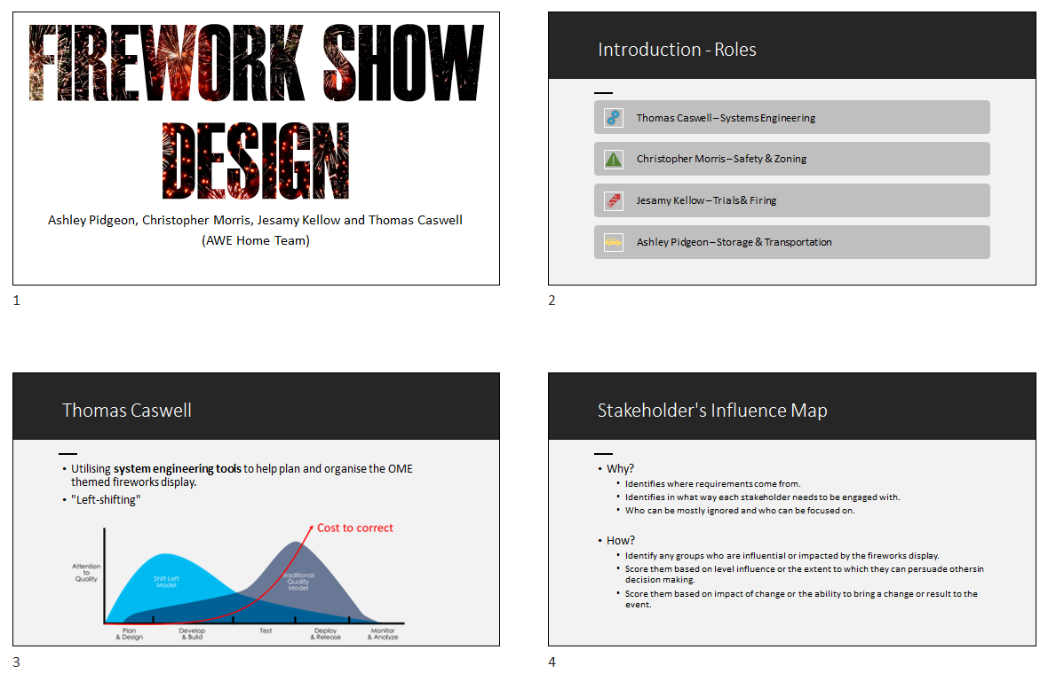
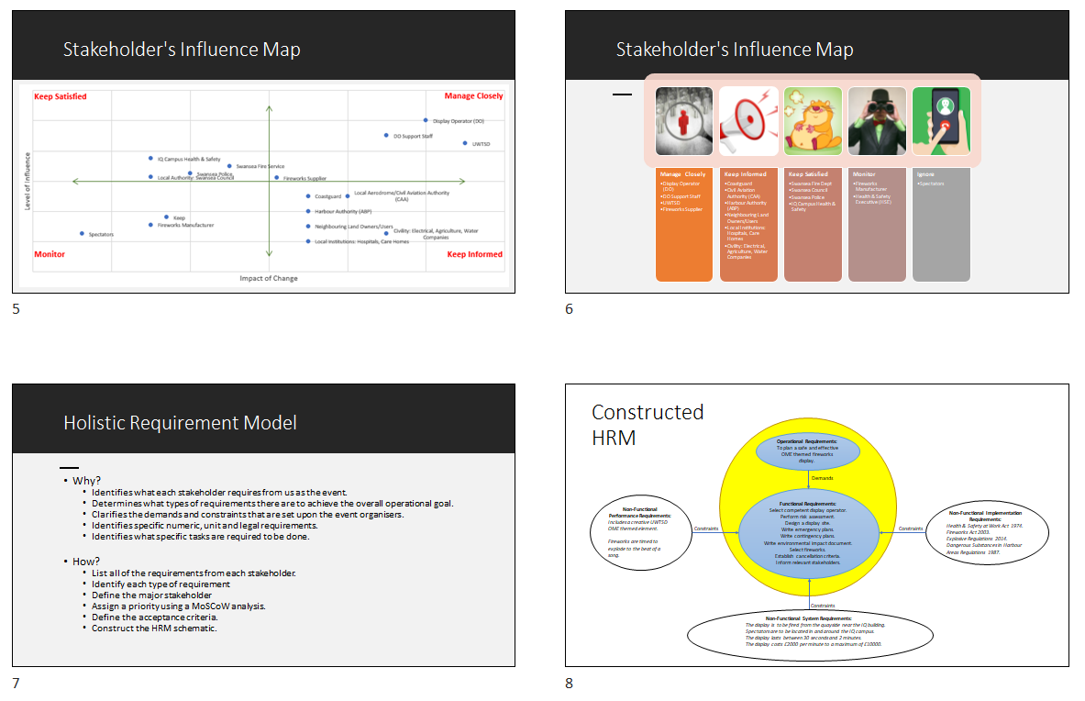
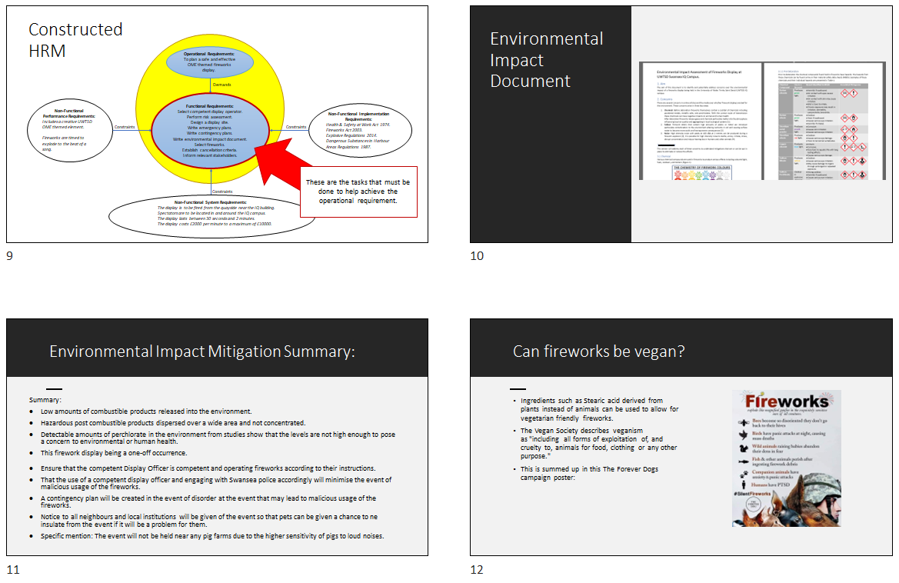
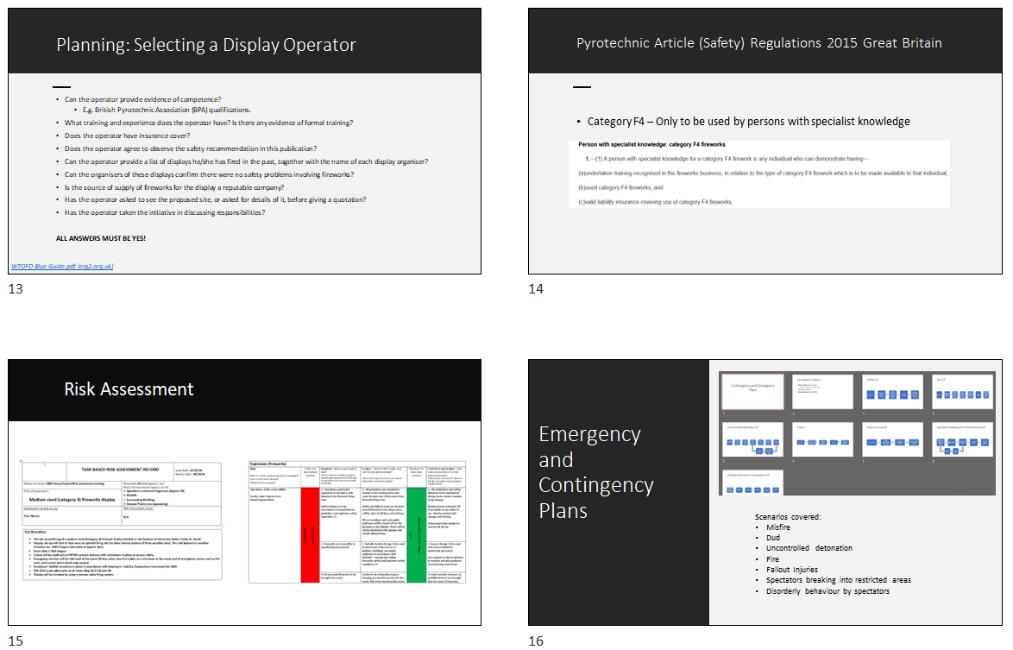
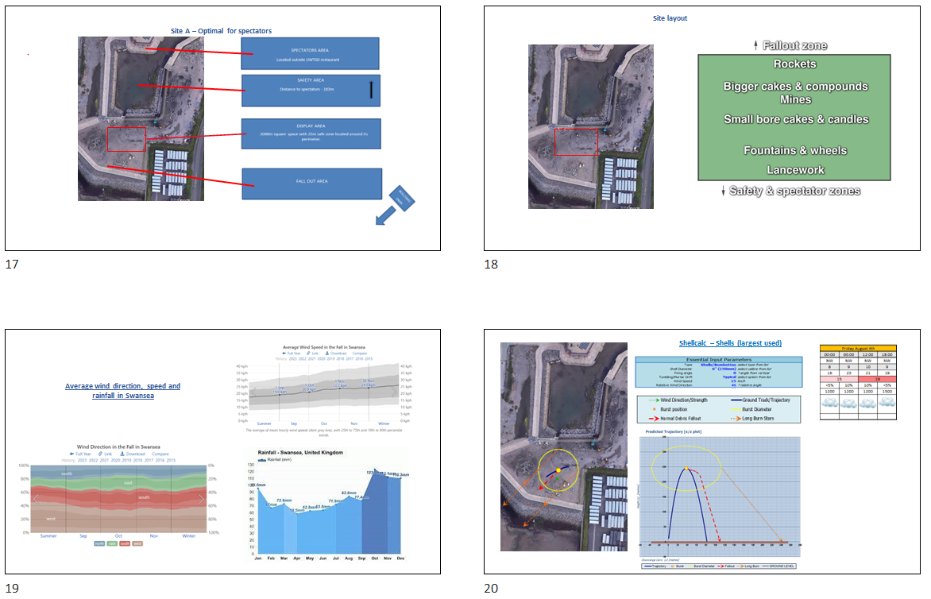
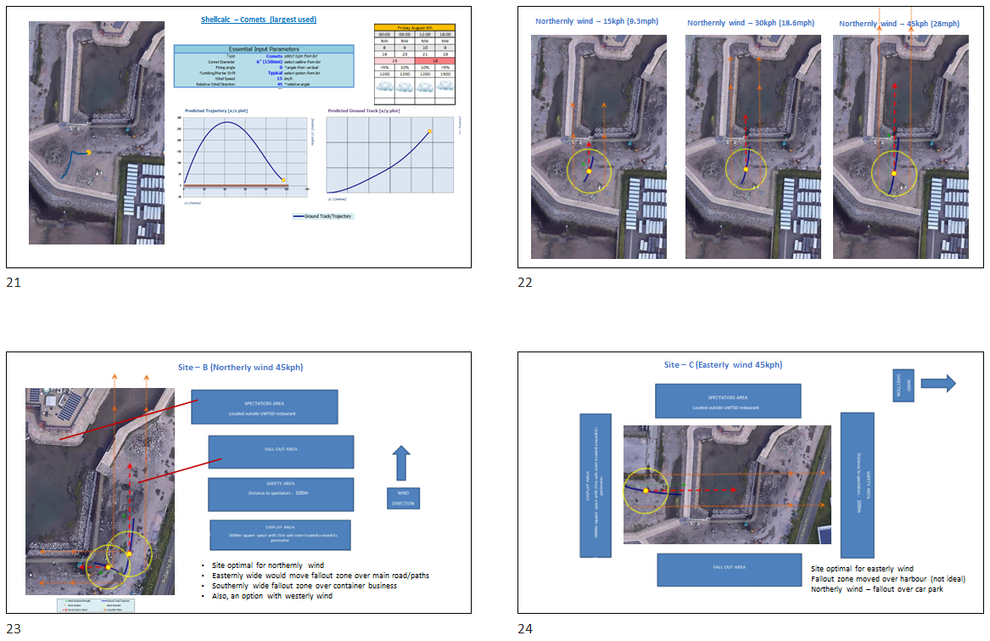
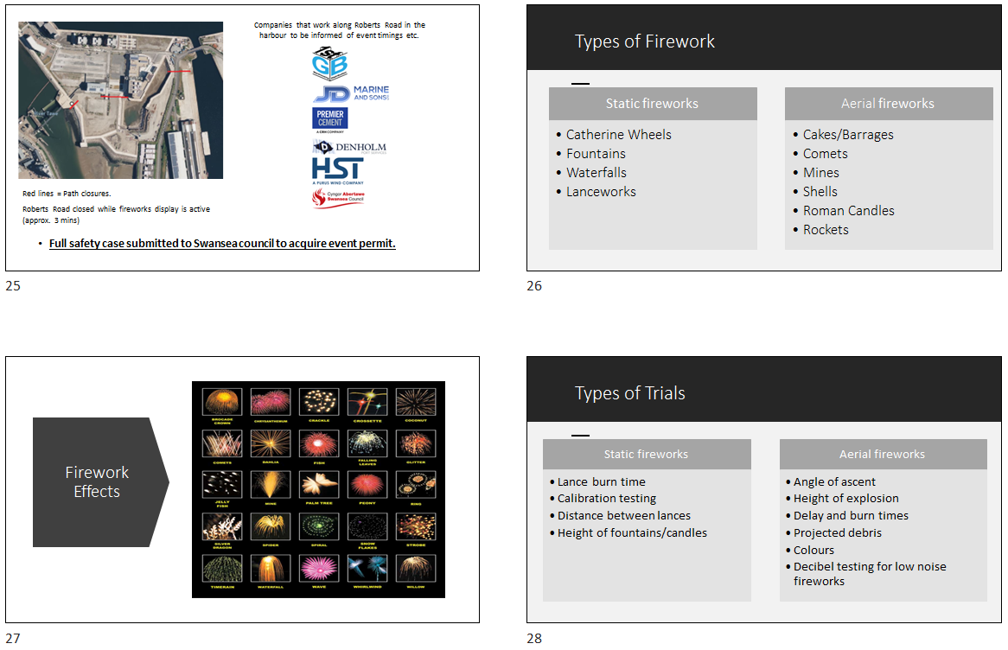
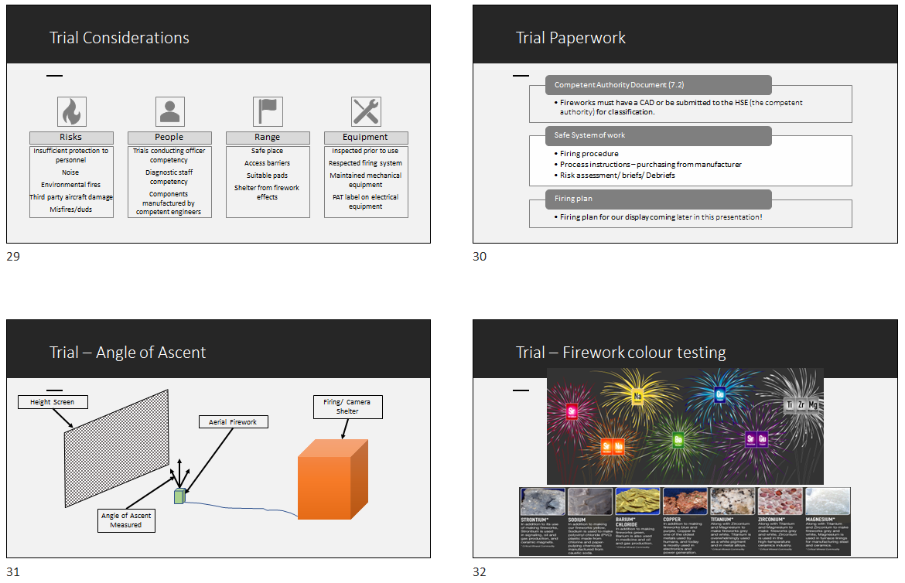
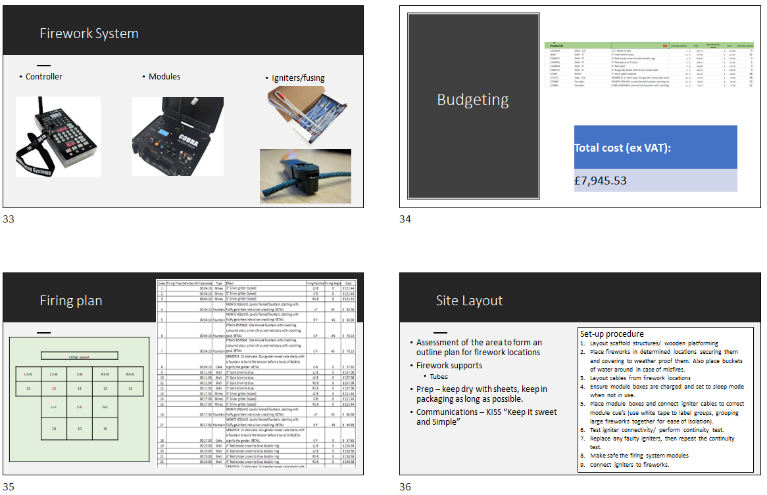
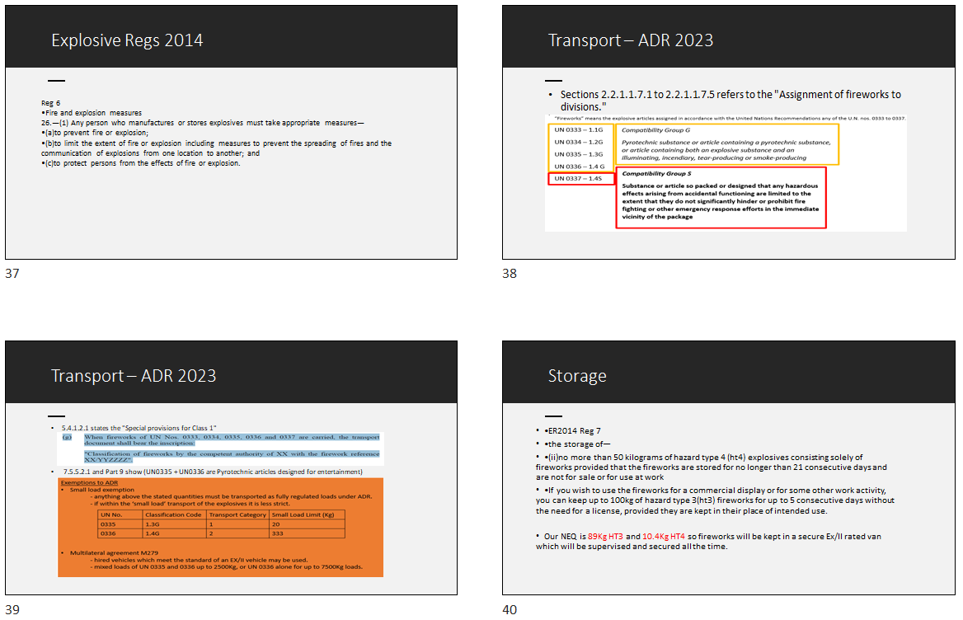
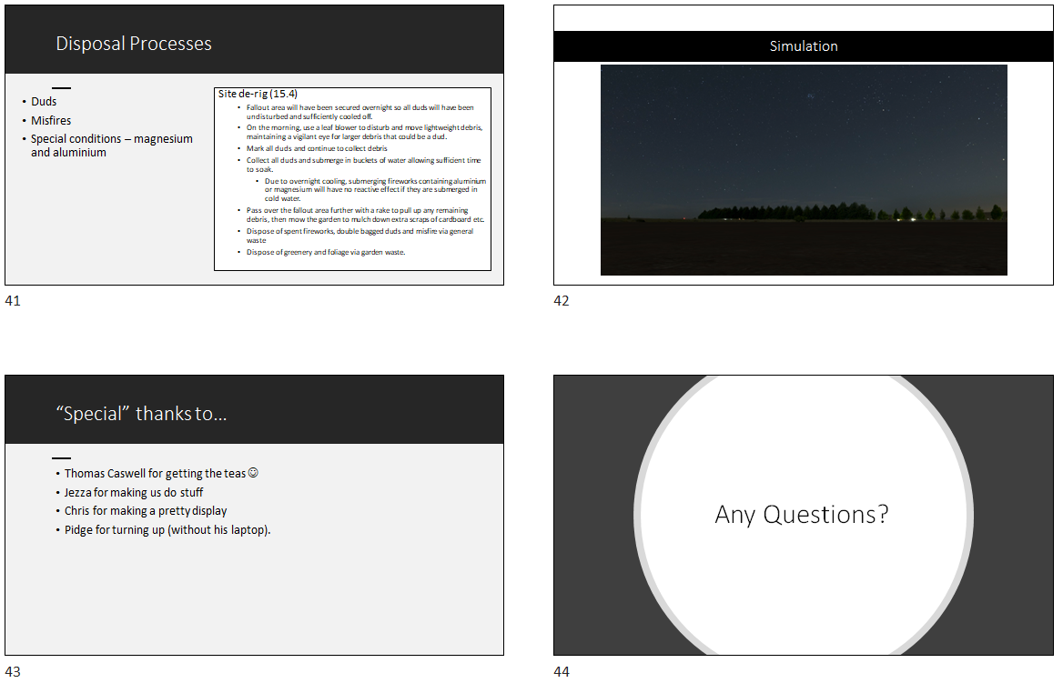

Appendix 4: Presentation feedback

Group Name: | Group 2 AWE Angleterre.
Title of Project: | Graduation Firework
Supervisor: | Dave Holley
2nd marker: | Steve Miller (AWE/IExpE)
Pathway: | Technical Research & Development  Safety  Manufacturing & Processing  Breakdown & Disposal  Test & Evaluation  (Please indicate)
Project Type: | Survey Review Experiment Development (please indicate)

Final Viva
Project type: | Survey | Review | Experiment | Development
1. Response to Questioning | /30 | /30 | /30 | 15/30
2. Presentation of Design | /50 | /50 | /25 | 20/30
3. Demo | - | - | /25 | 15/20
4. Presentation Style | /10 | /10 | /10 | 5/10
5. Presentation Quality | /10 | /10 | /10 | 8/10
TOTAL | /100 | /100 | /100 | 63/100

(Feedback/Comments on next page)
Feedback/Comments:
Tom

Introduced roles.
SE tools used.
Influence map. Good.
Why ignore spectators??
Environmental mitigations mentioned. Process needs to be brough out in the report.
Read slides…. pointing towards telly.

Ash

Vegan fireworks? Additional requirement
Category F4
Types of firework selection
What did you pick for your display and why?
Regs covered including transport,

Jess

List of criteria for competent supplier, good
Trials and tests. Where does the target information come from. Are you verifying performance or trying to meet a target with your own design?
Overall diagram of firing control would be good??
Firing plan good
Disposal and misfires. Are there any frequent issues from any of the types used? Past accidents.

Chris

Safety case prepared, how was this created? What are the scoring scales.
How did you scale down the risk assessment for the programme.
Detonation?? I hope not with fireworks.
Looked at various scenarios for incident…Causes?

Shel calc used for development of the safety case.
Scenario based calculations were supplied.
Wind direction terminology wind blows from the direction stated. (Work is sound…. just needs tying in with the correct direction.)

All.

Talk to your audience, try not to read off the telly.
I got a lot of what each of you had done to produce the display but not an overall goal for the display design.

There was a lot of the how but not the what.

Would the higher altitude effects be seen with the incoming cloud cover on the day.
Have a look at the weather forecasts supplied on Moodle and see how these affect your decisions.

Stand up when you speak. It shows intent.

