


remediating polluted land

Environmental Pollution Control – M6X01198
Author: Sion Evans (P150600)
Lecturer: Andrew Thorn
School of Engineering

Executive Summary
This paper aimed to describe how a site investigation would take place, evaluate remediation techniques and proved recommendations to a potential site developer. The findings can be summarized below:
- Site investigation takes place in a three-stages conceptual model phase whereby potential pollution is determined, later confirmed by a survey and desk study followed by a comprehensive site investigation to determine significant risks.
- There are many remediation techniques that work by physical, chemical, biological and electrical mechanisms through the method of either immobilisation, separation, toxicity reduction or extraction.
- For a potential developer looking to remediate land a consideration of ethical acceptance, cost, effectiveness, efficiency and site-specific contamination levels, depth and mixture should be considered in your remediation technique decision.

List of Figures
Figure 1. Three-stage conceptual model diagram (Environmental Health and Trading Standards, 2006). 6
Figure 2. Exposure model diagram (F.A Swartjes, 2012) 9
Figure 3. Division of remediation categories with multiple techniques (Lianwen Liu, 2018). 10

List of Tables
Table 1. Impacts of heavy metal contaminants associated with the former industrial site. 5
Table 2. Matrix of likely contamination risk scoring system (Environmental Health and Trading Standards, 2006) 7
Table 3. Igeo classes with relation to sediment quality (F.A Swartjes, 2012). 8
Table 4. Organic immobilizing amendments for heavy metals (Raymond A.Wuana, 2011) 11
Table 5. In-organic immobilization amendments for heavy metals (Raymond A.Wuana, 2011). 11
Table 6. heavy metal hyperaccumulating plants with concentration values (Raymond A.Wuana, 2011) 12
Table 7. Evaluation of remediation techniques with respect to cost, efficiency and effectiveness. 14

List of Equations
$Igeo=log2Cn1.5Bn$ Equation 1. Geo-accumulation Index equation. 8
$Σoral exposureCEVoral+Σinhilation exposureCEVinhilation=1$ Equation 2. Human health based risk equation 9

Contents
1. Introduction 3
2. Basic Soil Chemistry and Impacts of Contaminants 4
3. Identification of Contaminated Land. 6
3.1. Three-Stage Conceptual Model 6
3.1 1. Stage 1 – Identify Potential Pollution Linkages. 7
3.1 2. Stage 2 – Establish Actual Pollutant Linkage. 7
3.1 3. Stage 3 – Establish Significant Linkages. 7
4. Land Remediation Techniques 10
4.1. Overview 10
4.1 1. Immobilization 11
4.1 2. Toxicity Reduction 12
4.1 3. Extraction 12
4.1 4. Separation 12
4.2. Evaluation of Techniques 12
5. Recommendations 14
6. References 15

1. Introduction
Soil contamination can be a serious threat to humans and all living organisms, in a world with limited resources and an ever-growing population, the remediation of contaminated land is of paramount importance for improving the health and safety of living beings and the availability of land for future human activities (Deyi Hou, 2017). Contaminated land is any land which appears to the local authority to be in such a condition where significant harm can or is being caused or where polluted water is or likely to be caused – Part IIA Contaminated land 1990 (Environment Agency, 1990).
Heavy metals are a group of metals and metalloids that naturally occur in the Earth’s crust, with an atomic density greater than 4000 $kg{ m}^{-3}$, many of them are essential micro nutrients for organic life however, the accumulation through human activities such as warfare and military training, mining, smelting, electronic industries, fossil fuel consumption, waste disposal, irrigation and agrochemical use (Lianwen Liu, 2018). Those most commonly found in contaminated land are Lead (Pb), Chromium (Cr), Arsenic (As), Zinc (Zn), Cadmium (Cd), Copper (Cu), Mercury (Hg) and Nickel (Ni) (Raymond A.Wuana, 2011).
Through a review of literature surrounding field tests, this paper aims to explain how a site survey can be undertaken on a former industrial site that has suspected to be contaminated with Cd, Hg, Cr and Zn. Following investigations this paper will evaluate techniques that can potentially remediate the land with consideration of the financial, ethical and health & safety issues that follow and recommend the most appropriate technique subsequent to condition such as contaminent, geology and quanitity.

2. Basic Soil Chemistry and Impacts of Contaminants
Soil chemical material is a function of its parent material ranging from glacial drift, fluvial material and mass wasting of rock caused by gravitational forces (Mahdi M. Al-Kaisi, 2017). Heavy metals occur naturally in the Earth’s crust and therefor occur in the soil from the weathering of parent material at acceptable trace levels of <1000 $mg kg^{-1}$. The acceleration of the slow geochemical cycle of metals by human activities described in section 1, one or more of the heavy metals accumulate and impact the ecology of the environment. The distribution of such metals through soils takes place through ion exchange, complexation, adsorption, mineral precipitation & dissolution and desorption (Raymond A.Wuana, 2011). Details of the role and impacts of the four constituent metals can be seen in [Table. 1] with information sourced from (Deyi Hou, 2017; Chao Su, n.d.; Lianwen Liu, 2018; Raymond A.Wuana, 2011). (CHANGE) Research has clearly shown that it is not the total concentration but the reactive fraction of heavy metals in soil that dictates their toxicity to plants, microbes, and human beings. The water-soluble and exchangeable forms of heavy metals are much more reactive and bioavailable than the precipitated species (Robertset al., 2005; Leitgib et al., 2007; Kim et al., 2015). (Rog-Young Kim, 2015)
Major pathways for heavy metals to enter into the soil include poorly treated industrial waste-water used for crop irrigation, pesticides, animal manure, fertilizers and the atmosphere where heavy metals in the form of vapour deposit into the soil through percipitation and natural sedimentation (Chao Su, n.d.). Soil is a major sink for heavy metals, they are adsorbed by initial fast reactions followed by slow adsorption reactions and redistributed into various chemical forms with varying txicity and bioavailibility (J. Shiowatana, 2001). This accumulation of heavy metals has a detrimental effect on soil chemistry and subsequent effect on the ecosystem, humankind and can inhibit the biodegredation of organic contaminents. It can be done through drinking conta,inated water, ingestion or contact with soil, phytotoxicity and It can lead to environmental issues such as bioaccumulation and biomagnification in the food chain (Yohey Hashimoto, 2009). As a result numerous remediation technologies have been divised to remove and reduce contamination to a desried level restoring the land to a stable and ussable condition.

Metal | Anatomy | Natural levels in Soil ($mg kg^{-1}$) | Roles | Impacts
Cadmium (Cd) | An (Z) – 48  Group – IIB  Post-transition metal  Occurs as –  Cd (II) ion | N/A – does not occur naturally in soil | Has no essential biological function and part of the “big three” heavy metal poisons. (among Pb and Hg). | i) Similarities with essential trace element Zn, substitution causes malfunctions of metabolic processes.  ii) Adversely affects enzymes responsible for absorption of proteins in kidney tubules.  iii) Can cause painful bone disease and kidney malfunction
Chromium (Cr) | An (Z) – 24  Group - VIB  Transition metal  Contaminant occurs as –  Cr (VI)  Cr +III oxidation state | Occurs as a compound Chromite -$FeCr2O2$ | Essential trace mineral that improves insulin sensitivity and enhances protein, lipid and carbohydrate metabolism. | i) Can leach from soil into groundwater.  ii) Leachability increases as soil pH increases.  iii) Associated with allergic dermatitis, along with low blood sugar and kidney damage.
Mercury (Hg) | An (Z) – 80  Group – IIB  Post-transition metal  Contaminant occurs as –  Mercuric ($Hg^{2+}),$  mercurous $(Hg2^{2+}$),  elemental ($Hg^{o}$),  alkylated form. | N/A – does not occur naturally in soil. | No essential biological functions. | i) Associate with kidney damage  ii) Soluble in water and volatile in air
Zinc (Zn) | An (Z) – 30  Group – IIB  Post-transition metal | 70$mg kg^{-1}$)  Occurs in the earths rocks. | Essential mineral for human health, preventing - birth defects, stunted growth, acute diarrhoea in children and Wilsons disease | i) Large presence in industrial wastewater plants, Increases the acidity of water subsequently increasing Cd concentration.  ii) Enters the body of fish and biomagnifies up the food chain to fatal levels.  iii) Plants cannot handle accumulated levels of zinc causing phytotoxicity.  iV) Negatively influences the activity of microorganisms reducing the breakdown of organic waste
Table 1. Impacts of heavy metal contaminants associated with the former industrial site.

3. Identification of Contaminated Land.
The identification of contaminated land is done through a risk assessment approach as per the Part 2A of the environmental protection act 1990 (Environment Agency, 1990). In order to prompt remediation, there must be one or more contaminant-pathway-receptor linkages whereby hazards pose risk defined by the DEFRA statutory guidance (Environmental Health and Trading Standards, 2006) as:
- The likelihood that harm, or pollution of water will occur as a result of contaminants in, on or under the land.
- The scale and seriousness of such harm or pollution if it did occur.
Where,
- A ‘contaminant’ as a substance which is in, on or under the land which has the potential to cause significant harm to a relevant receptor or to cause significant pollution to controlled waters.
- A ‘receptor’ as something that could be adversely affected by a contaminant, typically categorised into four groups: Human, groundwater, surface water and ecology.
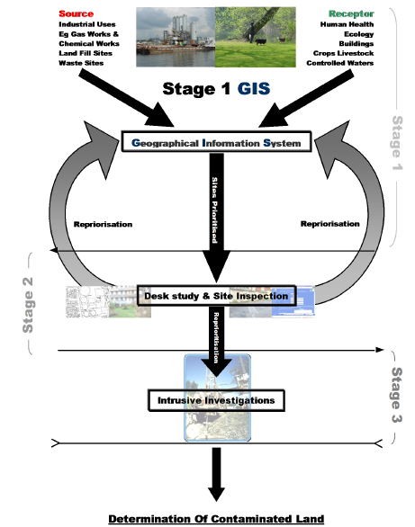
- A ‘pathway’ as a route by which a receptor is or might be affected by a contaminant.

3.1. Three-Stage Conceptual Model
The risk-based approach is completed through the use of a three-stage conceptual model that is as follows: stage 1-identify potential pollution linkages within the matrix, 2-establish actual pollutant linkage and 3-establish significant linkages as shown in [Fig. 1] (Environmental Health and Trading Standards, 2006). A breakdown of each stage as reported by the Environment Agency can be seen below. The model is constructed for each receptor type separately to prioritise risks of harm to human health.

Figure 1. Three-stage conceptual model diagram (Environmental Health and Trading Standards, 2006).

3.1 1. Stage 1 – Identify Potential Pollution Linkages.
This process is undertaken by combining sources of existing information held by ordinance surveys, Environment Agency, British geological survey and the council. This information is used to investigate historical land use, geology, hydrogeology and potential receptors to determine whether pollution linkages occur. Data sets are used to determine coincidence influential relationships between the source and receptor (Environmental Health and Trading Standards, 2006). Potential linkages are scored and numbered to evaluate the risk index before moving onto stage 2 and 3. An example of this can be seen in [Fig. 2].
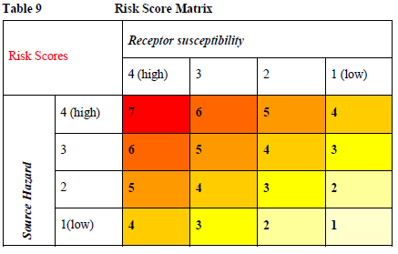

Table 2. Matrix of likely contamination risk scoring system (Environmental Health and Trading Standards, 2006)

3.1 2. Stage 2 – Establish Actual Pollutant Linkage.
Once the potential of pollutant linkage is determined as desk-based study and walkover survey is done to determine the existence of pollutant linkage and the likelihood of significant harm and/or pollution. The process begins with a walk over survey to validate the interpretation of data from stage 1. Next a formal desk study is carried out where external regulatory authorities and landfill operations (British geological society, Environment Agency) are consulted along with landowners and property developers to consider whether there is enough evidence of pollutant linkages before moving onto stage 3.

3.1 3. Stage 3 – Establish Significant Linkages.
This stage the presence of significant pollutant linkages is established through a comprehensive investigation where soils and groundwater samples are taken in a sampling strategy, followed by a site-specific risk assessment (DEFRA, 2010).
Sampling Strategy:
Tier 1 of establishing significant linkages is determining a sampling strategy with clearly defined objectives, the strategy chosen is determined through considering several factors (National Academy of Sciences, 2005) such as:
1. Sample handling protocols. 2. Laboratory capabilities. 3. Collection efficiency. 4. Risk assessment. 5. Other potential uses of collected samples.

Some objectives of sampling strategies include:
1. To provide preliminary screening of a facility. 2. Identification of threat agents in bulk material. 3. Extent and location of contamination. 3. Determine efficiency of decontaminations.
Sample grids are formulated around local pollution sources for soil contamination depending on the purpose and site-specific conditions of the investigation. For example if the pollutant is spread evenly samples are collected at regular distances from one another, if they are spread un evenly the separation of samples depends on distance from the source and influencing factors like wind direction and gradient (Algirdas Dumčius, 2011).
Sampling is typically done alongside subsampling site within 1-5m of each other to account for differences in soil type. The depth of the samples is dependent upon site-specific conditions and investigation scope. For the most precise soil examination sample depths of 0-6cm is required and samples for ecological investigations are collected at around 10-25cm depth. However, physical clay fractures permit the contaminants to spread deeper with greatest concentrations of Cr, Ni, Cu and Zn are found as deep as 40-60cm (Algirdas Dumčius, 2011). Stainless steel spades are typically used to collect soil samples, although soil layer deeper than10cm requires a soil drill. Deeper samples >20 are collected using a Niemest type gravity tube.
Sample analysis is carried out using a range of technologies such as: Atomic Absorption Spectroscopy, Inductively Coupled Plasma atomic absorption and direct current electrical breakdown of gas atomic emission spectroscopy. Following sample analysis, a geo-accumulation index is calculated using [Eq. 1] to determine the accumulation of heavy metals (F.A Swartjes, 2012; Lianwen Liu, 2018). which is then used alongside a risk assessment and compared with soil quality standards to validate whether intervention levels have been succeeded, resulting in confirmation of an urgent remediation. Intervention levels are described as contaminant values that succeed the intervention value, based on if 50% of the species is at or above their normal observed effect concentration, prompts a human health and ecological risk assessment (F.A Swartjes, 2012)
$Igeo=log2\frac{C_{n}}{1.5Bn}$ Equation 1. Geo-accumulation Index equation.
Where,
$C_{n}$ = the concentration of element ‘n’.
1.5 = variation factor.
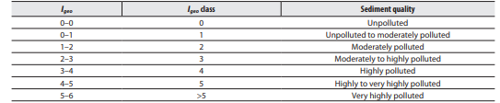
Bn = background data.
Table 3. Igeo classes with relation to sediment quality (F.A Swartjes, 2012).

Site specific risk assessment for human health and ecology typically starts with an exposure assessment using an exposure model. Such model determines contaminant distribution, transfer from soil to contact media and direct and in-direct critical exposure values (CEV) to humans seen in [Fig. 2] (F.A Swartjes, 2012). With greater difficulty around assessing ecosystem exposure since each species explores its environment in different ways.
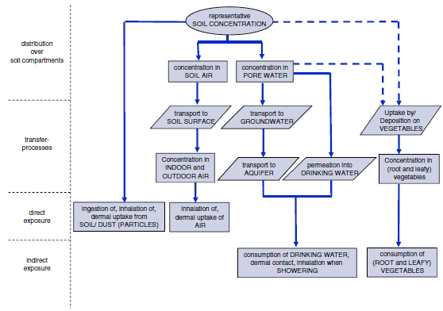
Figure 2. Exposure model diagram (F.A Swartjes, 2012)

Human health risk based can be defined as the concentration of a contaminant in a soil, for which the sum of oral and inhalation risk indices equals 1 (F.A Swartjes, 2012). This can be written as:
$\left(Σ\frac{oral exposure}{CEVoral}\right)+\left(Σ\frac{inhilation exposure}{CEVinhilation}\right)=1$ Equation 2. Human health based risk equation
Where,
$Σ$ oral exposure = sum of exposure from all pathways [$mg kg^{-1}bw d^{-1}$].
CEV oral =reference dose of oral exposure [$mg kg^{-1}bw d^{-1}$].
$Σ$ inhalation = sum of inhalation exposure from all pathways [$mg kg^{-1}bw d^{-1}$].
CEV inhalation = reference value of inhalation exposure [$mg kg^{-1}bw d^{-1}$].

4. Land Remediation Techniques

4.1. Overview
This section aims to evaluate remediation techniques with a brief overview description of the main 5 categories. A more comprehensive description into how each technology works can be found across a range of literature, however, it is not within the scope of this report to provide full descriptions (Chao Su, n.d.; Guanlin Guo, 2006; Kene Onwubuya, 2009; Guanlin Guo, 2006; Celestino Quintela-Sabarís, 2017; M.A. Hashim, 2011).
The objective of land remediation is to create a soil composition with acceptable levels of heavy metals that do not have an adverse effect on humans, flora or fauna (S E P A, 2008). This is done by interrupting the pollution linkage ideally at the source though typically done along the path. This is done by either reducing the toxic material within the soil or by increasing the separation of contaminants from the pollution linkage through a range of techniques. Remediation techniques can be classified into three categories, including: i) in situ gentle remediation. ii) in situ harsh soil restrictive measures. iii) In or ex situ harsh soil destructive measures (Raymond A.Wuana, 2011). In-situ meaning performed on sire and ex-situ meaning performed on an external site. Heavy-metal remediation techniques can be further classified into Isolation, Immobilization, Toxicity reduction, Physical separation and Extraction (REF). This can be done through physical, electrical, chemical or biological methods, through taking in-situ or/and ex-situ measures. An example of some of the technologies used can be seen in [Fig. 1].
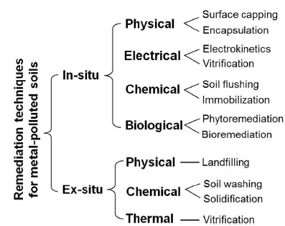

Figure 3. Division of remediation categories with multiple techniques (Lianwen Liu, 2018).

4.1 1. Immobilization
The function of immobilisation is to alter the contaminant soil metals to a more geochemically stable phase via precipitation, sorption and complexation using organic and in-organic amendments, shown in [Tables. 4, 5]. This is done by accelerating the attenuation of metal mobility (Yohey Hashimoto, 2009). Immobilisation method covers a range of sub-techniques such as vitrification, solidification and chemical immobilisation and is performed in-situ or/and ex-situ depending on site-specific conditions.
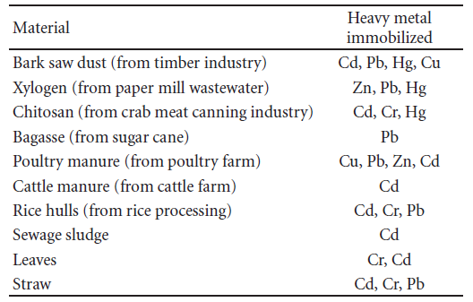

Table 4. Organic immobilizing amendments for heavy metals (Raymond A.Wuana, 2011)
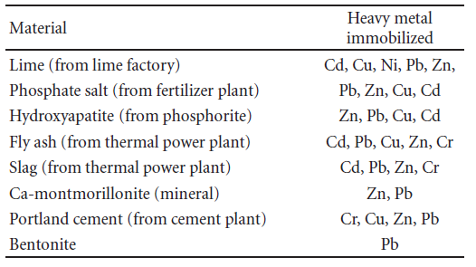

Table 5. In-organic immobilization amendments for heavy metals (Raymond A.Wuana, 2011).

4.1 2. Toxicity Reduction
This is the process of reducing the toxicity of the soil to acceptable levels through a range of techniques from chemical treatment (oxidation), bioremediation (bioleaching, bioextraction), Phytoremediation (Cystus ladanifer). It is worth noting that phytoremediation and bioremediation both include a range of sub-technologies, descriptions of which can be seen in (Celestino Quintela-Sabarís, 2017; J. Paz-Ferreiro, 2014). An example of phytoremediating plants are shown in [Table. 6]. The previously discussed techniques can be done in or ex-situ depending on the depth and accumulation of the contamination.
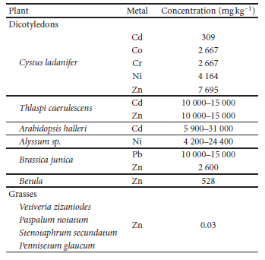

Table 6. heavy metal hyperaccumulating plants with concentration values (Raymond A.Wuana, 2011)

4.1 3. Extraction
This technique aims to extract the contaminant from the matric using a range of technologies from soil vapour extraction, electrokinetic extraction and the use of landfill sites.

4.1 4. Separation
Using a physical or chemical mechanism, the contaminant is separated from the environment. This can be sub-divided into soil washing, surface capping and encapsulation.

4.2. Evaluation of Techniques
The remediation techniques are evaluated as a function of cost-effectiveness, effectiveness, efficiency, environmental impacts, with data sourced from (Okoduwa, 2018; Lianwen Liu, 2018; Raymond A.Wuana, 2011; Chao Su, n.d.; Rog-Young Kim, 2015).

Technique | Applicability | Advantages | Disadvantages | Target Metals
Chemical Immobilization | In or Ex-situ, high contamination. | Affordable, immediate effect easy to implement | Metal specific, temporary effectiveness contamination remains in the soil | All
Vitrification | In or Ex-situ, high contamination | Easily applied for reclamation of heavily polluted matrix, high efficiency, may destroy volatile metal species (Hg) | High cost, limited to small area, treated land loses environmental functions | Hg, Cd, Cr
Solidification | In or Ex-situ, high contamination | Fast to implement, high efficiency | High cost, treated land loses its environmental functions. | All
Soil Flushing | In-situ, course soil moderate to high | Contaminant removal, minimal soil disturbance, easy to implement, low cost | Specific to course-textured soils, potential aquifer pollutant. | All
Phytoremediation | In-situ, low to moderate contamination | Environmentally friendly, high public acceptance, no need for disposal site, low cost, can treat sites with more than one type of pollutant, easy to implement, suitable for large areas, | Limited to shallow contamination, dependant on growing conditions, metal specific, time-consuming, depending on plant tolerable, low efficiency | Cd, Cr, Zn
Bioremediation | In-situ, low to moderate contamination | Environmentally friendly, low cost, easy to implement, minimal soil disturbance | Low efficiency, supplemental to principle remediation techniques | Cd, Cr, Hg, Zn and more
Landfill | Ex-situ, high contamination | Immediate action, high security | Requires additional land contamination, high cost | All
Electrokinetic Extraction | In-situ, fine soil moderate to high contamination | Contaminant removal, minimal soil disturbance. | Low efficiency, specific to fine-textured soil,  Time consuming | Cr, Zn, Hg
Surface Capping | In-situ, high contamination | High security, low cost, easy to install. | Loss of land Limited to a small area, | All
Sub Surface Barrier | In-situ, high contamination | High security, fast to install | high cost, loss of land Limited to a small area, specific to shallow contamination, | All
Soil Washing | Ex or in-situ, moderate to high contamination | Fast acting, soil can be recycled on site, High efficiency, reduces long-term liability | Extreme soil disturbance, risk of spreading contaminants, high cost | All
Pump and Treat | In situ, moderate to high contamination | Efficient | Extracted water has to be treated, specific to homogenous soil, | Soluble pollutants
Table 7. Evaluation of remediation techniques with respect to cost, efficiency and effectiveness.

5. Recommendations
Assuming the site investigation finds the potential contaminants to be present, using the evaluation table in section 4 the best remediation technique can be determined with respect to the following recommendations:
Cost-effectiveness – availability of funding
Effectiveness of treatment – the future land use of the site determines the level of contamination that must be removed, for example residential allowable contamination is lower than that of an industrial site therefor the future land use must be considered.
Ethical reasoning - some remediation techniques have negative impacts on the environment and other only temporarily remediate the land, therefor ‘doing the right thing’ is a consideration that should be included in your decision.
Site-specific conditions – certain techniques are limited to specific contaminants, whilst others work for all and usually it is a trade off for each. Consideration into the accumulated level and mixture of heavy metals should be included to ensure an effective remediation solution.

6. References
Algirdas Dumčius, D. P. J. K.-K., 2011. Selection of Investigation Methods for Heavy Metal Pollution on Soil and sediments of Water Basins and River Bottoms: A Review. EKOLOGIJA., Volume 57, pp. 30-38.
Celestino Quintela-Sabarís, L. M. P. S. K., 2017. Assessing Phytotoxicity of Trace Element-contaminated Soils Phytomanaged with Gentle Remediation Options at Ten European Field Trials. Science of the Total Environment, Volume 599-600, pp. 1388-1398.
Chao Su, L. Q. J. W. Z., n.d. A Review on Heavy Metal Contamination in the Soil Worldwide: Situation, Impact and Remediation Techniques.
DEFRA, 2010. Contaminated Land Remediation, London: DEFRA.
Deyi Hou, S. Q. B. Z. M. R., 2017. Incorporating Life Cycle Assessment With Health Risk Assessment to Select the ‘Greenest’ Cleanup Level for Pb Contaminated Soil. Journal of Cleaner Production, Volume 162, pp. 1157-1168.
Environment Agency, 1990. Environment Act 1995. [Online]
Available at: http://www.legislation.gov.uk/ukpga/1995/25/section/57
[Accessed 02 03 2020].
Environmental Health and Trading Standards, 2006. Strategy for The Identification of Contaminated Land, London: Environmental Health and Trading Standards.
F.A Swartjes, M. R. J. L., 2012. State of The Art Contaminated Site Management in The Netherlands: Policy Framework and Risk Assessment Tools. Science of the total Environment, Volume 427-428, pp. 1-10.
Guanlin Guo, Q. Z. l. Q. M., 2006. Availability and Assessment of Fixing Additives for The in Situ Remediation of Heavy Metal Contaminated Soils: A Review. Environmental Monitoring and Assessment , 116(1-3), pp. 513-528.
J. Paz-Ferreiro, H. L. S. F., 2014. use of Phytoremediation and Biochar to remediate Heavy Metal Polluted Soils: A Review. Solid Earth, Volume 5, pp. 65-75.
J. Shiowatana, R. M. N. C. a. A. S., 2001. Fractionation of Arsenic in Soil by a Continuous-Flow Sequential Extraction Method. Journal of Environmental Quality, 30(6), pp. 1940-1949.
Kene Onwubuya, A. C. M. P., 2009. Developing decision support tools for the selection of “gentle” remediation approaches. Science of Total Environment, Volume 407, pp. 6132-6142.
Lianwen Liu, W. L. W. S. M. G., 2018. Remediation Techniques for Heavy Metal-Contaminated Soils: Principles and Applicability. Science of the Total Environment, Volume 633, pp. 206-219.
M.A. Hashim, S. M. J. N. S., 2011. Remediation Technologies for Heavy Metal Contaminated Groundwater. Journal of Environmental Management , Volume 92, pp. 2355-2388.
Mahdi M. Al-Kaisi, B. L., 2017. Soil Health and Intensification of Agroecosystems. 1st ed. s.l.:Academic Press.
National Academy of Sciences, 2005. Sampling Strategies and Technologies. In: Reopening Public Facilities After a Biological Attack: A Decision Making Framework. s.l.:National Academies Press, pp. 120-136.
Okoduwa, S. I. R., 2018. Toxicity and Bioremediation of Heavy Metals Contaminated Ecosystem from Tannery Wastewater: A Review. Journal of Toxicology, Volume 1, p. 16.
Raymond A.Wuana, F. E. O., 2011. HeavyMetals in Contaminated Soils: A Review of Sources, Chemistry, Risks and Best Available Strategies for Remediation. International Scholarly Research Network, Volume 1, p. 20.
Rickson, R. J., 2007. Land Remediation. [Online]
Available at: https://www.aweimagazine.com/article/land-remediation-464/
[Accessed 26 03 2020].
Rog-Young Kim, J.-K. Y. T.-S. G. O., 2015. Bioavailability of Heavy Metals in Soils: Definitions and Practical Implementation—A Critical Review. Environmental geochemistry and Health, Volume 37, pp. 1041-1061.
S E P A, 2008. Land Remediation and Waste Management Guidelines, s.l.: Scotish Environmental Protection Agency.
Yohey Hashimoto, H. M. M. T., 2009. Impacts of Chemical Amendment and Plant Growth on Lead Speciation and Enzyme Activities in a Shooting Range Soil: An X-ray Absorption Fine Structure Investigation. Journal of Environmental Quality , 38(4), pp. 1420-1428.

