Investigating Contemporary Issues in Secondary Education
ECSP7001

James Little

Student Number: 1701370
2017/2018

PGCE Business Studies
Faculty of Education and Communities

Total Word Count: 6,533
Actual Word Count: 5,034



Contents Page
- Table of Abbreviations …………………………………………………………………. 3
- Introduction …………………………………………………………………………....4-5
- The Value of Assessment of Learning ………………………………………………. 5-6
- Overview of Improvement Plans …………………………………………………….7-10
4.1 The Schools Improvement Plan ………………………………………………7-8
4.2 Business, Economics and I.T Departmental Plan ………………………….8-10
- Strategies Applied to Assess Learning within School X ………………………….10-11
- Recommendations for Improving the Quality of Assessment for Learning …….11-15
  - Feedback …………………………………………………………………….11-12
  - Questioning ………………………………………………………………….13-15
- The Progress made to date by School X ………………………………………………16
- Conclusion ………………………………………………………………………………17
- References …………………………………………………………………………...18-21
- Appendices …………………………………………………………………………..22-27

- Table of Abbreviations
Professional Teaching Experience | PTE
Digital Competency Framework | DCF
Literacy and Numeracy Framework | LNF
Y Cwricwlwm Cymreig | YCC
Welsh Joint Education Committee | WJEC
Welsh Education Inspectorate | ESTYN
Assessment for Learning | AFL
More Able and Talented | MAT
Additional Learning Needs | ALN
Special Educational Needs | SEN
University of Wales Trinity St David | UWTSD
Key Stage 3/4/5 | KS3/4/5
More Knowledgeable Other | MKO
Post Graduate Certificate in Education | PGCE
Dedicated Improvement Reflection Time | DIRT

- Introduction

The purpose of the following report is to inform the Governors at School X of a critical account of progress made on the introduction of an initiative which is identified in the schools Departmental Improvement Plan.
Students at School X perform exceptionally well at all key stages. The school consistently performs well above expected levels and achieve some of the highest outcomes in both Wales and the UK. The school achieved the highest performance at GCSE in the country, with 85% of students achieving 5 or more A* - C grades. Nearly all students progress to university with a significant number attending Oxbridge and Russel Group Universities. It is clear to see that the systems in place are working well within School X and it is reasonable to say that the Assessment for Learning strategies that are in place, are efficient and succeeding. Nevertheless, there is always scope for scrutiny and improvement.
The main focus of this report will be concerned with the applied strategy of improving and adapting the inclusion of Assessment for Learning within Business Studies lessons at School X. Not only will the Business, Economics and I.T. (one joint faculty) Department Plan be thoroughly scrutinised and digested but so will the schools overall Improvement Plan. The Department and School Improvement Plans (DIP and SIP respectively) will be measured against academic and professional literature. Particular focus and detail will be given to the current implementation strategies in place, specifically within Business Studies, to assess pupils learning. By doing this the overall purpose of the report should be achieved. Assessment within School X has been chosen as an area to report on and improve on following the further analysis of the Schools Estyn Report. It is within this report that one of the recommendations given was to “ensure more consistency in the quality of assessment and its impact on the standard of pupils’ work” (Estyn, 2011).²⁴
It must be remembered that assessment not only takes place of teachers towards pupils, but pupils will also make their own daily assessments. “It is the belief that teaching is the inverse of learning, and that in the context of organised schooling one cannot occur without the other” (Lewis, 1974).³⁶ As a process, AfL is structured, interactive, and involves both teachers and learners working together to elicit, interpret, and act on information about student learning (Vlachou, 2015)¹²
Literature, along with the authors knowledge will expectantly create recommendations for subject specific, and overall departmental strategies to target the Assessment for Learning (AfL).

- The Value of Assessment for Learning

It does not take a well-educated academic to realise that within the education system, assessment of a student or pupils learning is occurring on a daily basis. However, many are not aware of the various forms of assessment. Assessments towards learners are based on several different aspects during their careers. Aspects may include assessing their knowledge and understanding, skills, attitudes and values, and also behaviour. According to literature, AfL (or formative assessment, as it is also known) is intended to enhance both teaching and learning (Black et al. 2003; Earl 2013; Heritage 2013; Shepard 2007; William 2011; Vlachou 2015).⁷

Tanner and Jones support the idea that “Educational policy in England and Wales has emphasized the managerial and communicative purposes of assessment at the expense of pedagogical purposes. When the National Curriculum was first introduced, it was claimed that its assessment would support five purposes: formative, summative, evaluative, informative and helpful for professional development.” (Tanner and Jones, 2003., p13)⁵ Similarly, Isaacs and colleagues (2013), citing Crooks (2011), point out six factors in effective AfL: 1) committed, motivated participants; 2) students’ acceptance that they need help; 3) students’ understanding of the learning goals; 4) appropriate learning goals; 5) the development of students’ self-assessment skills; and 6) feedback (Vlachou, 2015).⁹ Moreover, similar reviews by other authors have shown equally high effect sizes of AfL practices, especially on feedback (Hattie, 2008; Hattie and Timperley, 2007, Vlachou, 2015)¹¹ The curriculum design seems to have a core impact on the implementation of AfL (Vlachou, 2015).¹³

Many think of assessment in schools as the standard ‘summative’ or ‘terminal’ formal exams or class tests, and in doing so do not realise that assessments are being made by teachers on a daily basis. A teacher providing suggestions or finding solutions by an informal, ‘interim’ simple conversation occurs on a far more regular basis, especially when they absorb and react to the way the class is responding. It is the finding solution and pupil needs that is further supported by Shepard: “In terms of identifying the big ideas behind AfL, scholars argue that AfL is to be used for adjusting and learning instruction to better meet students’ needs” (Shepard, 2007).⁸ In addition to formal exams and class tests, it must be remembered that the implementation of AfL should not be evaluated as effective only by a rise in examination scores (Black and William, 2010).¹⁸

As E. Wragg states, “It is safe to say that assessments are mainly carried out by teachers, but some examples illustrate self-evaluation” (Wragg, 2001., p6)¹ such as pupils collaborating to achieve a certain goal. Nevertheless, it is without doubt that all assessments, be it ‘formal’ or ‘informal’ will influence the learners finished product. Assessment has and will always be a crucial element within the education system, and an attribute that all teachers must be able to develop and execute efficiently. “In such a rapidly changing environment, where teachers have to think on their feet and are denied the luxury of hours of reflection over each of their pedagogic choices, assessment has to be carried out on the move.” (Wragg, 2001., p7)² To oppose this however, assessment experts from many countries have made radical claims about the effectiveness of AfL on student learning (Black et al. 2003; Popham 2011; Earl 2013; Vlachou 2017)¹⁰

Building on the idea of change within the system, it is clear to see that great changes are being made within Business Studies, especially due to the removal of coursework for GCSE pupils. Coursework has been a vigorous and broadly used form of assessment within schools for many a year. However, it comes with challenges. “Coursework must be carefully monitored if it is to be taken seriously. Badly monitored coursework is open to abuse, especially in the form of plagiarism.” (Wragg, 2001., p10).⁴ Therefore the value and effectiveness of assessment has clearly been analysed by many. It is this analysis that is helping address the pitfalls in assessment. It is challenging as a school and as a teacher to ensure the validity, reliability and consequences of assessments are occurring.

“The ultimate end user of assessment information should be the student, and to be considered formative, assessment should be used to improve student performance.” (Black and William, 1998)⁶

- Overview of Improvement Plans

The school improvement plan creates an overview and sets several target areas for development. The SIP of School X covers a three-year period of 2017-2020, although it will be modified periodically and reviewed to measure the impact of their actions.

Key Stage 4 and Key Stage 5 will be the primary focus of this report due to the fact Business Studies is only taught at Key Stage 4 and above. The Department Plan and overall School Improvement Plan at School X correlate well and hold several similarities. “It is essential that all teachers within a school develop a teaching and learning policy together, to be committed to their beliefs and ideals for their students and their school.” (Clarke and Fisher, 2009., p23)³. This is supported by the SIP of School X, “All performance management and departmental/faculty improvement planning will link closely to the whole-school planning cycle” (See Appendix 1). It becomes clear that one of the main focuses of School X is the importance of AfL within the centre.

4.1 The Schools Improvement Plan
The Sutton Trust defines effective teaching as “that which leads to improved student achievement using outcomes that matter to their future success” (Sutton Trust, 2018). Educational research into effective teaching and learning returns to this critical point: student progress is the yardstick by which teacher/school effectiveness should be measured. And so as stated within the SIP, “Our priority is to help make our ‘most effective practice, daily practice’ for all of our students (See Appendix 1). There are many examples of excellence in teaching or learning at School X. It is the previously mentioned daily practice that is heavily reliant on The 5 Principles of ‘Excellence’.

School X has made great changes to their Schools Improvement plan. Following their Estyn Report feedback in 2011 and later in 2013, new approaches and process have been put in place. One such process is the creation of their 5 Principles of ‘Excellence’ criteria that each department works towards (See Appendix 4). The 5 Principles of ‘Excellence’, one of the Prioritised Objectives within the SIP, are heavily based upon the AfL for the pupil within the classroom. It is seen across all subject areas that leads to consistently ‘good’ or better learning. The overall approach to AfL has improved in recent years and this has come with great successes, as previously mentioned.

One of the main features of the 5 Principles of ‘Excellence’ is the High Level of Challenge. It is this approach to challenging the learner along with their important view upon assessment that has guided the school towards a ‘growth mind set’. “Perhaps the most common misconception is simply equating the growth mindset with effort. Certainly, effort is key for students’ achievement, but it’s not the only thing. Students need to try new strategies and seek input from others when they’re stuck. They need this repertoire of approaches – not just sheer effort – to learn and improve.” (Ritchie, 2018).

A further area of the 5 Principles of ‘Excellence’ is ‘Quality Questioning’. “Teachers use questions to engage the students and sustain an ‘active’ style to the learning.” (NSEAD.org, 2018)
It is clear to see that the approach to questioning within School X has been passed down to applied to the department of Business, Economics and I.T. This will be expanded in section 4.2.

  - Business, Economics and I.T Departmental Plan
There is strong correlation between the SIP and the DIP in more ways than one. Both plans are concerned with assessment. As previously stated, School X has the widely known goal of achieving high grade results. What is clear to see from analysis of the DIP, is the attention given to assessment outside of the classroom, in terms of examination assessments, and not so much attention upon daily assessments. It is the focus upon daily assessments in various forms, not just that of examinations, that the author will later recommend take place.

However, it must be said that daily, internal assessments do occur on a regular basis. As a whole school approach, DIRT time is allocated to pupils on a regular basis. It is used effectively as a good way of analysing and acting upon feedback. “Feedback is one of the most powerful influences on learning and achievement, but this impact can be either positive or negative.” (Hattie and Timperley, 2011)

“Quality focused specific feedback and helpful way forward ensure the highest standards are achieved. ‘Feedback for Improvement’ documentation provides detailed written comments with effective WWWs and EBIs. In many lessons DIRT activities allow opportunities for students to respond to feedback and make further progress” (See Appendix 2). Quality focused specific feedback and helpful way forward ensure the highest standards are achieved. It must be mentioned that the approaches to feedback within School X is a stronger element on their Estyn Report. “Most teachers provide good verbal feedback to pupils in lessons. In many cases, teachers put an appropriate emphasis on developing pupils’ abilities to critically evaluate their own and other pupils’ work against explicit assessment criteria” (Estyn, 2011).²⁵

The quality of feedback given by teachers is specific and helps identify ways for students to improve their learning. Useful opportunities for checking progress are used well by nearly all teachers. As a result, most students can confidently describe what learning is taking place, reflect on the progress they have made, and can identify their own specific targets for improvement.

To further add to the efficient use of DIRT time, the department likes to focus heavily on questioning. “Assessment is regular for Business and Economics and informs future improvement. In the most effective lessons, questioning is open-ended and this encourages students to deepen their understanding very well. Students set specific individual targets to focus progress and these are shared and agreed” (Refer to Appendix 2). It is the simple use of using open ended questions, or asking the whole class a question and then following it with a pupils’ name, which is widely approved by scholars as an effective way to increase and improve a student’s learning. Leaving the direction of the question hidden until the end ensures all pupils are listening and do not ‘zone out’ as they know they will not be asked to answer. It is the application of questioning that can ultimately help decrease the attainment gap within the classroom and also ensure pupils are more well prepared for examination practical scenarios. “The females in the class outperformed males in 5 out of the 7 practical questions and males slightly outperformed females in 2 out of 6 of the written theory questions.” (Refer to Appendix 3) It is the application of different questioning techniques that will ensure School X are able to close the gap between the males and females within Business Studies. Questioning techniques are one recommendation the author will make later in this report.
The faculty have consistently worked within the guide lines of the Schools current SIP as well as introducing their own elements to improve the performance of their learners. One latest element applied to improve the outcome in assessments for the learners is to carry out their own marking of various exam answers through the use of colouring systems applied to assessment objectives. The department understands where it is at and where is needs to be. Teachers regularly undertake more formal assessments of pupils’ work and record the outcomes efficiently. Most teachers have a good understanding of the data for their classes and department, and of departmental targets (Estyn, 2011).²⁶

- Strategies Applied to Assess Learning within School X
Multiple approaches to assess the learning of all pupils within School X are taking place. However, these approaches can be labelled by scholars as ‘standard’, or ‘overused’. On an overall school basis, the approaches are heavily based upon controlled assessments.

Current strategies in place are heavily based on controlled assessments. Controlled Assessments will have commenced at the end of year 10 and in GCSE business all student work showed evidence of a wide range of ICT skills in preparation of the controlled assessment and for external competitions. The department ensures quality assurance of the monitoring of standards achieved in lessons through work scrutiny, moderation and a tracking system of internal assessments whilst maintaining the target that controlled assessment will remain a focus of the department. Further to this, the department has often used controlled assessments as a means to improve standards, instead of looking within the classroom on a daily basis to improve the end result. “Raise standards of Business at A*-A, A*-B and A*-C by providing greater support for controlled assessments.”

However, on an individual department based assessment, as well as internal end of term tests, their approach consists of using questioning as a strong method of assessing the pupils learning. questioning is open-ended and this encourages students to deepen their understanding very well (Refer to Appendix 2). “It is axiomatic in assessment of any kind that the person asking the question should make it absolutely clear to the students what their question is all about. This does not necessarily mean that the question need be the kind where there is only one possible answer.” (Hudson, 1973 )²⁷

Nevertheless, it is key to use several different approaches within the classroom to achieve a set goal. It is the use of different AfL approaches that enable teachers to maintain and improve a learner’s overall attainment, whether that be to decreases the attainment gap or improve individual attainment further. As a result of a detailed research and analysis the author has drawn up two recommendations to improve the quality of assessment for learning within School X.

- Recommendations for Improving the Quality of Assessment for Learning
Bearing in mind the afore-mentioned analysis, it is clear that there is plenty of room to improve how AfL is embedded in classrooms. However, due to the limitations of this report, in that being the sole focus be upon one experience during one placement, I will focus only on the implementation of recommendations within School X. The following two recommendations are purely suggestions from the author that have been thought upon following a detailed analysis of the current DIP and SIP along with heavy research into AfL.

6.1 Feedback
If assessment is to be linked to learning, then feedback, or knowledge of results’, is an important part of this connection. The absence of feedback may cause uncertainty (Wragg, 2001).³³ It is reasonable to say, the use of feedback within School X is being used in an effective manner. The use of DIRT tasks is consistent and occurs on a regular basis. Teacher is given the opportunity to provide feedback to pupils on a daily basis. However, the author recommends that School X should aim to implement a strategy whereby pupils are able to give their own feedback to the teacher. Such feedback may include their personal feelings of how comfortable they are with a topic or even how they feel about the teacher. Such feedback can be carried out through the use of interviews. The author would recommend a group of two pupils to one teacher. More than one pupil within an interview will ensure the learner feels more comfortable to speak to the teacher to express their opinions. It is well known that learners of all ages within the education system often speak out their opinions and don’t hold back. It is within such interview that the teacher and pupil will be able to develop and grow. “We found that students’ mindsets—how they perceive their abilities—played a key role in their motivation and achievement, and we found that if we changed students’ mindsets, we could boost their achievement.” (Dweck, 2015)³⁷

A further recommended method of gaining feedback from a pupil may be the application of anonymous surveys. By remaining anonymous pupils are able to express their true thoughts without the worry of being ‘told off’. Although, anonymising feedback forms may result in the teacher not being fully able to assess the individual’s progress in learning.

In conclusion of the first recommendation. Feedback is a powerful tool to use for both the learner and the teacher. Feedback can be used to better the learner’s experience and not hinder it.
Feedback is an essential part of effective learning. It helps students understand the subject being studied and gives them clear guidance on how to improve their learning. Bellon et al. state 'academic feedback is more strongly and consistently related to achievement than any other teaching behavior. Feedback can improve a student's confidence, self-awareness and enthusiasm for learning (Reading.ac.uk, 2015).³⁸

According to D. Wiliam, the only thing that matters with feedback is the reaction of the recipient. That’s it. Feedback, no matter how well designed, that is not acted upon by the student is a waste of time. This may seem obvious, but hundreds of researchers have ignored this basic truth, and have tried instead to find out whether feedback should be immediate or delayed. Should it be specific or general? Should it be verbal or written? Ultimately, it just comes down to the simple truth that the most effective feedback is just feedback that our students actually use in improving their own learning. (William, 2015)⁴⁰

6.2 Questioning
Questioning within the classroom tends to focus on subject matter, which checks knowledge and understanding, often asking for facts or diagnosing pupils’ difficulties. According to Wragg, teachers may ask on average one, or even two, questions per minute, which means several hundred in a day and tens of thousands over a school year. Since a large number of these are connected in some way to assessment, it is worth giving careful thought to how they can best be framed and what to do with pupils’ answers, for questioning represents a significant investment in time and energy (Wragg, 2001., p32).³²

Questioning is an area of formative assessment which, in many ways, encapsulates ‘the active involvement of students in their own learning.’ Although improving teacher questions is a continual process, it is an area of formative assessment which can result in relatively rapid, positive changes in the classroom (Clarke and Fisher, 2009., p49).²⁹ Each assessment situation must be clearly evaluated before deciding which forms of questions should be used. According to Hudson, there are four main points which should be considered: the nature of the group to be tested; the subject matter of the test; the abilities to be tested; and the purpose of the test. (Hudson, 1973 )²⁸

Recent findings by well-respected professionals have evaluated the use of a ‘no hands up’ approach to questioning within the classroom. The typical response within a classroom setting is that the same few students continually have their hands up and, in order to elicit the right answers, the teacher chooses the right students. Not only has this finding been shown by academics, but it is something the author has witnessed during their placement. If the wrong answer is given, (however the students who would usually give the wrong answer don’t have their hand up) the teacher gives a side-stepping response and moves to someone who does (Clarke and Fisher, 2009., p50).³⁰ There is no doubt that the hands up approach is widely used. It has been the main technique used by most teachers for the past century. It allows teachers to gain order and opportunity trough comfort. However, it does have a detrimental effect on the pupil. Whilst a pupil is thinking of their answer, another may think faster, and so their thinking is halted and as a result, they may not even begin to think of the answer in the future.

An approach used within School X involved asking the question to the class followed by a pupils’ name. this method is supported by Dylan Wiliam; “Many teachers prefer to choose the student first and then ask the question, but this is generally a bad idea because as soon as students know who is going to have to respond to the question, all the other students can relax. It is far better to ask the question first, give students time to think of a response, and then pick a student at random to respond.” (Ascd.org, 2014)³⁴

Perhaps the simplest way to improve classroom questioning is simply not to ask for volunteers, but instead to choose a student at random. To make the process simpler for the teacher, the teacher could have names on a lollipop stick or a tongue depressor, and pull out lollipops for each question. Such a move is unpopular—teachers find it difficult to manage, students who used to raise their hands in response to every question can't show off their knowledge, and students who used to have a quiet life now have to pay attention. But in terms of small changes that can have big effects, "no hands up" may be the most significant thing a teacher can do.

Furthermore, a questioning technique supported my scholars including Dylan Wiliam, include using mini white boards and plastic coloured cups.
Mini white boards were used during the assessment of pupils in School X, however the full potential may not have been reached. The teacher must be aware that they should not use this technique too often, as in Economic terms, the marginal rate of utility may decrease. The more teachers use mini white boards the less effective they may become. However, they are a great tool in identifying the current attainment and position of all learners and not just those who are willing to answer. According to Candler, there are seven reasons for why mini white boards within the classroom are a great tool (Refer to Appendix 6) (TeachHub, 2012). However, E. Brown provides a opposition to the use of white boards. She states that the teacher must first consider their environment and the abilities of their learners in terms of the visual abilities. “White boards polished white finish can create a ghostly glare, making it difficult for visually impaired students to discern what is written. Colored markers in red, green and orange are deemed bright and eye-catching, and teachers employ them to enhance the text, but they can actually diminish a student's ability to read what’s written. Black markers work best against the white surface to decrease glare and increase contrast.” (Brown, 2009)³⁹
What the author means by a set of coloured cups is a system whereby learners have their own plastic cups, one red, one amber and one green. If a pupil places their red cup on show, then that means they are stuck and are not happy to proceed. They need urgent guidance and support in answering questions. If a pupil has the amber cup on show, then their thought process is ok and they are doing ‘fine’ however more assistance and reassurance may be needed. Finally, a green cup on show will suggest the pupils feel they are happy and comfortable with the task. This method enables teachers to visibly assess pupils progress (one of the five principles of success at School X) on a quicker basis, whilst not leaving any pupil behind. Furthermore, pupils with the same coloured cup are able to come together and collaborate with the teacher to solve the issue with each other. The process of collaboration can go even further. As stated by Wiliam, accountability is built in by the fact that as soon as one student shows a red cup, the teacher can select another student at random from among those showing green cups, and that student is expected to answer the question being posed by the student who showed the red cup. (William, 2015)⁴⁰ However, there have been instances within the classroom setting where teachers have tried and failed with this approach. A handful of academics have attempted this strategy to then be faced with pupils becoming distracted with their ‘latest free toy’.

Bloom (Bloom’s Taxonomy, refer to Appendix 5) identified a hierarchy of questions that are extremely useful for helping teachers to move classroom questions beyond the literal and to support differentiation within the classroom (Clarke and Fisher, 2009., p57).³¹ Bloom’s Taxonomy provides an important framework for teachers to use to focus on higher order thinking. By providing a hierarchy of levels, this taxonomy can assist teachers in designing performance tasks, crafting questions for conferring with students, and providing feedback on student work (Ascd.org, 2015).³⁵

To conclude the authors second recommendation. The application and use of questions within the education system have remained stagnant for several years. However, scholars and professionals are collaborating and working individually to create new and effective ways to improve the AfL for all. It is within these ways that the above techniques come to light as being among the most effective.

- The Progress Made to Date by School X

It was mentioned in the 2013 Estyn report that School X has made good progress in addressing many of the recommendations identified in the previous inspection report. However, it must be stated that there has not been enough progress since the previous inspection in the key areas of improving the quality of marking and challenging higher ability pupils in classes. It is through the use of advanced assessments of the learners and questioning that School X may be able to challenge those of higher attainment in classes. Pupils generally make good progress by the end of key stage 4 taking into account their attainments at the end of key stage 2 and to further add to this, no pupils have failed to gain at least one recognised qualification at the end of key stage 4 in the last four years. As previously stated by the author, School X often attains higher than the nations average at GCSE level and their A-Level pupils’ often leave to enter further education into Russel Group Universities or Oxbridge.

Due to the limited availability to the author of a full up to date SIP, the author is limited in their final judgement of where School X is currently attaining. Nevertheless, the school will ensure the quality of learning experiences through a dynamic curriculum will undoubtedly lead to high quality outcomes in the future. The teaching will stretch and challenge students of all abilities to achieve their full potential. To further implement the new strategies, the author feels, upon consideration, that a fully differentiated approach to staff training in terms of leadership, learning and teaching will take place.

- Conclusion
Finally, it should be made clear to policy makers that effective implementation of AfL in classrooms needs time (Bennet 2011; Earl 2013).²⁰ Moreover, as many scholars argue, such changes in teachers’ practices are challenging and complex, and teachers not only need time, but also support from educational policy to achieve them (Earl 2013, William 2006).¹⁵ It is teachers who are responsible for providing opportunities for learning and raising standards (William, 2011),¹⁶ but policy makers can and should provide direct help and support for everyday classrooms to achieve better learning (Vlachou, 2015).¹⁷ Introducing new and effective AfL in teaching is not simply adding some new procedures. It requires a change of classroom culture, giving students a more central role in assessment procedures. Hence, investment in AfL should be seen by policy makers as an investment in the future for better teaching and learning. They should not expect visible learning gains from one day to the next (Vlachou, 2015).²¹ although these changes will have their challenges, it is worthwhile for policy makers to go the extra mile and invest in and support the implementation of AfL (Vlachou, 2015).²³

I hope that this critical analysis upon School X will be relevant to other educational institutes outside of Wales that have already integrated AfL into their educational strategy, or have attempted to do so, as the challenges are surprisingly similar (Sebba, 2012).²²

- References

- Wragg, E. (2001). Assessment and learning in the secondary school. 2nd ed. London: RoutledgeFalmer, p.6.
- Wragg, E. (2001). Assessment and learning in the secondary school. 2nd ed. London: RoutledgeFalmer, p.7.
- Clarke, S. and Fisher, S. (2009). Formative assessment in the secondary classroom. 23rd ed. London: Hodder

- Wragg, E. (2001). Assessment and learning in the secondary school. 2nd ed. London: RoutledgeFalmer, p.10.
- Tanner, H. and Jones, S. (2003). Marking and Assessment. 2nd ed. London: continuum, p.13.

- Black, P. J. and William, D. (1998) Inside the Black Box: Raising Standards Through Classroom Assessment (London: King’s College)
- Black, P. 2013. Formative and summative aspects of assessment: theoretical and research foundations in the context of pedagogy. In SAGE handbook of research on classroom assessment, ed. J.H. McMillan
- Shepard, L. A. 2007. Formative Assessment: Caveat emptor. In the future of assessment: shaping teaching and learning, ed. C. A. Dwyer, 279-309
- Vlachou, M. (2015). Does assessment for learning work to promote student learning? The England paradigm. p.102.
- Black, P., and D. William. 1998. Assessment and classroom learning. Assessment in Education: Principles, policies and practice 5 (1): 7-74
- Hattie, J. 2008., Visible learning: A synthesis of over 800 meta-analyses relating to achievement. Abingdon, UK: Routledge; Hattie and Timperley, 2007, Vlachou, 2015¹¹.
- Vlachou, M. (2015). Does assessment for learning work to promote student learning? The England paradigm. p.102.
- Vlachou, M. (2015). Does assessment for learning work to promote student learning? The England paradigm. p.103.
- Vlachou, M. (2015). Does assessment for learning work to promote student learning? The England paradigm. p.104.
- Earl, L. M. 2013, Assessment as Learning: Using classroom assessment to maximise student learning. London: Sage. William 2006.¹⁵
- William, D. 2011. Embedded formative assessment. Bloomington.¹⁶
- Vlachou, M. (2015). Does assessment for learning work to promote student learning? The England paradigm. p.104.
- Black, P., and D. William. 1998. Assessment and classroom learning. Assessment in Education: Principles, policies and practice 5 (1): 7-74
- Peddar, D., and M. James. 2012. Professional learning as a condition for assessment for learning. In assessment and learning, ed. J. Gardner, 33-48. London: Sage.¹⁹
- Bennet, R. E. 2011. Formative Assessment: a critical review. Assessment in education: principles, policy and practice 18 (1): 5-25; Earl 2013.²⁰
- Vlachou, M. (2015). Does assessment for learning work to promote student learning? The England paradigm. p.102.
- Sebba, J. 2012. Policy and practice in assessment for learning: The experience of selected OECD countries. In Assessment and learning, ed. J. Gardner, 157-170. London: Sage
- Vlachou, M. (2015). Does assessment for learning work to promote student learning? The England paradigm. p.105.
- A Report on ***** School. (2011). Wales: Estyn, p.5.
- A Report on ***** School. (2011). Wales: Estyn, p.8.
- A Report on ***** School. (2011). Wales: Estyn, p.9.
- Hudson, B. (1973). Assessment Techniques. 2nd ed. Somerset: Methuen Educational Ltd, p.93.
- Hudson, B. (1973). Assessment Techniques. 2nd ed. Somerset: Methuen Educational Ltd, p.95.
- Clarke, S. and Fisher, S. (2009). Formative assessment in the secondary classroom. London: Hodder. P49²⁹
- Clarke, S. and Fisher, S. (2009). Formative assessment in the secondary classroom. London: Hodder. P50
- Clarke, S. and Fisher, S. (2009). Formative assessment in the secondary classroom. London: Hodder.p57 ³¹
- Wragg, E. (2001). Assessment and learning in the secondary school. 2nd ed. London: RoutledgeFalmer, p.32.
- Wragg, E. (2001). Assessment and learning in the secondary school. 2nd ed. London: RoutledgeFalmer, p.35.
- Ascd.org. (2014). The Right Questions, The Right Way - Educational Leadership. [online] Available at: http://www.ascd.org/publications/educational-leadership/mar14/vol71/num06/The-Right-Questions,-The-Right-Way.aspx [Accessed 24 Jan. 2018].
- Bloom, B. (2006). Bloom's Taxonomy. [online] Bloomstaxonomy.org. Available at: http://www.bloomstaxonomy.org/Blooms%20Taxonomy%20questions.pdf [Accessed 24 Jan. 2018].
- Lewis, D. (1974). Assessment in Education. 1st ed. London: University of London, p.169

- Dweck, C. (2015). Carol Dweck Revisits the 'Growth Mindset'. [online] Education Week. Available at: https://www.edweek.org/ew/articles/2015/09/23/carol-dweck-revisits-the-growth-mindset.html [Accessed 24 Jan. 2018].
- Reading.ac.uk. (2015). Why is feedback important? - University of Reading. [online] Available at: http://www.reading.ac.uk/internal/engageinfeedback/Whyisfeedbackimportant/ [Accessed 24 Jan. 2018].
- Brown, E. (2009). The Disadvantages of Whiteboards in the Classroom | Synonym. [online] Classroom.synonym.com. Available at: http://classroom.synonym.com/disadvantages-whiteboards-classroom-5805781.html [Accessed 24 Jan. 2018].
- Wiliam, D. (2015). Practical Ideas for Classroom Formative Assessment | Learning Sciences Dylan Wiliam Center. [online] Dylanwiliamcenter.com. Available at: http://www.dylanwiliamcenter.com/practical-ideas-for-classroom-formative-assessment/ [Accessed 24 Jan. 2018].

Sutton Trust. (2018). Sutton Trust - Improving Social Mobility for 20 years. [online] Available at: https://www.suttontrust.com [Accessed 24 Jan. 2018].

Ritchie, M. (2018). The Value of a 'Growth Mindset' in Education. [online] Info.thinkfun.com. Available at: http://info.thinkfun.com/stem-education/carol-dweck-growth-mindset-in-education [Accessed 24 Jan. 2018].

Nsead.org. (2018). [online] Available at: http://www.nsead.org/downloads/Effective_Questioning&Talk.pdf [Accessed 24 Jan. 2018].

Hattie, J. and Timperley, H. (2011). The Power of Feedback. [ebook] Auckland: University of Auckland, p.2. Available at: http://education.qld.gov.au/staff/development/performance/resources/readings/power-feedback.pdf [Accessed 7 Jan. 2018].

Bellon, J.J., Bellon, E.C. & Blank, M.A. (1991) Teaching from a Research Knowledge Base: a Development and Renewal Process. Facsimile edition. Prentice Hall, New Jersey, USA.

TeachHUB. (2012). Teaching with Dry Erase Boards (Part I). [online] Available at: http://www.teachhub.com/teaching-with-dry-erase-boards [Accessed 24 Jan. 2018].
Fidler, B (November 2000) Strategic Management for School Development: Leading your School’s Improvement Strategy, Published in association with the British Educational Leadership and Management Society by Paul Chapman Publishing Ltd.
Fullan, M (2004) The New Meaning of Educational Change, Jossey-Bass.
MacGilchrist, B (2004) The Intelligent School, Sage Publications.
Preedy, M (2003) Strategic Leadership and Educational Improvement, Open University Press.
Tracy, D.A (2013) School Improvement: Revitalize your School with Strategic Planning, Xlibris Corporation.

- Appendices
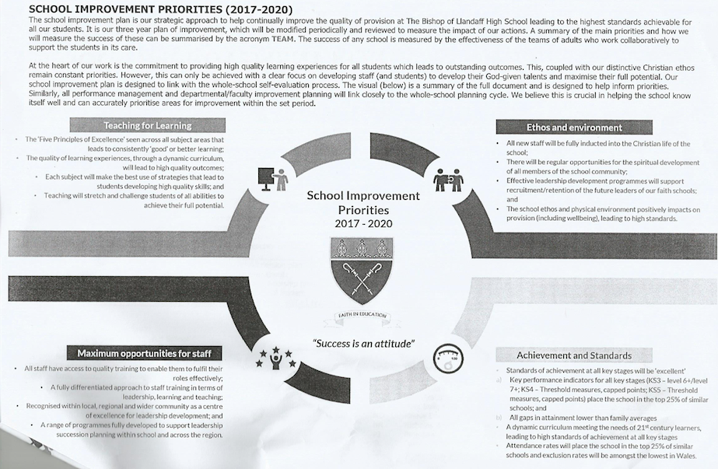
Appendix 1

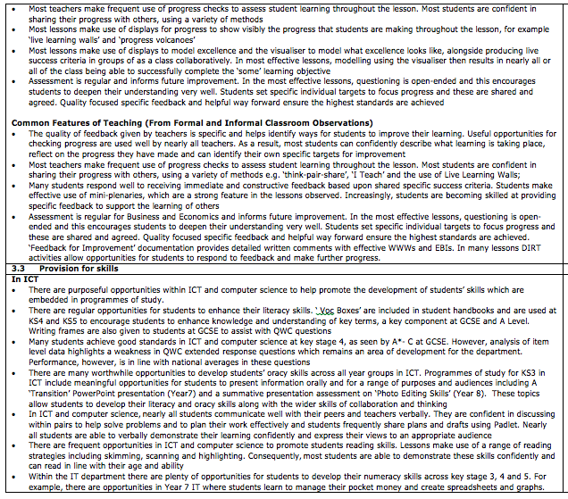
Appendix 2

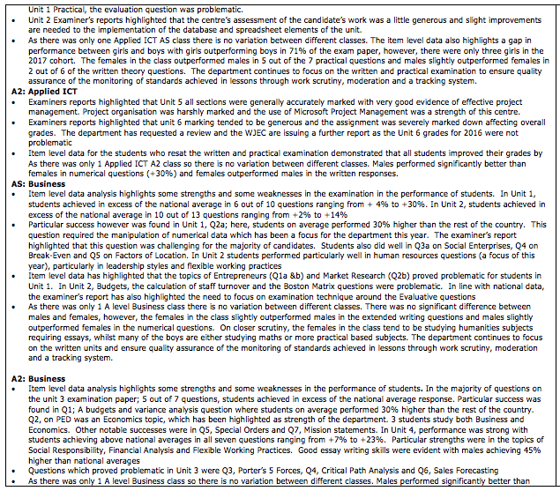
Appendix 3

Appendix 4
The 5 Principles of ‘Excellence’

- High Level of Challenge
- Plan for the needs of the highest ability students and work downwards;
- Have high expectations and promote a “Growth Mind-set”;
- Set clear, stretching and measurable objectives linked to student data (All, Most, Some);
- Plan engaging learning activities with extension and challenge tasks always available

- Development of Skills
- Literacy skills: reading, writing and speaking;
- Numeracy skills (where appropriate)
- Learning skills – students working independently and collaboratively;
- Thinking skills and problem solving

- Visible Progress in Learning
- Regular and appropriate reviews against lesson objectives;
- Clear success criteria shared for learning tasks and used as a checklist for progress;
- Students given opportunity to demonstrate their learning in different ways;
- Students involved in talking about assessing their own progress

- ‘Quality’ Questioning
- Questioning is differentiated to check for depth of understanding and progress;
- Questions are used effectively to help scaffold improvement;
- Different types of questions are modelled and highlighted;
- Students understand what a good question for learning is and regularly ask these questions

- Feedback for Improvement
- High quality work is modelled and analyses;
- Students understand clearly the specific features that make work high quality;
- Feedback for improvement from teachers and peers is positive, specific and helpful;
- Students given regular opportunities to improve their own work based on feedback

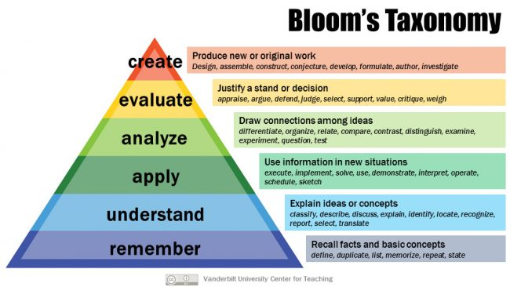
Appendix 5

Appendix 6

7 Reasons to Use Dry Erase Boards in the Classroom
1. You can use them to engage every child in every single lesson.
2. Minute by minute, you’ll know exactly who’s grasping the concepts and who’s not.
3. Students love them because they’re fun. Mistakes made during guided practice can be easily brushed away.
4. Using dry erase boards will save paper and significantly reduce the stack of work you take home to grade.
5. Dry erase boards can be used in whole group instruction, small guided groups, and learning centers.
6. No need to worry about technology failing when you need it most.
7. No learning curve or advanced prep! Just pass out the dry erase boards and let the learning begin!

