

Module Name: Digital Skills for Personal and Professional Growth
Module Code: (BMSW4008)
Assignment Name: Market Research and Website Development Project
Student Name: Roqia haji haidar
Student Number:2422002
Lecturer: Muhammad Cassamo
Wordcount:1002
AI Acknowledgement
I confirm that I have not presented any AI generated materials as my own work. I confirm that I have copies of my drafts, notes, and other resources I used before and after the use of AI tools which I may be asked to provide in evidence.

Market Research and Website Development Project
Contents
- Overview
- Summary of Questionnaire Findings
2.1 Key Question 1: Lash Style Preference (Natural – 47%)
2.2 Key Question 2: Budget for Lash Services (Under £40 – 53%)
2.3 Key Question 3: Preference for Home-Based Services
- Audience Segmentation
- SEO Strategy
- Connection Between Research and Materials
- Summary
- References
- Appendices

1. Overview
For this project, I carried out market research to help guide my business idea, Lash Aura, a home-based lash service offering natural lash extensions, lash lifts, and tints. I designed a questionnaire using Microsoft Forms with ten questions to find out about people’s beauty habits, lash preferences, spending, and lifestyles. The survey was shared with classmates and potential customers to get a good variety of responses.
Analysing this data helped me make informed decisions about the business, website, and marketing. Research shows that proper market research helps small businesses reduce uncertainty and plan effectively (Slávik et al., 2022; Yakiv Baytelman and Voropayeva, 2025). This report explains the three main findings from the survey, how they shaped the business and marketing strategy, and how I used the results to design a website and Canva materials. It also looks at audience segmentation and SEO planning.

2.Summary of Questionnaire Findings
The main trends from the survey were:
- Experience: 34% of respondents were already familiar with lash services.
- Style preference: 47% preferred a natural lash look.
- Budget: 53% spend under £40 per appointment.
- Lifestyle: Many follow beauty trends and value self-care routines.
- Location: Most live in urban areas, making home-based services convenient.
These results show that Lash Aura should target women in cities, especially students and young professionals, who want natural, affordable lashes delivered conveniently at home (Atiqa Radhi, Hamdan and Muneer Al Mubarak, 2024; Sadiq, Ahmad and Khan, 2021).
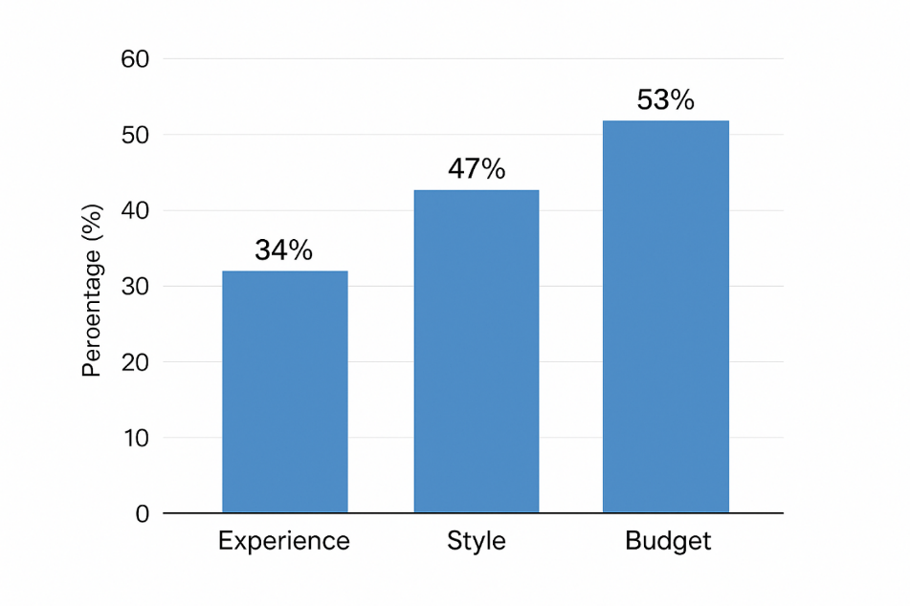

2.1. Key Question 1: Lash Style Preference (Natural – 47%)
Almost half of respondents preferred natural-looking lashes. This is an important insight because it tells me the type of services customers want. Many people want subtle, everyday lashes rather than bold, dramatic styles, which is also a trend in the beauty industry (Mewoh, Lapian and Gunawan, 2023).
Impact on Business Idea:
Lash Aura will focus on natural lash extensions, lash lifts, and tints, instead of dramatic sets. This fits what most clients are looking for and encourages repeat bookings.
Impact on Website Design:
- Soft, neutral colours and a clean layout
- Photos showing natural lash results
- Simple, easy-to-read content
These choices make the website visually appealing and build trust with potential clients (Sumelius, 2022).
Impact on Marketing Materials:
Canva posters highlight:
- Natural results with before-and-after images
- Words like “soft,” “natural,” and “everyday confidence”
- Clean, simple visuals
This ensures that marketing reflects what the audience wants (Lupo and Stroman, 2020).

2.2 Key Question 2: Budget for Lash Services (Under £40 – 53%)

Budget is another important factor. More than half of respondents said they normally spend under £40 on lash treatments, which shows that affordability is very important, especially for students and young professionals (Rye, 2020; Williams, Yehezkeil Hasudungan and Nur Azizah, 2025).
Impact on Business Idea:
- Pricing will be between £30–£40 per service
- Loyalty schemes, student discounts, or package deals can attract repeat clients
This strategy keeps services affordable but competitive (Mewoh, Lapian and Gunawan, 2023).
Impact on Website Design:
- Clear pricing tables on the homepage
- Transparent and easy-to-read information
Transparency helps clients feel confident in booking appointments (Moschella, Boulianne and Magnan, 2022).
Impact on Marketing Materials:
Marketing posters highlight affordability with phrases like:
- “Beauty under £40”
- “Affordable, natural lashes”
These phrases directly respond to the audience’s preferences (Atiqa Radhi, Hamdan and Muneer Al Mubarak, 2024).

2.3 Key Question 3: Preference for Home-Based Services

Many respondents preferred home-based lash services because of convenience, comfort, and flexible timings. This aligns with research showing that home-based beauty businesses are popular for women looking for flexible, personalised services (Sadiq, Ahmad and Khan, 2021).
Impact on Business Idea:
Lash Aura will operate fully from a home setting and offer:
- Evening and weekend appointments
- Comfortable, safe, and friendly environment
This home-based model becomes a unique selling point (USP) and attracts clients who value convenience (Chonyitree Sangwijit, Fatima Ibrahim Abdulsalam and Nitikorn Phoosuwan, 2024).
Impact on Website Design:
- General service area map
- “Book Now” button for flexible scheduling
- Safety and hygiene information
These features make the site user-friendly and reassure clients (Moschella, Boulianne and Magnan, 2022).
Impact on Marketing Materials:
- Posters and social media highlight “beauty at your doorstep”
- Comfortable, home-based service is emphasised
- Friendly, personalised experience is showcased
This ensures marketing speaks directly to what clients want (Sadiq, Ahmad and Khan, 2021).

3.Audience Segmentation
Survey results helped identify three main segments:
- Students: Budget-conscious, prefer natural lashes, need flexible appointments
- Young professionals: Interested in self-care, follow trends, want reliable results
- Urban women: Prefer home-based services, convenience and accessibility
Segmentation helps with targeted messaging, website design, and marketing campaigns

4.SEO Strategy
Insights from the survey guided SEO choices to attract the right clients:
- Keywords: “Natural lash extensions UK,” “Affordable lash services near me,” “Home-based lash technician,” “Lash lifts for students”
- Meta description: “Affordable, natural lash services in a friendly home-based setting.”
Using research-driven keywords improves search visibility and brings in clients who are likely to book appointments (Sumelius, 2022; Lupo and Stroman, 2020).
5.Connection Between Research and Materials
- Website: Colours, images, content, and pricing reflect survey insights. Booking features emphasise convenience.
- Canva Marketing: Posters highlight home-based comfort, natural lashes, and affordability.
- Graphs from Questionnaire: Helped confirm service types, pricing, and design choices.
Survey data directly influenced all design and marketing decisions, showing a clear link between research and business strategy. The results helped the business understand what customers want, so the designs and marketing could match their needs. This made the overall plan clearer, more focused, and more likely to attract the right clients.
6. Summary
The questionnaire results strongly shaped Lash Aura’s business model, website, and marketing materials by showing that customers prefer natural lash styles, affordable pricing, and the convenience of a home-based service. These insights helped the business tailor its offerings and messaging to real client needs (Buttle & Maklan, 2019). The research also supported audience segmentation and guided SEO planning by identifying which keywords and services potential clients search for most often (Guerrero, 2019). Overall, this project shows how market research reduces risk and helps build a strong foundation for a start-up beauty business (Messer, 2020).
7.References

- Slávik, Š., Hudáková, I.M., Procházková, K. and Zagoršek, B. (2022). Strategic Background of the Start-Up—Qualitative Analysis. Administrative Sciences, 12(1), p.17. doi:https://doi.org/10.3390/admsci12010017.
- Rye, J. (2020). What is the difference between a sole trader and a limited company? Setting Up and Running a Therapy Business, pp.132–134. doi:https://doi.org/10.4324/9781003096320-38.
- Dehghan Bejarkenari, Z., Farzpourmachiani, M., Fojlaley, M. and Rajacic, S. (n.d.). Entrepreneurship in Women’s Beauty Sciences. [online] 3, p.2024. Available at: https://dl.tubittumjournal.com/articles/2024/issue3/652-660.pdf.
- Yakiv Baytelman and Viktoriya Voropayeva (2025). A Start-Up for Business Development of Start-Ups. Lecture notes in networks and systems, pp.195–202. doi:https://doi.org/10.1007/978-3-031-83523-0_18.
- Moschella, J., Boulianne, E. and Magnan, M. (2022). Risk Management in Small‐ and Medium‐Sized Businesses and How Accountants Contribute†. Contemporary Accounting Research. doi:https://doi.org/10.1111/1911-3846.12819.
- Business development of eyelash extension salon A Case Study for Brows & Lashes Bar. (n.d.). Available at: https://www.theseus.fi/bitstream/handle/10024/894859/Saarik_Elizaveta.pdf?sequence=2.
- Atiqa Radhi, Hamdan, A. and Muneer Al Mubarak (2024). Factors Influencing Consumer Buying Behavior of Beauty and Personal Care. Studies in systems, decision and control, pp.409–424. doi:https://doi.org/10.1007/978-3-031-62106-2_32.
- Mewoh, I.A., Lapian, S.L.H.V.J. and Gunawan, E.M. (2023). THE INFLUENCE OF BRAND IMAGE, PRODUCT VARIETY, AND PRICING STRATEGY ON PURCHASE DECISION OF EYELASH EXTENSION AT LASHTHETIQUE MANADO (STUDY ON LASHTHETIQUE CUSTOMERS). Jurnal EMBA : Jurnal Riset Ekonomi, Manajemen, Bisnis dan Akuntansi, [online] 11(3), pp.359–370. doi:https://doi.org/10.35794/emba.v11i3.49619.
- Chonyitree Sangwijit, Fatima Ibrahim Abdulsalam and Nitikorn Phoosuwan (2024). Health and safety in hair salons during the Covid-19 situation: A cross-sectional study in a semi-urban district in Thailand. Public Health in Practice, [online] pp.100472–100472. doi:https://doi.org/10.1016/j.puhip.2024.100472.
- Sadiq, S., Ahmad, A. and Khan, I.U. (2021). Analyzing the impact of Women-Owned Home-based Businesses on Income Generation and Household Livelihood in Khyber Pakhtunkhwa Pakistan. VFAST Transactions on Education and Social Sciences, [online] 9(2), pp.19–29. doi:https://doi.org/10.21015/vtess.v9i2.782.
- Lupo, C. and Stroman, J.R. (2020). Social Media Marketing Adoption Strategies: An Exploratory Multiple Case Study of Landscape Industry Small Businesses. Journal of Social, Behavioral, and Health Sciences, 14(1), pp.211–220. doi:https://doi.org/10.5590/jsbhs.2020.14.1.15.
- ieeexplore.ieee.org. (n.d.). Cosmetic Products Customisation and Customer Segmentation | IEEE Conference Publication | IEEE Xplore. [online] Available at: https://ieeexplore.ieee.org/abstract/document/10200286.
- Sumelius, J. (2022). How visual identities influence the performance and success of start-ups. [online] Aalto.fi. Available at: https://aaltodoc.aalto.fi/items/5a9a4d80-90cb-415a-9be6-c6165f3e5ae4.
- Fu, X. and Pang, J. (2018). Effect of e-referral incentive programs on referrer loyalty on social platforms. The Service Industries Journal, pp.1–22. doi:https://doi.org/10.1080/02642069.2018.1505872.
- Williams, A., Yehezkeil Hasudungan and Nur Azizah (2025). The Implementation of Effective Financial Management to Increase the Profitability of Startups. Startupreneur Business Digital (SABDA Journal), [online] 4(1), p.-. doi:https://doi.org/10.33050/sabda.v4i1.714

- Appendices

QUESTIONEER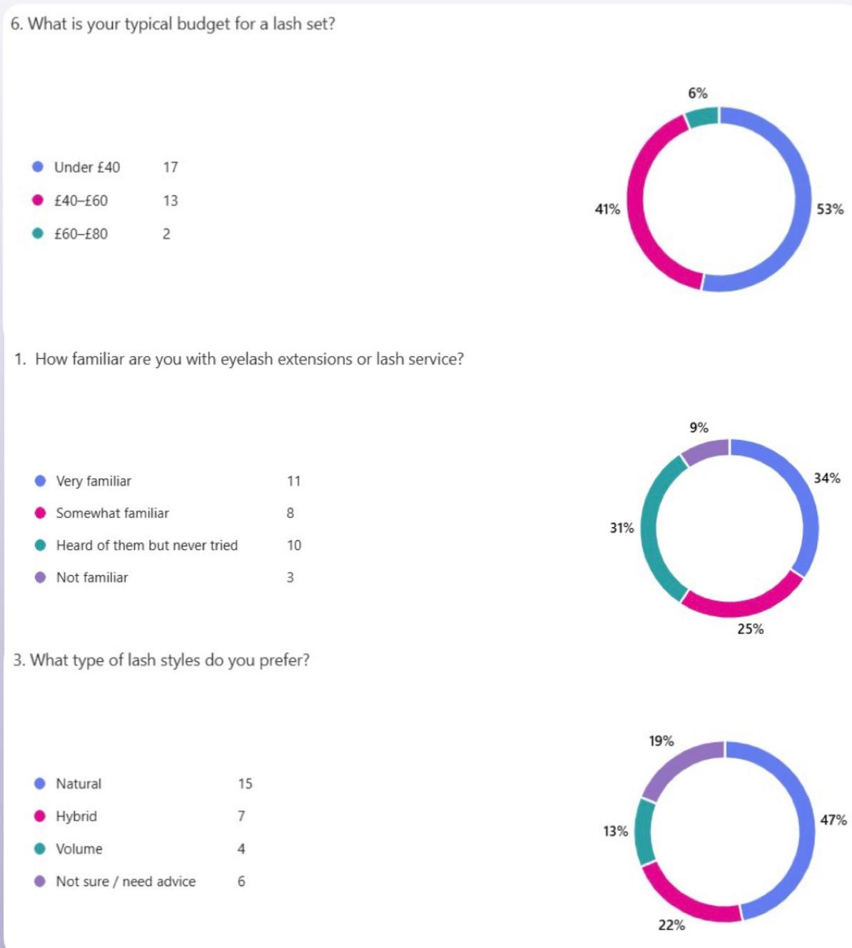
WEBSITE
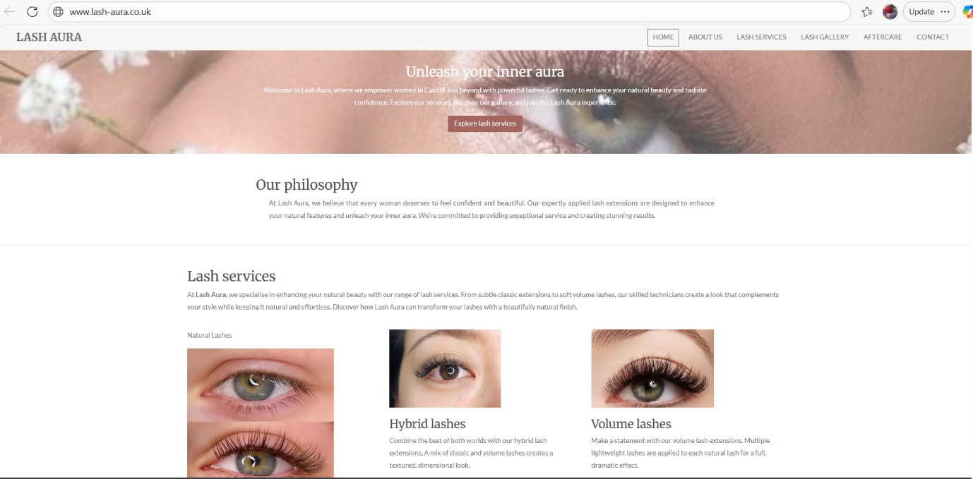
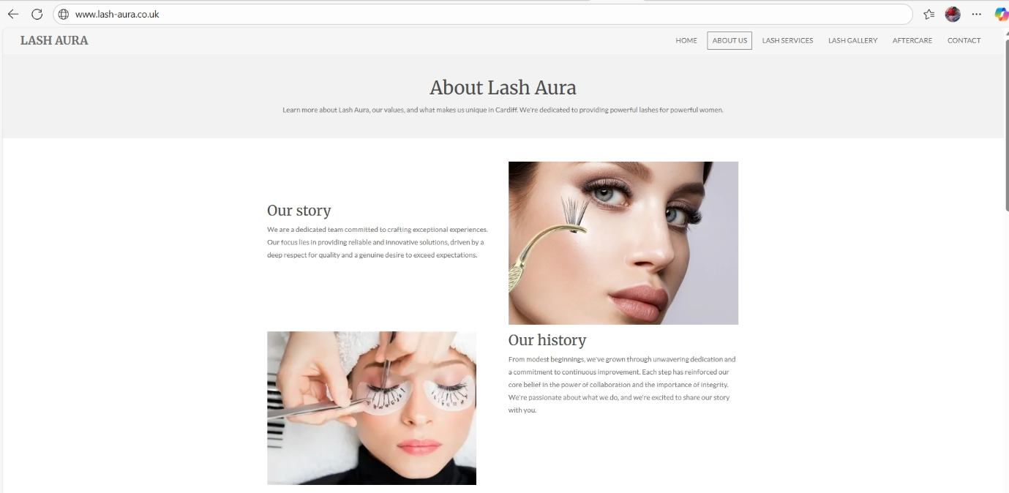
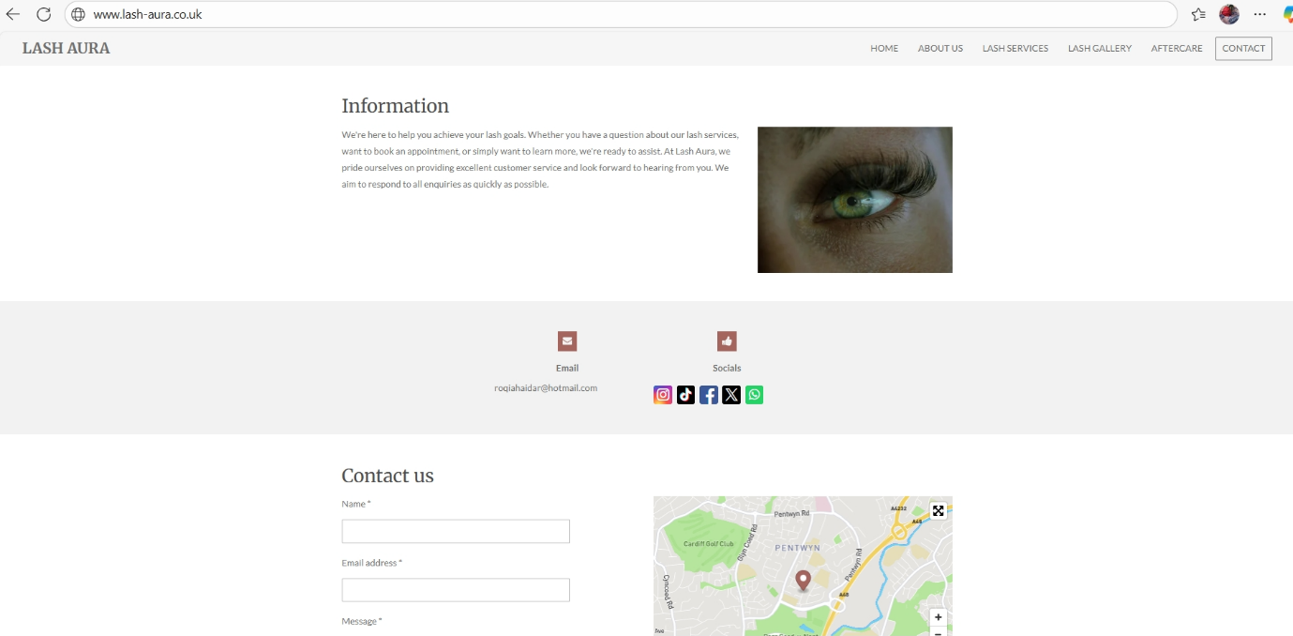
BUISNESS CARD

BUISNESS FLYER


Module Name: Digital Skills for Personal and Professional Growth
Module Code: (BMSW4008)
Assignment Name: The importance of Excel in the digital era
Student Name: Roqia haji haidar
Student Number:2422002
Lecturer: Muhammad Cassamo
Wordcount: 752
AI Acknowledgement
I confirm that I have not presented any AI generated materials as my own work. I confirm that I have copies of my drafts, notes, and other resources I used before and after the use of AI tools which I may be asked to provide in evidence.

The importance of Excel in the digital era
Contents
- Overview
- Planning Finances
- Data Analysis
- Budget Management
- Data Visualization
- Efficiency and Time saving
- Planning
- Summary
- References
10. Appendices
1. Overview
Businesses now depend on technology to do their everyday tasks One of the most useful tools for businesses is Microsoft Excel. It is not just a spreadsheet for numbers; it is a tool that helps business owners organize, plan, and manage different parts of their business. Small businesses, like Lash Aura, which provides eyelash services such as extensions, lifts, and tints, can benefit a lot from using Excel to handle finances, track performance, and make better decisions (Guerrero, 2019).
2. Planning finances
One of the main ways Excel helps businesses is through financial planning. Small business owners need to know how much money is coming in from sales and how much is going out for costs. Excel allows them to create tables to plan monthly income and expenses. For example, Lash Aura can record how many clients are booked each month, how much each client pays, and how much the business spends on supplies like lash glue and cotton pads. Using simple formulas, Excel can calculate total income, total expenses, and the profit or loss for each month. This helps the business owner see clearly if the business is earning money or if changes are needed to stay profitable (Google Books, 2019).
3. Data Analysis
Excel also makes it easy to analyze data. Small businesses can collect information about their customers and services and use Excel to find patterns. For instance, Lash Aura can see which lash services the most popular, which months are have the highest number of clients, and what price ranges most customers prefer. By understanding these trends, the business can make decisions that improve service, attract more clients, and increase revenue (Buttle & Maklan, 2019; Guerrero, 2019).
4. Budget Management
Another important use of Excel is budget management. Every small business has costs that need to be monitored, such as rent, insurance, marketing, and materials. Excel allows owners to list all expenses, sum them up, and compare them with income. This helps spot areas where costs are high and need to be reduced. Using colors and formatting, Excel can make income, expenses, and profits easy to read at a glance (M esser, 2020). For Lash Aura, this means the owner can quickly see how much is spent on materials or advertising and make sure the business does not spend more than it earns.
5. Data Visualization
Excel also helps businesses visualize information. Charts and graphs make numbers easier to understand. For example, a simple bar chart showing income and expenses for each month can help Lash Aura see which months the most profitable and which months are need more attention. Charts are also useful when showing business results to partners or investors because they give a clear picture without needing to look at long lists of numbers (Oike, Ogawa, & Oishi, 2019) (LaPolla, 2020).
6. Efficiency and Time saving
Excel also saves time by making tasks more efficient. Repetitive tasks, like adding totals, updating client records, or calculating profits, can be done automatically with formulas or templates. This reduces errors and frees up time to focus on other areas of the business (Oike, Ogawa, & Oishi, 2019). For Lash Aura, this could mean spending more time on serving clients and less time on manual calculations.
7. Planning
Finally, Excel is useful for planning for the future. Small business owners can use it to test different scenarios and make decisions. For example, Lash Aura can see what happens if the number of clients increases, if prices are changed, or if more money is spent on marketing. Excel can show how these changes would affect profits, helping the business make smarter and safer decisions (Pozo & Rouwette, 2023).
8. Summary
Microsoft Excel is a very useful tool for small businesses in today’s digital world. It he8.lps with planning money, understanding customers, tracking performance, managing budgets, showing information in charts, saving time, and making good decisions. For a small beauty business like Lash Aura, Excel can help the owner clearly see how the business is performing, identify which services are most popular, and plan for future growth. Using Excel makes running the business easier, more organized, and more likely to succeed (Guerrero, 2019; Messer, 2020; Google Books, 2019).
In addition, Excel can help keep track of product stock, monitor how often clients book appointments, and predict future earnings based on previous results. This makes it easier to prepare for busy periods, avoid running out of supplies, and set realistic targets. With its flexible spreadsheets and simple tools, Excel supports both daily tasks and long-term business planning.

9. References

- Guerrero, H. (2019). Excel Data Analysis. Cham: Springer International Publishing. doi:https://doi.org/10.1007/978-3-030-01279-3.
- Messer, R. (2020). Budget Management Decisions. Financial Modeling for Decision Making: Using MS-Excel in Accounting and Finance, pp.241–257. doi:https://doi.org/10.1108/978-1-78973-413-320201015.

- Oike, H., Ogawa, Y. and Oishi, katsutaka (2019). Simple and Quick Visualization of Periodical Data Using Microsoft Excel. Methods and Protocols, 2(4), p.81. doi:https://doi.org/10.3390/mps2040081.

- Pozo, K.C. and Rouwette, E.A.J.A. (2023). Types of scenario planning and their effectiveness: A review of reviews. Futures, 149(103153), p.103153.

- Buttle, F. and Maklan, S. (2019). Customer Relationship Management. 4th ed. [online] Fourth Edition. | New York : Routledge, 2019. | Revised edition of the authors’ Customer relationship management, 2015.: Routledge. doi:https://doi.org/10.4324/9781351016551.

- Google Books. (2019). Hands-On Financial Modeling with Microsoft Excel 2019. [online] Available at: https://books.google.co.uk/books?hl=en&lr=&id=uQyiDwAAQBAJ&oi=fnd&pg=PP1&dq=+7.%09Financial+Forecasting+with+Excel&ots=vKnfFFKzQK&sig=UYugpgPpbnsL90CeabfqdoRaNgQ&redir_esc=y#v=onepage&q=7.%09Financial%20Forecasting%20with%20Excel&f=false [Accessed 24 Nov. 2025].

- LaPolla, F.W.Z. (2020). Excel for data visualization in academic health sciences libraries: a qualitative case study. Journal of the Medical Library Association, 108(1), pp.67–75. doi:https://doi.org/10.5195/jmla.2020.749.

10. Appendices
CASHFLOW SPREADSHEET MO.xlsx



