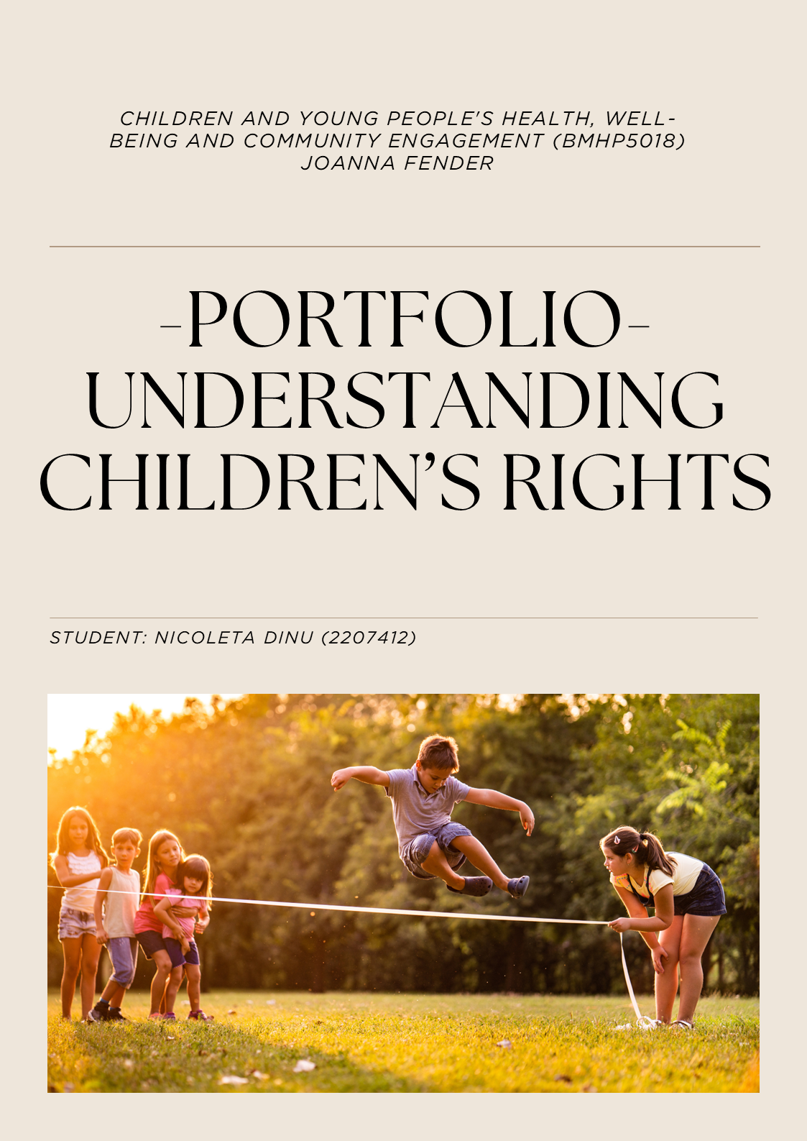
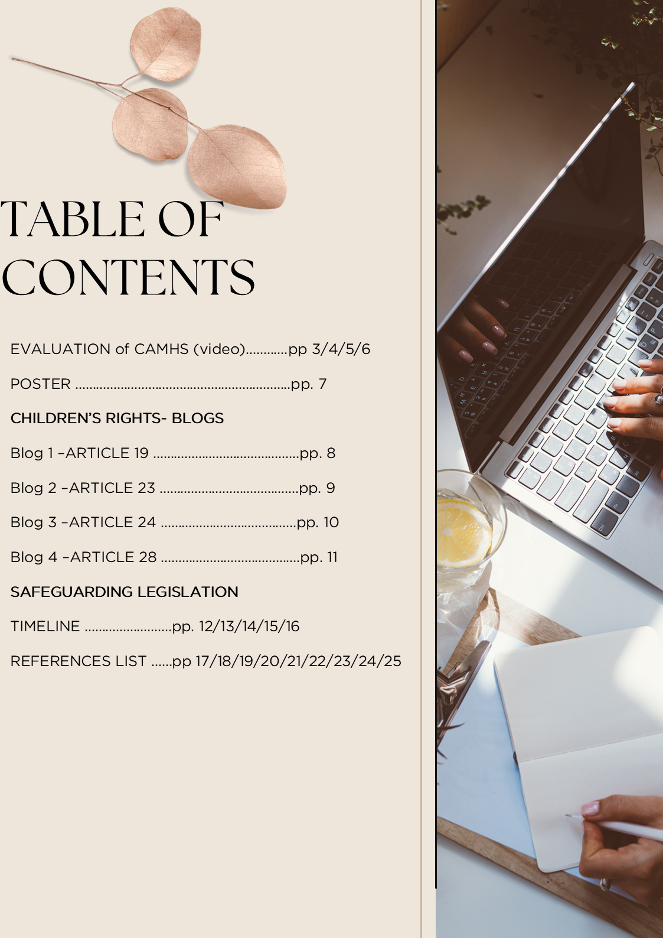
Evaluation of CAMHS Video and Service Provision:
Overview of CAMHS
Child and Adolescent Mental Health Services (CAMHS) play a crucial role in supporting children and young people facing mental health challenges (Ani, Ayyash, and Ogundele, 2022). CAMHS is a specialised service within the National Health Service that meets the mental health needs of individuals up to age 18 (Livanou et al., 2024).
A dedicated multi-disciplinary team, including psychiatrists, psychologists, mental health nurses, and therapists, collaborates to assist children and young people with a variety of mental health conditions, including anxiety, depression, and behavioural issues. This collaborative approach aligns with national guidelines to promote a holistic and integrated strategy for child mental health (Price et al., 2018).
Providing care for young people requires a coordinated effort, where families, schools, and healthcare providers collaborate to ensure consistent support (NICE, 2021). A comprehensive understanding of these processes is essential, as it enables families to advocate effectively for their children's unique needs and ensures that they receive the necessary and suitable care tailored to their specific circumstances (Harding, Camden, and Lewis, 2022).
The video from Norfolk and Suffolk NHS Foundation Trust (2021) briefly introduces Child and Adolescent Mental Health Services (CAMHS) and illustrates the referral process, assessment, treatment, and discharge pathways. This critical commentary examines the factors involved in CAMHS support, from referral to discharge, and evaluates the strengths and weaknesses presented in the video. Additionally, it focuses on the approaches and interventions that may impact a child's well-being, drawing on organisational guidelines from CAMHS in the United Kingdom (Oxford Health NHS Foundation Trust, 2021).
Referral Process and Initial Assessment
The referral process begins when a concern is raised by a parent, guardian, teacher, or healthcare professional (Catty, 2021). After receiving a referral, CAMHS conducts an initial assessment to see if the child's challenges meet their criteria. This process can create stress for the child and family due to fears of stigma and uncertainty about a diagnosis. Early intervention and prompt referrals are crucial for improved treatment outcomes (Emme-Lina, Grip and Axberg, 2024).
The CAMHS care service provides essential support; however, it encounters notable challenges, particularly concerning extended waiting times, which remain a primary concern (Thomas, Schroder, and Rickwood, 2020). Reducing these waiting periods would improve access to timely care and better outcomes for young individuals requesting mental health support. Enhancing service delivery could increase efficiency and reduce anxiety for patients and their families (NICE, 2021; Valentine et al., 2024).
Comprehensive Assessment and Formulation
Following the referral, Child and Adolescent Mental Health Services (CAMHS) professionals conduct a comprehensive assessment using interviews, questionnaires, and observations. This assessment aims to develop a nuanced understanding of the child's situation, underscoring the importance of considering the child's developmental history, family dynamics, and environmental influences (Buchanan, Blackburn and Hayhurst, 2022).
By adopting a biopsychosocial approach that integrates emotions, behaviours, and social determinants, such as cultural influences and family support, practitioners are empowered to identify psychological factors and contextual elements. These elements include socioeconomic status, the educational setting, and cultural background (Vizard, 2020).
Effective information sharing among professionals within Child and Adolescent Mental Health Services (CAMHS) and various associated agencies, such as social services, multidisciplinary teams, educational psychologists, and youth justice organisations, is critical for achieving a comprehensive understanding of the challenges confronted by children (Evans et al., 2021).
Additionally, the assessment process requests collaboration, prioritising the young person's voice in decision-making. Emphasising the child's autonomy and encouraging active participation during the assessment phase can enhance therapeutic engagement and improve adherence to subsequent interventions (Department of Health and Department of Education, 2017).
Intervention and Therapeutic Approaches
The integration of interventions such as psychotherapeutic approaches and specialised support is vital for effectively addressing the intricate mental health needs of children and adolescents. In current practice, evidence-based methodologies, including Cognitive-Behavioural Therapy (CBT), Interpersonal Therapy (IPT), and systemic family therapy, are frequently utilised by Child and Adolescent Mental Health Services (CAMHS) to treat conditions such as depression, anxiety disorders, and conduct disorders (Balkin, 2023).
In circumstances where psychological therapies may prove inadequate, medication is warranted as part of a comprehensive treatment plan, particularly for individuals experiencing moderate to severe mental health challenges. Such pharmacological interventions aim to improve symptoms and enhance the efficacy of psychotherapy, with careful consideration of the associated risks and benefits (Public Health England, 2022).
Additionally, the active involvement of parents or care professionals has been identified as a crucial factor in treatment success, as recent research highlights the positive influence of a supportive home environment on therapeutic outcomes. An expanded discussion on strategies for family engagement and motivational techniques would further elucidate how Child and Adolescent Mental Health Services (CAMHS) practitioners develop therapeutic alliances and optimise treatment interventions (British Psychological Society, 2017).
Multi-Agency Collaboration and External Support
Multi-agency coordination is needed for children with complex needs, such as those with neurodevelopmental conditions or comorbid psychiatric presentations. The sharing of relevant information, with the necessary consent, is essential for preventing care fragmentation, reducing service duplication, and fostering a cohesive support network (Anna and Emily, 2022).
Shah et al. (2024) assert that supportive relationships and effective communication are essential for managing mental health disorders in children. Optimal outcomes for children and adolescents are realised when multiple systems collaborate to develop interventions adjusted to the needs of the family, school, community, and clinical environments.
Discharge and Transition Planning
Child and Adolescent Mental Health Services (CAMHS) are crucial in preparing children and their families for life beyond specialised care during the discharge planning phase. This stage thoroughly evaluates treatment progress, provides relapse prevention strategies, and establishes aftercare arrangements. Transition planning is particularly essential for older adolescents who may require a transfer to adult mental health services (NHS England, 2023).
The adverse effects of abrupt disruptions in care underscore the need to establish a meticulously organised transition process. Such sudden changes can precipitate a relapse of symptoms and may result in a disconnection from vital services, jeopardising the individual's overall well-being. This circumstance underscores the importance of a deliberate approach during transitions to ensure continuity of care and support (Zavras, 2022).
According to the British Psychological Society (2017), implementing graduated discharge protocols and facilitating referrals to voluntary or community services can significantly enhance resilience and foster sustained well-being. Illustrative examples of effective support mechanisms include participation in support groups, engagement in online forums, and access to community-based counselling services, all of which exemplify how continuity of care is effectively maintained.

Conclusion
Child and Adolescent Mental Health Services (CAMHS) provides a structured approach to supporting mental health in children and adolescents. With early referral pathways, multidisciplinary assessments, and evidence-based treatments, CAMHS tailors care plans to individual needs (Fiona et al., 2022).
Collaboration among families, schools, and agencies enhances support and continuity, reducing risks associated with fragmented services. Additionally, focus on discharge planning for older adolescents transitioning to adult services ensures ongoing care and decreases relapse risk, promoting overall well-being and resilience (Andrews et al., 2022).

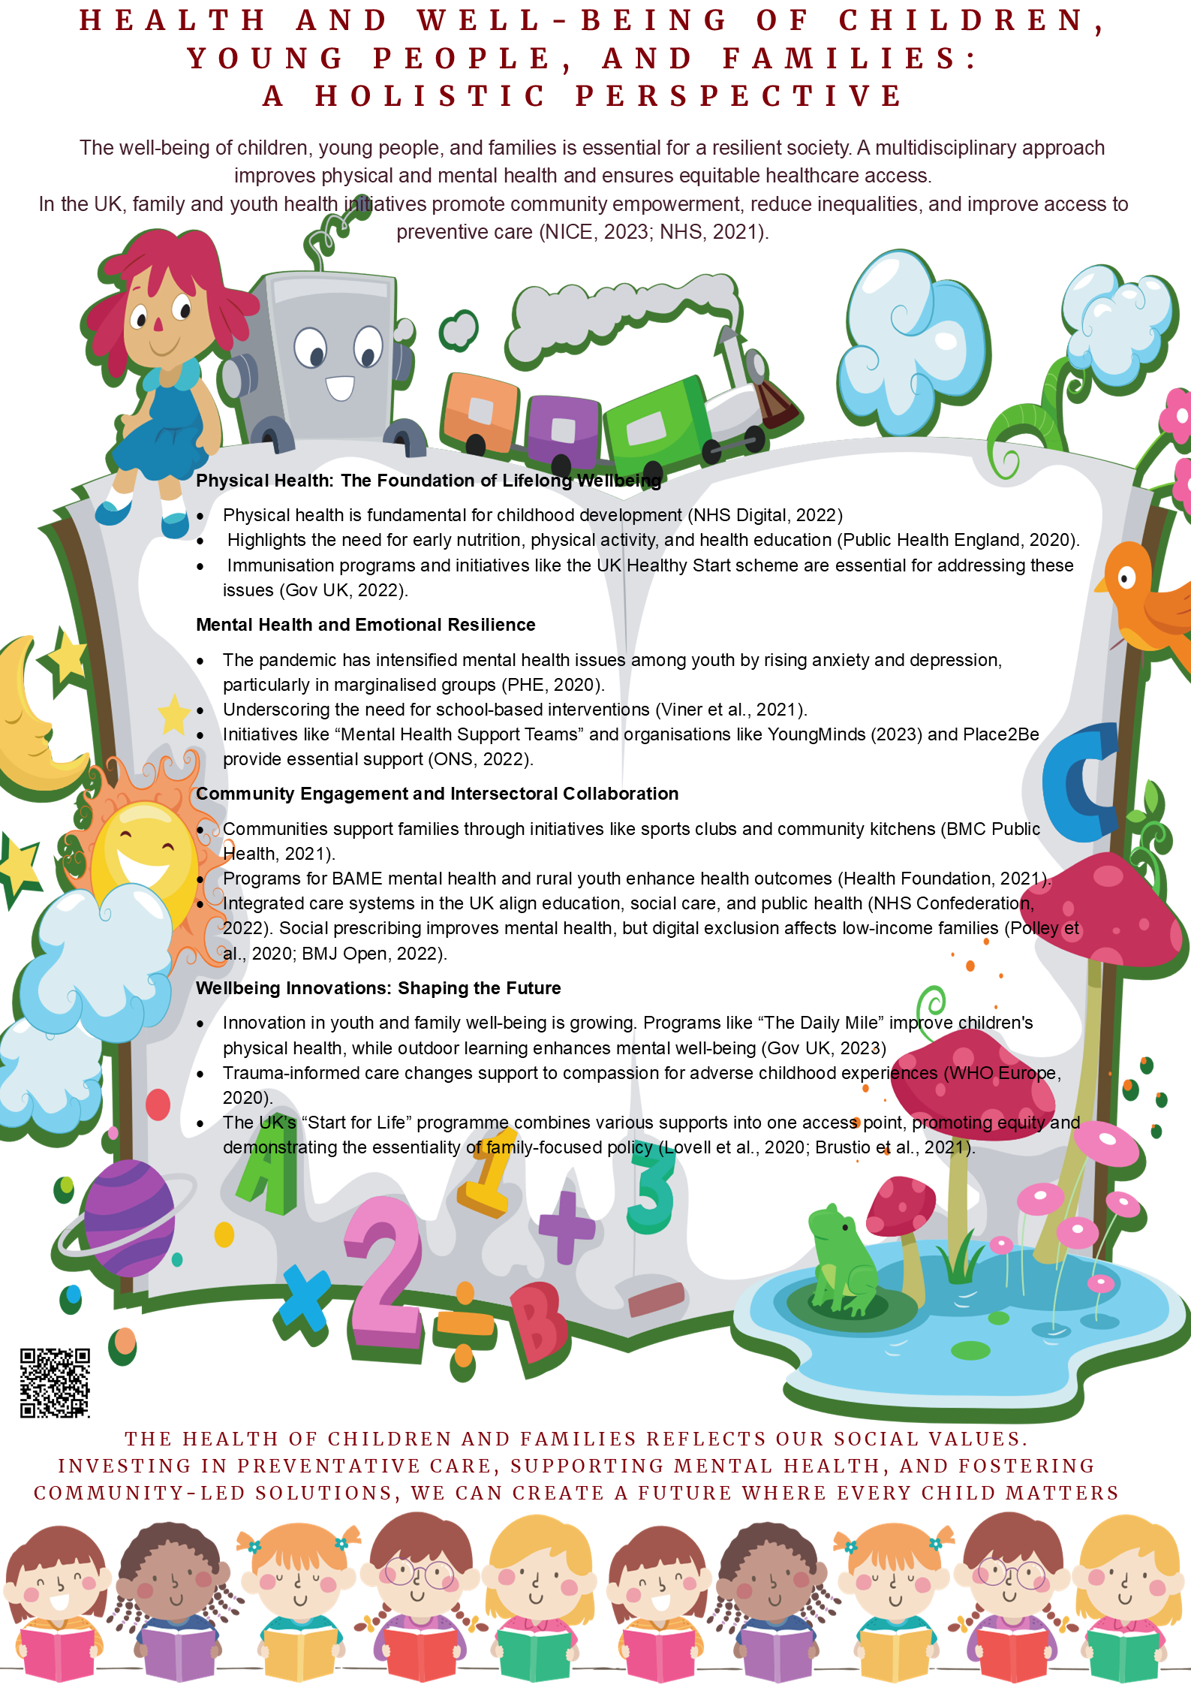
Children’s Rights: BLOGS
Blog 1 – Article 19: Protection from Violence, Abuse and Neglect
Article 19 of the United Nations Convention on the Rights of the Child (UNCRC) mandates that States implement measures to protect every child from physical and mental violence, injury, abuse, neglect, and exploitation (Hoffman and Stern, 2020). Ensuring safety is essential, as extended exposure to fear can elevate toxic stress levels, disrupt neural development, and increase the risk of cardiovascular, metabolic, and psychiatric disorders throughout a person's life (World Health Organisation, 2020).
The United Nations International Children’s Emergency Fund, UNICEF (2024), reports that global monitoring indicates one in two children experiences violence annually. Additionally, approximately 400 million children under the age of five endure violent disciplinary practices at home. Such exposure can significantly delay the development of secure attachments, causing children to perceive care as unpredictable, which fosters challenges in establishing trust, regulating emotions, and forming healthy peer relationships (Moylan et al., 2010).
Attachment theory asserts the significant impact of violence, neglect, and inconsistent care on a child's development, emphasising the deep emotional and psychological trauma that these experiences inflict (Howe and Betts, 2023). Hughes and Gurney (2020) assert that secure and responsive relationships are essential for a child's psychological, emotional, and cognitive development. Furthermore, they indicate that instances of abuse or neglect can profoundly disrupt these critical connections.
A comprehensive public health strategy is essential to implement Article 19 effectively. This strategy must encompass establishing laws prohibiting corporal punishment, introducing evidence-based parenting programs, and developing community initiatives to challenge harmful societal norms (Clark et al., 2020). Also, establishing child-friendly reporting mechanisms and integrated support systems is important (Cross, Vandervort, and Block, 2023). Trauma-informed services should prioritise the child's voice, ensuring confidentiality and cultural safety. It is imperative to recognise that many individuals may carry invisible trauma into adulthood, which can hinder personal fulfilment and national advancement (Pletcher et al., 2019).
Prevention offers substantial and quantifiable benefits. A recent economic analysis by the World Health Organisation (2020) reveals that the annual global costs associated with child maltreatment divert resources that could be more effectively allocated to educational and health initiatives. Upholding Article 19 not only safeguards children in the present but also contributes to long-term prosperity by interrupting intergenerational cycles of violence, enabling future generations to succeed (Conti, Morris, and Melnychuk, 2017).
Blog 2 – Article 23: Rights of Children with Disabilities
Article 23 of the United Nations Convention on the Rights of the Child (UNCRC) emphasises the entitlement of children with disabilities to lead fulfilling and self-sufficient lives while actively engaging in society. UNICEF (2021) estimated that approximately 240 million children worldwide are affected by disabilities, which results in a likelihood that they are 49 per cent likely never to attend school. The challenges posed by limited access to healthcare, education, and rehabilitation further heighten their vulnerability to malnutrition, social isolation, and poverty.
Sen (1999) articulated that the capabilities approach provides a compelling theoretical framework for analysing Article 23. This approach highlights that authentic inclusion necessitates the empowerment of every child to realise their full potential (Vizard, Fukuda and Elson, 2011).
From this perspective, disability is viewed as more than just an individual impairment; it is seen as a complex interaction between a person's unique challenges and the societal constraints that hinder their opportunities (Department for International Development, 2010). These constraints can include environmental barriers, lack of access to resources, and social stigmas that restrict the full participation of children with disabilities in everyday activities (Apgar, 2023).
Understanding the impact of disability, societal attitudes and structural factors influencing a child's ability to succeed and develop within their community. This comprehensive perspective necessitates addressing not only the specific needs of children with disabilities but also advocating for systemic reforms that foster a more inclusive society (Babik and Gardner, 2021).
Bronfenbrenner's (1979) ecological systems theory further emphasises the importance of collaborative support networks, including families, educational institutions, communities, and policies, in fostering an inclusive environment. Particularly, UNESCO UIS (2022) reports a concerning increase in the number of out-of-school disabled children, thereby highlighting significant discrepancies between policy frameworks and their implementation in practice.
According to the Department of Health, GOV UK (2009), implementing inclusive education with early identification, assistive technology, and peer-mediated support significantly enhances children's health, mental well-being and future employment opportunities. This Article mandates dedicated investment in inclusive systems, targeted support for families, and proactive initiatives to combat stigma. Facilitating the capabilities of every child transcends ethical considerations, as it is also a legal obligation. This commitment not only fortifies social cohesion and fosters economic innovation but also fully realises the potential of every young individual (Collett, 2018).

Blog 3 – Article 24: The Right to Health and Health Services
Article 24 affirms that every child is entitled to achieve "the highest attainable standard of health," which includes access to healthcare services, nutritious food, clean water, and a safe environment (Ruck et al., 2014).
Good health is a fundamental cornerstone for realising all other rights; illness and malnutrition reduce children's physical energy, disrupt cognitive development, and inhibit overall growth. Malnutrition is a significant contributing factor in nearly fifty per cent of mortality rates among children under the age of five worldwide. Additionally, adverse health outcomes disadvantage educational achievement and restrict future economic opportunities for those impacted (Mark et al., 2020).
Karatekin et al. (2024) articulate that the Social Determinants of Health Framework distinctly highlights the significant impact of socioeconomic status, housing conditions, educational opportunities, discrimination, and environmental changes on children’s health outcomes. Addressing these fundamental inequalities is essential to achieving the right to health equity.
Educational institutions serve as essential environments for health promotion. Health-Promoting Schools, which are recognised globally, incorporate comprehensive policies addressing nutrition, mental health, physical activity, and the creation of safe learning environments. Evidence supports that this holistic approach significantly enhances children's dietary practices, mental well-being, physical health, and academic achievement (WHO and UNESCO 2021).
The practical implementation of Article 24 requires a comprehensive strategy that addresses essential social determinants, including universal healthcare access, establishing robust primary care systems, developing adequate sanitation infrastructure, creating resilient food systems, and adopting proactive preventive measures, including vaccinations and micronutrient supplementation (Cecil et al., 2024).
Implementing collaborative and culturally responsive health services that empower children's voices in the decision-making process is essential. Adhering to Article 24 not only safeguards children's immediate survival but also fosters the development of lifelong competencies. This approach promotes the establishment of healthier and more resilient societies where all children can prosper (NSPCC, 2024).

Blog 4 – Article 28: The Right to Education
Article 28 protects the right of every child to receive a free primary education, access secondary schooling, and enjoy equitable opportunities for higher education. Education is a powerful catalyst for transformation. Global initiatives, such as the United Nations' Sustainable Development Goal 4, aim to guarantee inclusive and equitable quality education for all by 2030 (Adipat and Chotikapanich, 2022).
Additionally, programs like the Global Partnership for Education fund and support educational systems in developing nations, organisations such as UNICEF and UNESCO play an important role in enhancing educational access and outcomes on a global scale (United Nations Sustainable Development Group, 2024).
The World Bank (2023) underscores the vital role of education in lifting poverty, improving health outcomes, advancing gender equality, and promoting peace. Similarly, the United Kingdom Department for Education (2021) draws comparable conclusions regarding the educational landscape in the United Kingdom.
UNESCO (2023) reported that approximately 244 million children and adolescents were out of school in 2021, with a disproportionate impact on girls, children with disabilities, and those residing in conflict-affected areas. The failure of educational opportunities exacerbates social inequality and obstructs national development, with projections indicating that learning poverty may cost low- and middle-income countries.
The Capability Approach, developed by Amartya Sen, articulated in the 1980s, emphasises education as an economic tool essential for expanding individual freedoms. It empowers children by providing vital skills like literacy and critical reasoning, enabling their active participation in personal and community development. Additionally, developmental psychology highlights the importance of nurturing educational environments for cognitive growth and emotional resilience (Garces-Velastegui, 2023).
Article 28 necessitates removing financial barriers, recruiting qualified educators, implementing inclusive curricula, and enhancing educational infrastructure. Equitable funding must prioritise marginalised communities and assist children affected by crises (Atherton, Lewis, and Bolton, 2024).
According to the United Kingdom Government (GOV.UK, 2024), educational institutions' requirements are designed to uphold the dignity of all children by prohibiting corporal punishment and degrading practices. Ensuring universal access to quality education and fostering equity empower all children to lead healthier, more fulfilling lives and to contribute meaningfully to sustainable societal progress (Lokot et al., 2020).

Safeguarding Legislation Timeline: 1960s–2020s (UK)
Over the past sixty years, the evolution of safeguarding legislation in the United Kingdom has undergone significant changes, influenced by shifting social attitudes, public tragedies, and a better understanding of children's needs and rights (Featherstone and Gupta, 2018). This journey reflects the nation’s response to crises and the growing importance of protecting vulnerable young people (Firmin and Lloyd, 2023).
Since the Children and Young Persons Act of 1969 (Hoffman, 2020), which established the State's role in safeguarding, to the Domestic Abuse Act of 2020 (Jones, 2021), Parliament has strengthened its commitment to supporting children, young people, and families. This evolution emphasises the need to protect these populations while ensuring their voices are heard (Douglas and Barlow, 2023).
Each legislative act has expanded local authority responsibilities and promoted multi-agency collaboration, addressing specific vulnerabilities such as care leavers and domestic abuse. Understanding this progression is essential for practitioners and policymakers, as it highlights achievements and gaps in current safeguarding practices (Davies and Duckett, 2016).
1969 – Children and Young Persons Act
This legislation established foundational principles for contemporary safeguarding practices by emphasising vulnerable children's care, protection, and welfare. It described the state's obligation to intervene in parental failure and introduced legal responsibilities for local authorities to evaluate and address concerns effectively. Importantly, it granted courts the authority to issue care and supervision orders in cases of neglect or abuse (Davidson and Bifulco, 2018).
Impact:
The 1969 Act significantly transformed the perception of child protection, establishing it as a collective societal responsibility. Additionally, it enhanced the role of local authorities in the early intervention framework (NSPCC, 2024).
Evaluation:
Although the 1969 Act marked a significant milestone, it failed to establish a rights-based framework and lacked comprehensive guidance for inter-agency collaboration, shortcomings that later legislation aimed to address. Furthermore, its language and provisions did not adequately reflect children's voices in decision-making (Independent Care Review, 2020).

1989 – Children Act
The Children Act 1989 represented a pivotal development in child welfare. It established the principle that "the child's welfare is vital." This legislation defined the responsibilities of local authorities in safeguarding and promoting the welfare of children, clarified the roles assigned to social workers, and advocated for collaboration with families, except in circumstances where a child's safety is at risk (Department for Education, 2014).
Impact:
The Act substantially improved legal consistency and prioritised the welfare of the child. It established definitive legal criteria for state intervention and mandated convening child protection conferences and conducting core assessments (Department for Education, 2021).
Evaluation:
The Act is known for its child-centred approach, but challenges in interpretation and inconsistent implementation across local authorities have led to criticisms. This variability can result in unequal access to essential support for children and families. Some argue that systemic pressures and austerity measures have weakened the Act's effectiveness (Helen and Nina, 2016). The government should provide clear guidelines and resources to ensure consistent application and increase funding, enabling practitioners to deliver high-quality services. Regular monitoring and evaluation are essential to identify areas for improvement and maintain the Act's focus on children nationwide (Helen and Nina, 2016).
2000 – The Children (Leaving Care) Act
The Children (Leaving Care) Act of 2000 was introduced to support young individuals transitioning from care to independent living. This legislation aims to mitigate social exclusion and enhance outcomes for care leavers. It requires local authorities to develop pathway plans and provide personal advisers to these individuals until the age of 21 or until the age of 25 if they are engaged in educational interests (Department of Health, 2011).
Impact:
The Act acknowledges that the necessity for care and support extends beyond age 18, facilitating the development of comprehensive support frameworks that persist into adulthood. This important recognition facilitated improved planning for educational opportunities, vocational training, and housing solutions, ensuring that young adults receive the resources and guidance they require to succeed as they transition to independence (Palmer, Norris, and Kelleher, 2022).

Evaluation:
The legislation enhancing rights for care leavers marks a significant advancement in support for young individuals transitioning from care. However, evaluations reveal inconsistencies in assistance and outcomes across local authorities. Many care leavers still face critical issues like homelessness and limited educational opportunities, hindering their potential for successful futures (Sadovnik, Semel, and Coughlan, 2018).
2004 – Children Act (Every Child Matters)
The reform was initiated in response to the tragic death of Victoria Climbié. This Act established a mandate for key agencies, specifically those in health, education, and law enforcement, to collaborate effectively in safeguarding children. Additionally, it created Local Safeguarding Children Boards (LSCBS) and introduced the position of Director of Children’s Services (Foster, 2024; Chambers, Cantrell and Booth, 2021).
Impact:
The initiative incorporated a multi-agency framework, emphasising the importance of early intervention while striving to reduce service duplication. The "Every Child Matters" agenda focused on five fundamental outcomes, primarily focusing on children's safety and well-being, promoting a holistic approach to their care and development (O’Dean et al., 2025).
Evaluation:
Implementing the Act initially facilitated the integration of services, promoting a cohesive approach among various sectors. However, over time, the emergence of bureaucratic complexities and substantial funding reductions has adversely impacted its effectiveness. Critics contend that the Act's reliance on performance targets may have overshadowed the importance of relational practices with families, which are essential for fostering trust and delivering meaningful support (Baginsky, Manthorpe and Moriarty, 2020).
2014 – Children and Families Act
The Special Educational Needs and Disability (SEND) reforms, established by the 2014 Act, aim to improve support for children with special educational needs and disabilities. A significant aspect of this legislation is the introduction of Education, Health, and Care Plans (EHCPS), which replace the previous Statements of Special Educational Needs. These plans take an integrated approach by combining educational, health, and social care needs in one document. The Act also empowers families, giving them more control and choice over the support services for their children (Tysoe, Vincent, and Boulton, 2021).

Impact:
The legislation acknowledged children's comprehensive and interconnected needs, prioritising an efficient method for accessing support services across various agencies. Additionally, it encompassed significant reforms in adoption processes and the family court system, reflecting a commitment to creating a nurturing and efficient environment for children's welfare (Tucker, 2025).
Evaluation:
The Special Educational Needs and Disability (SEND) reforms were established to enhance support for children with special educational needs and disabilities. However, these reforms have been subject to substantial examination due to inconsistent implementation across various regions and insufficient funding for the required services (Cosma and Mulcare, 2022).
Therefore, numerous families experience continual delays and are often constrained to engage in legal disputes to secure essential support for their children. This ongoing issue underscores the disconnect between the reforms' intended objectives and the actual experiences of the families they were designed to assist (Salem and Kelly Browe Olson, 2024).
2020 – Domestic Abuse Act
The Act acknowledges children as victims and expands the legal definitions of domestic abuse to include both strict control and emotional abuse. This significant enhancement recognises the detrimental effects these forms of abuse can have on children's mental and emotional health (Williams, 2023). Also, the Act establishes new obligations for local authorities, requiring them to provide secure accommodation and necessary support services to safeguard the well-being of affected children and their families (NSPCC, 2024).
Impact:
This legislation has significantly enhanced the legal framework for addressing domestic abuse, necessitating that services actively consider the experiences of children who are exposed to violence in the home. Moreover, it established the role of the Domestic Abuse Commissioner, whose responsibilities include monitoring practices in the field and promoting optimal outcomes for individuals affected by domestic abuse (Lawyer, 2021).
Evaluation:
Challenges remain in providing consistent assistance and resources across England and Wales, particularly for migrant families in unstable housing, leading to increased vulnerabilities (Hock et al., 2024). Local authorities face limited funding and staffing, which restricts their support capabilities. Complex bureaucratic processes further delay essential services, exacerbating the difficulties for vulnerable populations. Effective collaboration among agencies is crucial, but differing priorities and resource limitations often lead to inconsistent service provision (Russell et al., 2022).
Conclusion
Over the six decades, safeguarding legislation in the United Kingdom has transitioned from a reactive framework to a proactive, rights-based, and multi-agency approach. Each legislative development has significantly contributed to establishing a safer environment for children and families (Laming, 2009)
While considerable progress has been achieved in centring children's voices and enhancing institutional systems, challenges related to implementation, resource limitations, and persistent inequalities continue to exist. Future reforms were built upon these foundational achievements, focusing on strengthening preventative measures and addressing gaps in practice to ensure that every child is effectively safeguarded, supported, and heard (Toros, 2021).

References list
Adipat, S. and Chotikapanich, R. (2022) ‘Sustainable Development Goal 4: An Education Goal to Achieve Equitable Quality Education’, Academic Journal of Interdisciplinary Studies, 11(6), pp.174. Available at: https://www.richtmann.org/journal/index.php/ajis/article/view/13111/12703 (Accessed 28 April 2025).
Ani, C., Ayyash, H.F. and Ogundele, M.O. (2022) ‘Community paediatricians’ experience of joint working with child and adolescent mental health services: findings from a British national survey’, BMJ Paediatrics Open, 6(1), pp.1–10. Available at: https://bmjpaedsopen.bmj.com/content/bmjpo/6/1/e001381.full.pdf (Accessed 23 March 2025).
Anna, E., Emily, S. (2022) International Review of Research in Developmental Disabilities: Contemporary Issues in Evaluating Treatment in Neurodevelopmental Disorders. 1st edn. London: Elsevier.
Amanda A. (2023) The Disabled Child: Memoirs of a Normal Future. 1st edn. USA: University of Michigan Press.
Atherton, G., Lewis, J. and Bolton, P. (2024) ‘Higher education in the UK: Systems, policy approaches, and challenges’, House of Commons Library, pp. 1–98. Available at: https://researchbriefings.files.parliament.uk/documents/CBP-9640/CBP-9640.pdf (Accessed 24 April 2025).
Balkin, R.S. (2023) Counselling Youth: Systemic Issues and Interventions. 1st edn. USA: Oxford University Press.
Baginsky, M., Manthorpe, J. and Moriarty, J. (2020) ‘The Framework for the Assessment of Children in Need and Their Families and Signs of Safety: Competing or Complementary Frameworks?’, The British Journal of Social Work, 51(7), pp.2571–2589. Available at: https://doi.org/10.1093/bjsw/bcaa058 (Accessed 24 April 2025).
British Psychological Society (2017) Children and young people's mental health. Available at: https://cms.bps.org.uk/sites/default/files/2022-06/BPS%20Response%20-%20HSCC%20consultation%20on%20Children%20and%20Young%20Peoples%20Mental%20Health.pdf (Accessed: 24 March 2025).
Bronfenbrenner, U. (1979) The Ecology of Human Development: Experiments by Nature and Design. 1st edn. Cambridge: Harvard University Press.

Buchanan, M., Blackburn, R. and Hayhurst, C. (2022) ‘1902 Children and adolescent mental health (CAMH) services in the emergency department’, BMJ Paediatrics Open, 6(1). Available at: https://doi.org/10.1136/bmjpo-2022-RCPCH.41 (Accessed 23 March 2025).
Catty, J. (2021) ‘Out of time: adolescents and those who wait for them’, Journal of Child Psychotherapy, 47(1), pp.20–34. Available at: https://pmc.ncbi.nlm.nih.gov/articles/PMC7612633/ (Accessed 23 March 2025).
Cecil, E., Forman, J., Newham, J., Hu, N., Lingam, R. and Wolfe, I. (2024) ‘Investigating a novel population health management system to increase access to healthcare for children: a nested cross-sectional study within a cluster randomised controlled trial’, BMJ quality and safety, 33 (11), pp.694-703 Available at: https://qualitysafety.bmj.com/content/qhc/33/11/694.full.pdf (Accessed 22 April 2025).
Chambers, D., Cantrell, A. and Booth, A. (2021) ‘Recognition of Risk and Prevention in Safeguarding of Children and Young People: a Mapping Review and Component Analysis of Service Development Interventions Aimed at Health and Social Care Professionals’, BMC Health Services Research, 21(1), pp. 1–11. Available at: https://doi.org/10.1186/s12913-021-07257-8 (Accessed 25 April 2025).
Clark, H., Awa, M., Coll-Seck, Banerjee, A., Peterson, S., Dalglish, S., Ameratunga, S., Balabanova, D., Kishan Bhan, M., Bhutta, Z., Borrazzo, J., Claeson, M., Doherty, T., El-Jardali, F., George, A., Gichaga, A., Gram, L., Hipgrave, D., Kwamie, A. and Meng, Q. (2020) ‘The Lancet Commissions: A future for the world’s children?’, A WHO-UNICEF-Lancet Commission Executive summary, 395 (22), pp. 1–54. Available at: https://www.thelancet.com/action/showPdf?pii=S0140-6736%2819%2932540-1 (Accessed 22 April 2025).
Collett, C. (2018) Diversity and Inclusion in the Early Years: Disability and inclusion in early years education. 1st edn. London: Routledge.
Conti, G., Morris, S. and Melnychuk, M. (2017) ‘The Economic Costs of Child Maltreatment in the UK’, A Preliminary Study, pp. 1–59. Available at: https://learning.nspcc.org.uk/media/1094/economic-cost-child-maltreatment-united-kingdom-preliminary-study.pdf (Accessed 22 April 2025).
Cosma, P. and Mulcare, R. (2022) ‘EHCPS: A help or a hindrance to the inclusion of young people who have offended? An exploration of EP’s perceptions of the facilitating factors and barriers of EHCPS and the SEN processes involved in Youth Justice, Educational and Child Psychology, 39(2) pp.42–55. Available at: https://doi.org/10.53841/bpsecp.2022.39.2.42 (Accessed 25 April 2025).

Cross, T.P., Vandervort, F.E. and Block, S.D. (2023) Commentary: The Legal System Response to Child Maltreatment, 28(3) pp.1–4. Available at: https://journals.sagepub.com/doi/pdf/10.1177/10775595231176447?casa_token=0pojwXP1dewAAAAA:sEHp-0PKG0EHRI0YmaKBTgTFNjKsZKtz5IRQS3aJujbGn-30ni189bucA5xOFsGCzfMsfy2iNo4zyA (Accessed 22 April 2025).
Davidson, J.C. and Bifulco, A. (2018) Child abuse and protection: Contemporary Issues in Research, Policy and Practice. 1st edn. Oxon: Routledge.
Department for Education (2014) Court Orders and pre-proceedings for Local Authorities, pp. 1-63. Available at: https://assets.publishing.service.gov.uk/media/5a7ebaab40f0b62305b82ce7/Statutory_guidance_on_court_orders_and_pre-proceedings.pdf (Accessed 24 April 2025).
Department for Education (2021) The Children Act 1989 guidance and regulations volume 2: Care planning, placement and case review, pp. 1-191. Available at: https://assets.publishing.service.gov.uk/media/60e6fb43d3bf7f56896127e5/The_Children_Act_1989_guidance_and_regulations_Volume_2_care_planning__placement_and_case_review.pdf (Accessed 25 April 2025).
Department for Education (2023) Working Together to Improve School Attendance, pp. 1-94. Available at: https://assets.publishing.service.gov.uk/media/66bf300da44f1c4c23e5bd1b/Working_together_to_improve_school_attendance_-_August_2024.pdf (Accessed 24 April 2025).
Department of Health (2011) Children (Leaving Care) Act 2000 - Explanatory Notes. Legislation.gov.uk. Available at: https://www.legislation.gov.uk/ukpga/2000/35/notes/division/2#:~:text=5.,give%20their%20carers%20a%20break. (Accessed 25 April 2025).
Department of Health and Department of Education (2017) Transforming Children and Young People’s Mental Health Provision: A Green Paper, pp. 1-54. Available at: https://assets.publishing.service.gov.uk/media/5a823518e5274a2e87dc1b56/Transforming_children_and_young_people_s_mental_health_provision.pdf (Accessed: 24 March 2025).
Department of Health (2009) Statutory Guidance on Promoting the Health and Wellbeing of Looked After Children, UK Government, pp. 1-93. Available at: https://assets.publishing.service.gov.uk/media/5a7c0121ed915d41476222b1/promoting_health_of_looked_after_children.pdf (Accessed 23 April 2025).
Department for International Development (2010) Education for children with disabilities: improving access and quality, UK Government. Available at: https://www.gov.uk/government/publications/education-for-children-with-disabilities-improving-access-and-quality-guidance-note-a-dfid-practice-paper/education-for-children-with-disabilities-improving-access-and-quality (Accessed 23 April 2025).
Douglas, H. and Barlow, H. (2023) Social Work in Wales: A joint children and adult approach to safeguarding. 1st edn. Bristol: Policy Press.
Davies, L. and Duckett, N. (2016) Proactive Child Protection and Social Work. 2nd edn. London: Sage.
Emme-Lina, W. N., Grip, K. and Axberg, U. (2024) ‘The patient and the family: investigating parental mental health problems, family functioning, and parent involvement in child and adolescent mental health services (CAMHS)’, European Child and Adolescent Psychiatry. Available at: file:///C:/Users/COMP/Downloads/s00787-024-02607-3.pdf (Accessed 23 March 2025).
Evans, R., Boffey, M., MacDonald, S., Noyes, J., Melendez-Torres, G.J., Morgan, H.E., Trubey, R., Robling, M., Willis, S. and Wooders, C. (2021) ‘Care-experienced children and young people’s Interventions to improve Mental health and well-being outcomes: Systematic review (CHIMES) protocol’, BMJ Open, 11(1), pp. 1–12. Available at: https://bmjopen.bmj.com/content/bmjopen/11/1/e042815.full.pdf?with-ds=yes (Accessed 22 March 2025).
Featherstone, B. and Gupta, A. (2018) Protecting children: A Social Model. 2nd edn. Bristol: Policy Press.
Firmin, C. and Lloyd, J. (2023) Contextual Safeguarding: The Next Chapter. 1st edn. Bristol: Policy Press.
Fiona G., Ben A., Jessica E. B., Roberto F. C., Alisha D., Sebastien P., Roberta P., Ruth T., Charles T. (2022) ‘Improving children and young people’s mental health services: Local data insights from England, Scotland and Wales’, The Health Foundation, pp. 1–38. Available at: file:///C:/Users/COMP/Downloads/CYPMHbriefing_Web_Final.pdf (Accessed 22 March 2025).
Foster, D. (2024) ‘An Overview of Child Protection Legislation in England’, Parliament, UK, pp. 1–24. Available at: https://researchbriefings.files.parliament.uk/documents/SN06787/SN06787.pdf (Accessed 22 March 2025).
Garces-Velastegui, P. (2023) ‘Towards a behavioural capability approach: the contribution of behavioural economics to Amartya Sen’s framework’, International Review of Economics, 70(1) pp. 101–120. Available at: https://doi.org/10.1007/s12232-023-00411-0 (Accessed 24 April 2025).

Harding, K.E., Camden, C., and Lewis, A.K. (2022) ‘Service redesign interventions to reduce waiting time for paediatric rehabilitation and therapy services: A systematic review of the literature’, Health and Social Care in the Community, 30(6), pp.1–14. Available at: https://onlinelibrary.wiley.com/doi/epdf/10.1111/hsc.13866 (Accessed 23 March 2025).
Helen, B. and Nina, B. (2016) Briefing on the English Child Protection System: The policy framework, pp. 1–7. Available at: https://www.projecthestia.com/wp-content/uploads/2015/03/POLICY-BRIEFING-ENGLAND.pdf (Accessed 25 April 2025).
Hock, E.S., Blank, L., Fairbrother, H., Clowes, M., Cuevas, D.C., Booth, A., Clair, A. and Goyder, E. (2024) ‘Exploring the impact of housing insecurity on the health and wellbeing of children and young people in the United Kingdom: a qualitative systematic review’, BMC Public Health, 24(1) pp. 1–37. Available at: https://doi.org/10.1186/s12889-024-19735-9 (Accessed 25 April 2025).
Hoffman, S. and Stern, R.T. (2020) ‘Incorporation of the UN Convention on the Rights of the Child in National Law’, The International Journal of Children’s Rights, 28(1), pp.133–156. Available at: https://doi.org/10.1163/15718182-02801001 (Accessed 22 April 2025).
Hoffman, S. (2020) ‘Ex ante children’s rights impact assessment of economic policy’, The International Journal of Human Rights, 24(9), pp.1–40. Available at: file:///C:/Users/COMP/Downloads/55418.pdf (Accessed 24 April 2025).
Howe, D. and Betts, L.R. (2023) Attachment Across the Lifecourse: A Brief Introduction. 2nd edn. London: Bloomsbury Publishing Plc.
Hughes, D.A. and Gurney-Smith, B. (2020) The Little Book of Attachment: Theory to Practice in Child Mental Health with Dyadic Developmental Psychotherapy. London: Norton and Company.
Independent Care Review (2020) Evidence Framework: Feb 2017 - Feb 2020, pp. 1-1973. Available at: https://www.carereview.scot/wp-content/uploads/2020/07/ICR_Evidence_Framework_v2-1.pdf (Accessed 25 April 2025)
Jones, B. (2021) Exploring the impact of Domestic Violence Protection Notices on victims and perpetrators of domestic violence, pp. 1–108. Available at: https://research.bangor.ac.uk/portal/files/36680253/2020JonesBMARes.pdf (Accessed 24 April 2025).
Karatekin, C., Gresham, B., Barnes, A.J., Corcoran, F., Kritzik, R. and Mason, S.M. (2024) ‘Re-politicising the WHO’s social determinants of health framework’, Health Promotion International, 39(5). Available at: https://doi.org/10.1093/heapro/daae122 (Accessed 23 April 2025).
Laming, H. (2009) ‘The Protection of Children in England: A Progress Report. London, The Stationery Office, pp.1–102. Available at: https://dera.ioe.ac.uk/id/eprint/8646/1/12_03_09_children.pdf (Accessed 23-5 April 2025).
Lawyer, T.F. (2021) ‘The UK’s legal approach to domestic abuse, comparisons to other jurisdictions’, Today’s Family Lawyer. Available at: https://todaysfamilylawyer.co.uk/the-uks-legal-approach-to-domestic-abuse-comparisons-to-other-jurisdiction/ (Accessed 25 April 2025).
Livanou, M., Bull, M., Manitsa, I., and Hunt, J. (2024) ‘Digital intervention for the transition from adolescent secure hospitals’, Child and Adolescent Mental Health, Early View, 29(1) pp. 43–55. Available at: https://doi.org/10.1111/camh.12667 (Accessed 22 March 2025).
Lokot, M., Bhatia, A., Kenny, L. and Cislaghi, B. (2020) ‘Corporal punishment, discipline and social norms: a systematic review in low- and middle-income countries’, Aggression and Violent Behaviour, 55(1), pp.101507. Available at: https://doi.org/10.1016/j.avb.2020.101507 (Accessed 24 April 2025).
Mark, H.E., Costa, G.D. da, Pagliari, C. and Unger, S.A. (2020) ‘Malnutrition: the silent pandemic’, BMJ, (371), pp.1–2. Available at: https://www.bmj.com/content/bmj/371/bmj.m4593.full.pdf (Accessed 23 April 2025).
Moylan, C.A., Herrenkohl, T.I., Sousa, C., Tajima, E.A., Herrenkohl, R.C. and Russo, M.J. (2010) ‘The Effects of Child Abuse and Exposure to Domestic Violence on Adolescent Internalising and Externalising Behaviour Problems’, Journal of Family Violence, 25(1), pp.53–63. Available at: https://pmc.ncbi.nlm.nih.gov/articles/PMC2872483/ (Accessed 22 April 2025).
National Health Service England (2023) ‘Children and Young People’s Mental Health Services: Delivering the Long-Term Plan. Available at: https://www.longtermplan.nhs.uk/areas-of-work/mental-health/children-and-young-peoples-mental-health/ (Accessed: 24 March 2025).
National Institute for Health and Care Excellence NICE (2021) Depression in Children and Young People: Identification and Management (NG134), pp. 1-47. Available at: https://www.nice.org.uk/guidance/ng134/resources/depression-in-children-and-young-people-identification-and-management-pdf-66141719350981 (Accessed 23 March 2025).
National Society for the Prevention of Cruelty to Children (2024) How Can We Hear and Facilitate the Voice of the Child? Practice Points, NSPCC Learning. Available at: https://learning.nspcc.org.uk/research-resources/practice-points-series/voice-child (Accessed 23 April 2025).
National Society for the Prevention of Cruelty to Children (2024) ‘History of Child Protection in the UK’, NSPCC Learning. Available at: https://learning.nspcc.org.uk/child-protection-system/history-of-child-protection-in-the-uk (Accessed 24 April 2025).
National Society for the Prevention of Cruelty to Children (2024) ‘Protecting Children from Domestic Abuse’, NSPCC Learning. Available at: https://learning.nspcc.org.uk/child-abuse-and-neglect/domestic-abuse (Accessed 25 April 2025).
Norfolk and Suffolk NHS Foundation Trust (2021) The Child and Adolescent Mental Health Service (CAMHS) at Norfolk and Suffolk NHS Foundation Trust. YouTube. Available at: https://www.youtube.com/watch?v=em1yckn5TJ4 (Accessed 23 March 2025).
O’Dean, S., Spry, E., Evans-Whipp, T., Mansour, K., Glauert, R., Olsson, C.A. and Slade, T. (2025). Scientific Progress in Mapping the Relational Ecology of Early Child Development: A Systematic Scoping Review. Clinical Child and Family Psychology Review, pp. 1-13. Available at: file:///C:/Users/COMP/Downloads/s10567-025-00522-w.pdf (Accessed 25 April 2025).
Palmer, A., Norris, M. and Kelleher, J. (2022) ‘Accelerated adulthood, extended adolescence and the care cliff: Supporting care leavers’ transition from care to independent living’, Child and Family Social Work, 27(4), pp.748–759. Available at: https://doi.org/10.1111/cfs.12922 (Accessed 25 April 2025).
Price, A., Janssens, A., Woodley, A.L., et al. (2018) ‘Experiences of healthcare transitions for young people with ADHD’, A systematic review of qualitative research. Child and Adolescent Mental Health, 24(2), pp.113-122. Available at: https://doi.org/10.1111/camh.12297 (Accessed 22 March 2025).
Pletcher, B., O’Connor, M., Swift-Taylor, M. and DallaPiazza, M. (2019) ‘Adverse Childhood Experiences: A Case-Based Workshop Introducing Medical Students to Trauma-Informed Care’, Association of American Medical Colleges, 15(1) pp.1–8. Available at: https://www.mededportal.org/doi/epdf/10.15766/mep_2374-8265.10803 (Accessed 22 April 2025).
Public Health England (2022) ‘COVID-19 Mental Health and Wellbeing Surveillance: Report’, Office for Health Improvement and Disparities. Available at: https://www.gov.uk/government/publications/covid-19-mental-health-and-wellbeing-surveillance-report (Accessed: 24 March 2025).
Ruck, M.D., Keating, D.P., Saewyc, E.M., Earls, F. and Ben-Arieh, A. (2014) ‘The United Nations Convention on the Rights of the Child: Its Relevance for Adolescents’, Journal of Research on Adolescence, 26(1), pp.16–29. Available at: https://ssw.umich.edu/sites/default/files/documents/fauri-lecture/2017/rights-mss-for-sw-talk.pdf (Accessed 23 April 2025).
Sadovnik, A., Semel, S. and Coughlan, R. (2018) Exploring Education: An Introduction to the Foundations of Education. 1st edn. London: Routledge.
Salem, P. and Kelly Browe Olson (2024) Family Dispute Resolution: Process and Practice. 1st edn. London: Oxford University Press.
Shah, A., Holland, J., Briley, P.M. and Majumder, P. (2024) ‘Experiences of clinicians working in the inpatient and community mental health care pathway for young people in the UK’, British Journal of Healthcare Management, 30(12), pp.1–13. Available at: https://doi.org/10.12968/bjhc.2024.0020 (Accessed 22 March 2025).
Thomas, K.A., Schroder, A.M. and Rickwood, D.J. (2020) ‘A systematic review of current approaches to managing demand and waitlists for mental health services’, Mental Health Review Journal, 26(1) pp. 1–17. Available at: file:///C:/Users/COMP/Downloads/A_systematic_review_of_current.pdf (Accessed 23 March 2025).
Toros, K. (2021) ‘Children’s Participation in Decision Making from Child Welfare Workers’ Perspectives: A Systematic Review’, Research on Social Work Practice, 31(4), pp. 367–374. Available at: https://journals.sagepub.com/doi/pdf/10.1177/1049731520984844?casa_token=1ByPC8rtFuoAAAAA:3hiYXoX8HUCd8PAVJoegeGGRgAjP6CfUJG-dodgu84QwsA-GLNotIWuSGLmpDUuH4DMbPqnetHw1BA (Accessed 25 April 2025).
Tucker, N. (2025) Educating for Humanity: The Holistic Principle. 1st edn. Oxon: Taylor and Francis.
Tysoe, K., Vincent, K. and Boulton, H. (2021) ‘Implementing the 2014 SEND reforms in England: perspectives from SENCOS’, Support for Learning, 36(3), pp.486–505. Available at: https://doi.org/10.1111/1467-9604.12374 (Accessed 25 April 2025).
UNESCO Institute for Statistics (UIS) (2022) Global Education Monitoring Report. UNESCO, pp. 1-26. Available at: https://uis.unesco.org/sites/default/files/documents/2022_UIS_Narrative_Report.pdf (Accessed 23 April 2025).
UNESCO (2023) Global Education Monitoring Report 2023: Technology in Education. UNESCO, pp. 1-547. Available at: https://unesdoc.unesco.org/ark:/48223/pf0000385723 (Accessed 24 April 2025).
UNICEF (2021) ‘Seen, Counted, Included: Using data to shed light on the well-being of children with disabilities, UNICEF. Available at: https://data.unicef.org/resources/children-with-disabilities-report-2021/ (Accessed 23 April 2025).
United Nations International Children's Emergency Fund (2024) ‘Nearly 400 million young children worldwide regularly experience violent discipline at home, UNICEF. Available at: https://www.unicef.org/press-releases/nearly-400-million-young-children-worldwide-regularly-experience-violent-discipline (Accessed 22 April 2025).
Valentine, A.Z., Hall, S.S., Sayal, K. and Hall, C.L. (2024) ‘Waiting-list interventions for children and young people using child and adolescent mental health services: a systematic review’, BMJ mental health, 27(1), pp.1–6. Available at: https://mentalhealth.bmj.com/content/ebmental/27/1/e300844.full.pdf (Accessed 22 March 2025).
Vizard, T. (2020) ‘Mental Health of Children and Young People in England’, Office for National Statistics, pp. 1–20. Available at: https://www.governmentevents.co.uk/wp-content/uploads/2020/10/Tim-Vizard.pdf (Accessed 22 March 2025).
Vizard, P., Fukuda‐Parr, S. and Elson, D. (2011) ‘The Capability Approach and Human Rights’, Journal of Human Development and Capabilities, 12(1), pp.1–24. Available at: file:///C:/Users/COMP/Downloads/The-Capability-Approach-and-Human-Rights.pdf (Accessed 23 April 2025).
Zavras, D. (2022) Economic Crisis and Healthcare Services: Multidisciplinary Digital Publishing Institute. 1st edn. London: Environmental Medical Research and Public Health MDPI.
Williams, B. (2023) Policing Mental Health, Vulnerability and Risk: The Professional Policing Curriculum in Practice. 1st edn. Oxon: Routledge.
World Health Organisation (2020) Global Status Report on Preventing Violence Against Children 2020. 1st edn. Geneva: Department of Social Determinants of Health.
World Bank (2023) Education – Overview: World Bank. Available at: https://www.worldbank.org/en/topic/education/overview (Accessed 24 April 2025)
World Health Organisation, WHO (2021) Making every school a health-promoting school: Global standards and indicators, UNESCO, pp. 1-62. Available at: https://iris.who.int/bitstream/handle/10665/341907/9789240025059-eng.pdf?sequence=1 (Accessed 23 April 2025).

