

Changemakers: Creativity and Value Creation
Professions (BMHP5014)

Component 1: Online portfolio of set exercises

Student name: Yuliia Silman
Student number: 2431446
Lecturer’s name: Laila Surani

Table of Contents
Introduction 3
Task 1 - Key Concept in Practice 3
Task 2 - Mind Map 4
Task 3 - Self-Reflection of Group Activity 5
Task 4 - Case Study Analysis of a UK Innovation 6
Task 5 - Research Task 7
Task 6 - Exploring Digital Innovation in Health and Social Care 8
Task 7 - Understanding the NHS Leadership Framework 10
Task 8 - Self-Reflection Journal Entry 12
Reference List 13

Introduction
This portfolio explores how creativity, innovation and value creation can improve health and social care. Using weekly activities, academic frameworks and practice examples, it reflects on how collaboration, digital technology and leadership can help turn ideas into meaningful changes in care.

Task 1 - Key Concept in Practice
Creativity
Creativity involves generating new and useful ideas. Anderson et al. (2014) link creativity to idea generation and use a levels-of-analysis framework to examine it at individual, team and organisational levels. This is important in health and social care because existing routines may not always meet changing patient needs. During the Week 1 forum activity, flexible appointment times and alternative consultation formats were considered as responses to long waiting times. This challenged my earlier assumption that creativity was mainly artistic and helped me see its practical role in improving care.
Innovation
Innovation is the process of putting a new and useful idea into practice. The Process Model of Continuous Innovation presents innovation as an ongoing process rather than a single action (Dawson and Andriopoulos, 2021). Remote consultations illustrate this: the idea becomes an innovation only when it is integrated into routine care. They can improve access and may reduce waiting times, although staff and patients need appropriate support. This distinction helped me recognise that a creative idea does not create improvement by itself; implementation and evaluation are equally important.
Value Creation
Value creation occurs when a solution provides meaningful benefits for the people affected by it. The Value Creation Wheel focuses on identifying problems and developing solutions that create value for those involved (Lages et al., 2020). In health and social care, value includes patient experience, access and health outcomes, rather than financial efficiency alone. Online appointments may create value by saving time, reducing travel stress and making support easier to access. This framework made me question whether new technology is genuinely valuable from the patient’s perspective.
Change
Change is the transition from an existing way of working to a different practice, process or behaviour. Lewin’s Three-Stage Change Model describes unfreezing current practice, moving towards a new approach and refreezing it so that it becomes established (Dawson and Andriopoulos, 2021). Moving from face-to-face to remote appointments illustrates this process. Staff and patients may need clear information, training and time to adapt. This showed me that technology is only one part of change; people also need support for the new practice to work safely.
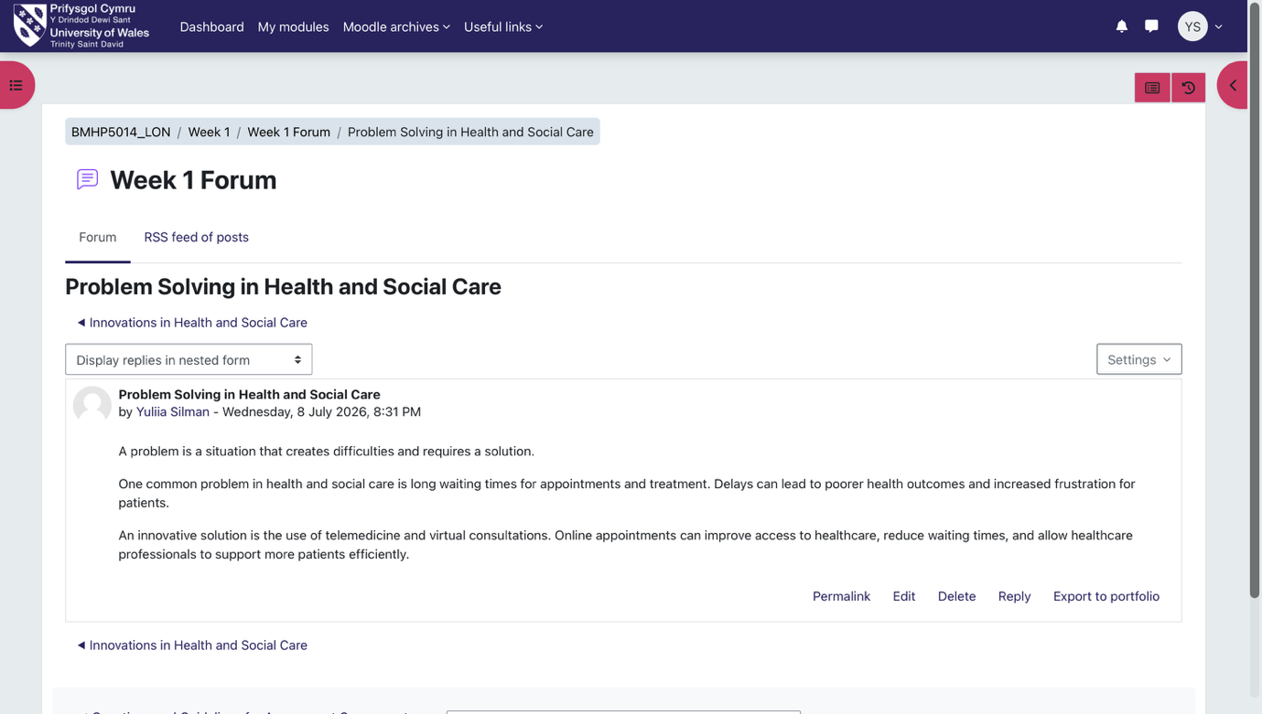

Task 2 - Mind Map
Creating the mind map as a group helped me understand drug misuse in Kennington as a complex health and social care problem rather than an isolated issue. The map connected unemployment, family difficulties, poor mental health and peer pressure with addiction, homelessness, crime and pressure on local services. Meadows’ (2008) systems thinking framework explains how these factors can form reinforcing feedback loops. For example, unemployment and poor mental health may increase vulnerability to drug misuse, while addiction can further damage health and employment, making recovery more difficult. If unaddressed, people using drugs and their families may experience the greatest harm, while services face growing pressure. Our proposed responses included school drug education, youth clubs, counselling, support groups and rehabilitation. Combining prevention and treatment requires local services to work together rather than separately.
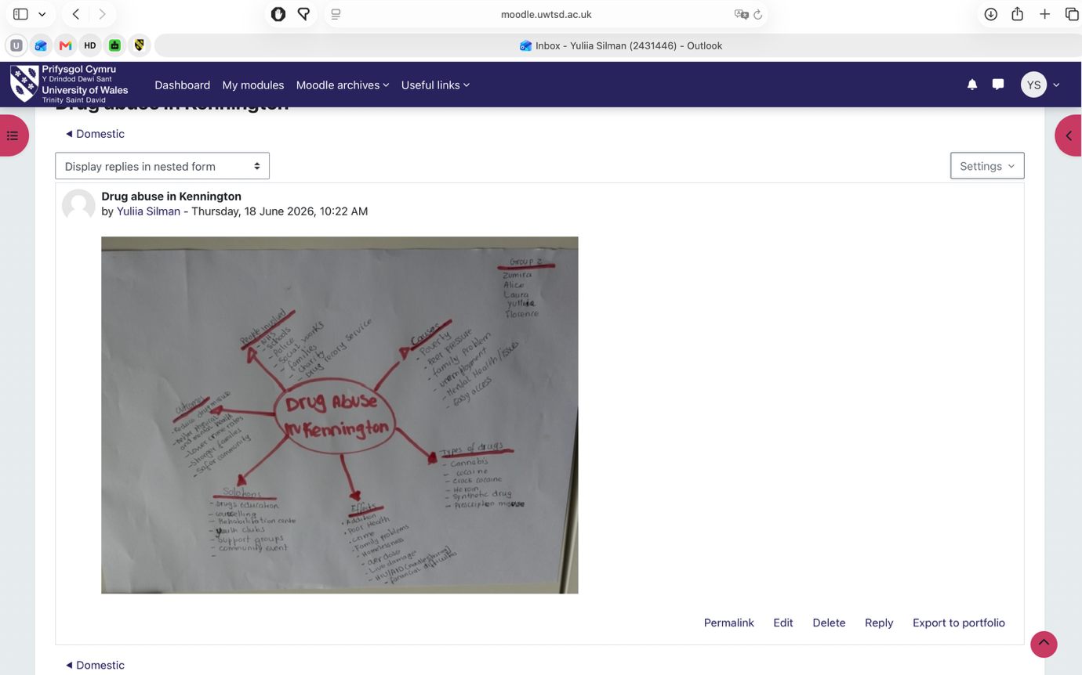

Task 3 - Self-Reflection of Group Activity
Using Gibbs’ (1988) reflective cycle, I reflected on our group response to Stanley’s vaccine equity case. Divergent thinking generates a range of ideas, whereas convergent thinking evaluates them to identify a suitable solution (Cropley, 2006). During the activity, we suggested recruiting additional staff, increasing vaccine supplies, using mobile vaccination clinics and working with community leaders. We then selected a combined approach involving increased staffing and vaccine availability alongside local partnerships. I contributed by summarising our agreed ideas and posting the final response on the forum.
Divergent thinking felt more natural to me because ideas could be shared freely without being judged immediately. The group generated several options quickly, and everyone could contribute. However, moving to convergent thinking was more difficult because we had no agreed criteria for comparing the options. This showed me that generating ideas and selecting them require different skills. I concluded that group decision-making becomes clearer when members agree how solutions will be assessed.
Next time, I would suggest agreeing criteria before we evaluate the ideas, such as feasibility, available resources and likely benefits for vulnerable people. This would help us reach a clearer decision while still allowing everyone to contribute.
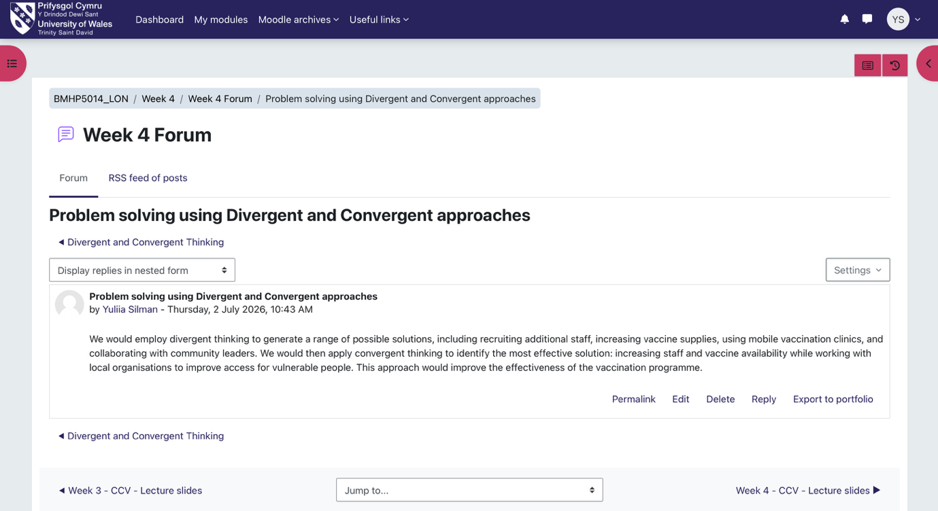

Task 4 - Case Study Analysis of a UK Innovation
Building on my Week 1 forum post identifying AI as a healthcare innovation, I examined Brainomix e-Stroke as a UK example. A key challenge in acute stroke care is rapid CT scan interpretation and access to specialist expertise when treatment decisions are time-critical (Nagaratnam et al., 2024). Brainomix addresses this need creatively by combining rapid AI-assisted analysis with real-time information sharing between hospitals (Department of Health and Social Care, 2023). This supports clinical judgement and remote specialist review.
Using Davis’s (1989) Technology Acceptance Model, I considered how the system might be adopted. Clinicians may adopt e-Stroke when they see it as useful for faster decisions and easy to use through its app and image-sharing platform.
The innovation creates value across the care pathway. Patients may be referred for treatment sooner, clinicians receive decision support, and hospitals can coordinate transfers more efficiently. In one UK single-centre observational study, hospital arrival-to-transfer time fell from 141 to 79 minutes. Among patients receiving specialist clot-removal treatment, the proportion living independently increased from 16% to 48% after implementation (Nagaratnam et al., 2024). However, the study involved a small sample, so these findings suggest potential benefit rather than proving that e-Stroke alone caused the improvements. Its design suggests it could support stroke services elsewhere.
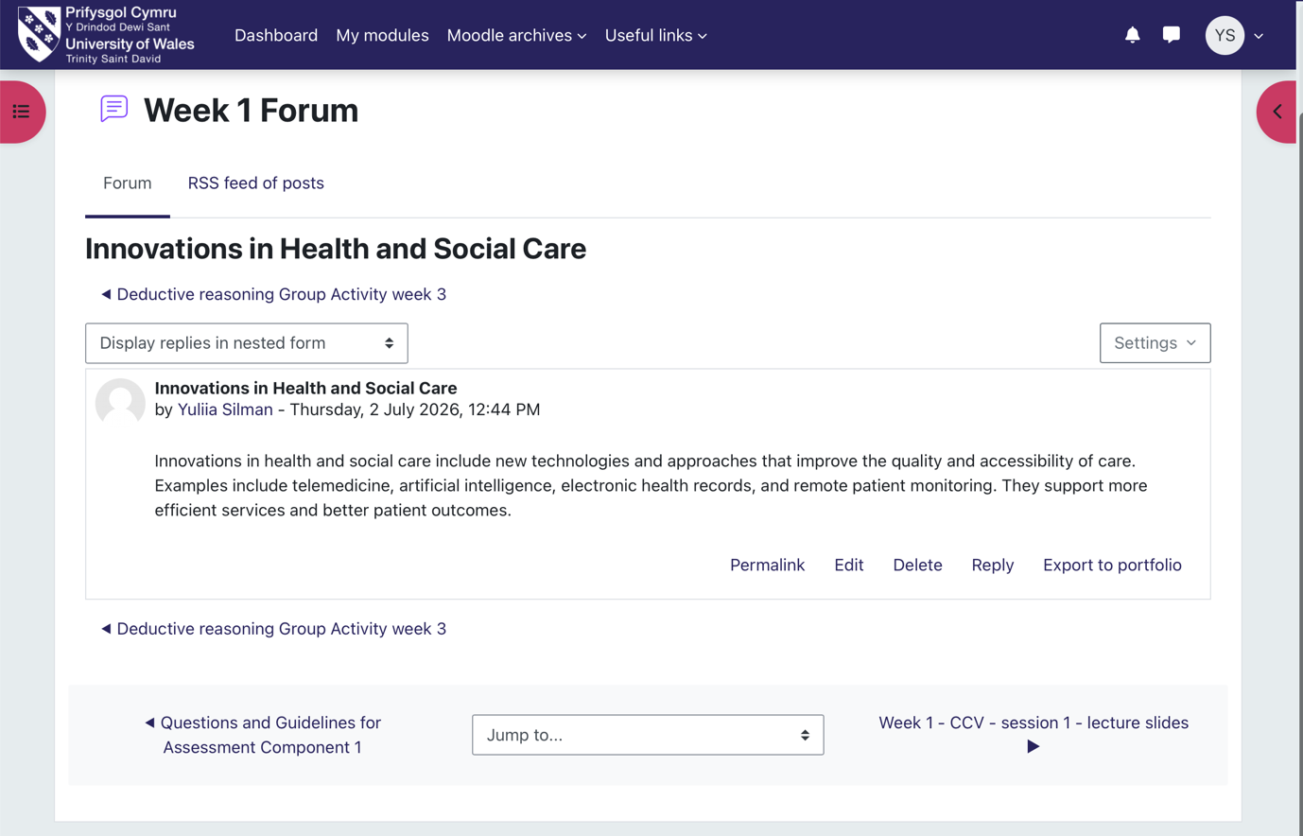

Task 5 - Research Task
Reflecting on my Week 3 research plan about staff burnout and care quality, I compared two peer-reviewed studies. The Job Demands-Resources Model suggests that high demands contribute to exhaustion, while insufficient resources contribute to disengagement (Demerouti et al., 2001).
Nagle et al. (2024) reviewed 38 studies and identified factors including heavy workload, time pressure, limited resources and insufficient workplace support, alongside individual and socio-demographic factors. This broader evidence showed me that burnout develops through several interacting pressures rather than a single cause.
Dall’Ora et al. (2023) surveyed 873 nursing staff in the UK and Ireland. Inadequate staffing and limited choice over shift length were associated with burnout, while rarely or never taking breaks was associated with exhaustion. This showed how everyday staffing and shift arrangements can place additional pressure on workers.
Both articles emphasise working conditions but differ in scope and method. Nagle et al. provide a broad synthesis, whereas Dall’Ora et al. offer evidence about specific shift conditions. In practice, inadequate staffing and missed breaks may leave workers exhausted and less able to provide consistent, patient-centred care. Although the studies did not directly measure care quality, they helped me recognise that addressing burnout requires organisational changes rather than relying only on individual resilience.
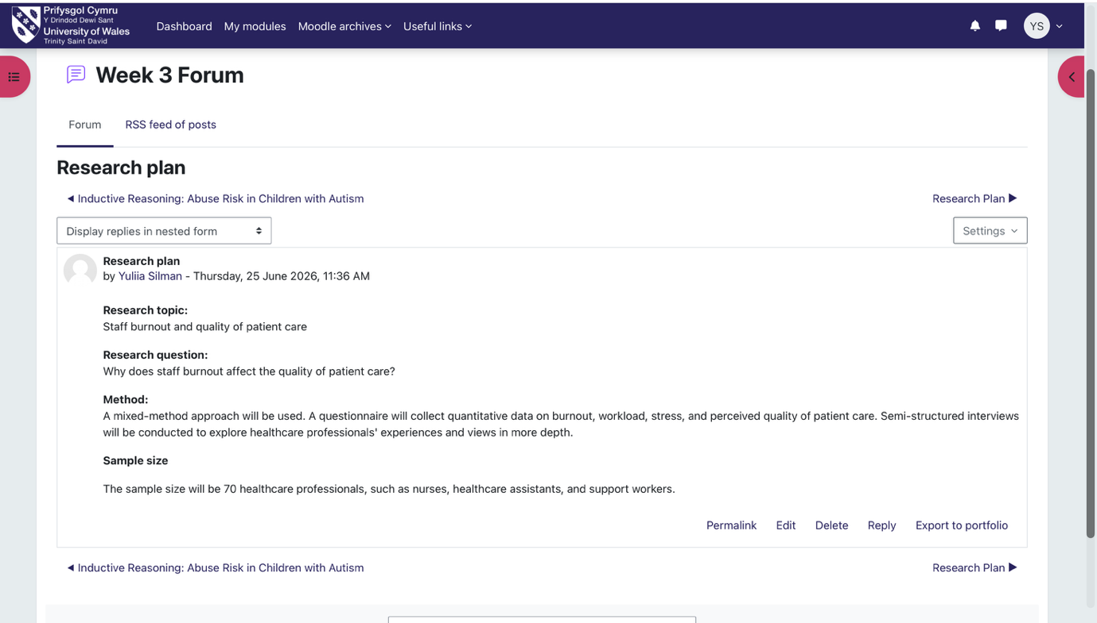

Task 6 - Exploring Digital Innovation in Health and Social Care

Wearable Health Technologies in Chronic Condition Management
Exploring wearable technologies helped me understand how continuous data can support chronic care between appointments. Devices such as smartwatches and continuous glucose monitors collect heart rate, activity, sleep or glucose data during daily life. One benefit is that users can identify patterns and discuss them with professionals before problems become more serious. For example, a person with diabetes may notice repeated high or low glucose readings and adjust food, activity or treatment with clinical guidance. Kamei et al. (2022) reviewed wearable interventions combined with educational support. They found improvements in blood glucose control and weight for people with diabetes, and in exercise time for people with heart disease. However, adherence did not improve overall, and the strength of evidence varied between conditions. This suggests that wearables may strengthen self-management, but their value depends on the condition, support and professional assessment.

Electronic Health Records and Healthcare Collaboration
Electronic health records (EHRs) can improve collaboration through shared care records, which allow authorised professionals to access current information across a person’s care pathway. NHS England (2025) explains that a shared record can combine information from primary care, hospitals, mental health services, community teams and social care, including medicines, allergies, test results and care plans. For example, when a patient arrives at an emergency department, clinicians may view medication and allergy information from another service instead of waiting for telephone confirmation. This can support faster, safer decisions and reduce repeated explanations from the patient. Shared records may also reduce duplicated tests, medication discrepancies and delays in treatment. Learning about this system made it clear that the value of EHRs is not simply storing information digitally but enabling professionals to work from a complete and consistent understanding of the person’s needs.

Digital Technology in Preventative Care and Health Promotion
During our Week 6 activity, developing a medication reminder app helped me understand how digital tools can support preventative care. Designed for older adults, the prototype included reminders, a confirmation button and an emergency contact feature. It could remind users when medication is due, record when doses are taken and help them seek support. Peng et al. (2020) found that mobile apps improved medication adherence among adults with chronic conditions, but the evidence was low quality and interventions were short, requiring caution. Davis’s (1989) Technology Acceptance Model suggests that people are more likely to adopt technology they perceive as useful and easy to use. For older users, this would require a simple layout, clear instructions and large buttons. The prototype could reduce missed doses and support safer, more independent self-management, but it would not guarantee adherence or replace professional support.
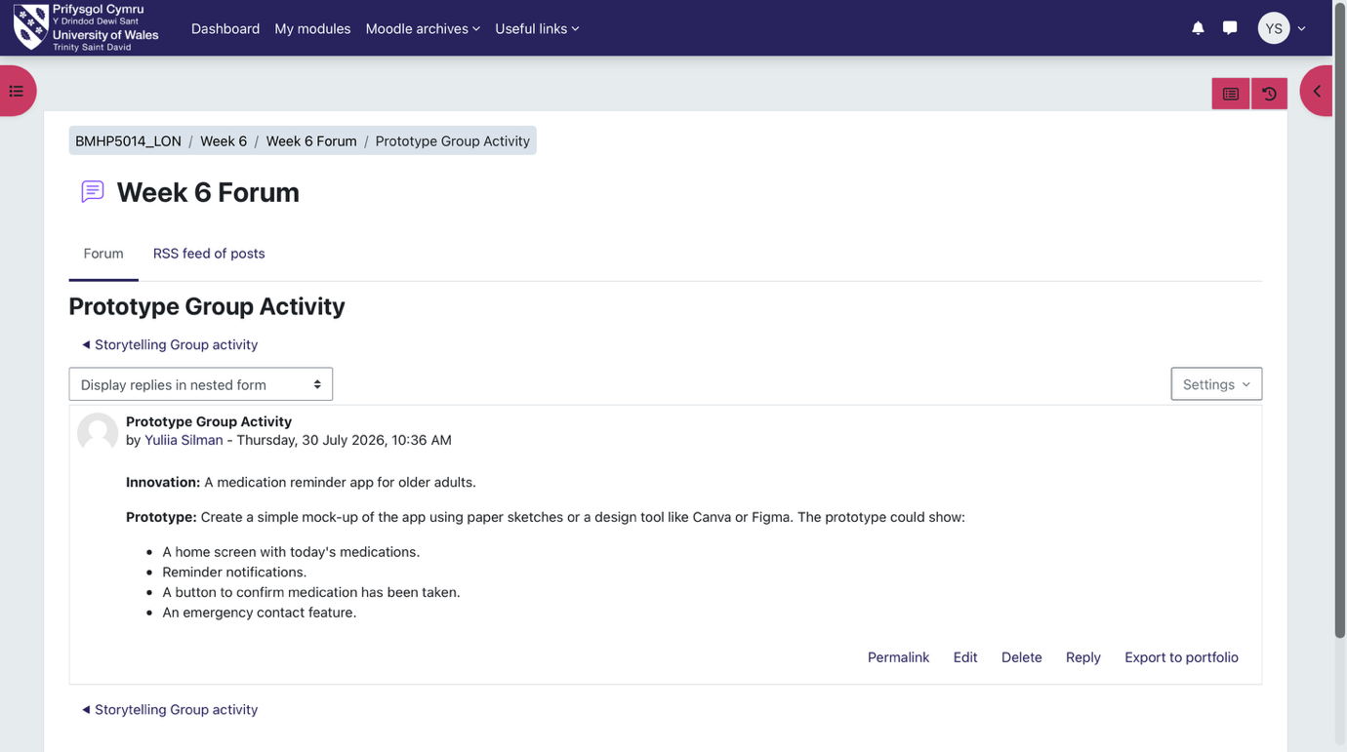

Task 7 - Understanding the NHS Leadership Framework

Summary of the NHS Leadership Framework
The NHS Healthcare Leadership Model describes nine dimensions that help health and care staff develop leadership behaviours, whether or not they hold formal management roles. These are inspiring shared purpose, leading with care, evaluating information, connecting our service, sharing the vision, engaging the team, holding to account, developing capability and influencing for results. Each dimension is presented across four levels: essential, proficient, strong and exemplary (NHS Leadership Academy, 2013). This structure helps staff reflect on their leadership and identify areas for development. The model is important because leadership behaviours influence team culture and the quality of service-user care. West et al. (2015) argue that collective leadership, staff engagement and compassionate care are essential for improving healthcare organisations. The model helped me understand that leadership is not limited to senior managers; it can be demonstrated in daily practice by listening to colleagues, sharing responsibility and supporting ideas that improve health services.

Leadership Behaviour in Practice
Inspiring shared purpose means acting in line with NHS values and showing commitment to improving services (NHS Leadership Academy, 2013). In my Week 5 campaign plan for Tower Hamlets, a leader could use this behaviour to unite GP surgeries, schools, charities and community groups around reducing stigma and improving access to support. By keeping local needs and service-user wellbeing at the centre, the leader could invite partners to suggest culturally appropriate digital content, workshops and community events. This would encourage creativity without losing sight of the campaign’s purpose. Shared ownership could strengthen participation and make the support more relevant to residents.

Reflective Journal Entry
At the beginning, I associated innovation with technology and value with efficiency. The drug misuse mind map, burnout research and Week 6 prototype changed this view. Systems thinking showed me that health and social care problems are connected, while the leadership activities demonstrated that creativity could involve collaboration, service redesign and responding to community needs. I now understand value as an improvement in people’s access, safety or experience, not simply a financial result. In future practice, I would involve service users and colleagues when developing solutions and assess ideas by whether they are practical, inclusive and likely to improve care.
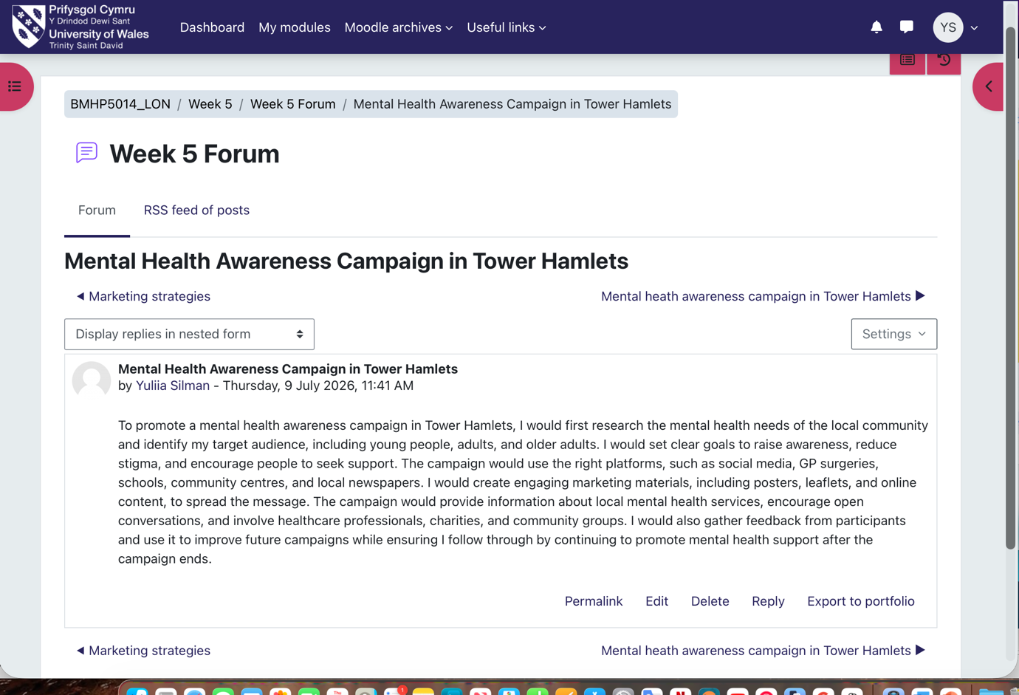

Task 8 - Self-Reflection Journal Entry
Before examining Brainomix e-Stroke, I mainly judged innovation by how advanced the technology appeared. The case showed me that its real value came from supporting faster decisions and giving patients better access to specialist expertise. The Week 6 medication-reminder activity also showed that creativity starts with recognising a practical need and adapting an idea for the people who will use it. Anderson et al. (2014) describe creativity as producing ideas that are both new and useful. This framework helped me see why an original idea has limited value if it is difficult to use or does not improve care. In future health or social care roles, I would first listen to service users and staff, then consider whether a proposed change is useful, accessible and realistic. The main lesson I will carry forward is that innovation creates value only when it improves people’s experience of care.

Reference List
Anderson, N., Potočnik, K. and Zhou, J. (2014) ‘Innovation and creativity in organizations: A state-of-the-science review, prospective commentary, and guiding framework’, Journal of Management, 40(5), pp. 1297-1333. Available at: https://doi.org/10.1177/0149206314527128 (Accessed: 18 July 2026).
Cropley, A. (2006) ‘In praise of convergent thinking’, Creativity Research Journal, 18(3), pp. 391-404. Available at: https://doi.org/10.1207/s15326934crj1803_13 (Accessed: 25 July 2026).
Dall’Ora, C., Ejebu, O-Z., Ball, J. and Griffiths, P. (2023) ‘Shift work characteristics and burnout among nurses: Cross-sectional survey’, Occupational Medicine, 73(4), pp. 199-204. Available at: https://doi.org/10.1093/occmed/kqad046 (Accessed: 22 July 2026).
Davis, F.D. (1989) ‘Perceived usefulness, perceived ease of use, and user acceptance of information technology’, MIS Quarterly, 13(3), pp. 319–340. Available at: https://doi.org/10.2307/249008 (Accessed: 13 July 2026).
Dawson, P. and Andriopoulos, C. (2021) Managing change, creativity and innovation. 4th edn. London: SAGE.
Demerouti, E., Bakker, A.B., Nachreiner, F. and Schaufeli, W.B. (2001) ‘The job demands–resources model of burnout’, Journal of Applied Psychology, 86(3), pp. 499-512. Available at: https://doi.org/10.1037/0021-9010.86.3.499 (Accessed: 21 July 2026).
Department of Health and Social Care (2023) How we are delivering innovation in health and social care services. Available at: https://healthmedia.blog.gov.uk/2023/06/23/how-we-are-delivering-innovation-in-health-and-social-care-services/ (Accessed: 14 July 2026).
Gibbs, G. (1988) Learning by doing: A guide to teaching and learning methods. Oxford: Further Education Unit, Oxford Polytechnic.
Kamei, T., Kanamori, T., Yamamoto, Y. and Edirippulige, S. (2022) ‘The use of wearable devices in chronic disease management to enhance adherence and improve telehealth outcomes: A systematic review and meta-analysis’, Journal of Telemedicine and Telecare, 28(5), pp. 342-359. Available at: https://doi.org/10.1177/1357633X20937573 (Accessed: 19 July 2026).
Lages, L.F., Ricard, A., Hemonnet-Goujot, A. and Guerin, A.M. (2020) ‘Frameworks for innovation, collaboration, and change: Value creation wheel, design thinking, creative problem-solving, and lean’, Strategic Change, 29(2), pp. 195-213. Available at: https://doi.org/10.1002/jsc.2321 (Accessed: 21 July 2026).
Meadows, D.H. (2008) Thinking in systems: A primer. Edited by D. Wright. White River Junction, VT: Chelsea Green Publishing.
Nagaratnam, K., Neuhaus, A., Briggs, J.H., Ford, G.A., Woodhead, Z.V.J., Maharjan, D. and Harston, G. (2024) ‘Artificial intelligence-based decision support software to improve the efficacy of acute stroke pathway in the NHS: An observational study’, Frontiers in Neurology, 14, article 1329643. Available at: https://doi.org/10.3389/fneur.2023.1329643 (Accessed: 19 July 2026).
Nagle, E., Griskevica, I., Rajevska, O., Ivanovs, A., Mihailova, S. and Skruzkalne, I. (2024) ‘Factors affecting healthcare workers burnout and their conceptual models: Scoping review’, BMC Psychology, 12, article 637. Available at: https://doi.org/10.1186/s40359-024-02130-9 (Accessed: 18 July 2026).
NHS England (2025) Shared care records. Version 1.5, 26 March. Available at: https://www.england.nhs.uk/long-read/shared-care-records/ (Accessed: 13 July 2026).
NHS Leadership Academy (2013) The Healthcare Leadership Model. Version 1.0. Leeds: NHS Leadership Academy. Available at: https://www.leadershipacademy.nhs.uk/wp-content/uploads/dlm_uploads/2014/10/NHSLeadership-LeadershipModel-colour.pdf (Accessed: 22 July 2026).
Peng, Y., Wang, H., Fang, Q., Xie, L., Shu, L., Sun, W. and Liu, Q. (2020) ‘Effectiveness of mobile applications on medication adherence in adults with chronic diseases: A systematic review and meta-analysis’, Journal of Managed Care & Specialty Pharmacy, 26(4), pp. 550-561. Available at: https://doi.org/10.18553/jmcp.2020.26.4.550 (Accessed: 20 July 2026).
West, M., Armit, K., Loewenthal, L., Eckert, R., West, T. and Lee, A. (2015) Leadership and leadership development in health care: The evidence base. London: Faculty of Medical Leadership and Management, The King’s Fund and Center for Creative Leadership. Available at: https://assets.kingsfund.org.uk/f/256914/x/6577e5c839/leadership_in_health_care_report_february_2015.pdf (Accessed: 15 July 2026).

