
Master of Business Administration

LCMB7023-Human Capital Management
Lecturer: Gladius Kulothungan Ejike Udeogu

Student Name: Ikhtear Mahbub
Student ID: 2527585

Word Count: 2625
Submission Date: 20th March 2026
Table of Contents
1. Introduction 1
2. Current Performance Management and Job Design Practices in Technology Companies 1
3. Proposed Modern Performance Management System for Aether Innovations 2
3.1 Implementation of OKR Framework 2
3.2 360-Degree Feedback System 3
3.3 Continuous Performance Reviews 4
4. Job Analysis and Job Design for Key Positions 4
5. Job Descriptions and Specifications for Key Leadership Roles 5
6. Creating a Performance-Driven Culture 6
7. Reflective Learning (Gibbs Reflective Cycle) 7
8. AI and Future Career Development 9
9. Conclusion 10
10. References 11

1. Introduction
Aether Innovations is an expanding technology firm of about 300 employees. Although the organisation has been doing well initially, it is presently facing a number of setbacks such as a stagnating growth, high turnover rates among the employees and customer dissatisfaction. In the technology-intensive sector, this makes Human Capital Management (HCM) an important factor that can facilitate the improvement of the organisational performance of the employees, innovation and competitiveness in the organisation (Bratton and Gold, 2022). With strategic management of human resources, organisations are in a better position to match the capabilities of employees to the goals of the organisation and respond to the changing market environments (Noe et al., 2021). This report critically evaluates the recent trends in performance management and job design, new performance appraisal system and reformulation of the major leadership roles. The aim of the proposed paper is to show how strategic HR practices may enhance innovation and organisational performance at Aether Innovations.

2. Current Performance Management and Job Design Practices in Technology Companies
Modern practice in performance management and job design is becoming more and more commonplace in technology companies to aid in supporting innovation and collaboration and employee performance. Continuous feedback systems that are slowly becoming the replacement of traditional annual performance appraisals include managers coaching and giving consistent performance feedback to employees to enable the development of employees and organisational flexibility (Armstrong and Taylor, 2023). Such systems help organisations to be responsive to the dynamics of the market and development needs of employees. Agile performance management is also practised in many technology companies and this enables organisational objectives to be periodically revised to incorporate the changing nature of business environments.
One of the most popular approaches is the Objectives and Key Results (OKR) model, popularised by the companies like Google. This style connects personal goals with quantifiable results that lead to organisational strategy and performance (Doerr, 2021). Moreover, technology organisations like Microsoft and Netflix are also placing more importance on team-based performance measurement because they understand that innovation and product development are often products of teamwork, and not individual effort (Boxall and Purcell, 2022).
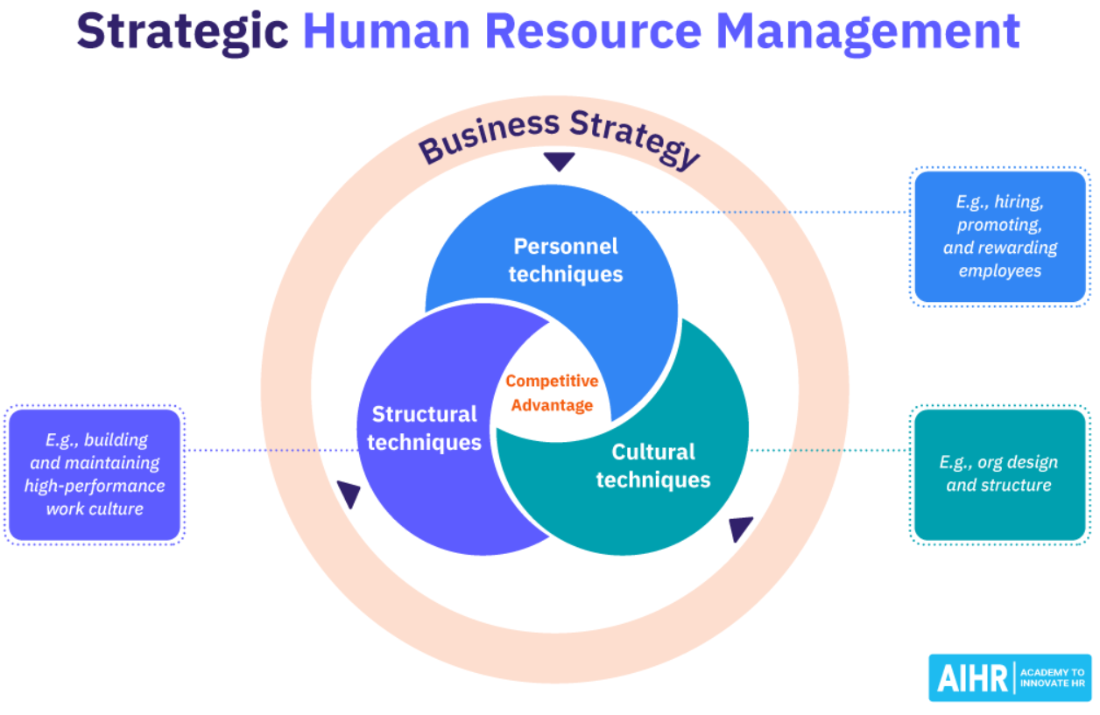
Figure 1: Strategic Human Resource Management (Vulpen, 2020)
The practices align with the purposes of Strategic Human Resource Management that prioritize the alignment of both HR policies and practices with organisational objectives in order to increase competitiveness (Armstrong and Taylor, 2023). Moreover, the Goal-Setting Theory proposes that set objectives should be specific and challenging to enhance employee motivation and performance outcomes (Locke and Latham, 2020). Nevertheless, along with such advantages, over-monitoring of performance and constant assessment can also cause the pressure and workplace stress of employees when no effective measures are introduced (CIPD, 2024).

3. Proposed Modern Performance Management System for Aether Innovations

3.1 Implementation of OKR Framework
The Objectives and Key Results (OKR) performance management tool should be applied to Aether Innovations to enhance performance and innovation in the organisation. OKRs imply the establishment of specific organisational goals with the assistance of quantifiable key results to monitor the movement towards the goal accomplishment. This system allows organisations to align personal and unit performance to the overall organisational strategy (Doerr, 2021). As an example, one of the organisational goals can be to be increasingly innovative in its products and the outcomes of such goals might include introduction of 2 new software features in the next six months and the customer satisfaction score should rise by 15%. Using a clearly defined connection between personal performance goals and strategic priorities, OKRs help employees to pay their attention to the outcomes that can directly lead to the business success. In addition, the OKR system enhances clarity of goals, accountability and transparency since employees have a clear understanding of how their individual roles will help in organisational performance (Armstrong and Taylor, 2023). Studies also indicate that employees become more motivated and productive when using goals systems like OKRs that are specific, measurable and challenging (Locke and Latham, 2020). Nevertheless, organisations should make goals achievable to prevent undue stress in workers due to the overloaded performance demands.

3.2 360-Degree Feedback System
Another tool that should be introduced by Aether innovation to supplement the OKR system is 360-degree feedback. This method will collect performance feedbacks which are multiple and comprise of managers, peers, team members and self-evaluations. This type of system enables a fuller evaluation of the performance of employees and their leadership abilities (CIPD, 2023). Multi-source feedback can be used to enhance leadership development, transparency and employee engagement in technology organisations where teamwork and collaboration are critical elements. This allows employees to develop and improve their personal growth regularly by providing them with valuable information about their strengths and areas of development (Armstrong and Taylor, 2023). However, organisations have to be extremely cautious on the process so that the feedback remains constructive and unbiased since poorly adopted systems may cause confusion among employees or result in inter-personal conflict.

3.3 Continuous Performance Reviews
Lastly, to make sure that traditional annual appraisals are substituted with continuous quarterly-based performance reviews, Aether Innovations should implement this change. Constant review systems prompt regular coaching between managers and employees to enable them to solve performance issues early and recognize the development requirements earlier (CIPD, 2024). Moreover, the data analytics tools may be used to facilitate the evaluations based on data on employee progress and accomplishment of goals. This will enhance organisational learning, agility and innovativeness as employees will have continuous guidance and support instead of having to wait until the end of the year to be assessed. Continuous feedback is especially useful when working in a dynamic technological environment where modernisation and constant advancement should be linked to being competitive (Deloitte, 2023).

4. Job Analysis and Job Design for Key Positions
Job design and job analysis are required to make sure that job roles facilitate performance and innovation among employees in an organisation. Job Characteristics Model is an explanation of the impact of job characteristics on motivation and effectiveness. The model recognizes five dimensions, which are skill variety, task identity, task significance, autonomy and feedback. Skill variety can be defined as an application of various skills and abilities in a job that enables workers experience a variety of tasks and attain greater competencies. Task identity entails the accomplishment of a complete body of work and this makes employees have a sense of accomplishment. Task significance indicates the level of influence a job has on the work of others, customers or the success of an organisation in that their work is more valued. Autonomy gives the employees liberty to make their choice on how the work is done which promotes creativity and problem-solving on their own. The feedback gives details on the performance outcomes, and this allows employees to work and learn better (Campion et al., 2020).
Such job design factors are associated with intrinsic motivation, work satisfaction and innovative behaviour especially in knowledge intensive industries. Skills-based job design is increasingly becoming popular in modern organisations whereby jobs are defined in terms of the abilities of the employees instead of job tasks. In the case of Aether Innovations, this will be able to promote cross-functional collaboration, flexibility and on-going innovation within the fast-changing technological landscape (Parker, 2022).

5. Job Descriptions and Specifications for Key Leadership Roles
Chief Executive Officer (CEO)
The Chief Executive Officer (CEO) offers the general strategic guidance and makes sure that the organisational objectives are conducive to long term innovation and competitive advantage. The CEO will create organisational culture, facilitate teamwork and lead the digital transformation efforts. The competencies necessary in this job include strong leadership, strategic thinking and handling complicated technological change (Teece, 2020).
Chief Financial Officer (CFO)
The Chief Financial Officer (CFO) is in charge of financial planning and makes sure that the organisational resources are used to facilitate innovation and long-term development. This position requires assessing the risks associated with financial matters, managing investment decisions and sponsoring strategic projects regarding the technological development. Adequate financial strategy, analytical ability and risk management are critical in facilitating organisational stability and performance (Hiebl, 2021).
Chief Technology Officer (CTO)
The Chief Technology Officer (CTO) is the head of technology architecture in the organisation and the development of digital products and systems. The position demands knowledge of software engineering management, as well as the capacity to observe the new trends in technology that improve the competitiveness of the organisation (Ransbotham et al., 2021).

Chief Innovation Officer (CIO)
The Chief Innovation Officer establishes and realizes strategies on innovation and oversees the initiatives on product development. Strategic innovation management and cross-functional collaboration are essential to maintain organisational development, as well as creativity (O'Connor and Kelly, 2021).
HR Director
The HR Director creates talent plans, administers performance systems and encourages employee involvement. HR leadership and organisational development competencies are useful in aligning human capital practices to the business (Cooke, Xiao and Chen, 2021).
Head of Research and Development (R&D)
The R&D head manages the research and technological experimentation of a product to aid in innovation. To create new solutions and ensure a competitive advantage, powerful research leadership and technical skills are required (Salerno et al., 2020).

6. Creating a Performance-Driven Culture
To establish a performance based culture in Aether Innovations, the effective performance systems in terms of job design and leadership alignment is needed. The OKR framework is a model that helps employees to align their personal goals with organisational objectives, enhancing clarity, accountability and strategy (Doerr, 2021). Simultaneously, employee motivation and innovative behaviour are induced by modern job design which fosters autonomy, skill variety and collaboration (Campion et al., 2020). Cooperation in leadership at the senior level further supports values and strategic priorities of an organisation. When the elements work in concert, organisations enjoy greater employee engagement, productivity and innovativeness that results in better customer satisfaction and success of the organisation in the long run (Armstrong and Taylor, 2023).

7. Reflection (Gibbs Reflective Cycle)
Description
The Human Capital Management module made me acquire critical information regarding the manner in which organisations strategically manage people to succeed in business. Other concepts that were brought forward in the module include performance management, talent management and strategic human resource management. I also gained knowledge on how organisations develop performance systems so as to align employee objectives to organisational strategy and how talent management assists organisations in attracting, developing and retaining skilled employees. The other area of learning was how the HR practices affect organisational culture, employee engagement and productivity. Another aspect brought to light by the module was the use of the HR strategies to facilitate innovation and organisational change in contemporary businesses. The obtained knowledge allowed me to realise that the management of human capital could play a crucial role in organisational success and the ability to remain competitive in the long run (Bratton and Gold, 2022).
Feelings
Prior to studying this module, I had the impression that the primary activities of HR concerned administrative functions of recruitment, payroll and employee policies. I was not well aware of the role of HR in strategic decision making of organisations. Nonetheless, this module has made me understand that HR is an essential factor in enhancing the performance of an organisation, as well as aiding leadership and increasing employee motivation. This learning experience altered my understanding of HR as a strategic and not an administrative role (Stone, Cox and Gavin, 2020).
Evaluation
The ability to know how HR strategies affect the performance of an organisation was one of the most important things about the module. The explanation of the correlation of HR practices and business performance made me understand that people management is crucial to organisational success. Specifically, the performance management issue proved the way how explicit goals, feedback and staff development programs could enhance motivation and productivity. Talent management was another significant learning area that focuses on the development of capabilities of employees and their potential to lead organisations in order to remain competitive in the market. Another aspect brought out in the module was the contribution of the HR in developing good working conditions that foster teamwork and creativity. These lessons assisted me in understanding the fact that HR professionals are a major contributor to the development of organisational culture, as well as the proponent of sustainable growth (Noe et al., 2021).
Analysis
The HR strategies play a major role in determining the organisational performance, innovation and the involvement of the employees. A good HR practice helps organisations to utilize workforce potentials in the same direction as the business needs and this enhances productivity and competitiveness of an organisation. As an illustration, performance management systems enable the employees to know their roles and organisational expectations and this motivates them to be accountable and improve in the process. Also, the HR practices based on employee development would facilitate innovation since the employees would be better prepared to address change in technology, as well as have the capability to resolve complicated issues. Closely associated with HR policies that facilitate recognition, cooperation and supportive leadership are the employee engagement. The studies indicate that employee commitment and organisational performance is higher in organisations that have robust HR strategies since employees feel appreciated and inspired (Paauwe and Boon, 2021). Thus, HR professionals need to collaborate closely with organisational leaders in order to create strategies that facilitate the development of the workforce and organisational achievement.
Conclusion
On balance, this module allowed me to realize the strategic role of human resource management. I have now understood that HR practices affect organisational culture, employee performance and innovation. This information has enhanced my curiosity to acquire skills associated with strategic HR management (Cascio and Montealegre, 2020).
Action Plan
I will use these HR concepts in my career by developing performance management and employee engagement skills and leadership in the future.

8. AI and Future Career Development
Artificial intelligence (AI) is becoming a factor in organisational practices and future of work. Most organisations currently employ AI-based recruitment systems, HR analytics and automated performance monitoring systems as a way of enhancing efficiency and making decisions. As an illustration, AI can process vast amounts of data to draw trends regarding the performance of staff, forecast labour trends and help organisations to pick the appropriate candidates to fill job-related vacancies. Such technologies help the HR departments to make quicker and more educated choices, and minimize administrative loads (Vrontis, Christofi and Pereira, 2022).
Nevertheless, even with the increased application of AI in organisations, human capabilities are also vital in successful leadership and management of organisations. Automated systems can hardly duplicate such skills as strategic thinking, emotional intelligence, leadership and ethical decision-making. HR experts should thus come up with the competencies that can go hand in hand with AI technologies, but not work against them. As an example, AI may produce analytical data on the trends in the workforce, but then human managers have to decipher the generated data and make decisions that reflect the organisational culture and the welfare of employees (Jarrahi et al., 2023).
Thus, I will employ AI to assist in the data analysis process, workforce planning and decision support in my future career, but I will not stop acquiring interpersonal and leadership skills. With the integration of technological expertise and strategic thinking, as well as human-centred leadership, HR professionals will be able to stay current and efficient in a workplace that is becoming more digital.

9. Conclusion
Finally, the report has emphasised the significance of strategic human resource management as a tool of enhancing organisational performance in Aether Innovations. Modern performance systems, good job design and well-outlined leadership positions can lead to better employee motivation, innovativeness and productivity. The HR practices aligned with the organisational strategy can help Aether Innovations overcome such issues as employee turnover and waning customer satisfaction and deliver sustainable growth and long-term competitive advantage.

10. References
Armstrong, M. and Taylor, S. (2023) Armstrong’s Handbook of Human Resource Management Practice. 16th edn. London: Kogan Page.
Boxall, P. and Purcell, J. (2022) Strategy and Human Resource Management. 5th edn. London: Red Globe Press.
Bratton, J. and Gold, J. (2022) Human Resource Management: Theory and Practice. 7th edn. London: Palgrave Macmillan.
Brewster, C., Mayrhofer, W. and Morley, M. (2020) Human Resource Management in Europe. London: Routledge.
Campion, M.A., Campion, E.D., Campion, M.C. and Reider, M.H. (2020) ‘Job design: A review and future directions’, Annual Review of Organizational Psychology and Organizational Behavior, 7, pp. 193–226.
Cascio, W.F. and Montealegre, R. (2020) ‘How technology is changing work and organisations’, Annual Review of Organizational Psychology and Organizational Behavior, 3, pp. 349–375.
CIPD (2023) Performance management: An introduction. Available at: https://www.cipd.org/en/topics/performance-management/ (Accessed: 12 March 2026).
Cooke, F.L., Xiao, M. and Chen, Y. (2021) ‘Still in search of strategic human resource management? A review and suggestions for future research’, Human Resource Management Review, 31(2), pp. 1–13.
Deloitte (2023) Global Human Capital Trends 2023. Available at: https://www2.deloitte.com (Accessed: 12 March 2026).
Doerr, J. (2021) Measure What Matters: How Google, Bono and the Gates Foundation Rock the World with OKRs. New York: Penguin.
Hiebl, M.R.W. (2021) ‘The role of the CFO in strategic decision making’, Journal of Management Control, 32(3), pp. 249–281.
Jarrahi, M.H., Lutz, C., Newlands, G. and Lehdonvirta, V. (2023) ‘Artificial intelligence and the future of work: Human–AI collaboration in organisational decision-making’, Business Horizons, 66(1), pp. 87–99.
Locke, E.A. and Latham, G.P. (2020) ‘Building a practically useful theory of goal setting and task motivation: A 35-year odyssey’, American Psychologist, 57(9), pp. 705–717.
Noe, R.A., Hollenbeck, J.R., Gerhart, B. and Wright, P.M. (2021) Human Resource Management: Gaining a Competitive Advantage. 12th edn. New York: McGraw-Hill.
O’Connor, G.C. and Kelly, P. (2021) ‘Leading innovation in large organisations’, Research-Technology Management, 64(4), pp. 28–36.
Paauwe, J. and Boon, C. (2021) ‘Strategic HRM: A critical review’, Human Resource Management Journal, 31(1), pp. 4–20.
Parker, S.K., Morgeson, F.P. and Johns, G. (2017) ‘One hundred years of work design research: Looking back and looking forward’, Journal of Applied Psychology, 102(3), pp. 403–420.
Ransbotham, S., Kiron, D., LaFountain, B. and Khodabandeh, S. (2021) ‘The cultural benefits of artificial intelligence in organisations’, MIT Sloan Management Review, 62(4), pp. 1–10.
Salerno, M.S., Gomes, L.A.V., da Silva, D.O., Bagno, R.B. and Freitas, S.L.T.U. (2020) ‘Innovation processes: Which process for which project?’, Technovation, 35(1), pp. 59–70.
Stone, D.L., Cox, S. and Gavin, M. (2020) ‘Advancing research on the future of work and HRM’, Human Resource Management Review, 30(3), pp. 1–9.
Teece, D.J. (2020) ‘Dynamic capabilities and entrepreneurial management in large organisations’, Strategic Management Journal, 41(1), pp. 1–20.
Vrontis, D., Christofi, M. and Pereira, V. (2022) ‘Artificial intelligence, robotics, advanced technologies and human resource management: A systematic review’, The International Journal of Human Resource Management, 33(6), pp. 1237–1266.
Vulpen, E. van (2020). Strategic Human Resource Management: The Basics. [online] AIHR. Available at: https://www.aihr.com/blog/strategic-human-resource-management/ (Accessed 12 Mar. 2026).

