DATA CAPTURE TRIAL NOTES
Contents
Figures 1
Tables 1
Introduction 2
Area of Operations 2
Data Capture Methods 4
Spot® 4
Djibouti Mavik 2 Drone 6
References 6

Figures
Figure 1 – Example of a Dummy Mine 2
Figure 2 - Area of Operations 3
Figure 3 - Photograph of Area of Operations 3
Figure 4 - SPOT 4
Figure 5 - Search Lanes 5

Tables
Table 1 - Weather During the Trial 4
Table 2 - SPOT Advantages & Disadvantages 5

Introduction
12 dummy mines had been placed on university grounds with the aim of trialling remote sensing equipment’s ability to locate the mines. The dummy mines were orange plastic, with a hollow centre which was then filled with heated plasticine to give the dummy mines a heat signature. Figure 1 shows one of the dummy mines.
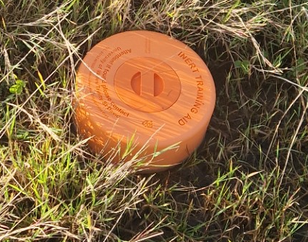
Figure 1 – Example of a Dummy Mine
These notes detail different methods used to try and locate the mines and a discussion on their suitability for the task. Two different methods were trialled, Spot® - the agile mobile robot, constructed by Boston Dynamics and a Djibouti Mavik 2 Drone.

Area of Operations
An area just South of the university library was used for the activity. Figure 2 shows the area required to be searched as a red outline. The perimeter of the minefield was 321m long and the area of the minefield was 5826 square metres. The drones take off and landing zone was located on an observation platform just off the South-West corner of the minefield.
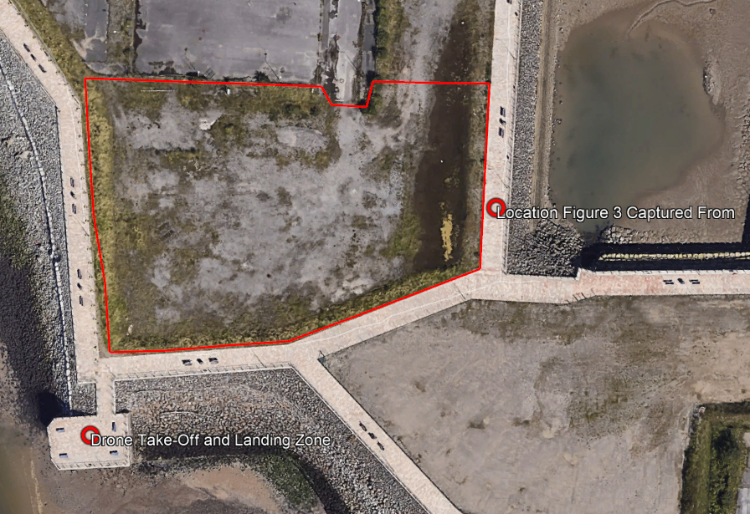
N
Figure 2 - Area of Operations
Figure 3 shows a photograph taken from the Eastern side of the area of operations. A large puddle of water had formed on the Eastern edge, estimated to be 15m across at its widest. The rest of the area consisted of scrubland, mostly gravel with patches of coarse grass and small plants growing through. The Northen edge of the perimeter had some bigger bushes and shrubs and scattered rubble.
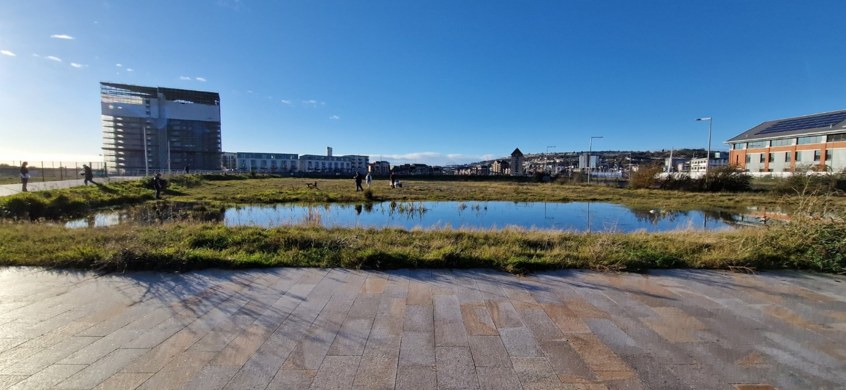
Figure 3 - Photograph of Area of Operations
Table 1 shows the weather during the trial.

Table 1 - Weather During the Trial
Time | Wind Direction | Average Wi`nd Speed | Gust Speed | Air Temperature | Humidity | Cloud Cover | Pressure
1400 | W | 6mph | 8mph | 8°C | 73% | 57% | 1015mb
1500 | W | 8mph | 10mph | 8°C | 75% | 64% | 1016mb
1600 | W | 7mph | 8mph | 6°C | 77% | 40% | 1016mb

Data Capture Methods

Spot®
Spot® is a robot designed and manufactured by Boston Dynamics. It is primarily used by University of Wales Trinity St. David for research purposes, but is utilised in industry for inspecting facilities autonomously. [1] The robot has several configurations, the UWTSD robot has a moveable arm on the top, front facing camera and a PTZ thermal camera on top. Figure 4 shows the university’s SPOT.
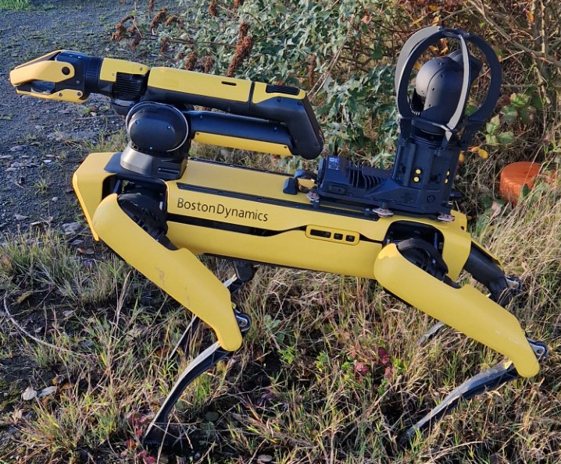
Figure 4 - SPOT
The robot has an operating time of 90 minutes and was controlled by the operator from a tablet, the range of control is between 20 and 30 metres. SPOT was measured to have a field of view of 2.1m width. With this in mind, the area to search was split into lanes as per figure 5, with each lane the width of the field of view. The robot would patrol each lane using it’s IR camera to identify hotspots signifying a mine location.
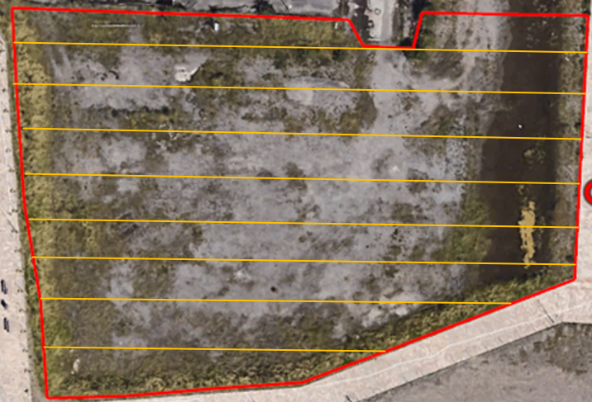
Figure 5 - Search Lanes
Open starting the search, it became apparent the SPOT would be unable to enter the Eastern edge of the search zone due to the large puddle, so this area was omitted from the search zone. On the first lane (Southernmost), SPOT fell down the bank, but was able to self-right and continue the search.
On the second lane, it was identified that the PTZ camera mounted on the rear of the robot was unable to properly see the ground in front, the decision to turn the robot through 180 degrees and reverse SPOT along the rest of the lanes, this provided much better vision on the tablet display.
After the 3rd lane it was apparent the SPOT would be unable to search the whole area on one battery charge, due to the slow walking speed of the robot. It was decided to use the robot to search around the trees and bushes of the Northern edge of the search zone, as the robot would have better luck than the drone searching under the bushes, however, the robot did struggle to move through some of the denser scrub. During the search it was discovered that other hot spots such as tree roots showed up more brightly than the dummy mines.
Table 2 below tabulates the advantages and disadvantages of SPOT as discovered during the trial.
Table 2 - SPOT Advantages & Disadvantages
Advantages | Disadvantages
The potential for full autonomy. | The SPOT that UWTSD owns, requires the operator to be as close as 20m to the robot. Which would not be useful in a real minefield.
The ability to self-right. | Unable to effectively scan the ground in its current set up.
Able to get close to mines. | Inability to wade through water.
Able to search under trees and through shrubbed areas. | Struggles with dense scrub.
Modular construction would allow for a more optimised loadout for mine searching. | Other hot spots could spoof the camera.
 | Low battery life.
 | Large heavy equipment.

Djibouti Mavik 2 Drone
The Mavik 2 is a small, 322mm × 242mm × 84mm (length × width x height), and lightweight, 905g, drone. It has 8GB internal storage allowing for plenty of IR footage to be saved. [2] The drone flew roughly 10m above ground level following the same search pattern as SPOT.
The drone was faster than SPOT and was able to identify the surface mines heat signatures easily and quickly. However, the drones IR sensor was unable to penetrate the canopy of shrubbery, and mines placed here went undetected by the drone.
Table 3 - Drone Advantages & Disadvantages
Advantages | Disadvantages
Operator remains out of danger zone. | Unable to penetrate the canopy of shrubbery.
Good quality camera. | Drone pilots licence required.
Speed.
Lightweight small equipment.

References

[1] | [Online]. Available: https://bostondynamics.com/industry/manufacturing/. [Accessed 27 11 2023].
[2] | [Online]. Available: https://www.dji.com/uk/mavic-2/info#specs. [Accessed 28 11 2023].

