

BSc (Hons) Cloud Computing
ACCA5033_BIRM

ONLINE MARKETING FOR CAFE POD

Assessment 1

Lecturer: Aliyu Sambo
Student: Bitca Cristian 2026078

2022

Table of Contents
Task 1: Mind map 2
Task 2. Ideation 3
Task 3. Project poster and chart 4
3. a. Project planning 4
3. b. Project management 1
E-portfolio address: https://sites.google.com/view/cafepod-uk/home?authuser=0 3
References 2

Task 1: Mind map
Innovation is more likely to shape the world as innovation requires critical thinking, and it allows society to enhance the urgency related to that. Innovation within society mainly fosters creative thinking, and therefore people become more productive [1]. Innovation drives people and inspires them to observe different points of view to solve the same problems. Since innovation allows people to become more aware of their surroundings and act accurately, it creates competitive advantages as well [2]. Innovation also allows creativity within society as it includes several technologies that allow people to access wider information easily. Exchanging information is quite time-consuming without the help of technology, and therefore innovation saves time, and it is also quite cost-efficient.
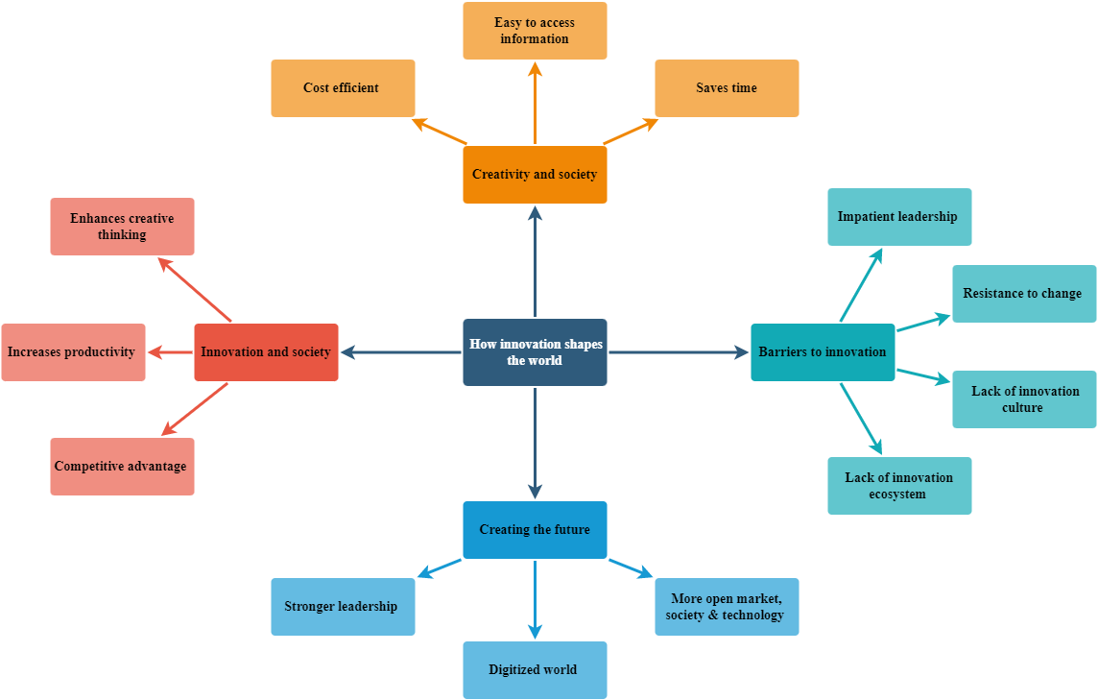
Fig 1: Mind map
(Source: Created by the scholar)
However, there are several barriers to innovation as well that make it impossible to implement. It has been evaluated that resistance to change is one of the biggest barriers to driving innovation besides impatient leadership [3]. Also, it has been observed that the lack of culture and ecosystem for innovation also drives poor strategies that result in failed experiments [2]. However, if the strategies for innovation are implemented carefully and appropriately, it certainly has the ability to drive a bright future in the world. Innovation has the ability to create world leaders even stronger. Also, innovation can digitise the world and make the market, society, as well as a technology even more open to experimentation and changes [1]. Therefore, it is understood that innovation truly shapes the world.

Task 2. Ideation
Project idea: content marketing for newly start-up SME Cafe Pod is the initial idea of the project. Mostly, SME companies are more likely to be quite delicate in nature as it is considered a start-up that requires market exposure and a loyal customer base [1]. In order to achieve this, it is important to build trust and develop relationships besides generating leads and improving the discussions. Content marketing, therefore, is a wise choice for Cafe Pod at this moment to work on these targeted aspects to grow.
Opportunity: through content marketing, content creation skills can be enhanced. Also, it is evaluated that content marketing requires editing, planning, and research skill [2]. Therefore, it is a good opportunity to scale up these skills. An individual can also be quite dedicated to understanding the sales funnels besides upgrading the data analysis skills.
Contribution: content marketing provides customers with high-quality content, and it shows the consistency of a brand towards the customers [1]. Hence, it creates more customer satisfaction and results in increased loyalty. Being an SME company, Cafe Pod, at this moment, requires massive clout for the business. Content marketing can allow this business to not only build better relationships but trust with the customers besides attracting new ones by establishing more conversations aligning with brand value and promise. Therefore, content marketing can positively impact and contribute to the business of Cafe Pod to help build more brand awareness and success.

Task 3. Project poster and chart

3. a. Project planning
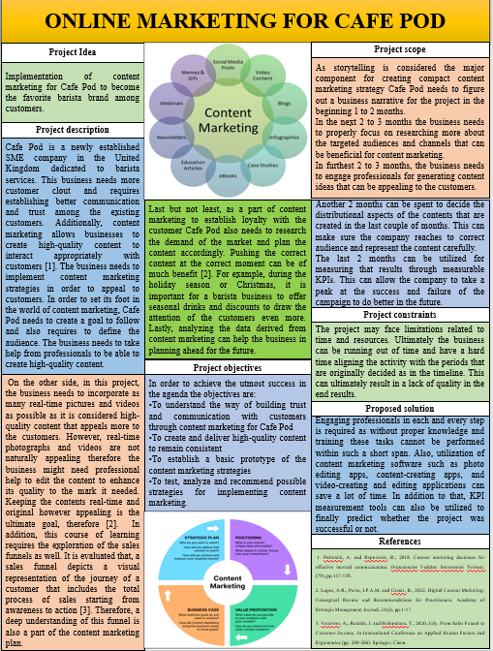
Project Idea
Implementation of content marketing for Cafe Pod to become the favourite barista brand among customers.
Project description
Cafe Pod is a newly established SME company in the United Kingdom dedicated to barista services. This business needs more customer clout and requires establishing better communication and trust among the existing customers. Additionally, content marketing allows businesses to create high-quality content to interact appropriately with customers [1]. The business needs to implement content marketing strategies in order to appeal to customers. In order to set its foot in the world of content marketing, Cafe Pod needs to create a goal to follow and also requires to define the audience. The business needs to take help from professionals to be able to create high-quality content.
On the other side, in this project, the business needs to incorporate as many real-time pictures and videos as possible as it is considered high-quality content that appeals more to the customers. However, real-time photographs and videos are not naturally appealing; therefore, the business might need professional help to edit the content to enhance its quality to the mark it needs. Keeping the contents real-time and original, however appealing, is the ultimate goal, therefore [2]. In addition, this course of learning requires the exploration of the sales funnels as well. It is evaluated that; a sales funnel depicts a visual representation of the journey of a customer that includes the total process of sales, starting from awareness to action [3]. Therefore, a deep understanding of this funnel is also a part of the content marketing plan.
Last but not least, as a part of content marketing to establish loyalty with the customer, Cafe Pod also needs to research the demand of the market and plan the content accordingly. Pushing the correct content at the right moment can be of much benefit [2]. For example, during the holiday season or Christmas, it is important for a barista business to offer seasonal drinks and discounts to draw the attention of the customers even more. Lastly, analysing the data derived from content marketing can help the business in planning ahead for the future.
Project objectives
In order to achieve the utmost success in the agenda, the objectives are:
- To understand the way of building trust and communication with customers through content marketing for Cafe Pod
- To create and deliver high-quality content to remain consistent
- To establish a basic prototype of the content marketing strategies
- To test, analyse and recommend possible strategies for implementing content marketing.
Project scope
As storytelling is considered the major component for creating a compact content marketing strategy, Cafe Pod needs to figure out a business narrative for the project at the beginning of 1 to 2 months.
In the next 2 to 3 months, the business needs to properly focus on researching more about the targeted audiences and channels that can be beneficial for content marketing.
In furthest 2 to 3 months, the business needs to engage professionals to generate content ideas that can be appealing to the customers.
Another 2 months can be spent to decide the distributional aspects of the contents that are created in the last couple of months. This can make sure the company reaches to correct audience and represent the content carefully.
The last 2 months can be utilised for measuring those results through measurable KPIs. This can allow the company to take a peek at the success and failure of the campaign to do better in the future.
Project constraints
The project may face limitations related to time and resources. Ultimately the business can be running out of time and have a hard time aligning the activity with the periods that are originally decided as in the timeline. This can ultimately result in a lack of quality in the end results.
Proposed solution
Engaging professionals in each and every step is required as without proper knowledge and training; these tasks cannot be performed within such a short span. Also, utilisation of content marketing software such as photo editing apps, content creating apps, and video creating and editing applications can save a lot of time. In addition to that, KPI measurement tools can also be utilised to finally predict whether the project was successful or not.

3. b. Project management
The Gantt chart is an efficient way to plan a project. Therefore, the proper five stages plan for content marketing for the business has been evaluated below.
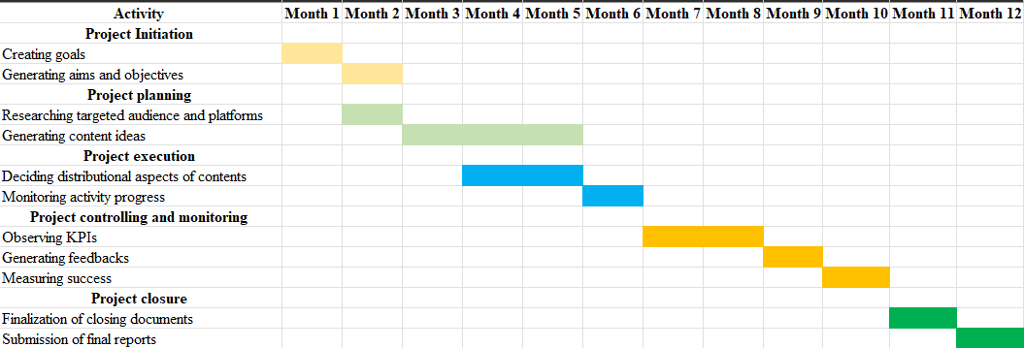

Table 1: Gantt chart
(Source: Developed by the researcher)
The project is divided into 5 particular parts such as initiation, planning, execution, trolling and monitoring, and closure. The intention to create the goals for the company and align them with the aim and objective that are created for the project is mainly done within the first two months. This 12-month plan application of strategies and resources in order to become successful. Therefore, in the project planning phase, it is extremely important to figure out the targeted audiences that the business is willing to push the high-quality content to and through the platform so that the content can be more visible. It is extremely important for a business to figure out a particular platform for distributing content to reach wider audiences [1]. Therefore, choosing among the most popular social media, such as Instagram, Twitter, Facebook, Snapchat, and others, is part of this process.
Also, during the project planning, the professionals are meant to be hired to generate suitable content ideas that appear attractive to the customers. This particular task is considered one of the main tasks and therefore requires almost 3 months. It is extremely important to create high-quality content, as the main attraction of content marketing is meaningful content [2]. Also, it is believed that, through the content, the businesses indirectly communicate with the customers. Content that is of high quality is capable of attracting the attention of the customers and makes the brand seem dedicated to fulfilling the needs of the customers [2]. Therefore, taking a particular stage carefully is a crucial point in this project.
A Gantt chart is supposed to easily allow us to understand the start date of the project and the project tasks in detail. It also allows insight into the people that are working for each and every respective task that can be useful for holding someone accountable upon any incident [3]. In addition to that, WBS, also known as the "work breakdown structure" in a project, mainly refers to the work that needs to be done within a project, and it mainly defines them. In order to understand the subtasks in a better way, a work breakdown structure is created below:
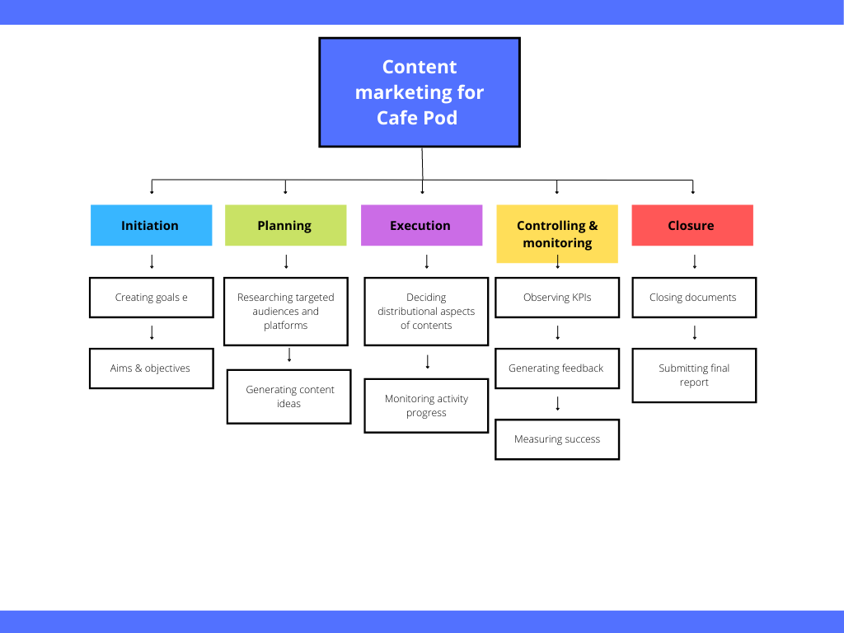
Fig 2: Work breakdown structure
(Source: Developed by the researcher)
The WBS has small and quick developments within the schedule of the project by approving more effort to estimate. In addition to that, this particular way can allow the project manager to identify the potential possibilities of risks that a particular branch carries in order to be able to implement strategies as efficiently as possible to mitigate them. Therefore, the WBS in this project is important for providing the project managers with an entire visual of the project scope [3]. The business, besides generating exciting content for the customers’ needs to also focus on deciding the distribution matters of those contents. It is extremely important to understand the distributional platform and time of a particular content that allows the content to reach the maximum targeted people and acquire their attention.
Seasonal content needs to be posted at least 24 hours prior to create a sense of urgency to engage with the business [1]. Also, as a part of project execution, the project requires monitoring the progress of the contents that are distributed among different platforms and the targeted audiences. Understanding the algorithms and taking advantage of those to understand whether content has been successfully distributed among the targeted audience and if it has been perceived well within the audiences can be done. Last but not least, under the segment of the project controlling and monitoring the observation of the KPI is important. By evaluating the key performance indicators, the business can understand the field in which the project has excelled and the areas in it that have not performed up to the mark. This outlet can help the project manager to build and plan the upcoming projects for the future in a better way. In addition to that, generating feedback on the activities that are performed needs to be done in order to measure success. Critical judgment can be quite helpful. Lastly, the project closure requires the submission of the final reports as evidence for future reference.

E-portfolio address: https://sites.google.com/view/cafepod-uk/home?authuser=0

References
Task 1
[1]. Millar, C.C., Groth, O. and Mahon, J.F., 2018. Management innovation in a VUCA world: Challenges and recommendations. California management review, 61(1), pp.5-14.
[2]. Schoemaker, P.J., Heaton, S. and Teece, D., 2018. Innovation, dynamic capabilities, and leadership. California management review, 61(1), pp.15-42.
[3]. Teece, D.J., 2018. Profiting from innovation in the digital economy: Enabling technologies, standards, and licensing models in the wireless world. Research Policy, 47(8), pp.1367-1387.
Task 2
[1]. Dabić, M., Maley, J., Dana, L.P., Novak, I., Pellegrini, M.M. and Caputo, A., 2020. Pathways of SME internationalization: A bibliometric and systematic review. Small Business Economics, 55(3), pp.705-725.
[2]. Naseri, Z. and Noruzi, A., 2018. Content marketing process model: a meta-synthesis of the literature. Webology, 15(1), pp.8-18.
Task 3: 3 a
[1]. Pažėraitė, A. and Repovienė, R., 2018. Content marketing decisions for effective internal communication. Organizacijø Vadyba: Sisteminiai Tyrimai, (79), pp.117-130.
[2]. Lopes, A.R., Porto, I.P.A.M. and Casais, B., 2022. Digital Content Marketing: Conceptual Review and Recommendations for Practitioners. Academy of Strategic Management Journal, 21(2), pp.1-17.
[3]. Venermo, A., Rantala, J. and Holopainen, T., 2020, July. From Sales Funnel to Customer Journey. In International Conference on Applied Human Factors and Ergonomics (pp. 200-206). Springer, Cham. Task 3: 3 b
[1]. Lee, D., Hosanagar, K. and Nair, H.S., 2018. Advertising content and consumer engagement on social media: Evidence from Facebook. Management Science, 64(11), pp.5105-5131.
[2]. Dwivedi, Y.K., Ismagilova, E., Hughes, D.L., Carlson, J., Filieri, R., Jacobson, J., Jain, V., Karjaluoto, H., Kefi, H., Krishen, A.S. and Kumar, V., 2021. Setting the future of digital and social media marketing research: Perspectives and research propositions. International Journal of Information Management, 59, p.102168.
[3]. Robles, V.D., 2018. Visualizing certainty: What the cultural history of the Gantt chart teaches technical and professional communicators about management. Technical Communication Quarterly, 27(4), pp.300-321.

