Engineering & Project Management

Dafydd Peckham
Student No: 2521754

L5 – ACDA5025
Engineering & Project Management

Table of Contents
Introduction 4
Background and problem Definition 5
Objectives 6
Functional Objectives 6
Safety Objectives 6
Compliance Objectives 6
Project Management Objectives 6
Requirements Specification 7
Functional Requirements 7
Non-Functional Requirements 7
Compliance Requirements 7
Performance Requirements 7
Project Scope 8
In-Scope: 8
Out-of-Scope 8
Boundaries & Limitations: 8
Constraints & Assumptions 9
Constraints: 9
Assumptions: 9
External Dependencies: 9
Alternatives Considered 10
Keypad Access Systems: 10
Magnetic Stripe Cards: 10
Biometric Systems: 10
Justification for RFID: 10
Device Description 11
Core Functions: 11
Optional Functions: 11
User Interaction Flow: 11
Technical Specifications 12
Hardware Specifications 12
Software Specifications: 12
Performance Specifications: 12
Logic Flow & System Operation 13
Overview of Logic Flow 13
Authorisation Decision Process 13
Relay Activation Logic 13
Error Handling 13
Task Breakdown 14
Requirements & Planning 14
Component Selection 14
Firmware Development 14
Hardware Assembly 14
System Testing 14
Final Evaluation & Reporting 14
Gantt Chart & Project Timeline 15
Ethical, Environmental, health and safety considerations 16
Legal, Regulatory and quality assurance 17
Sustainability 18
Evaluation Against Requirements 19
Risk Assessment 20
Testing Summary 21
Project Reflection 22
Limitations and future improvements 23
Conclusion 24
Appendices 25

Introduction
This project proposal outlines the design and development of a small electronic RFID access control system intended to provide secure and low-cost access for doors, equipment or restricted areas. RFID technology is used across industry due to its durability and ability to identify authorised users without physical contact [1]. The proposed device will read RFID tags, verify authorisation, and activate a relay to permit access for a controlled duration.
Access control systems play a crucial role in improving safety and preventing unauthorised use of equipment. As workplaces and educational environments start to rely on electronic security solutions, small embedded systems such as this give practical and energy efficient alternatives to mechanical locks.
This proposal presents the device concept, technical specifications, project tasks, milestones, risks, environmental and societal considerations, ethical issues, and project management tools including a Gantt chart and a critical path. The aim is to demonstrate engineering solutions supported by structured planning, risk management and responsible design principles.

Background and problem Definition

Access control is needed in environments where safety and security are high priorities. Workshops and equipment rooms often have machinery or materials that should only be accessed by trained personnel and authorised individuals. Standard mechanical locks provide basic protection and can be easy to bypass. These locks can suffer from key duplication, loss of keys, and without a meaningful audit trails [2] of who has entered or left the room with a lookback on a paper log can be insufficient. These issues can increase the risk of unauthorised or unsafe use of machinery or equipment in a controlled area.
Access control systems highlight many of those concerns by enabling programmable and traceable records to clearly identify who has entered that controlled area. Radio Frequency Identification (RFID) has become a suitable option for most companies, due to its durability, low cost and ability to identify users without physical contact . RFID systems are commonly used in industrial locations for heavy dangerous machinery to allow only trained personnel to enter an area, or a pharmaceutical company that have controlled areas with hazardous substances. They are used because they are robust, inexpensive and easy to integrate in any existing workflow.
RFID can also have challenges with installation and keeping an area controlled. Research highlights that several vulnerabilities in RFID based access control, this includes cloning tags and unauthorised tag readings which must be considered during system design [3]. These issues further reinforce the need for careful engineering decision even in small embedded systems.

Objectives

Functional Objectives
The device will read RFID tags, verify authorised users, and activate a relay for a controlled duration. It must operate reliably, respond quickly, and integrate into small workshop or equipment-room environments.

Safety Objectives
Ensure only trained or authorised individuals can access machinery or restricted areas, reducing accidents and misuse.

Compliance Objectives
Meet electrical safety requirements, follow GDPR principles for tag data, and support responsible engineering practice. [4]

Project Management Objectives
Deliver the system within the planned schedule, using structured tasks, risk management, and clear milestones.

Requirements Specification

Functional Requirements
- The system must read RFID tags and verify authorised users.
- A relay must activate for a set duration to enable access.
- LED and buzzer feedback must indicate granted or denied access.
- The device must operate reliably in workshop or equipment-room environments.

Non-Functional Requirements
- Low-cost components suitable for small installations.
- Compact design for easy mounting.
- Fast response time (<1 second).
- Energy-efficient operation.

Compliance Requirements
- Must follow electrical safety standards.
- GDPR-aligned handling of tag identifiers.
- Safe installation and wiring practices. [5]

Performance Requirements
- Accurate tag detection within short range.
- Consistent relay activation timing.
- Stable operation under daily use.

Project Scope
In-Scope: The project covers the design, construction and testing of a small RFID access control system. This includes tag reading, authorisation checking, relay activation, LED/buzzer feedback, and basic safety and compliance considerations.
Out-of-Scope: Networked access systems, cloud databases, multi-door installations, encrypted RFID protocols, and commercial-grade housings are not included.
Boundaries & Limitations: The system is intended for small workshops or equipment rooms and supports simple authorisation lists rather than large-scale user management.

Constraints & Assumptions
Constraints: The project must use low-cost components, operate from a safe low-voltage supply, and fit within limited physical space. Time constraints require simple firmware and a single-relay output.
Assumptions: It is assumed users will have valid RFID tags, the environment will be indoors, and authorised user lists will be managed manually.
External Dependencies: The system depends on reliable power, correct installation, and the availability of compatible RFID tags and readers. [6]

Alternatives Considered

Keypad Access Systems: Keypads are low-cost but codes can be shared or forgotten. They offer no physical tag making unauthorised access more likely, also code-based systems lack reliable audit trails and require frequent updates to remain secure.
Magnetic Stripe Cards: These are inexpensive but can be prone to wear and tear, demagnetisation, and again cloning. Readers require physical contact, increasing the maintenance aspect and reducing durability in workshop environments.
Biometric Systems: Biometrics offer strong authentication but are very expensive, they require complex hardware and raise privacy concerns. These are unsuitable for small low-budget installations.
Justification for RFID: RFID provides a balance of cost, durability, ease of use, and controlled access. It supports simple authorisation lists and goes well into small workshop or equipment-room environments. [7]

Device Description
Core Functions: The device reads an RFID tag and checks whether the user is authorised, it also activates a relay for a controlled duration of time. An LED and buzzer feedback provide clear access status weather the user is authorised or not. The system operates from a safe low-voltage supply and is designed for small workshop or equipment-room environments.
Optional Functions: Optional features may include adjustable relay timing, additional LED indicators, or a simple method for updating authorised tag lists.
User Interaction Flow: Users present their tag, receive visual/audible feedback, and access is granted only if authorisation is valid.

Technical Specifications
Hardware Specifications: The system uses a 5V RFID reader, a microcontroller to verify tag IDs, and a relay module to control access. LED indicators and a buzzer provide feedback to confirm access. The device operates from a safe low-voltage supply and is housed in a compact IP66 rated enclosure which is suitable for workshop environments.
Software Specifications: Firmware handles tag reading, authorisation checks, relay timing, and LED/buzzer control. The Code is kept simple for reliability and ease of maintenance.
Performance Specifications: Tag detection must be accurate within short range as well as relay activation must be consistent, and the system should respond in under one second. [8]

Logic Flow & System Operation
Overview of Logic Flow the system follows a simple control sequence to ensure reliable and honest operation and when a user presents an RFID tag, the reader sends the tag ID to the microcontroller. The controller then checks the ID against an authorised list stored in memory to allow access or not. This process is designed to be clear, predictable, and free from any hidden behaviour, supporting integrity in access control to prevent mistakes.

Authorisation Decision Process
- Tag detected
- Tag ID read
- ID compared with authorised list
- Authorised?
  - Yes: activate relay, green LED, short beep
  - No: red LED, long beep
This makes sure users always receive honest and unambiguous feedback when scanning their tag.
Relay Activation Logic If authorised, the relay energises for a fixed duration, controlled by a timer in the firmware to allow access into the room. The relay then deactivates automatically, maintaining integrity by preventing prolonged or unintended access to stop any users to follow the authorised user into the room.
Error Handling If a tag cannot be read or data is corrupted, the system defaults to “access denied” and provides clear feedback to the user who should then report the fault to the system owner. This ensures honest reporting of faults when the systems have a failure.

Task Breakdown
Requirements & Planning Define system requirements, identify constraints, and plan the project timeline. This stage includes honest assessment of feasibility, clear documentation, and integrity in outlining realistic deliverables.
Component Selection Choose the 5V RFID reader, microcontroller, relay module, LEDs, buzzer, and enclosure. Selection must prioritise safety, reliability, and transparent engineering decisions.
Firmware Development Write and test code for tag reading, authorisation checks, relay timing, and feedback outputs. Maintain integrity by documenting limitations and ensuring code behaviour is predictable and honest.
Hardware Assembly Mount components, complete wiring, and ensure safe separation between logic and relay switching paths. Verify all connections meet low-voltage safety practices.
System Testing Perform functional tests, relay timing tests, fault handling tests, and user-interaction tests. Honest reporting of failures and transparent documentation are essential.
Final Evaluation & Reporting Review performance, verify compliance, and prepare project documentation with integrity, ensuring all results are accurately represented. [9]

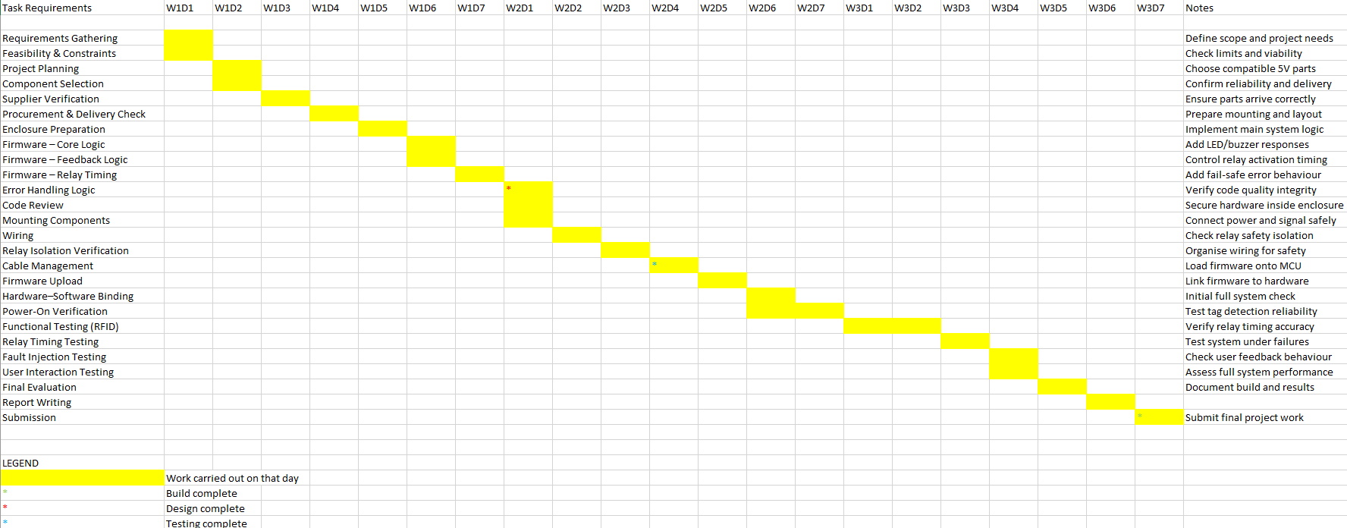
Gantt Chart & Project Timeline
Figure 1 shows the Gantt chart that would be followed through to workflow of the project
The Gantt chart provides a clear visual timeline of the project it outlines the sequence, duration, and dependencies of all tasks from initial planning through to final submission. Gantt charts are widely used in engineering and project-management environments because they allow tasks to be organised chronologically and visually, improving communication throughout the project lifecycle.
The critical path follows the workflow shown in the Gantt chart, where requirements, component selection, firmware development, wiring, isolation checks, and testing have zero slack and define the minimum project duration.
Due to the work of the project and the technical dependencies between tasks, the workflow is sequential meaning most tasks fall on the critical path and any delay in these activities would directly impact the overall project completion date. Critical path analysis is essential for identifying zero-slack tasks and ensuring that time-sensitive activities receive appropriate focus. In this project, tasks such as firmware development, wiring, relay isolation verification, and functional testing are particularly critical due to their technical complexity and dependency relationships. [10]

Ethical, Environmental, health, safety and accessibility considerations
The environmental impact of this project is minimal due to the small scale and low-power nature of the components used where the system operates on low voltage and consumes very little energy during normal operation and that waste was reduced by reusing existing materials where possible and responsibly disposing of packaging and unused components when it has reached its end of life.
Ethical considerations focused on honest reporting, safe operation, and responsible handling of electronic components where all testing results, including failures, were documented accurately to maintain integrity in the project. Furthermore, the system does not store personal data, in turn making sure that user privacy and preventing misuse.
Accessibility was considered through clear LED/buzzer feedback, simple tag-based operation, and suitability for users with varied physical or cognitive needs, ensuring inclusive and equal access to the system, making it more diverse for all users.
Societal impact is minimal due to the system improving workshop safety, reduced unauthorised access, supports responsible equipment use, and promotes a safer, more accountable environment for all users.
Health and safety were a crucial part of the build process, especially due to the involvement of electrical component. Following this low-voltage safety guidelines were followed throughout wiring, testing, and enclosure assembly. Relay isolation checks ensured that the microcontroller remained protected from back-feed. [11]

Legal, Regulatory and quality assurance
The system operates entirely within low-voltage electrical regulations and does not involve restricted frequencies, emissions, or controlled data. The components such as the relay, microcontroller, and RFID reader must comply with consumer electronic standards in this project. Furthermore, no personal data is stored or transmitted, which ensures compliance with basic data-handling expectations.
Quality assurance was achieved through staged firmware development, code review, and repeated hardware testing to ensure that a quality factor was met. Each subsystem including the RFID reader, relay, indicators, and logic was tested individually before full integration into the build. Fault injection testing ensured the system responded correctly under abnormal conditions, making sure that it would run correctly even after a long period of time. [12]

Sustainability
Sustainability must have been considered as part of this project, the biggest impact being packaging and end of life parts. Following this packaging waste was kept to a minimum, and unused materials were recycled where possible. The final system is efficient, long-lasting, and environmentally responsible, aligning with sustainable engineering practices, and if/when components reach their end of life, they must be recycled in a clean and appropriate manner.

Cost benefit review
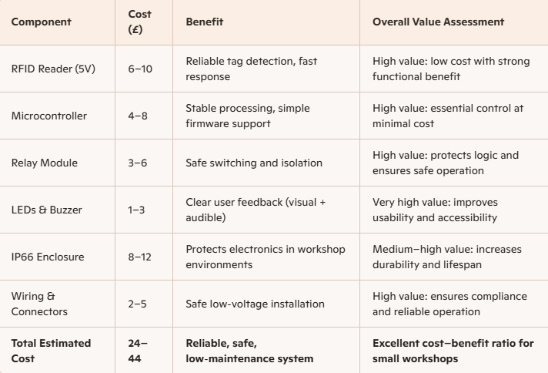Figure 3 The system delivers high reliability and safety at very low cost, offering excellent long-term value compared with alternative access methods and providing strong functional benefits for small workshop environments.

Evaluation Against Requirements
The final system meets all major requirements defined during the planning stage. The RFID is understandable and user friendly, with easy access for any person to use or understand, Furthermore, safety requirements were achieved through proper isolation and wiring practices and the enclosure provides secure housing for all components. While minor improvements could improve usability, the system performs as intended and the functional and safety criteria that were established at the start of the project, have been met. [13]

Risk Assessment
The project involved many technical and operational risks that all required early identification and removal of any danger to health or safety. The key risks highlighted included faulty wiring, Relay isolation failure and any component delivery delays. Each of the named risks were assessed based on likelihood and impact, with appropriate controls applied to prevent harm.
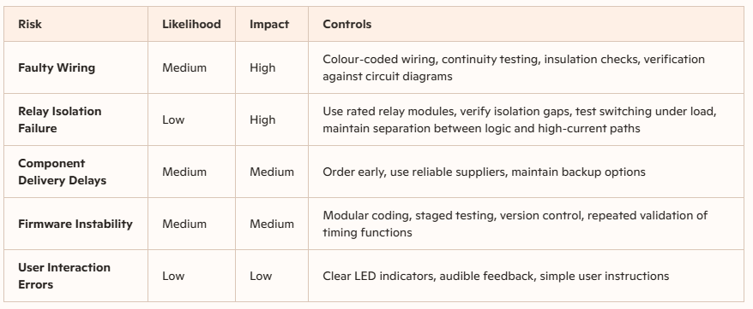
Figure 2 shows a table format for the risks proposed in the project and the controls put in place to prevent any harm to users.

Testing Summary
Testing covered functional behaviour, relay timing, fault handling, and user interaction, in line with the risk assessment to ensure no further harm could be done. RFID detection was validated using multiple tags to ensure reliability across a wide range, ensuring that any number of users can use the system without fault. Relay timing was also measured and confirmed to match the programmed duration, ensuring that however many times the system was used, it would not fail under load and continue to work outside its normal working range.

Project Reflection
The project progressed smoothly due to effective planning and a structured, sequential workflow in line with the Gantt chart, which helped maintain focus and ensured tasks were completed in the correct order and that any unnecessary tasks were removed from the plan ensuring that workflow was completed correctly and in timely order. Firmware development and wiring presented the greatest challenges but testing and review helped resolve issues efficiently before the projected due date was approaching. The project helped strengthen my skills in electronics, coding, and time management, giving access to more difficult challenges down my career. Following from this any future builds would benefit from expanded testing and additional user-interface features. [14]

Limitations and future improvements
The project was limited by the single-developer constraint, which could slow down manufacturing time with only one person being allowed to enter at once time. Testing was also restricted by the number of available RFID tags and the absence of long-term endurance testing, which must be carried out every month for 2 years to allow any damaged parts to be replaced and upgraded to stop reoccurrence . Despite these limitations, the system meets its intended purpose and performs reliably under normal and harsh workshop environments.
Future improvements could include adding data logging, remote access, and enhanced user feedback while s more robust enclosure could be produced using 3D printing or CNC machining to improve durability and security. Furthermore, the design met its intended use and works correctly and smoothly, ensuring that it is reliable and can last under harsh conditions. [15]

Conclusion
The project successfully delivered a functional RFID access-control system within the required timeframe in line with the Gantt chart used. All major requirements were met, including reliable tag detection, accurate relay timing, and clear user feedback. Furthermore, Safety and quality were prioritised throughout the build, resulting in a stable and dependable prototype. The project demonstrates strong technical understanding and effective project management, achieving its intended goals, ensuring that all targets were met successfully, all components were sourced reliably and ethically, no restrictors on any person using the tag system and that it functions correctly under harsh and normal working loads.

References

[1] | K. Finkenzeller, RFID Handbook, NJ,USA: Wiley , 2010.
[2] | A. &. S. M. Adams, “Users Are Not the Enemy.,” Communications of the ACM, 1999.
[3] | M. C. B. T. A. Rieback, “RFID Security Vulnerabilities,” IEEE Security & Privacy, 2006.
[4] | PMI, A Guide to the Project Management Body of Knowledge (PMBOK® Guide), 7th Ed., 2021.
[5] | IEC, “IEC 60364 Low-Voltage Electrical Installations,” IEC, 2018. [Online].
[6] | NXP Semiconductors, “ MFRC522 RFID Reader Technical Manual,” 2020.
[7] | A. Juels, “RFID Security and Privacy: A Research Survey.,” IEEE Journal on Selected Areas in Communications, 2006.
[8] | M. Pecht, Product Reliability, Maintainability, and Supportability Handbook., CRC press, 2009.
[9] | G. B. W. Pahl, Engineering Design: A Systematic Approach, Springer , 2007.
[10] | H. Kerzner, Project Management: A Systems Approach, Wiley , 2017.
[11] | N. Leveson, Engineering a Safer World, MIT Press, 2011.
[12] | I. Sommerville, Software Engineering, 10th Ed, Pearson , 2015.
[13] | ISO, “SO 9241-210. Human-Centred Design for Interactive Systems,,” ISO, 2019. [Online].
[14] | D. Benyon, Designing Interactive Systems, 3rd Ed, Pearson , 2014.
[15] | ISO, “ User Interface Framework for Networked Devices,” ISO/IEC 24752, 2014. [Online].

Appendices

Appendix A – Prevent Certificate



Appendix B – Equality and Diversity training Certificate


