
DIGITAL SKILLS AND RESEARCH METHODS

THE IMPACT OF VIRTUAL LEARNING ENVIRONMENT (VLE) AT UNIVERSITY OF WALES TRINITY SAINT DAVID

Research Report

Module code: BMSW4003
Student name: BOZHIDAR HADZHIN
Student ID: 2020824
Lecturer: JOHN MALAGILA
MAY 5, 2021

Table of Contents

INTRODUCTION 3
BACKGROUND 3
AIMS AND OBJECTIVES 4
METHOD 5
RESULTS 5
DISCUSSION 11
CONCLUSION 12
REFERENCES 13
APPENDIX 14

INTRODUCTION

Virtual learning environment is a learning environment that found great spread during the coronavirus pandemic. It is definitely not something new and, even before the coronavirus pandemic, there has been broad opportunities for remote learning through internet platforms, websites and applications (Ali, 2020) like Skype where teachers lectured students all around the globe. Schools, universities and educational centres provided people of all ages with courses remotely. But now the COVID-19 crisis gave an unprecedented launch of the remote learning transforming it into the only possible way to continue learning while respecting the public health measures (Smith and Judd, 2020).

BACKGROUND

The virtual learning is supposed to have found its initial spread in corporate environment. Many of the biggest companies across the globe have used it for decades, from the nineties of the twentieth century, to educate their teams in different continents and to train them for work purposes on a lower cost than if engaging local trainers and mentors (Mohelska and Sokolova, 2014). At the same time, the virtual learning has successfully protected the know-how of the companies during the education and trainings of their employees as courses are accessible only for the ones working in the company (Derouin, Fritzsche and Salas, 2005).
And finally, the virtual learning has let to companies to track in real time the real progress of their workers through tests and exercises common for all the offices, excluding the potentially partial assessment of local trainers and local team leaders that may intentionally exaggerate on how good their teams are (Jokic et al. 2012). So definitely the virtual learning is a fruit of the efforts of the corporate world, in the context mostly of the globalisation and the outsourcing (Sambrook, 2003).
From the corporate world, the practice of e-learning has spread to the international organisations whose structure supposes collaboration and knowledge exchange between the different offices across the globe, but also the same standards of knowledge to be covered by the employees there (Jokic et al. 2012). So after gaining recognition from leading businesses and institutions the remote learning has gradually gained terrain at small businesses, universities and educational centres across the globe (Jokic et al. 2012).
For the purposes of the online learning, different virtual learning environments and resources are created. Some may rely just on digitalised books within a simple online library, while other more complicated environments may have a broad range of courses, digitalised books and other materials, tests and exercises, gamified simulations, etc. (Mohelska and Sokolova, 2014). It depends on the purposes of the company or the institution that uses them, the number of people that need to use them, their roles into the organisation, their levels of access, etc.
An interesting phenomena that has spread across the globe is the public debate over the online learning. Opinions are very contradictory and while some see the online learning as equal and as efficient as the live one, others say that nothing can replace the face to face contact between teachers and students or between trainers and mentors and trainees (Derouin, Fritzsche and Salas, 2005). Debate has become even harsher during the COVID-19 pandemic when countries across the globe closed schools and universities.

AIMS AND OBJECTIVES

The topic of the actual study is the virtual learning environment at University of Wales Trinity Saint David and how students assess the remote education during the pandemic. The object of the study is the virtual learning environment itself.
The study is based on a survey amongst the students at University of Wales Trinity Saint David and the results of the survey serve as main base for conclusions on the VLE at the university and how do the students perceive it and the whole online learning as a process.
The aims of the survey are as following:
1. Assessing the quality of the virtual learning environment at University of Wales Trinity Saint David.
2. Assessing the quality of the work of the teachers at University of Wales Trinity Saint David during the lockdown.
3. Assessing the motivation of students during the online learning.
4. Assessing the preferences of students regarding the live and the remote education.
The objectives of the survey are as following:
1. To provide the University of Wales Trinity Saint David with accurate data on how the students perceive the virtual learning environment and if any recommendations arise, to be taken into account in aim to improve it.
2. To provide the University of Wales Trinity Saint David with accurate data on how the students perceive the work of the teachers at the university during the remote learning.
3. To provide potentially the government with accurate data on what do the students expect for their high education if the pandemic endures longer than expected and should the university be allowed to restore in some kind the live education.
The stakeholders of the study could be the University of Wales Trinity Saint David as an institution, its academic community and potentially the government in aim to consider the expectations of the students on how do they would like to run their education – live or remotely, but also is it possible to find a consensus between the public health measures and the students’ expectations.

METHOD

The survey is absolutely anonymous and voluntarily. It includes the answers of seventeen students at University of Wales Trinity Saint David, provided through a Survey Monkey form to be filled online. The forms include nine questions of closed type with only one possible answer per question and one opened type.
The survey was done in seven days. The Survey Monkey forms to fill were sent by e-mail to twenty respondents but only seventeen of them returned their forms fully filled, which ensured a high accuracy of the survey and excluded the risk of missing information that would impact on the results. The overall return rate was fixed at 85 percent. The results were analysed through Excel tables and for each group of questions a relevant graph is done. The main method to interpret the results is the analysis, based on the answers.

RESULTS

the results are shown by number of answers per question in the tables below and each question is also graphically represented in the relevant graph below the table. The first four Yes and No questions are shown in table 1 and graph 1.
Table 1. Questions 1 to 4.

Question | ANSWERS YES | ANSWERS NO
Question 01  Do you think the VLE is better than live learning at UWTSD? | 4 | 13
Question 02  Do you learn easily material at VLE? | 7 | 10
Question 03  Does the actual VLE at UWTSD need improvement? | 12 | 5
Question 04  Do you think students are more motivated when they have live lectures? | 14 | 3

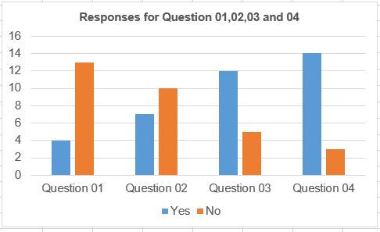
Graph 1. Questions 1 to 4.

Responses of questions 05 and 06 are presented in Table 2 as follows:
Table 2: Every time/Often/Rarely/Never sure questions as number of answers

Question | ANSWERS  Every time | ANSWERS  Often | ANSWERS  Rarely | ANSWERS  Never
Question 05  Did you have any difficulties studying at VLE? | 2 | 9 | 6 | 0
Question 06  How often do you use the virtual learning platform to communicate with your colleagues and lectures? | 3 | 14 | 0 | 0

Chart 2 Graph on 5th to 6th questions
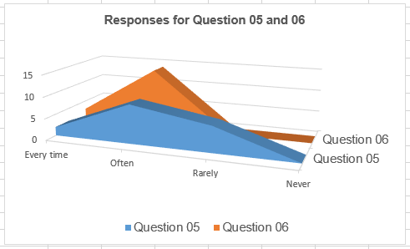

the results of the third group of questions that reveal the level of agreeing and disagreeing with the statement are shown in table 3 and table 4, and graph 3 and graph 4.

Table 3. Questions 7
Question | ANSWERS  Strongly disagree | ANSWERS  Disagree | ANSWERS  Undecided | ANSWERS  Agree | ANSWERS  Strongly agree
Question 07  Do you agree the virtual learning is helping you in reaching your learning goals? | 1 | 3 | 4 | 5 | 4

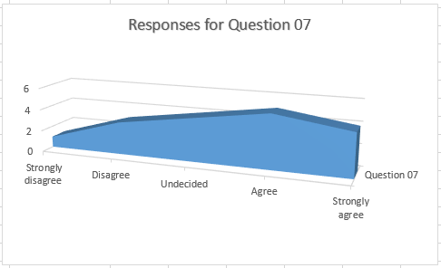
Graph 3. Questions 07.

Table 4. Questions 08

Answers  Question | Strongly disagree | Disagree | Somewhat disagree | Neither agree nor disagree | Somewhat agree | Agree | Strongly agree
Questions 08  Do you agree with the statement that the quality of the knowledge and skills acquired through normal studies at UWTSD is higher than through virtual learning? | 0 | 0 | 1 | 2 | 6 | 4 | 4
Graph 4. Questions 08.

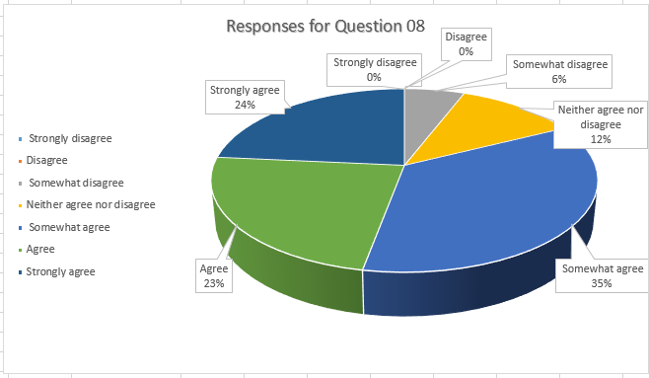
The results of the fourth group of Question 09 about satisfaction are shown in table 5 and represented graphically in graph 5.

Table 5. Questions 09.
Question | ANSWERS  Very  Satisfied | ANSWERS  Satisfied | ANSWERS  Neither Satisfied nor Disagree | ANSWERS  Dissatisfied | ANSWERS  Very  Dissatisfied
Question 09  How satisfied are you to interact with lecturer on virtual learning platform than in class room? | 10 | 5 | 2 | 0 | 0

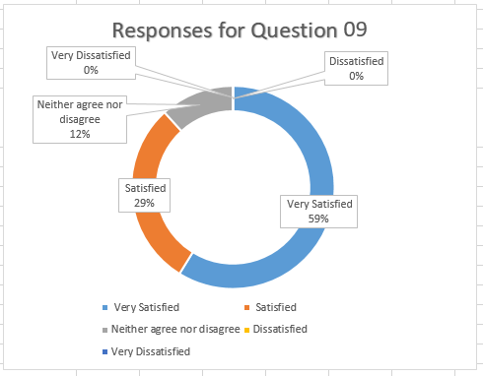
Graph 5. Questions 09.

Responses of open Question 10 are presented in Table 6 as follows.

Question | Happy with the VLE platform | Recommended improvements | Identified future opportunities
Question 10 | 5 | 8 | 4

Chart 6 Graph on 10th question
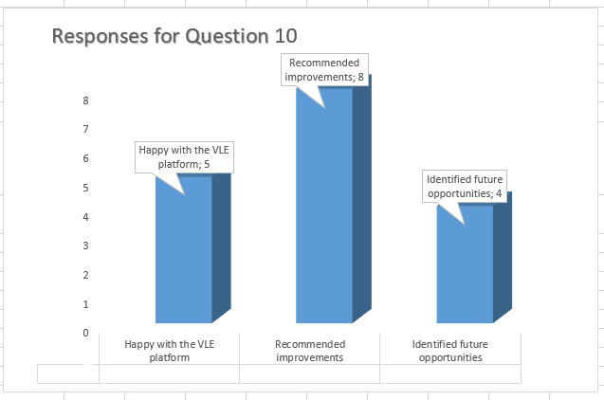

DISCUSSION

The survey reveals very interesting trends within the results that can be resumed as following:
1. The students give a very positive mark for the virtual learning environment at University of Wales Trinity Saint David. Eight of seventeen (47 percent) say that it deserves a positive mark and more five of seventeen (29 percent), a mark close to the average. It means that the overall satisfaction with the quality of VLE is high. A certain part of the students – four of seventeen (24 percent) – also would like to see the VLE at university a bit easier to use as well.
2. The students overall give a very positive mark for the quality of teaching that their lecturers at University of Wales Trinity Saint David provide them with. Fifteen of seventeen (88 percent) respondents say that lecturers are good during the remote education. It is an important recognition for the lecturers’ as well skilled professionals who manage to handle their job with even in difficult times and to provide the students with high quality education remotely.
3. The majority of students manage to keep their motivation through the remote learning as well. Nine of seventeen (53 percent) of the respondents say that they manage to keep themselves motivated during online learning.
4. The students – if they have the choice – would definitely choose to attend live lectures and put a preference over the traditional live education face to face instead of on the remote one. Thirteen of seventeen (76 percent) respondents say that it is the best education and four more (24 percent), a mark close to the best. It means that the students tend to prefer the face to face contact during learning.
5. The students would like that the government do something in aim to let the universities to restore the live education even in small groups each at their turn. Fourteen of seventeen (82 percent) agree completely with the possibility to restore the live education at universities even in small groups. This give a very interesting perspective on what possibilities exist for bringing the high education close to its back to normal state if the coronavirus pandemic endures more than we can expect, e.g. for one or two more years.

CONCLUSION

The answers of the respondents give precious food for thoughts on how to possible handle the impact of the pandemic over the high education. It is obvious that most of students still put a preference over the traditional face to face high education at university and that they expect, once the crisis is over, a life back to normal. In the same time, they even would like that government allows more autonomy to universities so that, if they are ready to, try to restore live education in certain manner, again respecting the anti-pandemic measures. The students are satisfied with the work of their teachers, giving them a high score on their professional attitude during online lectures.

REFERENCES

- Derouin, R., Fritzsche, B., Salas, E. (2005) ’E-Learning in Organizations’, Journal of Management, [Online]. Available at: https://journals.sagepub.com/doi/abs/10.1177/0149206305279815 (Accessed: 12 April 2021).
- Jokic, S. et al. (2012) ‘Training and development of employees through e-learning’ Metalurgia international, [Online]. Available at: https://www.researchgate.net/publication/294637124_Training_and_development_of_employees_through_e-learning (Accessed: 17 April 2021).
- Mohelska, H., Sokolová, M. (2014) ‘Effectiveness of using e-learning for business disciplines: The case of introductory management course’, E a M: Ekonomie a Management , 17(1), [Online]. Available at: https://www.researchgate.net/publication/269581433_Effectiveness_of_using_e-learning_for_business_disciplines_The_case_of_introductory_management_course (Accessed: 15 April 2021).
- Sambrook, S. (2003) ‘E-Learning in Small Organisations’, Education and Training, 45(8/9), pp. 506-516, [Online]. Available at: https://www.researchgate.net/publication/235251076_E-Learning_in_Small_Organisations (Accessed: 20 April 2021).
- Smith, J., Judd, J. (2020) ‘COVID-19: Vulnerability and the power of privilege in a pandemic’, Health Promotion Journal of Australia, 31(2), pp. 158–160, [Online]. Available at: https://www.ncbi.nlm.nih.gov/pmc/articles/PMC7165578/ (Accessed: 23 April 2021).
- Wahab, A. (2020) ‘Online and Remote Learning in Higher Education Institutes: A Necessity in light of COVID-19 Pandemic’, Higher Education Studies, [Online]. Available at: http://www.ccsenet.org/journal/index.php/hes/article/view/0/42784 (Accessed: 9 April 2021).

APPENDIX



