
Student ID: 2527935
Student Name: Krish Ghanshyambhai Sharma
Course Name :- International Marketing: Principles and Practices
Lecturer Name :- Tola Odugbesan
Word Count :- 5201
Submission Deadline :- 13th August 2026

Table of Contents
Introduction 3
Section 1: Report on International market entry and marketing mix of Toyota 3
a. A comparative analysis of the market in both countries 3
b. A comparative analysis of STP and 7Ps strategies in Japan and the USA 7
c. An analysis of the market entry strategy in one of the countries 13
d. An evaluation of ethical issues related to this brand’s marketing mix in USA 16
e. Recommendations on their international marketing strategies 18
Section 2: Reflective account 20
Description 20
Feelings 20
Evaluation 21
Analysis 21
Conclusion 22
Action plan 22
Conclusion 23
Reference List 24

Introduction
Organisations can grow through international marketing by adopting different marketing strategies to cater to their operations in various economic, cultural and competitive environments. In this report, we examine Toyota’s international marketing strategies in Japan and the United States and compare their STP and 7Ps strategies in order to evaluate Toyota's market entry strategy in the USA.

Section 1: Report on International market entry and marketing mix of Toyota

a. A comparative analysis of the market in both countries
PESTLE
Factors | Japan | USA | Impact
Political | - Stable government regulations  - Strong automotive policy, EV incentives | - Stable federal systems  - Tariffs and trade policies with EV tax credits | Positive
Economic | - Fourth largest automotive market  - Auto manufacturing comprised 2.9 percent of Japan’s GDP and 13.9 percent of its manufacturing GDP (Trade.gov, 2026) | - 1.59 trillion U.S. dollars in revenue from road vehicle and parts retail trade (Statista, 2026)  - USA is the third largest market for EVs (Statista, 2026) | Positive
Social | - 4,421,494 new passenger vehicles were sold in Japan (Trade.gov, 2026)  - The automotive industry is Japan’s leading industry, with 5.4 million people employed (Trade.gov, 2026) | - 75 percent of the U.S. population reported having access to their own car (Statista, 2026)  - Preferences of consumers for SUVs, and they are looking for convenience | Positive
Technological | - Global leader in robotics and hybrid technology  - Innovative automotive manufacturing technology | - Advanced AI investments  - Development of autonomous driving, connected vehicle technologies | Positive
Legal | - Strict vehicle safety  - Consumer protection laws | - USA has stringent product liability laws  - Strict safety regulations enforced by NHTSA | Negative
Environmental | - Carbon neutrality target  - Strict emission regulations | - Different environmental regulations across federal and state jurisdiction  - Emission standards and zero-emission vehicle (ZEV) mandates | Negative
Table 1: PESTLE
Japan and the US give a favourable macro environment for the company although they differ in terms of strategic aspects. Politically, the countries offer stable governance that give support to long-term business investment. Japan mainly promotes the automotive sector based on industrial policies and sustainability initiatives (Chen et al. 2022). On the other hand, the United States influences innovation based on incentives, though it is influenced by trade policies that can impact on global manufacturers. Economically, the markets are considered to be highly attractive due to their strong growth in the automobile sector. The markets have high consumer power to purchase cars. Japan has been identified as a mature domestic market, while USA is a market with significant growth opportunities. There is a high demand for vehicles with the expansion of the electric vehicle market. Based on the social dimension, it has been identified that automobiles remain a critical part of the daily lives of people in both countries. Japanese consumers are driven by reliability, fuel efficiency, and compact vehicles.
American consumers have a preference for larger vehicles, performance and convenience. These are the differences that require the company to adjust its product portfolio. Both countries have capabilities to utilise advanced technologies. This enables the company to invest in manufacturing efficiency and research for next-generation mobility solutions. There are strict emission regulations in Japan, and in the USA, it requires following strict product liability laws. There are varied environmental requirements across federal and state jurisdictions. It results in increased cost of compliance and operational complexity. Thus, both markets offer opportunities as well as challenges. The company is required to adopt a localised strategy that can address the regulatory and consumer differences present between Japan and the US.
Application of Hofstede cultural dimensions
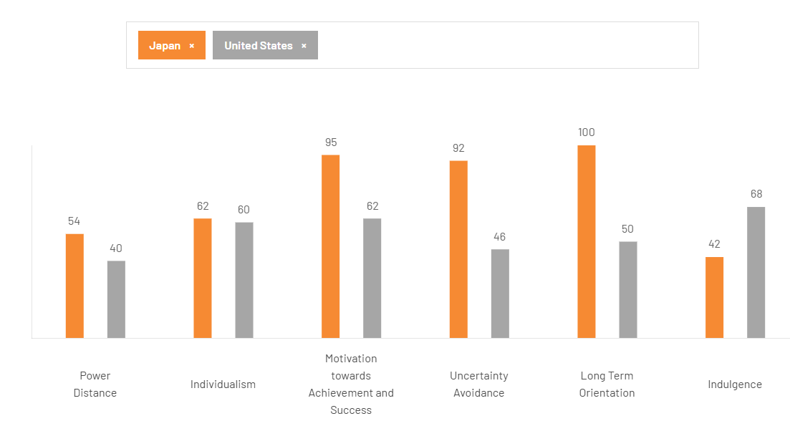
Figure 1: Hofstede cultural dimensions
(Source: Theculturefactor, 2026)
The cultural dimensions provide an effective framework that helps in understanding how national culture has an influence over consumer behaviour and business practices, and marketing strategies. The comparison has been conducted between the US and Japan that shows how cultural differences shape the company’s global marketing strategies. Japan has a high score of 54 based on the dimension of power distance. It indicates that the country has a higher level of acceptance of hierarchical structures as compared to the US. The US has scored around 40 in this dimension. Japanese culture mainly value respect for authority and formal decision-making process. On the other hand, American organisations mainly thrive on flatter organisational structures and employee participation. Thus the management practices need to be more hierarchical in Japan. There is a need for greater empowerment of employees in the US.
Based on the dimension of individualism, both countries have high score, although Japan is considered to be more individualistic as compared to the US. Japan has been identified as individualistic, although it differs from Western culture. American consumers mainly focus on independence, freedom, and self-expression while making decisions regarding purchasing. There is a great emphasis on social harmony and long-term relationships in Japan. Thus, the promotional content of Toyota in the US highlights personal mobility. It also reflects lifestyle benefits and freedom. The marketing in Japan is driven by reliability, family values, and societal contribution. There is a substantial difference present in the dimension of motivation towards achievement and success. Japan has a high score of 95 as compared to the US, which has scored around 62. It can be stated that Japanese society is highly competitive. People in Japan are achievement-oriented and driven by excellence. Consumers mainly value high quality of products with continuous innovation. Consumers mainly put greater emphasis on value and comfort while purchasing cars (Jiang et al. 2022). Thus, the company is designed with engineering excellence in Japan. It balances its performance with consumer convenience in the US market.
A major difference has been identified in terms of uncertainty avoidance, where Japan has a score of 92 as compared to the US's 46. The consumers in Japan mainly look for detailed product information before purchasing. This characteristic reinforces the company to invest in quality assurance and safety. As consumers are willing to accept new technologies and innovation, enabling the company to introduce autonomous driving innovations rapidly (Ahmed et al. 2022). Another major difference is long term orientation. Japan has a score of 100 while US scores 50. This states that Japanese people are strongly focused on long term planning and continuous development. The people in the US are driven by immediate results and short-term performance. Thus the Kaizen and sustainable innovation is the strategic focus of Toyota in Japan. In the US, there are immediate customer benefits, promotional offers and current product performance which drive operations and marketing.
The indulgence dimension highlights the contrasts in the lifestyle of consumers. Japan has a low score of 42, stating the restrained culture. US has a high score of 68, reflecting aspects such as personal gratification. The marketing of Toyota incorporates emotional appeal while driving lifestyle aspirations in the USA. On the other hand, the marketing in Japan remains quality-driven and informative. Thus the application of the cultural dimension model reflects the differences in terms of values and consumer expectations in the markets of Japan and the US.

b. A comparative analysis of STP and 7Ps strategies in Japan and the USA
STP
Segmentation
Customer segment | Japan | USA
Geographic | Compact hybrid cars appeal to crowded urban markets | SUVs and pickups preferred by urban/rural customers
Demographic | An ageing population and professional clients with ages ranging from 25-55 years | Family and professional clients requiring utility with ages ranging from 30-65
Psychographic | Valuing innovation, sustainability and reliability | Valuing performance, comfort and technology
Behavioural | Loyalty clients valuing quality and hybrid technology | Clients valuing utility, safety and convenience
Table 2: Segmentation table
(Source: Self-created)
The difference in segmentation of Toyota’s customers is due to the fact that customer lifestyle, demographic features and needs for mobility are extremely different in Japan and the USA. With the help of regional product adaptation, the company satisfies its customers’ preferences while enhancing its market competitiveness (Nazara, 2025). Thus, the company pays more attention to small and fuel-efficient cars in Japan and larger SUVs and pickups in the USA. This differentiated segmentation strategy allows Toyota to improve customer satisfaction, strengthen market responsiveness and sustain competitive advantage across both countries.
Targeting
Toyota uses differentiated targeting as a result of different consumer requirements in the Japanese market and the United States. In Japan, the major target audience of the firm comprises urban professionals, elderly consumers and environmentally concerned buyers due to small cars, hybrids and technologically advanced vehicles. In the USA, Toyota targets middle and upper-class families, young professionals and consumers who enjoy the outdoors owing to their offer of SUVs, pickups and family vehicles that focus on safety, comfort and flexibility. Differentiated targeting helps companies obtain more customer value because of how suitable the products are to the customers' needs (Jerab and Mabrouk, 2023). This strategy enhances Toyota's competitiveness and customer satisfaction across both markets.
Positioning
Toyota has a coherent global corporate image but applies a different positioning strategy in the two markets depending on their particular peculiarities.
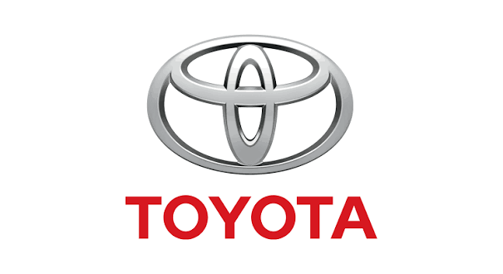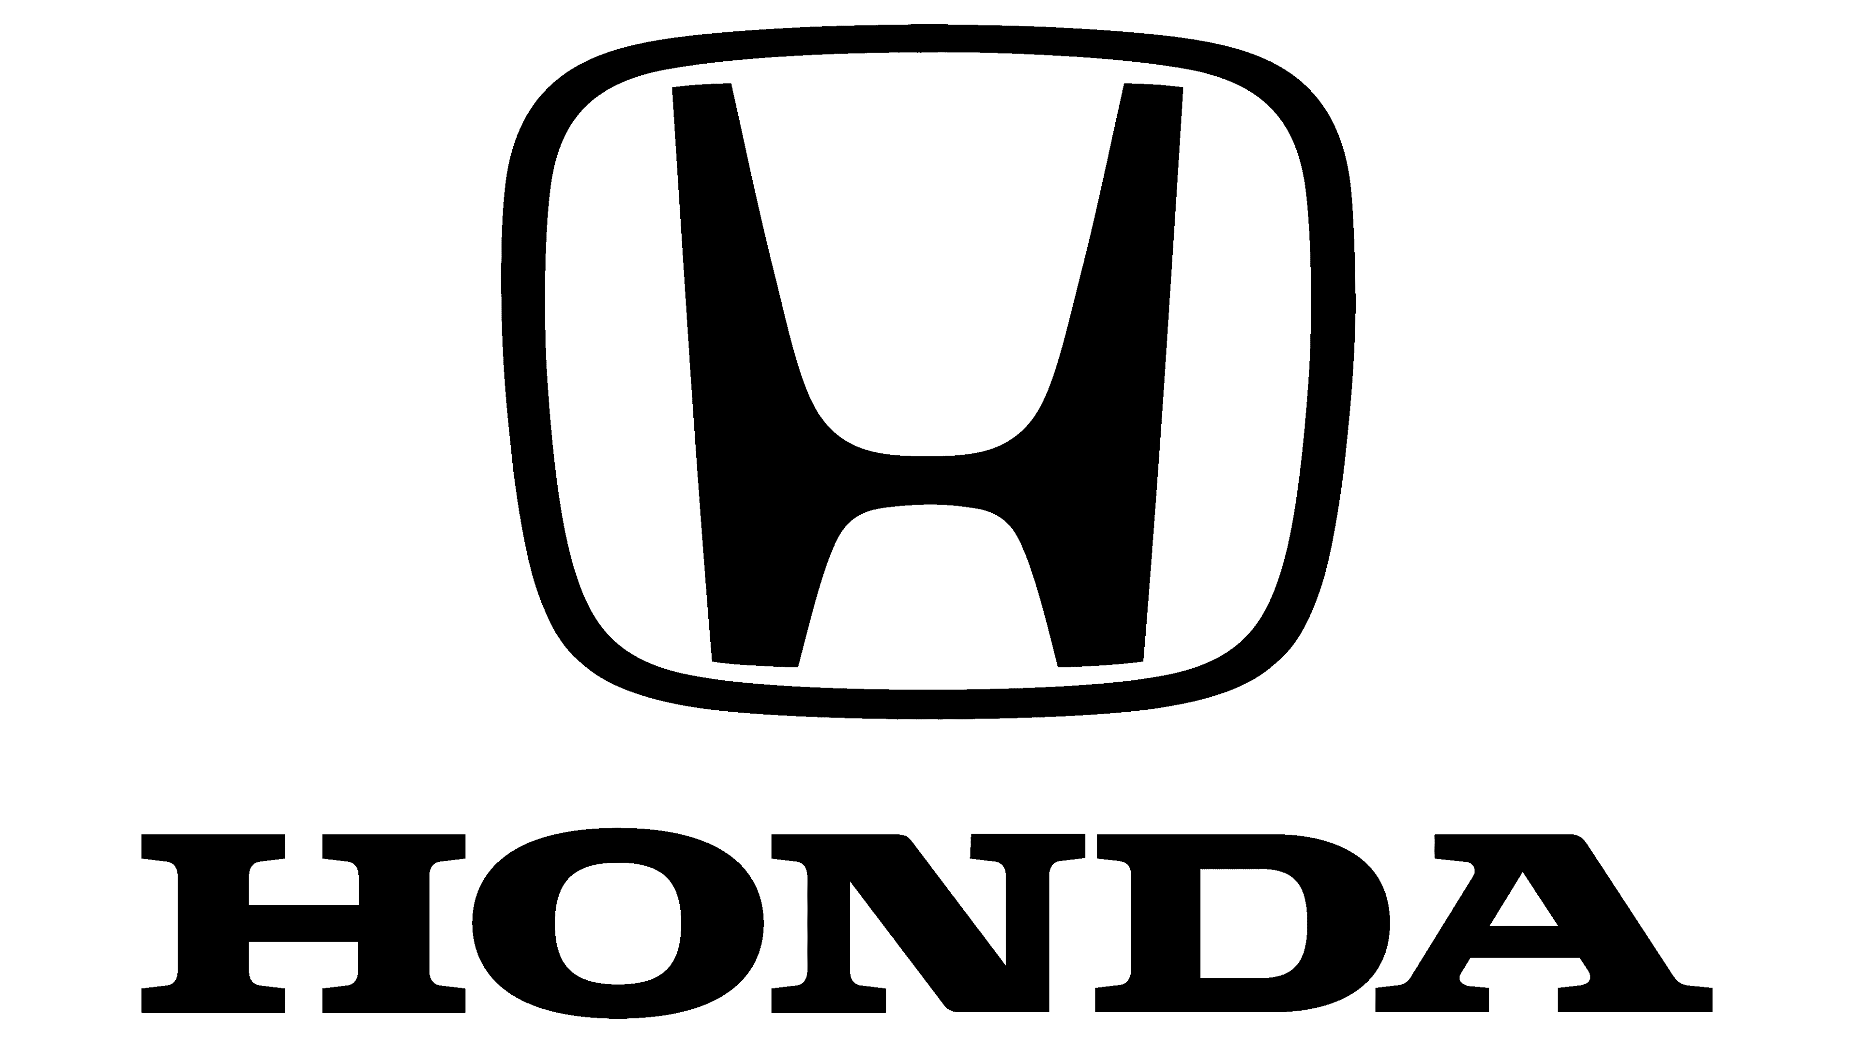
Price
Quality/Innovation
High
High
Low
Low
Figure 2: Positioning map (Japan)
(Source: Self-created)
In Japan, the company is perceived as a supplier of reliable, efficient and innovative vehicles, mostly compact and hybrid cars that satisfy the requirements of urban and ageing customers. Positioning allows brands to differentiate by creating a unique value proposition that corresponds to the perceptions of the target consumers (Duarte et al. 2024). The emphasis on innovation and sustainability strengthens Toyota's reputation in its domestic market.

Price
Quality/Reliability
High
High
Low
Low
Figure 3: Positioning map (USA)
(Source: Self-created)
On the other hand, Toyota is positioned in the USA on the basis of reliability, safety, and versatility with SUVs, pickup trucks, and family cars, which cater to different lifestyles and travelling needs. In accordance with the consumer behaviour in America, Toyota prefers not to sacrifice its values.
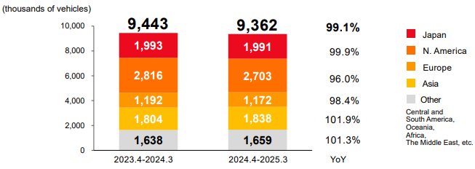
Figure 4: Consolidate vehicle sales
(Source: Toyota, 2025)
The total sales of Toyota automobiles stood at 9 million 362 thousand units in the year 2024-25 (Toyota, 2025). America is still among the biggest markets for Toyota automobiles in relation to sales numbers because of the large sales numbers of the RAV4, Camry, and Tacoma models. Consequently, Toyota successfully balances global brand consistency with local market adaptation, reinforcing its competitive advantage in both countries.
7Ps marketing mix
Marketing Mix | Japan | USA
Product | Compact hybrids focus on efficiency and urban mobility | SUVs, trucks and sedans cater to varied consumer demands
Price | Value-based pricing facilitates affordability and prolonged possession | Competitive pricing along with financial assistance programmes
Place | Widespread availability through dealerships and digital marketing | Distribution network through dealerships and local manufacturing
Promotion | Marketing focuses on hybrid technology, product quality and eco-friendliness | Emphasis on durability, safety and quality of life
People | A well-trained workforce provides personalised service | Experienced dealers offer high-quality services to customers
Process | Online purchasing and efficient after-sales services make buying easier | Online configuration, financing and maintenance facilitate ownership
Physical Evidence | Advanced showroom facilities ensure brand quality | Contemporary facilities and brands increase consumer confidence
Table 3: 7P’s marketing mix
While Toyota embraces a standardised approach in its global marketing strategy, each component of the marketing mix is adapted to meet different market situations in Japan and the USA. This is because products have distinct variations since the consumers in Japan tend to like compact cars, hybrids and fuel-efficient models as compared to their counterparts in the USA who prefer SUVs and family sedans due to their long-distance travelling. Such an adaptation of the marketing mix ensures that multinational corporations meet the demands of their customers in respective markets while preserving their brands globally (Eze et al. 2024). This is evident when considering the difference in prices, where Toyota uses value-based pricing in Japan but competitive pricing in the USA.
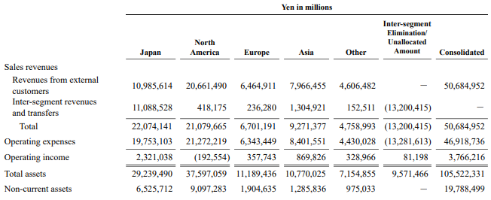
Figure 5: Financial performance of Toyota
(Source: Toyotaglobal, 2026)
Further, the distribution approach adopted by Toyota in the two countries is another indication of the flexibility of the organization when meeting the needs of the market. In Japan, for example, the sales turnover of the firm increased by 215.0 billion yen, 1.0%, to 22,074.1 billion yen in 2026 from 2025 (Toyotaglobal, 2026). Operating income, however, declined by 26.3% to 2,321.0 billion yen in 2026. The decline in operating income was mainly attributed to the increase in costs and other related expenses. The above table shows that North America is one of the largest markets for the company, that exceed its Japan operation in asset generation. While the Japanese operations of Toyota experienced a drop in operating income, Toyota Motor North America sold 2.5 billion vehicles in North America in 2025 (Toyota USA, 2026). North America continued to be one of the largest regional markets of the company.
As such, Toyota spends its resources on digital sales systems, a national dealership network, and after-sales integration in order to improve the convenience of customers and the accessibility of the brand in both markets. The training of employees, efficient purchase procedures, and digital showrooms increase customer satisfaction and trust irrespective of the location of any automobile firm (Gundupagi et al. 2026). In summary, Toyota effectively combines global standardisation with localisation through the adaptation of the 7Ps marketing mix in accordance with the cultural preferences, purchasing behaviour, and conditions of the markets. In addition to this, Toyota’s continuous effort in innovations, digital transformation, and sustainable mobility in relation to the customers ensures brand loyalty for the company.

c. An analysis of the market entry strategy in one of the countries
Overview of Toyota's Entry into the US Market
The international market entry segment provides some of the ways that can be used for market penetration into a country. These methods include exporting, licensing, franchising, strategic alliances, joint ventures, acquisition, and wholly-owned subsidiaries. Each market entry method is unique because of the level of investments, managerial control, and operational risks involved. For example, while exporting has low levels of investment involved but limited control over operations, wholly owned subsidiaries involve high levels of investment but maximum control over production and marketing (Teece, 2025). Joint ventures enable companies to divide the risks and costs associated with penetrating an unfamiliar market environment with domestic partners.
The market entry of Toyota into the United States is among the best instances of international market entry strategy in the automobile industry. The company adopted exporting as its first entry strategy when it started doing business in the USA market in the late 1950s (Toyota, 2022). It then went on to set up manufacturing plants and form partnerships as well as an effective distribution network. The company has sold 2.33 million vehicles in the USA in 2024 (Reuters, 2025). In this way, Toyota was able to enter the US market in a low-risk manner and gain insight into the needs and regulations of American consumers. At present, the US is among the biggest markets for Toyota outside Japan, which contributes greatly to the success of the company on a global scale.
Initially, Toyota engaged in exporting as an approach to enter the US market, and this gave the company the opportunity to gauge the market demand without investing considerable financial resources into it. However, growing tension in the international business arena and the emergence of voluntary export restraints in the 1980s led to the need for localisation of production by Japanese automakers (Toyota, 2022). Thus, Toyota adopted a market entry strategy involving joint venture and wholly-owned subsidiaries, which is a more committed approach than exporting.
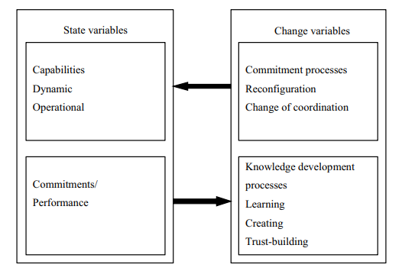
Figure 6: The Uppsala framework
(Source: Wu and Vahlne, 2022)
Toyota market entry development aligns with the principles of the Uppsala Internationalisation Model. According to the Uppsala model, companies invest in foreign markets as they gain market knowledge and decrease the degree of uncertainty (Wu and Vahlne, 2022). Another one of the major strategic moves made by Toyota was the creation of the joint venture NUMMI with General Motors in California. The collaboration offered Toyota a lot of useful information regarding labour conditions in America, consumers' demands, and production regulations. The joint venture with NUMMI allowed Toyota to implement its highly successful “Toyota Production System” in American conditions of manufacturing (Toyota, 2022). At the same time, General Motors gained access to Toyota's knowledge about lean production. Even though the collaboration was shut down in 2010, it helped Toyota a lot in getting familiar with the American market.
Application of International Market Entry Theories
After the success witnessed from NUMMI, Toyota decided to spend heavily on wholly owned manufacturing plants in North America. The firm has 11 manufacturing plants in the US, which manufacture popular cars such as the Camry, Corolla Cross, Highlander, Sequoia, Tacoma and Tundra, in addition to engines and other vehicle parts (Hayzlett, 2025). The firm has been able to lower its transportation costs due to localisation. In addition, the strategy has helped the firm cope with changes in domestic demand. Moreover, localisation has lowered Toyota’s exposure to exchange rate risk between the Japanese Yen and US dollars.
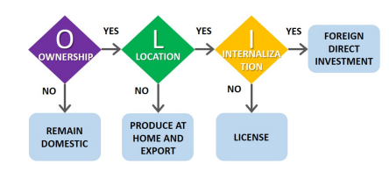
Figure 7: The OLI model
(Source: LARADI et al. 2026)
Moreover, Toyota’s market entry strategy is also an example of Dunning’s Eclectic (OLI) Paradigm of international business. As per the OLI framework, international business operations need ownership, location, and internalisation advantages (LARADI et al. 2026). Location advantages for entering the USA include being one of the largest car markets in the world, developed infrastructure, availability of skilled labour and a politically and legally stable environment. Internalisation advantages come from the fact that Toyota controls every aspect of the process, including manufacturing, quality checking, R&D, logistics and customer services (Toyota EU, 2025). This way, Toyota ensures high efficiency of its operations and protection of technology and product quality.
Critical Evaluation of Toyota's Market Entry Strategy
Traditionally, American consumers prefer larger cars for family use as well as for recreational and business purposes. It has been found that 80% of light vehicles sold in the US in 2024 were either SUVs or pickups, which shows a considerable difference between the tastes of Americans and Japanese (Khadka, 2025). Therefore, to meet the demands of its American customers, Toyota has adjusted its international marketing approach by producing and selling models like the RAV4, Highlander, Tacoma, Tundra and Sequoia. As for political and regulatory variables, these factors have affected Toyota's market entry strategy.
In particular, the country's trade policies and environmental regulations play a significant role in manufacturing and supply chain management practices. Local manufacturing allows Toyota to avoid possible barriers related to the use of tariffs as well as fulfil production obligations (Washington, 2024). On top of that, rising fuel economy and carbon emission standards are one more reason to introduce a number of hybrid models into the company's line-up. Toyota provides jobs to some 49,000 workers, investing billions of dollars per year in manufacturing, research and development, community development, and environmental sustainability activities in the US (Faulner, 2024). Therefore, it is apparent that the shift from exporting to joint ventures and wholly-owned subsidiaries by Toyota has enabled the organisation to enjoy significant competitive advantages in the long run.

d. An evaluation of ethical issues related to this brand’s marketing mix in USA
Toyota has faced significant ethical challenges based on its marketing mix. The major ethical challenges are emerging based on their promotion and product strategies. Toyota has repeatedly faced ethical challenges regarding falsified emissions and certification tests. The automaker was fined approximately $1.6 billion for selling illegal engines (BBC, 2025). The organisation has faced ethical inspection based on its strict "Kaizen" manufacturing practices. The poor or unsafe working conditions may create significant ethical challenges for the organisation. Ethical challenges of the car industry depend on emissions and supply chain manipulation. Toyota subsidiary “Hino Motors” has agreed to pay approximately $1.6 billion and feels guilty for defrauding US regulators about the number of emissions produced by its diesel engines. The truck organisation will be banned from exporting its diesel engines to the country for approximately five years. Hino was charged with fraud in a “Detroit court” for selling approximately 105000 illegal engines in the US between the year of 2010 and 2022 (BBC, 2025). However, the ethical challenges within the car industry may disrupt the organisation's overall manufacturing process and global supply chain networks.
Ethical challenges of the car industry completely depend on the overall business structure of the specific organisations. Hino submitted "false and fraudulent" emission testing and fuel consumption data in a "criminal conspiracy", according to the US Justice Department. The fine of Toyota includes a $236.5 million civil penalty to California and another civil penalty of approximately $442.5 million due to false and fraudulent CO2 emissions test data (Reuters, 2025). Organisations' strong supply chain networks and strategic approaches play an essential role in mitigating the organisational ethical challenges. Data breaches and workplace pressures are other sources of creating ethical challenges within the car industry (Ogbuke et al. 2022). Ethical challenges in an organisation are deeply connected with the aspects of harassment, discrimination or fraud. Ethical challenges or organisational business-related issues can damage employee trust and the overall organisational reputation within the global competitive market. Organisations' strengths strongly depend on skilled employees and strong supply chain networks to ensure business development. Effective strategies of organisations help to identify major challenges of organisations. Each market entry strategy is unique because of the level of investments, managerial control, and operational risks involved. Organisations' operational efficiency and financial development depend on strategic and ethical approaches. Organisations fail to maintain ethical labour practices, data privacy, or environmental standards due to data breaches and poor supply chain networks (Dawood and Afzal, 2025). The “Product, place, distribution and promotion” is Toyota's marketing mix. The strategic importance of a well-executed marketing mix helps to develop customer loyalty and satisfaction. The process of resource optimisation and brand consistency helps to maintain organisational ethical standards.
Organisations' ethical standards help to mitigate financial and legal challenges and build trust with investors and customers. The market entry strategy of Toyota into the United States is a unique instance of the international automobile industry. Ethical standards ensure sustainable and long-term organisational business success. Transparent ethical guidelines protect the organisation from fraud and legal violations (Maulidi et al. 2024). Honesty and transparency build a strong brand identity that attracts loyal customers. Organisations' business ethics can mitigate the complex ethical challenges to improve brand reputation within the global competitive market. Organisations' ethical challenges help to develop better risk management strategies and identify the loopholes of the specific organisations.

e. Recommendations on their international marketing strategies
Toyota should strongly focus on the international marketing strategies based on “localised sustainability solutions and digital software-driven experiences”. Toyota can defend its market share against emerging “electric-only competitors”. Organisations' eco-conscious messaging and direct-to-consumer software engagement system will help to improve the overall manufacturing process.
Recommendation 1: Expand the regional electrification business structure
The process of expanding a regional electrification business structure helps organisational development through decentralising decision-making and improving local community engagement. The strategic alignment directly supports the long-term capacity building of regional teams (Lansing et al. 2023). Organisations' traditional strategies depend on hybrid-only models where the international markets demand faster shifts to “zero-emission vehicles”. The organisation should focus on its “Multi-Pathway Strategy” for better development.
Recommendation 2: The technological customer experience
The “Digital-native competitors” are capturing younger buyers through the process of direct-to-consumer online sales. Organisations' marketing model helps to make the dealership experience software-centric. Customers can clearly visualise software features and digital key technology through the organisation's technical showrooms (Pascucci et al. 2023). Organisations' technological customer experience is strongly connected with vehicle services with “AI-driven support”. The organisation use machine learning platforms to identify customer data to improve organisational marketing strategies within the global competitive market. However, Organisations' ethical standards help to mitigate financial and legal challenges and build trust with investors and customers.
Recommendation 3: Purchase a lifestyle-focused sub-branding strategy
The “lifestyle-focused sub-branding” strategy helps in organisational development through the process of segmenting audiences from the main brand. Sub-branding enables the organisation to enter specific markets without weakening the major brand identity. The sub-branding strategy clarifies internal roles and departmental capabilities of organisations. The strategy helps organisations to strongly compete against major competitors (Farida and Setiawan, 2022). However, a strong strategic approach and supply chain networks will improve business sustainability and brand reputation within the global competitive market.
Recommendation 4: Sustainability and green messaging systems
The “data-driven ESG metrics” and authentic green messaging strategies will help the organisation through transparent and open communication. The strategic approach of the organisation helps to improve business sustainability and organisational management systems. Green messaging is the essential business practice of communicating a brand's environmental commitments and sustainability. The strategy will help to build customer trust to ensure organisations' long-term brand loyalty. Ethical standards of organisations ensure long-term organisational business success (Njom and Kelemba, 2025). Transparent ethical guidelines protect the organisation from fraud and legal violations. Honesty and transparency build a strong brand identity that attracts loyal customers. Effective sustainable communication helps to maintaining organisational ethical standards and brand reputation.

Section 2: Reflective account

Description
This report on the international market entry strategy and marketing mix used by Toyota enabled me to gain deeper knowledge of the concepts of international marketing. It entailed the comparative analysis of the macro environment using the PESTLE model, cultural factors using the Hofstede’s culture dimensions, and Segmentation, Targeting and Positioning (STP) strategy alongside the international marketing mix (7Ps). Moreover, the assessment of Toyota's market entry strategy in the United States, the ethical issues related to its marketing activities. The recommendations on how to improve a company’s international marketing strategy helped to understand the importance of market entry (Lubis and Muniapan, 2024). While researching for the report, I have used the data taken from scientific journals, company reports, governmental documents, and industry publications to make sure that it is based on facts. I have also compared the way how Toyota has adjusted its marketing strategy according to different economic, political and cultural environments in Japan and the United States. Thus, to write this report, it was necessary to engage in critical thinking, time management, information evaluation, and to combine the theory and practice in marketing.

Feelings
At the start of the research process, I was motivated by the fact that Toyota is one of the most advanced automobile makers with an international presence all around the world. Yet at the same time, I was worried about the necessity of comparing two different markets since the economies of both countries have their unique features and preferences of consumers and regulations. I was sure that the collection of adequate academic sources and making a balance between them would be difficult. With the development of the work, I got more and more confident, as I was getting to know more about the theories. Toyota makes the best out of its marketing approach in different countries which contributes towards generating profit (Hino, 2024) Analysis of culture via the Hofstede model made me understand the impact of consumer behaviour on international marketing. Even though organising a huge amount of information in a certain structure took me some time, I was feeling more and more satisfied watching the report evolve.

Evaluation
The process of researching and reporting proved to be a fruitful one. First, I had a chance to employ a number of international marketing models at once as opposed to analyzing each of them separately. Thus, such tools as “PESTLE analysis” and “Hofstede's model” helped me comprehend the impact of the external environment and culture on Toyota's marketing practices. The analysis of the “STP approach” and 7Ps marketing mix showed how multinational companies adapt their products, pricing policy, promotion and distribution to specific conditions of the market (Fadhila, 2025). Moreover, employing a number of reliable sources increased the quality of the report itself.
Finally, the comparison of Japan and the USA helped me realise the necessity of localising my marketing strategy. However, besides these advantages, I faced several problems as well. For instance, some pieces of information about the marketing strategies of Toyota were not accessible to me because I had to deduce this information based on some evidence. Besides, compiling data from various academic and industry literature sources without repetition took me much time. Moreover, it was difficult for me to manage my report due to its limited word count.

Analysis
Through this assessment, my knowledge of how international marketing strategy works has been greatly increased since I have been able to see how the theories work in practice. Prior to the report, my knowledge on concepts such as PESTLE and Hofstede was largely theoretical. Using them in the analysis of Toyota has helped me to see how these factors interact in determining international business decisions. Comparison of Japan and the United States proved that a successful international marketing strategy is based on finding a balance (Kim et al. 2026). This combination between the requirement of having a reputation globally and the requirement of adaptation is very important. This is how Toyota maintains its reputation globally, but it varies some things about its marketing mix according to conditions in different countries. This assessment has taught me the very essence of the standardisation vs adaptation problem in international marketing.
In addition, I was able to develop my skills in locating authentic academic material, analysing business reports and analysing secondary data. Instead of taking any information for granted, I became more skilled at comparing data from various sources and drawing conclusions based on that. Through the analysis of the ethics of marketing practices of the Toyota Corporation, I came to know about the growing importance of corporate social responsibility. The issues of environmental sustainability and communications in global business operations can help us in comprehending the internationalisation process (Sohns et al. 2023). Preparing this report improved many of my transferable skills, including academic writing. These skills will be very useful in future academic evaluations and marketing professions where decision-making must be based on facts.

Conclusion
On considering this assessment, it is safe to say that the whole learning process has been very useful indeed. The assignment helped me to apply theoretical marketing approaches to the practice of international businesses while gaining important research skills and understanding of critical analysis. This process provided me with a better insight into the way that multinational companies like Toyota manage to apply their marketing approaches in different countries without changing the image of the company globally.

Action plan
Objective | Specific | Measurable | Achievable | Relevant | Time-bound
To get better at academic research | Better peer-review journals and company reports | I will cross check at least 10 sources | I will utilise university database | This will help me to get better at analysis | 1 week
To improve understanding | Proper comparison of evidence and models | I will implement 3 theoretical models in each report | I will focus on analytical writing | Academic performance and better higher-order thinking | 2 weeks
To better manage time | Structured study timeline | I will finish initial draft at least 1 week | I will use digital planners | This will lower my stress | 3 weeks
Table 4: Action plan
(Source: Self-created)
This plan will provide me with a step-by-step plan to ensure continuous personal and professional growth after conducting this evaluation. Every goal is clear, measurable, realistic, relevant, and timely

Conclusion
In conclusion, consumer preferences represent an important contextual variable for Toyota’s entry in the USA. Local production allows for flexible manufacturing, better supplier relations, job creation, and a good corporate reputation in the United States. Ownership advantages are available to Toyota through its well-known brand name, technological superiority, hybrid technology, and productive process.

Reference List
Ahmed, H.U., Huang, Y., Lu, P. and Bridgelall, R., 2022. Technology developments and impacts of connected and autonomous vehicles: An overview. Smart Cities, 5(1), pp.382-404.
BBC, 2025. Toyota unit to settle emissions scandal for $1.6bn. Available at: https://www.bbc.com/news/articles/c62666374l4o [Accessed on 10.07.2026]
Chen, H., Yu, J. and Liu, X., 2022. Development strategies and policy trends of the next-generation vehicles battery: focusing on the international comparison of China, Japan and South Korea. Sustainability, 14(19), p.12087.
Dawood, H.M. and Afzal, N., 2025. Ethical Issues and Role of Smart Supply Chain Management. In Smart Supply Chain Management: Design, Methods and Impacts (pp. 73-97). Singapore: Springer Nature Singapore.
Duarte, A., Till, B. and Hafeez, K., 2024. Brand positioning strategies: Creating and communicating unique value propositions. Strategies for brand communications and management: Bridging academia and practice, pp.86-115.
Eze, F.J., Inyang, I.B. and James, E.E., 2024. Standardization versus adaptation of marketing mix in international markets: A systematic literature review. World Journal of Advanced Research and Reviews, 22(2), pp.1192-1212.
Fadhila, A.N., 2025. Proposed Marketing Strategy to Enhance the Competitiveness in a Mixue Franchisee Store (Case Study: Mixue Merdeka Lhokseumawe). Eduvest-Journal of Universal Studies, 5(8), pp.10627-10649.
Farida, I. and Setiawan, D., 2022. Business strategies and competitive advantage: the role of performance and innovation. Journal of open innovation: Technology, market, and complexity, 8(3), p.163.
Faulner, M., 2024. Toyota Charges Up Investment and Jobs in U.S. Manufacturing. Available at: https://pressroom.toyota.com/toyota-charges-up-investment-and-jobs-in-u-s-manufacturing/ [Accessed on 17.07.2026].
Gundupagi, M., Balraj, I., Chandhan Prashad, N. and Durdana, M., 2026. Driving Sales Digitally: An Empirical Study of Digital Showrooms in the Automotive Sector. Cureus Journals, 3(1).
Hayzlett, N., 2025. Anderson-Weber Toyota. Available at: https://www.andersonwebertoyota.com/toyota-manufacturing-in-the-u-s/ [Accessed on 17.07.2026].
Hino, S., 2024. Inside the mind of Toyota: Management principles for enduring growth. Productivity Press.
Jerab, D. and Mabrouk, T., 2023. Strategic excellence: Achieving competitive advantage through differentiation strategies. Available at SSRN 4575042.
Jiang, L., Zhao, M., Lin, H. and Yang, L., 2022. How do consumer innovation characteristics and consumption value shape users’ willingness to buy innovative car safety seats?. Sustainability, 15(1), p.172.
Khadka, N., S., 2025. With the world heating up, why are more SUVs being sold? BBC. Available at: https://www.bbc.com/news/articles/c778ekg64mjo [Accessed on 17.07.2026].
Kim, H., Haque, M.A., Razzak, M.A., Jang, M.J., Song, S. and Ku, S., 2026. Probiotic development strategy centered on stability and regulatory considerations. Comprehensive Reviews in Food Science and Food Safety, 25(1), p.e70320.
Lansing, A.E., Romero, N.J., Siantz, E., Silva, V., Center, K., Casteel, D. and Gilmer, T., 2023. Building trust: Leadership reflections on community empowerment and engagement in a large urban initiative. BMC Public Health, 23(1), p.1252.
LARADI, M., DOURAID, A. and Bedida, E.M.S., 2026. The Evolution of the Eclectic Paradigm: A Review of the OLI Framework in International Business Research. Moroccan Journal for Publishing Scientific Research, (3085-4873) – Issue 5).
Lubis, M. and Muniapan, B., 2024. International market development Strategies for enhancing global expansion in the export industry. Involvement International Journal of Business, 1(1), pp.14-28.
Maulidi, A., Girindratama, M.W., Putra, A.R., Sari, R.P. and Nuswantara, D.A., 2024. Qualitatively beyond the ledger: unravelling the interplay of organisational control, whistleblowing systems, fraud awareness, and religiosity. Cogent Social Sciences, 10(1), p.2320743.
Nazara, D.S., 2025. Marketing strategy innovation: Enhancing competitiveness and differentiation of local products in the global market. Oikonomia: Journal of Management Economics and Accounting, 2(3), pp.101-112.
Njom, B. and Kelemba, J., 2025. Evaluation of What Would Happen Over A Long Period of Time to Success and Profitability of An Organisation Which Chooses to Do Away with Ethical Standards. Journal of Human Resource & Leadership, 9(3), pp.52-64.
Ogbuke, N.J., Yusuf, Y.Y., Dharma, K. and Mercangoz, B.A., 2022. Big data supply chain analytics: ethical, privacy and security challenges posed to business, industries and society. Production Planning & Control, 33(2-3), pp.123-137.
Pascucci, F., Savelli, E. and Gistri, G., 2023. How digital technologies reshape marketing: evidence from a qualitative investigation. Italian Journal of Marketing, 2023(1), pp.27-58.
Reuters, 2025. Toyota posts 3.7% rise in 2024 US sales. Reuters. Available at: https://www.reuters.com/business/autos-transportation/toyota-posts-37-rise-2024-us-sales-2025-01-03/ [Accessed on 17.07.2026].
Reuters, 2025. Toyota unit Hino Motors reaches $1.6 billion US diesel emissions settlement. Available at: https://www.reuters.com/legal/toyota-unit-hino-motors-charged-with-diesel-emissions-fraud-2025-01-15/ [Accessed on 10.07.2026]
Sohns, T.M., Aysolmaz, B., Figge, L. and Joshi, A., 2023. Green business process management for business sustainability: A case study of manufacturing small and medium-sized enterprises (SMEs) from Germany. Journal of cleaner production, 401, p.136667.
Statista, 2026. US automobile industry. Available at: https://www.statista.com/topics/1721/us-automotive-industry/?srsltid=AfmBOoqZyqhA25UMHFaa7hdOxCpWfwktsqOGTXigAtwebBH80GgIli5g#topicOverview [Accessed on 17.07.2026]
Statista, 2026. US car manufacturers. Available at: https://www.statista.com/topics/1736/us-car-manufacturers/?srsltid=AfmBOooIyWK4h1o87c9MnSb7acU3wd-SnSU9bW10V0WqHTn6z1btlQYS#topicOverview [Accessed on 17.07.2026]
Teece, D.J., 2025. The multinational enterprise, capabilities, and digitalization: governance and growth with world disorder. Journal of International Business Studies, 56(1), pp.7-22.
Theculturefactor, 2026. Cultural dimensions. Available at: https://www.theculturefactor.com/country-comparison-tool?countries=japan%2Cunited+states [Accessed on 17.07.2026]
Toyota EU, 2025. Toyota Production System. Available at: https://www.toyota-europe.com/about-us/toyota-vision-and-philosophy/toyota-production-system [Accessed on 17.07.2026].
Toyota USA, 2026. Toyota motor north america reports 2025 U.S. sales results - toyota USA Newsroom. Available at: https://pressroom.toyota.com/toyota-motor-north-america-reports-2025-u-s-sales-results/ [Accessed on 17.07.2026].
Toyota, 2022. Global Website | 75 Years of Toyota | Section 1. Voluntary Restraints Imposed on Exports to U.S. | Item 1. Japan, U.S. Agree on Voluntary Restraints on Exports. Available at: https://www.toyota-global.com/company/history_of_toyota/75years/text/leaping_forward_as_a_global_corporation/chapter1/section1/item1.html [Accessed on 17.07.2026].
Toyota, 2022. Global Website | 75 Years of Toyota | Section 3. Local Production Starts in North America | Item 2. Joint Venture with GM. Available at: https://www.toyota-global.com/company/history_of_toyota/75years/text/leaping_forward_as_a_global_corporation/chapter1/section3/item2_a.html [Accessed on 17.07.2026].
Toyota, 2022. TOYOTA MOTOR CORPORATION GLOBAL WEBSITE | 75 Years of TOYOTA | Part1 Chapter2 Section9 | Item 5. Establishment of Toyota Motor Sales, U.S.A. and Crown Exports. Available at: https://www.toyota-global.com/company/history_of_toyota/75years/text/taking_on_the_automotive_business/chapter2/section9/item5.html [Accessed on 17.07.2026].
Toyota, 2025. Fy2025 financial results. Available at: https://global.toyota/pages/global_toyota/ir/financial-results/2025_4q_presentation_2_en.pdf [Accessed on 17.07.2026].
Toyotaglobal, 2026. Financial summary FY2026. Available at: https://global.toyota/pages/global_toyota/ir/financial-results/2026_4q_summary_en.pdf [Accessed on 17.07.2026].
Trade.gov, 2026. Japanese automobile. Available at: https://www.trade.gov/country-commercial-guides/japan-automotive [Accessed on 17.07.2026]
Trade.gov, 2026. Japanese market intelligence in automobile. Available at: https://www.trade.gov/market-intelligence/japan-automotive-oem-and-parts [Accessed on 17.07.2026]
Trade.gov, 2026. Market trends in Japan. Available at: https://www.trade.gov/country-commercial-guides/japan-automotive [Accessed on 17.07.2026].
Washington, D., 2024. As filed with the U.S. Securities and Exchange Commission on UNITED STATES SECURITIES AND EXCHANGE COMMISSION FORM 20-F. Available at: https://global.toyota/pages/global_toyota/ir/library/sec/20-F_202403_final.pdf [Accessed on 17.07.2026].
Wu, J. and Vahlne, J.E., 2022. Dynamic capabilities of emerging market multinational enterprises and the Uppsala model. Asian Business & Management, 21(5), pp.690-714.

