Gallwch ychwanegu’ch targedau o’ch aseiniad diwethaf (Ond yn berthnasol os yr ydych wedi cwblhau aseiniad) / Please add your targets from the previous assignment (Only relevant if you have completed an assignment)
 | Targed/target | Yr hyn yr wyf wedi'i wneud yn yr aseiniad hwn  What I have done in this assignment...
Targed/Target 1 | “Use literature throughout your writing; both to support, evaluate and reflect on focus.” | I have attempted to weave literature throughout my report, rather than confining it to the literature review section.
Targed/Target 2 | “Consider further how what you suggest might reflect or relate to underlying learning theories.” | I felt as though specific learning theories (constructivism, behaviourism etc.) were not directly related to the development of an SDP, although I have considered the effect parental engagement has on learning.
Targed/Target 3 | “Revise use of referencing, ensuring date is consistently given and brackets and punctuation is correct.” | I have paid extra attention to my referencing and used the referencing guide to support this.

How School A develops one aspect of its School Development Plan: A report that critically reflects on the actions, impact, and evidence base

Introduction
Every school in Wales is expected to produce a School Development Plan (SDP) which outlines the steps the school is taking on its journey towards improvement. Data-driven, goal orientated planning is considered the benchmark for a successful SDP, and one most likely to secure improved outcomes for learners. This report will focus on a single school (School A – anonymised in adherence to BERA (2018) guidelines) and how it develops one aspect of its SDP. It will demonstrate how the target was initially identified, what actions have been put in place, and how the impact of those actions are measured in light of an evidence-based framework.
School A is an English medium comprehensive with around 1,500 pupils, 300 of whom attend the Sixth Form. 4% of pupils are eligible for free school meals (eFSM): this is significantly lower than the 16.4% national average. Around 8% of pupils have an additional learning need, again much lower than the national average of 19.2%. The school is situated in an affluent area, with a local reputation of high achievement and success. As shown in Appendix A, the SDP produced by the school is concise, outlining three Key Priorities (“Sustain Exceptional Standards”, “Provide Outstanding Care, Support, Provision and Guidance”, and “Inspirational Teaching and Leadership”) with points expanded within. The focus of this report will be Objective Two under “Sustain Exceptional Standards” as seen in Appendix B: “Raise aspirations, progress, engagement and attendance of disadvantaged pupils (eFSM/LAC) to secure high outcomes and reduce the current gap in performance compared to non-eFSM” (School A, 2019, p.4).

Literature Review
The school development process as seen through the lens of an SDP can be understood as a systemic way of planning development, implementing changes, and then tracking their progress over time (Park, 2013). Research by Schildkamp (2019) suggests that goals can be divided into three types: accountability goals, school development goals, and instructional goals. Accountability goals are those concerning the demonstration of progress to senior leaders, parents, or other stakeholders. School development goals are concerned with improving how the school functions, this might be in terms of its curriculum and its delivery, or the continued professional development of staff. Instructional goals relate specifically to classroom teaching and the outcomes for learners. Delineating the types of goal in this way illustrates how competing priorities tend to emerge, often resulting in tensions between using data for accountability rather than instructional purposes, leading to a myriad of problems. Emphasis may be placed on accountability and on staff being able to show evidence of meeting their targets while school development goals are disregarded. Likewise, attention might become preoccupied with instructional goals and pupil achievement, while the very policies which could improve this achievement go undeveloped. Earl and Katz observe that “accountability without improvement is empty rhetoric, and improvement without accountability is whimsical action without direction” (Earl and Katz, 2006, p.12). It is for this reason that an ideal SDP includes all three types of goal, keeping the school’s purview condensed enough to action specific change, but broad enough to address all aspects of development.
As the availability of data for schools has increased, so too has the need to use analysis accurately to render it useful for informing school development. On the surface, it seems as though a logical inconsistency exists; the argument runs that schools must use data to identify which areas need development so that goals can be formulated, while simultaneously holding that any and all data collection must be related to already formulated goals lest it be directionless - evidently, one must precede the other. Likely, some form of either qualitative or quantitative data comes first, perhaps an Estyn inspection report or exam results, which highlights areas of concern. These areas then become the focus of data collection, from which the specific goals which constitute the SDP are shaped. Schildkamp offers an insight into this relationship between data and goal setting:
…data collection needs to be related to the goals; sense-making should revolve around the goals; actions should be directed towards these goals; and the evaluation should focus on whether or not the goals were achieved. (Schildkamp, 2019, p.258)

When formulating an SDP for a school in Wales, data concerning the systemic poverty affecting a significant portion of learners must be confronted and incorporated into the school’s planning. With almost 30% of children in Wales living in poverty, and an estimated half of those cases considered ‘severe’, Wales has the highest rates of child poverty in the UK (Pollock, 2019). eFSM statistics are usually considered a proxy for socio-economic disadvantage within education (although as Taylor, (2018) advises there are certainly instances of poverty which are not encapsulated by this factor; figures from the Millennium Cohort Study of children born in 2000-2001 indicate that just under 8% of non eFSM children were living in poverty for over half of the first seven years of their lives). The correlation between eFSM status and barriers to education are well documented; for example, eFSM learners of secondary age in Wales are four times more likely to be persistently absent from school than their non-entitled peers (Welsh Government, 2014). Of particular relevance to School A are Welsh Government statistics which demonstrate that having a very low percentage of eFSM pupils does not translate into high educational outcomes for those learners in the same way that having a very high percentage does not; the underperformance of eFSM learners is categorically not an issue confined to schools with high eFSM (Welsh Government, 2014).
Similarly, the difference in attainment between looked-after children (LAC) and their peers is well-documented and persistent: for example, in 2014, the overall achievement rate (where achievement is defined as having reached National Curriculum Level Five at the end of the Key Stage) for Key Stage Three pupils was 81%, while the achievement of their looked-after peers was 46% (Welsh Government, 2016b). This gap reflects the educational needs of children in care consistently failing to be met by the agencies who care for them, including schools.
Action Point
Upon meeting with the member of the senior leadership team responsible for the development of Objective Two, (Raise aspirations, progress, engagement and attendance of disadvantaged pupils (eFSM/LAC) to secure high outcomes and reduce the current gap in performance compared to non-eFSM) the importance of accurate and relevant data was clear to see. The senior management team communicates the needs of pupils who are eFSM or looked after to individual teachers. The school has access to their previous achievement, and is informed about exceptional home circumstances or other factors likely to affect wellbeing and achievement. This data offers a valuable if imperfect picture of a child’s current circumstances and opportunities for progression.
When setting goals, there is much at play – they are not value neutral, but the result of competing interests from different stakeholders. In the case of the Action Point at hand, Objective Two is in line with Welsh Government’s intention to have eFSM learners make gains faster than their non eFSM counterparts, in an effort to reduce the sizeable achievement gap between the groups, an issue at the forefront of initiatives tackling deprivation in Wales (Welsh Government, 2014). In addition to the actions listed in the SDP, School A supports eFSM pupils and LAC in several ways. If issues of underachievement or behaviour present themselves, meetings with parents or carers are organised. The school reported on this subject that there is much variety in the levels of parental engagement of their disadvantaged pupils: some welcome meetings while others rarely attend. The progress of eFSM pupils and LAC is continually monitored using data capture, specifically in literacy and numeracy. If underachieving, the pupil joins the school-wide system of literacy and numeracy intervention, until their scores reach a designated point, at which point they are removed. School A also recognises pupils from families who are ‘just about managing’, who despite not falling under the eFSM bracket may face similar challenges. LAC each have a Personal Education Plan (PEP) which secures their individual rights, outlines their particular educational needs, and is updated yearly. The school’s LAC co-ordinator works closely with Social Services to ensure effective multi-agency support and communication, and that a child-centred approach is enacted. Other support for eFSM pupils already available at School A involves financial assistance for at least one local and one international trip during their educational career, as well as provision for music lessons and instruments if required. This support comes both from the Pupil Deprivation Grant, a Welsh Government scheme established in 2012 which allots funding for the purpose of overcoming barriers faced by poorer pupils, as well as from the school’s own trust. The culture of School A is one in which academic achievement is highly valued, and if a pupil is facing restrictions due to circumstances related to their eFSM status, the school will direct its resources towards removing those restrictions.
The target of the Objective Two is to “reduce the achievement gap between eFSM and non-eFSM pupils at Key Stage 3 and 4, so that nearly all eFSM students achieve in-line or above other similar students in similar schools” (School A, 2019, p.4). The actions proposed to meet this goal, as shown in Appendix B, are: embedding discussion on the progress of eFSM pupils in departmental meetings, reviewing the strategies used to support eFSM pupils and training staff in these strategies, assessing the option choices of eFSM pupils to ensure they are the most appropriate for future success, and introducing mentoring booklets. The intended outcomes of these actions are described as teaching and support which is empathetic towards the backgrounds of pupils who are eFSM. These pupils will be engaged in their learning, and working towards reaching their academic potential while mentoring and incentivisation programs maintain high levels of attendance and a positive attitude to learning. Objective Two was decided upon after data analysis revealed that eFSM pupils at School A were performing less well than not only their peers but than similar pupils in other schools. The school took from this data the need to compensate for this underperformance, thus formulating the actions listed above.
The issue of the attendance of eFSM and LAC pupils is explored in the SDP, which details incentive schemes with rewards such as vouchers for shopping centres are to be used to maintain a 96%+ attendance rate. While no doubt impactful more broadly, particular cases perhaps call for incentivisation to be used in addition to other outreach strategies which address the underlying causes of poor attendance - for example parental engagement. If these other avenues are being implemented, they are not reflected in Objective Two of the SDP.
It may be pertinent to note that School A has a number of pupils who are eFSM but choose not to receive free meals. This is despite the school canteen being cash free and operated by fingerprint – the pupil need not even be aware that the money in their account was not provided by their parents – nevertheless families opt out. The school knows that its disadvantaged pupils may feel doubly alienated because most of its pupils are from a prosperous socio-economic background. For those pupils from poorer backgrounds, learning in the company of those with plenty can emphasize their difficulties, making compensatory strategies all the more necessary.
Reflection and Evaluation
School A’s SDP outlines several measures taken to encourage the engagement of disadvantaged pupils, namely incentivisation schemes for attendance. A strategy not mentioned in Objective Two, but instead included in the section on behaviour is parental engagement. This section expands on the school’s adoption of the Pivotal behaviour management system, and outlines that regular meetings are to be held with parents/carers on a needs basis, and that strategies are to be “explored, implemented and trialled to engage the small number of parents who do not engage successfully with [redacted]” (School A, 2019, p.9). The strategies are not expanded upon further in the plan.
It could be argued, however, that “progress”, “engagement”, and “attendance”, the focuses of Objective Two, are in fact all factors which stand to improve through parental engagement. There is a tendency to connect parental involvement in school life to negative behaviour issues; if such issues arise parents are asked to attend a meeting. This attitude is reflected in this SDP as parental engagement strategies fall under the Key Priority dealing with behaviour, and not with achievement or learning. A more productive outlook might be to position parental engagement as something continuously occurring, and not confined to instances of poor behaviour, and thus included in Objective Two. This could be achieved through a scheme similar to Newport High School's, wherein teachers have a one-hour home contact session timetabled into their schedule to call home and the highlight achievements of that week (Welsh Government, 2016a).
With such a small amount of eFSM pupils, only 4%, perhaps focusing on developing relationships with the parents/carers of disadvantaged pupils would prove to be an accomplishable goal, and one which would foster longer-lasting positives outcomes not only for behaviour, but also for learning. Especially in School A, where some parents may feel alienated from the school’s middle-class, affluent culture, practical ways to involve all parents and carers in the life of the school may be required. It is precisely the parents who are liable to feel most alienated by the school who it would be most beneficial to engage. The influence of parental engagement with their child’s learning is such that by age 16, “learners with strong support but in lower quality schools outperform those with weak support in strong schools.” (Welsh Government, 2016a, p.5) This presents a strong case for prioritising the involvement of parents and carers over other strategies of re-engagement. Furthermore, research by the Joseph Rowntree Foundation based on large datasets asserts that “parents/carers’ aspirations and expectations were powerfully related to outcomes” for learners (Welsh Government, 2014, p.31). If parents believe their child will go on to higher education, they are more likely to do well in their GCSEs. In the model instance, parental belief translates into self-belief, and then into actualisation. Engaging productively with parents and carers, whether through social events, phone calls, or other means, has the potential to contribute to a significant attitudinal change in learners. An earlier study of American eighth-grade pupils went as far to equate the influence of parental aspiration and the influence of prior engagement (Singh et al., 1995). It was demonstrated that parental aspiration, defined as the hope and expectation that their child continue in education, has the largest impact on achievement outside of socio-economic factors. The SDP of School A reflects a senior leadership team which is au fait with this research, but re-positioning parental engagement as a strategy to improve learning and not only to negate negative behaviour could nevertheless be helpful.
Ultimately, School A develops its SDP with practical and ambitious actions specifically targeted at raising the achievement of its disadvantaged pupils. Although there are undoubtedly avenues to explore more fully, such as strategies encouraging parental engagement, School A’s actions are specific, and formulated with the success of the pupils’ holistic development in mind – academic achievement being just one component of a successful education. It is reassuring that serious consideration and scope is devoted to these issues at the level of planning considering that eFSM children and LAC constitute a comparatively small percentage of the school’s pupils.
Conclusion
Ultimately, School A develops Objective Two of its SDP by including discussions of the progress of eFSM pupils in meetings, reviewing the strategies used to address the underachievement of disadvantaged pupils, assessing the option choices of eFSM pupils, and introducing mentoring booklets. The school takes practical steps in line with Welsh Government plans to “place tackling the underachievement of learners from deprived backgrounds at the heart of school development planning” (Welsh Government, 2014, p.7). The process of compiling this report has demonstrated the importance of understanding the larger system one operates within as a classroom teacher; it is clear that the actions of each individual teacher have a part to play in the developmental life of the school. Even a school which has good reason to consider itself successful continually uses data to identify areas of improvement and create a perpetual sense of momentum. By always striving to provide the best possible opportunities for those with the least, school development planning seems to be intimately connected to education’s very raison d'être.

Reference List

British Educational Research Association [BERA] (2018). Ethical Guidelines for Educational Research, fourth edition, London. Available at: https://www.bera.ac.uk/researchers-resources/publications/ethicalguidelines-for-educational-research-2018. (Accessed: 11 April 2020).
Schildkamp, K. (2019) ‘Data-based decision-making for school improvement: Research insights and gaps’, Educational Research, 61(3), pp. 257-273.
Lai, M.K. and Schildkamp, K. (2013) ‘Data-Based Decision Making: An Overview’, in Schildkamp, K., Lai, M.K., and Earl L. (ed.) Data-Based Decision Making: Challenges and Opportunities. Dordrecht: Springer.
Park, S., et al. (2013) “Continuous Improvement in Education,” Carnegie Foundation for the Advancement of Teaching. Available at: https://www.carnegiefoundation.org/wp-content/uploads/2014/09/carnegie-foundation_continuous-improvement_2013.05.pdf. (Accessed: 11 April 2020).
Pollock, I. (2019) Child poverty: Wales is the only UK nation to see increase. Available at: https://www.bbc.co.uk/news/uk-wales-48259327 (Accessed: 11 April 2020).
School A. (2019) School Development Plan.
Singh, K. et al. (1995) ‘The effects of four components of parental involvement on eighth grade student achievement: structural analysis of NELS-88 data’ School Psychology Review, 24(2), pp. 299-317.
Taylor, C. (2018) ‘The Reliability of Free School Meal Eligibility as a Measure of Socio-Economic Disadvantage: Evidence from the Millennium Cohort Study in Wales’, British Journal of Educational Studies, 66(1), pp. 29-51.
Welsh Government (2014) Rewriting the future: Raising ambition and attainment in Welsh schools. Available at: https://gov.wales/sites/default/files/publications/2018-03/rewriting-the-future-raising-ambition-and-attainment-in-welsh-schools.pdf (Accessed 12 April 2020).
Welsh Government (2016a) FaCE the challenge together: Family and community engagement toolkit for schools in Wales. Available at: https://gov.wales/sites/default/files/publications/2018-12/face-the-challenge-together-family-and-community-engagement-toolkit-for-schools-in-wales-main-guidance.pdf (Accessed 12 April 2020).
Welsh Government (2016b) Raising the ambitions and educational attainment of children who are looked after in Wales. Available at: https://gov.wales/sites/default/files/publications/2018-03/strategy-raising-the-ambitions-and-educational-attainment-of-children-who-are-looked-after-in-wales.pdf (Accessed 14 April 2020).
Welsh Government (2019) Pupils eligible for free school meals by local authority, region and year. Available at: https://statswales.gov.wales/Catalogue/Education-and-Skills/Schools-and-Teachers/Schools-Census/Pupil-Level-Annual-School Census/Provision-of-Meals-and-Milk/pupilseligibleforfreeschoolmeals-by-localauthorityregion-year (Accessed 12 April 2020).

Appendices

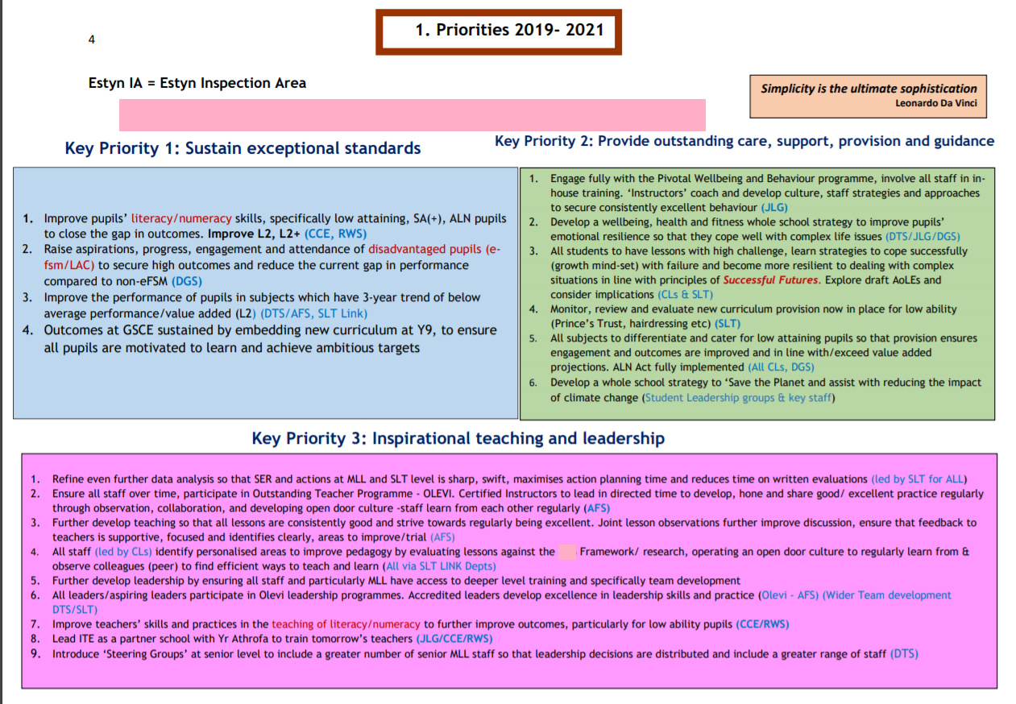
Appendix A

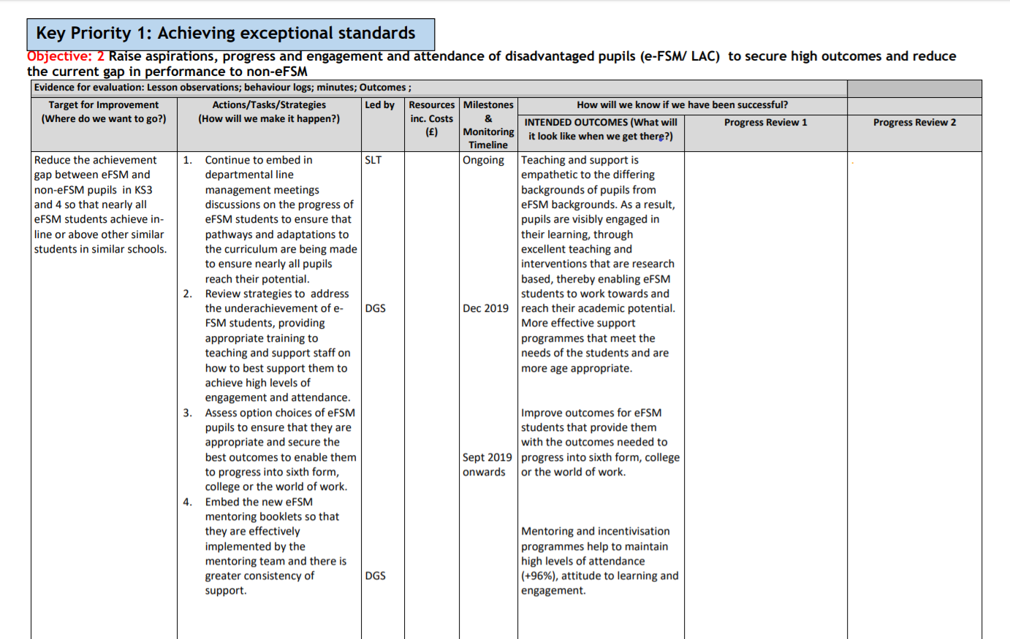
Appendix B

