Evidence-Based Practice Report: Section One

For Section One, it has been requested to produce a report that will emphasise what Evidence-Based Practice is and its significance to practitioners in gaining understanding in their dealings within Human Resources (HR) people practices and organisational issues, mostly in the areas of critical thinking and decision-making.

AC1.1 Evidence-Based Practice (EBP)

Simply put, EBP is the process that employs best available evidence from multiple reliable sources to attain knowledge, inform rational judgement and ultimately produce unbiased and unsurpassed decision-making outcomes (Barends, Rousseau and Briner, 2014; Waite et al, 2021; Young, 2023).
To increase the prospect of positive outcomes, HR practitioners should take a punitive approach to not trust their decision-making on instinct, what they know or fads, thus use the sources of evidence that can be found in scientific literature, organisational data, stakeholders’ concerns and professional expertise / experiential (Waite et al, 2021; Briner, 2019; Taylor and Woodhams, 2016).
These four sources should be used in tandem with the systematic six-step evaluation process: ‘Ask, Acquire, Appraise, Aggregate, Apply and Assess’ to combine and reinforce the evidence basis for decision-making (Waite et al, 2021; Briner, 2019). The ultimate aim for using the four aforementioned sources and Six Steps is to promote critical thinking, close the evidence gap and enable a more trustworthy, de-bias managerial decision-making for an effective EBP (Capezio and L’Espoir Decosta, 2023; Reid Elder and Nikodem, 2023). According to Pfeffer & Sutton (2000) organisations that have the ability to identify the causes for the ‘knowing-doing gap’ and turn knowledge into actions would produce quantifiable outcomes. Moreover, for this to happen, HR practitioners should develop the skills and have the willingness to explore different avenues of data to inform decision-making and provide strong evidence foundation to main stakeholders (CIPD, 2017).

It is also proposed that practitioners follow suitable models for decision-making, one of them being the rational model. This model comprises a step-by-step procedure whereby facts and information are used to logically evaluate all alternatives before reaching a decision (Uzonwanne, 2016).
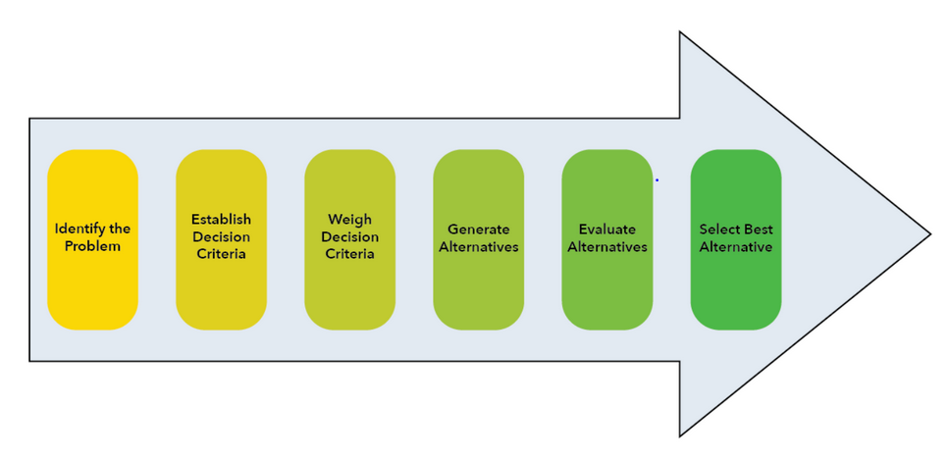Figure 1: Rational Decision-Making Model (Kumar, 2022)

The step-by-step rational model is advantageous when time allows for information gathering and when all individuals agree on the best alternative, thus becoming problematic to use when time is a constraint or / and where there are various objectives coming from several stakeholders (Kumar, 2022).

Whilst EBP for best practice decision-making is becoming more prevalent within Management and HR settings and it is proving to be effective if the above information is taken into account (Briner, 2023), it is imperative to note its limitations. Firstly, evidence is not always perfect, hence the need to always start with a critical mindset. Secondly, there may be little or inadequate evidence availability (Barends, Rousseau and Briner, 2014). Lastly, there could be a combination of situational factors such as time constraints, limited budget for training and resources (Reid Elder and Nikodem, 2023). To conclude, although EBP can be a precaution against futile action, it is not a flawless solution. Hargreaves and Fullan (2012) argue that the evidence in itself could be blurred or outdated, thus it is imperative that HR practitioners use a ‘spirit of enquiry’ and systematic critical thinking approach to effectively evaluate when engaging with EBP for decision-making processes (Gill, 2018; Armstrong and Taylor, 2020).
Example:

AC1.2 Evaluating Analysis Tools and Methods

There is a broad availability of analysis tools and methods that will aid detection of organisational issues, challenges and opportunities by looking at how both internal and external factors could impact on an organisation. Practitioners would identify and choose the most applicable ones to address a particular situation, thus bearing in mind that each of them will present strengths and weaknesses that could influence final outcomes.

To decide on what analysis methods to use for decision-making, practitioners need to identify what type of data they want to gather: quantitative (measurable / numbers) or qualitative (cannot be measured, open to interpretation), thus it could be a combination of both. Therefore, making use of the most appropriate one is paramount (Corbin and Strauss, 2007).

Regardless of what tools and methods would be used for analysis, it imperative to preserve the reliability of the findings in terms of evenness, trustworthiness and replicability (Nunan, 1999).

AC1.3 Principles of Critical Thinking

As a key skill for practitioners, Critical Thinking (CT) requires to question and check validity of everything through sound thinking and objective reflection when it comes to other people’s ideas, as this will help them replace confusion with clarity, deal with complex issues and improve decision-making processes (Howlett and Coburn, 2019).
Glaser (1941) stated that CT calls for ‘persistence’ to consider (and reconsider) a problem carefully, evaluate the ‘evidence’ and ‘implications’ for the conclusions to be suitable and rational.
Furthermore, the importance of rational thinking and an argument that is well reasoned, start with an evaluation of how valid and relevant the evidence is, if it has a logical progression, if it contains any untrue premises or blemished reasoning (Cottrell, 2013).

A valid criterion to evaluate the evidence (adapted from Cottrell, 2013 and LinkedIn, 2023c) through CT lenses could be to:

Other important aspects to consider would be to identify and test out the conclusions found in the presented evidence. This would determine if CT is applied rigorously, or has reliance on one’s intuitions, feelings or prejudice.
As a prerequisite to EBP for questioning, although a natural attribute to the human mind, CT is not a fixed trait but rather a dynamic process that should be cultured through continuous intellectual development (Elder & Paul, 2010) to enhance the ability to critique a particular opinion, method or system (Taylor and Woodhams, 2016).

AC1.4 Decision-Making Processes

In a world where change is the only constant, having the versatility to steer multifaceted challenges and implement sound Decision-Making Processes (DMPs) that are best fit, is a strong, essential skill for practitioners to ‘effective team management’ and ‘drive organisational change’ (Gavin, 2020).
There are several methods that could be employed to achieve effective outcomes through DMPs. Examples would include De Bono Six Thinking Hats, Action Learning Approaches’, Best Fit, Future Facing and Problem-Outcome Frame. Below, three of them are being explained.

Problem-Outcome Frame | This process is used to identify different solutions to specific problems, where by framing will enable practitioners to ‘locate, perceive, identify and label’ the context of a problem (Goffman, 1974). Simply put, the process looks at a problem / issue from all angles, considers all available options and lastly, evaluates the advantages and disadvantages before making a decision (Harrin, 2023).
De Bono Six Thinking Hats | Developed in 1985 by Edward De Bono, although simple, this method is a parallel thinking approach that increases productivity, by aiding HR Practitioners to focus and be mindfully involved, challenging them to use the ‘how to think’ not ‘what to think’ approach to DMPs by focusing on one issue at the time whilst permitting for alteration in thinking (Channell, 2021).  The colours of the hats represent different styles of thinking:  White Hat: Facts & Figures, Black Hat: Judgement & Caution; Red Hat: Intuition, Feelings & Emotions; Green Hat: Creativity; Yellow Hat: Logical & Positive; Blue Hat: Overview & Process (Mulder, 2019).  Besides the parallel thinking benefits of this approach, the different colours of Six Thinking Hats also ‘encourage full-spectrum thinking’ and ‘separate ego from performance’ (Goebe and Seabert, 2006).  By assigning each participant to a specific hat and rotating the hats throughout the discussion, the Six Thinking Hats method encourages a more balanced and comprehensive approach to problem-solving. It helps to suppress biases and groupthink, allowing for a broader range of perspectives to be considered (MindManager Blog, 2023).  Overall, the Six Thinking Hats method is a valuable tool for HR practitioners who want to improve their decision-making and problem-solving skills. It can be used in a variety of settings, from team meetings and can help to foster more effective communication, collaboration, and innovation within the HR function.
Action Learning | Action learning is a cyclical process that involves identifying a problem, forming a team, taking action, reflecting, and learning. It is a powerful tool for improving decision-making because it is focused on solving real problems, encourages collaboration, and promotes continuous learning (Serat, 2017; WIAL, 2023).

AC1.5 Ethical Perspectives and their influence

According to Lawton (1998), ethical perspectives are ‘a set of principles and values that guide ethical behaviour’. Waite et al. (2021) further elaborate that EPs are ‘a framework for promoting ethical behaviour by always applying principles and values when making decisions’. Armstrong (2012) emphasises that EPs encourage individuals to ‘do what is morally acceptable’ when navigating ethical dilemmas.

For the purpose of this task, three main EPs would be considered.

Utilitarianism | A consequentialist ethical theory that holds that the morality of an action is determined solely by its consequences whereby, the right action is the one that produces the greatest good for the greatest number of people (Sinnott-Armstrong, 2003; Waite et al., 2021).  As an example, HR practitioners can use this EP to identify and implement initiatives that promote employee engagement and well-being, leading to a more productive and satisfied workforce (Russell and Weeks, 2019). Additionally, a company might consider offering flexible work arrangements, providing opportunities for professional development, or promoting a healthy work-life balance, evaluating the potential benefits of each initiative against the potential costs (McCartney, 2023).
Deontology

Teleology

In conclusion, EPs play a crucial role in shaping ethical behaviour and promoting a more ethical society. They provide a framework for making informed decisions, fostering moral reasoning, and contributing to a more just and equitable world. By incorporating EPs into decision-making processes, HR practitioners can strive to make choices that are morally sound and beneficial to all (Ovenstone, 2020).

AC3.1 Measuring Financial and Non-financial Performance

AC3.2 People Practices: Adding Value and Measuring Impact

Evidence-Based Practice Report: Section Two

Section Two of the report will address the analysis review of both quantitative and qualitative data provided, highlighting the key findings and the recommendations that can be made when evaluating potential solutions.

AC2.1 Interpretation of analytical data

lkk

Overall Average Salary paid by the company:
£ 8,235,440 / 260 = £31,674.76

AC2.2 Key Findings

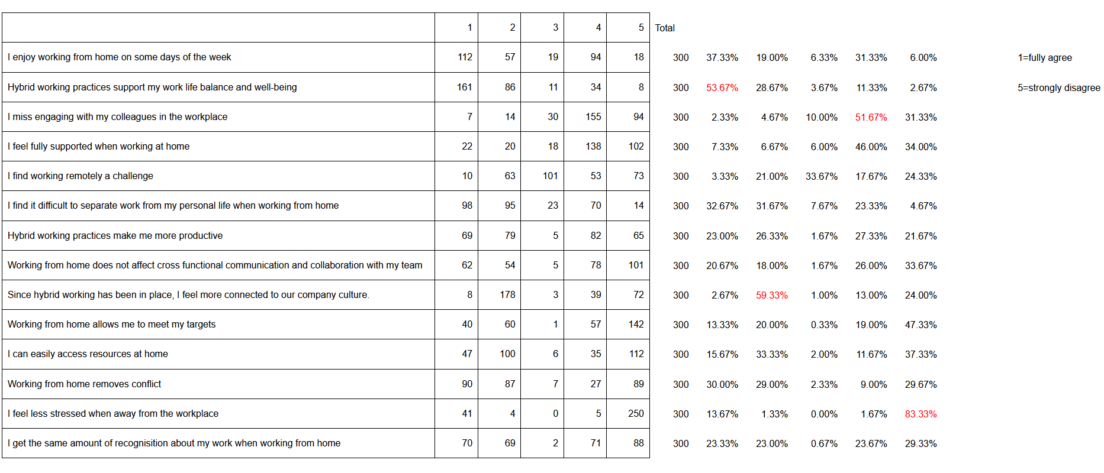

AC2.3 Recommendations

Bibliography

- Armstrong, M (2012) Armstrong’s Handbook of Human Resource Management Practice, 12th edn. London: Kogan Page
- Armstrong, M. and Taylor, S. (2020) Armstrong’s Handbook of Human Resource Management Practice. 15th edn. London: Kogan Page
- Barends, E. & Rousseau, D.M. (2018) Evidence-based management: how to use evidence to make better organizational decisions. New York & London: Kogan Page.
- Barends, E., Rousseau, D. and Briner, R. (2014) Evidence Based Management: The basic principles, Centre for Evidence-Based Management Amsterdam. Available at: https://cebma.org/assets/Uploads/Evidence-Based-Practice-The-Basic-Principles.pdf [Accessed 20/11/2023].
- Battista, M. (2023) PESTLE analysis Available at: https://www.cipd.org/uk/knowledge/factsheets/pestle-analysis-factsheet/ [Accessed 28/11/2023]
- Bosley, A (2023) Job Design. Available at: https://www.cipd.org/uk/knowledge/factsheets/job-design-factsheet/#assessing-job-quality [Accessed 15/11/2023]
- Boyce, C and Neale, P. (2006) Conducting In-Depth Interviews: A Guide for Designing and Conducting In-Depth Interviews for Evaluation Input, Monitoring and Evaluation - 2. Pathfinder International Available at: https://nyhealthfoundation.org/wp-content/uploads/2019/02/m_e_tool_series_indepth_interviews-1.pdf [Accessed 28/11/2023]
- Briner, R. (2019) The Basics of Evidence-Based Practice. People + Strategy Journal Winter 2019 Available at: https://www.shrm.org/executive/resources/people-strategy-journal/winter2019/pages/ebp-briner.aspx [Accessed 20/11/2023].
- Briner, R. (2023) Aligning HR with the business through the evidence-based HR process Available at: https://www.hrdconnect.com/2023/10/03/aligning-hr-with-the-business-through-the-evidence-based-hr-process/?fbclid=IwAR2Vap6WGIjgC4GfRObldULYTv_BlRlfj27QjkcpujxNQwArTxIKDYtrq8Y [Accessed 20/11/2023].
- Capezio, A. and L’Espoir Decosta, P.J-N. (2023) Evidence-Based Decision-Making and Practice in Organizations Available at: https://oxfordre.com/psychology/display/10.1093/acrefore/9780190236557.001.0001/acrefore-9780190236557-e-9 [Accessed 20/11/2023].
- CIPD (2017) Human capital analytics and reporting: exploring theory and evidence. Research report. London: Chartered Institute of Personnel and Development. Available at: https://www.cipd.org/globalassets/media/knowledge/knowledge-hub/reports/human-capital-analytics-and-reporting_tcm18-22281.pdf [Accessed 20/11/2023].
- Channell, M. (2021) The Six Thinking Hats: How to Improve Decision Making, with Examples available at: https://www.tsw.co.uk/blog/leadership-and-management/six-thinking-hats/ [Accessed 30/11/2023].
- Connelly, M. (2023) Force Field Analysis - Kurt Lewin Available at: https://www.change-management-coach.com/force-field-analysis.html [Accessed 28/11/2023].
- Corbin, J., & Strauss, A. (2007) Basics of qualitative research: Techniques and procedures for developing grounded theory (3rd edn.) Thousand Oaks, CA: Sage
- Cottrell, S (2013) The study skills handbook, Hampshire: Palgrave Macmillan
- Creswell, J. W., & Plano Clark, V. L. (2018). Designing and Conducting Mixed Methods Research (3rd edn.) Thousand Oaks, CA: Sage
- De Bono, E. (1985). Six Thinking Hats: An Essential Approach to Business Management. Little, Brown, and Company
- de Vaus, D. (2009) Research design in social research, Thousand Oaks, CA: Sage
- DOBBS, M.E. (2014) Guidelines for applying Porter's five forces framework: a set of industry analysis templates. Competitiveness Review. Vol 24, No 1, pp32-45.
- Du Plessis, M. (2007), “The role of knowledge management in innovation”, Journal of
- Elder, L., & Paul, R. (2010) Critical thinking development: A stage theory. Available at: https://www.criticalthinking.org/pages/critical-thinking-development-a-stage-theory/483 [Accessed 20/11/2023].
- Gavin, M. (2020) 8 Steps in the Decision-Making Process Available at: https://online.hbs.edu/blog/post/decision-making-process [Accessed 30/11/2023].
- Gill, C. (2018) Don’t know, don’t care: An exploration of evidence-based knowledge and practice in human resource management. Human Resource Management Review, 28(2), pp.103-115. Available at: https://www.sciencedirect.com/science/article/pii/S1053482217300451 [Accessed 28/11/2023].
- Glaser, E (1941) An Experiment in the Development of Critical Thinking. New Yook: Teachers’ College, Columbia University
- Goebel, G. and Seabert, D. (2006) Put on your thinking hats. Journal of School Health, 76(7):393-395. Available at: http://dx.doi.org/10.1111/j.1746-1561.2006.00131.x [Accessed 09/12/2023]
- Goffman E. 1974. Frame Analysis: An Essay on the Organization of the Experience. New York: Harper Colopho
- Hann, S. (2023) SWOT analysis. Available at: https://www.cipd.org/uk/knowledge/factsheets/swot-analysis-factsheet/ [Accessed 28/11/2023].
- Hargreaves, A. and Fullan, M. (2012) Professional Capital: Transforming, teaching in every school. Abingdon: Routledge
- Harrin, E. (2023) The Impact of Framing in Decision Making. Available at: https://rebelsguidetopm.com/the-impact-of-framing-in-decision-making/ [Accessed 10/12/2023]
- Howlett, W. and Coburn, T. (2019) Critical thinking | Podcast CIPD. Available at: https://www.cipd.co.uk/podcasts/critical-thinking#gref [09/11/2023].
- Hooley, G., Piercy, N.F. and Nicoulaud, B. (2008) Marketing Strategy and competitive Positioning 4th edn. Harlow: FT Prentice Hall
- Information Resources Management Association, (2021) Research Anthology on Developing Critical Thinking Skills in Students. Available at: https://doi-org.ezproxy.uwtsd.ac.uk/10.4018/978-1-7998-3022-1[Accessed 20/11/2023].
Knowledge Management, Vol. 11 No. 4, pp. 20-29.
- Kumar, A. (2022) Decision Making Models: Concepts, Examples, Importance Available at: https://vitalflux.com/decision-making-models-concepts-examples-importance/ [Accessed 28/11/2023]
- Lawton, A. (1988) Ethical Management for the Public Services, Open University Press
- LinkedIn (2023b) What are the advantages and disadvantages of using questionnaires for job analysis? Available at: https://www.linkedin.com/advice/1/what-advantages-disadvantages-using-7045065278488993792 [Accessed 15/11/2023]
- LinkedIn (2023c) What are some strategies to critically analyse and compare different types of evidence? Available at: https://www.linkedin.com/advice/3/what-some-strategies-critically-analyze-compare [Accessed 30/11/2023].
- LinkedIn, (2023a) What are the advantages and disadvantages of the Ansoff matrix? Available at: https://www.linkedin.com/advice/0/what-advantages-disadvantages-ansoff-matrix [Accessed 30/11/2023]
- MindManager Blog (2023) The six thinking hats method: how to use it for effective brainstorming. Available at: https://blog.mindmanager.com/six-thinking-hats-method/ [Accessed 11/12/2023]
- McCartney, C. (2023) Flexible working practices Available at: https://www.cipd.org/uk/knowledge/factsheets/flexible-working-factsheet/ [Accessed 11/12/2023]
- Mulder, P. (2019) Six Thinking Hats by Edward De Bono, a decision making tool | ToolsHero. [online] ToolsHero. Available at: https://www.toolshero.com/decision-making/six-thinking-hats-de-bono/ [Accessed 28/11/ 2023]
- Nunan, D. (1999). Research methods in language learning. Eighth printing. Cambridge: CUP
- Ovenstone, O. (2020) An Exploration of Ethical Trading Challenges in Educational Psychology Available at: https://www.proquest.com/openview/7c478dfdbc70c0d59c16a827e6b3865d/1?pq-origsite=gscholar&cbl=2026366&diss=y [Accessed 11/12/ 2023]
- Patton, M. Q. (2002). Qualitative research and evaluation methods (3rd edn.). Thousand Oaks, CA: Sage
- Peterdy, K. (2023) Ansoff Matrix The Product/Market Expansion Grid Available at: https://corporatefinanceinstitute.com/resources/management/ansoff-matrix/ [Accessed 28/11/2023]
- Peterdy, K. (2023) SWOT Analysis A framework to understand and analyse a company’s Strengths, Weaknesses, Opportunities, and Threats Available at: https://corporatefinanceinstitute.com/resources/management/swot-analysis/ [Accessed 28/11/2023].
- Pfeffer, J. and Sutton, R. I. (2000) The Knowing-doing Gap: How Smart Companies Turn Knowledge Into Action. Boston, MA: Harvard Business School Press.
- Reid Elder, S. and Nikodem, M. (2023) Considering the application and relevance of evidence-based HR Available at: https://www.peoplemanagement.co.uk/article/1845833/considering-application-relevance-evidence-based-hr [Accessed 20/11/2023].
- Russell, T. and Weeks, A. (2019) Ethics at work: An employer’s guide Available at: https://www.cipd.org/uk/knowledge/guides/ethics-work-guide/ [Accessed 11/12/2023]
- Serat, O. (2017) Action Learning. Available at: https://link.springer.com/chapter/10.1007/978-981-10-0983-9_62 [Accessed 11/12/2023]
- Sinnott-Armstrong, W. (2003) Gert Contra Consequentialism in Rationality, Rules, and Ideals, New York: Rowman and Littlefield
- Taylor, S., & Woodhams, C. (2016) Studying Human Resource Management. 2nd edn. London: CIPD.
- Uzonwanne, F.C. (2016). Rational Model of Decision Making. In: Farazmand, A. (eds) Global Encyclopedia of Public Administration, Public Policy, and Governance. Springer, Cham. Available at: https://doi.org/10.1007/978-3-319-31816-5_2474-1 [Accessed 28/11/2023]
- Waite, K. et al (2021) People Practice: A Complete Guide. London: Kogan Page.
- Weber, E., Wyverkens, A. and Leuridan, B. (2023) Rethinking Evidence-Based Management. Philosophy of Management. Available at: https://doi.org/10.1007/s40926-023-00236-5 [Accessed 20/11/2023].
- WIAL (2023) What is Action Learning? Available at: https://wial.org/action-learning/ [Accessed 20/11/2023].
- Wisker, G. (2008) The Postgraduate Research Handbook 2nd edn, Hampshire: Palgrave Macmillan
- Young, J. (2023) Evidence-based Practice for Effective Decision-Making | Factsheets. [online] CIPD. Available at: https://www.cipd.co.uk/knowledge/strategy/analytics/evidence-based-practice-factsheet#gref [Accessed 20/11/2023].

