Alisha Mahmood CV

Tel: 07449007476
Email: alisha24fab@gmail.com
LinkedIn: Alisha Mahmood
Personal Profile

A proactive highly motivated individual who has extensive experience in the administration / customer service during my employment. Highly focused with a comprehensive knowledge of how to maintain a professional, helpful, and courteous relationship with customers and team members. I am keen to develop a long-term career within the administration sector and believe I have the relevant skills and qualities required for the role. I am prepared to undertake any relevant training to enhance my prospects.

Key Skills

- Administration skills.
- Communication skills.
- Time Management.
- Organised with ability to multitask.
- Versatile and flexible to new procedures and changes.
- Team Player with the ability to work on own initiative.
- Customer service skills.
- Problem solver.

Employment History:

Nationwide care services carer 2026

- Looking after clients
- Making client food
- Washing client clothes and putting out clients washing
- Administering medications
- Admin – doing up clients notes, sending emails, putting down what medication was given at what mg.
- Communicating with client
- Giving personal care with dignity.

Parvinder Kaur Moore and Gurmail Singh Admin - Cleaner 2024 – 2025

- All aspects of administration completed for the owner.
- Ensuring the best customer interaction always.
- All aspects of completing paperwork for maintenance jobs.
- Cleaning house to house.
- Understanding chemicals and storage accurately.

Digital Marketing Marketing Assistant 2021 – 2022

- Create and upload copy and images for the organisation's website.
- Write and dispatch email marketing campaigns.
- Provide accurate reports and analysis to clients and company management to demonstrate effective return on investment (ROI)
- Research new online media opportunities that may benefit the business including mobile, social media, development of blogs and forums.
- Design website banners and assist with web visuals.
- Communicate with clients, affiliate networks and partners.
- Conduct keyword research and web statistics reporting.
- Contribute to social media engagement and brand awareness campaigns.
- Use web analytics software to monitor the performance of client websites and make recommendations for improvement.
- Contribute to company and industry blogs and manage e-communications.
- Assist with paid media, including liaising with digital advertising agencies.
- Develop and integrate content marketing strategies.
- Keep up to date with current digital trends.
- Manage the contact database and assist with lead generation activities.
- Negotiate with media suppliers to achieve the best price for clients.

Amazon Warehouse Operative 2017 – 2019
Our little angelz Nursery Classroom Assistant

- Use scanners to read bar codes on products.
- View prompts on screens and follow the direction.
- Troubleshoot problems.
- Ensure product meets quality requirements.
- Operate power industrial trucks (PIT) such as a forklift or pallet driver, and work at heights up to 35 feet.
- Keep pupils engaged in learning and stay on task during the lesson or activity so that they can become independent learners.
- Support the social and emotional development of pupils, reporting any issues when required.
- Support the teacher in managing challenging pupil behaviour and promoting positive behaviour.
- Listen to pupils read and read to pupils as a class, group or one-to-one.
- Monitor and record pupils' progress and provide detailed and regular feedback to teachers.
- Carry out administrative duties, such as preparing the classroom and clearing away after class to ensure effective teaching can take place.
- Look after pupils who have had accidents, administering first aid where necessary, and those who need help dressing or are upset.
- Make resources for use by teachers and pupils and create art displays of pupils' artwork.

Education and Training

- Secondary Education Completed to a very high standard.
- University of Wales trinity saint David (UWSTD)

References Available on Request

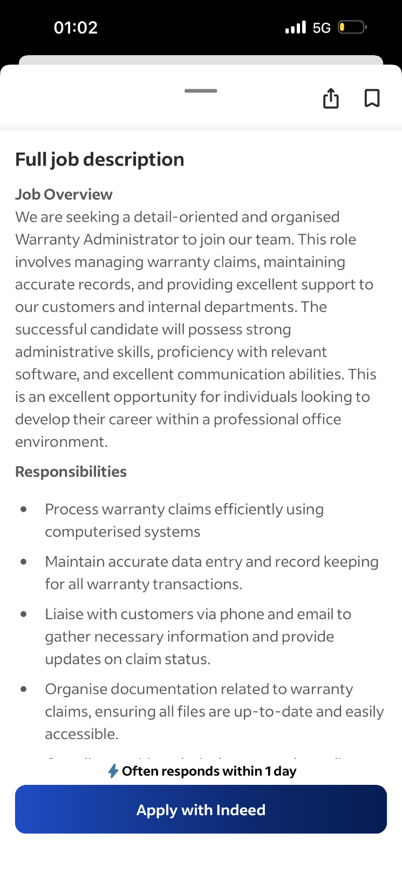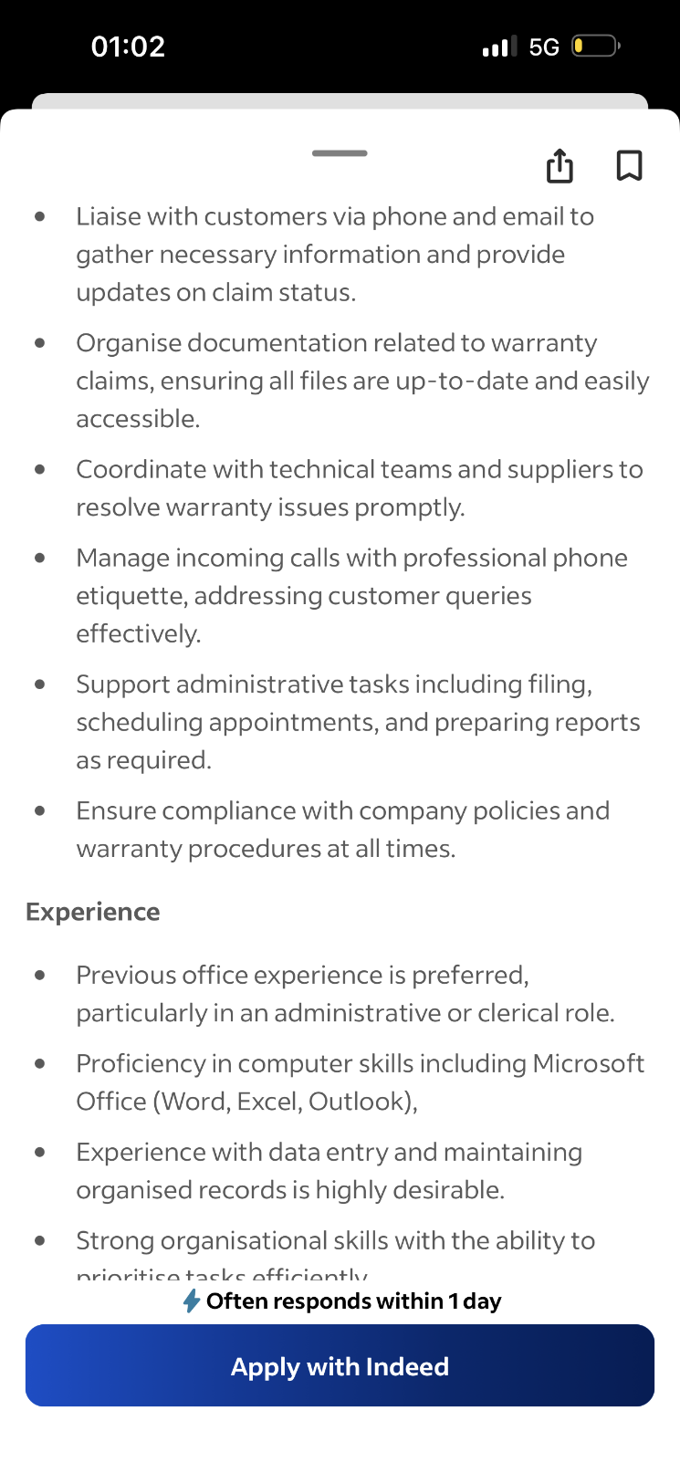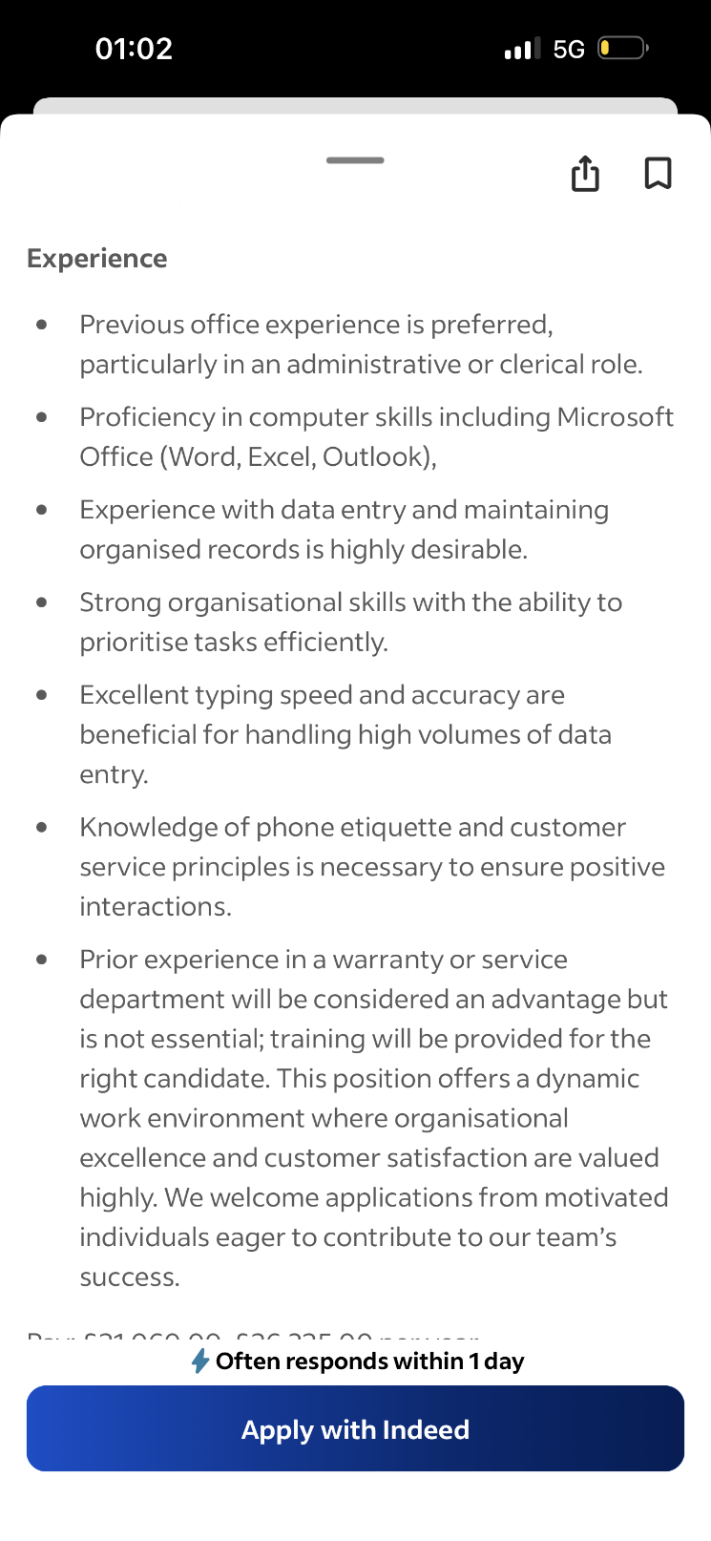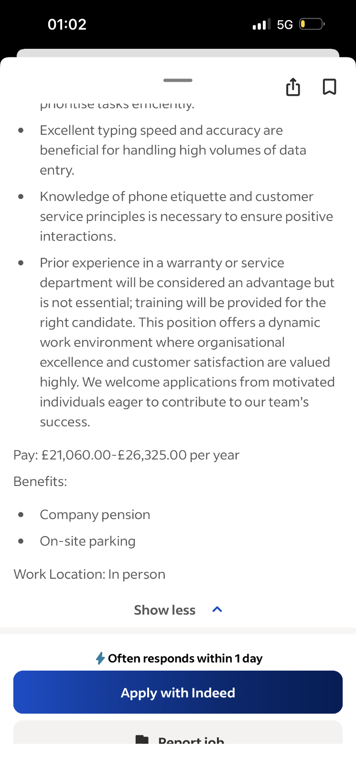

cc

Alisha Mahmood
17 stechford road hodge hill Birmingham B34 6AA
07449007476
alisha24fab@gmail.com
19/10/2026
Hiring Manager
The motorhome depo (midlands)
Dear Hiring Manager,
Re: Application for Warranty Administrator Position
I am writing to express my interest in the Warranty Administrator position at your company. I am an organised, detail-oriented, and reliable individual with strong administrative and communication skills. I am confident in my ability to support warranty operations, maintain accurate records, and ensure warranty claims are processed efficiently and accurately.
I understand the importance of attention to detail when handling warranty claims, checking documentation, maintaining customer and vehicle records, and liaising with manufacturers, suppliers, technicians, and customers. I am comfortable managing administrative tasks, working to deadlines, and ensuring that information is recorded correctly in line with company procedures.
I take pride in providing excellent customer service, resolving queries professionally, and working effectively as part of a team. I am also willing to learn new systems and processes to ensure that warranty claims are handled promptly and that the business operates efficiently.
I would welcome the opportunity to bring my organisational skills, positive attitude, and commitment to accuracy to your team. Thank you for considering my application. I look forward to the opportunity to discuss how I could contribute to your company.
Yours sincerely,
Alisha Mahmood

