Joseph Lloyd
Student number: 1803656
Course: BA Graphic Design
Tutor: Timi O’Niell
Module: Research in Practise (ADAD5004)
Keywords: Emotion, Empathy and Passion
Word count: 2490

Through this essay I will explore the use of three keywords that are supported by a minimum of three images. These words will also be used in synthesis with designers and practitioners. The keywords in which I have chosen to explore are emotion, empathy and passion. Hopefully through researching and analysing these words it will lead me to form a question for my dissertation. I will be researching how these words influence design and how they create a sense of connection with an audience. As a graphic designer these keywords reflect my interests in my field. Also, the chosen keywords are ones that I use in my own practise as I think they are important in the process of making a design successful. This idea will also be discussed and explored through this essay.

Emotion can be defined in various ways, Daniel Goleman characterizes the word by saying ‘I take emotion to refer to a feeling and its distinctive thoughts, phycological and biological states, and a range of propensities to act.’ (Goleman, 1995) Therefore ‘emotion’ can be perceived to create a sense of connection with something or someone. Goleman’s Definition is important as it explains the term emotion as a ‘feeling’. From this we realise that emotion plays an important role in making a design successful and engaging. On the other hand, Candice Pert defines emotion by saying ‘There is in fact no such identity as emotion. There is simply perception and bodily response.’ (Pert, 1997) Indicating there is no feeling involved, only our ability to understand the connections between the object and the person. This is interesting as both authors have construed the word emotion in dissimilar ways. Investigation into emotion has demonstrated that its paramount for design and designers as it creates a connection between the audience and design. Furthermore, from research on how emotion is used in design and from the definitions previously discussed, it led towards the research of the practitioner Trevor Van Gorp and his book ‘Design For Emotion’(2012). After reviewing the context of ‘Design for Emotion’, it is clear that there are many types of emotion, which is why the book has been useful to aid the understanding of the vast connotations that come with the word ‘emotion’ in graphic design. In addition, when emotion is used in design it can ‘trigger’ an emotional response from an audience or viewer, whether this being a physical or psychological feeling (Gorp, 2012). Denoting these gives the interpretation that these states are how the audience acts and how we can change perceptions after a seeing a piece of graphic design. For better understanding of these states research was completed using ‘Design and Emotion (2003) by Deana McDonagh’ as it discusses how emotion relates to the audience’s experience when viewing a piece of graphic design or advertisement. Designers have had to converge the relation previously mentioned to create an experience that allows emotion to ‘command attention’(Gorp, 2012).
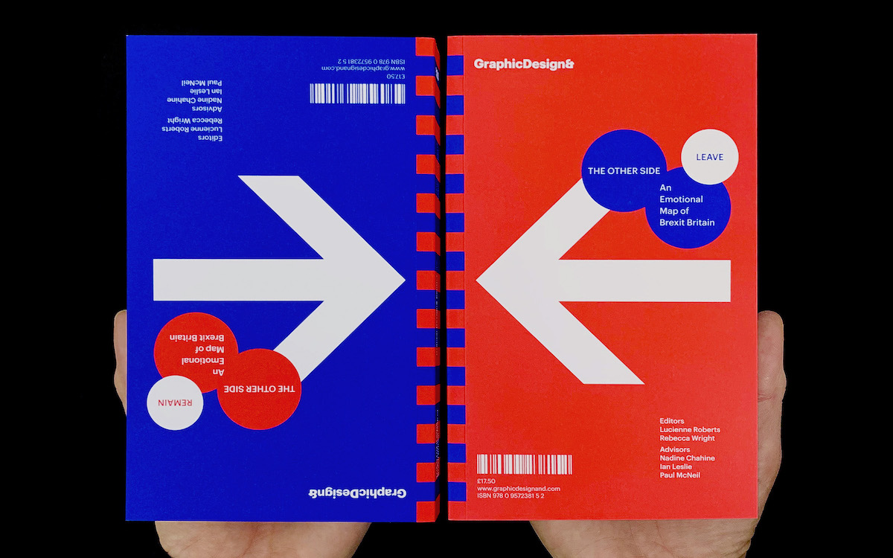
Figure 1. Roberts, L. (2020) Other side
‘Other Side’ (2020) Figure 1 by Lucienne Roberts and Rebecca Wright shows how designers use emotion within their artwork. In this occasion Roberts and Wright have created a book combining the reasons for voting leave and remain during the Brexit referendum. The perceptions within display the divide we have in Britain from the referendum. Leave and remain are not usually seen together. However, these designers and practitioners challenge this and push the viewer into considering the perspectives of the other side, this is done through the keyword: emotion. Moreover, to further my knowledge of this work research will concentrate on ‘Persuade Don’t Preach’ (2020) by Karen Tibbals, as this betters the understanding of how the work can evoke empathy and bring people closer together, making the divide smaller. On the other hand, a counter argument to this would be, emotions can also be seen to make the divide. Emotion in design can make a split of opinions and challenge people’s perceptions in a variety of means. Antonio Damasio reveals that ‘we cannot identify the emotion-causing thought’ (Damasio, 2004). Therefore, explaining we cannot understand why we think and feel differently from one another. To further develop the understand of this, research focuses on ‘Emotions, Cognition, and Behaviour’ (1984) by Carroll E. Izard, as this benefits the understanding of why we as humans change perceptions and opinions based on other people’s emotions and behaviours.
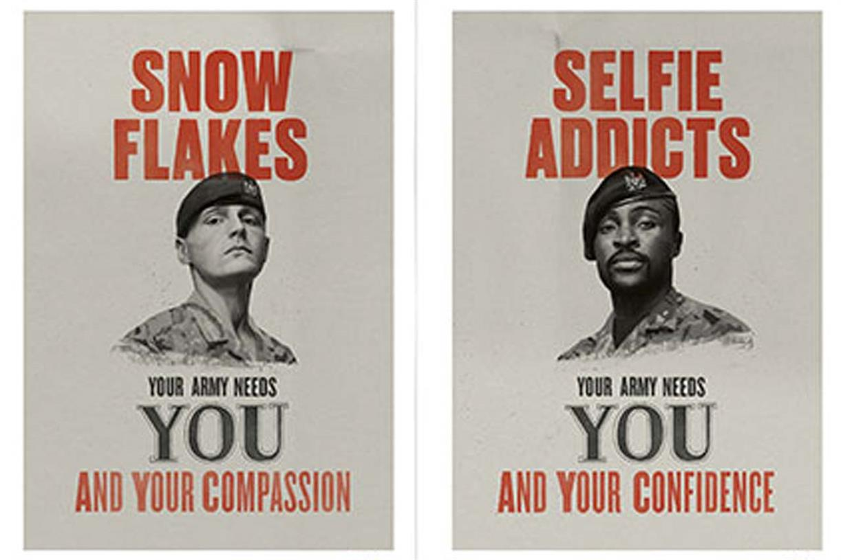
Figure 2. British army (2019) Your Army Needs You

‘Your Army Needs You’ (2019) Figure 2 by the British Army is a campaign that can be used as an example of how emotion can divide people and not just bringing people closer together. Research into this showed that these poster designs were clever and unique. However, there was a lot of criticism around the campaign which sparked many different perceptions. Again, the book ‘Emotional Design’ (2003) by Don Norman, has been of value in terms of developing understanding of why everyone has different emotions with designs and why empathy is conveyed through design.


This leads me onto my second keyword, which is ‘Empathy’. Amy Coplan defines it, ‘Empathy is the source of meaning.’ (Coplan, 2011). This suggests that everything we create is in some way influenced by empathy. As humans we all have empathy, some more than others, which is why it is important as a designer to introduce the concept of empathy into artwork. This is so we can build a relationship between us and the audience. The above definition adds to the knowledge of the concept of empathy as it broadens the term bringing in new perceptions. On the other hand, Hasso Plattner defines the concept of empathy by stating that it ‘is an ability that allows us to comprehend the situations and the perspectives of others.’ (Plattner, 2014). Therefore, this conveys empathy as a way to understand the feelings of others and their emotions, whilst giving a sense of connection. I find this interesting due to the fact that within design empathy is given a new connotation as this suggests designers are able to send a message to an audience in an emotional and empathetic manner, this making artwork more meaningful bringing more attention. Further research into the concept of empathy has led me to the practitioner and philosopher Lou Agosta and his book ‘Empathy in the Context of Philosophy’ (2010). Once having reviewed the content of the book, the understanding of the keyword ‘empathy’ has vastly improved from the notion ‘Empathy puts the human in human being.’ (Agosta, 2010). This suggests that without empathy we are empty beings. This led to a question of: What does this mean in terms of design? This would imply that without empathy design would be inattentive and struggle to hold a place in a fast-passed environment like the world we live in today. In contrast, does design without empathy work better? If this is to be true, then there would be no place or need for the emotional connection between the design and audience. To better the knowledge of this scenario, research will focus on ‘Empathy: What is it and why it Matters’ (2012) by David Howe, as it discusses how empathy develops and how ‘empathy plays in defining our shared humanity.’ (Howe, 2012). This gives a further understanding of what it means to be empathetic.

Figure 3. Always. (2014) Like a Girl Figure 4. Nike. (2019) Believe in something

Designers and advertisers have had to utilise the emotional connection between the viewer and their designs, this is so empathy can draw attention and bring more interest towards their artwork. ‘Like A Girl’ (2014) figure 3 and ‘Believe in Something’ (2019) figure 4 by the brands Always and Nike both use a positive empathy in their core designs which evokes intrigue. Figure 3 is about empowering girls; the core idea was to get women talking about their periods. This empathy allowed women to feel strong as individuals and made them proud to be who they are. As previously mentioned, the designs and the campaign itself evoked empathy as they created a connection. This connection can be seen to make us as humans loyal to a design or a brand. To further my knowledge of the subject research will concentrate on ‘Human Connection’ (2017) by Arthur F. Coombs as this shows how we as humans connect to one another through our art. Positive empathy is a tool that cannot go unlooked as it is vital in drawing attention. It allows the audience to get emotionally attached to the design or advertisement, which makes that design and concept successful. Modern design is using this concept of empathy to evoke a sense of passion and pride into the audience. Again, this gives that emotional connection. In contrast, is empathy used to create a sense of fear and sadness through designs? In this case the concept would be negative empathy rather than positive empathy. This concept widens empathy’s definitions from previous as it can be used to make us as humans feel bad for something or give the feeling of being scared. To further my knowledge on the concept, research is focused on ‘The Dark Sides of Empathy (2019) by Fritz Breithaupt’ as the book illustrates how empathy links with morality. Furthermore, it betters the understanding of false and filtered empathy. (Breithaupt, 2019). Moving on, Hilary Gallo suggests ‘fear exists in our minds and logic struggles to touch it.’ (Gallo, 2019). Therefore, giving the interpretation that fear can overpower us as beings. This can give better understanding of why negative empathy is so successful within the world of design.
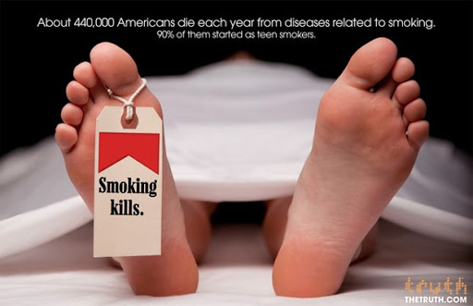

Figure 5. The Truth. (2017) Smoking Kills Figure 6. Save the Children (2017) End of childhood

‘Smoking kills’(2017) Figure 5 by ‘The Truth’ is a campaign that shows how negative empathy is used and how it evokes fear into the viewer. Research into the design showed that people found the advert disturbing and frightful. This is what allows the design to be effective as the concept of empathy and fear deter people from the harmful behaviour of smoking. The book ‘Managing Emotion in Design Innovation’(2013) by Amitoj Singh, has furthered my knowledge of the use of fear and empathy in context with making design successful. Moreover, Figure 6 displays an advertisement from ‘Save The Children’, The design will be analysed along side figure 5 through the concept of empathy within design. To add to this, Figure 3 and Figure 4 will also be further investigated to find out more about the passion that helps connect people to one another.


This Leads on to my final keyword, being passion. Research conducted shows that there are various ways in which passion can be defined. One being ‘passion is energy.’ (Suchy, 2004). This definition suggests that passion is a strength that is to be required to work towards something. Passion allows people to focus on their goals, which is why it is seen as an importance in design. This concept sparked some questions: Without passion are the designs we create empty and meaningless? Additionally, do we have an audience for our work if passion doesn’t exist in design? This is why I think the concept of passion defines who we are as human beings as it helps discover interests and creates enthusiasm for our goals and aims. From this definition I think that the meaning of passion amplifies the importance of harvesting the concept. On the other hand, another definition of passion challenges the previous as, Marcia McClure mentions it to be ‘An occurrence of powerful love.’ (McClure, 2011). This gives the interpretation that the concept of passion comes from the enjoyment and pleasure of creating something powerful. This links back to empathy as this could imply that both are a way to understand feelings and perceptions of others. Furthermore, I find this concept of passion interesting as it gives the knowledge that designers are able to grasp attention from an audience by creating artwork that evokes enjoyment and intrigue. This then creates the connection between people, and houses the ability to give purpose and meaning to something. (Hansen, 2018). Research has led me to explore the work of Robert J. Vallerand and his book ‘The Psychology of Passion’, (2015). After having reviewed the context of the book, the understanding of passion as a concept has changed my perceptions due to the vast array of meanings. Vallerand mentions that ‘Passion would appear to facilitate creativity’. This gives the connotation that within design passion is what sparks creativity and without it, would design work effectively in terms of sending a message? For better understanding of the scenario research will conduct through ‘A Passion for Ideas’ (2002) by Heinrich Von Pierer, as it thoroughly explores how passion creates new ideas within the design process. Designers have used passion to further their creative boundaries and have used this concept to make. A connection to a viewer, much like emotion.
Figure 7. Labour Party. (2020) Supporting Keyworkers
To add to this, designers have had to use passion through their designs, whether it being in poster designs or advertisement campaigns. This is so it attracts an audience allowing important information to be passed in a creative manner. ‘Supporting Key Workers’ (2020) Figure 7 by the Labour Party is formed from the current pandemic of the Corona Virus. The campaign is about supporting the keyworkers who help keep the county going in this tough time. Figure 7 shows how passion within design can bring people closer together, it shows the strength we have as humans and how we can break a divide and come together to support others. The colours within the design evoke passion from the main colour of red. Developing this further, colours can be analysed through the use of semiotics. To understand more about the subject of semiotics, research will focus on ‘Semiotics: The Basics’ (2003) by Daniel Chandler. This will lead to the introduction of more practitioners which will allow the image to be further explored.

In conclusion, I have explained each of my three keywords and how they relate to my practise of graphic design. I have explored the emotion within designs and how they can bring people closer together as well as dividing them. Empathy has also been shown to create relations and connections to design and with emotion. Furthermore, passion has been linked with the strength we have as humans. It is obvious that these three keywords can be linked with one another as they all lead to the connection between the design and the audience. Throughout this proposal many questions have come to the forefront for my dissertation. Some being; How does emotion influence the audience through graphic design? How does fear affect people’s judgement once viewing a piece of graphic design? Does passion and empathy create a sense of connection in graphic design? However, my final proposed question for my dissertation is; Can emotion, passion and empathy through the means of graphic design bring people closer together?

Bibliography
Goleman, D. (1996). Emotional Intelligence: Why It Can Matter More Than IQ. London: Bloomsbury Publishing.

Pert, C. (1997). Molecules of Emotion: Why You Feel the Way You Feel. New York: Scribner.

Gorp, T.V. (2012). Design for Emotion. Waltham: Morgan Kaufmann.

McDonagh D. et al. (2003). Design and Emotion. London: Taylor and Francis.

Tibbals, . (2020). Persuade, Don’t Preach: Restoring Civility across the Political Divide. UK: Ethical Frames.

Damasio, A.R. (2004). Looking for Spinoza: Joy, Sorrow, and the Feeling Brain. UK: Random House

Izard, C.E. et al. (1984). Emotions, Cognition, and Behaviour. New York: Cambridge University Press

Norman, D. (2007). Emotional Design: Why We Love (or Hate) Everyday Things. UK: Hachette

Coplan, A. and Goldie, P. (2011). Empathy: Philosophical and Psychological Perspectives. New York: Oxford University Press

Plattner, H. et al. (2014). Design Thinking Research: Building Innovators. Stanford: Springer

Agosta, L. (2010). Empathy in the Context of Philosophy. UK: Palgrave Macmillan

Howe, D. (2012). Empathy: What is it and why it Matters. UK: Palgrave Macmillan

Coombs, A.F. (2017). Human Connection: How the “L” Do We Do That?. UK: Scrivener Books

Breithaupt, F. (2019). The Dark Sides of Empathy. New York: Cornell University Press

Gallo, H. (2019). Fear Hack. London: Unbound Publishing

Singh, A. (2013). Managing Emotion in Design Innovation. New York: CRC Press

Suchy, S. (2004). Leading with Passion: Change management in the 21st Century Museum. Oxford: Rowman Altamira

McClure, M. (2011). The Trove of the Passion Room. US: Distractions Ink

Hansen, M.T. et al. (2018). Purpose, Meaning and Passion (HBR Emotional Intelligence Series). US: Harvard Business Press

Vallerand, R.J. (2015). The Psychology of Passion. New York: Oxford Press

Pierer, H.V. and Oetinger, B.O. (2002). A Passion for Ideas. US: Purdue University Press

Chandler, D. (2003). Semiotics: The Basics. London: Routledge

Images

Roberts, L. (2020) Other Side. Available at: https://www.graphicdesignand.com/product/the-other-side (Accessed: 15th April 2020).

British Army. (2019) Your Army Needs You. Available at: https://www.forces.net/news/your-army-needs-you-army-unveils-latest-recruitment-campaign (Accessed: 15th April 2020).

Always. (2014) Like a Girl. Available at: https://www.always.co.uk/en-gb/about-us/our-epic-battle-like-a-girl (Accessed 28th April 2020).

Nike. (2019) Believe in Something. Available at: https://www.forbes.com/sites/willburns/2018/09/04/with-new-kaepernick-ad-what-does-nike-believe-in/#45e2440e1081 (Accessed 28th April 2020).

The Truth. (2017) Smoking Kills. Available at http://natmonitor.com/2017/07/01/why-are-the-poor-still-smoking/ (Accessed 28th April 2020).

Save the Children (2017) End of Childhood. Available at https://campaigns.savethechildren.net/news/one-every-four-children-being-robbed-their-childhood-new-report-save-children-finds (Accessed 28th April 2020).

Labour Party. (2020) Supporting Keyworkers. Available at: https://www.labourdesign.co.uk
(Accessed 3rd May 2020).

