AN

An audit case study of the organizational structure of the International Hotels Group.

A 2000 Word Report

BMIH 5004 Management and Organisational Behaviour
STUDENT: FESTUS TUMI 2121888
LECTURER: Charlotte Joyner

Contents

Executive Summary 1
Introduction: 2
Definitions and Theories 3
IHG’s Organisational Structure, Culture, and Goals 5
Organisational Structures within IHG corporate and individual units 5
Goals 7

.

Executive Summary

This study delves into an analysis of the organizational management structure and practices within the International Hotel Group (IHG), a globally recognized entity in the hospitality industry with a diverse portfolio of brands and a widespread international presence. IHG's corporate framework, leadership dynamics, and operational strategies are scrutinized at both the overarching corporate level and the individual unit level.
At the corporate level, the audit explores theories such as strategic management, organizational culture, and corporate governance to understand IHG's strategic direction and operational framework. The examination of IHG's organizational behaviour, human resource management, and service operations at the unit level aims to identify areas for performance enhancement and the cultivation of a culture of continuous improvement across its extensive portfolio of hotels.
Key theories examined include Mintzberg's model of organizational structure, which delineates the strategic apex, middle line, operating core, technostructure, and support staff, all contributing to the efficiency of IHG's operations. Schein's iceberg model of culture underscores the importance of leadership and organizational culture in shaping IHG's identity and behaviour, with visible manifestations such as brand logos and deeper elements like vision and mission statements.
IHG's organizational structure, characterized by a functional yet hierarchical model, emphasizes centralized decision-making while allowing for flexibility and adaptability at the unit level. The challenge lies in balancing centralized control with local autonomy to align with corporate goals while catering to diverse market demands.
At the individual unit level, IHG-operated franchises are managed by third-party owners, posing challenges in maintaining consistent organizational cultures aligned with IHG's strategic vision.
In summary, IHG's organizational structure, culture, and goals reflect a commitment to industry leadership, value creation, and responsible business practices, underpinned by a strategic vision that emphasizes guest satisfaction, owner returns, and positive societal impact.

Introduction:

This study embarks on an examination of the organisational management structure and practices within the International Hotel Group (IHG), a prominent player in the global hospitality industry renowned for its extensive portfolio of brands and international presence.
IHG describes itself as “a global hospitality company, with 19 hotel brands, one of the industry’s largest loyalty programmes, over 6,000 open hotels in more than 100 countries, and a further 1,800 hotels in our development pipeline.” (IHG 2022)
IHG predominantly operates by franchising brands and managing hotels on behalf of third-party owners, leveraging its expertise and reach to craft exceptional guest experiences and drive owner returns. IHG's culture, as emphasized in its annual reports, underscores its commitment to providing "True Hospitality for Good" and is reinforced by global delegation of authority policies.
At the corporate level, this audit delves into pertinent theories such as strategic management, organizational culture, and corporate governance to analyse IHG's overarching strategies, leadership dynamics, and structural frameworks.
At the individual unit level, the audit draws upon theories of organizational behaviour, human resource management, and service operations to scrutinize the efficacy of IHG's management practices at various hotel properties. By examining aspects such as employee engagement, customer satisfaction, and operational efficiency, this report endeavours to identify opportunities for enhancing performance and fostering a culture of continuous improvement across IHG's diverse portfolio of hotels.

Definitions and Theories

Organisation
Mintzberg (1989) defines a formal organisation as a collection of people that has an authority figure and support structure or team that keeps and directs the whole grouping together towards a common goal. Meanwhile Griseri (undated) states “An ongoing group of individuals who are formally recognised as associated with the group, and with a common set of goals which they are systematically structured to accomplish.”

Organisational Structure
Mintzberg’s organisational model divides the organisation into five separate but interconnected components:

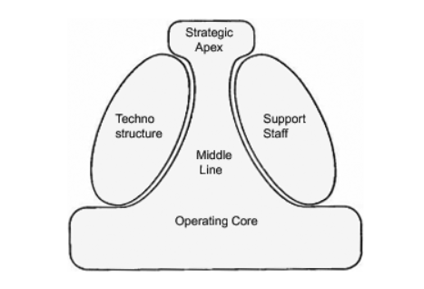
Figure 1. Mintzberg’s model of organisational structure
The strategic apex is responsible for the direction of the organisation, the middle line executes the vision through effective management, while the operating core perform the day to day duties that determines the organisations’ purpose. Mintzberg (1989) adds that the technostructure and support staff all contribute to the efficiency of the entire operation

Organisational Culture
Schein (2004) likens an organisations culture to an individual’s character, and that is what underpins and guides its attitudes and behaviour. He adds that leadership and culture is a critically reciprocal relationship that can define an organisation.
Schein’s Iceberg model shown below highlights the fact that much of an organisations culture is hidden below the surface as intangible but conscious or sub-conscious patterns of behaviour or processes.
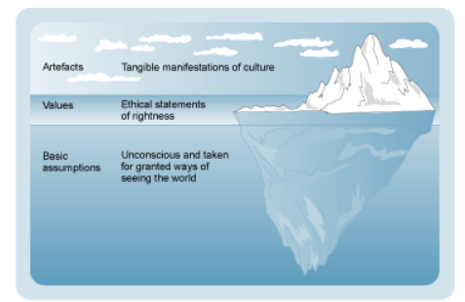
Figure 2. Shein’s iceberg model of culture.

Visible manifestations for IHG for example include the brand logos and colour schemes for Holiday Inn for example. At the water level and below would be IHG’s vision and mission statements. IHG’s mission statement reads “our purpose is to create Great Hotels Guests Love by providing true hospitality to everyone.” However, Lewis (1995) suggests that many organisations mission and vision statements may be full of “wishy washy generalities” that have no clear meaning or direction.
Management
Dam and Marcus (2007) describe the activities of management below:
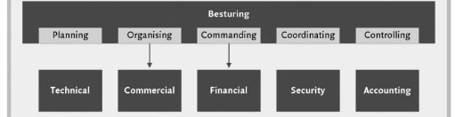
Fig 3. (Dam & Marcus 2007)
They explain planning as setting up the goals for the future; organising the structure, its people and other resources; commanding as leading the way to ensure full participation; coordination ensuring each activity works to achieve the overall goal; and controlling to make sure that the outcomes are as planned.

IHG’s Organisational Structure, Culture, and Goals:

Organisational Structures within IHG corporate and individual units

IHG’s strategic vision “focuses on value-creation by building preferred brands, delivering a superior owner proposition, strengthening our loyalty program, leveraging scale and generating revenue through the lowest-cost direct channels. Our targeted portfolio, together with disciplined execution of our strategy and a commitment to doing business responsibly, are designed to achieve industry-leading net rooms growth over the medium term (IHG Global Leadership 2024)
To achieve this at the corporate level, IHG Hotels' organizational structure is headed by an 11 member board of directors that is “responsible for ensuring leadership through effective oversight and review of the Group's activities (IHG Corporate Governance 2024a) With delegated authority from the Board, a 9 member Executive Committee headed by the Chief Executive Officer is responsible for the implementation of the operational decisions as determined by the Board (IHG Corporate Governance 2024b)

.
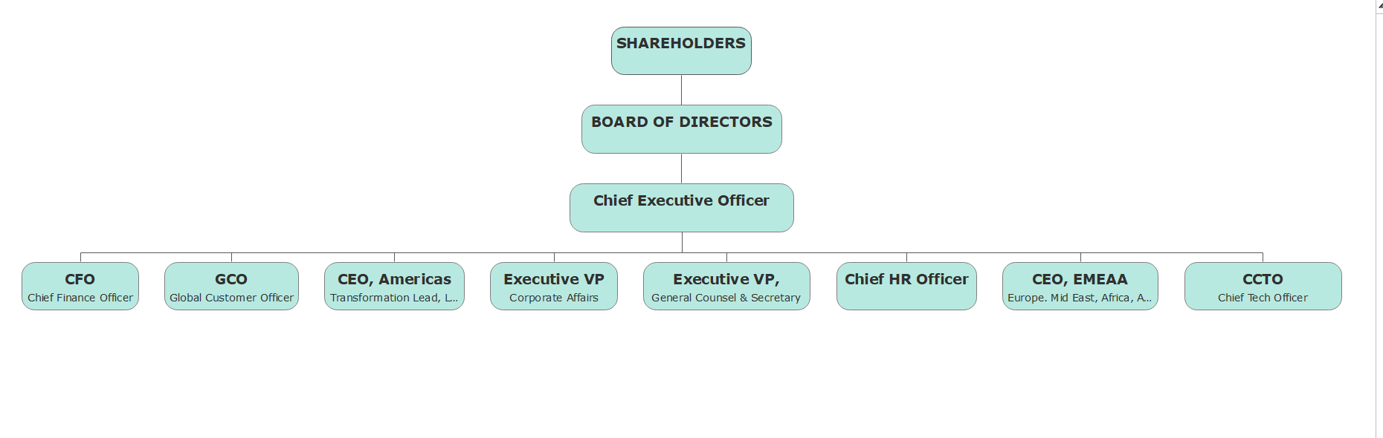
Fig 4. IHG Corporate Structure.
The above reflects a functional structure, characterized by centralized decision-making with division of work both by location and function.
Drawing upon theories of organizational structure, IHG's functional yet hierarchical model allows for efficient coordination and resource allocation, while also fostering flexibility and adaptability at the unit level. However, the challenge lies in maintaining a delicate balance between centralized control and local autonomy to ensure alignment with corporate goals while catering to diverse market demands and cultural nuances.
To overcome this challenge IHG operates by “predominantly franchis(e)ing our brands and manage hotels on behalf of third-party hotel owners.”
IHG strategy is to use their proficiency and extensive reach to craft outstanding guest encounters and generate owner profits essential for expanding brands in the industry's most lucrative markets and sectors. This is achieved by fostering a culture that nurtures and attracts top talent while seizing opportunities to make a positive difference in our surrounding world. (IHG Hotel Development 2024)

Corporate Culture
“Our culture sets the tone for how we do business and drives forward our purpose of providing True Hospitality for Good. (IHG Annual Report and Form 20-F 2022)”
The Group operates a Global Delegation of Authority Policy, which sets out financial commitment and expenditure approval controls.” IHG Annual Report and Form 20-F 2022b.
On the IHG LinkedIn (2024) page it describes itself as working “together as one team, and care enough to listen to ourselves, to others and to the world around us. It reflects a priority of caring for our people, our business and our community.” The advertising text for recruitment suggests a welcoming and supportive working environment. An employee testimonial echoes this stating:
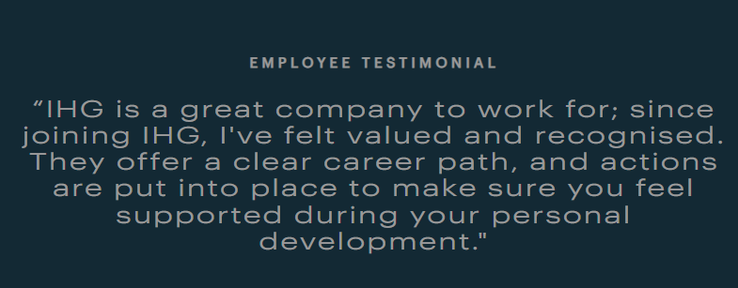
Figure 6 IHG Careers (2024)
However, the US Fortune 100 best places to work for index (2023), Hilton Hotels (ranked 2) and Marriott International (ranked 10) both outrank IHG. In fact, Hilton a direct competitor ranked 2nd on the global “Best Places to Work” list, the only hotel group in the top 25. This suggests that in direct head to head, Hilton would be more likely to attract top talent.

Individual Unit Level
At the individual level almost every hotel operates as a franchise and is managed by IHG on behalf of third party hotel owners IHG informs investors that “our asset-light business model means we do not employ colleagues in franchise hotels, nor do we control their day-to-day operations, policies or procedures (IHG Strategic Report 2022). This admission means that the individually franchised hotels may well have organisational cultures very different from that which is espoused by the strategic core.
However, to ensure that the individual franchises meet and exceed expectations of stakeholders, customers and employees, it is important that the individual units place emphasis on understanding cultural aspects of tolerance and hospitality, and yet understand the core vision of the strategic apex (Puciato and Plawiak 2019).

Goals

IHG describes its core mission, under its “True Hospitality for Good” tagline is to ensure that this permeates right across both the corporate and individual units and hope that this ethos will cut across all IHG brands. “Uniting them all is a commitment to deliver True Hospitality for Good in our hotels and communities all over the world (IHG About Us 2024).

Move to Sustainability

Jones and Comfort (2019) note that the tourism and hospitality industry has become more conscious of its ecological footprint and have suggested that the major hospitality companies are well positioned to contribute to the success of the United Nations Sustainable Development Goals (SDG’s). Emulating many of the leading hotel chains sustainability programmes, IHG launched its “Journey to Tomorrow” programme in 2021. Aligned to the SDG’s it is a 10 year plan that will focus on “people, communities, carbon & energy, waste and water”. Commitments to the success of this programme includes a 46% reduction in emissions, minimise food waste and eliminating single use items – however many of these appear too vague and immeasurable. Again, as a company dependent of the actions of independent unit operators, IHG is mindful that it can only “encourage IHG hotels to operate with respect for their surroundings, as well as participating in conservation initiatives to safeguard local flora and fauna, protecting and regenerating nature where possible (IHG Responsible Business 2024).”

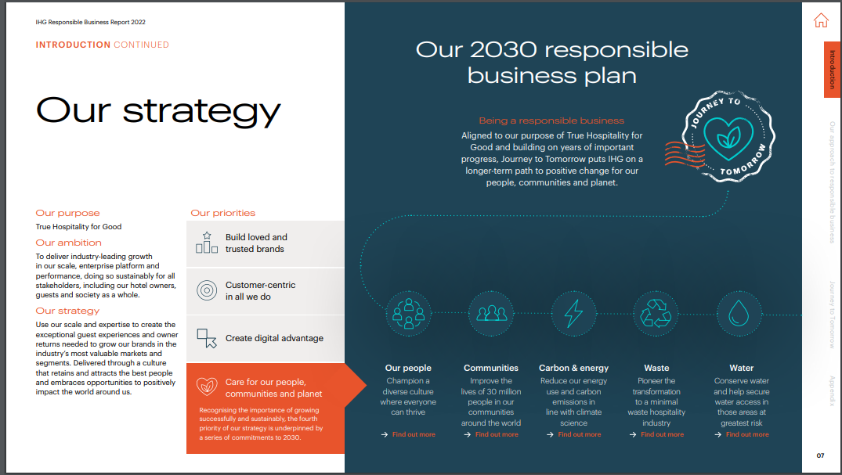
Figure 6. (IHG Responsible Business Report 2022)

Market Share

CSI Market.com reports IHG’s market share relative to its main competitors as at Q4 2022 at 5.06%, some way behind Marriott’s 31% the market leader. It is about 4% behind the Hyatt Hotels Corporations, its more direct competition.
Strategically, the group is moving towards expanding its luxury and lifestyle market segment, acquiring Six Senses, and Regent Hotels and Resorts among others (IHG Strengthens 2024)

Conclusion

In conclusion, the examination of International Hotel Group's (IHG) organizational management structure and practices provides insights into both the strengths and challenges faced by the prominent player in the global hospitality industry. The corporate-level analysis reveals a functional yet hierarchical structure, emphasizing centralized decision-making to align with overarching strategies. The delicate balance between centralized control and local autonomy poses a challenge, particularly in catering to diverse market demands. IHG's emphasis on franchising, global delegation of authority, and commitment to a positive corporate culture contributes to its operational efficiency and commitment to sustainable business practices.
However, the study also highlights areas for improvement. While IHG's commitment to sustainability is commendable, the specific commitments outlined in its "Journey to Tomorrow" program need more clarity and measurability. The comparison with competitors, such as Hilton and Marriott, in terms of being recognized as one of the best places to work indicates a potential need for enhancing the employee experience.
As IHG aims for industry-leading net rooms growth and market share expansion, it must continue fostering a culture of continuous improvement, ensuring alignment between its corporate goals and the diverse cultures of its individual units. The journey towards sustainability and market share growth requires a comprehensive and measurable approach, coupled with a focus on employee satisfaction to attract and retain top talent in a competitive industry.

REFERENCES:
- (Figure 1) ACCA Think Ahead Available at: https://www.accaglobal.com/gb/en/student/exam-support-resources/fundamentals-exams-study-resources/f1/technical-articles/mintzberg-theory.html#:~:text=in%20diagrammatic%20form.-,Strategic%20apex,are%20consistent%20with%20this%20mission. Accessed: 27th February 2024
- CSIMarket Company (2024) Available at: https://csimarket.com/stocks/competitionSEG2.php?code=IHG Accessed: 28th February 2024
- Dam, H; Marcus, J. 2019. Organisation and Management: An International Approach Available at: https://www.google.co.uk/books/edition/Organization_and_Management/5_S9DwAAQBAJ?hl=en&gbpv=1&dq=Organisational+Structure&printsec=frontcover Accessed: 26th February 2024
- Fortune 100 Best Companies to Work For 2023: Available at: https://www.greatplacetowork.com/best-companies-to-work-for Accessed: 28th February 2024
- Griseri Final Proof.pdf Available at: https://uk.sagepub.com/sites/default/files/upm-binaries/54404_Griseri_ch1.pdf Accessed: 19th February 2022
- IHG Hotels “About us” 2024 Available at: https://development.ihg.com/about-us#:~:text=IHG%20Hotels%20%26%20Resorts%20is%20a,in%20the%20world's%20best%20markets. Accessed: 29th February 2024
- IHG | Annual Report and Form 20-F (2022) Available at: https://www.ihgplc.com/~/media/Files/I/Ihg-Plc/investors/annual-report/strategic-report-ar2022.pdf Accessed: 24th February 2024
- IHG | Annual Report and Form 20-F (2022b) Available at: https://www.ihgplc.com/~/media/Files/I/Ihg-Plc/investors/annual-report/strategic-report-ar2022.pdf Accessed: 24th February 2024
- IHG Annual Report (2022) Available at: https://www.ihgplc.com/~/media/Files/I/Ihg-Plc/investors/annual-report/annual-report-2022.pdf Accessed 24th February 2022
- IHG Corporate Governance (2024) Available at: https://www.ihgplc.com/en/about-us/our-leadership/our-board Accessed: 25th February 2024
- IHG Corporate Governance (2024b) Available at: https://www.ihgplc.com/en/about-us/our-leadership/our-board Accessed: 25th February 2024
- IHG Hotel Development About Us (2024). Available at: https://development.ihg.com/about-us Accessed: 26th February 2024
- IHG “Legendary Global Leadership” 2024. Available at: https://ihgolm.my.site.com/s/amer-about#panel2 Accessed: 27th February 2024
- IHG LinkedIn Company Spotlights (2024) Available at: https://www.linkedin.com/company/ihghotels&resorts/life/c7ce2ab2-6be6-48fd-9a49-be6714c53bb1/ Accessed: 28th February 2024
- IHG Responsible Business (2022) Available at: https://www.ihgplc.com/~/media/Files/I/Ihg-Plc/investors/annual-report/ihg-responsible-business-report-2022.pdf Accessed: 24th February 2024
- IHG “Responsible Business” 2024. Available at: https://www.ihgplc.com/en/responsible-business Accessed: 28th February 2024
- IHG Strategic Report “Our business model” 2022. Available at: https://www.ihgplc.com/~/media/Files/I/Ihg-Plc/investors/annual-report/our-business-model-2022.pdf Accessed: 27th February 2024
- IHG Hotels & Resorts Strengthens Leading Position in the Luxury & Lifestyle Segment (2024) Available at: https://www.ihgplc.com/en/news-and-media/news-releases/2024/ihg-hotels-and-resorts-strengthens-leading-position-in-the-luxury-and-lifestyle-segment Accessed:28th February 2024.
- IHG “Who we are” (2024) Available at: https://careers.ihg.com/en/life-at-ihg/about-us/ Accessed: 28th February 2024.
- Jones, Peter and Comfort, Daphne (2019) Sustainable Development Goals and the World’s Leading Hotel Groups. Athens Journal of Tourism, 6 (1). pp. 1-14. doi:10.30958/ajt.6-1-1 Available at: https://eprints.glos.ac.uk/6401/1/6401%20Jones%20%282019%29%20Sustainable%20Development%20Goals%20and%20the.pdf Accessed: 28th February 2024.
- Lewis, B (1995) “If you know where you want to go, you may get there” Journal of Management in Engineering Volume 11, Issue 3 https://doi.org/10.1061/(ASCE)0742-597X(1995)11:3(24) Available at: https://ascelibrary.org/doi/abs/10.1061/%28ASCE%290742-597X%281995%2911%3A3%2824%29 Accessed: 29th February 2024
- Mintzberg, H (1989) Inside our strange world of organizations pg7. The Free Press Available at: https://books.google.co.uk/books?hl=en&lr=&id=9XOXVxN1GMsC&oi=fnd&pg=PR9&dq=types+of+organisations+mintzberg&ots=t-CXrmWK8F&sig=LLIYw_Gd4gFMr-3c5MvPpal-3oE&redir_esc=y#v=onepage&q=types%20of%20organisations%20mintzberg&f=false Accessed: 24th February 2024
- Schein, E.H., 2010. Organizational culture and leadership (Vol. 2). John Wiley & Sons. Available at: https://books.google.co.uk/books?hl=en&lr=&id=Mnres2PlFLMC&oi=fnd&pg=PR9&ots=oqbxFd0rPk&sig=BmohG00sbg1E7vPUjvsiitvfH_w&redir_esc=y#v=onepage&q&f=false Accessed: 26th February 2024

.

