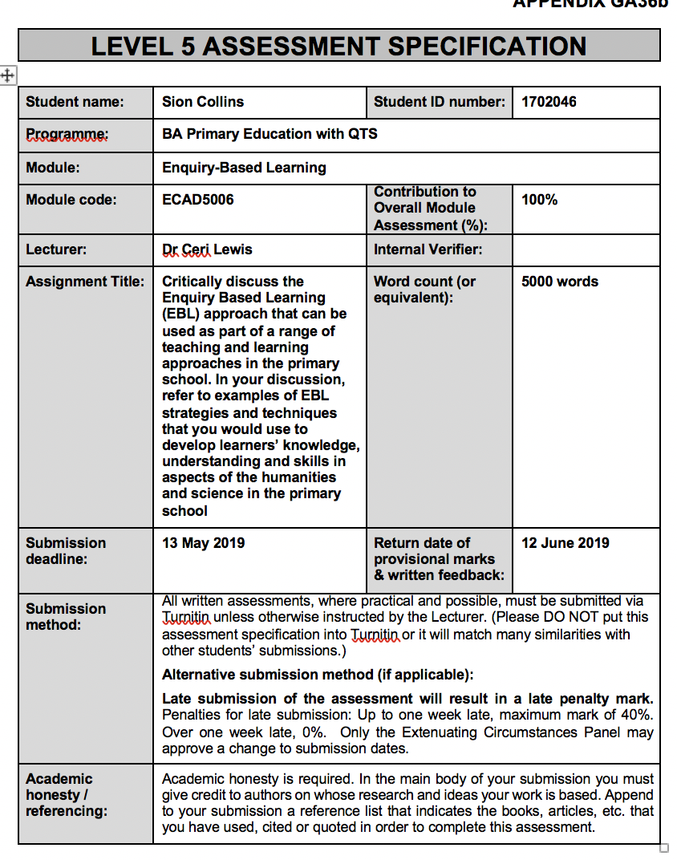

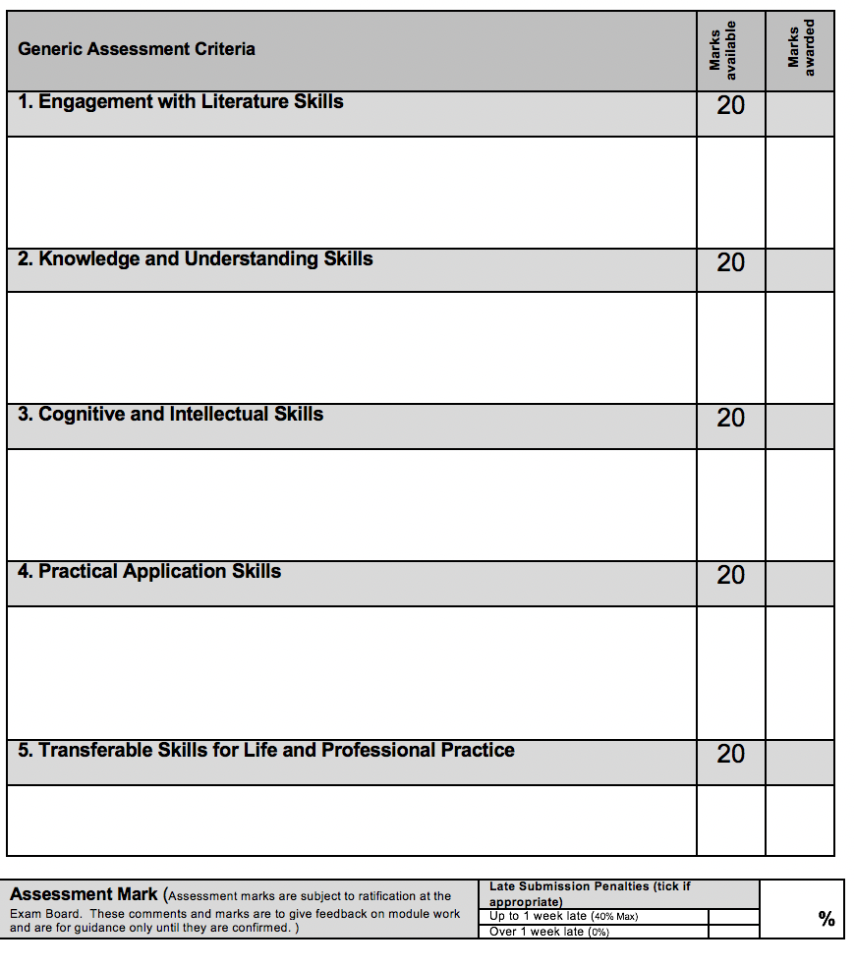

When you teach a child something, you take away forever his chance of discovering it for himself.
(Piaget, 1972)

The process of enquiry is what allows children to learn by themselves and not to be completely reliant on a teacher. Piaget believes that children would be at a disadvantage if they are not able to learn for themselves and they may never fully understand the concept if they are not able to piece this information together in their own way (Gopnik & Meltzoff, 1984). Children learn in many different ways and they should be able to learn in different ways to allow them to reach their full potential. This enquiry-based learning model first appeared in the 1960’s becoming known as ‘discovery learning’ (Wittrock, 1964; Taba, 1963).

Enquiry based learning is a style of learning that enables students to express themselves and is based on self-directed enquiry by the learner (Lodge, 2008). This is less reliant on the teacher and structured towards engaging the children and finding what areas of the subject that they are interested in learning about, thus the learning is driven by discovery and enquiry of the child themselves (Harlen, 2018; Krajcick et al, 1998). If a child is in control of their own learning and able to learn about subjects they are interested in, this will motivate them to do well and complete their work with less difficulty (Hutchings, 2007). It can also be argued that knowledge gained in this way is more readily retained because it has been acquired by experience and in relation to a real problem (CEEBL, 2010).

The teacher’s responsibility is more of an observer where they guide the class, they can motivate the children to think critically and question their understanding of a subject (Kahn & O’Rourke, 2005). The teachers are able to motivate the children to learn, encouraging them to answer questions and develop their understanding. The children are encouraged to ask questions to satisfy their own curiosity, which would benefit them as they are learning when taking part in this process (Vale, 2013; Zion & Sadeh, 2007). When the children are engaged they are able to develop problem solving skills and leadership skills which will benefit them in later life. The children are able to use their prior knowledge in this activity to guide them in their learning. The children are able to investigate an open question or a problem. Learning is pupil-centred, with an emphasis on independent/group work and use of library, web and other information resources (Guido, 2017; Zion & Sadeh, 2007).

Enquiry based learning also links to Bloom’s Taxonomy. Children are able to rise up through the Bloom’s Taxonomy Pyramid where the children will be able to develop new skills and become a better learner (Seaman, 2011; Armstrong, 2019). Enquiry based learning also has four principles which are used to form lessons which are successful (Guido, 2017). The first principle discusses learners and their central role in enquiry based learning practice. Often the teacher supports this central role with given instructions and allocation of resources organised to aid the learning. Principle two relates to information processing skills and activities that can improve the learning and development in these skills. Principle three discusses the teacher as a facilitator of the learning take place in the lesson and that there needs to be an effort to learn more about the students in the enquiry process. Principle four discusses the importance of developing the information processing skills and the understanding of the learning (Pappas, 2014; Guido, 2017). These different principles can be applied to suit different classrooms when necessary.

EBL is closely linked with some principles of pedagogy, Pedagogy is what makes for good teaching and it has become common practice for teachers to implement as many of the principles of pedagogical theory as possible into their sessions (Stephan, 2010). Elements of pedagogy do relate closely to EBL. Motivation is a key element of good pedagogy and this is related to EBL in that it allows for children to enjoy what they are doing by providing a stimulus for them to be excited about and want to research and learn more about. The direction of the activity is important as the aim of EBL is to allow for the children to lead their own enquiries based on their previous knowledge and their missing knowledge from a subject (Weston, 2013). This child led ethic also satisfies the ‘child-centredness’ aspect of pedagogical practice (Stephan, 2010).

Enquiry based learning is beneficial for the children’s learning, with an improvement of achievement and educational attainment (Chu, Loh & Chow, 2011; Hwang et al, 2011). Also improving children’s engagement as the learning is considered to be more enjoyable and relevant to the pupils, this encourages more enthusiasm, and the readiness to learn new and interesting things (Gibson & Chase, 2002). EBL also encourages learners to develop a different approach to learning where they have the freedom and the responsibility to complete the task or find the information that is needed (Hohmann, Weikart & Epstein, 1995). EBL also encourages working within a group where the children can develop new social skills, they may also be able to teach their peers and find new information (Fosnot & Perry, 1996), and enquiry-based learning environments are inclusive for other pupils with learning deficits Rapp, 2005). EBL helps the children and teachers to understand the learning process, which in turn helps to challenge the learner in particular areas (Kahn & O’Rourke, 2005). Dangerfield (2008) has described learning through enquiry as a “maturation process” as it promotes children to follow their own path and find things out for themselves instead of following the same path as their peers and the teacher. EBL is also beneficial to the teacher as it can allow for less preparation time and less challenge in behavioural problems as the children are engaged and there is less time spent sat down in a chair, which can be very beneficial for the learner by taking them out of their comfort zone (Luckie et al 2012; Kahn & O’Rourke, 2005).

Challenges of EBL could be that the children taking part in the session may dislike a certain subject and would therefore not participate at the same level that some other students would. This would then have a detrimental effect on that child’s learning as they would not be engaging with their own development (Oxford Learning, 2019). EBL cannot be used in all subjects which is difficult as the children might really enjoy this method of learning, but it may not be suitable to use in certain subjects due to the limited need for research or group work (Deignan, 2009). It is also more challenging for the teacher as it requires more planning, preparation and responsibility from the teacher as they would need to guide the children in the direction needed to learn and the point of help for the children if it is needed with questioning and answers (Crawford, 1999). Teachers could also be challenged by the need to encourage the children in good questioning skills which is needed for this method of learning (Hall, 2019; Barron & Hammond, 2008). These sessions also require more class time as there would have to be time to set out the enquiry for the children and time for them to gather their information and to process this. It would also be a challenge to teachers as the class may not be developing the specific subject related skills the teacher may have planned for and make this difficult when preparing for tests and other specific assessment for the children in the class (National Research Council, 2000; Deignan, 2009).

There are papers that rival the fact that teaching through enquiry and experiential learning does work and have a positive effect on students. The lack of instruction could have a negative effect on pupils (Kirschur, Sweller, Clark, 2006). The opposite of enquiry-based learning is the direct instruction which closely rivals this, supporters of this include Engelmann (1968), Rosenshine (2012). This is based upon that every pupil learns by instruction and the pupils who do not learn or develop have not been following instructions (Engelmann, 1980). Active learning is seen as the more fun and appealing to some students. The criticism is that the pupils could be seen to do what they want when they want to do it sort of approach and gain very little out of the experiences they are having (Weltman, 2008). Didau (2018) states that “The more lessons focus on inquiry-based methods the lower student attainment becomes.” John Hattie also disagrees with the idea of the teacher being the facilitator of learning in that the students are motivated and have the opportunity to discover and is concerned with the sharing of ideas with other pupils without corrective intervention (Terhart,2011).

EBL is linked to constructivist learning theory; constructivism (Schwab, 1970; Hein 1991) is a theory which is based on observation and scientific study, about how people learn (Schunk, 1996). It highlights that people construct their own understanding and knowledge of the world, through experiencing things and reflecting on those experiences (Hein, 1991; Bereiter, 1994). When we encounter something new, we have to reconcile it with our previous ideas and experience, changing what we believe, or discarding the new information as irrelevant. In all cases, we are active creators of our own knowledge. To do this, we must ask questions, explore, and assess what we know (Bada & Olusegun, 2015). In the classroom, the constructivist view of learning can point towards a number of different teaching practices. In the most general sense, it usually means encouraging students to use active techniques (experiments, real-world problem solving) to create more knowledge and then to reflect on and talk about what they are doing and h ow their understanding is changing (Bada & Olusegun, 2015). The teacher makes sure he/she understands the students' pre-existing conceptions and guides the activity to address them and then build on them (Oliver, 2000; Hein, 1991; Bada & Olusugen, 2015). Vygotskys (1962) work concentrated on this constructivist approach for early years education and applied these theories to learning practice for young children (Rieber 1998), increasing the opportunity to create ‘autonomous democratic agents’ instead of ‘compliant conformists’ (Hyslop-Margison & Strobel, 2007), building up agency in individuals that can be effective tools throughout the life course (Wandrei, 2001).
These theories and the practice of EBL enables children to learn by doing. Dewey’ (1998), Schwab’ (1970) and Bruner’ (1996) theories link in most similarly to EBL theory. Vygotsky’s theories (1962) tie in with the concept of social development and its importance for learning, also a theme in Dewey and Bruner’ work. Vygotsky puts more emphasis on the children working in groups or pairs where they can interact socially and learn collectively and individually from this. One of Vygotsky’s theories is the ‘zone of proximal development’ (Chaiklin, 2003). Vygotsky believes that children should learn socially with other peers from their class. EBL offers the chance for students to make experiences for themselves. It is said to benefit the learner and aid there learning in specific subjects. Due to the development in technology this has allowed for more enquiry via research through the internet. If children have access to the internet they are then able to ask more questions and find more information out for themselves rather than just the knowledge of the teacher. They are then able to find more information out for themselves and build up a greater knowledge of the subject (Kimmons, 2016), in a modern world building on these technological aspects of education can create autonomous, scientifically minded individuals, with the ability to identify research ideas and the tools to test these hypotheses.
children become engaged in many of the activities and thinking processes that scientists use to produce new knowledge
(Abdi, 2014)
EBL in humanities is an important opportunity for learning. It allows for ways which can motivate and inspire the children in a subject and help them to develop in their understanding the subject, with the opportunity for experience. (Grigg and Hughes, 2014). If the children have the opportunities to ask their own question this will aid their inquisitiveness. Having the opportunity to play the role of an historian or geographer, as example, enables them to find their own way of learning and discovering new things, and cementing the process of learning. There are models that could be followed to ensure the opportunities to engage with the learning in the “S’ Model which would be based on the local area. The 4-stage model which would concentrate closely on the investigation cycle. The 6-stage model framework which is used to move the learning along and to show progression. There are lots more models, but all of these allow for an opportunity to develop different skills and challenge different students. From questioning to an experiential learning, it allows for children to learn and develop differently (Hughes, S. Lecture notes, Session 3, UWTSD).
EBL is seen as vital in science, as both share the option of open enquiry (De Jong, 2006). Science encourages enquiry as the children would need to learn new and amazing things for themselves and using experiments to motivate them. Models for scientific enquiry are important and detailed an example is KWLAQ. This allows for students to interact with their prior knowledge and use that to establish where the students want to go next. This model allows for lots of questioning and encourages enthusiasm where at the end the students could ask new questions based on their knowledge they have acquired. There is also the generic enquiry model which is used in most scientific investigations. This would allow for students to plan their enquiry, perform the investigation for themselves and to reflect on what they have done. This then encourages the children to research and this further and develop their knowledge further. (Lewis,C. Lecture notes, Session 1-2, UWTSD)
In enquiry-based learning children are encouraged to become scientists, experiencing these amazing discoveries for themselves, instead of working in textbooks. Science educators encourage teachers to replace traditional teacher-centred instructional practices, such as emphasis on textbooks, lectures, and scientific facts, with enquiry-oriented approaches that (a) engage student interest in science, (b) provide opportunities for students to use appropriate laboratory techniques to collect evidence, (c) require students to solve problems using logic and evidence, (d) encourage students to conduct further study to develop more elaborate explanations, and (e) emphasize the importance of writing scientific explanations on the basis of evidence (Secker, 2002).
There are also 4 types of enquiry-based learning. The different areas would look to challenge students in different areas and develop different skills this would depend on the class and the different groups and ability of the children. These are confirmation enquiry were the students would be given an open question, its answer and the method of reaching the answer. This is designed to build enquiry skills and learning specific methods this would be best to adopt in a class where they are inexperienced in this particular method of learning. Structured enquiry is where the students would be given an open question and a way of investigating. They would then use these skills to research and find information to back up their enquiry and to conclude. Then there is guided enquiry where students would be given an open question. The class can then be split into groups where they will design methods to eventually reach a conclusion. Lastly there is the open enquiry were the class will be given time and guidance from the teacher. They will come up with their own questions and lines of enquiry by using their own methods, eventually reaching a conclusion where it they can present their findings.

In this assignment, rivers will be the topic for enquiry-based learning. In this enquiry the open enquiry will be used as it allows for the children to experience their own thinking and to answer their own questions. Guiding themselves to fulfilment and the enjoyment of learning about rivers through enquiry. The theme will be related to the 6 Stage framework model where there will be a focus on this geographical enquiry concerned with rivers.
Geography relates to the learning of humanities. By exploring rivers, it provides the children with an opportunity to engage with their natural environment where they can learn for themselves and ask relevant questions. This relates to the geography curriculum in that they have the opportunity to study “the physical world: the processes and landforms of coasts or rivers”. Rivers give plenty of opportunities to develop in many areas of the child’s development.
In the first stage of this model would be based on questioning. The pupils will have the opportunity to come up with many questions to answer their queries. These questions can lead onto many different subjects and develop lots of different skills. This would contribute to cross-curricular learning as it enables the class to ask any question that they wanted not only limiting them to geography but to whatever enquiry they wanted to make. Questioning is a skill that needs to be developed from the framework of KS2 in geography as the children will need to “observe and ask questions about a place, environment or a geographical issue” (Government, 2015). The first thing that would be done is a KWL grid, this will be given to each pupil. Each pupil will use this template to note down what they already know about rivers in the k column. In the W column they will write down most importantly what they would like to know. This will allow the teacher to be able to guide the learning of the pupils. The class can be split into groups who have similar enquiries to pursue where they can share their previous knowledge and gather research together. Another skill that could be developed when conducting this activity is allowing the children to “express their own opinions and be aware that people have different points of view about places, environments and geographical issues” (Government, 2015). This could include the children’s opinion on efficient supplies of electricity, could hydro power be placed in the river? In this area the teacher’s job would be of facilitator as they would firstly introduce the task and explain what was wanted and the children would then be left to work independently. The teacher would try to have as little impact with affecting the children’s line of questing as possible as it would be encouraged that they produced their questioning and line of enquiry. This would motivate them to develop their understanding of the topic and learn new things. The second area of this stage would then lead onto more questions which the children could identify as important to them and allow for curiosity in what they are learning, showing more understanding. This could be through a picture or a video showing a river which would encourage questioning (who, what, where, when and why) allowing the children to develop their prior knowledge and motivating and encouraging them to find out more and feed that hunger to learn more about the subject. This would link into an AFL strategy of questioning, where the teacher could very easily grasp where the students are in their learning and how much information they already know. With the KWL grid it also shows what the students want to learn in future lessons and the teacher could have an opportunity to guide the students down a certain path if needed to achieve certain outcomes for their key stage if needed. This can also relate closely to the S model which involves a lot of questioning (Hughes, S. Lecture Notes, session 3, UWTSD). This could be used to provides more guidance for the pupils to conduct their enquiries. In this the teacher may have more involvement as they are able come up with an open question to start the discussion. This will develop the use of oracy in the classroom as the children would “express issues and ideas clearly, using specialist vocabulary and examples” (Government, 2015).
In Stage 2 the children will be tasked with collecting and recording data. This could be done by going onto a trip to a local river. This could be where the class can conduct some fieldwork, “through fieldwork, the plants and animals found” (Government, 2015). When at the river, the class can be split up into groups where they are free to explore the river using different equipment to measure and record the data. An area of the river can be split up into different sections where the children can explore. This could give different findings and generate more knowledge and understanding. The children could have opportunities to measure the temperature, depth and gather other information. This relates closely to a geographical skill where the pupils would “measure, collect and record data through carrying out practical investigation and fieldwork, and using secondary sources, e.g. using instruments to measure rainfall” (Government, 2015). There could also be an opportunity to investigate the wildlife that live in and around the river. The children can use this time to try and answer some of their questions that were made previously and increasing their knowledge of the subject. They could make comparisons between other areas of the river, where they can demonstrate their understanding. The children would be gathering the data and information themselves without help from the teacher as they would be left to lead their own enquiry. The children could try to gather data to answer any of their questions and even form new questions and queries that they could research and then gather more knowledge on the subject. This trip could also have a benefit historically as there could be a harbour with a rich history, which could help inspire and motivate the children to learn. If this was a possibility the children could interview people from the local area with their views on a certain subject or even an expert on the subject if available.

The teacher would be able to oversee the learning of the children and if needed help them to use new equipment and help them with their vocabulary that was used and encourage more enquiry and questing of what the pupils were doing. The children could also be tasked with some activities when visiting the river, where the pupils could build a boat out of materials available to them. This boat could have a specific specification where it needs to float and travel for a certain amount of time. This would develop design and technology skills “to develop a simple specification for a product”, making skills “work to spec, choose appropriate materials, measure using tools, use a range of materials, making choices based on their knowledge” (Government, 2015). This could all have been discussed in previous lessons where the children would design their own boat out of many materials they had available to them this activity at the river would make this more challenging. There could be an opportunity to bring in some science skills to benefit the children in this area. This is a humanities project but to include cross-curricular learning which can allow for an element for science, another activity which could intrigue the leaner could be a water filtering activity. Using apparatus, the pupils could use water dipping apparatus in ascertain what lives in the shallow waters and eddy pools of the river allowing for the children to learn a new skill. This would help the pupils to develop scientific skills in that “using equipment and techniques required for the enquiry. Using apparatus and equipment correctly and safely, it also gives the children an opportunity for enquiry and to explore and predict wat they think will happen” (Government, 2015). This would be encouraged with a practical educational theory, the theory of learning by doing. This allows for the children to gather their own information and to learn to use the different equipment practically, problem solve and ask their peers for help. This could be very effective as some children are able to retain the information more clearly if they had found the information out for themselves. The children are participating in a concrete activity and in doing so helps them understand complex concepts.

In Stage 3 the children will would be processing the information that was gathered from the fieldwork. The children can then bring their recorded data back to the classroom where they would have the opportunity to formulate graphs and discuss their findings with others, this would relate to the maths skill of “representing data using-lists, tally charts, tables and diagrams” (Government, 2015). This could be done using ICT were the children could develop their skills and allow them to gain more knowledge of different types of graphs as they would be responsive with formulating and presenting these graphs. The children will be able to develop a wide range of skills. A skill where the children would need to “communicate findings in a variety of ways, e.g. using geographical terms, annotated photographs, maps, diagrams, or ICT” (Government, 2015). The pupils could also comment on their results as they could make suggests to why some results were like they were and how these could change over time. For example, the depth of the river and how this could change if there was rain the night before or the temperature of the water if the results were recorded in the summer or the winter. This would be the children showing their knowledge and understanding of their results and using what they have learn to explain challenges they may have faced and unpredicted results. This will help the pupils to develop their skills to “extract and interpret information from graphs” (Government,2015). The teacher’s involvement in this would be minimal. The teacher could look at made graphs and make suggestions and remind the children about what they had done previously when drawing graphs, which could improve the data when being presented (David, 2015). This gives them the opportunity to answer previous questions and develop ideas and new questions to research. This information can be gathered up into groups.

In Stage 4 the children will be drawing conclusions from the processed data. From their graphs and other evidence gathered they will be able to draw conclusions and try to answer the questions suggested. This would allow for the pupils to analyse their results and to question the work that they have done., this would have developed the skills to “extract and interpret information from the graphs” (Government,2015). The children will also be able to talk about the activities and tests they have performed. They can then evaluate these and discuss if they were to do these things again what would they do differently? And how this could affect their result?.

In Stage 5 the children will be sharing the learning and affective outcomes. The pupils will develop their “decision making skills about geographical issues by distinguishing fact and opinion and considering different arguments” (Government, 2015). In this stage the children will be able to present their finds in groups. Each group will have their findings from the fieldwork and the graphs from the previous stages. The class could either present their findings to their peers in front of their class or they could have one or two individuals or move around the groups sharing their ideas and their findings. This would allow the students to teacher their peers resulting in the spread of their knowledge and enthusiasm for that subject. There could also be a hot seating where the students could ask their peers questions and debate answers to these on the knowledge that had been acquired. Another task for the class would be to interview or question an expert in this field. This could be an interesting opportunity for the children to ask any remaining questions that they were not able to find a definite answer, enabling them to show their knowledge and understanding.

In Stage 6 the children will be evaluating their work and their enquiry. In this stage the pupils would be evaluating their work and choosing which were the weakest areas that they assessed. At the end of the topic the pupils would complete their KWL grids where they would fill out the L column and would discuss what new things they have learnt about the topic. Hopefully this column would then be far longer than the K column and all questions that were asked were answered and a greater knowledge and understanding of the topic would be gained (James, 2006; Klenowski, 1996).

To conclude the geographical enquiry would enable the opportunity for children to experience different methods of learning. Children who would learn more through doing would benefit from stage 2 where the children would be involved in their learning as they conducted experiments and collected data. There is an opportunity to work in groups in stage 3 when gathering the data and providing questions in stage 1. The pupils are also able to develop a wide range of skills due to the cross curricular approach. The children could have the opportunity if feasible to interview a local resident or expert on the subject if available which could be a real insight into the subject prompting curiosity and motivation.

Many models of teaching practice exist that incorporate the values and principles of constructivist learning theory and use the refinements of enquiry-based learning practice to stimulate and encourage self-learning in pupils. This stage of the educational process is a key area where these lifelong skills of curiosity and enquiry can be formulated and expanded upon. Cementing these skills helps to increase educational attainment and expand the learning capacity of young children, who also retain these skills in an applicable way for future educational life and beyond. Utilising these methods generates many interesting and sometimes cross-curricular opportunities, these become learning opportunities for the pupils and give a more rounded, valuable approach to education.

The methodology behind these practices is well researched and identifies where instilling these enquiry-based approaches can benefit pupils, teachers and the whole school. In terms of pupils there is an obvious individual benefit but also the chance to create unique multiple intelligences, where every individual in the classroom can play a pivotal role in their own, and other pupils learning. This approach leads to unique progressive idea making and plasticity of thinking in the pupils, formulating strong ideas of how to enquire and test things that they experience. This ties in nicely with many subject areas and allows for increased learning opportunities which are transferable throughout the rest of the education process, and into post educational life itself.

References

Piaget, J., (1972). Play and development: a symposium with contributions by Jean Piaget... Norton.

Weston, C. (2013). Five principles of pedagogy. [online] Ed Tech Now. Available at: https://edtechnow.net/2013/05/12/pedagogy/ [Accessed 18 Apr. 2019].

Rapp, W.H., (2005). Inquiry-based environments for the inclusion of students with exceptional learning needs. Remedial and Special Education, 26(5), pp.297-310.

Gibson, H.L. and Chase, C., 2002. Longitudinal impact of an inquiry‐based science program on middle school students' attitudes toward science. Science education, 86(5), pp.693-705.

Chu, S.K.W., Tse, S.K., Loh, E.K.Y. and Chow, K., 2011. Collaborative inquiry project-based learning: Effects on reading ability and interests. Library & Information Science Research, 33(3), pp.236-243.

Hwang, G.J., Wu, P.H., Zhuang, Y.Y. and Huang, Y.M., 2013. Effects of the inquiry-based mobile learning model on the cognitive load and learning achievement of students. Interactive learning environments, 21(4), pp.338-354.

Schwab, J. J. (1970) The Practical: A Language for Curriculum (Washington, DC: National Educational Association).

Hein, G., (1991). Constructivist learning theory. Institute for Inquiry. Available at:/http://www. exploratorium. edu/ifi/resources/constructivistlearning. htmlS.

Hyslop-Margison, E.J. and Strobel, J., (2007). Constructivism and education: Misunderstandings and pedagogical implications. The Teacher Educator, 43(1), pp.72-86.

Rieber, R.W., (1998). Development of thinking and formation of concepts in the adolescent. In The collected works of LS Vygotsky (pp. 29-81). Springer, Boston, MA.

Vygotsky, L.S., (1962). Thought and word.

Dewey, J. (1998). Experience and Education. The 60th. Anniversary Edition., Lecture Part. Kappa Delta Pi, International Honor Society in Education.

Bruner, J.S., (1996). The culture of education. Harvard University Press.

Chaiklin, S., (2003). The zone of proximal development in Vygotsky’s analysis of learning and instruction. Vygotsky’s educational theory in cultural context, 1, pp.39-64.

Grigg, R., Hughes, S., (2014). Teaching Primary Humanities. Routledge.

De Jong, T., (2006). Technological advances in inquiry learning. Science, 312(5773), pp.532-533.

Government, W. (2015). Learning Wales. [online] Learning.gov.wales. Available at: https://learning.gov.wales/resources/collections/key-stages-2-4?lang=en [Accessed 26 Apr. 2019].

David L, "Information Processing Theory," in Learning Theories, December 4, 2015, https://www.learning-theories.com/information-processing-theory.html.

Alberta Learning (2004). Inquiry-based Learning. [ebook] Edmonton, Alberta: Alberta Learning. Available at: http://www.learnalberta.ca/content/kes/pdf/or_ws_tea_inst_02_inqbased.pdf [Accessed 19 Apr. 2019].
Armstrong, P. (2019). Bloom’s Taxonomy. [online] Vanderbilt University. Available at: https://cft.vanderbilt.edu/guides-sub-pages/blooms-taxonomy/ [Accessed 6 May 2019].
Bada, S.O. and Olusegun, S., (2015). Constructivism learning theory: A paradigm for teaching and learning. Journal of Research & Method in Education, 5(6), pp.66-70.
Barron, B. and Darling-Hammond, L. (2008). Teaching for Meaningful Learning: A Review of Research on Inquiry-Based and Cooperative Learning. [ebook] Stanford University: John Wiley & Sons. Available at: https://files.eric.ed.gov/fulltext/ED539399.pdf [Accessed 16 Apr. 2019].
Casey, L., Bruce, B.C., Martin, A., Hallissy, M., Shiel, G., Reynolds, A., Brown, C. and Coffey, L., (2009). Digital literacy: New approaches to participation and inquiry learning to foster literacy skills among primary school children.
CEEBL (2010). What is Enquiry-Based Learning | Centre for Excellence in Enquiry-Based Learning (The University of Manchester). [online] Ceebl.manchester.ac.uk. Available at: http://www.ceebl.manchester.ac.uk/ebl/ [Accessed 6 Apr. 2019].
Craig, C.J., (2008). Joseph Schwab, self-study of teaching and teacher education practices proponent? A personal perspective. Teaching and Teacher Education, 24(8), pp.1993-2001.
Dostál, J. and Gregar, J., (2015). Inquiry-based instruction: Concept, essence, importance and contribution. Univerzita Palackého v Olomouci.
Gopnik, A. and Meltzoff, A.N., (1984). Semantic and cognitive development in 15-to 21-month-old children. Journal of child language, 11(3), pp.495-513.
Guido, M. (2017). Inquiry-Based Learning Definition, Benefits & Strategies. [online] Prodigy. Available at: https://www.prodigygame.com/blog/inquiry-based-learning-definition-benefits-strategies/ [Accessed 6 May 2019].
Harlen, W., (2018). The teaching of science in primary schools. David Fulton Publishers.
Heick, T. (2019). 4 Phases of Inquiry-Based Learning: A Guide For Teachers. [online] TeachThought. Available at: https://www.teachthought.com/pedagogy/4-phases-inquiry-based-learning-guide-teachers/ [Accessed 6 May 2019].
Herman, W.E. and Pinard, M.R., (2015). Critically Examining inquiry-based learning: John Dewey in theory, history, and practice. In Inquiry-Based Learning For Multidisciplinary Programs: A Conceptual and Practical Resource for Educators (pp. 43-62). Emerald Group Publishing Limited.
Hohmann, M., Weikart, D.P. and Epstein, A.S., (1995). Educating young children: Active learning practices for preschool and child care programs. Ypsilanti, MI: High/Scope Press.
Hutchings, W. (2007). Enquiry-based learning: definitions and rationale [Online]. http://www.campus.manchester.ac.uk/ceebl/resources/essays/hutchings2007_definin gebl.pdf [Accessed 18 April 2019].
Kahn, P. and O’Rourke, K., (2005). Understanding enquiry-based learning. Handbook of enquiry and problem based learning. Galway: CELT, pp.2005-2.
Kleeman, G. (2015). Inquiry-‐Based Learning in Geography. [ebook] Sydney: Macquarie University. Available at: https://www.gtansw.org.au/files/resources/2015/Inquiry-Based%20Learning.pdf [Accessed 6 Apr. 2019].
Krajcik, J., Blumenfeld, P., Marx, R. and Soloway, E., (1998). Instructional, curricular, and technological supports for inquiry in science classrooms.
Lazonder, A.W. and Harmsen, R., (2016). Meta-analysis of inquiry-based learning: Effects of guidance. Review of Educational Research, 86(3), pp.681-718.
Lee, C.D. and Smagorinsky, P. eds., (2000). Vygotskian perspectives on literacy research: Constructing meaning through collaborative inquiry. Cambridge University Press.
Lodge, C., (2008). Engaging student voice to improve pedagogy and learning: An exploration of examples of innovative pedagogical approaches for school improvement. International Journal of Pedagogies and Learning, 4(5), pp.4-19.
McCrory, A., (2017). Scientific enquiry and engaging primary-aged children in science lessons: reflections on provision for scientific enquiry in primary schools in England and Wales: Part 1. Journal of Emergent Science, 13.
Olson, D.R., (2014). Jerome Bruner: The cognitive revolution in educational theory. Bloomsbury Publishing.
Pappas, C. (2014). Instructional Design Models and Theories: Inquiry-based Learning Model - eLearning Industry. [online] eLearning Industry. Available at: https://elearningindustry.com/inquiry-based-learning-model [Accessed 20 Apr. 2019].
Roth, W. and Jornet, A. (2014), Toward a Theory of Experience. Sci. Ed., 98: 106-126. doi:10.1002/sce.21085
Schravemade, K. (2014). Piaget | Learning Through Inquiry. [online] Learningthroughinquiryblog.wordpress.com. Available at: https://learningthroughinquiryblog.wordpress.com/tag/piaget/ [Accessed 20 Apr. 2019].
Seaman, M., 2011. BLOOM'S TAXONOMY. Curriculum & Teaching Dialogue, 13.
Taba, H., (1963). Learning by discovery: Psychological and educational rationale. The Elementary School Journal, 63(6), pp.308-316.
Takaya, K., (2008). Jerome Bruner’s theory of education: From early Bruner to later Bruner. Interchange, 39(1), pp.1-19.
TeachThought. (2018). 4 Characteristics Of Critical Digital Pedagogy. [online] Available at: https://www.teachthought.com/the-future-of-learning/zombie-pedagogies-embodied-learning-digital-age/ [Accessed 6 Apr. 2019].
Twigg, V. V. (2010). Teachers’ practices, values and beliefs for successful inquiry-based teaching in the International Baccalaureate Primary Years Programme. Journal of Research in International Education, 9(1), 40–65. https://doi.org/10.1177/1475240909356947
Vale R. D. (2013). The value of asking questions. Molecular biology of the cell, 24(6), 680–682. doi:10.1091/mbc.E12-09-0660
Wagstaff, S., Brown, J., Claypool, M. and Fahlberg, B. (2019). Active Learning Models & Approaches. [online] Wisc.pb.unizin.org. Available at: https://wisc.pb.unizin.org/teachingwithtech/chapter/active-learning-models-approaches/ [Accessed 30 Apr. 2019].
Winterbottom, M. (2017). Cambridge Assessment International Education:Active learning. [ebook] Cambridge: UCLES. Available at: https://www.cambridgeinternational.org/Images/271174-active-learning.pdf [Accessed 18 Apr. 2019].
Wittrock, M.C., (1964). The learning by discovery hypothesis.
Zion, M.I. and Sadeh, I., (2007). Curiosity and open inquiry learning. Journal of Biological Education, 41(4), pp.162-169.

Fosnot, C.T. and Perry, R.S., (1996). Constructivism: A psychological theory of learning. Constructivism: Theory, perspectives, and practice, 2, pp.8-33.
http://faculty.arts.ubc.ca/emeyers/LIBR535/readings/Fosnot&Perry_2005.pdf

Luckie, D.B., Aubry, J.R., Marengo, B.J., Rivkin, A.M., Foos, L.A. and Maleszewski, J.J., (2012). Less teaching, more learning: 10-yr study supports increasing student learning through less coverage and more inquiry. Advances in physiology education, 36(4), pp.325-335.

Deignan, T., (2009). Enquiry-based learning: Perspectives on practice. Teaching in Higher Education, 14(1), pp.13-28.

Crawford, B.A., (1999). Is it realistic to expect a preservice teacher to create an inquiry-based classroom?. Journal of Science Teacher Education, 10(3), pp.175-194.

Hall, G. (2019). The Importance of Questioning. [online] Gary Hall. Available at: https://garyhall.org.uk/importance-of-questioning.html [Accessed 31 Apr. 2019].

National Research Council, (2000). Inquiry and the national science education standards: A guide for teaching and learning. National Academies Press.
Schunk, D.H., (1996). Learning theories. Printice Hall Inc., New Jersey, 53.

Abdi, A., (2014). The Effect of Inquiry-Based Learning Method on Students' Academic Achievement in Science Course. Universal journal of educational Research, 2(1), pp.37-41.

Secker, C.V., (2002). Effects of inquiry-based teacher practices on science excellence and equity. The Journal of Educational Research, 95(3), pp.151-160.

James, M., (2006). Assessment, teaching and theories of learning. Assessment and learning, 47, p.60.

Klenowski, V., (1996), September. Connecting assessment and learning. In British Educational Research Association annual conference, Lancaster University.

Stephen, C., 2010. Pedagogy: The silent partner in early years learning. Early Years, 30(1), pp.15-28.

Kirschner, P.A., Sweller, J. and Clark, R.E., 2006. Why minimal guidance during instruction does not work: An analysis of the failure of constructivist, discovery, problem-based, experiential, and inquiry-based teaching. Educational psychologist, 41(2), pp.75-86.

Engelmann, S., 1980. Direct instruction (Vol. 22). Educational Technology.

Weltman, D., 2008. A comparison of traditional and active learning methods: An empirical investigation utilizing a linear mixed model.

Didau, D. (2018). What's the best (and easiest) way to teach?. [online] David Didau. Available at: https://learningspy.co.uk/featured/back-to-group-work/ [Accessed 1 May 2019].

Terhart, E., 2011. Has John Hattie really found the holy grail of research on teaching? An extended review of Visible Learning. Journal of curriculum studies, 43(3), pp.425-438.

