Laura Jones
1701632
BA Graphic Design Year 2

Dissertation Proposal
Gender
Beauty
Branding

Louise Burston

Word Count: 2448

Three Key words:
Gender
Beauty
Branding

Three Images
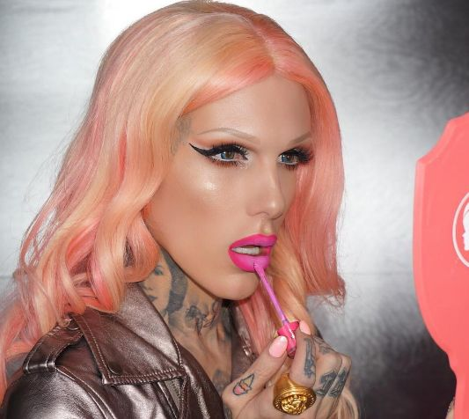
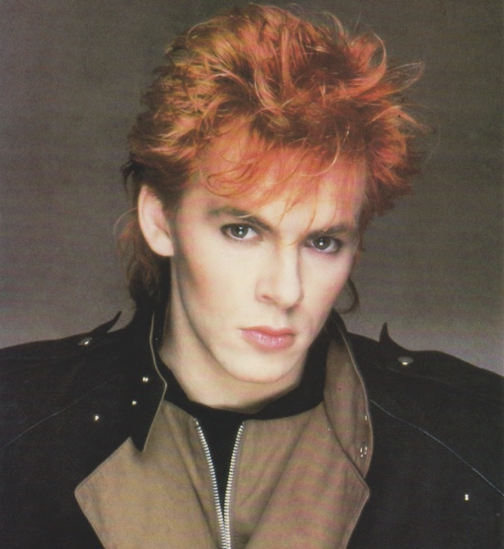
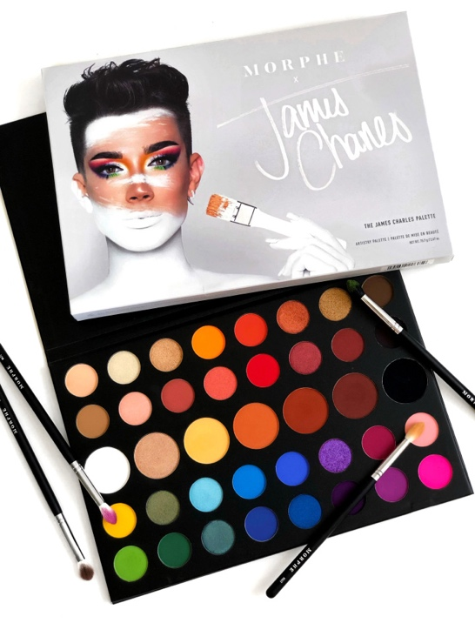

Introduction
There has always been a history of men wearing some type of cosmetics. However, I wish to explore the relationship between men and cosmetics over the last thirty years. I aim to examine the issue of gender; the reasons men wore cosmetics and the changes over the last thirty years. While delving into the question of beauty, and how cosmetics have been used to portray male beauty over the past thirty years. Finally, I will be looking at branding of male cosmetics, and how this has changed over time. How have men pushed their own brands into main stream society. Has gender neutral branding and social media been used successfully to accomplish this?

Gender
For thousands of years, makeup has been applied by men, for numerous different reasons. During the time period of 1650 men were found to be wearing cosmetics in a discreet manner. Men would often appreciate the idea of makeup but did not want to be made aware of its artificiality when applied to women. “men secretly appreciated the effects of makeup when applied well and discreetly” (2015) a statement made in the novel Face Paint: The Story of Makeup (2015). The average male at this time would appreciate the effects however would not choose to wear it to fit in with the societal normalities, if a male did wear cosmetics they were an aristocrat or part of the upper class, outside of those outliers it was frowned upon. Although it was worn by high society men, as time went on, society determined that the of hiding flaws through the use of artificial cosmetics, did not suit the notion of masculinity and as a result, ideologies surrounding cosmetics shifted centring around femininity.
The glam rock era in the 1980s was a famous time period for men in makeup. Bands such as ‘Duran Duran’ and ‘KISS’ would always wear makeup onstage. Below is an image of Nick Rhodes, the lead singer of one of the most famous heavy metal bands ‘Duran Duran’. Rhodes was one of the males to wear makeup in the glam rock culture, through his popularity, he began to normalise the use of cosmetics by men. Rhodes stated in an interview “What a lot of people don’t realise, is all men who are on television or stage (even newscasters) wear makeup. I believe it’s a tool to be utilized if you wish.” (www.thestolenleopard.wordpress.com)

Duran Duran, Nick Rhodes

This leads to the question of whether or not it is more acceptable for men to wear makeup now, or thirty years ago, when the glam rock era began. The era of glam rock became split into two sections for men in makeup, two groups who advocated the use of makeup, but in varying degrees and for contrasting statements, ‘the new romantics’ and ‘the glam rockers’. The new romantic men were wearing makeup to enhance their features, such as Nick Rhodes and Spandau Ballet, there was no question of gender but there was a link to questioning their sexuality, they were still viewed as male, but homosexual. Rhodes states, “We’ve been accused of creating metro sexuality,” (www.thestolenleopard.wordpress.com) After wearing makeup, himself and his band ‘Duran Duran’ were accused of creating a different sexuality called ‘metrosexual’, the idea that some males care about their appearance more than women.
The glam rock men would wear outrageous costumes and make up in relation to their rock and metal bands, and much like the new romantics, there was no question of their sexuality, but there was no question of their gender either. Men of the new romantic period were seen to be more androgynous.
This leads us to how men in makeup are perceived now. Most of the world’s most famous makeup artists are now males in makeup. The difference to wearing it now as oppose to the 1980s is that men wearing cosmetics are viewed as androgynous and their gender and sexuality are now directly linked to wearing makeup, whereas thirty years ago wearing makeup was more part of a culture and influenced by the music or fashion scene.

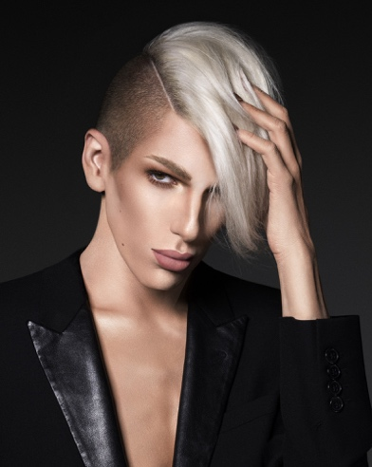
Makeup Artist Jeffree Star Is Launching His Own Metallic Liquid Lipsticks Line
www.glamour.com/story/jeffree-star-androgyny-palette

A famous makeup artist of our time is Jeffree Star, often harassed online and abused in real life for his love of makeup. In the images above Star is advertising his own make up brand, Jeffree Star Cosmetics. The photos are taken for campaigns for the company, in one he looks more female and in the other more masculine. He identifies himself as ‘androgynous’ meaning he can appear both male and female but is overall a male. He states in an interview with ‘Heavy’ “People see men in makeup and have so many different opinions” and then goes on to say “It’s being fearless and yourself. I feel like with the whole Internet era, people can be so judgmental and evil online. I think androgyny is a good example of being you, being completely fearless and really not letting anyone tell you what to do.” (www.heavy.com) This is an example of how men wearing cosmetics has changed, and that is now for everybody, not just women.
Gender has appeared to play a vital role within the world of cosmetics and men wearing makeup, it is interesting to see how people such as Jeffree Star are subjected to more homophobia or abuse than men were thirty years ago. This has a direct link to the prominence of social media today.

Beauty
This leads on to men and the notion of beauty, and how cosmetics have been used to portray male beauty over the past thirty years. It has been said within the publication ‘The Beauty Myth’ by Naomi Wolf that “young women and men too often feel that physical perfection is the gateway to acceptable sexuality.”(1991) From the beginning of time up until now there has always been a beauty standard set in place for both men and women, meeting an unrealistic and idealistic physical perfection within beauty has always been a contributing factor. More than often the physical perfection men are trying to achieve does not involve wearing or the use of cosmetics.
During the 1980s cosmetics were used to portray men in makeup, David Bowie has been said to of changed the way people see men and beauty at this time. Bowie is someone who went against the beauty normality of men not wearing makeup and was influenced by the music culture to use cosmetics. In an article with ‘Glamour ‘ Bowie advocates the use of makeup through a now renown photo, which highlights the beauty of being different. He was described as “someone who told us that weird was not only OK, it was beautiful.” An idol for changing the beauty of men, showing that beauty is being eccentric and different.

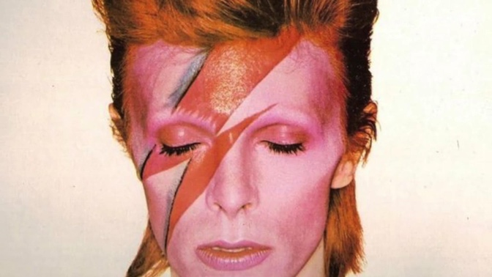
www.brooklynvegan.com/gdpr/consent/?redirect=/david-bowie-biopic-stardust-will-star-johnny-flynn/

Pierre La Roche (David Bowies makeup artist) began creating beautiful celestial makeup looks on Bowie, which had a resounding influence in the world of men and cosmetics. This is an example of how cosmetics were used to portray beauty within men wearing makeup. Wearing cosmetics was a way for Bowie to express his music and the culture that comes with this, it is stated by ‘Fashion’ that “his music is inseparable from his style statements.” (www.fashion.com). The men wearing makeup during this time period had connections to the music scene and culture, wanting to influence others to normalise wearing cosmetics, this is what beauty was within the 1980s.
The beauty standards for men now have changed within the past thirty years, and cosmetics are being used to show beauty in a different way. Today men wearing makeup has been labelled as the next trend to take over. The beauty industry has been due a long-awaited wakeup call and brands such as ‘Fenty Beauty’, ‘CoverGirl’, and ‘Illamasqua’ have taken over and have introduced men in makeup and advertising this as beautiful. The ‘Bodedit’ says “It is not just changing how we view beauty but, also how we view gender.” (www.bodedit.com). Men are now applying makeup to prove that it is for everyone, there no longer needs to be a cultural influence such as music. There is beauty in people expressing who they are through makeup, this is how men in cosmetics are being portrayed now.
Relating back to the question of, is it more acceptable for men to wear makeup now or thirty years ago, men are wearing makeup now to feel beautiful, but it often comes with a price of receiving homophobic backlash. During the time of Bowie wearing extravagant celestial makeup looks, he was viewed as a strange creature, a being who thrives to stand out. This was what beauty was during the 1980s. Although it was deemed to be more acceptable due to the cosmetics being related to the music culture, and it could be perceived that men like Bowie or Prince were wearing the makeup just as part of a character, not to set a new male beauty standard. Whereas now there is the added notion of gender lines being blurred, men wanting to appear androgynous and show that makeup is for everyone, but this is often confused with wanting to be the opposing gender, thus creating homophobic connotations surrounding the idea. It is said by David Yi, an editor-in-chief of the male beauty editorial ‘Very Good Light’, “It’s not being gender fluid, it’s being the better version of a man.” When asked about men taking over the beauty industry. Wanting to be feminine and part of the female gender is often a misconception men wearing makeup face in our present time.

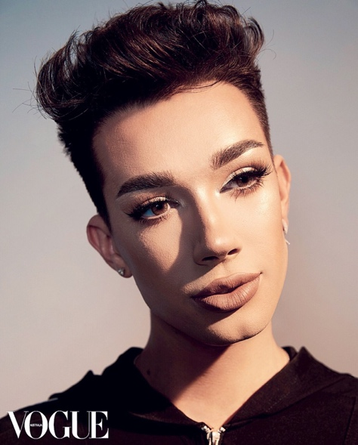
James Charles, VOGUE

Branding
This leads us onto the branding side of men wearing makeup and discussing if men have pushed their own brands into main stream society and if men wearing makeup is now used as a tool within advertising and campaigns to show the companies diversity and inclusivity. The now nicknamed ‘Beauty Boys’ are featuring within many campaigns and cosmetic brands to target other men; some men even owning their own cosmetic lines or are collaborating with other makeup brands. This is a significant change to thirty years ago, where no men were used to advertise cosmetics, it was only targeted towards women.

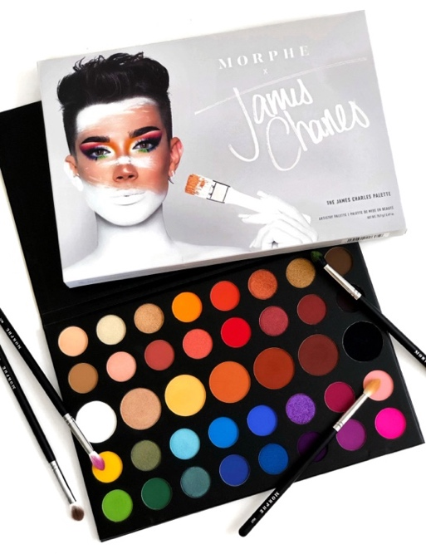
www.hercampus.com/school/u-iowa/james-charles-x-morphe-palette-it-worth-hype

A perfect example of how branding cosmetics have begun to be targeted towards men is James Charles’ makeup palette collection with the popular brand ‘Morphe’. James Charles is a twenty-year-old makeup artist who rose to fame in the cosmetic industry after the famous magazine ‘CoverGirl’ saw his Youtube videos and asked him to feature on the cover as the world’s first ‘CoverBoy’ for being a male wearing makeup. Since this magazine cover launched James Charles has become one of the most influential teenagers in the beauty industry with over 16.5 million people subscribed to his Youtube channel to watch his beauty videos and having up to 1.7 billion views on a video (www.youtube.com). This showcases how social media has a huge influence on the beauty industry and the perception people have of the male gender applying cosmetics.

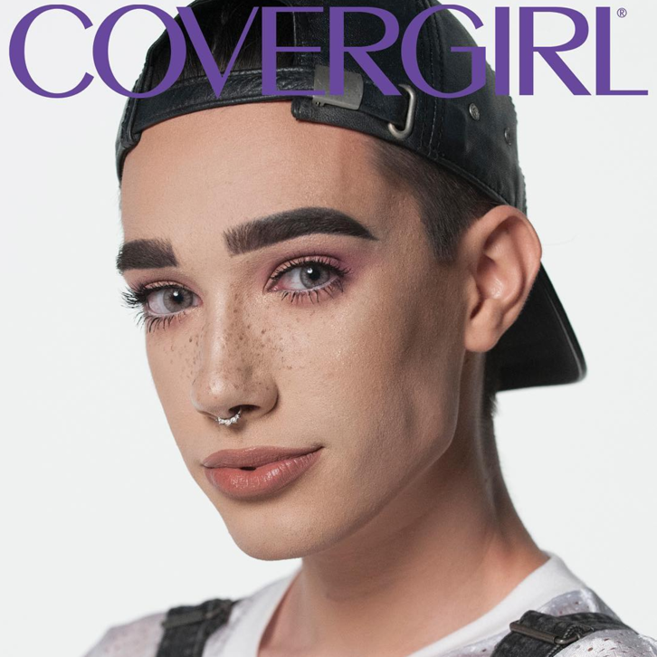
www.allure.com/story/covergirl-james-charles-controversy

Within the publication ‘Branded Beauty: How Marketing Changed the way that we Look” it is said that “Men are changing because the context in which they live their lives is changing.” (2011: 2017) This means that men are now living in a world where cosmetics are now being branded and accustomed to their gender as well as women, it is now becoming normalised that men can wear makeup. Brands such as Dior, Clarins, and Lancôme have all produced a line of cosmetics for men.
The notion of male figures being present in branding campaigns has begun to be prominent within today’s society. The latest example of this being Jeffree Star, who has previously been mentioned, releasing new concealers.

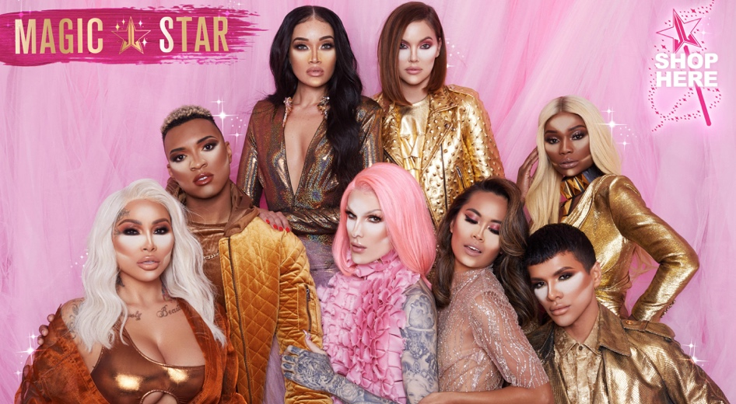
https://jeffreestarcosmetics.com

The campaign photographs released show a variety of skin tones, sexualities, and both genders. This is the way the beauty industry is shaping and forming to suit everyone and to break the barriers of gender and cosmetics. Star has even released a palette titled ‘Androgyny’ to showcase that his brand is catering to everyone.
Social media has had a huge influence on the branding of cosmetics and brands for men. People such as James Charles and Jeffree Star have built themselves as a brand, these men in cosmetics are a brand in themselves. Companies want to collaborate with them as due to the success they have had with the beauty industry and the impact they have had. Years ago, companies were not asking men to feature in their branding or campaigns, it was very much only catered towards women. Within in the publication ‘Branded Beauty: How Marketing Changed the way that we Look’ it is said that “Beauty companies have managed to globalize the male grooming trend” (2011:220) This statement shows that change has and is still happening within the beauty industry, and the idea of men wearing cosmetics is becoming normalised within today’s society. Relating back to the idea of social media having a huge impact on men within the beauty industry, whilst men in make-up are influencing others online this does subject them to a lot of homophobia and online hate.
Branding towards men in cosmetics is the direction the beauty industry is now progressing towards.

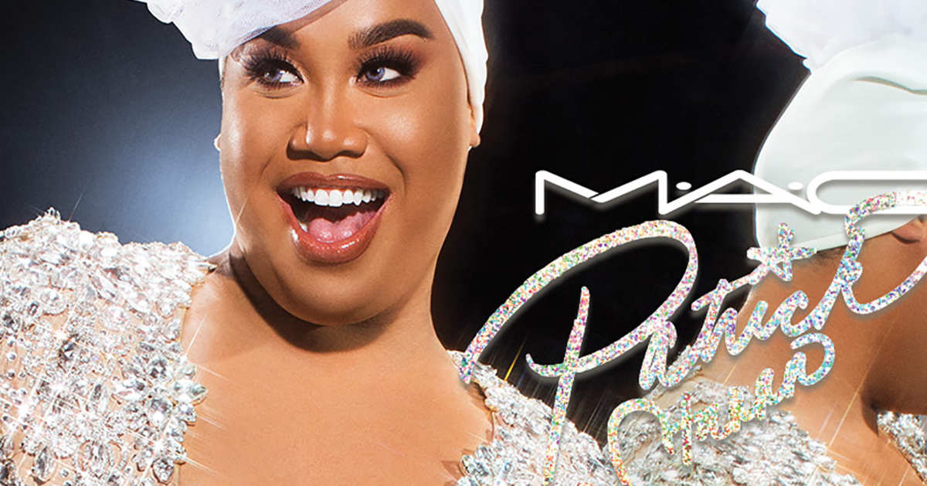
M.A.C x Patrick Starr. Photo: Courtesy of MAC

Patrick Star is an example of a popular beauty influencer used within MAC Cosmetics branding campaigns to target male consumers. As discussed previously Patrick Star is his own brand and has built himself up to have numerous companies hoping to collaborate with him to reach out to their consumers, thus allowing their brand to become all inclusive.

Contextualising my Question
All of the points that I have discussed within my proposal have led me to the idea of discussing men’s beauty and how it is being portrayed within branding and discussing whether or not it is normalised now or thirty years ago and how people’s attitudes have changed towards male beauty and cosmetics. I feel that the key words I have included cover all aspects of this topic appropriately. The images I have included show the different topics I have discussed and are a visual representation of how times are changing and how there are different beauty standards set for men now. With all of this taken into consideration I have concluded that I would like my question to include all of these topics. My question is: Have cosmetics become more acceptable for the male population to wear over the last twenty to thirty years? Have the reasons they wear makeup changed. How has this impacted the way cosmetics has been branded over the same period of time.

Bibliography

Eldridge, Lisa (2015) Face Paint: The Story of Makeup. Abrams Image, New York.

Nick Rhodes: World’s First Metrosexual?
The Stolen Leopard
https://thestolenleopard.wordpress.com/2012/12/07/nick-rhodes-worlds-first-metrosexual/
(no author or year published)
Accessed 17/04/19

Jeffree Star Identifies as Androgynous | Heavy.com
Heavy.com
https://heavy.com/entertainment/2017/08/is-jeffree-star-boy-or-girl-sex-transgender-gay-androgyny-drag-queen/
Effie Ofanides
Aug 15, 2017
Accessed 17/04/19

Wolf, Naomi (1991) The Beauty Myth. Vintage Books, London.

Condé Nast
How David Bowie Changed the Way We Look at Beauty
Glamour
https://www.glamour.com/story/how-david-bowie-changed-beauty
Accessed 20/04/19

A Look Back At All the Genius Ways David Bowie Transcended Beauty Norms
FASHION Magazine
https://fashionmagazine.com/beauty/david-bowie-beauty/
Kelly Dougher
January 8th 2018
20/04/19
Accessed 21/04/19

From Prince to David Bowie, 18 Iconic Men Who Made Makeup Look Good
Vogue
https://www.vogue.com/article/david-bowie-blackstar-famous-men-who-wore-makeup-elvis-mick-jagger
April 19, 2018
Accessed 21/04/19

Pretty Boy: The Rise of Male Beauty
The Bod Edit
https://thebodedit.com/style/male-beauty-trend-david-yi/
Accessed 25/04/19

Tungate, Mark. Branded Beauty: How Marketing Changed the Way We Look. CPI Group Ltd, Croydon.

