NAME: SHALOM JOSEPH
STUDENT ID: 2113608
DATE: 12/05/2022
COURSE: Engineering Mathematics and Structure
Within the world of civil engineering, structural engineers are tasked with the job of ensuring that the specific design requirements and wants made by the clients are met. More specifically, they assure, that the structure can safely support the intended loads and is cost-effective to construct and maintain.

There are many steps involved with structural engineering. Each of which are pivotal to the creation and protection of a building’s structure. These steps are:

Structural Scheming:

The decision to arrange columns, primary and secondary beams, and expansion and contraction joints in an economical and structurally efficient manner is decided during the structural scheming process.

Based on the architectural requirements, as well as the operational use of a building, the structural scheme is laid out. Normally, Architects must work along with structural engineers to bring designs to life with the appropriate conventions. In the case of structural engineering, The Eurocode standards provide common structural design rules for everyday use for the design of structures.
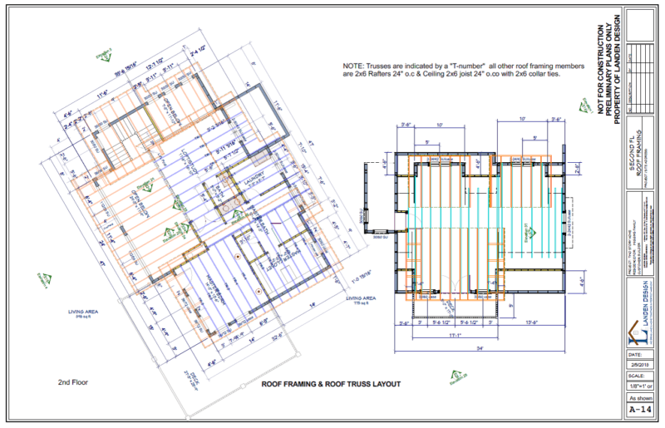

Loading Bearing:

In this step, the building’s or structure’s operational use is taken into consideration. Depending on said operational use, there will be different loads that may require different structural makeups and materials to support it.

Durability Design:

A structural engineer must consider the environment which the structure would be exposed to during the design process. This is important as it also has a direct influence on the material chosen to construct the project. Exposure conditions such as the wind, the ocean, the sun, etc. For instance, one may consider granite as a building material for a coastal home.



Structural Element Design:

This stage begins the design of individual structural elements such as beams, columns and slabs.

Structural Detailing:

Finally, details achieved by the previous stages are compiled within this stage and sent to site. This is the only drawing that is provided by the structural engineers.

Types of Loads:

Within Loading Schedule, one must be able to find dead load and live load. Dead Loads are constant loads resulting from the structure's weight or other fixed attachments, for example a wall attached to a floor. Whereas, Live loads are temporary loads that are applied to a structure on and off throughout its lifetime, for instance, persons entering and leaving a bathroom.

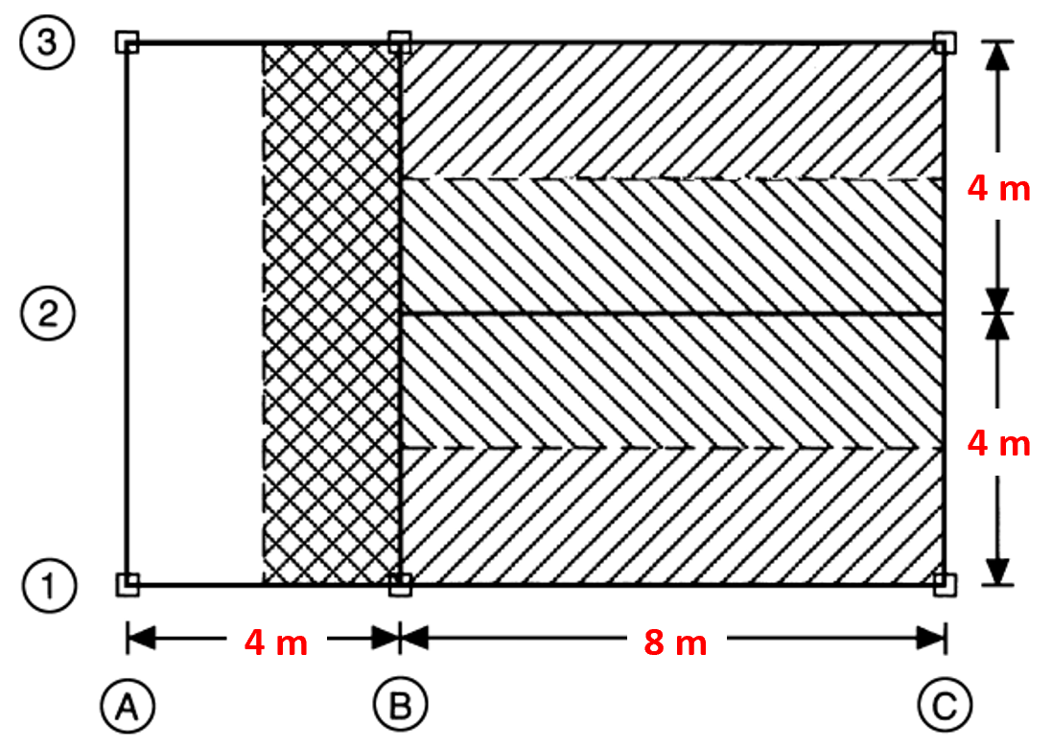
P1
P2

Loading on Slab

Dead load (Gk) = Self Weight (SW) + Total Weight of Finishes and Services
Self Weight (SW) = Density * Volume
SW = 24 KNm * 0.224 m = 5.4 kN/m²
Gk = 5.4 kN/m² + 1.2 kN/m² = 6.6 kN/m²

Imposed/Live Load (QK) = 4.5 kN/m²
Factor of Safety of Gk (FGk) = 1.4 kN/m²
Factor of Safety of Qk (FQk) = 1.6 kN/m²

Total Load = FGk * Gk + FQk * Qk
Total Load = 1.4 kN/m² * 6.6 kN/m² + 1.6 kN/m² * 4.5 kN/m²

Total Load = 16.44 kN/m²

P2
P1

Loading on Beam

SW = Unit Weight (75) = 75 * 10 = .75
Beam Ultimate Load = 1.4 * .75 + 1.6 * 4.5 = 8.25 kN/m²

Total Load on Beam B1 - C1 = (16.44 * 2) + 8.25 = 41.13 kN/m²
Total Load on Beam B2 - C2 = (16.44 * 2) * 2) + 8.25 = 74.01 kN/m²
Total Load on Beam B1 - B3 = (16.44 * 4) + 8.25 = 74.01 kN/m²

Loading on Column

SW = Unit Weight (50) = 50 * 10 = .5

Total Load on Column B1 =
Total Load on Column C1 =

P2
P1
Slab Design

