Effective Team Working and Communication
BMSW4002
Name of the student: Veselina Timeva
Student ID: 1917411
Lecturer Name: Akinseye Aluko

Executive Summary
Communication can take place privately as well as organization to achieve a goal. Communication simply transfers information or feelings between parties. There are at least three parts involved. They are- a sender, a message and a receiver. It helps organizations in many ways. It has a great influence on every day's life. With the help of good communication, system organizations can make a difficult job easier. Advanced technologies are used by almost every organization which makes the communication fruitful and faster.

Table of Contents
Introduction 4
Group dynamics theory 4
Teamwork theory 6
Interpersonal Communication Theory 8
Conclusion 11
Reference List 13

Introduction
Teamwork is an effort of a team or group to perform a job in an effective way. Communication is the most important nowadays. This is an age of information and the whole world is living like a global village. So people need to transfer information through an appropriate communication system. It may be on a personal level or organisation. It helps to achieve a goal in many ways. It also helps to improve teamwork. That is why organisations set up a good communication system so that all the departments are connected and can share that information without any obstacle. Some theories are going to be discussed here to understand the importance of communication deeply. Such as the group dynamic theory will say how communication conveys meaning from one group to another. Teamwork is also another essential part of communication which is also going to be discussed briefly. Besides, interpersonal communication theory presents how people exchange information face to face as it is one of the easiest ways.

Group dynamics theory
Tuckman's Theory
The most effective teamwork theory models was invented by Bruce Tuckman in the year of 1965. The original model of Tuckman's theory is reflecting with four forms of stages that the all of groups have passed through as they moved shifted from "newly formed" into "performance of high type" teams in the year of 1977. Then the innovator revised his model and included the fifth stage like adjourning, performing, norming. Storming, forming.
Forming: It is very vital for a manager of project to provide a proper direction and team’s structure. The project manager needs to define clearly the main objectives of a project and needs so that the members of team understand their responsibilities and roles. Then it will be helpful to lead the team as a manager of project to gain the ultimate success.
Storming: In this stage, some kind of skills can be helpful for a project manager. Because during any project the project manager can get challenges from any team member. The manager of project needs to handle those with some required skills like relationship building and active listening. It is also vital for a manager of project to be the more confident, assertive and positive mental attitude when any member of team is challenging the leadership of the manager of project.
Norming: When the conflicts are becoming less and the members of team are beginning to evaluate and they are accepting each other than that team can move into the norming stage. Then the team can concentrate more efficiently and effectively on the objectives and tasks of project. The project manager needs to direct the team members in the right directions. The constructive feedback and required good communication skills will help the manager of project to make that. The team-building process can be run with the help of some recognition and arranging social events for the team members by the project manager(Liu and Tsasis, 2017).
Performing: After the norming stage the team will become more efficient and effective to finish the project successfully. The team members can work with high energy levels with great performance. Then the project manager can focus on the leadership with effectiveness on the project.
Adjourning: As a manager of the project, it is very necessary to recognize the accomplishments of the team members. It will help to project closure with a note of positive. The team members will remember that programmers when they are on a new project.
Example: In our workplace, I have seen a project manager who was suffering some issues with his team members. Some of his team members challenged his leadership ability. Then, that project manager used some effective communication skills and also arranged some social events for his team members. After some days those team members were changed. They have started working with very efficiency. Then the project was done successfully before the time guideline. The relationship and bonding have become very strong between the manager and his team members(Robert, 2018).
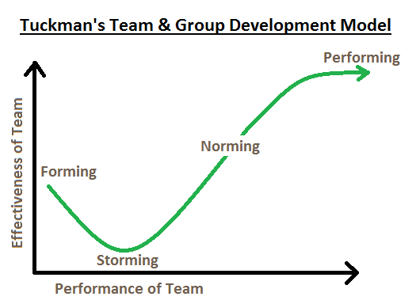
Figure 1: Tuckman’s Theory
Source : (Nawaz et al., 2016)

Belbin's Theory
Belbin suggested that by understanding an individual's role within a particular team that person can manage his or her weakness and strengths as a team member. So that it will be helpful to improve himself or herself by contribution. Be in a part of a team a person can learn from others and also from the managers. It will be more effective to change the weakness into a strength. It will also be helpful to improve communication skills.
Example: I have seen a person who was not a good performer. When he has put between a team after some time period he has become a great performer and he used to get help from his other team members (Saari et al., 2018).

Teamwork theory

MBTI Theory
MBTI stands for Myers Briggs Type Indicator. According to this theory module it is very important for a leader to have qualities such as expressive, sensible, thinking, judging, reserved, intuitive, friendly and probing. Acquiring or implying these qualities help a normal person to grow up as a leader with time. Expressing the capability of a person helps him in his communications. Being sensible is one of the most intellectual qualities a person can have. Thinking capacity of a person helps them to enlighten their mind with various thoughts. Judging capacity of a person helps to make conclusive statements about a situation. Also, it helps to decide who is right and who is wrong in a specific incident. Staying reserved helps a person to share the minimum information of their own. With this quality sometimes a person hides their drawbacks on various occasions. When it comes to intuitiveness, it actually indicates the truthfulness of a person from their gestures (Luciano et al., 2018). Friendly nature of a person helps them to go in the flow with a person and improves the bonding between people. Probing quality of a person distinguishes a person amongst others as their observation power is very keen.
For example, In our workplace, every employee of the company tries to acquire these qualities in various techniques and thus try to be leaders with these growing experiences opined by (Howe and Wig, 2017).
Maslow's Theory
Physiological Needs: Physiological needs are like the required basic needs of a human being to survive such as sleep, air, clothing shelter, water, food and many more. Being a manager he or she needs to provide comfortable conditions of working, reasonable working hours with necessary breaks to use a drink or eat and bathroom to the employees.
Social: Love and belongings are also called social needs and it is referring to the needs for a sense of acceptance and belonging. These social needs are very important for an employee that he or she never feels isolated, depressed and alone. Family, intimacy, friendship all are working to fulfil those social needs. As a manager, it is accountable that he or she needs to make sure that his or her team members must know each other well. A manager needs to encourage his or her employees with some kind behaviour like being accessible, cooperative teamwork and kind supervisory. It can promote a good work-life balance.
Safety: A company needs to provide its employees with well-being and some sense of security. Financial security, personal security, harm, accident protection, good health and they're adverse all are included with this safety needs. Being a manager he or she needs to provide a safe working atmosphere, job security, compensation. These are very important for any kind of company.
Esteem: Self-esteem, admiration and respect are included with esteem needs. In every workplace, each and every employee must need to respect each other. A manager also needs to respect his or her lower working employees and team members. A manager needs to offer recognition and praise that employees can get more motivation. Additional responsibility Offering promotion will make sure to believe an employee that he or she is important for the company(Nawaz et al., 2016).
Self-actualization: Self-actualization is a very important feeling for each and every person or an employee. It helps to describe an employee's needs to reach at a higher level with full potential. A parent who is also an employee needs to hold his or her position at the executive level so that he or she can give a better life to children.
Example: In my workplace, I had seen a man who was very effective with his work. But, after becoming a father he has become more effective and efficient with his working skills to fulfil the basic needs of a family(Lindberg et al., 2017).

Interpersonal Communication Theory
Interpersonal communication is a process by which the exchange of the information, meaningful thoughts and feelings take place in between the peoples through non-verbal and verbal messages. Interpersonal communication can also be stated as the face to face communication. Interpersonal communication majorly helps the individual within a workplace to create a good symbol of compactness and working efficiency under a mutual platform.
Conversation Theory
The theory of conversation is basically a theory of transdisciplinary learning. The theory was developed by Gordon Pask in 1975. The understanding of the psychological elements plays a major role in interpersonal communication. In better words, it can be described that the conversation theory highlights the factor of making meaningful context and understandable information no matter how intense and complex the topic may be(Hall and Davis, 2017).
In the working sector, there are often some of the major roles which are being allocated by the officials to the employees and those sometimes turn up as a complex topic. This is why the conversational theory has been developed which will help in breaking down every single point and will enable the employees or the individual in understanding the factor. The interaction or the conversation with the individual helps in overcoming the differences. This particular mechanism helps the employees in gaining motivation and enable the same level of understanding which can, therefore, be transferred to others in the working place if required.
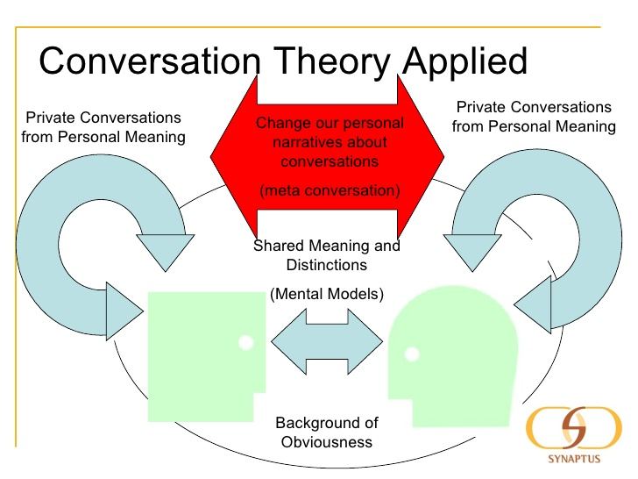
Figure 3: Conversation Theory
Source: (Hall and Davis, 2017)

Example: An illustration evaluated in a way that there are two individuals or students in a working place and the first individual starts a conversation with an element mouse. Since mouse has two different meanings thus a recognition is required. This is why the conversation is required so that clarification can be brought in between the correct view of the word mouse. When the first individual raises a question of clarification about exactly what the mouse is and how it looks and its purpose, the other individual pays close attention to the views and the discussion. If there is an issue regarding the views, then it can be discussed. Once it is done a complete understanding is created regarding the element mouse efficiently(Li et al., 2017).
Attachment Theory
The theory of attachment is the comprehensive theory of psychopathology, personality, motivation and development. In better words, the theory deals with the basic social and emotional factor. The theory also deals with emotional intimacy in the relationship.
The theory has been developed by John Bowly which basically focuses on the behavioural factor. The theory reflects the bond and attachment with an individual on others in order to maintain and satisfy the needs for the safety and comfort from dangers

Example: The theory of attachment can be illustrated with the help of an example which is that in a working place there are numerous factors present which put a stress factor in the mind of the employees and the workers. The stress factor can severely affect the organizational process as well as the employee's synchronization. So as a spectator the factor which has been noticed is that the management team within an organization makes contact with the employees emotionally and psychologically. This factor will help them in understanding their points where the issues are taking place. Thus the recognition will help in resolving and rectifying the problems in an efficient manner(Hatfield, 2018).
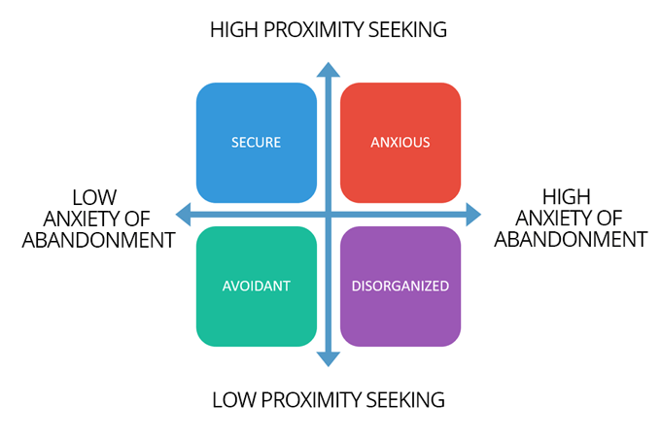
Figure 4: Attachment Theory
Source: (Hatfield, 2018)

Conclusion
Teamwork and communication connect various departments and people from top-level management to the root. The company makes relevant policies which need to inform everyone. There may be some circumstances where a company needs to make a quick decision. For that communication helps to perform a job in many ways. To make a good communication system Tuckman's theory is very popular which shows the reflection of communication in a team. Belbin's theory is also important. On the other hand, the interpersonal communication theory describes the face to face communication in the organizations as well as private level. For that, the theory includes conversation theory and attachment theory. Besides, Tuckman's group dynamic theory presents how a project manager defines a common goal and communicates it to a group of people. Finally, it can be said that nowadays people cannot think of a world without communication.

Reference List
Hall, J.A. and Davis, D.C., 2017. Proposing the communicate bond belong theory: Evolutionary intersections with episodic interpersonal communication. Communication Theory, 27(1), pp.21-47.
Hatfield, E.F., 2018. Narrative learning using podcasts in interpersonal communication. Communication Teacher, 32(4), pp.236-242.
Howe, L. and Wig, A.V., 2017. Metacognition via creative writing: dynamic theories of learning support habits of the mind in 21st century classrooms. Journal of Poetry Therapy, 30(3), pp.139-152.
Li, J.Y., Qiao, S., Harrison, S. and Li, X., 2017. Utilizing an interpersonal communication framework to understand information behaviors involved in HIV disclosure. International Journal of Information Management, 37(4), pp.250-256.
Lindberg, M.A., Fugett, A., Adkins, A. and Cook, K., 2017. Tests of theories of crime in female prisoners: Social bond and control, risk taking, and dynamic systems theories. International journal of offender therapy and comparative criminology, 61(3), pp.282-309.
Liu, G. and Tsasis, P., 2017. Scoping review of inter-professional teamwork theories in health care: Implications for policy, practice and research. Management in Healthcare, 2(1), pp.67-85.
Luciano, M.M., Mathieu, J.E., Park, S. and Tannenbaum, S.I., 2018. A fitting approach to construct and measurement alignment: The role of big data in advancing dynamic theories. Organizational Research Methods, 21(3), pp.592-632.
Nawaz, Z.A.K.D.A. and Khan_ PhD, I., 2016. Leadership theories and styles: A literature review. Leadership, 16(1), pp.1-7.
Robert, L., 2018. Motivational theory of human robot teamwork. Robert, LP (2018). Motivational Theory of Human Robot Teamwork, International Robotics & Automation Journal, 4(4), pp.248-251.
Saari, N.A.C., Jaafar, W.M. and Ahmad, N., 2018. Teamwork Process Among Amanah Ikhtiar Malaysia (AIM) Participants. Case Study in Hulu Langat District. Malaysian Journal of Social Sciences and Humanities (MJSSH), 3(4), pp.50-59.

