13/12/2017
DESIGNING WITH A CONCIOUS
HOW CONTEMPORARY DESIGNERS ARE ACTIVELY ENGAGED TO RESOLVE ISSUES OF OVERCONSUMPTION WITHIN THE FASHION AND TEXTILE INDUSTRY.
WORD COUNT: 5,938
SUPERVISOR: AINSLEY HILLARD
thainara leme ferreira (p146221)
ba surface pattern design

CONTENTS:
PAGE

LIST OF ILLUSTRATION 2
INTRODUCTION 3
CHAPTER 1 5
CHAPTER 2 12
CHAPTER 3 18
CONCLUSION 24
BIBLIOGRAPHY 26

LIST OF ILLUSTRATIONS
FIGURE: PAGE:
- Viktor and Rolf, 2008 Fall Ready-to-Wear, “NO”, LOOK 1 15
- Alexander McQueen, 2010, Spring/Summer, “Plato’s Atlantis” 16
- Yohji Yamamoto, 2017 Autumn Winter Haute Couture 17
- Yohji Yamamoto, 2017 Autumn Winter Haute Couture 17
- UNMADE, 2016 Unmade White Label, Calibration Sweaters 20
- UNMADE, 2016 Unmade White Label, Cut and Twist Scarves 20
- Margot Selby, one-off patchwork jacket 21
- Luisa Cevese – Riedizioni bag 22

INTRODUCTION

Fashion advertisement techniques in the 1920’s included using “social psychology for understanding and directing consumer behaviour” in order to encourage a wider group into buying products. By studying individual’s thoughts, feelings and behaviours companies were able to successfully convince society that by acquiring an item of clothing, one would experience happiness, pleasure and fulfilment in contrast to “personal failure and despair” (English, 2007, 27) This positive connotation linked to purchasing items led to an increase in consumerism where individuals are addicted to material consumption as a misleading way to reconstruct identity, build status and create new experiences. (Fletcher, 2008, 118) Undoubtedly, “over-consumption creates an ongoing cycle of appetite” as stated by Joy et all in 2012.
The term “conspicuous consumption” introduced to us by Veblen in 1899, successfully underlines the motivational role being able to display material wealth has played within society throughout the years. He argues such need to expose abundance through one’s wardrobe is a response to “status anxiety”. (English, 2007) The inability to fluidly move up the social ladder frustrates individuals who are then mistakenly persuaded that such goal can be achieved through material purchases. The notion that by following the latest trend and owning the newest fashion item will reward them with a higher position within the hierarchal system is a superficial one which has been imprinted into today’s consumers, resulting in fashion victims acquiring new items although these aren’t a necessity. (Fletcher, 2010) Consumption is no longer conscious and about fulfilling one’s emotional and psychological needs and is instead an addictive meaningless behaviour dictated by the mass-production driven fashion and textile industry. The same could be argued about design. Many designers have failed to stand strong against mass-production and are now passively designing without purpose. The importance behind the creative process of textile and fashion has been devalued and the complications generated by over consumption are simply disregarded by today’s designers.
This essay aims to identify some of the many negative impacts over consumption has had upon the fashion system including: increased levels of identity confusion amongst individuals; the loss of design craftsmanship and authenticity; the rise of disposable fashion and the environmental and social issues which have been so intensively ignored due to high demands within the fashion industry, they have almost been accepted as a normality. Chapter 2 and 3 will celebrate contemporary designer who take notice of the problematic issues raised by the industry and choose to actively engage and produce conscious designs through their practice striving to reduce consumption and/or bring back purpose to the industry. Whether it be by distancing themselves from the modern fashion demands or by incorporating sustainable methods to their creative process. (Fletcher, 2008)
As a young textile designer, I see myself as the future of the industry and I am therefore aware mass production and over consumerism have an unsatisfactory impact upon the textile and fashion industry. I hope this essay will further educate me on the issues therefore allowing me to more adequately address them and promote a more sustainable future for the industry through my practice.

CHAPTER 1

Over consumption within the textile and fashion industry has become a worrying issue today. As a society, we possess a greater amount of clothing articles than physically required to keep us protected and warm. In 1960, a person would buy 25 pieces of clothing a year, today that number has tripled. (Bedat, 2016) This could be explained by the fact we no longer shop for clothes simply because covering our bodies is something we must do, but because today, clothes are understood to reflect our character. In the book ‘Fashion Re-consumption, Kate Luckins (2010) argues that social consumption habits are an “attempt to reconcile an individual’s identity”. The purchases of clothes are now a reflection of one’s personality and individuality. In contemporary society, individuals shop to either express distinctiveness or to socially conform and fit into a desirable social group.
With the attempt to portray who we are through fashion, comes the “pressure to constantly re-formulate identity” (Fletcher, 2008, 117). New fashion trends are developed more times than society can cope in a year. With every new trend comes a new style thus triggering society to rush to stores and update their clothing collection without considering the negative impacts mass production and clothing waste has upon the environment. The false sense of satisfaction after every shopping trip stimulates the fashion and textile industry to keep on developing new tendencies therefore resulting on a vicious cycle of failed attempts to establish individual identities. (Fletcher,2008)
The rise of fast-fashion chains due to increased production speed and cheaper labour has resulted in more affordable items and a dissatisfactory homogeneity within the fashion industry. Fast- fashion is a phenomenon introduced to the industry around 1990 as stated by Miguel Angel Gardetti. It refers to the “fast production of cheaper versions of clothes produced by fashion houses” (Collins Dictionary, 2016) with the aim of mimicking current fashion trends through the exploitation of labour and low-quality materials. Prior to the introduction of fast-fashion, there were two main fashion seasons: Spring/Summer and Autumn/Winter in comparison to todays 52 micro seasons early (Whitehead, 2014).
Mass production resulted in consumers being offered limited style choices as copious amounts of same or similar items are quickly manufactured and released into the high street. (Luckins, 2010, 8) An individual’s cravings for individual style are unsatisfied thus increasing over consumption as he/she seeks to somehow stand out in a society where style has been standardised. For years fashion has been used a way to express one’s singularity. Historically it has witnessed the rise of many sub cultures including the Skins and Punks in the 70s who expressed their values and identities through wearing armbands, studs, zips and ripped T-shirts, all which went against the fashion norm of the time (Forte, 2017). In this context, mass-production and over consumption within the industry today has led to a level of confusion in relation to generating identities. We still attempt to express who we are through what we wear however it has become difficult to showcase originality when, so many replicates of the same item are produced and made available at such low prices through fast-chain stores such as Topshop, H&M and Zara.
With the normalisation of trends coming out with more frequency, the fast fashion chains will aim to push costumers into buying more than they need in a short space of time therefore maximizing profit. (Whitehead, 2014) The fashion industry is now more concerned with its economic growth other its original artistic aim of being expressive and creating exciting original garments for the public. Vivienne Westwood goes as far as stating consumption is not a “real choice” as society is being trained to be consumers other than fully engaging with the world. (Westwood, 2014) According to Westwood, the meaning behind shopping has been lost and it’s now a mechanical behaviour with a sole purpose of fitting in with the times. Veblen (1899) on the other hand, has a contrasting opinion stating individuals are aware of such pronounced behaviour. He uses the term “conspicuous consumption” to present his accountable argument that one’s consumer acts are visible and distinguishable today. Therefore suggesting, such behaviour doesn’t go unnoticed by the consumer and that the act of purchasing is, in contrary to what Westwood claims, a conscious independent choice. (English, 2013)
For many, the increase in mass consumerism reflects the constant bombarding of advertisements towards contemporary society. Controlling mechanisms such as broadcast media (television and radio) and print media (magazines and newspapers) as well as adverts all over social medias online seduces consumers into making purchases they wouldn’t have otherwise. It also leads less fortunate individuals into buying cheap fakes and knock off goods with the illusion of gaining social capital. (English, 2013) The media promotes “retail therapy and leisure consumption” amongst individuals. The word therapy would suggest physiological issues would be resolved through purchases however this is imprecise. Society is aware true long-term happiness and satisfaction is not achievable through consumption however this is not reflected through mainstream behaviour. Instead individuals are more like soldiers unconsciously following orders in the modern economic fashion battle. (Johansson, 2010) Undoubtedly purchasing mass-produced counterfeit goods generates an obstacle for designers within the fashion and textile industry as it devalues their genuine pieces, decreases their sale as well as creating friction between the designer, wearer and the modern fashion industry.
The new fast-fashion system has not only devalued the way society sees and experiences fashion, but it has also negatively impacted the crucial creative process behind a designer’s collection. Fast chain stores will launch their version of designers’ looks on the high street before pieces from the Ready to Wear catwalks arrive at their stores. Retailer stores such as H&M and Zara changed their strategies towards fashion adoption from the fashion catwalk and are now able to successfully introduce low cost interpretation of designer’s garments to the stores within roughly 3 weeks. (Gardetti. 2013) Suzy Menkes (2017) states haute couture is no longer a “one-to-one with wealthy clients” and is now just a “laboratory of ideas” where fast chain brands, smaller design houses and studios reach out to for inspiration. By doing so, low-quality replicates of outfits modelled down the catwalk, find their way into high street stores and online websites before designers have the chance to launch their original collections in stores. (Menkes, 2017)
Fast fashion retailers aim to reduce lead time and release new collection as soon as new trends are developed sometimes even adding weekly collections in between seasons thus keeping consumers eager to obtain new clothing items frequently. (Pookulangara and Shepard, 2013, 202) Subsequently, designers find themselves in competition with fast fashion adding pressure and a sense of constraint when it comes to being creative and taking risks. Countless identical articles of clothing are produced and released onto the market through mass-production methods devaluing the innovative creative work by the rightful designer.
It is also worth mentioning trend forecasting as it has always been important within the fashion industry and how it has experienced a noticeable transition in recent years. Whereas designers once held the power to dictate trends, designers now listen to consumer demands highlighted through seasonal trends when considering what to design. (English, 2007, 2002) The issue faced by designers here is that in order to stand out and obtain success, designers have to resist trends and provide the industry with innovative pieces of exquisite tailoring. This adds to the creative limitation faced by ready-to-wear designers as they risk failure by going against what’s labelled as the next big thing within the clothing sector other than fighting for originality. Tom Ford stated in 2001 that “if a collection didn’t sell, you were fired the next day”. A shocking realisation that the modern fashion industry is predominantly concerned with profit other than show casting design creativity.
Additionally, in an article published by Dazed Digital earlier this year, designer Yohji Yamamoto states “fast-fashion has replaced craftsmanship”. In his eyes, the high demands fabricated by fast fashion dependent consumerists allows no time for hand crafted techniques such as hand dying and hand loom-weaving to be applied to products and attention to detail is no longer crucial. (Reich, 2004) “The same happens to good quality, carefully designed embroidery” states Lily Reich (2004). The fashion industry has placed its focus on how quickly an item can be produced and replicated other than how authentic it is therefore resulting in “the appeal of a little lace (…) in a good design (being) lost in a few weeks as a result of thousand new mechanical lace designs”. (Reich, 2004, 152) Items made available by the fast-fashion industry are produced at such fast rate it results in fashion appearance being standardized. They are no longer distinctive and memorable, and have become commodities. The meaning behind the design and the purpose for designing fashion have been buried under over consumerism and by doing so individuals have been “accumulating useless things” resulting in “the very sense of beauty” being “dulled”. (Mackail,1970) Fashion today has no style, “it is just fashion”. What once defined tasteful fashion – fine finishing techniques such as embellishments and well-considered hand sewing - has now been disregarded due to the predominance of conventional mass-produced clothing and futile consumption. (Reich, 2004, 152)
The fashion and textiles industry are losing their essence as a negative impact of mass production; fashion is no longer treasured and is now simply disposable. Geofrey B. Small states last year, in the UK, “people threw away over two million tonnes of fast-fashion clothing that was worn an average of just six-times”. (Brown, 2010) This could be due to the fact mass-production has resulted in a drop of clothing prices therefore allowing individuals to buy bigger quantities more often. With the rise of fast fashion and the introduction of online shopping, consumers can replace clothing items with such easy and comfort, there is almost no reason not to. Fast production methods rely on producing items from cheap petrochemical synthetic fabrics such as polyester and acrylic which aren’t biodegradable. According to Bédat (2014), every piece of polyester clothing is still on the planet polluting the environment and slowly destroying the world. An issue which must be dealt with.
Kate Fletcher (2008) makes an interesting statement where she claims fashion and clothing as two distinctive terms. She states clothes are purchased in response to a human’s physiological need, as in a jacket to keep one warm, whereas fashion is merely symbolic. We indulge in over material consumption to manifest individuality or to show we belong as previously discussed. In this sense, it could be argued individuals don’t dispose of fashion items based on their short durability due to low quality, but because these items have lost context and no longer communicate what it is desired of them. (Black, 2012, 216) However, Kate Luckins (2010) states these cheap garments are not constructed to last and instead are designed to deteriorate at a fast rate therefore increasing consumption rate as consumers will dispose of damaged goods and purchase replacements.
Consumerism and mass production have not only added to the waste being produced but they have also resulted in the exploitation of resources; increase of chemicals being released onto our atmosphere, land and water as well as ethical issues linked to workers. Bédat (2014) states the textile and fashion industry is one of the largest in the world and is also the second greatest pollutant to our water due to 90% of dying chemicals being released into our fresh sources. According to Kruse (2013) textile factories located in Bangladesh alone are responsible for realising 56 billion litres of contaminated untreated water directly into rivers. It is estimated 8000 litres of water is needed to produce 1 kg of cotton. (Fletcher, 2008, 7) And although a small 2.5 per cent of the planet’s farming land is used for growing cotton, it accounts for a quarter of the global pesticide market and is the second most polluting crop. (Colchester, 2009, 23) At this rate, with the exponential growth of the fast fashion industry, the pollution levels will worsen leading to further ecological disaster. These are hard facts available to all however society is simply too blinded by the market and consumption to realise with every meaningless purchase our planet dies a little more.
Lastly, the ethical issues evident in the fast fashion industry should also be addressed. The clothing is one of the largest in the world and according to Roots (2008) it employs over 26.5 million people worldwide. On the surface this has a positive contribution to many developing countries however, the sad truth is that many of those who work in the industry do not receive living wages. In fact, Small (2010) states the average factory-worker producing well establish sport shoes earns on average £36 a month. (Brown, 2010) That is just over a pound a day for a full day of work. This sad reality reflects the bargains our society finds in clothing stores as workers in less developed countries are exploited and unfairly treated. Not to mention some of the poor working conditions and health and safety issues staining the industry as it fails to address the root of the problem relating to workers’ rights (Black, 2012, 140). The Clean Clothes Campaign reported emergency exists being blocked and fire extinguishing equipment missing during a factory fire in Bangladesh in 2010. (Black, 2012) This is just a short list of ethical issues which are a direct effect of fashion and textile mass-consumption and a greed for economic growth. Issues which should be recognised by the creative industry and addressed by contemporary designers and consumers in order to stop the social and ecological impairment caused upon society by fashion and textiles.

CHAPTER 2

As discussed problems within the supply chain: worker exploitation, low wages, as well as chemical and waste pollution to the environment during the processing of textiles make this a highly unsustainable industry. (Johansson, 2010, 4) The Brundtland Report defines sustainability as “finding a way to meet the current needs of all people today without compromising the needs of generations to come”. (Lucking, 2010, 9) This means considering the over exploitation of our planet resources – which are becoming very scarce, as well as the damage to the planet created by waste production – and addressing them correctly through more conscious and sustainable ways of providing clothing and fashion to society.
Fashion trends themselves have confused sustainability issues and promoted misconception today. A key example here is the Eco Chic early 90’s trend of garments advertised as being environmentally friendly which consisted of no more than “natural looking colours and fibres” (Fletcher, 2008) and did not deal with the problematic production of textiles overall. In fact, Fletcher (2008) argues it only served as an illusion to what was misunderstood to have been addressing sustainability problems. To diminish the harmful effects caused by societies usage of textiles, we must incorporate sustainability into the industry other than continue superficially addressing the complications.
Although the contemporary fashion industry has forced many designers to conform to its fast-developing pace (as mentioned in chapter one), there are many who have instead opted to set themselves apart and focus on creating mindful collections with the aim of addressing contemporary problems with in the fashion industry. In an article published by Scarlett Kilcooley-O’Halloran for Vogue online in 2015, Viktor Horsing and Rolf Snoeren (founders of Viktor and Rolf fashion house) announced they would be leaving the Ready-to-Wear fashion sector with plans to focus on their Haute Couture lines. According to the eccentric duo, the decision reflected their frustration towards the reformulated industry which was essentially anchoring them down. For them it “started to feel creatively restricting” and they concluded by letting go of it they would regain their freedom to communicate and express themselves creatively through high fashion which imposes less boundaries. (Zachary, 2015) To them “there is “no beauty without content” (Ahmed, 2016) therefore other than robotically listening to what the next tendency will be, Viktor and Rolf now concentrate on sending considered and contextualised spectacles down the catwalk. Actively choosing to create bespoke garments with a message which are not to be countlessly reproduced but are instead there to promote authenticity and inspire others to deviate from the constrains set by the fast-fashion industry.
Eleanor Johansson (2010) states Viktor & Rolf’s 2008 collection “NO” was presented as a political message against the high paced fashion industry. The public was presented with an innovative take on Parisian chic where a grey trench coat with a 3-D “no” jumped at the public accompanied by golden staples which replaced conventional stich. (Figure 1) Here, the staples said no to traditional embroidery in combination with serving as a positive symbol of defiance towards the current fashion system. (Ahmed, 2016) English (2007) claims the 2008 Fall performance is an “anarchic celebrations of freedom felt by Haute Couture designers” where media attention resulted in creative success other than public consumption of their pieces. This suggests Viktor and Rolf’s main concern does not evolve on how many replicates can be sold and spotted on individuals. Therefore, highlighting they do not support mass-production and instead promote custom-made items which aid making the industry more sustainable.
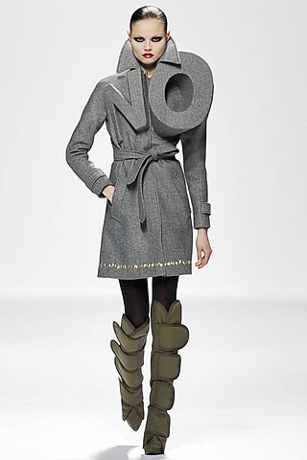
According to English (2007, 146) their aim was to reinforce the fact contemporary designers face difficulties when bringing out far-out innovative ideas due to tight schedules and competition with fast chain stores. In this sense, Viktor and Rolf imply to be innovate a designer must refrain from “walking the mainstream of fashion”. (Allwood, 2017) The collection, just like many others by the duo, also celebrated hand-craftsmanship of garments which has been much devalued throughout the years. Suzy Menkes (2017) states every piece in their Autumn/Winter 2008 collection was handmade in a couture atelier. A lot more attention to detail is visible through these carefully constructed garments therefore adding more value to them as well as evoking a higher level of admiration towards the piece which is unlikely to happen with a fast-fashion item of clothing. At the time, Johansson (2010) went as far as to claim the rebellion could be the start of a successful transition into a slow fashion movement where well considered designs would result in better purchases therefore putting an end to the mass production issue.
Figure 1
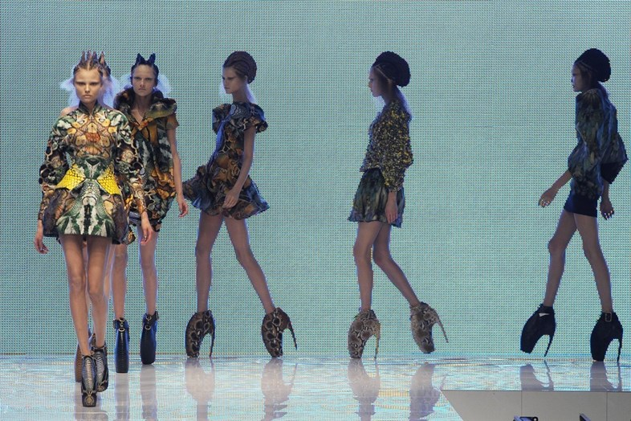
It is worth mentioning how much like Viktor and Rolf, Alexander McQueen’s most memorable and innovative high fashion designs were clearly not meant for the masses. His Spring/Summer 2010 collection tittles ‘Plato’s Atlantis’ (Figure 2) was not designed with the intention of being the next big seller. According to the V&A Museum website (2009), it was one of his greatest achievements offering an unimagined individualistic take on the future human kind through digital media with the attempt to creating an interactive dialogue between creator and consumer through fashion. Manifesting originality, innovation and high entertainment value therefore breaking away from constrictions set by the fashion system and resisting its power over designers. (Vam.co.uk, 2009) However, Bonnie English (2007, 147)) argues such creativity should not be interpreted as “pure art” to be admired and with the aim of satisfying societies need to experience fashion. But instead, as creativity with the goal of encouraging desire for the garments, fuelling consumption, resulting in a designer’s economic growth.
Figure 2
Another designer actively conscious and challenging society’s over consumption habits is Yohji Yamamoto. As a high fashion designer, and much like Viktor and Rolf, he is not afraid to take risks and chooses to “champion originality” by creating a “critical distance” between himself and the vicious trend cycle which inevitably prevents an artist from being experimental. (Allwood, 2017) English (2007, 127) describes Yamamoto as a niche designer known for not following stylistic trends or directions and instead choosing to maintain his identity. Hifu, a Japanese term referring to a “form of anti-style” is an unquestionable component within Yamamoto’s collections where he presents modern society with a catwalk show of Western fashion “contradictory” pieces, as described by himself (English, 2007, 121). He chooses to create clothing that has universal, timeless quality therefore disobeying the orders of the established fashion industry and positing himself far from disposable fashion.
Yamamoto continuously creates heavy layered looks, with sturdy fabrics and manlier abstract structures rejecting figure-hugging forms regardless of the fashion demand therefore preserving his authentic style (Figure 3 and 4). McGuirk (2011) suggests Yamamoto’s methods resemble those of a sculptor. He listens to the way the fabric moves around the body other than following a drawing and in this way shaping through draping takes place. His way of creating strongly portrays craftsmanship that is simply inimitable. (McGuirk, 2011) Yamamoto argues a respectable designer should never follow the mainstream and without risks there will be no progress within the fashion and textile industry (English, 2007, 122). It’s this belief that sets him apart from other designers who no longer see the meaning behind the existence and creation of fashion. English, (2007, 128) states he offers an expressive alternative to the regressive, superficial and unoriginal work presented by many current designers. Endeavouring to lead the industry back to when fashion pieces were highly valued and acquired for their exceptional beauty other than ordinary appearance.

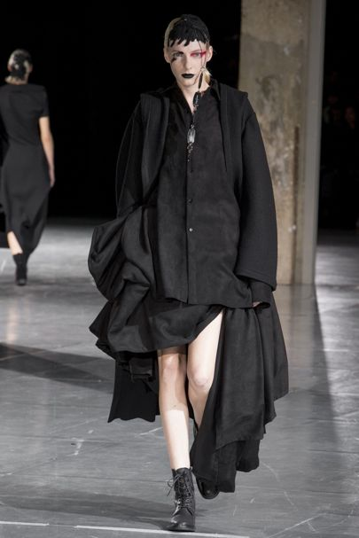
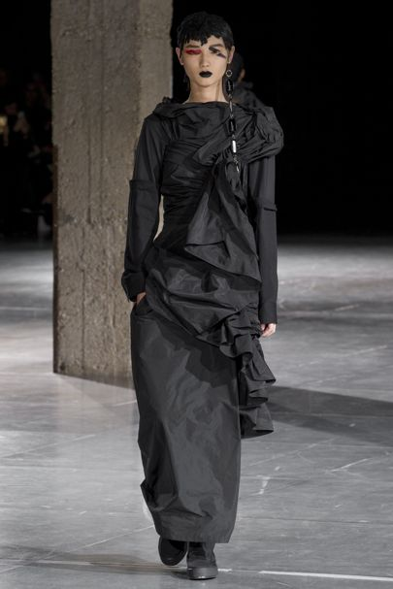
Figure 3
Figure 4
Undoubtedly, Viktor & Rolf, Yohji Yamamoto and Alexander McQueen have a positive impact upon the fashion and textile industry as they distance themselves from the dull, competitive system of modern fast fashion. However, Menkes (2016) argues they are able to focus on originality and innovation because they are well established designers. As respectable Haute Couture members, they have been granted creative freedom meaning they can be adventurous and defy trends as in the hierarchy of fashion they are placed above the rules. This places smaller designers at an unfair disadvantage when it comes to replicating such desires to be authentic and perhaps forces them down the mass-production path as a way to survive in the competitive industry.

CHAPTER 3

Today’s fast-fashion cycle goes beyond issues related to the restriction of a designer’s freedom of expression and creativity. The “shop until you drop” (Berger, 2005) mentality has been standardised amongst consumers resulting in an unconscious neglect towards moral and environmental issues linked to the production of textiles. Fortunately, society seems to be more aware of the problematic situation and there has been a rise on second hand purchases which of course has a positive impact overall. Yet, Brown (2010) states whilst reducing what you buy is a step towards minimizing fashion consumption, it does little for the environment when the Apparel industry is the second highest pollutant at present. In fact, it is accountable for 10% of the world’s carbon footprint.
Kate Fletcher is aware the fashion industry can’t just be stoped as its crutial to our identity, culture and history. However, she does state we need to slow it down, stop and consider the cost we are paying for choosing quantity over quality. (E. Johansson, 2010) The famous quote by William Morris: “have nothing in your house that you do not know to be useful or believe to be beautiful” (Mackail, 1970) is one society should turn to if we wish to resolve the issue of meaningless over-consumption of fashion and chemical and material waste. According to Fletcher (2008), individuals need to be educated about design and textile production in order to actively engage with the industry therefore moving away from passive “blind consumption” and towards “reflective competence”. (Johansson, 2010, 34) Vivienne Westwood (2014) asked for an end to “indiscriminate consumption” and promoted a “slow fashion principle” where she argued if you must choose something, you should choose wisely and invest your money on durable items. According to Rikamaria Paakkunainen, we should place quality over quantity which would then shrink production and minimalize negative social and environmental impacts by shifting the focus onto vital decisions along the creative and manufacturing process of fashion and textile. (Johansson, 2010, 37)
Many argue the “slow fashion trend” could be the answer to a more sustainable textile and fashion industry (Johansson, 2010, 4). The term serves as an umbrella promoting positive sustainable changes for the fashion and textile industry in relation to our environment, social and ethical aspects (Holt, 2009). Unlike the name suggests, it is not necessarily concerned with time. Fletcher (2008) argues slow fashion does not simply relate to pressing the brake pedal or slowing the production clock down, but it is a chance to re-consider fashion quality, not just regarding material durability but the quality of design and textile production.
Additionally, Johansson (2010,7) states improvements to the fashion and textile will be made if designers and consumers work together to slow the industry down. As suggested by Black (2012, 222) there should be a bond between clothing and wearer if we wish to distance ourselves from disposable fashion. In his eyes “it is only clothing that means something to us that can be endured”. UNMADE, is a technology-driven label doing exactly that. The label offers the opportunity to personalise knitted items to an individual’s specifications based on the concept a garment remains unfinished until its worn. (Hall, 2016)
Concerned with the worrying closeness between fashion and mass production, UNMADE focuses on offering bespoke knitwear produced on demand and by doing so minimizing textile waste (Arthur, 2015) The label believes allowing the consumer to take part in the designing process increases garment value therefore resulting in the piece being treasured. As previously mentioned, Fletcher (2008) clearly distinguishes fashion from clothing based on symbolic and physiological needs. However, it is not essential for these to be independent of eachother. By allowing the wearer to engage with the creative process, UNMADE successfully manages to combine fashion and clothing into one, reverting back to times when comsumption was significant. Shopping purposively with the aim of fulfilling one’s physical needs as well as satysfying an individuals manifestation of identity. UNMADE’s aim of slowing down fashion and reintroducing meaning to one’s wardrobe is realised through designing with a conscious. (Unmade.com, 2017) The label also dismisses the myth sustainability can only apply to handcrafted garments by pioneering digital eco-friendly fashion in the modern age. (Hall, 2017)

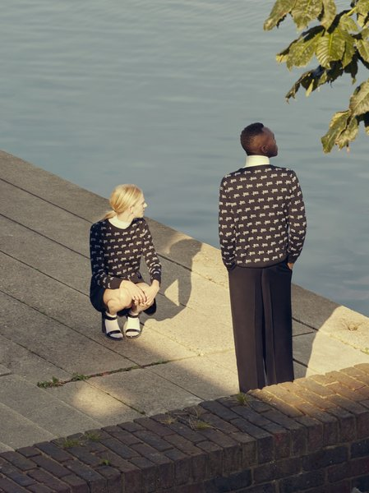
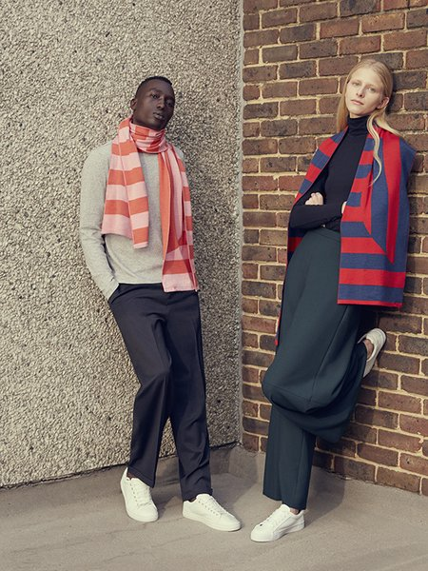
Figure 5
Figure 6

Margot Selby is another designer consciously engaging with the textile industry through her practice in pursuit of weakening over production. Much like the label UNMADE, Margot Selby produces unique, limited edition textiles which focus on making the fashion and textile industry more sustainable. In his book “Textile Visionaries – Innovation and Sustainability in Textile Design”, Quinn (2013) states Shelby recognises the growing emphasis on techno textiles today but argues there is still much to be explored from hand woven designs. She creates hand-woven products such as curtains, cushions, lampshades and fashion pieces in house through traditional weaving methods. The off-cuts and textile scraps are used to produced one-off items which would otherwise be thrown away creating textile pollution. The jacket in Figure 7 is a one of a kind made out of leftovers from 50 different designs. By making use of remnants, Selby expresses she is a conscious designer concerned with the environmental issues caused by the fashion and textile industry. Her textile pieces celebrate craftsmanship as well as highlighting the beauty of bespoke designs. (Quinn, 2013, 164) Selby’s attempt to make the industry sustainable does not stop there. She also combines yarns and fibres in such efficient way making her textile pieces strong and therefore durable. As previously discussed durability means quality pieces will transcend short lived trends resulting in long-term wearer satisfaction on and lowering the chance of clothing disposal. (Johansson, 2010)

.
It is important to acknowledge designers who are reusing and recycling materials to create innovative sustainable textile pieces. Johansson (2010, 37) states using textile waste as a resource to create new products has become a key tool for a selection of conscious designers who are giving new life and adding value to textile waste and pieces which have been unfairly disposed of. The act minimizes the demand for new ones being produced therefore lessening the negative impact the textile production methods have upon the environment. A noteworthy step towards a more sustainable industry. (Johansson, 2010)
After becoming aware of the shocking amount of textile waste produced by the industry, Luisa Cevese decided to upcycle leftover fabric pieces by fussing them with plastic creating strong, extremely desirable one-off products for her Riedizioni label. (Brown, 2010, 130) No two designs can be the same due to how the innovative materials are created. Firstly, scraps will vary in size, shape and quantity and secondly the plastic employed in each product varies depending on the selection of fabric pieces. Variation between Cevese’s bags and interior items make them more desirable to conscious individuals looking to deviate from consuming fast-fashion countlessly replicated items lacking character. Brown (2010) states Cevese’s main objective is to find the most effective solution involving minimum waste.
Lastly, the success of the Riedizioni label and authenticity of its textile products almost makes one wonder why so many designers aren’t interested in engaging with sustainable methods which are motivated by environmental and ethical choices other than economics. In the book “Eco Fashion” by Sass Brown, the clothing label TRAIDmade - a recycled fashion label providing a stylish alternative to fast-fashion – expressed issues relating to throwaway fashion are complicated. Much of what has been disposed of is of quality and durable meaning these can and should be reused to innovate and keep environmental damage as a result of textile production to a minimum. (Brown, 2010, 136). TRAID is a charity which collects unwanted clothing, upcycles them and diverts the innovated items back into the fashion and textile industry. According to Black (2012, 211) 94% of items collected are repurposed and sold every year. The money from sales is then invested in positive change such as increasing the supply chain of water in Kenya. Not only does its “waste not” ethos (Hall, 2016) protect the environment through its conscious ecological design production, but it also addresses worldwide social issues such as poverty. (Brown, 2010)

CONCLUSION:

It is clear in comparison to other creative industries, such as product design and architecture, the fashion and textile industry has been considerately slow at tacking mass production and blind consumption issues. (Black, 2012) In fact, the industry has taken a real beating and has been left almost shattered in relation to its true value within society. As mentioned, mass production has confused consumers as well as designers and the beauty behind original, innovative, eco-friendly designs has been buried under the fast-fashion demands and overconsumption. The current fashion system is bad all round. According to Black (2012), it is bad for the designer; bad for the environment; bad for the workers and without a doubt, bad for the wearer.
Societies taste for authenticity has been polluted by the pressure to be in trend which has resulted in fashion homogeneity. Yamamoto was brave enough to go as far as to say cheap fashion has made the majority look ugly. (Allwood, 2017) A designer’s creativity has been restricted to trend forecasting where rebelling against the season’s tendencies could result in a career defeat.
Although designers and labels such as Viktor and Rolf, Margot Selby and UNMADE should be celebrated for having made their intentions clear and chosen to deviate from the mainstream by designing purposively. Positive change will only be truly noticed if a wave of others rises to follow their footsteps towards a more sustainable industry and also decide to design with a conscious. Considering not only the concept behind a piece but its material qualities, durability and connection to the wear. (Fletcher, 2008) Essentially, society needs more designers willing to be adventurous, innovative and aiming to produce zero waste.
There needs to be a new definition of fashion where priority lays on developing real solutions to lifestyle and resource challenges other than insisting on promoting a romanticised image of fashion where the supply chain is treated as non-existent. Ideally, damage to the environment due to textile and fashion production should be kept to a minimal or awareness to the problems caused by industry should be made available to consumers therefore resulting in conscious consumption.
Ultimately the implications deriving from textile production will only be resolved by a society which is actively involved with fashion and textiles, and by establishing a strong connection between designer, clothing and wearer. (Black, 2012) As Vivienne Westwood suggest, the future of fashion is meaningful, and individuals should “buy less, choose well and make it last” other than uncontrollably attempting to quench one’s insatiable thirst for commodities.

BIBLIOGRAPHY

Ahmed, O. (2016). When Viktor & Rolf Fashioned a Statement of Intent. [online] AnOther. Available at: http://Www.anothermag.com/fashion-beauty/8904/when-viktor-rolf-fashioned-a-statment-of-intent [Accessed 11 Dec. 2017].
Allwood, E. (2017). Yohji Yamamoto on how not to be a fashion victim. [online] Dazed. Available at:
Arthur, R. (2015). Forbes Welcome. [online] Forbes.com. Available at: HTTPS://www.forbes.com/sites/rachelarthur/2015/12/21/unmade-the-london-start-up-publishing-clothing-on-demand/ [Accessed 08 Dec. 2017].
Bedat, M. (2016) for TEDx Talks. The High Cost of Our Cheap Fashion. Available at: https://www.youtube.com/watch?v=5r8V4QWwxf0&t=571s&list=PLMBvjs_izPJt1QTi4yQWTBo22eGRD6C9g&index=2
Berger, A. (2005). Shop 'til you drop. Lanham, MD: Rowman & Littlefield.
Black, S. (2012). The sustainable fashion handbook. London: Thames & Hudson.
Breward, C. (1994). The culture of fashion. Manchester: Manchester University Press.
Brown, S. (2010). Eco fashion. London: Laurence King, p.7.
Colchester, C. (2009). Textiles today. London: Thames & Hudson.
Collins Dictionary. (2014). fast fashion| Collins Dictionary. [online] Available at: Http://www.collinsdictionary.com/submission/13271/gasto fashion [Accessed 22 Oct. 2017].
English, B. (2007). A cultural history of fashion in the twentieth century. Oxford: Berg, p.27,.
Fletcher, K. (2008). Sustainable fashion and textiles. London: Earthscan, p.118.
Gardetti, M. (2013). Sustainability in fashion and textiles. Sheffield: Greenleaf Publ.
Hall, J. (2016). Five eco fashion warriors to hit follow on. [online] Dazed. Available at: http://Www.dazeddigital.com/fashion/article/29019/1/five-designers-revolutionising-sustainable-fashion [Accessed 12 Nov. 2017].
Johansson, E. (2010). Slow Fashion - The Answer for a Sustainable Fashion Industry?. [ebook] pp.8-37. Available at: http://bada.hb.se/bitstream/2320/6776/1/2010.9.15.pdf.
Joy, A., Sherry, J., Venkatesh, A., Wang, J. and Chan, R. (2012). Fast Fashion, Sustainability, and the Ethical Appeal of Luxury Brands. Fashion Theory, [online] 16(3), pp.273-295. Available at: http://dx.doi.org/10.2752/175174112x13340749707123 [Accessed 15 Nov. 2017].
Kruse, E. (2013) for TEDx Talks. Changing the World Through Fashion. Available at: https://www.youtube.com/watch?v=d4VTPLpfGq0&list=PLMBvjs_izPJt1QTi4yQWTBo22eGRD6C9g&index=6
Mackail, J. (1970). The life of William Morris. New York: Haskell House, pp.68, 69.
McGuirk, J. (2011). Yohji Yamamoto: the people's designer who cuts loose from the catwalk. [online] the Guardian. Available at: https://www.theguardian.com/artanddesign/2011/mar/14/yohji-yamamoto-designer-v-and-a [Accessed 06 Dec. 2017].
Menkes, S. (2016). #SuzyCouture: Viktor & Rolf - Wearable Art?. [online] Vogue.co.uk. Available at: http://Www.vogue.co.uk/article/suzy-at-paris-couture-viktor-rolf [Accessed 30 Oct. 2017].
Menkes, S. (2017). #SuzyCouture: Fantasy and Reality: Margiela and Viktor & Rolf Hover Between. [online] Vogue.co.uk. Available at: http://Www.vogue.co.uk/article/suzycouture-maison-margiela-viktor-and-rolf [Accessed 30 Oct. 2017].
Millar, L. and Imanishi, K. (2005). 2121. Canterbury: University College for the Creative Arts.
Pookulangara, S. and Shephard, A. (2013). Slow fashion movement: Understanding consumer perceptions - An exploratory study. Journal of Retailing and Consumer Services, [online] 20(2), pp.200-206. Available at: http://dx.doi.org/10.1016/j.jretconser.2012.12.002 [Accessed 15 Nov. 2017].
Quinn, B. (2013). Fashion futures.
Quinn, B. (2013). Textile Visionaries: Innovation and Sustainability in Textile Design.
Reich, L. (2004) ‘Question of Fashion’ in Against Fashion: Clothing as Art, London: MIT Press: 152
Southbank Centre (2014). WOW 2014| Vivienne Westwood in Conversation with Shami Chakrabarti. Available at: https://www.youtube.com/watch?v=LZZZYq5aohY&list=PLMBvjs_izPJt1QTi4yQWTBo22eGRD6C9g&index=8
Vam.ac.uk. (2017). Alexander McQueen: Savage Beauty - About the Exhibition - Victoria and Albert Museum. [online] Available at: http://Www.vam.ac.uk/content/exhibitions/exhibition-alexander-mcqueen-savage-beauty/about-the-exhibition/ [Accessed 06 Dec. 2017].
Wilcox, C. (2004). Vivienne Westwood. London: V&A.
Zachary, C. (2015). Avant garde fashion | The Art of Dress. [online] Theartofdress.org. Available at: http://theartofdress.org/tag/avant-garde-fashion/ [Accessed 23 Oct. 2017].
LIST OF ILLUSTRATIONS:

FIGURE 1: (Marcio) Madeira, M. (2008) Viktor and Rolf Fall 2008 Ready to Wear “NO” LOOK 1 [Online]. Available at: https://www.vogue.com/fashion-shows/fall-2008-ready-to-wear/viktor-rolf/slideshow/collection (Accessed: 16 October 2017).
FIGURE 2: Alexander McQueen Spring/Summer 2010 “Plato’s Atlantis” [Online]. Available at: http://www.dazeddigital.com/fashion/article/32285/1/the-mcqueen-show-that-changed-the-future-of-fashion-platos-atlantis-nick-knight (Accessed: 18 October 2017).
FIGURE 3 and 4: Yohji Yamamoto Autumn/Winter 2017 [Online]. Available at: http://www.vogue.co.uk/article/suzypfw-the-extraordinary-originality-of-japanese-design (Accessed: 18 October 2017).
FIGURE 5: (2016) UMD White Label Campaign Shoot – Calibration Sweaters [Online]. Availale at: https://umd.studio/journal/thamesmead/ (Accessed: 07/12/2017)
FIGURE 6: (2016) UMD White Label Campaign Shoot – Cut and Twist Scarves [Online] Availale at: https://umd.studio/journal/thamesmead/ (Accessed: 07/12/2017)
FIGURE 7: Margot Selby One-off Patchwork Jacket [Photograph] Available at: TextileVisionaries – Innovation and Sustainability in Textile Design by Bradley Quinn (2012), page 165.
FIGURE 8: Piero Gemelli – Riedizioni bag [Photograph] Available at: Eco Fashion by Sass Brown (2010), page 131.

