Programme: BSc (Hons) Computing Portfolio

Module: Internet Technology and Security
Module code: ACCA4018
Lecturer: Dr Carlene Campbell- Internal Verifier: Dr Kemi Ademoye
Assignment Title: Synthesize a solution to a potential real-life scenario

Table of Contents
BYOT 1
What is it? 1
Benefits of BYOT 2
Disadvantages of BYOT 2
Mobile Device Management Software 2
Recommended MDM Package 3
Policy 4
Access Control 4
Device Policy 5
Network Policy 6
DFD 6
Coffee Capulus Network Design 7
References 7

BYOT
What is it?
Bring your own technology (BYOT), or also commonly known as bring your own device (BYOD), is a model being taken up by various companies that allows employees to instead of using company provided equipment, can opt to use their own personally owned devices for work purposes. These devices will have access to the companies’ network, both on premises and remotely. [1]
Remote access is usually secured using VPN connection methods, and Mobile Device Management software is utilised to secure the company owned data on the devices, so if there was concern for the data (if the device was lost/stolen/employee dismissed), then the data can be wiped remotely, providing protection of intellectual property belonging to the company.
BYOT models should be using mobile device management software (MDM). MDMs are software packages designed to be able to provide an IT Department with a way to manage mobile devices that will be used by employees. At a minimum, these software packages should have the ability to register devices on the network with approval from the IT Department, to ensure only trusted devices owned by the employees are granted access to the network. They should also be able to work with many different operating systems, both mobile (Android/iOS/Blackberry) and desktop (Windows/iOS/Linux) to provide a full range of compatibility. Another important feature these packages should have, are the ability to secure the device and the data remotely, even removing data if required.
Benefits of BYOT
Productivity is likely to increase, and cost to the employer can be reduced. Employees can often be seen conforming to consumerism: the practice of wanting the latest most sophisticated and powerful personal devices. Following this, this means that employees would already be in possession of superior devices than the company would provide, which would normally be out of the company’s scope to provide comparable devices. From an employer point of view, this is a potential boost in productivity which would require no initial financial investment from the company. From an employee point of view, they can work from a device that they are already familiar with.
IT departments will also save costs by not having to purchase enterprise software licenses, which can be costly. As the devices are personally owned by the employee, they are more likely to take more care of it than they would a company provided device. They may very well have insurance on said device, which takes costs such as repairing, replacement, and maintenance costs away from the company.
Because of the likely device specification that employees will purchase personally, they may have benefits to increased security from biometrics, and having devices that are able to run the latest versions of operating systems and keeping up to date with the recent security patches.

Disadvantages of BYOT
There can be several disadvantages to a BYOT policy. If a strict policy is not followed on the minimum required specification of devices, companies could be left with employees running devices that run a wide range of operating systems and versions thereof. This can increase resource demand on the IT department to ensure that the network is capable with all of the devices, as well as having devices running which may not have the latest security patches, if the employee has not maintained the device efficiently.
Where security is concerned, there is also the onus on the employee to follow the policy and best practice guidelines of the BYOT policy to ensure that, as well as the steps the company has taken to secure the network for onsite and remote access, that the employee uses the device to minimise any security risk to a minimum. This could be a concern where perhaps some employees are not sufficiently IT literate to use their personal device in a safe manner. This could lead to the employee for example, contracting malware on their device at home, then connecting to the company network and unleashing damaging malware on the network.
Mobile Device Management Software
Choosing the correct MDM is an important choice to make when considering which package to utilise for a company. They should meet the above basic functionalities, and even further. A review taken by PCMag [2] has a comprehensive list of packages, comparing additional features. These features included these functions; user self-registration, remote device locking and wiping, granular selective wipe, SSO (Single Sign-On) for applications, and geofencing.
User self-registration is a function that allows employees to register their own devices. This is attractive to IT departments as this takes some of the manual work of registering individual devices and allows for a smoother set up process.
The granular selective wipe is a function that will wipe only the corporate data from a personal device. This is an important function as this will ensure that the employees truly feel that there is a very clear boundary on their device between personal use and business use, and important to the company as it will ensure that all corporate data can be removed without wiping personal data from an employee’s device. If personal data were to be deleted accidentally, it could lead the company open to liability in breaching the terms of BYOT as it is not the company’s property to be able to do so.
SSO is an arguably crucial feature from the viewpoint of productivity, security and user accessibility. SSO allows users to authenticate themselves once, and then access is granted to the set of applications that they are required to use in their working day. This has an impact on productivity by the fact that users sometimes do not see the benefits of adhering to complex password requirements. These requirements often lead users to having to create a password which is not memorable, and while that is the main purpose of complex password policies, from an user perspective it can be seen as a hindrance, and some users may even seek to circumvent policy and risking the security of their account. [3] SSO aims to assist security concerns of both employer and employee by providing a secure single sign on to all required applications, reducing overhead from the employee, and improving security for employer.
Geofencing is the ability to create a virtual geographic boundary, allowing software to trigger a response when the device enters or leaves a particular area. [4] Geofencing is used often in the credit/debit card industry as a form of authentication. Cards do not have GPS built in, but smartphones do, and point of sale readers do. By verifying the proximity of these two, it aims to verify if the transaction seems legitimate or not. The same could be used with an enterprise network for remote access, by limiting availability to select sites or areas.
Recommended MDM Package
From the many packages available, SOTI MobiControl meets the specifications listed above. It supports the majority of devices and OS versions. It supports iOS 8.0+ (Sep 2014), Android 4.2+ (Jul 2012), Windows XP SP2+ (Aug 2001) & macOS 10.2+ (Aug 2002). It supports version of OS which are far older than what is used on average. The benefits of this are support for older devices in case the need ever arose that such devices needed to be used temporarily. The package also supports two of the most popular web browsers, Chrome and Firefox.
It also supports remote control of devices on any HTML 5 web browser. This will potentially improve resolution of issues with the IT department as it offers a more direct approach of fixing issues.
Access control is thorough also, and LDAP integration is supported to dictate what files and websites are accessible dependent on the user’s profile. LDAP (Lightweight Directory Access Protocol) is suited for large numbers of database queries and minimal updates, which would be commonly used for login information. LDAP can also be used with the package to create user policies based on group membership, which would reduce overhead by formulating generic access right to certain groups, and users can be modified easily.
MobiControl supports app management with integrations to Google Play and Apple VPP, and also features blacklisting/whitelisting of apps. This will prevent unauthorised apps from being installed on personal devices and potentially causing a threat on the corporate network.
Policy
Below is a draft policy for Coffee Capulus. This policy will encompass best practice for staff to adhere to, ensuring that security of the network and associated corporate data is maintained.
Access Control
Coffee Capulus will provide authorisation and access to corporate data and systems in a secure and controlled manner. Each user will be given a unique profile dependent on their job role in the company which will define the access rights and ability to manage data. The process of implementing the above will be published and documented.
Access rights will be restricted to the minimum level so that productivity is not affected, but security is maintained.
Data of varying confidentialities will be tagged as such, so that only those users with access rights that meet the requirement will be able to access and/or manage, dependent on their profile.
All users will be issued with a Unique Identifying Number. This number, along with a minimum of a password, will be the lowest form of authenticating users. Data or systems requiring further security concerns, which shall be tagged as such, may require additional security using biometrics, multi factor authentication, RFID cards, or a combination of the afore mentioned where the company sees appropriate.
Access to networks, systems and data will be regularly monitored and audited to ensure compliance to the security policy, and to check for any suspicious activity. This monitoring and auditing will be adequate for the level of network/data/system which is being protected.
Sharing account information with your colleagues under any circumstance ( I have log in issues, I can’t remember my password etc) is strictly forbidden, and any instance of this will be met with strict disciplinary action, and depending on the severity of the incident, we may take further action to prevent this in future.
Access monitoring and auditing will comply with local data protection laws and regulatory requirements. Access rights will be reviewed periodically to ensure profiles are appropriate to your role, and to disable/delete inactive accounts.
Device Policy
We want to fully support any employee wishing to utilise your own personal device for purposes relating to work carried out for the company.
Devices which are suitable to be used with our Bring Your Own Technology initiative must meet a minimum set of requirements. They must meet the following operating system requirement: iOS 8.0+ , Android 4.2+ , Windows XP SP2+ & macOS 10.2+. At this time, Blackberry, and Windows mobile devices are not supported.
To enable access to the corporate network, either on site or remotely, your device must be registered with our Device Management Software. Failure to do so will not allow you access to the network. Any difficulties in doing so and we will support you with this. Any attempt to circumvent registering your device will be met with disciplinary action.
Any devices you wish to use on the corporate network should be maintained according to manufacturer’s instructions.
Any support required from our Device Management Software, or access to the network, will have a published point of contact for any issues that need to be raised.
Corporate data stored on personal devices will be encrypted, and depending on the level of information, may not be able to be viewed without connecting to our network and proper authentication.
We will manage the data on personal devices in the event that the device is lost or stolen, or if you have been dismissed from your role or redeployed within the company to another department, where your existing access rights may not be relevant or appropriate.
Devices must be installed with our Device Management Application, and any security applications which we find necessary for secure access to our network and data. Failure to comply will result in your device having access rights removed until the issue is resolved.
Any employees wishing to utilise our BYOT initiative must agree to the terms and conditions laid out. Any breach of these may be met with disciplinary action if required.

Network Policy
We will design and manage the network to protect the information we hold, and to ensure users of the network are secure and to prevent any unauthorised access.
We will design the network so that in event of any impacts to the network, performance will not be under operational levels.
We will employ adequate security measures to the network in the way of hardware and software.
We will always authenticate devices which request access to our network.
We will constantly monitor out networks for any security concerns and aim to remedy any potential exploits as soon as possible.

DFD
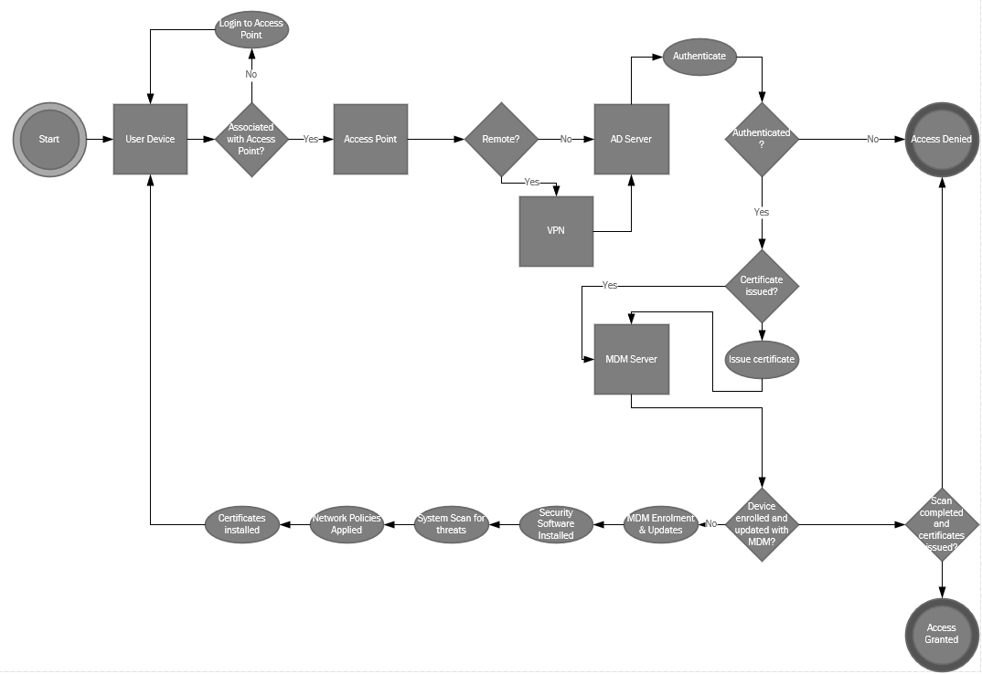Coffee Capulus Network Design
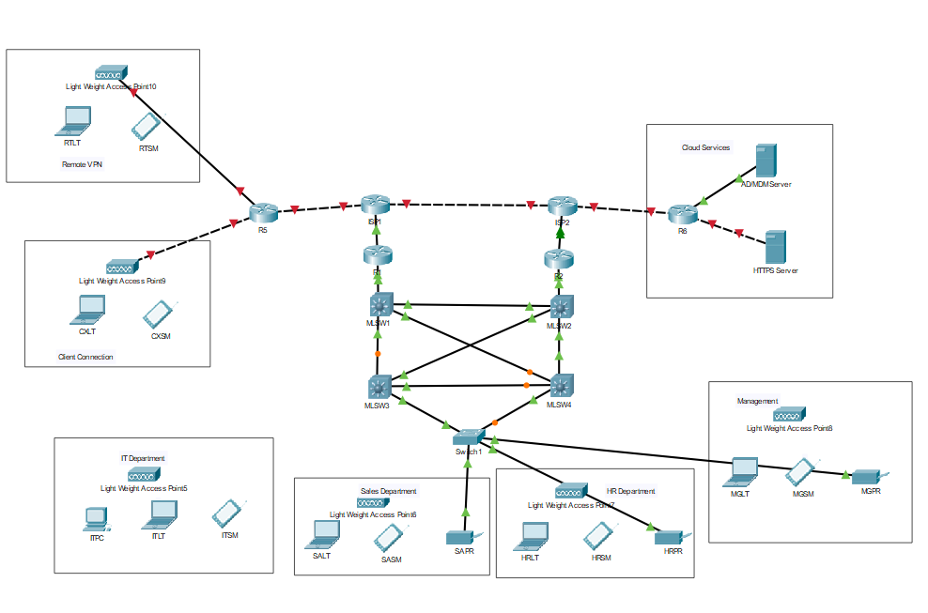

References

[1] | IT Pro , “What is BYOD?,” 15 4 2020. [Online]. Available: https://www.itpro.co.uk/strategy/28072/what-is-byod. [Accessed 15 4 2020].
[2] | P. Ferrill, “The Best Mobile Device Management (MDM) Solutions of 2019,” PC Mag, 8 1 2018. [Online]. Available: https://uk.pcmag.com/cloud-services/76018/the-best-mobile-device-management-mdm-solutions-of-2019. [Accessed 15 04 2020].
[3] | W. Harrison, “Passwords and Passion,” IEEE Software, vol. 23, no. 4, pp. 5-7, 2006.
[4] | J. Swedburg, “Geofencing,” Credit Union Management, vol. 40, no. 12, pp. 10-12, 12 2017.
[5] | P. Ferrill, “SOTI MobiControl,” PC Mag, 15 2 2018. [Online]. Available: https://uk.pcmag.com/cloud-services/82176/soti-mobicontrol. [Accessed 15 4 2020].

marking criteria and Student FEEDBACK

This section details the assessment criteria. The extent to which these are demonstrated by you determines your mark. The marks available for each criterion are shown. Lecturers will use the space provided to comment on the achievement of the task(s), including those areas in which you have performed well and areas that would benefit from development/improvement.

Common Assessment Criteria Applied (Assignment 1) | Marks available | Marks  awarded
1. Engagement with Literature Skills
Extent of research and/or own reading, selection of credible sources, application of appropriate referencing conventions.
You have used only websites for your referencing and did not engaged with any academic peer review article to make your work credible. Websites require careful consideration. Key concept considered. Utilise the University online resources and journals. (Grade mark: 50.00%) | 15 | 7.5
2. Knowledge and Understanding Skills
Extent of knowledge and understanding of concepts and underlying principles associated with the discipline.
You have demonstrated knowledge and understanding. However, see comment above. You have not used the IEEE report formatting. (Grade mark: 53.33%) | 15 | 8
3. Cognitive and Intellectual Skills
Analysis, evaluation and synthesis; logic, argument and judgement; analytical reflection; organisation of ideas and evidence
Your report discuss relevant areas for this assignment; policy, DFD, MDM, etc. . Very good DFD diagram. Number, name and refer to your figures within the report. No conclusion written (Grade mark: 65.00%) | 40 | 26
4. Practical Application Skills
Deployment of methods, materials, tools and techniques; application of concepts; formulation of innovative and creative solutions to solve problems.
Your edge devices are not configured with functional ports, therefore ping tests did not work. All core devices has security measures (password), best practice is to encrypt them within the configuration files so that they are not readable.. Redundancy considered in core and diagram labelled in a meaningful way. (Grade mark: 70.00%) | 20 | 14
5. Transferable Skills for Life and Professional Practice
Attributes in professional practice: individual and collaborative working; deployment of appropriate media; presentation and organisation.
Your report could be aligned justified. Writing need improvement (try to read more peer reviewed articles and emulate the writing style). See report for other comments. (Grade mark: 50.00%) | 10 | 5

Assignment Mark (Assessment marks are subject to ratification at the Exam Board. These comments and marks are to give feedback on module work and are for guidance only until they are confirmed. ) | Late Submission Penalties (tick if appropriate) |  | 61%
 | Up to four weeks late |  | 61%
 | First Attempt? |  | 61%

