FOOD & BEVERAGE OPERATIONS

MODULE CODE: BMIH4002

HOTEL TRINITY VALENTINE’S MENU

NAME: Nasima Akter

STUDENT NUMBER: 2210268

LECTURER: Ffion Cumberpatch
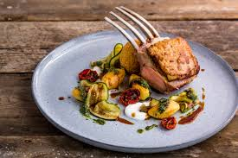
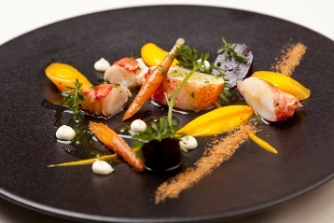

Hotel trinity
(Hints of Lemon and Honeysuckle with a lingering spicy finish from the Pinot Noir perfect to start off a romantic date)
Aperitif -Taittinger Brut Prestige Rose NV

♥ Focaccia Oysters with Mayonnaise (15)
Crispy native Oysters with a handmade Focaccia Breadcrumb with enriched silky Mayonnaise
 609 Kcal
Young Premier Cru Chablis

♥ Local Lobster (14)
Succulent Lobster meat with roasted heritage carrots, smooth carrot puree, buttermilk puree and spicy crumb
650 Kcal
Viognier
Appetizers

♥ Organic Quinoa with Halloumi Salad (9.5)
Baby Arugala, Tosted Walnuts and fragrant Lemon Vinaigrette
- 603 Kcal
Languedoc White

♥ The House Salad (11)
Grilled Smoky Salmon, Blood Orange Segments, handpicked Portobello Mushrooms & White Wine Vinegar mustard dressing.
- 230 Kcal
Dry Earthy Rhône
Appetizer Salads
Valentines A la Carte Menu has been designed with 3 courses in mind to enjoy with your loved one.
As we near the end of the Winter season, each dish includes seasonal fresh fruits and vegetables which have been locally sourced.

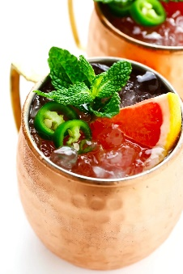
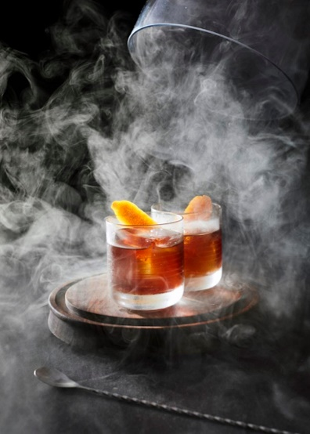
= Vegetarian  = Halal Certified = Contains Fish or Shellfish = Contains Dairy Products
Customer Advisory: Not all ingredients are listed, in case of any allergies please consult and inform your server.

♥ Herb Crusted Lamb Rack (30)
Served with charred Organic Vegetables and a Roasted Garlic Rosemary Puree 709 Kcal
Chateauneuf-du-Pape
♥ Chicken Rockefeller (21)
Rosemary Roasted fingerling Potatoes, Organic Asparagus and Pernod Scented Bechamel 678 Kcal
Bourgogne Pinot Noir
♥ Wild Mushroom and Spinach Linguine (20)
Handmade Linguine dressed in Vibrate Pesto and Handpicked mushrooms 483 Kcal
Oak Charndonnay

Mains
♥ Vanilla Panna Cotta (8)
Smooth silky Vanilla Panna Cotta Served with Dark Chocolate Bar and Pomegranate Glaze
584 Kcal
♥ Chocolate Fudge Torte (7)
Dairy Free Chocolate Torte Served with Tangy Raspberry Sorbet
582 Kcal

Desserts
♥Cocktails
Classic Mojito (5)
Royal Martini (5)
Daiquiri (5)
♥Mocktails
Citrus Cooler (3.5)
Berry Cooler (3.5)
Lime and Mint (3.5)

Drink List

References
Ali. (2020, December 30). Spicy Grapefruit Ginger Fizz Mocktail. Retrieved February 13, 2023, from https://www.gimmesomeoven.com/spicy-grapefruit-ginger-fizz-mocktail/
BBC Good Food Team. (2023). Quinoa Salad with Grilled Halloumi. Retrieved February 13, 2023, from https://www.bbcgoodfood.com/recipes/quinoa-salad-grilled-halloumi
Beckett, F. (2007, June 29). The 25 best food and wine pairings. Retrieved February 13, 2023, from https://www.decanter.com/learn/food/recipes/food-and-wine/best-food-and-wine-pairings-247325/
Davis, B., Lockwood, A., Pantelidis, L. S., & Alcott, P. (2018). Food and Beverage Mangement (6 ed.). London: Routledge.
Everitt-Matthias, D. (2015). Native lobster, roasted heritage carrots, carrot purée and buttermilk purée. Retrieved February 13, 2023, from https://www.greatbritishchefs.com/recipes/lobster-carrot-recipe
Lightspeed. (2022, April 4). Restaurant food cost formula: pricing your menu to turn a profit. Retrieved February 13, 2023, from https://www.lightspeedhq.co.uk/blog/how-to-calculate-restaurant-food-costs-uk/
Outlaw, N. (2023). Crispy focaccia oysters with oyster mayonnaise. Retrieved February 13, 2023, from https://www.greatbritishchefs.com/recipes/crispy-focaccia-fried-oyster-recipe/amp
Ozdemir, B., & Caliskan, O. (2014). A review of literature on restaurant menus: Specifying the managerial issues. International Journal of Gastronomy and Food Science, 2(1), 3-13.
Palasca, S. (2020, January 23). How to Write Delicious Restaurant Menu Descriptions That Sell More Food. Retrieved February 13, 2023, from https://www.restaurant-website-builder.com/restaurant-menu-descriptions
Ramsay, G. (2021). Grilled Salmon with Garlic Mushroom and Lentil Salad. Retrieved February 13, 2023, from https://www.gordonramsay.com/gr/recipes/grilled-salmon-with-garlic-mushroom-and-lentil-salad/
Silcock, E. (2023). Vanilla panna cotta. Retrieved February 13, 2023, from https://www.bbcgoodfood.com/recipes/vanilla-panna-cotta

Ali. (2020, December 30). Spicy Grapefruit Ginger Fizz Mocktail. Retrieved February 13, 2023, from https://www.gimmesomeoven.com/spicy-grapefruit-ginger-fizz-mocktail/
BBC Good Food Team. (2023). Quinoa Salad with Grilled Halloumi. Retrieved February 13, 2023, from https://www.bbcgoodfood.com/recipes/quinoa-salad-grilled-halloumi
Beckett, F. (2007, June 29). The 25 best food and wine pairings. Retrieved February 13, 2023, from https://www.decanter.com/learn/food/recipes/food-and-wine/best-food-and-wine-pairings-247325/
Davis, B., Lockwood, A., Pantelidis, L. S., & Alcott, P. (2018). Food and Beverage Mangement (6 ed.). London: Routledge.
Everitt-Matthias, D. (2015). Native lobster, roasted heritage carrots, carrot purée and buttermilk purée. Retrieved February 13, 2023, from https://www.greatbritishchefs.com/recipes/lobster-carrot-recipe
Lightspeed. (2022, April 4). Restaurant food cost formula: pricing your menu to turn a profit. Retrieved February 13, 2023, from https://www.lightspeedhq.co.uk/blog/how-to-calculate-restaurant-food-costs-uk/
Outlaw, N. (2023). Crispy focaccia oysters with oyster mayonnaise. Retrieved February 13, 2023, from https://www.greatbritishchefs.com/recipes/crispy-focaccia-fried-oyster-recipe/amp
Ozdemir, B., & Caliskan, O. (2014). A review of literature on restaurant menus: Specifying the managerial issues. International Journal of Gastronomy and Food Science, 2(1), 3-13.
Palasca, S. (2020, January 23). How to Write Delicious Restaurant Menu Descriptions That Sell More Food. Retrieved February 13, 2023, from https://www.restaurant-website-builder.com/restaurant-menu-descriptions
Ramsay, G. (2021). Grilled Salmon with Garlic Mushroom and Lentil Salad. Retrieved February 13, 2023, from https://www.gordonramsay.com/gr/recipes/grilled-salmon-with-garlic-mushroom-and-lentil-salad/
Silcock, E. (2023). Vanilla panna cotta. Retrieved February 13, 2023, from https://www.bbcgoodfood.com/recipes/vanilla-panna-cotta

