University of Wales Trinity Saint David Birmingham
Professional Development within Health and Social Care
LCHS4009

Personal Development Portfolio

Submitted by
Student: Yuliia Matytsyna
ID number: 2507682

Submitted to
Lecturer: Zarah Ahmed
Module Lead: Olubukola Adegbite

Table of Contents
CV 8
Personal Statement 10
Personal SWOT analysis 11
Personal Development Plan 12
Reflection 14
References 16

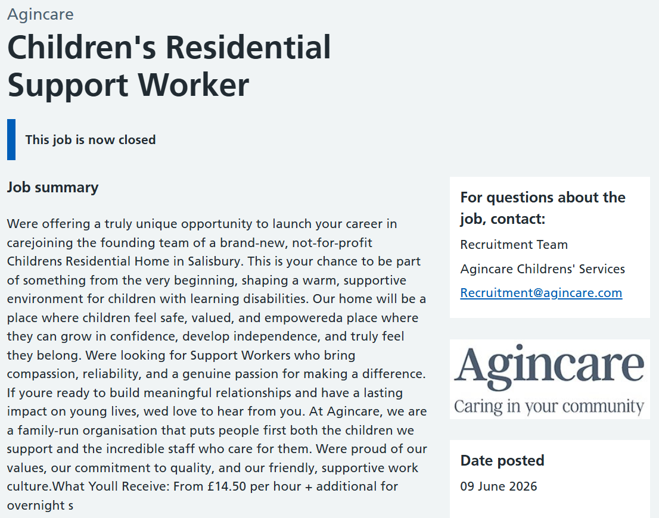
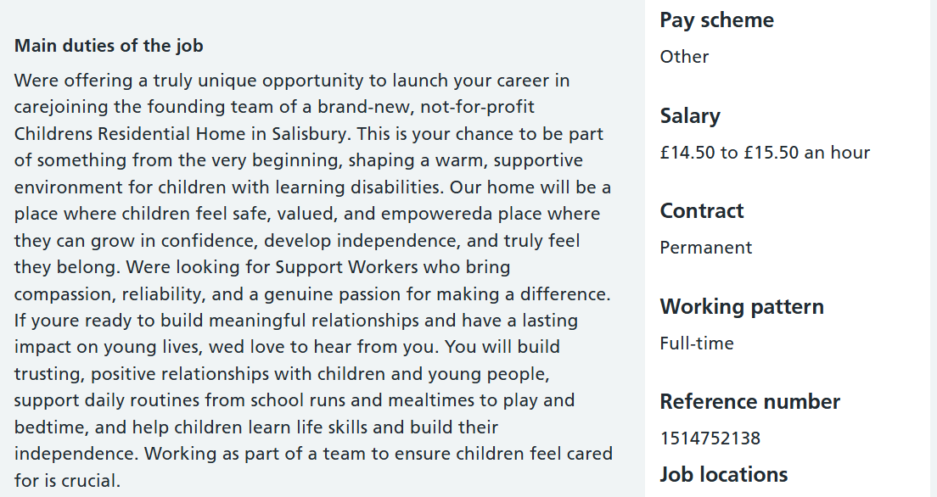
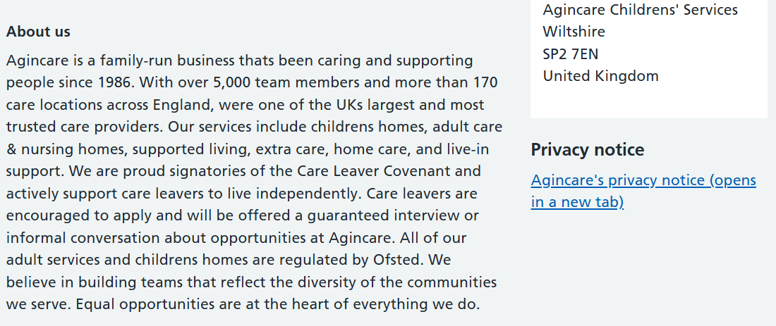
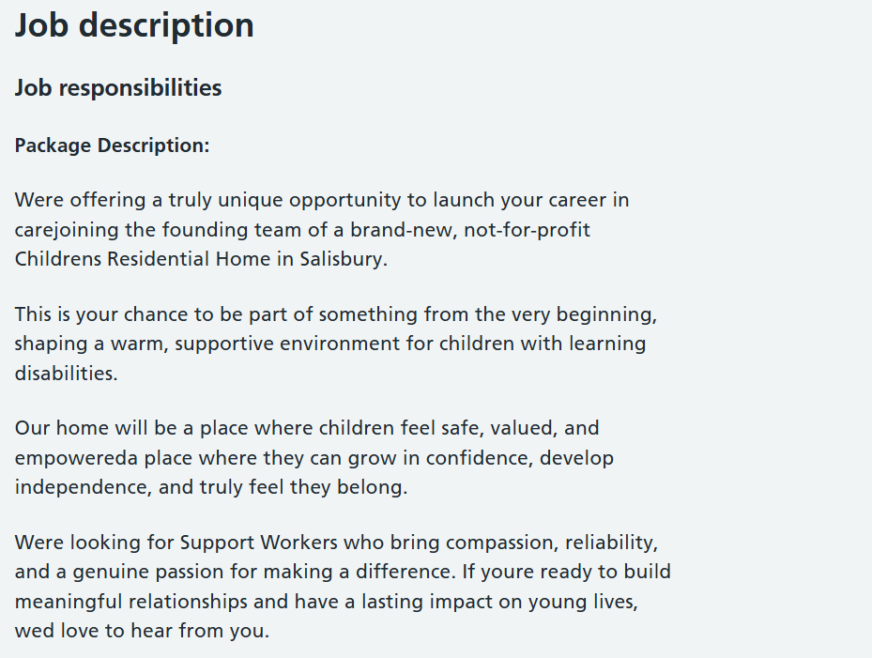
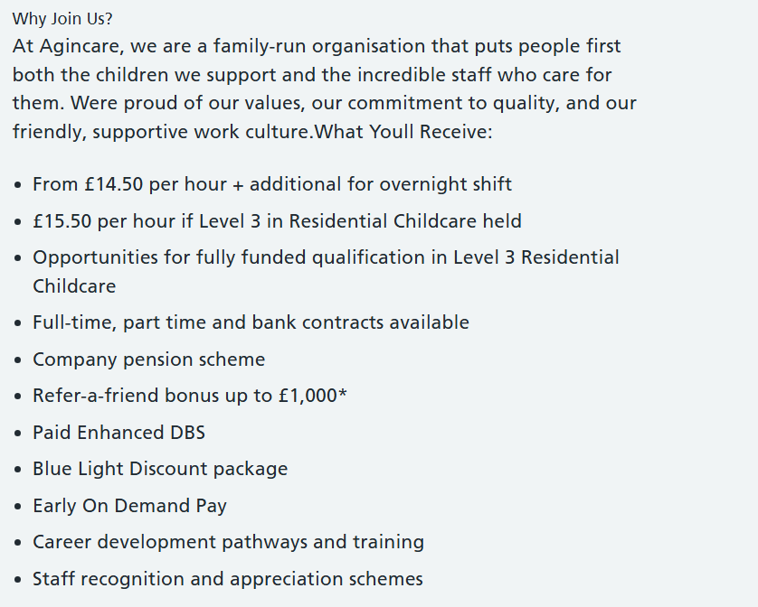
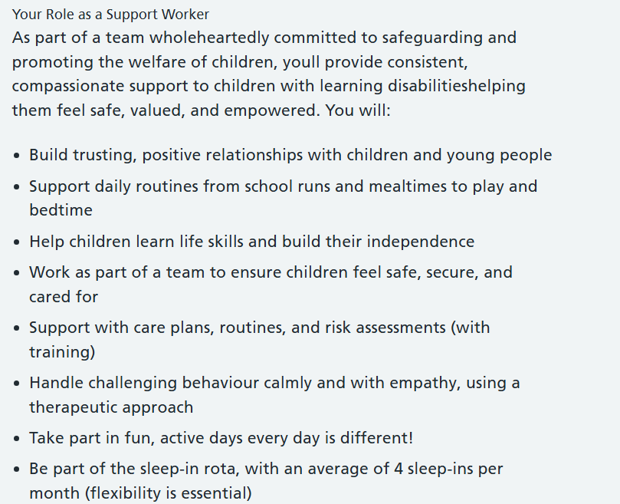
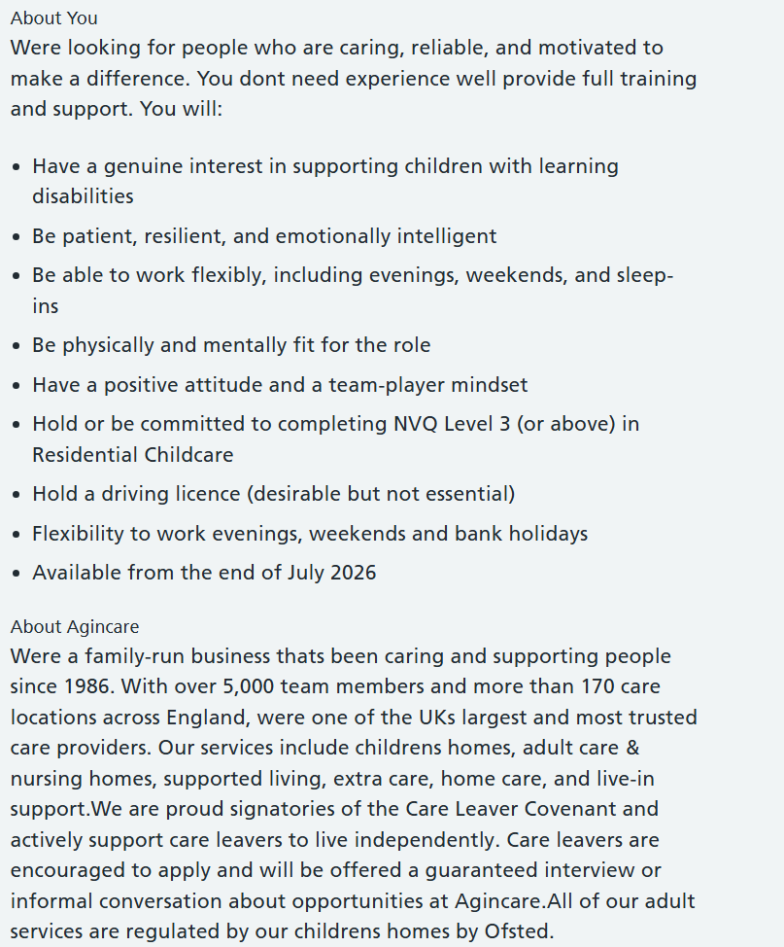
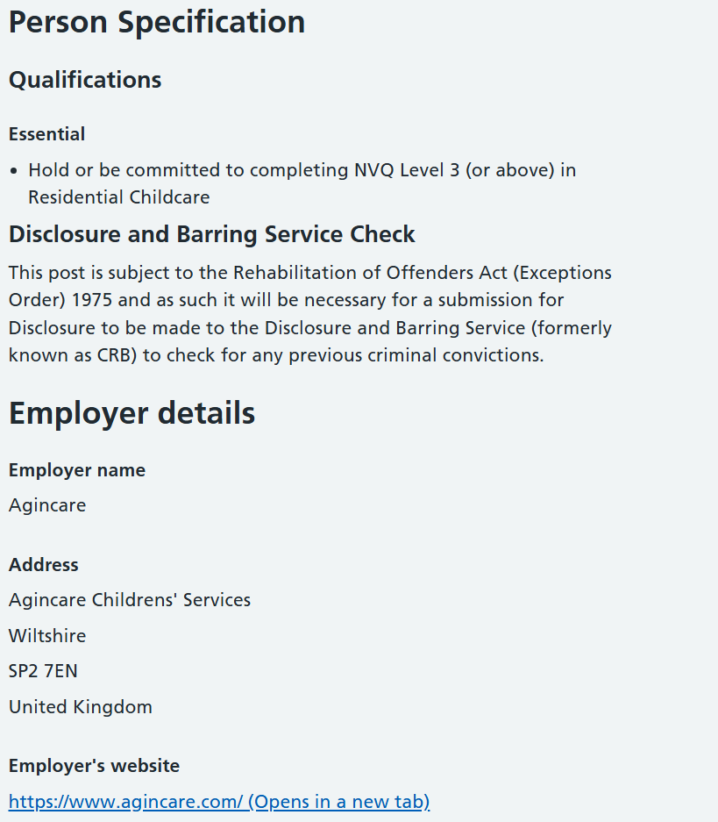

For my portfolio I have chosen a Children’s Residential Support Worker job role. National Careers Service (n.d.) states that the work of residential support workers includes taking care of the physical and mental health of children and vulnerable people in care settings.
I searched for job opportunities at NHS Jobs website and found this one: https://www.jobs.nhs.uk/candidate/jobadvert/L0014-26-0930

CV
Yuliia Matytsyna
Willey, Broseley, Shropshire, TF12 5JN
+447442751633 | yuliiamatytsyna@gmail.com | https://www.linkedin.com/in/yuliiamatytsyna
PROFILE
I am a compassionate, quick-learning and resilient professional currently studying Health and Social Care, with a clear interest in developing a career as a Children’s Residential Support Worker. I have four years’ experience in food production, where I developed strong communication, teamwork, time-management and problem-solving skills, alongside 18 months’ experience creating early childhood development resources for children aged 2–5. I bring empathy, patience, creativity and a calm, respectful approach to supporting children and young people, and I am motivated to help provide a safe, nurturing and positive environment where they can feel listened to, valued and supported.

EDUCATION & QUALIFICATIONS
CertHE Skills for the Workplace (Health and Social Care) Aug 2026
University of Wales Trinity Saint David, Birmingham
Level 2 AIM Qualifications Award in Child Development - Telford & Wrekin Council Aug 2025
Level 2 Pearson Edexcel Functional Skills Qualification in English and Mathematics
Pathway First LTD May 2025
Level 2 Certificate in Understanding Autism 601/63 - South Devon College Apr 2025

WORK EXPERIENCE
Bakery assistant | A Ryan and Son Limited Sep 2022 to Present
Traditional family-run butcher and bakery with over 50 years’ experience, offering handmade pies, pastries, sausage rolls, lasagnes, quiches, cottage pies and cakes, introducing seasonal products throughout the year.
- Prepared handmade bakery products with accuracy, consistency and attention to detail.
- Followed strict food hygiene, health and safety procedures in a busy working environment contributing to the maintained 5-star Food hygiene rating.
- Trained and encouraged new members of staff, explaining procedures clearly and helping them build confidence in their role.
- Worked calmly and efficiently under pressure.
- Communicated effectively with colleagues to ensure smooth teamwork and safe working practices, and demonstrated reliability, patience and responsibility.
- Supported new seasonal product development, showing creativity and flexibility.

Author of children’s developmental workbooks | ART Publishing House Sep 2019 to Jul 2021
ART Publishing House: Developmental workbooks for building various skills. Educational books for discovering new knowledge using a specially designed method.
- Produced original ideas for developmental tasks for children 2-5 years old (development of logic, language and counting skills)
- Created 10 developmental workbooks on paper (text and structure)
- Provided guidance descriptions of illustrations for an artist
- Strictly followed publisher instructions and work deadlines

ADDITIONAL INFORMATION
I am planning to continue obtaining different qualifications related to psychology, mental health, residential care, first aid and children’s development to enhance my knowledge and skills.

Languages – Russian (fluent in both written and verbal); Ukrainian (fluent in both written and verbal); Welsh (beginner)

Technical skills
Mental Health Awareness: I understand mental health conditions and can provide relevant support.
Digital Literacy: I have essential digital skills to work with documentation and digital resources.

INTERESTS
I enjoy hiking, walking and exploring new places, museums and art galleries, which is why I am a member of National Trust, English Heritage, and Canal Trust. I also donate monthly to ZSL, RNIB and RBL because I believe it is important to support and preserve nature, history and vulnerable people.

My biggest passion is reading and psychology, so I combine them together by reading books about psychology, mental health and children’s development.

Lastly, I want to add that music and photography occupy a significant part of my spare time. These hobbies support my creativity along with drawing and crafts.

Personal Statement
I am a warm, enthusiastic, creative, resilient, and patient person with a genuine passion for supporting children and vulnerable people. I care deeply about helping others feel safe, valued, listened to, and understood. I understand that residential support work requires strong communication, empathy, reliability, active listening, and the ability to remain calm and supportive in challenging situations.
Although I have not yet worked in residential childcare, my experience of raising my own children and supporting friends with childcare has shaped the way I care for others. It has helped me develop patience, flexibility, creativity, and a calm, nurturing approach. These experiences have shown me how important it is for children to feel safe, accepted, encouraged, and emotionally supported.
Since moving to the UK four years ago, my work as a bakery assistant has helped me grow in confidence and strengthen my communication, teamwork, and cultural awareness. Working with colleagues from different backgrounds has taught me the value of kindness, respect, patience, and building positive relationships with the people around me.
I also recognise that care and motivation must be supported by knowledge and training. I have completed Level 2 qualifications in children’s development and understanding autism, and I am currently studying Health and Social Care at university. This is helping me develop a deeper understanding of safeguarding, equality, communication, wellbeing, and person-centred care. In the future, I hope to work towards roles in play therapy and learning disability support, where I can continue helping people feel understood and included.
I am flexible, resilient, open-minded, and willing to work evenings, weekends, and nights. Relocating to the UK has been a big personal journey, and it has helped me develop independence, problem-solving skills, empathy, and understanding. I would bring these qualities, along with a caring and positive attitude, to a support worker role.
In conclusion, I believe I am well suited to the role of support worker because I would approach it with kindness, patience, compassion, and professionalism. I am eager to keep learning from experienced colleagues and to grow in this field. My goal is to build a meaningful career where I can support others to feel safe, build confidence, overcome challenges, and feel truly included.

Personal SWOT analysis
According to Cottrell (2021), a personal SWOT analysis is a quick, flexible tool for reviewing your strengths, weaknesses, opportunities and threats, helping you assess readiness, reflect on performance, understand situations, set priorities and consider how each area influences the others.
Strengths | Weaknesses
Patient  Empathetic  Observant  Responsible  Adaptable  Reliable  Resilient | Time-management skills  Credulity and suggestibility  Over sensitiveness and tearfulness  Language barrier (unable to understand strong accent and pronounce some sounds correctly)
Opportunities | Threats
University course  Career advice from university career team  Online courses and training  Apprenticeship | Lack of job opportunities in the area  Lack of job experience  Uncertainty of the future (immigration status)  Transportational issues (no driving license)

Strengths and opportunities support progress, while weaknesses and threats can create barriers. Effective planning involves identifying these internal and external factors and using them to build on strengths, address weaknesses, make the most of opportunities, and reduce potential threats (Gürel & Tat, 2017). This provides a useful foundation for my Personal Development Plan, where I can turn these reflections into specific goals and actions.

Personal Development Plan
To detect career ambitions and develop essential for work qualities, people are using an instrument called a personal development plan (PDP). For PDP to be successful, it is important to set SMART (specific, measurable, achievable, relevant, and time-bound) goals and remain dedicated to the plan, checking progress and adjusting it regularly (Williams and Nerys, 2023). Organisations need adaptable employees who can respond to change, and PDPs help staff keep their knowledge and skills current as products, policies and customer expectations evolve (Development and Learning in Organisations, 2017).
Therefore, to prepare to work as a children’s residential support worker I want to improve my time-management skills, language skills, and overcome my psychological problems (over sensitivity and tearfulness).
Goals | List the actions to complete to achieve the goal | Support/resources needed | Target date | Review date
Improve time-management skills | Use a weekly planner;  prioritise tasks using urgent/important list;  practice completing tasks withing agreed deadlines;  read books about time-management and find some courses online. | Phone calendar,  diary/planner,  library and bookshops (e.g., Books2Door),  online resources such as YouTube and LinkedIn. | 6 months | 2 months
Improve English communication skills for professional practice | Practise speaking English daily with classmates, colleagues, or friends;  keep a vocabulary notebook for health and social care terms;  read professional articles and course materials;  ask for feedback on written work;  take part in presentations and group discussions to build confidence. | University learning resources,  tutor feedback,  English language websites/apps,  library books,  professional journals,  group work,  private English tutor. | 6 months | 3 months
Develop emotional resilience and professional confidence | Use reflection after challenging situations;  practise breathing and grounding techniques;  seek constructive feedback from tutors or supervisors;  observe experienced practitioners managing difficult situations;  attend wellbeing or resilience workshops;  set small confidence-building goals during placement or group work. | Tutor or mentor support,  supervision sessions,  reflective journal,  wellbeing services,  self-help resources,  online resilience training. | 1 year | 2 months

Over the next two years, I will continue to develop my professional skills and confidence by building on the goals in my PDP. I will focus on improving my communication, time management and emotional resilience through regular reflection, feedback from tutors or supervisors, and practical experience in health and social care settings. By reviewing my progress regularly, I will be able to identify new learning needs and continue growing towards my career ambitions. Additionally, I will consider a possibility of attending psychotherapy sessions to support my resilience, self-awareness, and ability to manage sensitivity and tearfulness in professional situations.

Reflection
To reflect on my Component 1 presentation assessment, I chose to use a Gibbs reflective cycle because, according to Bassot (2024), the Gibbs model deepens reflection by focusing on feelings, marking a shift toward critically reflective practice. This model consists of six components: description, feelings, evaluation, analysis, conclusion, and action plan.
Description: I have done a presentation about critical thinking skills for Health and Social Care professionals – produced slides and delivered my presentation in a classroom to my lecturer Zarah Ahmed.
Feelings: During the presentation, I was confident in my knowledge but still nervous because I am not comfortable with public speaking. I remembered that I was short of breath rehearsing at home, therefore, I was trying to speak slower, which made me calmer. Gradually, I started to feel more relaxed because of my lecturer positiveness and calmness, and because I was well prepared.
Evaluation: Looking back, I can see that I have often used filler word ‘er’ and did not deliver all the information that I have prepared. Afterwards I received feedback from my lecturer: “For your practical example think about the actual professional. How professional (nurse or health professional) needs to demonstrate that critical thinking?” The reason I did not explain my practical example properly was that I did not stay within five minutes and rushed to conclusion. However, a positive aspect was that in the middle of the presentation, my pace became more stable, I memorised and comprehended information good, made proper conclusion, and answered the question from my lecturer confidently.
Analysis: Analysing my performance, I realised that I did not practice enough. I think, I should have asked for help my family or classmates and practiced my delivery in front of one of them, in which case they could have given me feedback for improvement. There is the other possible reason of why my presentation happened that way – I was rehearsing in front of my laptop; I saw my slides during the practicing. When I was delivering my presentation in the classroom, I have not seen my slides, therefore, I felt a little bit lost and looked notes more often. This experience is important for my future development as a Health and Social Care professional because clear communication, confidence, and the ability to explain ideas effectively are essential when sharing information with service users, families, and colleagues.
Conclusion: From that experience, I have learned that the key point for successful presentation is a proper preparation. Even though, I have read significant amounts of information, produced quality slides, and written a proper prompt, I did not leave enough time for rehearsing which made me to cut prepared speech in the end. Therefore, my time-management skills need improvement.
Action plan: In future presentations, I will manage my preparation time more effectively by creating a clear rehearsal schedule before the deadline. I will practise my presentation several times without looking at my slides so that I become more confident with the content and reduce my reliance on notes. I will also rehearse in front of a family member or classmate and ask for feedback on my pace, clarity, use of filler words, and whether my practical examples are fully explained. I will track my progress by keeping a rehearsal log, timing each practice, recording myself, counting filler words, and asking for feedback using a checklist so I can monitor improvements in confidence, pace, clarity, and time management. To improve my public speaking skills, I will watch relevant TED Talks and read guidance on presentation techniques. Additionally, I will use breathing exercises before presenting to help me stay calm, focused, and maintain a steady pace throughout my delivery.

References
Bassot, B. (2024) The reflective journal. 4th edition. London; Bloomsbury Academic, pp. 48-49. Available at: https://r4-vlebooks-com.uwtsd.idm.oclc.org/Reader?ean=9781350422995 (Accessed: 22 July 2026).
Cottrell, S. (2021) Skills for Success: Personal Development and Employability. 4th edn. London: Red Globe Press, p. 206. Available at: https://ebookcentral.proquest.com/lib/trinity/reader.action?docID=6577749&c=UERG&ppg=1 (Accessed: 22 July 2026).
Development and Learning in Organisations (2017) ‘Improving performance appraisal: The value of personal development plans’, Development and Learning in Organizations: An International Journal, 31(4), pp. 36–39. Available at: https://doi.org/10.1108/DLO-05-2017-0045
Gürel, E. and Tat, M. (2017) ‘SWOT analysis: A theoretical review’, Journal of International Social Research, 10(51). Available at: https://d1wqtxts1xzle7.cloudfront.net/109539676/jisr.2017-libre.pdf?1703499580=&response-content-disposition=inline%3B+filename%3DSwot_Analysis_A_Theoretical_Review.pdf&Expires=1784736129&Signature=fw5RGpg4p~4zqdbwviWzkmQSCmpnzUzVR2c-2Hd9R3X6bB6SpUylrhBSdvr6pfjh6-vEiM2uvMPx2aDwbRdJQq94Pv6GvVwsI9JLwSJIdp-9~vO7lD8JF6oi5lAZl6SVfZp6fUXV9yEs-VdM1dRWXzWwaLeT1-LnHdtgrt4Hs2PRdfzW2ktDrFloBp6RdfBgRwP0bE3EWj7sGQS471NoCWbQTZNQCCbh3JhebBXKWa4cX12acnpnJ0qc7ePQ7L1DnZ9GS0Guts5bEpXE7-AkPYdNS52VaNnPAQENrHt8IaqXmEsLcLSui8Ct9FgibxdENhc-Q6Kb~51AIT2E9M-1ag__&Key-Pair-Id=APKAJLOHF5GGSLRBV4ZA (Accessed: 22 July 2026).
National Careers Service (n.d.) Explore careers. Available at: https://nationalcareers.service.gov.uk/job-profiles/residential-support-worker (Accessed: 22 July 2026).
Williams, N. (2023) ‘Writing a Personal Development Plan’, Occupational medicine (Oxford), 73(6), pp. 381–381. Available at: https://doi.org/10.1093/occmed/kqad037

