Smart Navigation with
LEGO Spike Prime

Sean Young
2026

Contents
1 Introduction 2
2 Research 2
2.1 Robots, Sensors and Effectors 2
2.2 LEGO Spike Prime 3
2.3 Path Following and Maze Navigation 3
3 Planning 4
4 Robot Design 10
5 Programming 11
6 Conclusion 12
7 References 13

Introduction
Robotics is an interdisciplinary field, spanning a multitude of domains, including engineering, cognitive science, computer science and more [1]. Once almost exclusively the realm of military and manufacturing, robots are now increasingly beginning to see application in the wider world [1]. With input from the social sciences and humanities, the field of robotics is now starting to be applied to a wide range of societal issues, such as road safety, economic productivity and climate change [1]. Notable examples of this include the fields of assisted living technology, automated home cleaning and, in particular, self-driving vehicles [1].
This paper will discuss a project in which four students were tasked with designing and building an autonomous robot, using LEGO Education Spike Prime. This robot was required to navigate an obstacle course, using an algorithm developed by the students. The obstacle course included an initial stage in which the robot had to follow a curved line, as well as navigating around an obstacle. This was followed by a second stage, in which the robot had to navigate a maze, using its sensors to detect dead ends and search for available paths, before coming to a stop at the finish line.

Research

Robots, Sensors and Effectors
A robot can be defined as a machine that can interact with the physical world, using sensors and effectors [2]. Examples of common sensors in robotics include video cameras, microphones, sonars, lasers, GPS, accelerometers and more [2]. These sensors can enable the robot to determine things like its physical location or orientation in a space [2]. For example, a laser range scanner can measure distance by timing how long it takes for light to bounce off an obstacle, while an odometer can track the distance a robot has travelled [2]. Proprioceptive sensors are used to record things like the speed and position of robotic joints, which is especially important [2]. Effectors commonly used in robotics can be broadly split into two categories, locomotors and manipulators [2]. Locomotors are components that allow robots to move themselves around, such as wheels or legs [2]. On the other hand, manipulators are components like arms and hands, which allow robots to move around objects in their environment [2]. Since each of these components are really just a series of motors, they need to be configured to actuate in a specific sequence in order for them to function in a useful manner [2]. This can be accomplished through the use of appropriate algorithms [2].

LEGO Spike Prime
Spike Prime has been LEGO Education’s flagship STEAM (Science, Technology, Engineering, Arts and Math) product since 2019 [3]. Along with a variety of normal LEGO bricks, Spike Prime features a selection of sensor and motor-based components, similar to the ones described above, along with a hub component, which can be programmed via the Spike app [3].
The programmable hub functions as the central control unit and features a 5x5 LED matrix, a speaker, buttons for control and an embedded accelerometer and gyroscope [4]. It also has a USB port and Bluetooth, for connecting to devices running the Spike app, and six ports for connecting the various Spike Prime sensors and motors [4].
Of these components, the Spike Prime Colour Sensor is able detect a range of common colours, as well as ambient light levels and surface reflectivity, while the Distance Sensor uses ultrasonic technology to measure the distance of nearby surfaces, from 50 to 2000 millimetres [5] [6]. The Force Sensor can detect physical contact and measure applied forces up to 10 newtons, along with differentiating between quick taps and a sustained presses [7]. The included Angular Motors range in size from medium to large and are each equipped with integrated rotation sensors [8] [9]. This allows them to report their speed and their relative and absolute positions by degrees, as well as detecting manual rotation from outside forces [8] [9].

Path Following and Maze Navigation
Path following robots are locomotive robots that are able to detect and follow a path on a surface [10]. This may take the form of a visible path, such as high-contrast coloured line, or an invisible path, such as a magnetic field [10]. Typically, a path following robot will use something like an infrared (IR) sensor, installed to the underside of its chassis, in order to detect the path [10]. Once it has been detected, the robot will then track the path using a steering system and will typically vary its speed for improved stability and performance, such as slowing down for better traction in a curve or increasing speed for a straight [10]. These kinds of robots have uses in military settings but also in civilian fields like transportation, delivery and assistive technology [10].
Maze navigation requires the robot to have at least partial knowledge of its surrounding environment and the ability to use that knowledge for navigation [11]. The latter can be achieved algorithmically [11]. An example of a rudimentary solution is the Random Mouse Algorithm (RMA), where the robot will move forward without deviation until it reaches an intersection and will then pick a new direction at random and repeat [11].
Another solution is the Wall Following Algorithm (WFA), with the Left WFA and Right WFA variations depending on which wall is followed [11]. Here, the robot will navigate the maze, always turning to follow the wall on its dominant side [11]. This solution is only suitable for mazes where the followed wall is connected to all other walls, else the robot can enter a loop [11]. The Pledge Algorithm (PA) is an improved WFA, where the robot has a special mechanism to avoid entering loops [11]. This can be achieved by counting each turn the robot makes, starting at 0 and incrementing or decrementing by 1, depending on the direction of the turn [11]. Using this rule means that the number will always return to 0 when the robot is facing the start direction [11]. The PA can then tell the robot to follow the opposing wall at the next intersection and thereby escape the loop [11].

Planning
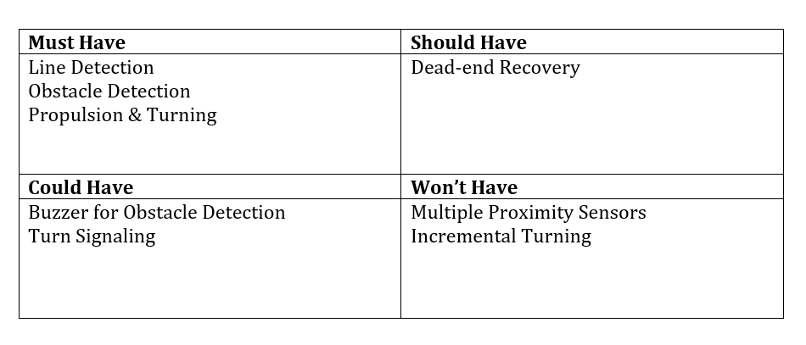
The research was conducted into the different sensors and algorithms that robots can use to navigate the kinds of obstacles found in the demonstration course. Once this had been completed, A MoSCoW table was used to define what features would be implemented in the robot and how they would be prioritised.
Figure 1 ~ Robot Features in MoSCoW Table

The robot was designed and constructed by the team, including the features that were highlighted in the MoSCoW table, based on the research. A prototype of the robot’s behaviour was created using flowcharts. These were separated into a main control routine and multiple sub-routines, in order to keep the design modular and aid in effective collaboration.
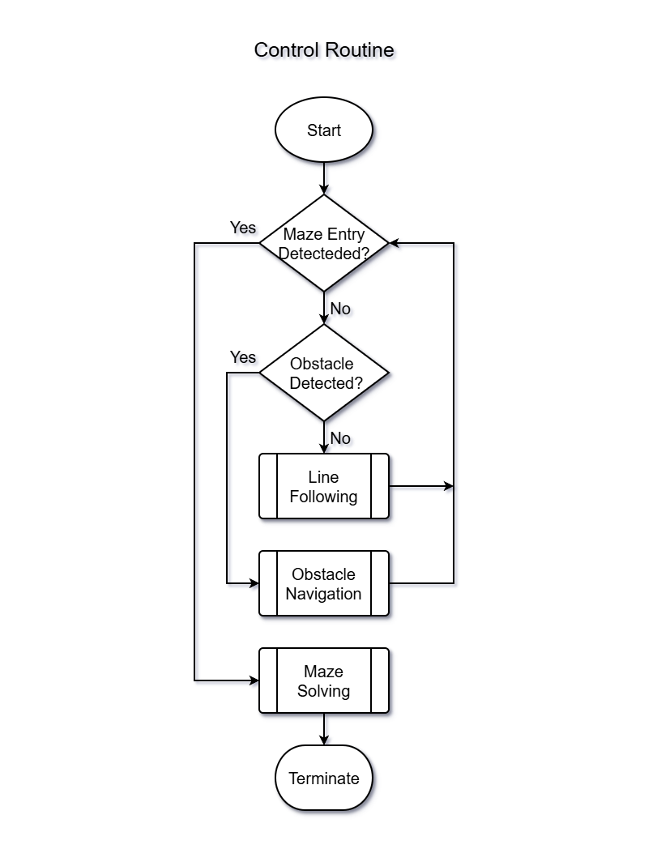
Figure 2 ~ Flowchart for the Control Routine

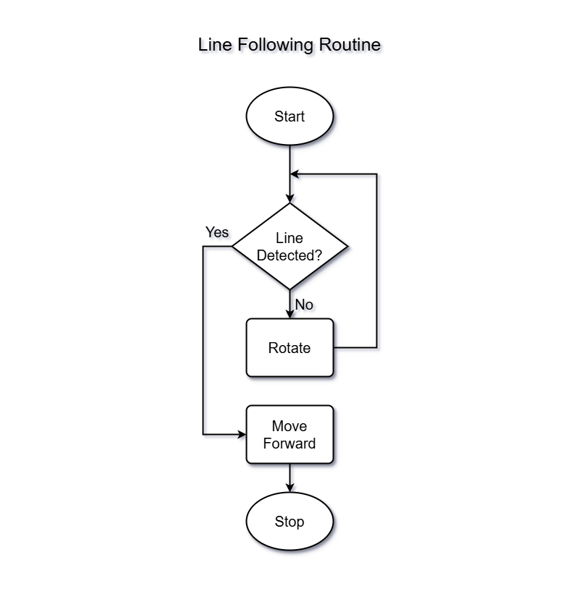
Figure 3 ~ Flowchart for Line Following Routine

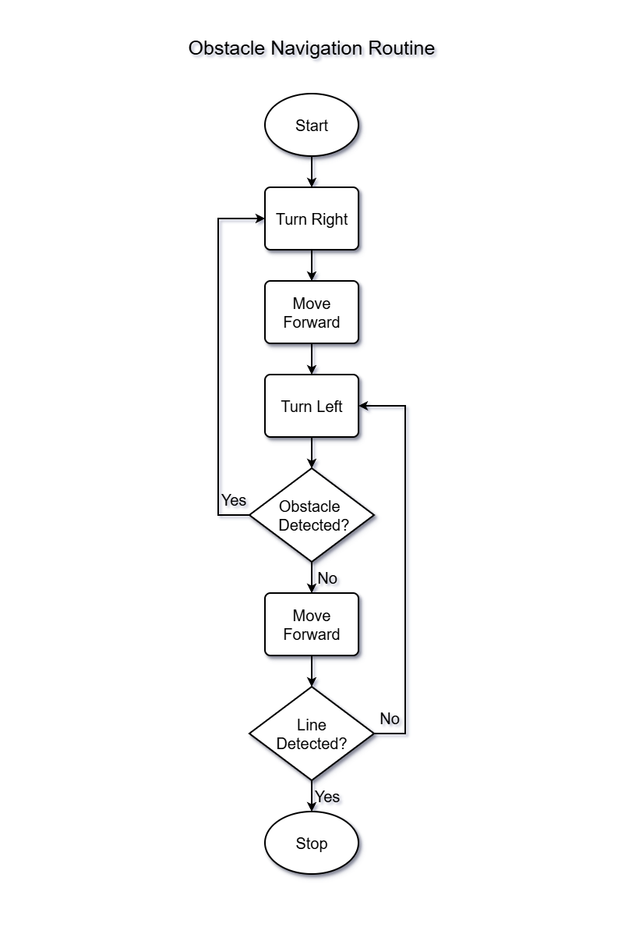
Figure 4 ~ Flowchart for Obstacle Navigation Routine
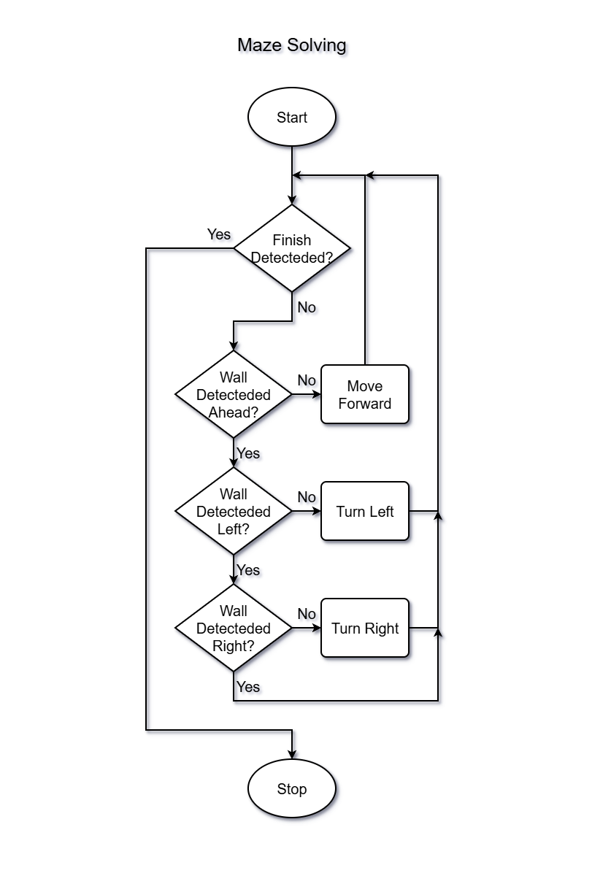
Figure 5 ~ Flowchart for Maze Solving Routine
The team decided they would use the Spike Prime app’s Code Blocks language to program the logic of the robot. Each of the different routines, or functions, of the robot were programmed separately and each one went through multiple rounds of testing and optimisation.
When the programming was complete, the team were able to run some final tests to make sure the robot could successfully navigate the different kinds of obstacles in the course, before it was time to make the demonstration.
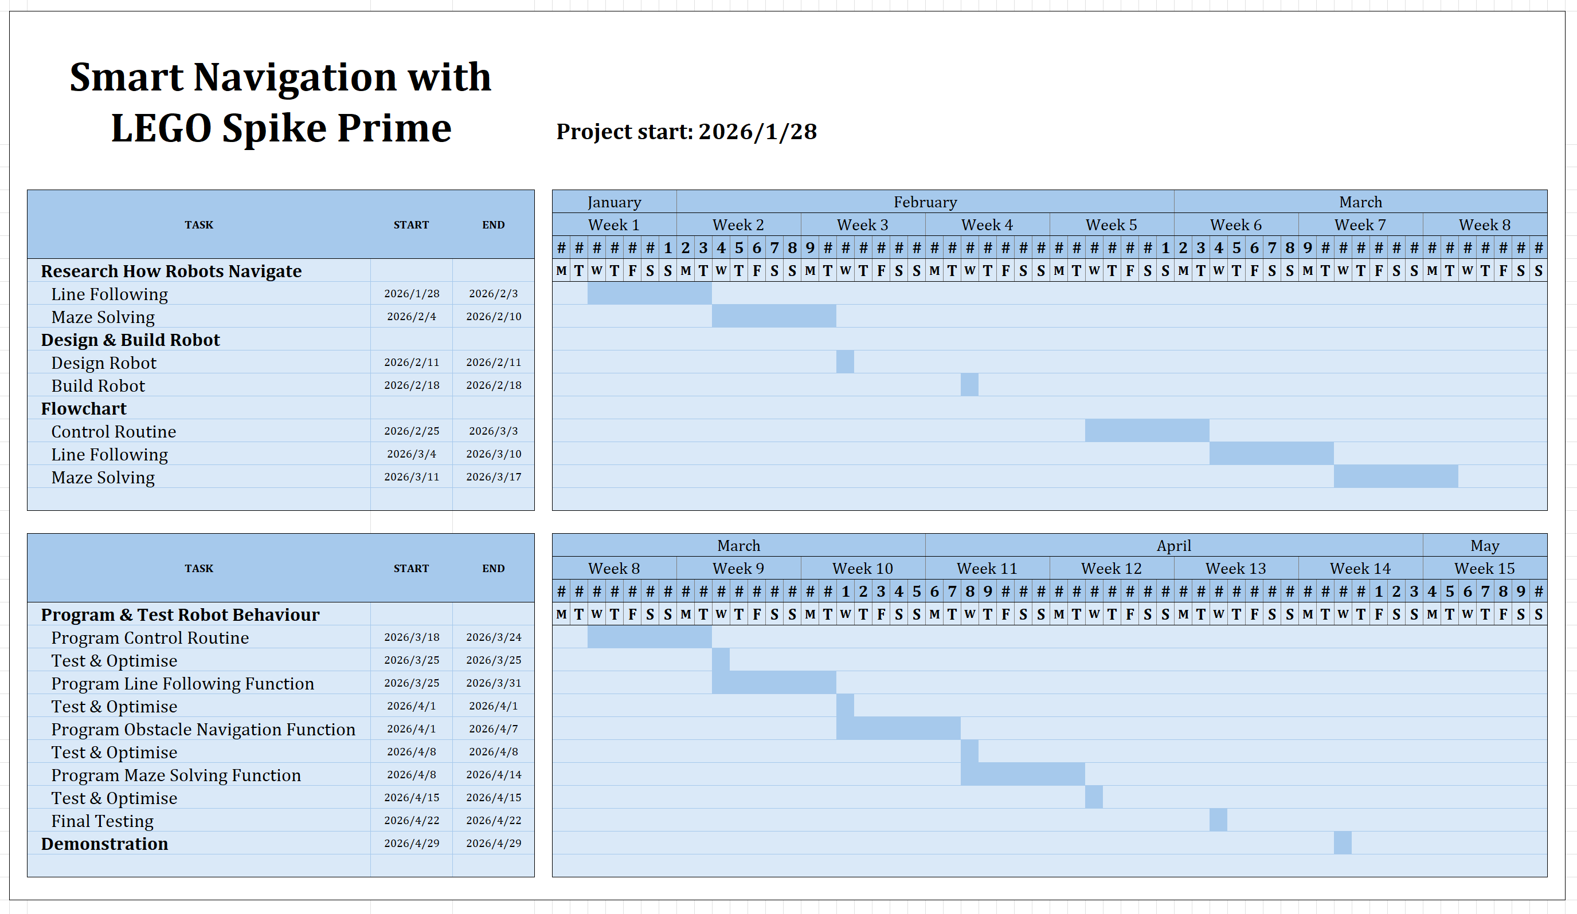
Figure 6 ~ Gantt Chart Depicting Structure and Schedule of Project

Robot Design
The robot uses two wheels, attached to the Medium Angular Motors, for propulsion. The accelerometer and gyroscope in the Programmable Hub allow the robot to track its rotation, which was used to program the robot to make set degree turns.
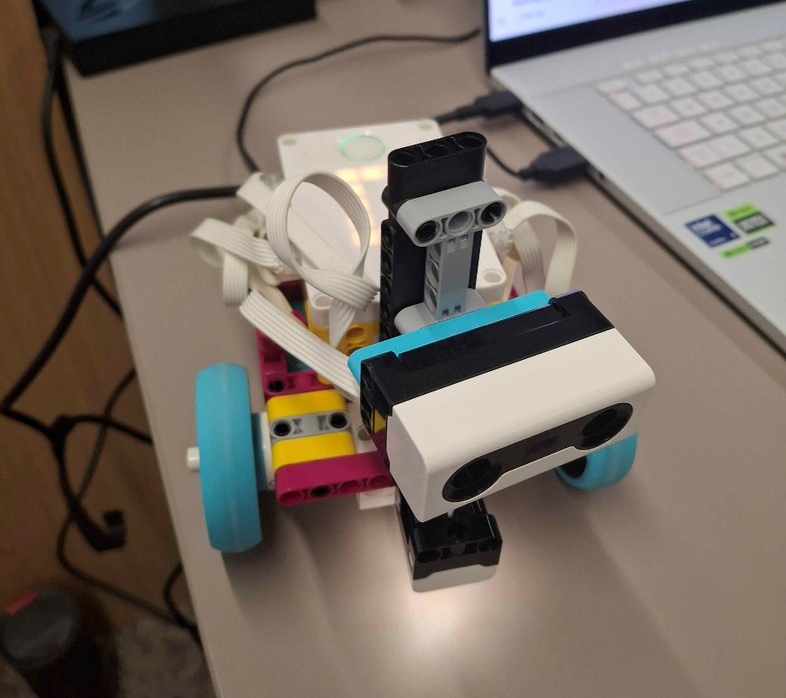
The Colour Sensor was mounted below the robot, at the front, allowing it to detect the line during the line following sequence, as well as to detect the entrance to the maze and the finish line at the end of the course.
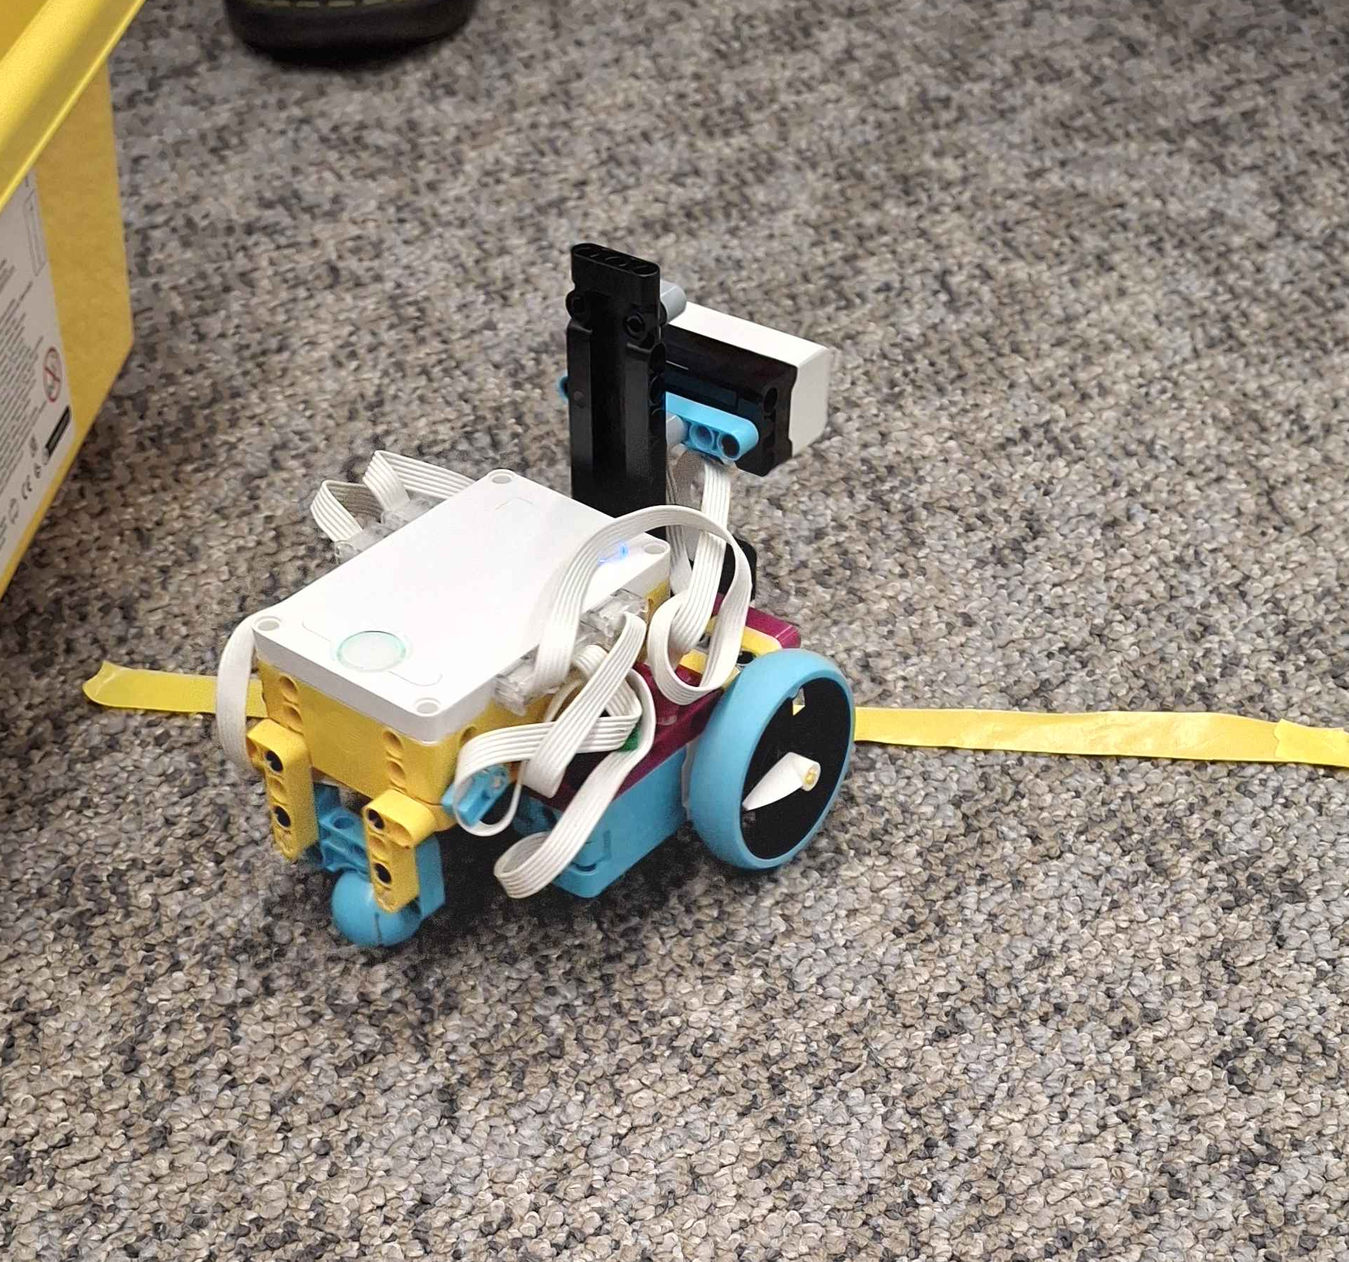
Finally, the Distance Sensor was mounted on a “neck”, connected to the Large Angular Motor, allowing it to swivel left and right. This was used to detect obstacles during the line following sequence and to detect available paths during the maze solving sequence.
The force sensor was deemed unnecessary to complete the course and so was not used, as to reduce the cost and complexity of the robot.

Figure 7 ~ Photographs of the Completed Robot

Programming
The team decided to use Spike Prime’s Code Blocks language to program the robot. The code was separated into a main control routine and three sub-routines, or functions. This modularity allowed functions to be re-used in multiple parts of the program, without duplicating code, and made it easier for changes and optimisations to be made efficiently. It also allowed the team to work more collaboratively. Important values such as the power assigned to different motors, the speed of the robot and wait timers were stored in variables so that the different functions could easily reference and update them, when needed.
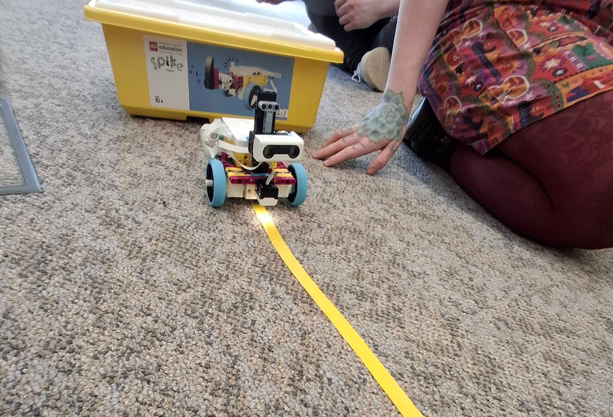
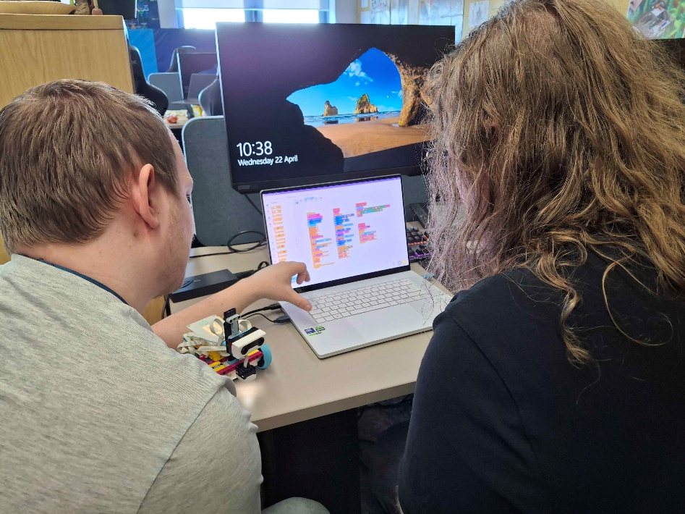
Each function was tested and optimised systematically by placing the robot in scenarios designed to mimic different stages of the final course. As the robot completed these mock scenarios with varying degrees of success, each team member was able to make suggestions for how the robot’s behaviour could be optimised. Different members of the team could then take turns attempting to implement these changes into the function that was currently being tested and then sync those changes back to the robot for further testing. This allowed for rapid-pace, iterative improvement of the code.
Figure 9 ~ Two Members of the Team Examine the Code
Figure 8 ~ Testing the Line Following Function

Conclusion
Initially there were some complications with communication and collaboration between team members, which caused delays in the design and programming of the robot. This was exacerbated by two team members being temporarily split off into a separate group and one member of the team being requited to take extended leave of absence, due to an injury, during some of the programming stages. Despite these setbacks, the team was able to complete the project and deliver the demonstration on time.
The robot was able to complete the line following sequence successfully but required manual intervention during the maze navigation phase, as it would get caught on the walls of the maze and had no mechanism to straighten itself out. However, once being put back on course, it was able to navigate the rest of the maze and come to a successful stop at the finish line.
Though it didn’t cause problems during the demonstration, the team were unable to implement the ability for the robot to recover from a dead-end scenario with walls on both sides. This would have required significant refactoring of the code but would have given the robot the ability to navigate more complex mazes.
Another limitation of the robot is that the program only allowed it to make 90 degree turns. This was a reasonable limitation, since the demonstration course only contained 90 degree turns. However, as noted above, it meant the robot was unable to recover if it went off course. This could perhaps have been mitigated by using the internal accelerometer in the hub to monitor the robot’s rotation and to make fine-tune adjustments when it measured and unexpected value.
The team agreed that the Code Blocks ended up being restrictive and unintuitive and that they would have found Python easier to work with.
These lessons should prove valuable to each of the team members in future projects.

References

[1] | O. Michalec, C. O’Donovan and M. Sobhani, “What is robotics made of? The interdisciplinary politics of robotics research.,” Humanities & Social Sciences Communications, vol. 8, 8 March 2021.
[2] | S. K. C. Tulli, “Motion Planning and Robotics: Simplifying Real-World Challenges for Intelligent Systems,” International Journal of Modern Computing, vol. 7, no. 1, pp. 57-61, 2024.
[3] | Enterprise Innovation, “LEGO Education unveils new hands-on learning product for classrooms,” 3 April 2019. [Online]. Available: https://www.proquest.com/trade-journals/lego-education-unveils-new-hands-on-learning/docview/2202614903/se-2. [Accessed 25 May 2026].
[4] | LEGO Education, “SPIKE Prime Technical Specifications: Technic Large Hub,” 2019. [Online]. Available: https://assets.education.lego.com/v3/assets/blt293eea581807678a/bltf512a371e82f6420/5f8801baf4f4cf0fa39d2feb/techspecs_techniclargehub.pdf?locale=en-us. [Accessed 25 May 2026].
[5] | LEGO Education, “SPIKE Prime Technical Specifications: Technic Color Sensor,” 2019. [Online]. Available: https://assets.education.lego.com/v3/assets/blt293eea581807678a/blt62a78c227edef070/5f8801b9a302dc0d859a732b/techspecs_techniccolorsensor.pdf?locale=en-us. [Accessed 25 May 2026].
[6] | LEGO Education, “SPIKE Prime Technical Specifications: Technic Distance Sensor,” 2019. [Online]. Available: https://assets.education.lego.com/v3/assets/blt293eea581807678a/blt64c2b9534cf10f68/5f8801b8bc43790f5c4389ea/techspecs_technicdistancesensor.pdf?locale=en-us. [Accessed 25 May 2026].
[7] | LEGO Education, “SPIKE Prime Technical Specifications: Technic Force Sensor,” 2019. [Online]. Available: https://assets.education.lego.com/v3/assets/blt293eea581807678a/blt23df304b05e587b2/5f8801ba721f8178f2e5e626/techspecs_technicforcesensor.pdf?locale=en-us. [Accessed 25 May 2026].
[8] | LEGO Education, “SPIKE Prime Technical Specifications: Technic Large Angular Motor,” 2019. [Online]. Available: https://assets.education.lego.com/v3/assets/blt293eea581807678a/bltb9abb42596a7f1b3/5f8801b5f4c5ce0e93db1587/le_spike-prime_tech-fact-sheet_45602_1hy19.pdf?locale=en-us. [Accessed 30 May 2026].
[9] | LEGO Education, “SPIKE Prime Technical Specifications: Technic Medium Angular Motor,” 2019. [Online]. Available: https://assets.education.lego.com/v3/assets/blt293eea581807678a/blt692436dd1e8fa71c/5f8801d5c8a27c1d9614c27e/techspecs_technicmediumangularmotor.pdf?locale=en-us. [Accessed 30 May 2026].
[10] | M. Pakdaman and M. M. Sanaatiyan, “Design and Implementation of Line Follower Robot,” in Second International Conference on Computer and Electrical Engineering, Dubai, 2009.
[11] | I. F. Fahmi and D. J. Suroso, “A Simulation-Based Study of Maze-Solving-Robot Navigation for Educational Purposes,” Journal of Robotics and Control (JRC), vol. 3, no. 1, pp. 48-54, 2022.

