Wanza Truck Wash, LLC Business Plan
By Andzhela Toneva
Student ID: 2217837
Course: Business Management
Module: Entrepreneurship LCBB 5001 Birmingham
Module leader: Masud Ibrahim

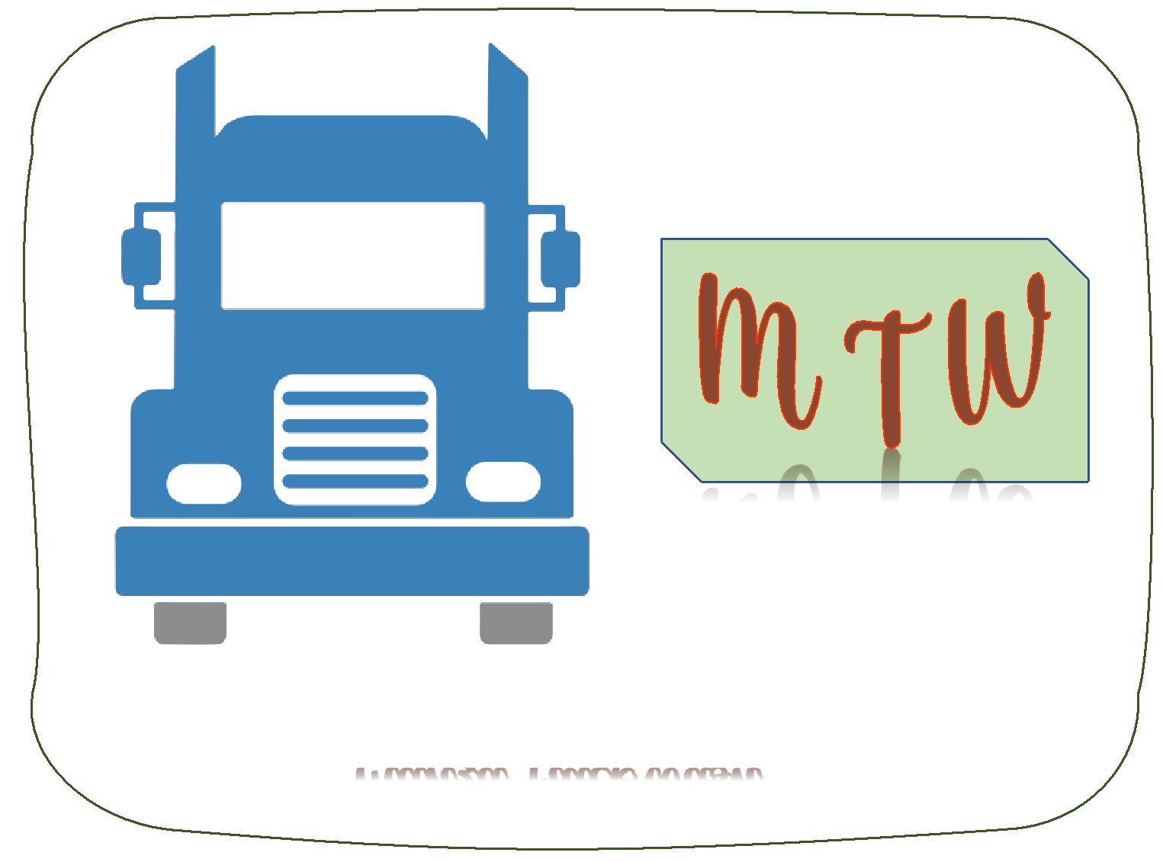

Contents
1 Business Idea Overview 3
1.1 Business Description 3
1.2 Products/Services 3
1.3 Mission Statement 5
1.4 Vision Statement 5
1.5 Business Objectives 5
2 Legal Format 5
3 Management of the Company 6
3.1 Owner 6
3.2 Employees 7
4 PESTEL Analysis 8
5 Marketing Mix 9
5.1 Product 9
5.2 Price 9
5.3 Place 9
5.4 Promotion 10
6 Financial Projections 10
References 15

Wanza Truck Wash Business Plan

Business Idea Overview

Business Description
Wanza Truck Wash is a new truck washing and detailing company targeting the large and growing trucking industry in the UK. As of 2022, road transport accounted for 89% of all inland freight movement in the UK, with over 198 billion tons-kilometers transported (Logistics UK, 2023). With over 524,000 heavy goods vehicles registered and in circulation, trucking represents a £15.2 billion industry (Statista UK, 2022). This essential sector keeps the UK economy moving, transporting everything from raw materials to finished products across the country.
As trucking activity continues to expand year over year, the need for convenient and quality truck care services has increased as well. However, current options for truck washing and detailing remain limited, especially along certain major highway routes. By positioning ourselves along one underserved route between Birmingham and Liverpool, Wanza Truck Wash will fill an important niche. Through focus on a differentiated strategy and blue ocean mindset, we have identified this opportunity to provide an innovative mix of essential and premium truck washing services in a highly convenient location.
Forecasts suggest the UK trucking industry will expand at a 1.9% CAGR over the next five years (Logistics UK, 2023). This translates to over £2 billion in new revenue opportunities for adjacent sectors supporting trucking operations. Our specialized truck cleaning services are poised to capture a share of this growth by saving truckers time while keeping their vehicles looking professional. By leveraging key small business concepts including competitive advantage, customer intimacy, and value innovation, Wanza Truck Wash aims to achieve strong market penetration within three years. Our vision is to then replicate this model across the UK, bringing quality truck washing services to all major transportation routes.

Products/Services
Wanza Truck Wash will offer a range of truck washing and detailing services to meet the needs of drivers at every level. The services will be offered in terms of three packages:
- Basic Wash: External wash and rinse for tractors and trailers
- Premium Wash: Basic wash plus tire/wheel cleaning and interior vacuuming
- Detailing: Thorough external hand wash, wax, interior deep clean, etc.
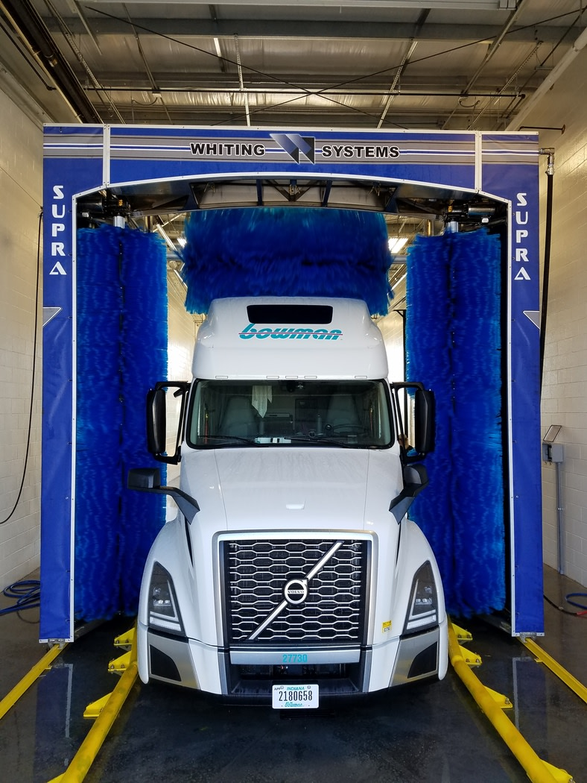
Our basic wash is targeted at truckers needing a quick but thorough external clean before getting back on the road. This 15-minute wash cleans the entire tractor and trailer using high-powered pressure washers. Detergent, brushes, and commercial drying equipment are utilized to clean even the toughest dirt from a truck’s exterior.
For those needing extra care, our premium wash adds several services, including scrubbing and polishing wheels/tires, vacuuming truck interiors, and using protectant on tires for added shine. This produces a sparkling clean truck inside and out. Our 30-minute premium wash enhances a truck’s appearance while also cleaning areas prone to collect damaging dirt and debris over long hauls.
Truckers wanting that true showroom look can upgrade to our detailing package. This multi-hour, hand-done service includes the latest techniques and products from the auto detailing industry adapted for big rigs. Acid-free cleaners give paint extra clarity and wax protection. Tires, wheels, chrome and interior all receive individualized attention from our staff, who are trained to clean every nook and cranny. This service leaves trucks literally shining and helps maintain vehicle value. Regular detailing can also aid mechanical inspection, as leaks, damage or other issues become more visible.

Mission Statement
To provide convenient, high-quality truck washing services to truck drivers along major transportation routes. Our priority is saving truckers’ time while keeping their vehicles looking professional.

Vision Statement
To be the premier trucks wash company in the UK, with locations providing quality washing services along all major highway routes.

Business Objectives
Our core goal is to make Wanza Truck Wash the leading dedicated truck cleaning provider in the UK, serving routes with the highest freight traffic levels. We aim to provide the best-in-class services’ meeting this industry’s unique cleaning needs.
Specific objectives within the first three years of operations include:
- Achieve 150+ weekly truck washes by Year 1
- Reach £8,000 in average monthly revenues by Year 1
- Expand to second location by Year 3
- Maintain at least 20% profit margin across all services
- Develop an employee training program to optimize wash quality
- Implement customer loyalty program with over 100 regular members
- Receive “Excellent” rating on over 80% of customer reviews

Legal Format
Properly understanding and complying with relevant UK legislation will be critical for our truck wash business across several regulatory domains.
Legal Registration - Forming as a limited liability company (LLC) will formally register Wanza with Companies House and legally separate our business assets from personal ownership. Registering for taxes with HMRC will also be necessary to properly account for VAT liabilities and income tax around our projected £80,000 first-year turnover. We will complete all required company filings.
Consumer Protection - As a customer-facing business, the Consumer Protection from Unfair Trading Regulations 2008 require we avoid misleading promotional claims about our truck washing services (McConnell, 2013). Clear service menus, pricing and disclosures on membership terms must be shared upfront with customers to foster transparency. Data privacy protocols will adhere to GDPR rules on securely collecting and retaining any driver information.
Environmental - Our truck washing operations carry environmental obligations around proper water use and disposal under the Environmental Permitting Regulations 2016. We are submitting the necessary application to the Environment Agency to obtain approval of our drainage plans for redirecting used wash water into approved recycling tanks rather than the public system. Monitoring discharge quality standards and submitting compliance reports will be essential ongoing.
Health and Safety - As an industrial business with heavy machinery and chemical handling, following the Health and Safety at Work Act 1974 is imperative for employee welfare. We are developing risk assessments and safe operating procedures for all truck washing tasks, equipment operation, chemical storage/handling and on-site vehicle movement around employees. Mandatory job training, safety gear and warning signage will be implemented, along with strict reporting procedures for any injuries or incidents (Bazan-Bulanda, 2019).
By thoroughly understanding these compliance areas upfront rather than reacting later, we can build regulatory adherence into all facets of our truck wash operating model. This helps ensure we avoid any violations that would damage our business, employees or the environment. We have budgeted for legal and consulting fees to assist with achieving full compliance from the outset.

Management of the Company

Owner
Wanza Truck Wash will be co-owned by me and my partner, bringing complementary skillsets as leaders to ensure smooth operations and sustainable growth. As Oivo (2019) highlights, having co-founders with both business management expertise and industry-specific operational experience is an ideal partnership for small startups to scale successfully.
I will serve as the General Manager, overseeing all administrative aspects including marketing, business development, hiring and legal compliance. My past experience managing three auto detailing franchises for over a decade positions me well to handle these duties. The most successful small business owners often start by managing within a related industry first before venturing out independently (Oivo, 2020). I exemplify this track record.
Meanwhile, Efrain will serve as Operations Manager given his 30+ years working in the trucking industry and spearheading major logistics initiatives. His focus will be on managing daily wash services, staff, equipment maintenance and quality assurance. As Marcon and Ribeiro (2021) advise, having structured procedures and protocols in place enables small service businesses to deliver consistent, high-quality results as they grow. Efrain will develop these to optimize efficiency.

Employees
In terms of staffing, we will hire on a contract basis experienced truck wash technicians to assist with cleaning duties during our 24/7 operating hours. By outsourcing workers in this way rather than taking on full employees initially, we avoid excessive HR burdens and can flex staff levels to match demand (Du Toit & Heinecken, 2021). We will also utilize accounting and legal professional services firms to handle our finances, taxes, and compliance rather than hire specialized internal roles right away. Regularly outsourcing specialized functions is an economical way for small businesses to remain lean.
As per our growth objectives, we will assess bringing select roles like operations supervisors and marketers in-house once our location reaches over 100 member accounts and £150,000 in annual revenue. This threshold indicates our management capacity needs expansion.

PESTEL Analysis
Political
- Recent environmental policies encourage cleaner vehicles, raising demand for washing
- Transportation regulations and taxes on freight industry could negatively impact routes/traffic
- Potential for stricter EPA-equivalent enforcement of truck wash water runoff

Economic
- Rising fuel prices may cut into trucking profits, limiting budgets for non-essential truck washes
- Inflation could also curb spending on truck washing and detailing services
- However, our low-cost basic washes appeal even in difficult economic periods
- Continued growth of UK trucking industry will provide customer base

Technological
- Advances in truck washing equipment improves efficiency of water and detergent use
- Pressure washer innovation allows matching diesel-powered washing strength
- Online platforms can streamline appointment booking and payment

Social
- Increased environmental consciousness from consumers means preference for eco-friendly brands
- Emphasis on vehicle appearance and customization is rising trend with truckers
- Truck wash employees require fair wages and safe working conditions

Legal
- Business permits/licenses for truck wash facilities
- Compliance to environmental regulations on water use and runoff disposal
- Proper insurance coverage, given workplace hazards

Environmental
- Managing truck wash runoff properly essential to avoid pollution issues
- Water drainage and recycling systems a priority investment
- Use of non-toxic, biodegradable cleaning solutions

This PESTEL analysis highlights key external factors across six domains that can impact the viability and operations of our UK-based truck wash business. We will monitor these influences closely and continually adapt our strategy to leverage opportunities and overcome threats within each area.

Marketing Mix

Product
- Our core offering includes essential and premium truck washing services
- Range from basic exterior wash to comprehensive detailing packages
- Bundled memberships allow drivers to access an array of services

Price
- Competitively priced per wash starting at £20 for basic wash
- Bulk discounting available via prepaid monthly membership plans
- Loyalty program provides points towards free or discounted washes

Place
- Located in prime spot along major trucking route near Birmingham
- Easy highway access and sufficient parking/queuing space
- Potential to open satellite mobile wash trucks at truck stops

Promotion
- Trade magazine ads in trucking/logistics publications
- Flyers, coupons at nearby truck stops catering to drivers
- Social media accounts and online directories to aid web discovery
- Referral rewards incentivize existing customers to share with others
This marketing mix will convey our unique value proposition as a specialized truck wash catering to drivers’ needs for convenience and quality. Our location and range of services address key pain points for truckers in keeping their vehicles properly maintained. Competitive membership rates and loyalty programs promote repeat business even on tight budgets. Multiple online and offline methods will raise ongoing awareness with truckers frequently travelling through the region.

Financial Projections
Based on market research of current industry figures, we estimate first year revenues averaging £8,000 per month, driven by an average of 150 truck washes weekly at an average price of £70. This factors in 60% uptake of premium services priced at £85. With operating expenses forecasted around £5,000 monthly, including labor, utilities, licensing and other overheads, we project achieving over 20% profit margins within the first year of operations. Our startup budget is capped at £25,000, funded by the owners’ investments. The following 12-month cash flow forecast estimates when this will be expended across different startup costs and operating expenses as revenues commence. Profitability is expected by Month 4.
Startup Resource Allocation
The table below shows the breakdown of how the £25,000 in available startup funding will be allocated across the major expense categories to launch Wanza Truck Wash. Equipment purchases represent the largest share at 40% based on costs of pressure washers, water treatment systems, and cleaning tools. The next highest allocation is labor at 30%, covering contract wash technicians.

Table 1: Startup Resource Allocation
Resource | Percentage Allocation
Equipment | 40%
Licensing & Permits | 6%
Lease & Utilities | 12%
Labor | 30%
Marketing | 5%
Other Overheads | 7%

Monthly Marketing Budget
This table summarizes the monthly marketing spend during the first year of operations. The highest portion at 40% is allocated to trade magazine advertising to target trucker publications. The next 30% covers promotional flyers and coupons to distribute at local truck stops. The remaining budget is split between online directories, website costs and sponsored social media posts.
Table 2: Monthly Marketing Budget
Marketing Activity | Percentage budget
Trade Magazines Ads | 40%
Truck Stop Flyers/Coupons | 30%
Online Directories | 10%
Website | 10%
Social Media | 10%
Break-Even Forecast- Based on our average revenue and costs assumptions, the break-even volume for profitability is approximately 90 truck washes per week. With projected volumes of 150 trucks per week by Year 1, we have comfortable margin to reach sustainable profit levels.
Liquidity Analysis- The cash flow forecast shows an initial £15,500 cash burn rate through equipment purchases and lease down payments before opening. But with over £9,000 still on hand, our liquidity stays sufficient prior to revenues kicking in by Month 3.
Profit Analysis- Conservatively using current industry revenue rates which already account for inflation, by Year 2 we forecast over £100,000 in net margins after all truck wash operating expenses. This funds our expansion goals while keeping the business stable.
Sensitivity Analysis- If start volumes prove 30% below projections, slowing growth, we would simply delay hiring additional staff. Our variable cost structure allows this flexibility while not hugely impacting service quality. We also have room to raise prices 10%+ if needed to improve margins during times of high inflation or supply costs.
By benchmarking to industry data, building in conservative estimates, pursuing variable cost structures and projecting realistic growth rates, our financial forecasts account for probable downside risks. The analysis shows sufficient liquidity and profitability to achieve sustainability within the first year. Ongoing monitoring of KPIs will enable adapting quickly if conditions change.

Wanza Truck Wash: 12-Month Cash Flow Forecast
Month | 1 | 2 | 3 | 4 | 5 | 6 | 7 | 8 | 9 | 10 | 11 | 12 | Total
Revenue | £0 | £0 | £6, 500 | £8, 000 | £8, 000 | £8, 000 | £8, 000 | £8, 000 | £8, 000 | £8, 000 | £8, 000 | £8, 000 | £80, 500
Equipment | -£10,000 | - | - | - | - | - | - | - | - | - | - | - | -£10,000
Licensing & Permits | -£1,500 | - | - | - | - | - | - | - | - | - | - | - | -£1,500
Lease & Utilities | -£1,000 | -£1,000 | -£1,000 | -£1,000 | -£1,000 | -£1,000 | -£1,000 | -£1,000 | -£1,000 | -£1,000 | -£1,000 | -£1,000 | -£12,000
Labor | -£2,000 | -£2,000 | -£1,500 | -£1,500 | -£1,500 | -£1,500 | -£1,500 | -£1,500 | -£1,500 | -£1,500 | -£1,500 | -£1,500 | -£18,000
Marketing | -£500 | -£500 | -£500 | -£500 | -£500 | -£500 | -£500 | -£500 | -£500 | -£500 | -£500 | -£500 | -£6,000
Other Overheads | -£500 | -£500 | -£500 | -£500 | -£500 | -£500 | -£500 | -£500 | -£500 | -£500 | -£500 | -£500 | -£6,000
Net Cash Flow | -£15,500 | -£4,000 | £3,000 | £4,500 | £4,500 | £4,500 | £4,500 | £4,500 | £4,500 | £4,500 | £4,500 | £4,500 | £26,500
Cumulative | -£15,500 | -£19,500 | -£16,500 | -£12,000 | -£7,500 | -£3,000 | £1,500 | £6,000 | £10,500 | £15,000 | £19,500 | £24,000

References

Bazan-Bulanda, A., 2019. Impact of occupational health and safety regulations on the employee's decision to take up employment. System Safety: Human-Technical Facility-Environment, 1(1), pp.141-148.
Du Toit, D. and Heinecken, L., 2021. Is outsourcing better? Clients' views on contracting in domestic cleaning services. Employee Relations: The International Journal, 43(5), pp.1147-1162.
Logistics UK. 2023. UK Logistics Sector M&A Index 2024. Logistics.org.uk. https://logistics.org.uk/executivemembership/insight-and-information/news-and-information/insight-reports/logistics-report-1-1
Marcon, A. and Ribeiro, J.L.D., 2021. How do startups manage external resources in innovation ecosystems? A resource perspective of startups’ lifecycle. Technological Forecasting and Social Change, 171, p.120965.
McConnell, S., 2013. Consumer Protection from Unfair Trading Regulations 2008—What Constitutes a Commercial Practice? R v X Ltd [2013] EWCA Crim 818. The Journal of Criminal Law, 77(5), pp.365-370.
Tripathi, N. and Oivo, M., 2020. The roles of incubators, accelerators, co-working spaces, mentors, and events in the startup development process. Fundamentals of software startups: Essential engineering and business aspects, pp.147-159.
Statista UK. 2022. 3PL revenue in the UK. Statista.
https://www.statista.com/statistics/1270808/3pl-revenue-united-kingdom/

