
advancing characters
ADVANCING CHARACTER ANIMATION

andrew davis
2220233
ACCA5038

Contents

Link to Animation
https://youtu.be/d845K_mZZ94?si=i8IhpYeVEdYulwGw

Research Material

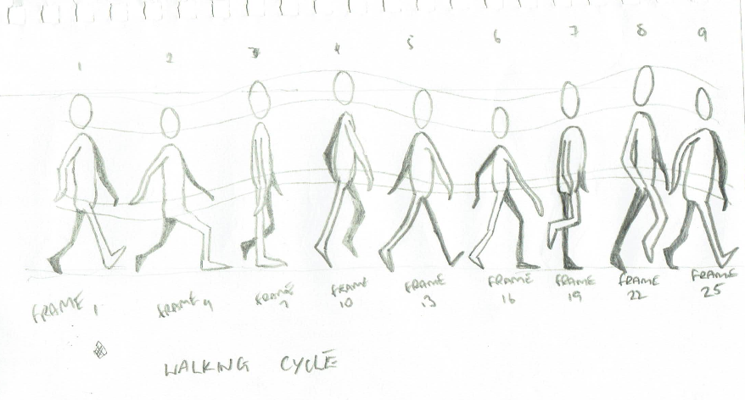

References and Bibliography

[1] A. Salsberg, “The 12 Principles of Animation | Lesley University,” Lesley.edu, 2019. https://lesley.edu/article/the-12-principles-of-animation
[2] “Moonwalk in Maya,” www.youtube.com. https://www.youtube.com/watch?v=gtnWksWWPn0
[3] “hogan animation maya moonwalk,” www.youtube.com. https://www.youtube.com/watch?v=ZS7yAbGn0K4
[4] “Maya Moom - walk cycle,” www.youtube.com. https://www.youtube.com/watch?v=szFQivMJAj8
[5] “Maya MoonWalk,” www.youtube.com. https://www.youtube.com/watch?v=UcEvl8XyPVY
[6] “Moonwalk Animation Cycle - Maya,” www.youtube.com. https://www.youtube.com/watch?v=Jhhx_AVFXww
[7] “Michael Jackson - The First Moonwalk (1983),” www.youtube.com. https://www.youtube.com/watch?v=EHdctcgVarg
[8] “Michael Jackson - Billie Jean - Motown 25th Anniversary - HD,” www.youtube.com. https://www.youtube.com/watch?v=fR2WFQRbP3g
[9] “Michael Jackson’s Longest Moonwalk,” www.youtube.com. https://www.youtube.com/watch?v=Iz4Vc83ZtP4
[10] “Michael Jackson Billie Jean Moonwalk Evolution (1983-2009) | High Quality,” www.youtube.com. https://www.youtube.com/watch?v=bCsjvYmnc58
[11] “Moonwalk Tutorial,” www.youtube.com. https://www.youtube.com/shorts/LGjGib4RRyE
[12] M. Jackson, “Michael Jackson - Smooth Criminal (Official Video),” YouTube. Nov. 19, 2010. Available: https://www.youtube.com/watch?v=h_D3VFfhvs4
[13] “Michael Jackson smooth criminal gravity lean,” www.youtube.com. https://www.youtube.com/shorts/ibDb9QF3gf8
[14] “Michael Jackson Anti Gravity Dance Move 🔥😱😱😱🧐 #michaeljackson #antigravitydancemove #shorts,” www.youtube.com. https://www.youtube.com/shorts/rTfwQnpwR1c
[15] “Animate a Walk Cycle for Beginners: Scene Set Up in Maya,” www.youtube.com. https://www.youtube.com/watch?v=1fauGW7MU4U

‌

