INFORMATION ENGINEERING
-Second Term-

STUDENT NAME: Andrei-Daniel Mihai
STUDENT ID: 1912494

LECTURER: MD. Sadeque Shaikh

Table of contents.

STAR UML print screen of ERD ……………………………………………………………………………… 2
Description of the Company ERD…………………………………………………………………………… 2
Part2. Microsoft Access Data Base Screen Shot……………………………………………………...3

In the figure Fig.1 we will have the Entity Relation Diagram of a company name Universal Sports.
In this diagram, we will see the relationships between the entity, and I will explain each of the individual.

Fig.1
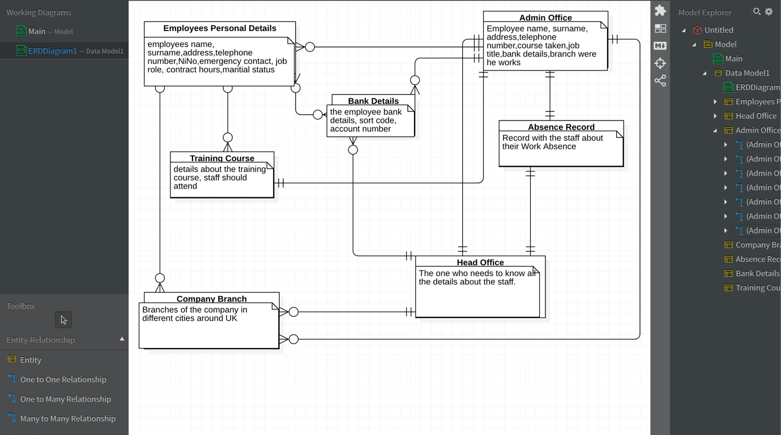

In the above figure, we have the ERD of the company we mentioned at the beginning of this assignment.
We can see the first entity (Employees personal Details). This entity contains all details about all the employees (swimming instructors, fitness instructors and casual staff).
After Employee detail we have Admin Office relationship. Head office relationship need to have all the details about the employee, in order to proceed with their payment, training course etc.
The relationship between those two is a ONE (Admin Office) to MANY (Employees).

Another entity will be Head Office, who is the first and the most important management centre. Here are stored most of the information about everything. We will have another 4 entities which are : company branches ( who represents all 6 centres in the whole UK), training course (who will have details about staff if they are updated with their training and if they are or not first aiders), bank details of the employees (which is very important because, at the end of the month people needs to be paid) and the last one but also important the Absence Record (who will keep a track on the absence of the employees).

After we named and we talk about all those entities, we need to see how those are linked between them.

The Admin staff will have the following relationships with the following entities:
Admin Office – Head Office – One to One Relationship (one admin office one head office).
Admin Office – Bank Details – One to Many relationship (one admin office many banks).
Admin Office – Company Branches – One to Many Relationship (one admin office 6 different branches).
Admin Office – Absence Record – One to One Relationship (one admin office to one absence record).
Admin Office – Training Course – One to one Relationship.

Bank details has 3 relationships – with the admin office and the head office has a one to many relationships and with the employee’s entity has a many to many relationships.

Company Branch – has 3 relationships, two of them being one to many (with the admin office and head office) and a many to many with the employees.

Part2.

For the second part of our assignment we have to create a data base using Microsoft Access.
I will attach a few print screens from my project in this word file, just to mention that the whole Microsoft Access data base I submitted on the smart link that was provided.

Fig.2 – Employees details table.

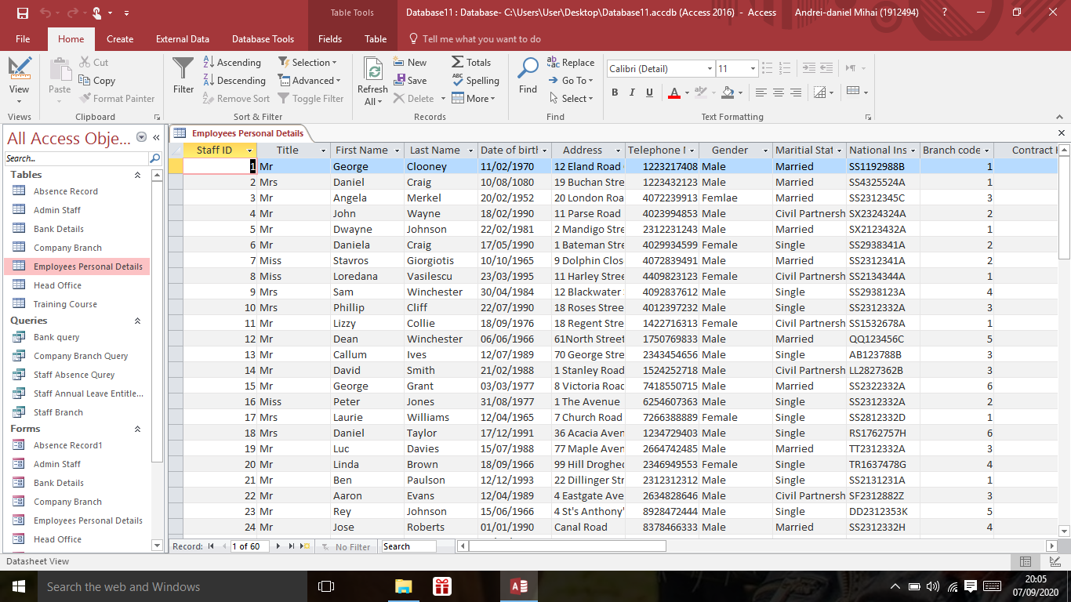

Fig.3- Head office design view table.

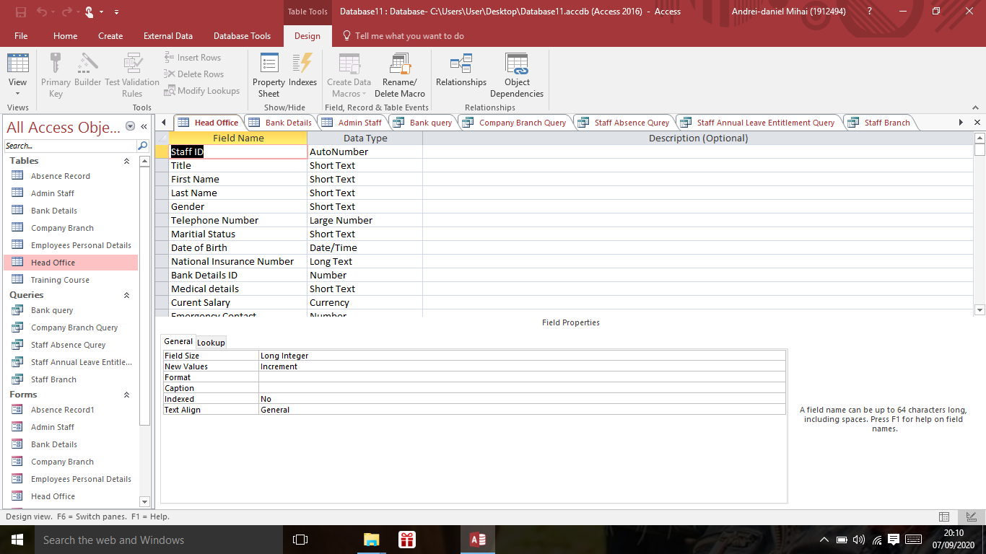

Fig.4 – Bank details table.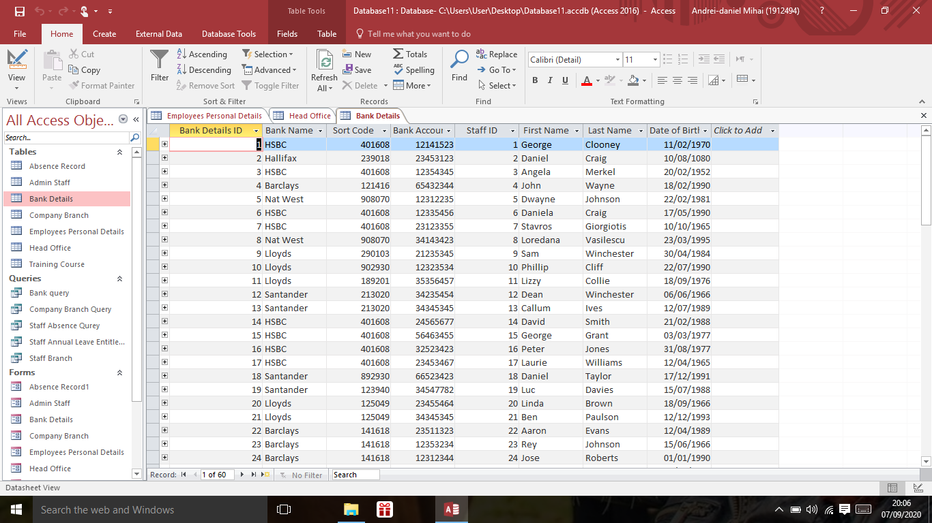

Fig.5 – Admin office table.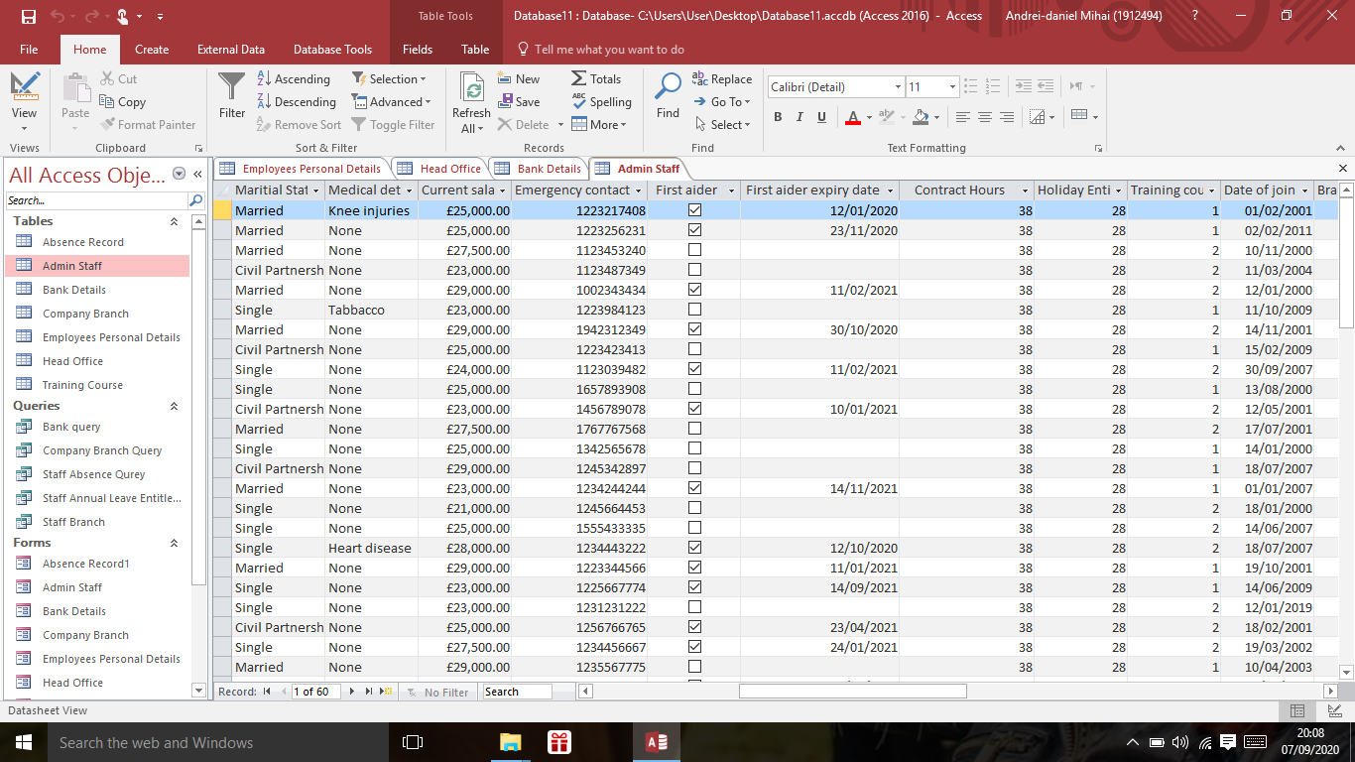

Fig.6 – Bank query.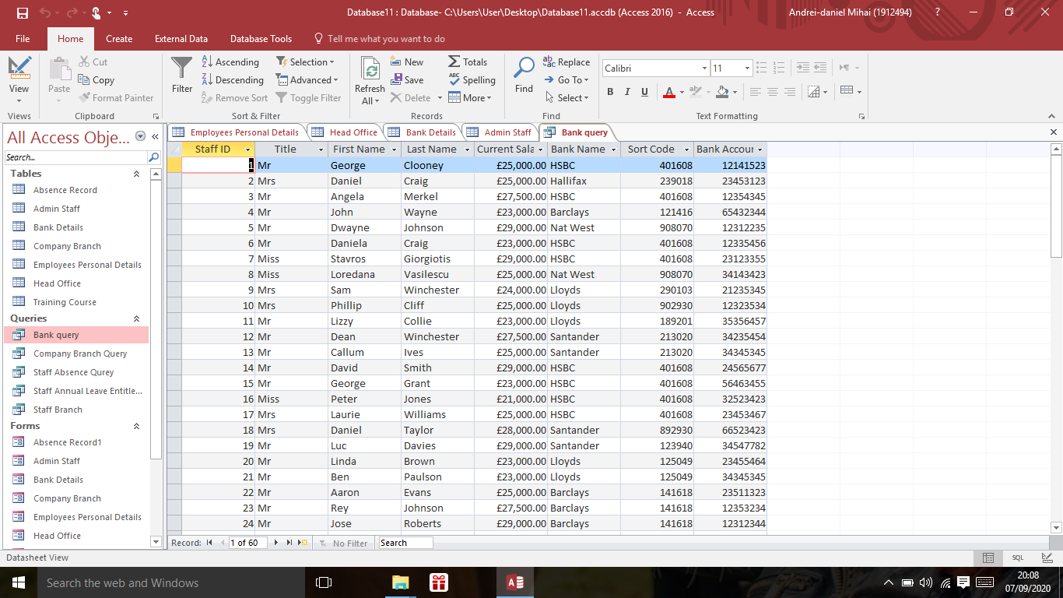

Fig.7 – Employees medical record.

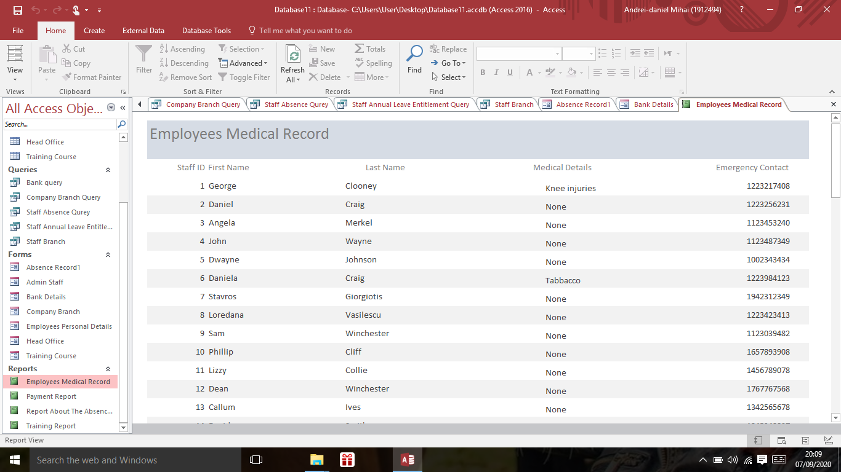

Fig.8- Bank details Form.
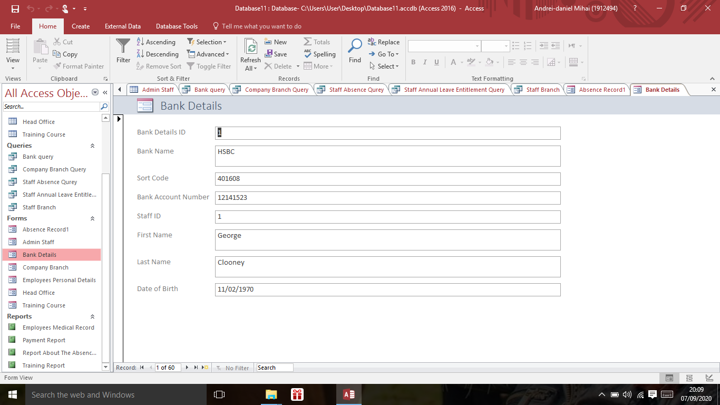

Fig.9 – Payment Report.

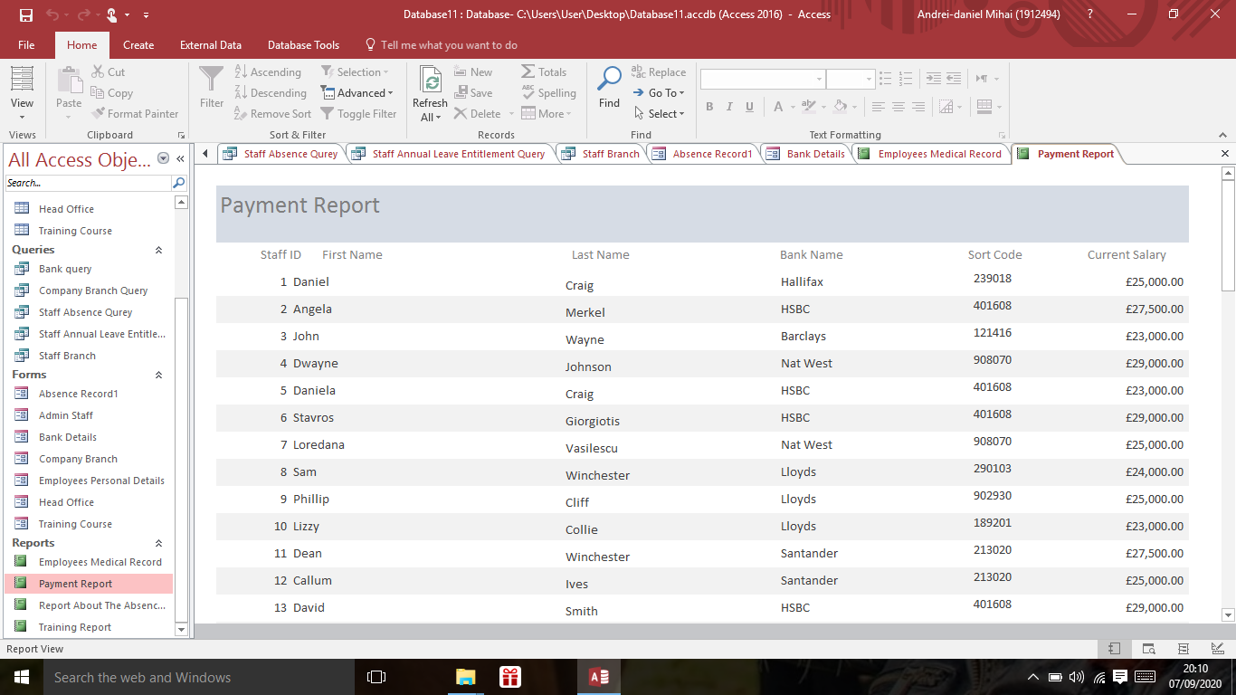

Fig.10 – Relationships


