

Programme: MSc Public Health and Social Care in Practice
Module: Health Care System Organisation and Leadership
Module code: LCHS7002
Assignment title: Case Study Analysis Report

Student name: Galina Bleidere
Student ID: 2244841
Lecturer name: Pascal Navelle

Table of Contents
1. Introduction 3
2. Main Body and Analysis 4
2.1 Identifying the Problem and Setting the System Context- Applying Systems Thinking and
the Rich Picture 4
2.2 Centralisation or Decentralisation within the Case Study 6
2.3 Leadership Theories and Applied to the Case Study 9
2.4 Improvement and Lessons Learned 12
3. Recommendations 14
4. Conclusion 16
5. References 17

6. Appendix ................................................................................................................................... 18

1. Introduction
This report presents the example of an unintentional overdose of morphine sulphate oral solution of Len, an elderly 89-year-old man with a medical condition known as Charcot-Marie-Tooth (CMT) disease, that was investigated by the Healthcare Services Safety Investigation Branch (HSSIB). Len was taken to the hospital and medically examined by his general practitioner (GP), and after falling and feeling pain in the chest and being out of breath, he was issued with morphine oral solution to aid him in relieving his pain (De Grado et al., 2025). However, the drug label was read incorrectly by Len and his wife, who, in an act of posing knowingly, took a lot of medication rather than the intended dose. Len was discovered in an unconscious state the next morning and was admitted into the hospital with a possible morphine overdose, pneumonia, and progressive CMT. He became better, but eventually became worsened, and he died. Then, the HSSIB inquiry revealed that all the factors interacted, leading to a breakdown in communications, medication labelling, patient understanding and the vulnerability of the whole system, but not one person’s mistake (Crompton et al., 2025; Macrae, 2025). The case illustrates the significance of patient safety, effective communication, learning in an organisation and excellent leadership in health and social care services (Payane et al., 2024; Crompton et al., 2025)
Achieving common goals, providing safe, effective, and person-centred care, and persuading people and the multidisciplinary staff may be considered the key characteristics of health and social care leadership (McCormack et al., 2021). Effective leaders develop a vision, empower teamwork, promote ongoing learning and establish an organisational culture in which patient safety is the central focus (Berisha et al., 2024). In various organisations, there are various leadership styles that would be suitable. Transformational leadership inspires employees in a common vision and creativity; transactional leadership emphasises a sequence of actions, responsibility and outcomes; and situational leadership allows people to adapt their leadership approach based on the complexity of situations and the needs of individuals and groups. Various organisational structures also exist in which healthcare organisations operate. Within a centralised system, the power of decision-making is concentrated at the apex of the leadership structure, where uniformity and standardisation are advocated, with responsiveness at the frontline. By contrast, decentralised systems decentralise control over local teams, which may result in a much quicker decision-making process, more empowered employees, and better responsiveness to patient needs, but it may also be harder to ensure uniformity (Corbett et al., 2020).

2. Main Body and Analysis

2.1 Identifying the Problem and System Context: Applying Systems Thinking

and the Rich Picture
The biggest challenge identified in this case study is unintentional overdose of morphine sulphate oral solution in the case of Len, an 89-year-old man with Charcot-Marie-Tooth (CMT) disease. One day, Len had a fall and was treated with paracetamol and ibuprofen first because he felt pain in the chest and was breathless. His pain had not been controlled, and thus he was given morphine oral solution in a lower dosage by his general practitioner according to his age and renal function. The prescription itself was based on national clinical guidance, although the two labels on the bottle of morphine by the manufacturer, which Len and his wife misconnected, stated that the strength of the medicine (10 mg in 5 ml) is the dosage prescribed to the patient (Ferner et al., 2023). This resulted in Len taking a lot more morphine than planned. The label dispensing letter that was exterior and contained the proper dosage instructions was not examined. The next morning, Len did not respond and was admitted to hospital with an assumed morphine overdose, pneumonia and deteriorating CMT. He has been responsive to treatment, but his condition has subsequently worsened, and he has passed away. The conclusions of the HSSIB study found that the accident resulted from a complex system of factors, rather than a single human error (see Appendix A) (HSSIB, 2022).
It is one of a series of patient safety cases in the world regarding drug-related injuries. The World Health Organisation (WHO, 2023) reports that in every ten patients, on average, one suffers some form of injury when they seek medical care; that over 50 per cent of this injury could be avoided. The incidence of being exposed to medication-related harm is approximately one per thirty individuals, and one- quarter of all the incidents are severe or even life-threatening. The fact that about one half of all preventable patient injury can be related to medication errors is one more indication that safe medication administration is one of the uniformly low priorities of healthcare organisations on the international level (WHO, 2023).
Medication errors also have great economic and organisational impacts. According to the WHO, it is estimated that the world healthcare system incurs the world about US 42 billion every year as a result of poor medication practices (WHO, 2023). Drugs, like opioids such as morphine, which have a high risk, must have extra protection since a little misconception about dosage may cause breathing slowness, hospitalisation or even death. WHO's Medication Without Harm program, therefore, aims to improve medication safety through a variety of means, namely, making communication simpler, labelling more effective, educating patients and organisational systems (WHO, 2023). Medication safety continues to be one of the patient safety issues in England (HSSIB, 2022). HSSIB shows that the most frequent intervention provided through the services of the NHS is medication and that untimely, misplaced or wrongly taken drugs may lead to disastrous consequences, such as irreversible worsening of the conditions and even death. Even though electronic prescribing systems have also reduced the number of prescription errors, there are still cases because effective communication among dispensing pharmacists, prescribers, carers, patients and healthcare workers is a prerequisite to ensure efficient medication management. The case of Len shows that the only method of prescribing a drug or treatment cannot be helpful when patients are unable to use and interpret the prescription (Elliott et al., 2021).
The case reflects a number of systemic vulnerabilities rather than individual professional incompetence. Firstly, there existed a lack of communication between the patient and health care professionals. The GP had given the right dose, but there was no confirmation that Len and his wife knew how to take the medicine correctly. Second, the bottles with the medications carried disorienting labelling, as the manufacturer's label displaying the strength size was bigger than the one on the outside box used for dispensing directions. Thirdly, the system was based on the fact that the patients had all the information about the difference between the strength of the medicine and the dose by which they received the prescription, though they were not introduced to checking during the verbal counselling and demonstration exercise. All the interacting factors led to a number of failures and opportunities before the overdose (Elliott et al., 2021).
The patient safety incident process may be a product of people, work processes, technology and organisational structure rather than an output of the efforts of an individual in the systems thinking approach. General practice and community pharmacy, dispensing procedures, medication wrapping, family education, patient education, and patient education as well as emergency services/hospital services constituted the integrated healthcare system, in which Len lived. The inappropriate performance of one aspect was putting a strain on the other aspects. Feedback mechanisms were not good, and hence no miscommunication was witnessed until the actual point of the overdose. Therefore, the negative outcome was a multiplicity of failures at multiple phases of healthcare processes, not a single-point failure. The management that impacted this accident was mainly on a local and national level. Prescribing practice, pharmacy dispensing procedures, communication within healthcare professionals, and the roles of seeking counselling for patients were also regarded as local governance (HSSIB, 2022; Elliott et al., 2021). The standards of medication labelling, regulation of medicines, and professional policies governing patient safety were impacted by national governance. HSSIB concluded that there should be a transformation at both individual organisations and the national process of regulating medication packaging, dosing devices and learning about patient safety questions. These results show that to ensure proper governance, there should be co-ordination between frontline healthcare givers and national policy makers to ensure that unnecessary harm is minimised (HSSIB, 2022). System stresses are an added contribution to risks of drug-related accidents (Payne et al., 2024).

2.2 Centralisation or Decentralisation within the Case Study
The healthcare services involved in the care of Len were run under a hybrid organisational structure which was inclusive of both the centralisation and the decentralisation process. National bodies have set the national policies, norms of prescribing and safeguarding of medications; these include: the Department of Health and Social Care (DHSC), NHS England, the Medicines and Healthcare products Regulatory Agency (MHRA) and the professional regulators. These standards are delegated to local organisations, namely general practitioners (GPs), local pharmacies, and local clinical departments of a hospital and multidisciplinary teams. According to the HSSIB study (HSSIB,2022), with the flexibility to deliver patient-centred care in combination, the lack of sufficient coordination between the national guidance and practice in the region might be at risk of disrupting patient care due to ineffective communication, governance, and accountability (Ferlie et al., 2025).
The centralised system concentrates power in decision-making in the top management or national organisations. Through centralisation in the NHS, the development of policies, prescription, medication, clinical governance, and patient safety would be made so that they are formulated on a similar basis in England (Chesser et al., 2022). One example of centralised governance that broadened the principles of evidence-based and standardised clinical practice, as in the case of Len, was the prescribing decision of the GP, which is nationally recognised clinical guidance on opioid prescribing. In the same way, national legislation and dispensing pharmacy regulations in medication labelling aim to lessen the variations and affect patient safety positively. These standards are nationally developed to assist in making sure that patients receive uniform care irrespective of their geographical location (Chesser et al., 2022).
Among the advantages of centralisation are a host of benefits. One is that it enhances standardisation of clinical practice by national guidance, which minimises unwarranted variability in prescribing decisions and medication management. Second, it boosts governance as organisations are able to meet common regulatory requirements and professional standards. Thirdly, national oversight of learning aids in learning about a serious case of patient safety. The investigations, e.g. one that was performed by Len, can be used to recommend the NHS on a larger scale, rather than to the organisation itself. The HSSIB investigations are more strategic in pursuing learning at the system level rather than individualisation to allow improvements that can be inclusive to healthcare organisations in the country (HSSIB, 2022; Hansen et al., 2020).
However, despite these advantages, drawbacks of excessive centralisation are also exhibited in this case. Prescription guidance at an international level cannot eradicate any risks when locally improper planning is taken. Although the prescription was right, the national labelling standards still did not prevent confusion about the medicine strength, which was printed by the manufacturer and the dosage instructions printed by the pharmacy. Subsequently, compliance with national policy was not enough to help patients understand it. More so, centralised policies might fail to effectively consider the personal needs of the elderly, those with long-term neurological disorders or those of the family carers/hesitant who need extra care when using the high-risk medicines. This shows that normalisation needs to be complemented by good local communication and personal considerations.
On the other hand, decentralisation is seen to give authority in decision-making to frontline health care workers, as they treat patients at the frontline. In Len, there was decentralised decision-making in the healthcare pathway (Demir et al., 2025). The GP evaluated the symptoms of Len and planned to tailor the pain management based on his clinical case and prescribed him to take morphine based on the evaluation made. Dispensing the medication, counselling and ensuring that patients were aware of how to administer the medication in a safe manner were the work of community pharmacists (Elliot et al., 2021). On their own, the hospital clinicians appraised the situation provided by Len upon his hospitalisation and made a decision regarding what was considered to be appropriate treatment of the potential opioid toxicity, pneumonia, and complications due to the presence of Charcot-Marie-Tooth disease. In this case, the diagrams show that devolved power can help medical personnel to react quickly to the new clinical statuses (Demir et al., 2025).
The healthcare organisations have a number of benefits as far as decentralisation is concerned.
Frontline professionals learn directly about patients' clinical needs and can modify care based on those needs. There will also be a more responsive decision-making process since clinicians will not be required to consult top-level management to authorise treating somebody. Moreover, decentralisation increases the multidisciplinary nature of doctors, nurses, pharmacists and other members of the health sector in order to create a community where the experience of other disciplines could be tapped to arrive at safer decision-making in clinical practices. In patients with complex healthcare needs like Len, who is an older and vulnerable individual due to frailty and multiple health issues, personalised decision-making is needed (Elhussein et al., 2023).
But there are numerous problems with the notions of decentralisation. There are communication differences in care delivery that may arise as a result of differences in communication, experience of the staff, local practice and the organisational culture. In the case of Len, the responsibility of ensuring that he and his wife comprehended the regularly prescribed dose was shared between various healthcare providers. However, even though the process of medication was divided and every possible professional took a role in completion, nobody or any organisation could confirm that all instructions were correctly comprehended and that the medicine was taken at home. This shows a flaw in the weakness of decentralised systems, which can diffuse accountability across organisational lines. The burden of safety checks could be left unattended until the communication and governance activities are clearly defined by sharing the responsibility among a set of providers (Rodrigues et al., 2020).
Research conducted by HSSIB (2022) led to the conclusion that the malfunctions in the system were the reasons for the overdose and not necessarily because of misbehaviours by the professionals. The prescribers, pharmacists, patients, and carers lacked communication, which allowed misinterpretation of the medicine label. This enquiry also found that there were wider issues with medication packaging, dose administration and patient education and learning at the organisation. The results help in comprehending that patient safety is not solely reliant on personal professional competence but on governance management within the healthcare system (Martin et al., 2025).
The hybrid organisational setup made the decision-making process more complicated when it comes to crisis management. Centralised governance has also been helpful in making sure that clinical advice, prescribing and regulatory standards of governance are accessible throughout the patient's care journey. Simultaneously, decentralised clinical autonomy enabled healthcare specialists to promptly intervene as Len started to deteriorate. However, communications within the organisations were not effective, and the opportunity to check understanding of the patients was not provided, which did not enable them to detect the overdose in time. This meant that there was a possibility of a missed intervention and Len became ill sooner than before.

2.3 Leadership Theories and Application to the Case Study
Leadership plays a critical role in enhancing patient safety, improving service delivery and shaping organisational cultures which influence the learning process rather than the blame game (Althobaiti, 2026). HCP leadership is more than managers and resource management; it is about how an individual can entice a multidisciplinary team to provide evidence-based, person-centred, and safe care. A good example of an accidental morphine overdose case shown by the HSSIB accidentals investigation of the accidental Len case clearly shows that it requires good leadership to promote communication, accountability, governance and continuous improvement in a highly intricate healthcare system (McCormack et al., 2021).
Transformational leadership is one of the leadership theories that is the most applicable in this case. Transformational leaders develop a common vision, spur innovativeness, empower and promote life-long learning. Transformational leadership is not based on adherence to procedures but rather on aligning the organisational culture by encouraging collaboration, openness and decision-making that are patient-centred. In the case of Len, transformational leadership would have motivated the healthcare professionals to go beyond prescribing and dispensing medication to patients and carers to develop a comprehensive understanding of the way how the medicines were to be administered safely. A transformational leader would also have enhanced communication across different disciplines between the general practitioners, pharmacists, and nurses, reducing the likelihood of misinterpretation in terms of medication dosage would have been reduced. The HSSIB inquiry has shown that the failure of the interacting system was one of the causes of the overdose, and that leadership that makes efforts to identify potential risks before they are hurt and react to the fact that an incident has already occurred would be more crucial (Macrae, 2025).
Transformational leadership also helps to establish a positive patient safety culture, whereby staff are not daunted to report risk, and learn through mistakes. High staff engagement enhanced communication, and better performance in terms of patient safety are evidenced in organisations with supportive leadership. This also focuses on learning organisations, with national patient safety studies showing that they focus more on identifying weaknesses in the system rather than this person. The transformational style would have been the most appropriate for Len, as it would have encouraged initiative when examining the issue of medication labelling, informing patients and identifying potential communication risks prior to the overdose. As a result, transformational leadership seems to be extremely suitable to avoid the occurrence of such incidents due to the focus on organisational culture and continual quality enhancement (Wood et al., 2022).
The second theory is transactional leadership theory, which is more structure-oriented, compliant, accountable and conforming to established policies and procedures. Transactional leaders ensure that employees do not go against clinical guidelines, regulatory standards and medication safety procedures and also audit and govern performance quality. Transactional leadership was applied in the case of Len through the application of the national prescribing guidelines, pharmacy dispensing policies and medicines governance models. The GP who recommended morphine wrote the file scripting standards by using conventional clinical practices. However, despite these structured processes, the medication error occurred because there was no compliance ahead in the form of a procedure to ensure compliance by Len and his wife with the dosage regimen. This demonstrates one of the main drawbacks of transactional leadership: it can be efficient due to its specialisation in everyday clinical activities but might not show an interest in human variables such as communication, health literacy and patient understanding (Berisha et al., 2024).
However, for consistency and accountability, transactional leadership is linked; excessive emphasis on procedures may demotivate front-line workers from personalising care to suit patients' individual needs. In this instance, more solid confirmation of the knowledge via verbal counselling, dose control demonstration or confirmation via the so-called teach-back method would have minimised the risk of overdose. This way, transactional leadership is a must in facilitating compliance and guideline adherence; it must be combined with leadership styles that assist in facilitating communication, adaptation, and patient-centred care. Enormous medication safety includes not only following the policy but also ensuring the realisation of the results.
Among the theories that prove to be especially relevant in the given situation, situational leadership is one of them. The hypotheses of situational leadership are that a leader should not have a constant leadership style depending on the complexity of the situation, the competence of team members, and the needs of individual patients. The healthcare environment is very dynamic, and leaders should change their behaviour depending on the various clinical situations. Len was a risky patient because he was of advanced age, had a neurological condition, a recent fall, had many health problems and depended on his wife to give him medicine. These characteristics required increased support from healthcare professionals as compared to the normal discharge instructions. These other risks would have been noticed by a situational leader, and communication strategies would have been altered by providing more detailed explanations, live demonstrations, written instructions, or follow-up communication with the client after sampling the medication (Heinemann et al., 2020).

2.4 Improvement and Lessons Learned
The case study on the accidental overdose of morphine on Len indicates that patient safety accidents are nearly impossible to be occasioned by only one clinical error, but a complex of the following influences results in the patient safety accident: leadership, governance, communication, organisational processes and human factors (Wood et al.,2022). Whereas the doctor had asked the general practitioner to administer morphine as per his national guideline at that time to re-adjust the dosage to Len's age and triggers of renal problems of Len, the healthcare system was not keen on ensuring that what was given was interpreted by Len and his spouse (Loucka, 2021). The HSSIB inquiry found interrelated factors to the incident, such as failure to package the medications, system design and communication failures, which caused the incident and not health care professional negligence of a particular health care professional (HSSIB, 2022). This supports the argument that leadership and governance systems need to embrace a systems approach where organisations identify and fix areas of weakness before they lead to patients being harmed (Wood et al., 2022).
Leadership/governance were involved in Len's care pathway and played a major role in the ultimate result. Governance at a national scale, including evidence-based prescribing procedures, medicine control and pharmaceutical regulations, was put in place to support patient safety (Wood et al., 2022). The task, however, was to convert these standards into successful clinical practice through effective communication, patient education and multidisciplinary collaboration with the local leadership. Governance made sure that the correct prescribing practice was applied; however, they failed to verify that Len and his wife were aware that the morphine solution on the bottle and printed on the dispensing label on the outer wrapping matched the required dose on the dispensing label on the prescription bottle. This confirms the fact that the governance system is inadequate to promote patient safety since the leaders ought to be keen on how implemented policies are performing on the ground and whether the patients are adequately informed about their treatment (van Riet-Nales et al., 2023)
Medication counselling and patient education were among the best chances that were not utilised. Morphine used orally is deemed to be one of the high-risk drugs because overdoses of morphine may easily result in respiratory depression, hospitalisation, or even death. Since Len is of advanced age, was allergic and relies on his wife to feed him medication, there should have been extra precautions taken prior to his departure from the pharmacy. Healthcare staff might have shown how to inject the right amount using an oral tube via an oral syringe, explained the concept using the teach-back technique and provided written instructions using simple, clear language and a bigger font. The HSSIB investigation also noted that both Len and his wife had not noticed the label on the external box indicating it was not properly dispensed; instead, they utilised the one printed on the bottle, which points to the aspect of packaging design in poor communication. These implications suggest that instead of the customary dispensing processes being assumed to have been in place for all patients, the best leadership practice should offer the centrality of communication to the patients (Crompton et al., 2025).
The other opportunity that was missed was intra-organisational communication. The medical environment that Len has been subjected to suggests an academic environment of healthcare givers (his GP), his local pharmacy, his ambulatory service and the employees of his hospital. Though every organisation had its respective role to play, their communication was not in good form, and no individual professional attested to the fact that the instructions regarding the medicines were properly heard and understood before medication intake at home. Multidisciplinary communication is a vital element of safe healthcare since patient safety is distributed across the whole care pathway (Baxter et al., 2020). Leaders must thus put in place mechanisms that would promote cooperation among prescribers, pharmacists, nurses, and patients, with critical information being shared between services. Having an accountability management team and responsibility among multidisciplinary teams, where the latter took part in collective responsibility, would have increased accountability and reduced the chances of miscommunication. Incident reporting and organisational learning were also revealed to be weak in the investigation. HSSIB noted that larger learning opportunities were limited by the fact that community pharmacy declined to participate in the investigation, which might have given the investigators greater opportunities to explore all the contributing factors that resulted in the incident. The investigation also revealed that a Yellow Card report that was to have been filed by the Medicines and Healthcare products regulatory agency (MHRA) for an overdose was not filed due to operational pressures. The lack of reporting of medication-related incidents restricts learning at a national level and postpones the advancements in medicines safety (Hillis et al., 2023).

3.Recommendations
What the case study reports indicate is that the interventions should not only be implemented at the practice level but also at the leadership, governance, communications and organisational systems level to address issues related to medicine harm. A commission conducted by the Healthcare Services Safety Investigation Branch (HSSIB) showed that the unfortunate overdose of morphine that Len had had was not due to a single professional failure but to a chain of system failures (Corkery, 2024). Systematic improvement, which should be accepted in the organisation, and facilitated patient safety with the help of evidence-based leadership, integrated governance, effective communication, and sustainable learning in the organisation, is something that should be considered. To sustain long-term improvement, the organisation must consider applying a transformational leadership style as the leadership model. Transformational leaders support a common vision, empower interdisciplinary teams, and develop a culture of innovation and lifelong learning. Transformational leadership as a component of medication safety would encourage healthcare workers to identify risks beforehand, report occurrences without fear of blame, and take part in quality improvement processes. However, distributed leadership should be used to complement transformational leadership, whereby responsibility for patient safety is shared among general practitioners, pharmacists, nurses, managers, and other healthcare professionals. Shared leadership would help improve teamwork and responsibility across organisational lines; patient safety would be the responsibility of the entire healthcare team, as opposed to individual practitioners solely (Morris et al., 2021).
Management structures should also be enhanced to advance accountability and infrastructure in patient safety policies. The multidisciplinary governance committee should ensure that routine medication safety audit reviews, evaluation of prescribing and dispensing policies and assessment of medications at high risk, like opioids, are conducted by the organisation. The reporting of medication errors and near-misses, as well as the incident reporting system, should be encouraged and required analysis should be undertaken to check the flaws of the system. The results of lessons learnt during the course of investigation have to be shared among the various departments through frequent safety briefs, clinical governance and organisational learning programmes. Such measures will support long-term observation and help leaders in establishing whether the safety measures are bearing positive results (Kelly et al., 2023). Information should flow up the medication management process ladder. Healthcare professionals should also use a structured communication tool and standardised patient education procedures when prescribing high-risk medicines. Written information should be given to patients and their relatives using easy-to-understand language, supported by verbal explanations. However, it must be adopted as standard practice before discharge or dispensing so that regular use of the teach-back method, where patients or carers explain medication instructions in their own words, is routine. This intervention will allow health practitioners to detect misconceptions at an early stage and provide more chances to administer safe medications. Continuity of care will also be enhanced by improving communication between primary care, community pharmacy, ambulance services, and hospitals to minimise the chances of information being lost during patient transfers (Thomas et al., 2025).

4. Conclusion
The possible role of leadership, governance and organisational structures on patient safety outcomes and systems thinking was critically discussed in the case report of the accidental morphine overdose of Len, who is an 89-year-old male with CMT disease. This critique revealed that the incident was caused by a plethora of interacting system failures that contributed to the incident, such as communication failures, lack of patient education, drug labelling errors, lack of responsibility and disorganisation among the health care professionals. All these contributed to an anticipated adverse event, and patient safety within health and social care organisations is a complex issue.
The report compared the impact of centralised and decentralised organisational structures and concluded that both of the strategies play a great role in safe healthcare provision. Centralised governance provides uniform clinical care, control and management of organisational duties, but decentralised decision-making allows front-line healthcare professionals to be flexible in meeting the needs of individual patients. However, the case showed that organisational structures are unsustainable for guaranteeing patient safety in the absence of effective leadership, effective communication, and shared responsibility between the multidisciplinary teams. The introduction of transformational leadership, transactional leadership, situational leadership, and distributed leadership theories also revealed that the workable implementation of patient safety involved leaders capable of encouraging collaborative practice, continuous learning, and employee empowerment, and who were capable of taking risks rather than depending on the system.

5. References
Althobaiti, F.M. (2026) “The effects of leadership on patient safety culture in health care: a systematic review,” BMC nursing, 25(1). Available at: https://link.springer.com/article/10.1186/s12912-025-04263-7 (Accessed: 21 July 2026).
Baxter, R., Shannon, R., Murray, J., O’Hara, J.K., Sheard, L., Cracknell, A. and Lawton, R. (2020) “Delivering exceptionally safe transitions of care to older people: a qualitative study of multidisciplinary staff perspectives”. BMC Health Services Research, 20(1), p.780. Available at: https://link.springer.com/article/10.1186/s12913-020-05641-4 (Accessed 21 July 2026).
Berisha, A., Govori, A. and Sejdija, Q. (2024) ‘Impact of leadership styles on employee performance in small and medium enterprises. Corporate Governance and Organizational
Behavior Review, 8(2), pp.171-178. Available at: https://pdfs.semanticscholar.org/671e/7a1d5eb29ee0f715c6f172dfa41bff93c8c9.pdf (Accessed 21July 2026).
Chesser, T.J., Javaid, M.K., Mohsin, Z., Pari, C., Belluati, A., Contini, A., Caiaffa, V., ChanaRodríguez, F., Gómez-Vallejo, J., Sánchez-Pérez, C. and Dailiana, Z.H. (2022) “Overview of fracture liaison services in the UK and Europe: standards, model of care, funding, and challenges’. OTA International, 5(3S), p.e198. Available at:
https://www.ovid.com/jnls/otainternational/fulltext/10.1097/oi9.0000000000000198~overview-of-fracture-liaison-services-in-the-uk-and-europe (Accessed 24 July 2026).
Corbett, T.K., Cummings, A., Lee, K., Calman, L., Fenerty, V., Farrington, N., Lewis, L., Young, A., Boddington, H., Wiseman, T. and Richardson, A. (2020) ‘Planning and optimising CHAT&PLAN: A conversation-based intervention to promote person-centred care for older people living with multimorbidity’. PloS one, 15(10), p.e0240516. Available at: https://journals.plos.org/plosone/article?id=10.1371/journal.pone.0240516 (Accessed 21 July 2026).
Corkery, J.M. (2024) ‘Developments in the epidemiology of drug-related mortality in the United Kingdom over the last 30 years: continuity, change, consistency, and challenge”. Available at: https://uhra.herts.ac.uk/id/eprint/15986/ (Accessed 21 July 2026).
Crompton, A., Waring, J., Macrae, C., Overton, C. and Benneyworth, R. (2025) ‘How can specialist investigation agencies inform system-wide learning for patient safety? A qualitative study of perspectives on the early years of the English Healthcare Safety Investigation
Branch’. Journal of Health Services Research & Policy, 30(1), pp.31-39. Available at: https://journals.sagepub.com/doi/full/10.1177/13558196241291816 (Accessed 21 July 2026).
De Grado, A., Serio, M., Saveri, P., Pisciotta, C. and Pareyson, D. (2025) “Charcot-Marie-Tooth disease: a review of clinical developments and its management-What’s new in 2025?. Expert
Review of Neurotherapeutics, 25(4), pp.427-442. Available at: https://www.tandfonline.com/doi/abs/10.1080/14737175.2025.24709806 (Accessed 21 July 2026).
Demir, E., Yakutcan, U. and Page, S. (2025) ‘informed decision-making for empowering integrated care system development: Co-creating innovative solutions to facilitate enhanced service provision”. PLoS One, 20(4), p.e0321994. Available at: https://journals.plos.org/plosone/article?id=10.1371/journal.pone.0321994 (Accessed 21 July 2026).
Elhussein, L., Jödicke, A.M., He, Y., Delmestri, A., Robinson, D.E., Strauss, V.Y. and PrietoAlhambra, D., (2023). Characterising complex health needs and the use of preventive therapies in the older population: a population-based cohort analysis of UK primary care and hospital linked data. BMC geriatrics, 23(1), p.58. Available at: https://link.springer.com/article/10.1186/s12877-023-03770-z (Accessed 25 July 2026).
Elliott, R.A., Camacho, E., Jankovic, D., Sculpher, M.J. and Faria, R. (2021) ‘Economic analysis of the prevalence and clinical and economic burden of medication error in England. BMJ Quality
& Safety, 30(2), pp.96-105. Available at: https://qualitysafety.bmj.com/content/30/2/96.abstract (Accessed 24 July 2026).

Ferlie, E., Fitzgerald, L., McGivern, G., Dopson, S. and Bennett, C. (2025) Making Wicked Problems Governable?: The Continuing Case of Managed Networks in Health Care. Oxford
University Press. Available at:
https://books.google.co.in/books?hl=en&lr=&id=hDN3EQAAQBAJ&oi=fnd&pg=PP1&dq=uk+bas ed++healthcare+services+involved+to+the+care+of+Len+were+run+under+a+hybrid+organisati onal+structure+which+was+inclusive+of+both+the+centralisation+and+the+decentralisation+&o ts=bdxTO1A70H&sig=OM9S_jxk-eRhHSWW2nv4xI9JTl0&redir_esc=y#v=onepage&q&f=false (Accessed 24st July 2026).

Ferner, R.E. and Aronson, J.K. (2023) ‘Medicines legislation and regulation in the United Kingdom 1500‐2020. British journal of clinical pharmacology, 89(1), pp.80-92. Available at: https://bpspubs.onlinelibrary.wiley.com/doi/full/10.1111/bcp.15497 (Accessed 21July 2026).
Hansen, K., Boyle, A., Holroyd, B., Phillips, G., Benger, J., Chartier, L.B., Lecky, F., Vaillancourt, S., Cameron, P., Waligora, G. and Kurland, L. (2020) ‘Updated framework on quality and safety in emergency medicine. Emergency medicine journal, 37(7), pp.437-442. Online available at: https://emj.bmj.com/content/37/7/437.abstract (Accessed: 21 July 2026).
Health Services Safety Investigations Body (HSSIB) (2022) Unintentional overdose of morphine sulfate oral solution: Investigation report. Available at: https://www.hssib.org.uk/patient-safety-investigations/unintentional-overdose-of-morphine-sulfate-oral-solution/investigation-report/ (Accessed: 6 August 2026).
Heinemann, A.W., Kinnett-Hopkins, D., Mummidisetty, C.K., Bond, R.A., Ehrlich-Jones, L., Furbish, C., Field-Fote, E. and Jayaraman, A. (2020) ‘Appraisals of robotic locomotor exoskeletons for gait: focus group insights from potential users with spinal cord injuries. Disability and Rehabilitation: Assistive Technology, 15(7), pp.762-772. Available at: https://www.tandfonline.com/doi/abs/10.1080/17483107.2020.1745910 (Accessed 21 July 2026).
Hillis, A., Germain, J., Whitfield, M., Halsall, D., McVeigh, J., Abbasi, Y. and Van Hout, M.C. (2023) “Internet sourcing and unsafe use of controlled drugs (opioids, sedatives and GABA drugs) in the
UK: An in depth case study of consumer dynamics during COVID-19”. Emerging Trends in Drugs,
Addictions, and Health, 3, p.100049. Available at:
https://www.sciencedirect.com/science/article/pii/S2667118222000162?__cf_chl_tk=zrhj8jUhg6
ZuX46MmvK8pVrBhfrt8zMMPnVy3WdtKMc-1784617271-1.0.1.1-
33NshmWqIWRpN_yAACHQAHqXmZSX5uHP9ZblsiStGRM (Accessed 28 July 2026).
Kelly, F.E., Frerk, C., Bailey, C.R., Cook, T.M., Ferguson, K., Flin, R., Fong, K., Groom, P., John, C., Lang, A.R. and Meek, T. (2023) ‘Implementing human factors in anaesthesia: guidance for clinicians, departments and hospitals: guidelines from the Difficult Airway Society and the Association of Anaesthetists. Anaesthesia, 78(4), pp.458-478. Available at: https://associationofanaesthetists-
publications.onlinelibrary.wiley.com/doi/abs/10.1111/anae.15941?af=R&__cf_chl_tk=YnJOrmQq m2H4qGDaHEpkJOegmnjQzZOLbAH_ApFHn4w-1784616579-1.0.1.1-
kVX05ijfmmRGfDZOeed6_NlLEJjNnZo1RL3tt2e_1FE (Accessed 30 July 2026).
Loucka, C.C. (2021) Long-Term Sobriety from Opioid Use: An Interpretive Phenomenological
Analysis (Doctoral dissertation, Nova Southeastern University). Available at: https://www.proquest.com/openview/ae6638cbd4536f6d2a49327f423a11dc/1?pqhttps://www.proquest.com/openview/ae6638cbd4536f6d2a49327f423a11dc/1?pq-origsite=gscholar&cbl=18750&diss=yorigsite=gscholar&cbl=18750&diss=y (Accessed 24 July 2026).
Macrae, C. (2025) ‘Failing to learn? The NHS is losing its capacity for system-wide safety investigation. Journal of the Royal Society of Medicine, 118(10), pp.317-319. Available at: https://journals.sagepub.com/doi/abs/10.1177/01410768251366879 (Accessed 21 July 2026).
Martin, G.P., Pralat, R., Waring, J. and Peerally, M.F. (2025) ‘New forms of expertise and their implications for the system of professions in healthcare: the case of the patient safety specialist role in the English NHS’. Social Science & Medicine, p.118562. Available at: https://www.sciencedirect.com/science/article/pii/S0277953625008937 (Accessed 24 July 2026).
McCormack, B., McCance, T., Bulley, C., Brown, D., McMillan, A. and Martin, S. eds. (2021) Fundamentals of person-centred healthcare practice. John Wiley & Sons. Available at:https://books.google.co.in/books?hl=en&lr=&id=KnYOEAAAQBAJ&oi=fnd&pg=PA17&dq=HC
P+leadership+is+more+than+managers+and+resources+management+but+how+an+individual
+can+entice+a+multidisciplinary+team+to+provide+evidence-based,+person-
centred&ots=3suFmuIgoO&sig=D4J-2dLbgZDvRW7ie78q446Tl3s&redir_esc=y - v=onepage&q&f=false (Accessed 21 July 2026).
Morris, R.L., Ruddock, A., Gallacher, K., Rolfe, C., Giles, S. and Campbell, S. (2021) ‘Developing a patient safety guide for primary care: A co‐design approach involving patients, carers and clinicians”. Health Expectations, 24(1), pp.42-52. Available at: https://onlinelibrary.wiley.com/doi/full/10.1111/hex.13143 (Accessed 21 July 2026).
Payne, R., Clarke, A., Swann, N., van Dael, J., Brenman, N., Rosen, R., Mackridge, A., Moore, L., Kalin, A., Ladds, E. and Hemmings, N. (2024) ‘Patient safety in remote primary care encounters: multimethod qualitative study combining Safety I and Safety II analysis’. BMJ quality
& safety, 33(9), pp.573-586. Available at: https://qualitysafety.bmj.com/content/33/9/573.abstract (Accessed 21 July 2026).
Rodrigues, A.M., Haste, A., Penn, L., Bell, R., Summerbell, C., White, M., Adamson, A.J. and Sniehotta, F.F. (2020) ‘Stakeholders’ perceptions and experiences of the National Health Service diabetes prevention programme in England: qualitative study with service users, intervention providers and deliverers, commissioners and referrers’. BMC health services research, 20(1), p.307. Available at: https://link.springer.com/article/10.1186/s12913-020-05160-2 (Accessed 30 July 2026).
Thomas, A., Denis, A., Robert, W., Kabiito, S.P., Morish, Z., Samuel, A., Sallam, M. and Adamopoulos, I. (2025) ‘Artificial intelligence-powered robotic technology for transforming palliative care '. Mesopotamian Journal of Artificial Intelligence in Healthcare, 2025, pp.58-84. Available at: https://mesopotamian.press/journals/index.php/MJAIH/article/view/793 (Accessed 24 July 2026).
van Riet-Nales, D. and Sinclair, A. (2023) ‘Product Care & Daily Practise. In Practical Pharmaceutics: An International Guideline for the Preparation, Care and Use of Medicinal Products (pp. 931-955). Cham: Springer International Publishing. Available at: https://link.springer.com/chapter/10.1007/978-3-031-20298-8_40 (Accessed 28 July 2026).
World Health Organization (2023) Patient safety. Available at: https://www.who.int/news-room/fact-sheets/detail/patient-safety (Accessed: 6 August 2026).
Wood, D.P. et al. (2022) “A study of the implementation of patient safety policies in the NHS in England since 2000: what can we learn?,” Journal of health organization and management, 36(5), pp. 650–665. Available at: https://www.emerald.com/jhom/article-abstract/36/5/650/217455/A-study-of-the-implementation-of-patient-safety?redirectedFrom=fulltext (Accessed: 24 July 2026).

Appendix
Appendix A – Rich Picture of Len's Case

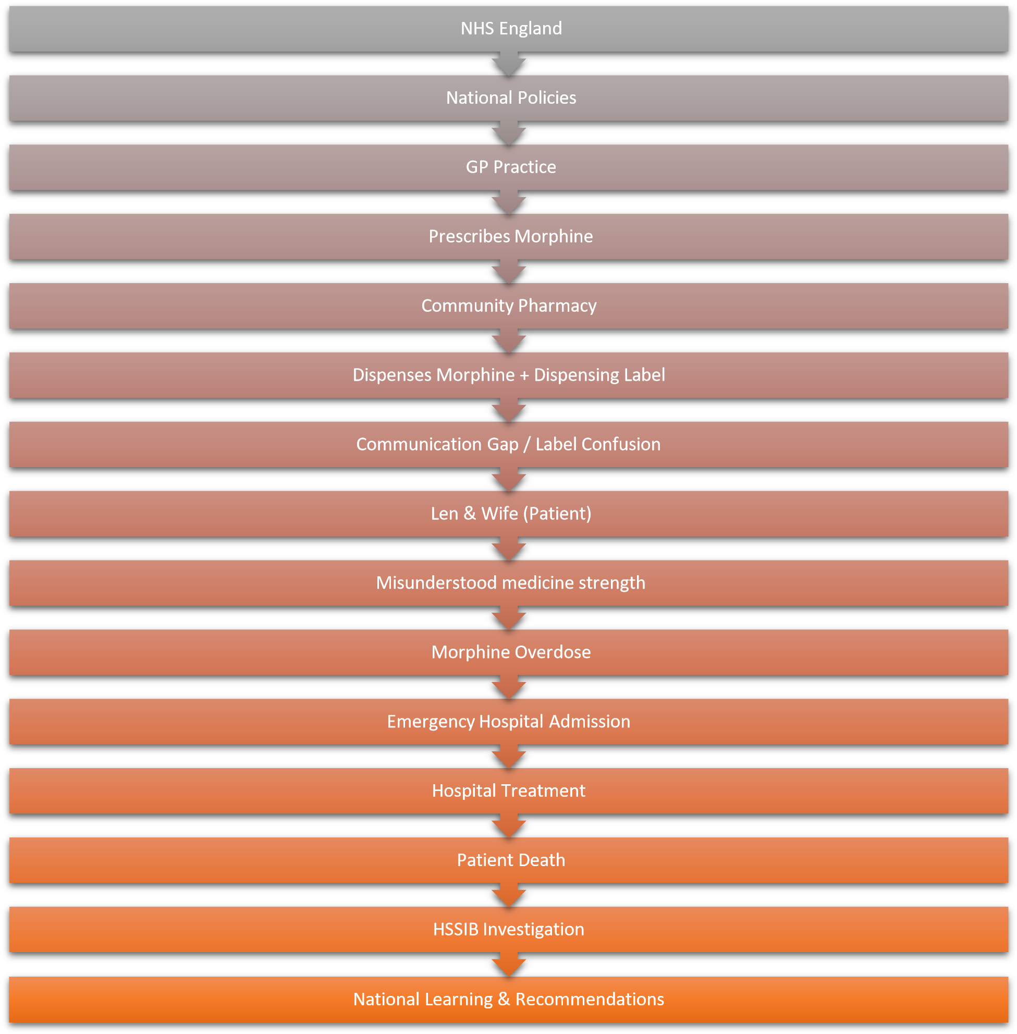

Appendix B – Timeline of Events
Date/Stage | Event
Fall | Len falls and develops chest pain
GP visit | Pain assessment
Hospital visit | Investigations completed
GP review | Morphine prescribed
Pharmacy | Medicine dispensed
Home | Wrong dose administered
Next morning | Found unresponsive
Hospital | Treated for overdose
Later | Patient died
Afterwards | HSSIB investigation

Appendix C. Global and National Medication Safety Data
Organisation | Latest evidence/statistics | Importance to Len's case
World Health Organization  (WHO) | Approximately 1 in 10 patients experience harm while receiving healthcare, and more than 50% of this harm is preventable. Around half of all preventable harm is medication-related. (World  Health Organization) | Demonstrates that medication-related harm is a major global patient safety issue rather than an isolated incident.
World Health Organisation  (WHO) | Medication-related harm affects 1 in every 30 patients, with more than one-quarter of cases  considered severe or life-threatening. (World Health  Organization) | Highlights the seriousness of medication errors involving high-risk medicines such as morphine.
World Health Organisation  (WHO) | Unsafe medication practices cost an estimated US$42 billion annually, representing almost 1% of global health expenditure.  (World Health  Organization) | Demonstrates the significant financial burden of medication errors and the importance of investing in safer systems.
Health Services Safety  Investigations Body (HSSIB) | HSSIB identifies medication as the most common intervention delivered within the NHS and reports that delayed, | Directly relates to Len's overdose and supports the need for improvements in medication safety, communication, and governance.
 | missed, or incorrect medicines can result in catastrophic harm, irreversible deterioration, or death.
HSSIB | HSSIB investigations recommend strengthening medication safety, organisational learning, communication, and electronic prescribing systems to reduce preventable medication harm. | Supports the recommendations made in this report regarding digital prescribing, leadership, and systems improvement.

Appendix D Centralisation vs Decentralisation
Feature | Centralised | Decentralised | Len's Case
Decision making | National policies | Local clinical judgement | Hybrid
Accountability | Senior management | Clinical teams | Mixed
Communication | Standard guidance | Team communication | Weak
Flexibility | Lower | Higher | Needed
Patient-centred care | Moderate | High | Better local communication required

Appendix E Leadership Theory Comparison
Theory | Characteristics | Application in Len's Case
Transformational | Inspires improvement | Needed stronger safety culture
Transactional | Rules and compliance | Prescription followed correctly
Situational | Adapts to patient needs | Better for elderly patient
Distributed | Shared responsibility | Better GP-pharmacy communication

Fishbone Diagram (Root Cause Analysis)
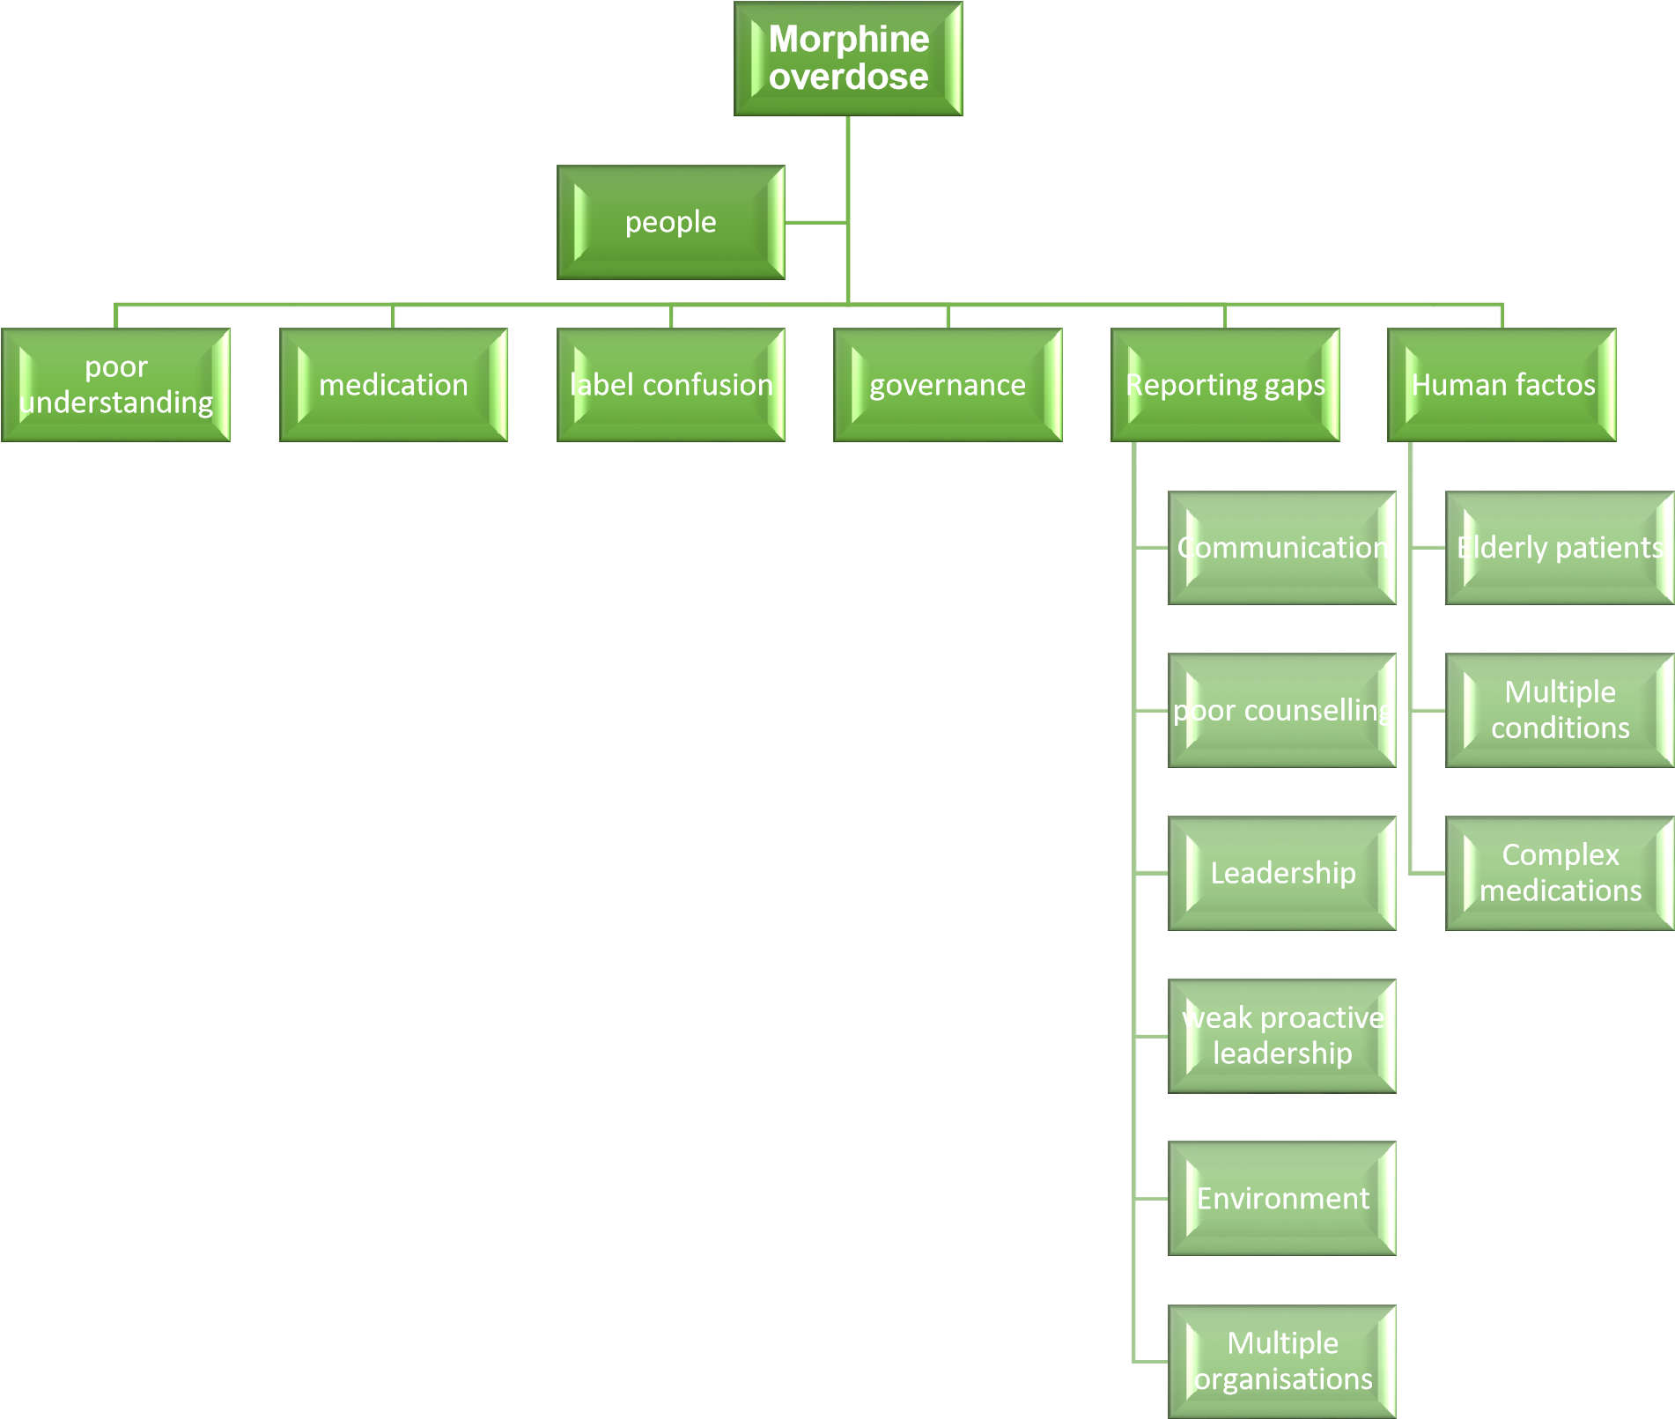

- Evidence Summary Table
Problem | Evidence | Impact | Solution
Medication misunderstanding | HSSIB | Overdose | Teach-back
Poor communication | HSSIB | Delay | MDT  communication
Labelling | HSSIB | Confusion | Clear labels
Governance | NHS | Learning gaps | Strong reporting
Leadership | Literature | Weak safety culture | Transformational leadership

- Improvement Plan
Recommendation | Responsible | Time | KPI
Teach-back method | Pharmacist | Immediate | 100% high-risk  patients counselled
Digital prescribing | NHS Trust | 6 months | Medication errors reduced
Medication audit | Governance team | Monthly | Compliance >95%
Staff training | Clinical Lead | Quarterly | 100% completion
MDT meetings | Department managers | Monthly | Communication improvements

- – HSSIB Recommendations Summary
Recommendation | Organisation Responsible | Expected Outcome
Improve medication labelling | MHRA | Reduce confusion
Improve patient information | NHS | Better understanding
Strengthen medication safety | Healthcare organisations | Fewer medication errors
Promote organisational  learning | HSSIB/NHS | Continuous improvement

