
1

Science Forces in Equilibrium Experimental Report

- Rationale

In this report, I will investigate, discuss and evaluate my data produced for how the angle between two strings and the length of the spring varies as they suspended load is increased. The reason for doing this experiment, is to help further my understanding of forces, I have been studying calculating forces within a component and forces in equilibrium. By completing this experiment, I will be validating my theory and therefore making it more reliable. The purpose of this experiment is for me to see and understand how this theory can be applied to a real engineering scenario.

- Apparatus set up

Before you start the experiment, you need to be prepared and have the apparatus set up correctly. Firstly, you must create a results table to record all your data. The table will need to have ten columns to record all data needed, three of these columns will be for derived data.

When creating this table, make sure all headings are clear and easy to read, all units are in the heading cells, not in with the numbers. All measurements must be recorded and not just skipping to the average, when recording measurements, make sure to match the correct s.f to the unit used in the heading, this statement is also true for all derived data.

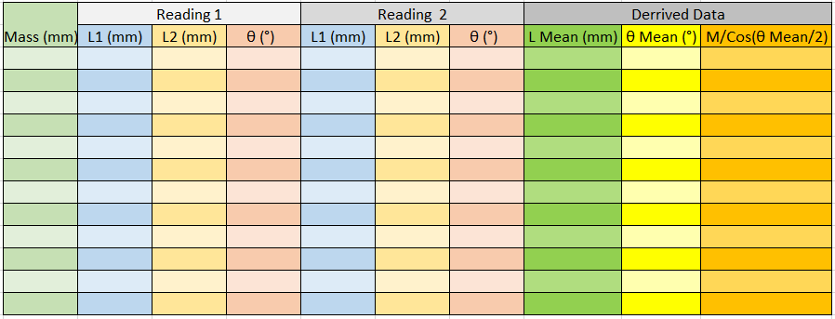
This is what my results table looked like prior to doing the experiment;

After you have created your table, you will move onto the setting up of the experiment. Once you are in the room where the experiment will take place, you will be supplied with all the needed apparatus, but you will need to check this upon arrival. You should have;

- Experimental instructions
- Retort stand
- Boss clamp
- 1 metre (1000mm) wooden rule
- 2 springs, connected 0.6 metres away from each other
- 0.3 metre (300mm) rule
- Protractor
- Spirit level
- 50g mass hanger
- 11 x 50g slotted masses

The only thing you will need to bring for yourself, is a pen or pencil accompanied with the results table you previously made. If all apparatus is present, you can successfully complete setting up the experiment.
The experiment will be mainly already set up and ready, but we will do a few checks to reduce our uncertainties within our results.
Firstly, check that the boss clamp is at the top of the retort stand, if at the top, check all tightening points are not loose with no movement. This is important as if the clamp moves during the experiment, it will cause the springs to oscillate, in turn making it difficult to make accurate and reliable readings.
Next, we shall make sure the 1 metre rule is straight and level, we will do this by using the spirit level supplied to us, to check the rule, simply place the level on top of the rule and bend down to get at eye level with the bubble inside the spirit level, check multiple points across the rule at eye level, doing this will help with reducing uncertainties.
Another check to do is to measure spring length prior to the experiment starting. This is so we can both springs are equal and haven’t begun plastic deformation. If they aren’t equal, ask supervisor or the lecturer hosting the experiment for a new spring.
Once the apparatus is correctly set up and have made all checks to reduce uncertainties, you can move onto starting the experiment.

- Method

Now you are ready to start your experiment, Firstly, check the 1 metre rule is still level and springs haven’t been stretched prior to you starting your experiment. Now to start measuring and collecting data.

Now, you shall prepare to measure the length of the springs and angle of the string with no added mass. To do this you will need to get down to eye level with the apparatus and directly in front of the measuring equipment, while resting your elbows on the desk to steady yourself and the equipment, doing this will reduce the chance of a systematic error. A common error seen is a zero error, this is when measuring equipment is not reading zero when it should be. In this case, from random error, the rule may not be at the end of spring, therefore giving an incorrect value.

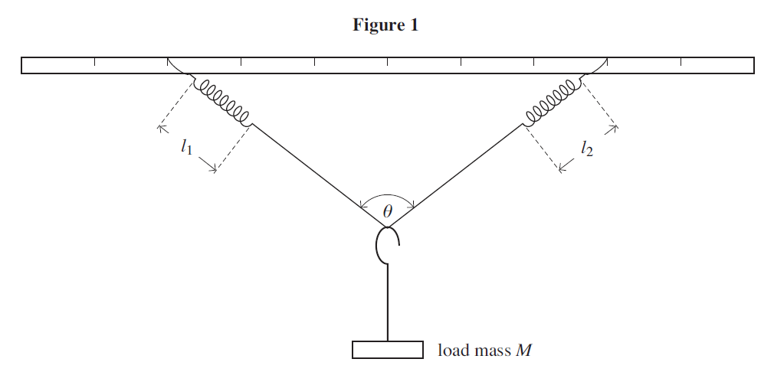
Once you have prepared to take your measurements, you will start with no masses on the string, so it shall be a straight line. You will take three measurements at each weight. By referring to figure 1, you will measure the length of the springs L1 and L2 from end to end by the rings each end of the spring. Once you have taken those measurements, you will measure the angle of θ, after this, you have successfully measured all aspects with no masses added, you will need to record all results within the table you created prior to starting the experiment.

Now you will add the 50g mass hanger, be sure to hang the mass hanger in the centre of the string. When the hanger is over the string, slowly lower the hanger onto the string, the slower you can do this, the better as it will minimise the oscillation, therefore reducing the time weighting for no oscillation which will increase efficacy. Once again, record all measurements taken.
Next, continue to add masses in increments of 50g at a time, taking measurements at each step the same way we have been doing.
It is good practice to use the spirit level to measure the metre rule throughout the experiment, this is to ensure the rule stays flat during the experiment.
Once completed, remove all weights and hanger and re do experiment for a second set of readings.

- Results
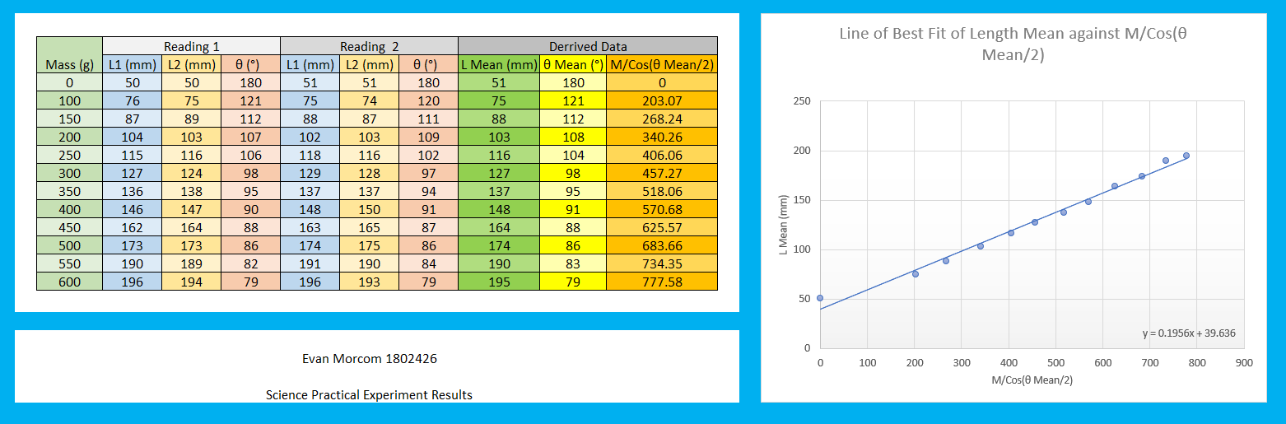
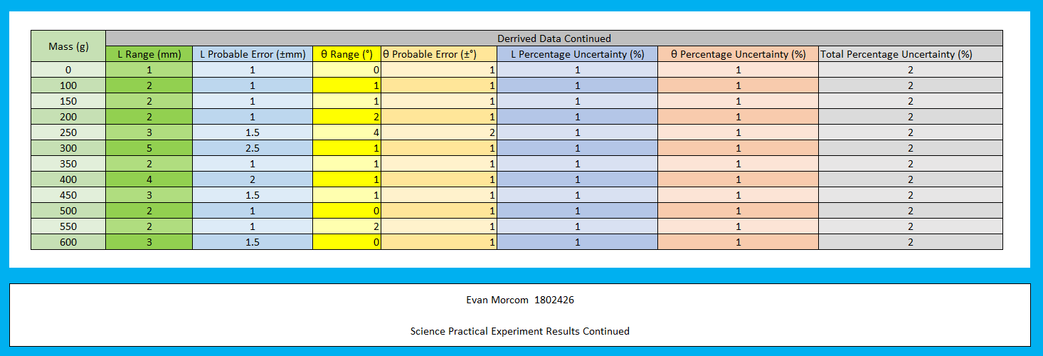

Above, are all my results I measured and calculated, there are some experimental uncertainties within my experiment unfortunately but with my equipment, this could not be avoided.

One of the main uncertainties, is a systematic error. While I was measuring lengths and angles, I could not perfectly steady myself to always get the zero mark where it should be, this was not the case with every measurement however it did happen at multiple stages throughout the experiment.

There will always be random error and it is inevitable however, it can be reduced by using the best measuring equipment available to you and being consistent with your measuring technique.

- Conclusions (this is where you say what you think your results tell you. Comment on your graphs – are they straight lines, if so, can you form an equation in the form y=mx+c? are they curved? What can you say about the curve, where do the maximums lie, what are the gradients like, do they vary throughout the graph and what do you feel is causing this to happen?)

To conclude my report, from reflecting and analyzing my results and graph, I can see I have a linear pattern with no curves and it occupies more than half of my available space, On my graph, I have used a straight line of best fit, this line is drawn so there are equal or close to equal points either side of my line. When drawing a straight line onto a graph, you should extrapolate the line, this means extending the line back until it crosses the axis. Doing this will allow me to calculate the equation y=mx+c. This is the equation of a straight line. Below is a diagram I found from a PowerPoint slideshow available on Moodle here; https://moodle.uwtsd.ac.uk/mod/folder/view.php?id=141113
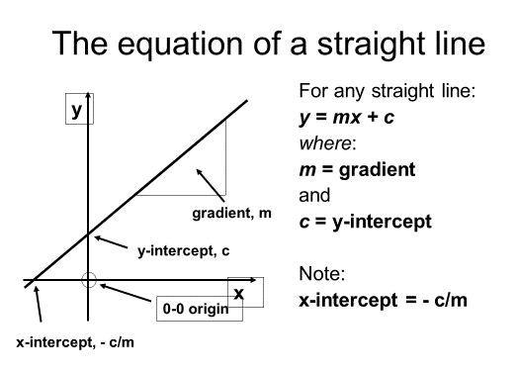

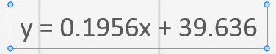

Using a function within excel, it will calculate and state the equation, now that I have this, I can input any average length (L Mean) into this equation in place of y and I can calculate x being M/Cos(θ Mean/2).
Now I will go onto talking about my results found in my results table above, unfortunately, I wasn’t using sensitive measuring equipment, therefore my data is not precise, however I have maximized the precision of my equipment. I was using a 30cm ruler with a millimeter scale to measure the length, therefore this has a precision of ± 1mm, and I used a protractor which had a scale of 1°, so this had a precision of ± 1°.
Even though my work my not have been 100% precise, it was accurate. This means that my measurement was close to the correct value of the apparatus that was measured.
I carried out my experiment twice to try and increase my reliability within my results. To achieve reliability when collecting data, your values must be consistent each time the same measurement is repeated. Therefore, knowing this, with the data I have collected, I will say my results are reliable, however I could increase the reliability if had continued the experiment and collected more data.
Within my experiment, I only had once independent variable, the added mass. The dependent variables were the length of the two springs and angle of the string. The control variables were;
- Height of retort stand
- Angle of metre rule
- Distance between springs
- Spring rate
- String thickness

Having a strong set of control variables, and little independent and dependent variables, will make the experiment easier to conduct and collect data from, and mainly help increase reliability within data.
When looking at results, it can sometimes not clearly display everything, so to understand the results better, you can calculate the probable error and the percentage of uncertainty of the data.
After calculating this simple and quick equations, you can input more data from the results table to enable you to calculate more percentages, the reason for calculating percentages is because you cannot add two different units together for a probable error total. So I can use a percentage uncertainty from the mean length and mean angle and combine the 2, giving me an overall percentage uncertainty, you can see this in my results table continued.



