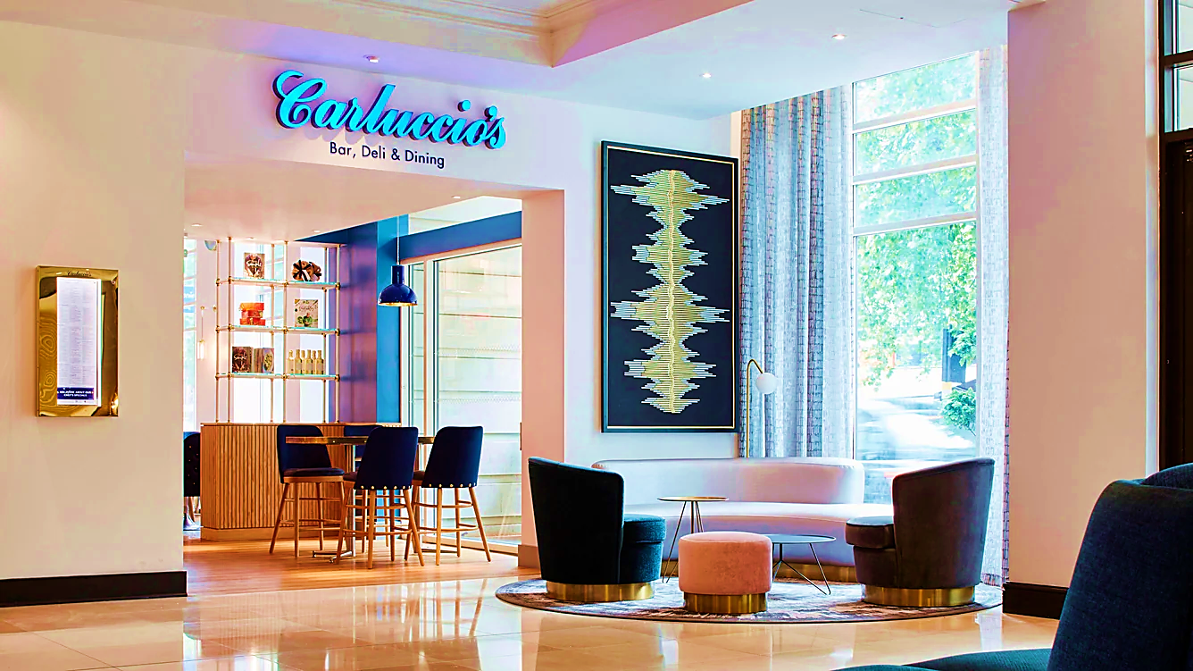 | Name: Rocio Garcia (2022578)  Module Title: Managing Food & Beverage Operations  Module code: BMIH6002  Lecturer: Lisa Bassler  Submission date: 13/11/23

Content Table
- Embarking on Morning Hospitality: Applying ERA Cycle
- Striving for Excellence in F&B Operations: A Breakfast Service Journey
- Unveiling the Basics: A Culinary Journey of Realization and Resilience
- Elevating Excellence: A Positive Action Plan for F&B Operations
- Conclusion
- Reference List

- Embarking on Morning Hospitality: Applying ERA Cycle
Introduction
In the heart of Marriott Maida Vale, my role as a host in the Food and Beverage department provided a daily immersion into the diverse world of breakfast. The buffet spread, a culinary mosaic, attracted guests from various corners of the globe, making the F&B department a hub of international flavours and conversations.

The breakfast routine wasn't just about serving meals; it was an opportunity to connect with guests from different cultures. Conversations flowed along with the clinking of cutlery, creating a dynamic ambiance where the diversity of languages spoken was as rich as the breakfast offerings.

Interacting with guests became a daily ritual, offering insights into their travels and providing recommendations for local experiences. Warm smiles and greetings set a positive tone for the day, ensuring that guests felt genuinely welcomed. Simple gestures, like a friendly hug or a heartfelt good morning, transcended language barriers, creating an atmosphere of warmth and familiarity.

As a host, my role extended beyond meal service; it was about fostering an inclusive environment where every guest, regardless of their origin, felt at home. In the Food and Beverage department of Marriott Maida Vale, breakfast wasn't just a meal—it was a shared experience, a moment to connect and set the stage for a positive day ahead. To augment this practice, I've applied the Jasper ERA Cycle Model (Jasper, 2013).

- Striving for Excellence in F&B Operations: A Breakfast Service Journey
Embarking on my role in the F&B department at the Marriott Maida Vale Hotel, I found myself immersed in the dynamic and fast-paced environment of the breakfast service. This experience was reminiscent of my early days in the hotel industry, where maintaining restaurant cleanliness and ensuring a well-stocked buffet were crucial components of exceptional customer service. Drawing on my past roles as a host and waitress, I eagerly anticipated the learning opportunities within this new department. However, my initial enthusiasm encountered challenges, particularly during the breakfast service, which comprised only four waiters catering to around 200 guests. This situation fostered an atmosphere of perpetual chaos, amplifying my perception of the staff constantly being understaffed.

In my role as a host responsible for welcoming guests and verifying breakfast inclusions, I faced the constant challenge of guests attempting to include breakfast in their package falsely. By the third day, my eagerness to learn was somewhat tempered as I found myself working without managerial supervision, a notable absence that I keenly missed. Following the breakfast service, my responsibilities transitioned from hosting to cleaning duties. By choice, I took on the task of cleaning tables and shining knives, aiming to integrate myself more closely with the team and gain insights into their dynamics.

My concerns deepened when, during routine cleaning, I stumbled upon several health and safety errors and hazard issues within the food and beverage areas. Perhaps the most alarming discovery was finding four surface cleaners stored in the wine coolers. This, to me, was an unacceptable and potentially dangerous practice, as mixing cleaning products with areas designated for food and beverages posed a significant risk. In response, I took immediate action to rectify the situation, removing the cleaners from the inappropriate storage location. It was during this intervention that a waitress, witnessing the potential danger, expressed her concern and alarm.

Adding to my observations was the conspicuous absence of a manager on duty, especially during the midday period when one would expect supervision in the restaurant. This raised questions about the adequacy of managerial oversight in the F&B department. Furthermore, the shortage of staff during the morning breakfast service, coupled with a lack of attention to cleanliness and sanitation, underscored systemic issues that needed to be addressed.

Despite my best efforts, communication barriers hindered my ability to convey these concerns to the management team. Limited interactions and trust with the managers made it challenging to articulate these observations effectively. It became evident that addressing the identified issues would require a comprehensive approach encompassing improved supervision, enhanced training protocols, and a renewed commitment to essential practices within the F&B department.

An additional concern that emerged was the normalization of potentially unsafe practices, symbolized by the presence of cleaning bottles in the fridge. This not only posed risks to staff and guests but also hinted at a broader cultural acceptance of suboptimal standards. The visible nature of these unsafe practices underscored the urgency of implementing changes to establish a safer and more compliant environment.

In reflection, this experience in the F&B department highlighted the critical need for comprehensive improvements, ranging from staffing levels and supervision to training and adherence to safety protocols. As a student keen on absorbing the intricacies of hotel management, this exposure provided valuable insights into the practical challenges and opportunities for improvement within the operational aspects of an F&B department.

- Unveiling the Basics: A Culinary Journey of Realization and Resilience
In this reflection from my perspective, amidst the hustle of the F&B department, a stark realization dawned upon me – in the culinary realm, it all boils down to the basics.
Maintaining cleanliness and caution, especially when handling food, is a fundamental requirement. However, as I navigated through the breakfast service, there was a palpable need to revisit the core principles of health and safety.
What proved most frustrating was the challenge of expressing my insights as an aspiring manager; it felt like my voice struggled to find resonance. Yearning for hands-on learning and the opportunity to shadow seasoned leaders, I found myself caught in a blend of confusion and boredom amid the chaos.
This experience underscored the importance of practical skills, particularly when confronted with unforeseen challenges. The key lesson was unmistakable – a well-trained staff is indispensable, and thorough preparation is crucial, especially in the face of limited support. This reflection marks a pivotal point in my journey, urging me to refine my skills and commit to comprehensive professional development.

- Elevating Excellence: A Positive Action Plan for F&B Operations
In the wake of the health and safety revelations during my F&B experience, I am propelled to enact a proactive action plan to fortify our operational standards and foster a culture of continuous improvement. First and foremost, I would initiate a comprehensive training program for all staff members, emphasizing the paramount importance of hygiene, cleanliness, and the correct handling of food items. This program would include periodic refreshers to ensure that these crucial aspects remain ingrained in our daily operations.

Simultaneously, I would propose the implementation of regular shadowing sessions for team members, offering them the opportunity to learn from seasoned professionals and gain practical insights into efficient service delivery.
This collaborative learning environment would not only enhance the skills of individual staff members but also promote a sense of shared responsibility for maintaining the highest standards.
To address the evident understaffing issues during breakfast service, I would recommend a reassessment of staffing levels, ensuring that we have an adequate number of team members to manage the rush efficiently. Additionally, the incorporation of a manager on duty during peak hours would provide essential oversight, fostering a safer and more organized working environment.

Expressing my eagerness to experience the dinner service, I recognize the potential for valuable learning opportunities during busier times with a full staff complement. This exposure would offer insights into managing higher volumes and handling the unique challenges that arise during peak hours.
In essence, this action plan aims not only to rectify the observed shortcomings but also to elevate our F&B operations, creating an environment where both staff and guests feel secure, valued, and engaged.

- Conclusion
In conclusion, my journey through the F&B department at Marriott Maida Vale provided valuable insights into the challenges and opportunities present in the dynamic world of hospitality. As I reflect on my experiences, I am driven to implement positive changes that prioritize staff training, safety, and well-being. The discovery of health and safety lapses has ignited a commitment to fostering a culture of continuous learning and improvement. This reflection serves not only as an acknowledgment of the existing gaps but as a catalyst for proactive measures to enhance operational efficiency and elevate the overall guest experience

- Reference List
(2023) 11 ways to improve employee development | . Available at: https://www.indeed.com/career-advice/career-development/employee-developement (Accessed: 13 November 2023).
Foy, D. (2021) The health and Safety Checklist for restaurants and Food Outlets, HSE Network. Available at: https://www.hse-network.com/the-health-and-safety-checklist-for-restaurants-and-food-outlets/ (Accessed: 06 November 2023).
Greenwood, K. and krol, natasha (2020) 8 ways managers can support employees’ mental health, Harvard Business . Available at: https://hbr.org/2020/08/8-ways-managers-can-support-employees-mental-health (Accessed: 04 November 2023).
Half, R. (2023) 14 effective employee retention strategies, English. Available at: https://www.roberthalf.com/us/en/insights/management-tips/effective-employee-retention-strategies (Accessed: 11 November 2023).
How Marriott Residence Inn engages its employees in Health &amp; Safety (2022) How Marriott Residence Inn Engages Employees in Health, Safety and Organizational Performance. Available at: https://www.wsps.ca/resource-hub/case-studies/how-marriott-residence-inn-engages-employees-in-health-safety-and-organizational-performance (Accessed: 06 November 2023).
L, L. (2023) The role of managers in supporting employee wellbeing, Loving Life. Available at: https://lovinglifeco.com/hr/the-role-of-managers-in-supporting-employee-wellbeing/ (Accessed: 04 November 2023).
Leggett, A. (2023) The importance of health and safety training in hospitality, Home. Available at: https://www.intuto.com/blog/importance-of-health-and-safety-training-hospitality (Accessed: 06 November 2023).
Miles , M. (2022) Supporting employees: 6 ways to unlock their full potential, BetterUp. Available at: https://www.betterup.com/blog/supporting-employees#:~:text=Better%20employee%20engagement.&amp;text=They%20are%20purpose%2C%20development%2C%20a,positive%20benefits%20for%20your%20organization. (Accessed: 05 November 2023).
Mistry, S. (2022) How to deal with common challenges in hotel industry in 2023?, eZee Absolute. Available at: https://www.ezeeabsolute.com/blog/how-to-deal-with-challenges-in-hotel-industry/ (Accessed: 06 November 2023).
Newsome, P. (2023) Supporting employees in the workplace: Benefits &amp; Tips, 4 Corner Resources. Available at: https://www.4cornerresources.com/blog/supporting-employees-in-the-workplace/ (Accessed: 04 November 2023).
Reflective writing (no date) Reflective writing - The University of Nottingham. Available at: https://www.nottingham.ac.uk/studyingeffectively/writing/writingtasks/reflective.aspx (Accessed: 01 November 2023).
Robinson, J. (2023) In-depth explanation of era cycle of reflection writing, Crowjack. Available at: https://crowjack.com/blog/strategy/reflection-models/era-cycle (Accessed: 10 November 2023).
School, E.B. (2021) 9 tips for dealing with the upcoming challenges in hotel management, Blog | EU Business School. Available at: https://www.euruni.edu/blog/tips-dealing-challenges-hotel-management/ (Accessed: 06 November 2023).
Tiernan, D. (2023) What are health and safety protocols in hotels? - amenitiz blog, Amenitiz. Available at: https://amenitiz.com/en/blog/health-and-safety-protocols-in-the-hospitality-industry/ (Accessed: 05 November 2023).
Wood, R.C. (2013) Key concepts in hospitality management. Los Angeles: SAGE.

