
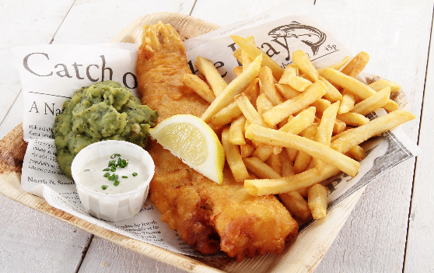


Main Dishes
Traditional Scampi & Chips . . . . . . . . . . . £11
Whole breaded langoustine tails, served with chips, garden peas, lemon & tartare sauce

Mushroom Stroganoff   . . . . . . . . . . . . . . .£11
Fried mushroom served in a creamy paprika and garlic sauce, served with rice

6oz Fillet Steak . . . . . . . . . . . . . . . . . . . . . £19
Served with grilled tomato, sliced mushroom, onion rings, chips & garden peas
RECOMMENDED WINE PAIR: Casa Santiago, Merlot

Classic Haddock & Chips . . . . . . . . . . . . . . . . £16
Battered & served with chips, garden peas & tartar sauce
RECOMMENDED WINE PAIR: Casa Santiago, Sauvignon Blanc

Chicken Burger . . . . . . . . . . . . . . . . . . . . . £10
Grilled chicken breast, served with gem lettuce, onion, slice tomato, relish & mayonnaise

Chicken Tikka Masala Curry . . . . . . . . . . . . . . £12
Classic chicken curry served in a Balti dish with long white grain rice and poppadom
Drinks
Casa Santiago Sauvignon Blanc, Chile. . . . . . . . . . . . . . . Bottle. . . £25
A combination of zesty lime & grapefruit with a refreshing soft & fruity aftertaste

Casa Santiago Merlot, Chile . . . . . . . . . . . . . . . . . . . . . . . . . . . Bottle. . . £25
Intense red fruit flavours of strawberry & raspberry. Fresh & silky with a lovely finish
Starters & Light Bites
Whitebait . . . . . . . . . . . . . . . . . . . . . . . . . . £7
Crispy fried whitebait served with garlic dip and wedge of lemon

Halloumi fries . . . . . . . . . . . . . . . . . . . . . . . . £7
Halloumi coated in breadcrumbs served with sweet chilli dip
Deserts
Cheesecake . . . . . . . . .. . . . . . . . . . . . . . £7
Homemade, please ask for today’s cheesecake special

Crumble . . . . . . . . . . . . . . . . . . . . . . . . . . . . £7
Homemade, please ask for today’s fruit selection
Vegetarian Gluten Free
- Order at 01202732142 or 
- Maritime Quarter, Swansea, SA1 3 SS
- Free Contactless delivery anywhere in Swansea  
- Distanced take away available starting December 2021
- Open 7 days a week from 8am - 11:30pm

